Prevalence of Contagious Ecthyma in Goats in Khagrachhari Sadar Thana
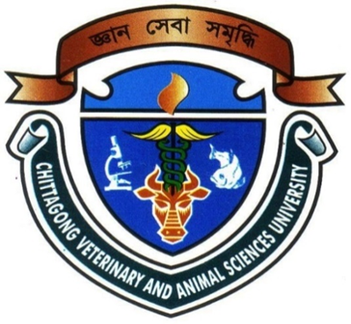

Submitted By
KUSHAL CHAKMA
ROLL NO: 2010/61
REGISTRATION NO: 00539
INTERN ID: E-45
SESSION: 2009-10

Clinical Report Presented In Partial Fulfillment of the Requirement for the Degree DVM (Doctor of Veterinary Medicine)
Faculty of Veterinary Medicine

CHITTAGONG VETERINARY AND ANIMAL SCIENCES UNIVERSITY,KHULSHI ,CHITTAGONG-4202.

Prevalence of Contagious ecthyma in Goats in Khagarachhari sadar Thana

Approved:

…………………………………………………………….
Dr. Md. Mizanur Rahman
Professor
Dept. of Medicine and Surgery
Faculty of Veterinary Medicine (FVM)
Chittagong Veterinary and Animal Sciences University

September, 2015

