ACKNOWLEDGEMENT

The author is ever grateful and indebted to the Almighty God without whose grace it would have never been possible to pursue this study in this field of science and to complete this clinical report writing for the Degree of Doctor of Veterinary Medicine (DVM).

The author would like to thank his reverend and beloved teacher and Supervisor Dr. Md. Mizanur Rahman, Professor, Department of Medicine and Surgery, Chittagong Veterinary and Animal Sciences University, Chittagong for his scholastic guidance, uncompromising principles, sympathetic supervision, valuable advice and constant inspiration of this study and preparing the manuscript.

The author would like to express his deed sense of gratitude and heartfelt appreciation to Dr. Bhajan chandro Das, (Ex- Director, SQTVH, Chittagong Veterinary and Animal Sciences University, Chittagong to allow me to record this study.

The author is grateful to Mozamal Ahamed, (the owner of goat) and Kamrul Hossain (staff of SAQTVH) for their cordial help at study period.

The author is ever indebted to his father, mother, brothers, sister, friends and other relatives for their sacrifices, blessing and encouragement to get him in this position.

---------------------------------------
The Author

Plagiarism certificate
This report is a significant new knowledge. No sentence, equation, diagram, table, paragraph or section has been copied verbatim from previous work unless it is placed under quotation marks and duly referenced. The work presented is original and own work of the author (i.e. there is no plagiarism) . No ideas, processes, results or words of others have been presented as author own work. There is no falsification by manipulating research materials, equipment or processes

CONTENTS
Title Page no
Acknowledgement…………………………………………………………………… 1
Plagiarism certificate………………………………………………………………… 2
Table of Contents…………………………………………………………………… 3
List of Tables……………………………………………………………………….. 4
List of Figures………………………………………………………………………. 4
Elaboration of all abbreviation………………………………………………… …… 5
Abstract……………………………………………………………………………… 6
Chapter 1. Introduction………………………………………………………………. 7-8
  - General Introduction…………………………………………………. 7
  - Background…………………………………………………………. 8
  - Objectives………………………………………………………… .. 8
Chapter 2. Case description………………………………………………………… 9-12

2.1 Anamnesis………………………………………………………… 9
2.2 Physical examination……………………………………………… 10
2.3 Clinical Examination……………………………………………… 10
2.4 Laboratory data…………………………………………………… 11-12
Chapter 3. Result and Discussion ……………………………………………….. 13-14
Chapter 4. Limitation ………………………………………………………………. 15
Chapter 5 Conclusion………………………………………………………………. 15
Chapter 6. Refference……………………………………………………………… 16
Chapter 7 Biography……………………………………………………………… 17

LIST OF TABLES
Table No | Contents | Page
Table no 1 | Blood biochemical value before treatment | 11
Table no 2 | Routine blood test | 11

LIST OF FIGURES
Figure no | Contents | Page
Figure 1 | Nervous disorder in goat | 10
Figure 2 | Lateral recumbence in goat | 10
Figure 3 | One direction movement | 10
Figure 4 | Health check up after recovery of goat | 10

ELABORATION OF ALL ABBREVIATION
Abbreviation Elaboration
PPR……………………………………Peste des Petits Ruminent
BBG……………………………………Black Bengle Goat
SAQTVH……………………………… Sohidul Alam Quadery Teaching Veterinary Hospital
CVASU…………………………………Chittagong Veterinary and Animal Sciences University
L. monocytogen……………………….. Listeria monocytogen
ESR……………………………………Erythrocyte Sedimention Rate
PCV……………………………………Packed Cell Volume
RBC……………………………………Red Blood cell
WBC……………………………………white Blood Cell
CBC…………………………………… Complete Blood Count

ABSTRACT
Listeriosis is a sporadic bacterial infection that affects a wide range of animals, including people and birds. Case of listeriosis found in goats as well. It is seen worldwide, more frequently in temperate and colder climates. There is a high incidence of intestinal carriers. Encephalitis or meningoencephalitis in adult ruminants is the most frequently recognized form. In this study a Jummuna pari male goat was tentatively diagnosed as having listeriosis based on presenting clinical signs. The patient was successfully treated with crystalline penicillin and dexamethasone in the S.A. Q. Teaching veterinary Hospital, CVASU
Key words: Listeriosis, goats , meningo-encephalitis, encephalitis, crystalline penicillin

INTRODUCTION
Bangladesh is an over populated, rural and agrarian country in the world and livestock has been an important component. About 80% of our population is employed in agriculture and livestock farming. Twenty percent people are involved in livestock sector as permanent occupation. The contribution of Livestock in the magnitude of Gross Domestic Product (GDP) is about 16.23 % in Bangladesh (BBS, 2008). Ruminant, especially cattle and goats constitute the major portion of the livestock. Most of these animals are reared under smallholder traditional management system in rural areas. The management practices of animals and geo-climatic condition of Bangladesh are favorable for the occurrence of various diseases and livestock diseases and disorders of animals are the most important hindrance towards livestock development in our country.

Small ruminants especially goat is very important in rural economy and nutrition and has the potentially of using it as a tool for poverty reduction in Bangladesh. Viral diseases like peste des petits of ruminant (PPR), goat pox, contagious ecthyma and viral pneumonia, and bacterial diseases such as listeriosis, enterotoxaemia, tetanus, brucellosis, mastitis and metritis, mycotic diseases like ring worm infection, and rickettial infections like conjunctivitis are common causes for goat mortality in rural areas. Gastro-intestinal nematodiasis, fascioliasis and tape worm causes less mortality but cause severe depression in the growth and reproductive rate of the Black Bengal Goat (BBG). Lack of proper care and overall faulty husbandry practices are also responsible for higher goat mortality in the prevailing production (Kabir et al.,2010).

Veterinary hospital is an ideal and reliable source and place of information about animal diseases and their solution. People from the neighboring areas bring their sick animals to the Veterinary hospital every day.(Karim et al.,2014) Listeriosis is one of the important diseases in goats There are 13 serotypes of L. monocytogenes that can cause disease, It can grow and reproduce inside the host's cells and is one of the most virulent food-borne pathogens, with 20 to 30 percent of clinical infections resulting in death(Toder ,2008) .
Clinical disease in goat occur mainly in the northern and southern latritudes and is much less common in tropical and sub tropical than in temperate climates,The Disease is important in North America, Europe, the United Kingdom,new Zealand, and Australia. In the Northern hemispheres Listeriosis has a distinct seasonal occurrence, probably associated with seasonal feeding of silage, with the highest prevalence in the months of december through May but seasonal occurrence is not a feature in Australia (Blood et al,. 2000).

In Bangladesh Listerioris is a common infectious disease in goat.The disease occurs sporadically, affecting a single animal in a heard or flock or a few individuals over several weeks. The mean attack rate in 50 affected flocks in Bangladesh Was 2.5% with a range of 0.1-13.3%. More serious outbreaks can occur with attack rates as high as 35% and cases occuring over a 2month period. This disease occur in goat older than 6weeks but may be more prevelent in kid between 6 and 12 weeks of age . This case fatality is high, especily in buck ang pregnant doe, because the short clinical course often precludes treatment (Karim et al., 2014).

Aim of work:
To prevent listeriosis in goat diagnosis is most important , but it is true that there is a very little scope to perform confarmatory diagnosis Listeriosis in goat in our situation , so it is necessary to follow alternative way to diagnose this fatal infectious disease like symptomatic diagnosis ,diagnosis by response to treatment etc. Still now it is quite impossible to perform modern technique to diagose listeriosis in case of goat, so an attempt was taken to see the response of treatment with crystalline penicilline and dexamethasone.

CASE DESCRIPTION
A 15months old male Jammunapari buck presented at SAQ Teaching Veterinary Hospital (TVH) with history of, weakness, loss of appetite, dull and depressed, dyspnea, lateral recumbence and nervous disorder for 2 days on 2nd May 2015 from Lalkhan-Bazar area.
There was no history of vaccination and deworming and previously administration of drug
General examination

Physical condition, behavior, posture, gait, superficial skin wound, nasal discharge, distension of the abdomen, locomotive disturbance etc were observed by visual examination of the patient.

Physical examination
At physical examination the rectal temperature was found 105°F. The patient was severely dehydrated with pink mucus membrane. Heart rate and respiratory rate recorded were 64/min, 30/min respectively with, dull and depressed, laterally recumbent, head low down, abnormal posture and gait.

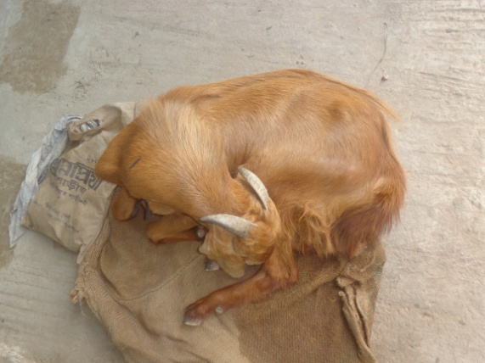 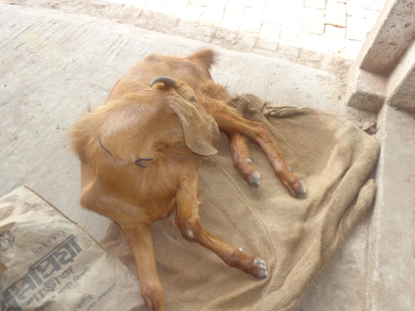Nervous disorder lateral recumbence
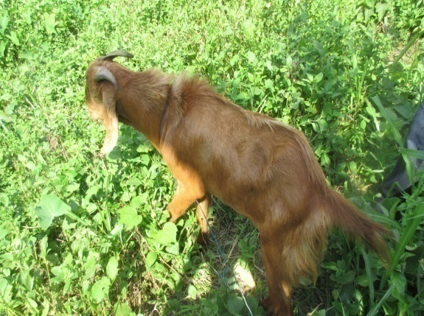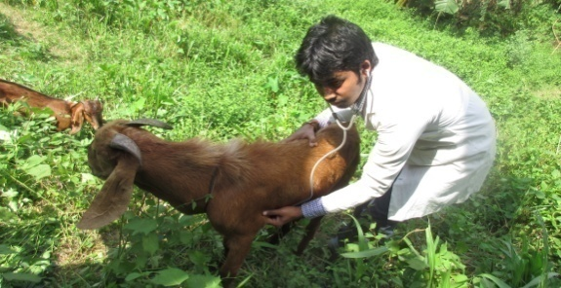
One direction movement Health check up after two months of recovery
Laboratory examination
Collection of sample
Total 6ml blood was collected from jogular vein of the buck with sterilized syringe and put 4ml in a procoagulation tube (without heparin) for serum analysis and 2ml blood in a sterilized tube, cotaining Lithium heperin for CBC analysis, labelled carefully and sent to biochemistry lab. physiology lab.

Table 1: Blood biochemical value before treatment
Name of the test | Result | Normal Range
S. Calcium | 7.95 | 9.7-12.4mg/dl
S. Magnesium | 1.8 | 1.8-2.3mg/dl
S. Phosphorous | 10.25 | 4.2-9.1mg/dl
Table 2: Routine blood test
Name of the test |  | Normal Range
Heamoglobin | 9.4 | 8-12gm%
ESR (Wintrobe tube method) | 0.5
Total Count
Total count of RBC | 12..06 | 8-18(million/cumm)
Total count of WBC | 7.75 | 8-12(thousand/cumm)
Platelet
Circulating eosinophils
PCV | 35 | 50-70%
Differential count of WBC
Lymphocytes | 47 | 22-35%
Neutrophils | 48 | 30-48%
Eosinophils | 4 | 1-8%
Monocytes | 1 | 0-4%
Basophils | 0 | 0-1%
Others
Initially the animal treated with streptomycin and penicillin (sterptopen, Renata Drugs Bangladesh Limited, 2.5 gm vial) combine preparation intramuscularly once at daily and antihistaminic (Histavet, ACI pharmaceutical limited, vial 10 ml) at 22.75mg/10 kg BW once daily for 2 days
Two days later after physical examination the temperature was 104°F with clinical signs like padding of limb, lateral recumbence. The animal was tentatively diagnosed having listeriosis and decision was taken to treat Penicillin-G-sodium (Pen-G®, Opsonin Pharmaceuticals Limited 10lac IU vial) 44000 IU/ kg at 6 hours interval daily until recovery as it crosses the blood brain barrier at 6 hours interval with dexamethasone (Dexavet, Techno Drugs, 0.5mg/kg BW) once daily I/V for preventing fibrosis in brain and normal saline (Normal Saline, Opsonin Pharmaceuticals Limited) for rehydration of animal for 5 days).

RESULT AND DISCUSSION
The animal was observed intensively and it was noticed that the health condition improved day by day .Temperature was decrease day by day, animal could try to move and stand , nervous sign was disappeared gradually
According to Blood et al.,(2000) listeriosis is a sporadic disease In the northern hemispheres listeriosis has a distinct seasonal occurrence, probably associated with seasonal feeding of sailage, with the highest prevalence in the months of December through May. According to Braun et al.,(2002),as Bangladesh is a country of northern hemispheres of the world and the study period was May , by epidemiological study the disease can consider a listeriosis. According to Blood et al.,(2000)the patients of listeriosis having septicemia which clinically indicate by high fever. Similarly it was noticed that the goat has fever (105°F).. Early clinical signs are depression, decreased appetite and fever .Signs progress to neuromuscular in-coordination where animals circle in the same direction. Other progressive signs include seizures, facial nerve paralysis (on one side), ear droop, salivation, lock jaw, impaired swelling, and death. This reported animal also had those signs .According to Durie et al.,(2010) patient of listeriosis having low calcium, high phosphorous in blood level. In this case study,the blood examination report shows that ,the animal also suffering from hypocalcimia and hyperphosphatemia. Lymophocyte also increase in blood leval , which shows animal suffering from infectious dieases. So due to lack confarmatory diagnostic tools, it is important to diagnose the animal according response to treatment, which is cost effective as well as accurate. After treatment on response, the level of calcium and phosphorous became normal, amount of lymphocyte also normal in blood level.
According to Smith and Sherman (2009).Early intervention improves the prognosis for recovery.Goats already recumbent rarely respond favorably to treatment and a poor prognosis should be given forrecumbent animals. Penicillins, tetracyclines, and where permitted, chloramphenicol, are effective antibiotics.Adult goats with the septicemic form of disease responded favorably to intramuscular penicillin administered for three consecutive days at a dose of 2.5 g per day, but shorter courses of therapy were lesse effective. In the encephaliticform, intravenous sodium penicillin at a dose of 40,000 IU/kg every six hours until improvement is noted, followed by a seven-day course of intramuscular procaine penicillin at a dose of 20,000 IU/kg twice a day has been recommended (Brewer 1983). Oxytetracycline should be given intravenously at a dose of 10 mg/kg twice a day for at least three days. These high dosage levels are necessary to promote passage of antibiotic across the blood brain barrier and developmentof high-tissue concentrations in the CNS.It has been reported that ampicillin or amoxicillingiven in conjunction with gentamicin is the treatmentregimen of choice in human listeriosis cases. The useof a combination of gentamicin given at a dose of 3 mg/kg bw IV BID and amoxicillin given at a dose of 7 mg/kg bw IM BID was reported in one retrospective case study in small ruminants (Braun et al. 2002). The outcomes for sheep and goats treated with gentamicin/ampicillin were better than those treated witheither penicillin or oxytetracycline. However, more of the animals treated with gentamicin/amoxicillin had a favorable prognosis at the onset of therapy because
they were not yet recumbent. The use of gentamicin in goats is problematic due to prolonged antibiotic residues in meat and milk.Dexamethasone given once a day at a dose of 0.1 mg/kg intravenously has also been used in conjunction with antibiotics in the treatment of encephalitic listeriosis with the rationale that steroids may suppress the infiltration of mononuclear cells that leadto microabscesses in the brain stem. The nonsteroidal anti-infl ammatory drug flunixin meglumine has been used at a dose of 2.2 mg/kg bw IV SID in the treatment of goats with encephalitic listeriosis but its contribution to a favorable outcome is not documented.Supportive therapy in the form of fluid and electrolyte administration, supplemental feeding, and managementof exposure keratitis associated with lid paralysis may be necessary in severely affected animals.Large amounts of bicarbonate and fluid may be lost when salivation is prolonged and intense, so fluid therapy should be tailored to address thesedefid578\ciencies
According to Blood et al(2000) The IV injection of chlortetracycline(10 mg/kg BW per day for 5 days) is resonable effective in meningoencephalitis of cattle but lees so in sheep and goat.Penicillin at a dosage of 44000IU/kg BW given IV daily for 7 days, and in many cases for 10 -14days, can also used.The recovery rate depends largely on the time that treatmant is started after the onset of clinical signs. If sever clinical signs are already eviden death

LIMITATIONS

In our laboratory as well as our country there is no available facility to culture listeria due to lack of specific media and other modern technique like ,ELISA, PCR, rtPCR, RIA are expensive enough to performby the part of the owner, so it it is difficult to confamatory diagnosis of the disease

CONCLUSION

The case study shows that proper diagnosis and treatment, that can save the life of goats which are suffering from listeriosis. The field veterinary can use the procedure to treat the animal which suffering from listeriosis. This case study helps the poor owner of goat to offer the treatment of listeria affected goat within lower cost.

REFFERENCES

Begum, I. A., Alam, M. J., Rahman, S., & Van Huylenbroeck, G. (2014). An assessment of the contract farming system in improving market access for smallholder poultry farmers in Bangladesh. For inclusive market access, 39.
Braun, U., Stehle, C., and Ehrensperger, F. (2002)Clinical findings and treatment of listeriosis in 67 sheep and goats. Veterinary record, 150(2), 38-41)
Douglas C,Blood Clive.grayOtt M. Radostitis,Kenneth .hinchliff.’’ A text book of diseases of cattle, pigs, goat and horses’’9th edition-2002, page736-741
Durie, I., Van Loon, G., Hesta, M., Bauwens, C., & Deprez, P. (2010). Hypocalcemia Caused by Primary Hypoparathyroidism in a 3‐Month‐Old Filly. Journal of veterinary internal medicine, 24(2), 439-442
Kabir, M.H.,Reza, M.R.,K.M.A.,Parvez,M.M.,Bag.M.A.S.,&Mahfuz,S.U.(2010).A report on clinical prevalence of diseases and disorders in cattle and goat at the Upazilla Veterinary Hospital, Ulipara, Kurigram, International Journal of Bio Research, 2,17-23
Karim, M. R., Parvin, M. S., Hossain, M. Z., Islam, M. T., & Hussan, M. T. (2014). A Report on Clinical Prevalence of Diseases and Disorders in Cattle and Goats at The Upazilla Veterinary Hospital, Mohammadpur, Magura. Bangladesh Journal of Veterinary Medicine, 12(1), 47-53
Mary C. Smith, David M. Sherman, “Goat Medicine” 2nd edition-2009, Page 202-208
Todar, K. (2008). "Listeria monocytogenes". Todar's Online Textbook of Bacteriology. Retrieved January 28, 2009.

Biography

I am Kalishangkar paul, intern student of Chittagong Veterinary and Animal Sciences University, Origin from Kalipur, Banskhali Chittagong. By this December I will receive my Doctor of Veterinary Medicine (DVM) degree, during this period of time I attent so many training programme, seminar and conference in home and abroad related my degree for better exposure knowledge and experience. I finished my primary, secondary and higher secondary education from Chittagong Board and belonging within top five top students in my class. I am personally self dependent one ,like to do my work with due response, active , punctually and dutyfully

