**Chapter-3**

**RESULTS**

**Results of Thin layer Chromatography (TLC)**

**Results for cheavon samples**

**3.1 Overall antibiotic residues percentage (%)**

A total of 60 samples (20 Liver, 20 Kidney and 20 Thai muscle) from 20 goat were screened for antibiotic residues. After collection of samples from some wet market of Chittagong City Corporation and studied for each type of antibiotics and antimicrobials for antibiotic residues detection by thin layer plate and detected. Table 1 showed that, 32 (53.3%) cheavon were positive under the UV light for the presence of antibacterial substances.

**Table 1.** Overall antibiotic residues percentage (%) of cheavon sample.

|  |  |  |  |
| --- | --- | --- | --- |
| **Sample** | **Total sample** | **Positive** | **Percentage (%)** |
| Liver | 20 | 14 | 70 |
| Kidney | 20 | 11 | 55 |
| Thigh muscle | 20 | 7 | 35 |
| **Total** | **60** | **32** | **53.3** |

Here, In case of Liver, Kidney and Thigh muscle sample 14, 11 and 7 were positive respectively. The total sample was 60 in which 32 samples were positive totally. The percentage of positive samples of liver, kidney and thigh muscle were 70%, 55% and 35% respectively. Totally 53.3% samples were positive for presence of antibiotic residues. The table shows that the highest percentage (%) of antibiotic residues presence in liver, that is 70% and the lowest percentage (%) of antibiotic residues presence in thigh muscle, that is 35%.

**3.2 Specific antibiotic residues percentage (%)**

A total of 60 samples (20 Liver, 20 Kidney and 20 Thigh muscle) from 20 Goat were screened for antibiotic residues. Of the 20 liver samples was studied, 4 (20%) were positive for tetracycline, 2 (10%) were positive for amoxicillin, 3 (15%) were positive for sulfanilamide and 5 (25%) were positive for ciprofloxacin and 1(5%) positive for penicillin. Of the 20 kidney samples was studied, 3 (15%) were positive for tetracycline, 1 (5%) were positive for amoxicillin, 2 (10%) were positive for sulfanilamide, and 3 (15%) were positive for ciprofloxacin and 1(5%) were positive for penicillin. Of the 20 Thigh muscles samples was studied, 2 (10%) were positive for tetracycline, 1 (5%) were positive for amoxicillin, 1 (5%) were positive for sulfanilamide and 2 (10%) were positive for ciprofloxacin and 1(5%) were positive for penicillin. Ciprofloxacin was the most predominant antibiotic detected 5 (25%), among four studied antibiotics and followed by tetracycline 4 (20%). Liver had the highest percentage (70%) of antibiotic detected, followed by Kidney (55%) and Thigh muscle (35%).

**Table 2.** Positive percentage (%) of studied samples for five antibiotics in cheavon samples.

|  |  |  |  |  |
| --- | --- | --- | --- | --- |
| **Antibiotic** | **Liver**  **(N=20)** | **Kidney**  **(N=20)** | **Thigh muscle**  **(N=20)** | **Total Sample**  **(N=60)** |
| Tetracycline | 4 (20%) | 3 (15%) | 2 (10%) | 9 (15%) |
| Amoxicillin | 2 (10%) | 1 (5%) | 1 (5%) | 4 (6.7%) |
| Sulfanilamide | 3 (15%) | 2 (10%) | 1 (5%) | 6 (10%) |
| Penicillin  Ciprofloxacin | 1 (5%)  4 (20%) | 2 (10%)  3 (15%) | 1 (5%)  2 (10%) | 4 (6.7%)  9 (15%) |

**Total 14 (70%) 11 (55%) 7 (35%) 32 (53.3%)**

**Table 3.** Positive percentage (%) of antibiotic in different market samples .

|  |  |  |  |  |  |  |
| --- | --- | --- | --- | --- | --- | --- |
| Place | Sample | Antibiotics | | | | |
| T | A | S | P | C |
| Reajuddin Bazar  (8) | Thigh Muscle | 1 (5%) | 1 (5%) | 3 (15%) | 1 (5%) | 2 (10%) |
| Liver | 2 (10%) | 1 (5%) | 3 (15%) | 1 (5%) | 1 (5%) |
| Kidney | 3 (15%) | 1 (5%) | 2 (10%) | 1 (5%) | 1 (5%) |
| Karnaphuli Market  (6) | Thigh Muscle | 1 (5%) | 1 (5%) | 2 (10%) | 1 (5%) | 1 (5%) |
| Liver | 2 (10%) | 1 (5%) | 2 (10%) | 1 (5%) | 0 (0%) |
| Kidney | 1 (5%) | 1 (5%) | 3 (15%) | 0 (0%) | 1 (5%) |
| Jautala Bazar  (6) | Thigh Muscle | 0 (0%) | 1 (5%) | 3 (15%) | 1 (5%) | 1 (5%) |
| Liver | 1 (5%) | 1 (5%) | 1 (5%) | 2 (10%) | 1 (5%) |
| Kidney | 3 (15%) | 0 (0%) | 1 (5%) | 1 (5%) | 1 (5%) |

(T=Tetracycline, A=Amoxicline, S=Sulfonilamide, P=Penicilline, C=Ciprofloxacin)

Here, different wet market samples shows that the amount of antibiotic in different samples (liver, kidney, thigh muscle). Where the highest evidence of antibiotic residue found in Reajuddin Bazar followed by Jautala Bazar, where liver contain the highest amount of antibiotic residue.

**No. of Positive Percentage**

35 %

55 %

70 %

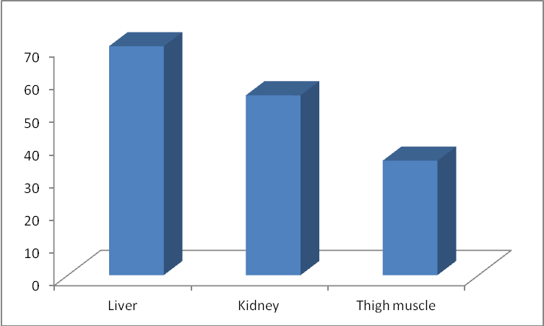

**Name of the Samples**

Fig-1: Positive Percentage (%) of Antibiotics in the organ Samples.

This bar diagram shows that the positive percentage (%) of antibiotics presents in different organ samples in which highest amount of antibiotic present in liver.

6.7 %

6.7 %

10 %

15 %

15 %



Fig-2 : Percentage (%) of antibiotics in cheavon sample.

This bar diagram indicates the percentage (%) of antibiotics, in which tetracycline and ciprofloxacin is in the higher percentage.