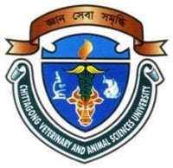

Chromatographic Analysis of Goat Meat in
Different Area of Chittagong, Bangladesh

Jannatul Ferdous
Roll : 09/40
Registration No : 450
Session : 2008-09

Clinical Report
Submitted in Partial Satisfaction of the Requirements for the degree of
DOCTOR OF VETERINARY MEDICINE
Faculty of Veterinary Medicine
CHITTAGONG VETERINARY AND ANIMAL SCIENCES UNIVERSITY

October, 2015

Chromatographic Analysis of Goat Meat in
Different Area of Chittagong, Bangladesh

Jannatul Ferdous
Roll : 09/40
Registration No : 450
Session : 2008-09

Clinical Report
Submitted in Partial Satisfaction of the Requirements for the degree of
DOCTOR OF VETERINARY MEDICINE

Dr. Md. Shohel Al Faruk
Lecturer
Department of Physiology, Biochemistry and Pharmacology
CHITTAGONG VETERINARY AND ANIMAL SCIENCES UNIVERSITY

October, 2015

