Productive Performance of Different Duck Genotypes Reared at Regional Duck Breeding Farm, Sonagazi, Feni

A Production Report Submitted
By
Md. Saiful Islam
Roll No: 2009/109
Registration No: 473
Session: 2008-09

Report is presented in partial fulfillment of the requirement for the Degree (DVM)
(Doctor of Veterinary Medicine)

CHITTAGONG VETERINARY AND ANIMAL SCIENCES UNIVERSITY, KHULSHI, CHITTAGONG - 4225
DECEMBER, 2015

Productive Performance of Different Duck Genotypes Reared at Regional Duck Breeding Farm, Sonagazi, Feni

This production report submitted as per approved style and content

....................................
Approved by
Dr. Gous Miah
Professor
Department of Genetics and Animal Breeding
Faculty of Veterinary Medicine
Chittagong Veterinary and Animal Sciences University (CVASU)

CONTENTS
TABLES ii
LIST OF ABBREVIATIONS iii
ABSTRACT iv
CHAPTER - I 1
INTRODUCTION 1
CHAPTER - II 4
MATERIALS AND METHOD 4
2.1. Selection of the study areas 4
2.2. Feeding and Management 4
2.3. Methods of data collection 5
2.4. Egg production performance 6
CHAPTER - III 7
RESULTS 7
CHAPTER - IV 8
DISCUSSION 9
CHAPTER - V 11
CONCLUTION 11
CHAPTER - VI 12
LIMITATION 12
CHAPTER - VII 13
REFERENCE 13
ACKNOWLEDGEMENTS 15
BIOGRAPHY 16

TABLES
Table 2.1: Nutritional requirements of duck pellet feed at different stages.…............05
Table 3.1: Production performance of three genotypes of ducks……….....................06
Table 3.2: Difference of egg production percentage of total number of egg production………………….....….…...........................................................................07

FIGURES
Fig. 1.1: Duck population in Bangladesh from year 2001 to 2006......………..….….02
Fig. 3.1: Regional duck breeding farm.........................................................................10
Fig.3.2: Infrastructure of duck breeding farm..............................................................10
Fig 3.3: Discussion with manager about farm.............................................................10
Fig. 3.4: Khaki Campbell duck population..................................................................10
Fig.3.5: Jinding duck population in farm.....................................................................10
Fig. 3.6: Deshi duck population in farm......................................................................10

LIST OF ABBREVIATIONS
Abbreviations | Elaboration
DLS | Department of Livestock Services
BLRI | Bangladesh Livestock Research Institute
Bd. | Bangladesh
Kg. | Kilogram
No. | Number
% | Percentage
Govt. | Government
RFLDC | Regional Fisheries and Livestock Development Component
NGO | Non-Government Organization
SLDP | Small Holder Livestock Development Project

ABSTRACT
The study was conducted at Regional Duck Breeding Farm in Sonagazi, Feni. The farming system of the farm is scavenging. The aim of the study was to understand the management practices and production performance of Jinding, Khaki Campbell and Deshi duck in scavenging farming system. The management conditions of the studied farms was observed by frequent visit the farms and egg production data were collected through a structured questionnaire and face to face interview of the manager. The egg production data was taken from the register book of the farm. Total egg production of the farm in the year 2014 was 287980. Average egg production of three genotypes of ducks was 230, 220 and 150 of Jinding, Khaki Campbell and Deshi duck, respectively. Better egg production percentage (63.01%) was observed for Jinding duck. The egg production performance of Jinding was 2.75% and 21.92% higher than Khaki Campbell and Deshi, respectively.
Keywords: Management practices, duck genotypes, live weight, scavenging.

CHAPTER - I

INTRODUCTION

Poultry production is an effective tool to bridge the gap between supply and demand of animal protein in developing countries (Alders and Pym, 2009). Among the other species of poultry, duck can be a potential source of meat and eggs in rural area of Bangladesh (Hoque et al., 2010). Chicken and duck or both rearing practiced are reported in Bangladesh. Majority portion of farmers raise 77.29% chickens and 84.41% duck respectively of the total population in Bangladesh (Huque et al., 2001). However the duck production is increasing steadily in Bangladesh. It’s increased from 25.8 million in 2001 to 38.1 million in 2006 (BBS, 2007).

Bangladesh has the third largest population of duck after China and Indonesia with a population of 41.5 million (Dolberg, 2008). Recent estimates of duck population are varying from 8% to 25% of the total population of chicken (DLS, 2012). The variation also clearly indicates the household and small scale duck production in Bangladesh. There are different types of duck rearing system is available in Bangladesh. It can be classified as house hold (scavenging), semi-intensive (semi scavenging) and intensive duck farming (Khan et al., 2013). Majority of the population of duck are reared by the small holders in coastal and low-laying areas under scavenging system, with little or without supplementation.
The potential of increasing duck production under scavenging system is closely related with the development of better feeding system. Khaki Campbell and Jinding which are not yet recognized as breed but considered to be a valuable indigenous poultry genetic resource like native (Deshi) in Bangladesh with many attributes better than other available indigenous types. In Bangladesh 90 to 95% of the ducks reared by village farmers are of Deshi type, which are very poor in egg production. But now day the tendency of rearing highly productive indigenous ducks is increasing day by day in our country in the rural sides. The preliminary studies showed that Jinding and Khaki Campbell are medium sized egg laying duck having potentials to survive well and giving very good production (Pervin et al., 2013). Duck eggs are quite large compared to chicken eggs (1.4 times), which makes them easily distinguishable. The duck egg contains relatively less water and higher percentage of proteins and fats in the yolk, albumen and total contents of egg as compared to chicken egg. Because of higher percentage of fat, its energy value is also higher than chicken eggs.
Poultry population estimates differ depending on the source of information. According to numbers provided by the Government of Bangladesh’s Livestock Department, the total chicken population is steadily increasing, from about 143 million birds in 2001 to 195 million birds in 2006. Over the same period the duck population increased from 25.8 million in 2001 to 38.1 million in 2006 (BBS, 2007) (Fig 1.1).

Fig 1.1: Duck population in Bangladesh from year 2001 to 2006.
Source: Government of Bangladesh's Department of Livestock Service's website: www.dls.gov.bd, 2008

A comparative study was therefore conducted at Regional Duck Breeding Farm Sonagazi, Feni with the following objectives:
Objectives
- To identify the egg production performance of different genotypes of duck.
- To select the best type of duck for rearing at rural level.

CHAPTER - II

MATERIALS AND METHOD

2.1. Selection of the study areas
Selection of study area is an important step for collection of data in accordance with the objectives set for the study. The experiment was conducted at Regional Duck Breeding Farm, Sonagazi, Feni.

2.2. Feeding and Management
The birds belong to three different genotypes were supplied with pellet feed. Each duck was supplied with 70g pellet feeds from laying stage, divided into two equal halves and were given twice daily; first in the morning at 07.30 hour and second time in the evening at 17.30 hours. Feeds were supplied in the plastic feeder and feeder was cleaned properly before each time of feeding. Sufficient clean drinking water was also supplied in each time.
There are three types of feeds has been provided. Feeds are bought from nearby market. Nutritional requirements of feeds are given below in the Table 2.1.

Table 2.1: Nutritional requirement of duck pellet feed at different stages.
Package no. | Name of goods | Standards
1 | Duck starter pellet feed | CP - 19% (min)  Crude fat - 4% (min)  CF - 3% (max)  Water - 12% (max)  Pellet size - 1.5-1.8 mm.
2 | Duck grower pellet feed | CP - 16% (min)  Crude fat - 4.5% (min)  CF - 5% (max)  Water - 12% (max)  Pellet size - 1.8-2.0 mm.
3 | Duck breeder pellet feed | CP - 18% (min)  Crude fat - 3.5% (min)  CF - 4% (max)  Water-12% (max)  Pellet size - 2.0-3.5 mm.

2.3. Methods of data collection
Data was taken with questionnaire method to the manager of the farm and also from the register book. For this study 1309 ducks were selected from the farm among three genotypes. Jinding, Khaki Campbell and Deshi were 700, 509 and 100, respectively. Then all the data was gathered together and calculate for results.

2.4. Egg production performance
It should better to mentioning that the egg production performance of duck be varied on analyzing freshly or preserved eggs. The egg production performances are described of ducks including these characters.
a) Total number of egg production (TNEP): Total amount of egg laid a type.
b) Average no. of egg production (ANEP): Total number of egg / Total number of duck.
c) Average egg weight (AEW): Total egg wt / Total no. of eggs.
d) Total egg mass production (kg) (TEMP): Total egg wt in kg.
e) Egg mass production (EMP): Total egg wt / Total no. of duck.
f) Age at sexual maturity (days) (ASM): 1st laying time.
g) Survivability: Total number of live duck / Total number of duck.

CHAPTER - III

RESULTS

The average no of egg production performance of Khaki Campbell, Jinding and Deshi was 220, 230 and 150 respectively. Age at sexual maturity was 157 for Jinding duck, which is less from other duck (Table 3.1). Among the results Jinding’s performance was best. Yearly no of egg production of Jinding was higher than others. These are some beneficial feature that I have found in the study.
Parameters | Khaki Campbell | Jinding | Deshi
Total number of egg production | 111980 | 161000 | 15000
Average no. of egg production | 220 | 230 | 150
Average egg weight (g/egg) | 65.20 | 64.30 | 58.70
Total egg mass production(kg) | 34.67 | 34.19 | 31.69
Egg mass production (g/bird/day) | 26.80 | 30.72 | 15.65
Age at sexual maturity (days) | 168 | 157 | 194
Survivability (%) | 94.70 | 97.48 | 96.60
Egg production % of TNEP | 60.28 | 63.01 | 41.09
Table 3.1: Production performance of three genotypes of ducks from January to December 2014.

The age of sexual maturity of Jinding is 157 days, which indicates more productive performance of the duck than other species such as Khaki Campbell and Deshi 168 and 194, respectively.
Survivability of Jinding (97.48%) is higher than other duck breeds which is an indicator of less duck death in the farm. The egg production percentage of Jinding is also top position than others.

Table 3.2. Difference of egg production % of TNEP
Egg % of Jinding | Egg % of Khaki Campbell | Egg % of Deshi | Difference %
63.01 | 60.28 |  | 2.75
 |  | 41.09 | 21.92

The egg production performance of Jinding was 2.75% and 21.92% higher than Khaki Campbell and Deshi, respectively (Table. 3.2).

CHAPTER - IV

DISCUSSION

The production performance of duck varies from breed to breed due to its genotypic characteristics. The present study gives the information of the egg production of Jinding was 230. Liu et al. (2008) reported that, Jinding duck, which can produce more than 260 eggs per year, was developed in the southern coastal area. Age of the first egg laying is 100~120 days. Average egg number is 260~300 per year per duck. This is almost similar to present study. Though varies a little from the standard level due to environmental conditions.

The recorded survivability percentage of present findings is 97.48, which varies a little from standard level of work of Islam et al. (2012). They showed that the survivability percentage of Jinding is 79-87. It may be due to the bio-security of farm was better.

Huque et al. (2010) reported that the sexual maturity of Jinding duck is 152-155. The study gave similar result like Huque et al. (2010). Proper brooding, housing, feeding, minimum crowded tends to early maturity of the duck.

Brooks and Taylor (1997) found the egg production percent of Jinding is 58. But the present study indicates this percentage is 63.01. This is more than the previous study. The formulated ration containing proper amount of nutrients leads to more egg production in the farm.

The egg production performance of Jinding was 63.01 which are similar to the study done by Salahuddin (2005).Genetic inheritance, good living environment, proper bio-security are responsible for more performance of the Jindings duck.

Fig.3.2: Infrastructure of duck breeding farm
Fig. 3.1: Regional duck breeding farm
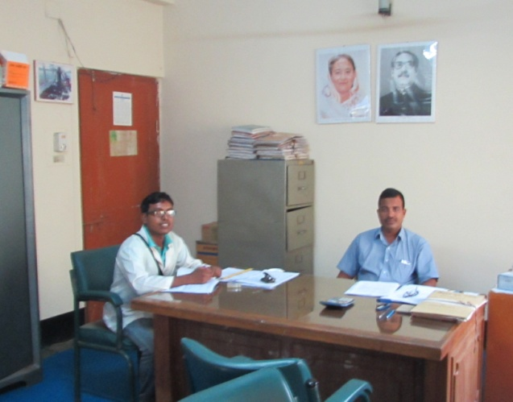
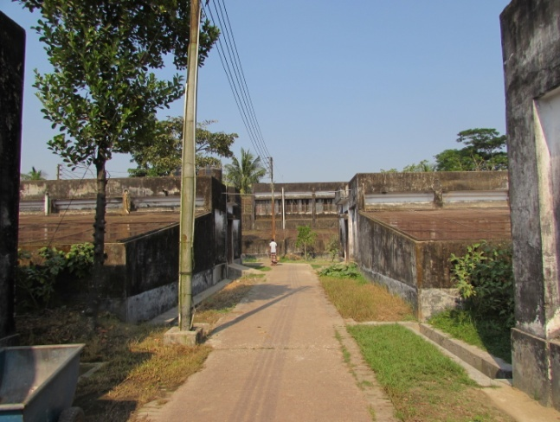
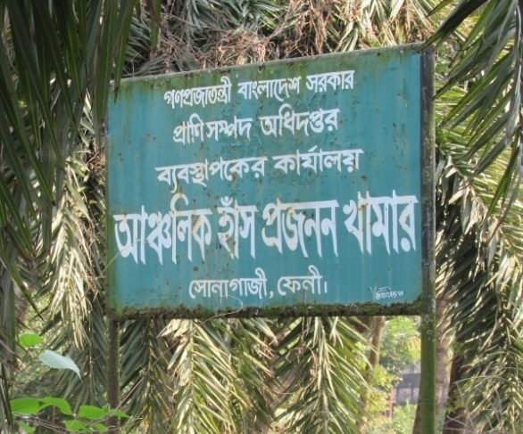

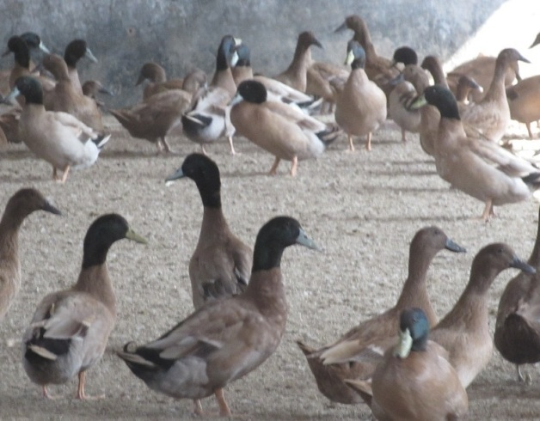
Fig. 3.4: Khaki Campbell duck population
Fig 3.3: Discussion with manager about farm

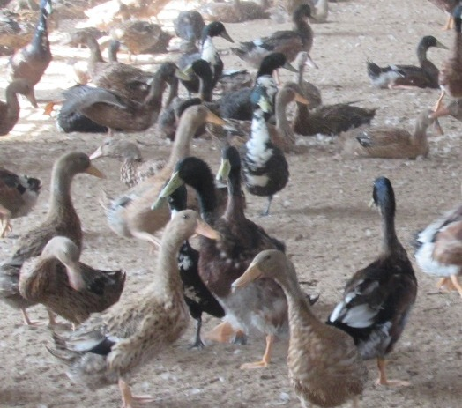
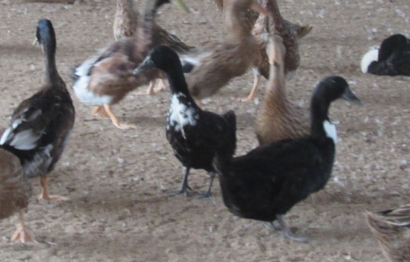
Fig. 3.6: Deshi duck population in farm
Fig.3.5: Jinding duck population in farm

CHAPTER - V

CONCLUTION

From the above result Jinding duck was the best for rearing in Bangladesh, due to its more productivity, early sexual maturity, and more survivability. Its egg production is moreover 21.92% higher than Deshi and 2.75% higher than Khaki Campbell. The villagers of Sonagazi may get benefit from rearing Jinding duck for better performance and improved their economic status. Due to higher survivability than other ducks, the farmer’s loss has become less. They should start rearing Jinding duck at high scale to overcome poverty.

CHAPTER - VI

LIMITATION
There was insufficiency in keeping data from record book. Limited access of entrance in particular sections of the duck farm. Vaccination schedule is not well developed that leads to insufficient study. Most of the data was collected through interviewing. The authority showed their negligence to give accurate data of the study due to some rules and regulations for their jobs.

CHAPTER - VII

REFERENCE

Alders, R. G. and Pym, R. A. E. (2009). Village poultry: still important to millions, eight thousand years after domestication. World's Poultry Science Journal, 65:181-190.
BBS. (2007). Bangladesh Bureau of Statistics.Statistical Year book of Bangladesh.Ministry of Planning, Government of the People’s Republic of Bangladesh, Dhaka, 7:33–34.
Brooks, J. and Taylor, D. J. (1997). Eggs and egg products.Department of Science Indian Research Food Investigation Board, 2:60-61.
DLS. (2012). Annual Progress Report. Department of Livestock Services., Farm gate, Dhaka.
Dolberg, F. (2008). Poultry sector country review: Bangladesh. Food and Agriculture Organization of the United Nations, Rome.ftp://ftp.fao.org/docrep/fao/011/ai319e/​ai319e00.pdf.Accessed: January 10, 2012.
Huque, K. S., Sarker, M. S. K., Huque, Q. M. E., and Islam, M. N. (2010). Duck production in the Sylhet basin of Bangladesh-Prospects and problems. Paper presented in the seminar and international poultry show organized by the World’s Poultry Science Association-Bangladesh Branch at IDB Bhaban, February, (16-17):40-51.
Huque, K. S., Sarker, M. S. K., Huque, Q. M. E., and Islam, M. N. (2001). Duck production in the Sylhet basin of Bangladesh prospects and problems. In Proceedings of WPSA. 2nd International Poultry Show and Seminar, 2:16-17
Islam, M. N., Q. M. E. Huque, M. S.Uddin and Sarker, M. S. K. (2012). Potentiality of native genotypes of Ducks. Proceedings of Third International Poultry Show and Seminar, Organized by World’s Poultry Science Association, Bangladesh Branch, Dhaka, 4: 259-270.
Khan, S. A., Alauddin, M., Hassan, M. M., Islam, S. K. M. A., Hossain, M. B., Shaikat, A.H., and Hoque, M. A. (2013). Comparative Performance and Hematoma-Biochemical Profile of Jinding Ducks in Different Production Systems of Bangladesh.Pakistan Veterinary Journal, 3: 33-37
Liu, W., Hou, Z. C., Qu, L. J., Huang, Y. H., Yao, J. F., and Li, N. (2008). Yang N. Population Structure and Biodiversity of Chinese Indigenous Duck Breeds Revealed by 15 Microsatellite Markers.Asian-Australian Journal of Animal.Science., 21: 314 – 319.
Pervin,W., Chowdhury, S. D., Hasnath, M. R., Khan, M. J., Ali, M. A., and Raha, S. K. (2013). Duck production strategy and profile of duck farmers in the coastal areas of Bangladesh. Livestock Research for Rural Development, 7: 25.
Salahuddin, A. (2005). Integrated Rice-Duck A new farming system for Bangladesh. Innovations In Rural Extension: Case Studies From Bangladesh, 1: 143-145.

ACKNOWLEDGEMENTS

All the praises and deepest sense of gratefulness belongs to the Almighty Allah, the merciful, the Omnipotent and the Beneficent but the Supreme Ruler of the Universe who enabled me to complete my clinical report successfully for the degree of Doctor of Veterinary Medicine (DVM).

Cordial cooperation, friendly collaboration, fruitful advice and guidance were received from many persons throughout the experiment. The author is immensely grateful to all of them and regrets for inability to mention every one by name.

The author sincerely desire to express his deepest sense of gratitude to his teacher and report supervisor Dr. Gous Miah, Professor, Department of Genetics and Animal Breeding, CVASU for his scholastic guidance, valuable advice, constant inspiration, affectionate feeling, radical investigation and constructive criticism in all phases of this study.

The author also expresses his good wishes to Mojibor Rahman, Manager of Regional Duck Breeding Farm, Sonagazi, Feni, and Lecturer Dr. Md. Saiful Bari, Department of Dairy and Poultry Science, CVASU. The author is immensely grateful to Md. Shahriar Hasan Sohel and Md. Kaisar Rahman for their kind cooperation.

Author
December, 2015

BIOGRAPHY
Md. Saiful Islam; son of Md. Najir Hossain and Mst. Amena Begum has passed the Secondary School Certificate with GPA-5, Sadakat Hossain High School and Higher Secondary School Certificate from Rajibpur Degree College with GPA-5 from Rajshahi education board. Now he is an intern student of Veterinary medicine, Chittagong Veterinary and Animal Sciences University. His favorite hobby is reading books; writing articles and he want to be an honest Veterinarian and researcher. He is interested for find out new techniques for the development of veterinary sciences.

