Acknowledgement

It goes without saying that all praises goes to Almighty “God”, the omnipotent, omnipresent and omniscient, who has enabled the author to complete this manuscript successfully.
The author doesn’t have adequate words to express deepest sense of gratitude, respect and immense indebtness to her honorable teacher and internship supervisor, Dr. Md. Hasanuzzaman, Professor, Department of Animal Science & Nutrition, Faculty of Veterinary Medicine, Chittagong Veterinary and Animal Sciences University (CVASU) for his scholastic guidance, sympathetic supervision, valuable advice, continuous inspiration, radical investigation and constructive criticism in all phases of study.
The author feel much pleasure to convey the profound thanks to his co-supervisor, Dr. Mahabub Alam, Lecturer, Department of Animal Science & Nutrition, CVASU and senior graduate Dr. Md. Imran Ahmed, DVM, MS in Animal Nutrition, CVASU for his valuable advice, scholastic guidance and full time support in data analysis and valuable advices during research work.
The author would like to give special thanks to the staffs of the Department of Animal Science & Nutrition, CVASU for conducting proximal analysis of the samples in the Nutrition Laboratory.
The author also expresses gratitude to her parents and friends for their inspiration and sacrifice from the beginning to the end of this work.
A work of this dimension is the product of many individual efforts. Supervisor’s help and cooperation have been received from many persons during the tenure of this place of report. Although it isn’t possible to mention everyone by name, the author is immensely grateful to them.

The Author
December, 2015

ABSTRACT

The study was undertaken to observe the chemical composition as well as quantifying the amount of dead chicken carcass and poultry offal that comes from Chittagong Veterinary and Animal Sciences University and Jhautola Bazar respectively from 16th February to 16th May 2016. Samples were collected from the study areas. Chemical analyses of the samples were carried out in triplicate for moisture, dry matter (DM), crude protein (CP), crude fiber (CF), nitrogen free extracts (NFE), ether extracts (EE) and total ash in the animal nutrition laboratory, Chittagong Veterinary and Animal Sciences University, Chittagong, Bangladesh and quantified during collection and after dressing. Results indicated that, all samples had substantial amount of proximate components that might have been used as alternative feed resource for animal feed. ME content in pure chicken intestine was 4687.73±60.01 Kcal/kg, Chicken intestine with skin 5107.73±26.82 Kcal/kg, Chicken meal 2996.93±73.44 Kcal/kg and Fish scale 2477.83±73.74 Kcal/kg. Crude protein content in pure chicken intestine was 47.69±0.25 g/100g, Chicken intestine with skin 41.21±0.76 g/100g, Chicken meal 65.67±0.72 g/100g and Fish scale 61.87±0.96 g/100g. Fat content in pure chicken intestine was 38.25±0.79 g/100g, Chicken intestine with skin 47.12±0.15 g/100g, Chicken meal 2.4±0.1 g/100g and Fish scale 4.7±0.26 g/100g. Quantification of the poultry waste shows that there were 29.37 kg usable meat and approximately 1484 kg poultry offal found at CVASU. It could therefore, be inferred that, these poultry wastes might be used as an alternative feed resource for different animals in scarcity of traditional feeds if available at cheaper price.

Key words: Poultry wastes, quantification, proximate component.

CHAPTER – I
INTRODUCTION

According to FAO (2014) there is 2.2 ×10¹⁰ poultry in Bangladesh. Farming systems produce a significant quantity of mortalities that need to be disposed safely. In developing countries approximately 80 percent of the population lives in rural areas (Kumar et al., 1989). The majority of animals are being slaughtered and processed locally or in tiny slaughter grits. The offal requires a technology for the processing and the proper utilization. Most of the fat and soft tissues are used for eating purposes in developing countries. This reduces the quantity of offal with 10-15% of the live weight killed. In developing countries the occurrence of natural death of livestock is relatively more due to a combination of inadequate on feeding practices, lack of knowledge of management needs and poor allocation of vaccines (Ali et al., 2012). And high number of mortality rather leads to hygienic problems than to environmental hazards as dead animals are mostly scattered over huge open areas (Verheijen et al., 1996).

According to Gerber et al., 2007 the dead poultry should be disposed off or to utilize properly in order to prevent environment pollution as well as healthy environment for the neighborhood. Several problems can arise if dead poultry are disposed of improperly, that include:

Diseases can be spread to people and animals.

Carcass fluids can leach into and pollute groundwater (wells).

Bacteria and viruses can be transmitted to surface water (creeks, ponds, lakes or rivers).

Obnoxious gases and odors can be emitted to the atmosphere.

The carcasses can catch the attention of rodents and scavengers and provide a breeding habitat for flies and other insects.

The sight or smell of dead animals may upset neighbors.

Scavenging animal such as road dogs who are mainly the prime eater of dead poultry which are scattered here and there due to inappropriate disposal has adverse effect on their endocrine systems. The excretion of hormones from poultry has been cited as a possible cause of endocrine disturbance in wildlife (University of Maryland, 2006). The microorganisms found in animal wastes, like Cryptosporidium, can also create significant public health threats. As an example, in 1993 after a severe rainstorm, Milwaukee's drinking water supply caused 100 deaths and sickened 430,000 people due to an outbreak of cryptosporidium (EPA, 2015).

Scavenging animal such as road dogs who are mainly the prime eater of dead poultry usually suffer for endocrine systems. The excretion of hormones from poultry has been cited as a possible cause of endocrine disturbance in wildlife (University of Maryland, 2006). The microorganisms found in animal wastes, like Cryptosporidium, can also create significant public health threats. As an example, in 1993 after a severe rainstorm, Milwaukee's drinking water supply caused 100 deaths and sickened 430,000 people due to an outbreak of cryptosporidium (EPA, 2015).

Considering the above fact the current study was undertaken with the following objectives:

To quantify the amount of poultry waste that is produce in CVASU and Jhautola Bazar.

To identify the chemical composition of the collected poultry waste.

CHAPTER – II
MATERIALS AND METHODS

2.1 Study area and period

The study was undertaken for a period of 4 months from February 2015 to May 2015 at in the Chittagong Veterinary and Animal Sciences University and Jhautola bazar, Chittagong, Bangladesh. The study samples were collected from, Jhautola bazar of Chittagong Metropolitan Area. The reason for choosing Jhautola Bazar, it’s a renowned bazaar in Chittagong and every type’s of meat sold there and slaughter done besides the bazaar and Chittagong Veterinary and Animals Sciences University has one of the best veterinary hospitals along with skilled practitioners. Daily lots of dead poultry came here to diagnose diseases. These large number of dead poultry meat were prime sample for my study.

2.2 Experimental Plan

- The total experiment was divided three stages:
- Collection of poultry waste from preferred site.
- Analyzed the proximate component of collected sample.

2.3 Collection of sample
Samples were collected by using simple random sampling technique. Samples were taken as pure chicken intestine, chicken intestine with skin, fish scale, dead poultry meat. Approximately 200 grams of each sample were collected. Samples were wrapped up by polythene bag and preserved in the laboratory for chemical analysis.

2.4 Preparation of sample
Samples were subjected to grinder to make it homogenous powder. Later on, it was mixed properly and exposed to shade to cool down for sampling. Individual samples were identified by marker and subjected to chemical analyses.

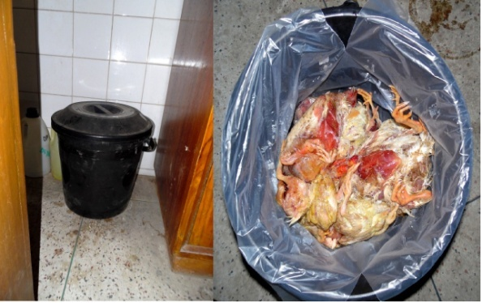 | 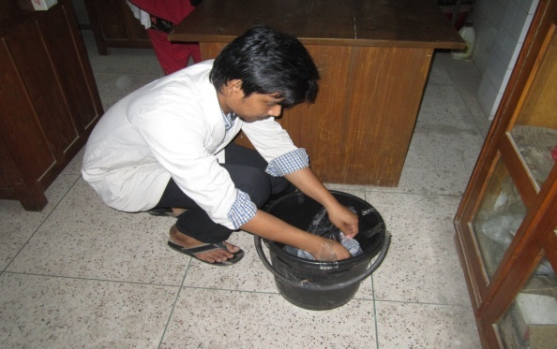
- Collection basket | - Collection of daily dead poultry
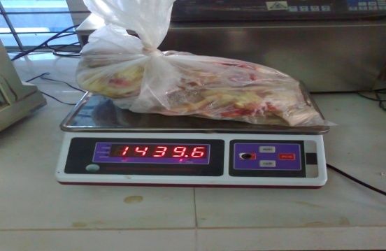 | 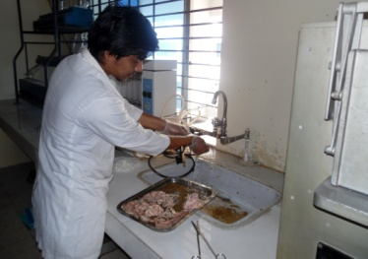
- Weighing of dead poultry | - Dressing dead carcass
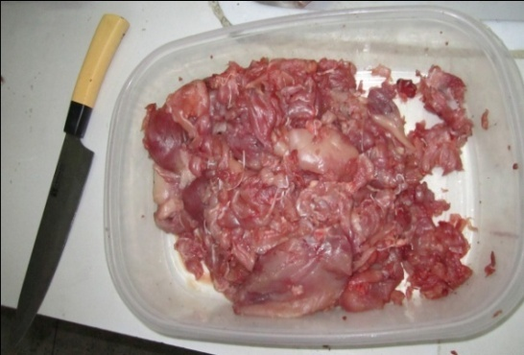 | 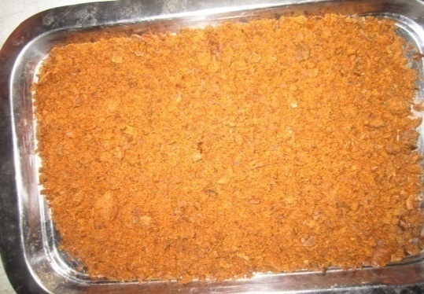
- Separation of pure meat | - Grinding of meat

Figure 1: Total process of collection of dead poultry to grounded dried meat

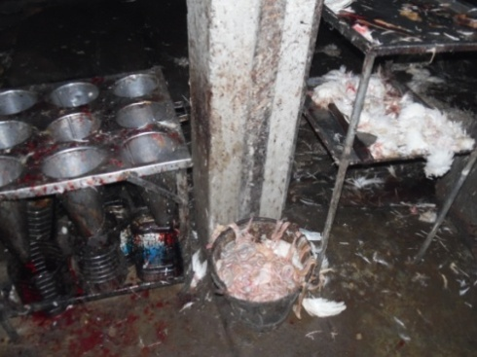
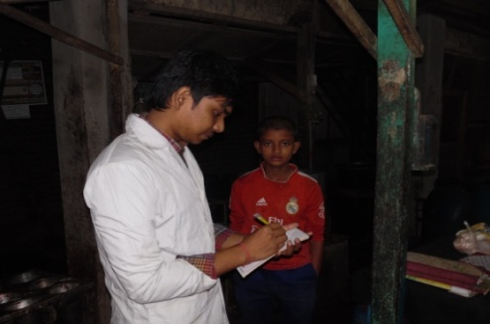
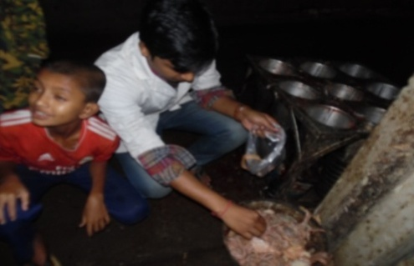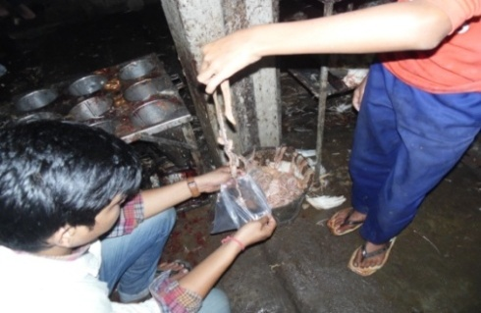
Figure 2: Collection of data and sample from Jhaotola Bazar

2.5 Analysis of sample

Chemical analyses of the samples were carried out in triplicate for moisture, DM, CP, CF, NFE, EE and ash in the animal nutrition laboratory and PRTC laboratory in Chittagong Veterinary and Animal Sciences University, Chittagong, Bangladesh as per AOAC (1994).

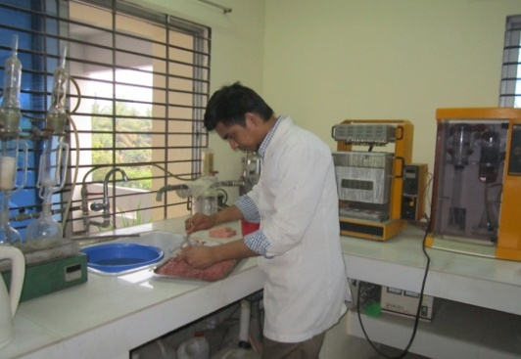 | 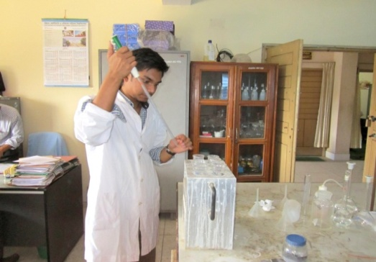
- Taking sample | b. Estimation of Crude protein
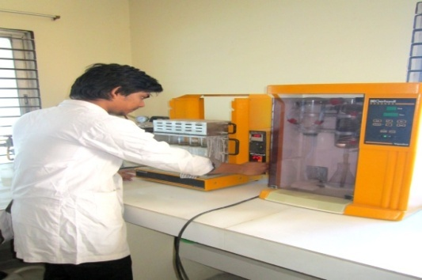 | 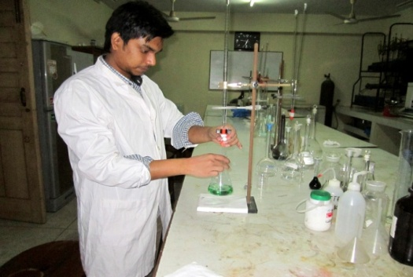
- Crude protein estimation | - Crude protein estimation
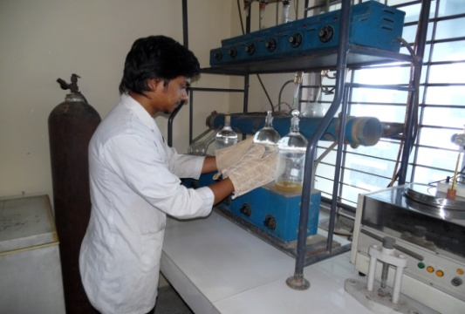 | 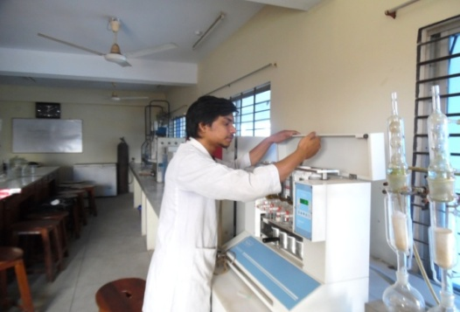
- Crude fiber estimation | - Ether extract estimation

Figure 3: Proximate estimation of different nutrients

2.6 Calculation of ME
Metabolizable energy (ME) was calculated separately for different samples. Calculation was performed by using the mathematical formula as per Lodhi et al., 1976.
ME kcal/kg = 32·95 (% crude protein + % ether extract × 2·25 + % available carbohydrate) –
29·20.

2.7 Statistical analysis
Data related to chemical composition of unconventional feeds were compiled by using Microsoft Excel 2007. Chi-square (χ²) test was performed to analyze the data by using SPSS 16.0. Statistical significance was accepted at 5 % level (P<0.05).

CHAPTER – III
RESULTS AND DISCUSSION

Chemical composition of these unconventional feeds particularly, moisture, dry matter (DM), crude protein (CP), crude fiber (CF), nitrogen free extract (NFE), ether extract (EE) and total ash contents in different samples have been presented in Table.
Table 1: Chemical composition (%) of identified samples
Sample | ME*  (Kcal/kg) | DM  (%) | CP  (Mean±SE)  (%) | CF  (Mean±SE)  (%) | EE  (Mean±SE)  (%) | NFE  (Mean±SE)  (%) | Ash  (Mean±SE)  (%)
Pure chicken intestine | 4687.73±60.01 | 80.5 | 47.69±0.25 | 0.32±0.02 | 38.25±0.79 | 9.47±0.68 | 4.28±0.08
Chicken intestine with skin | 5107.73±26.82 | 84.2 | 41.21±0.76 | 0.54±0.01 | 47.12±0.15 | 8.67±0.56 | 2.45±0.11
Chicken meal | 2996.93±73.44 | 35 | 65.67±0.72 | 2.6±0.06 | 2.4±0.1 | 20.77±0.84 | 8.57±0.03
Fish scale | 2477.83±73.74 | 48 | 61.87±0.96 | 0.38±0.04 | 4.7±0.26 | 3.64±0.69 | 29.34±0.05

^{ME}Metabolizable energy ; ^{DM}Dry matter; ^{CP}Crude protein, ^{CF}Crude fibre, ^{NFE}Nitrogen free extract, ^{EE}Ether extract; *ME was determined by Lodhi et al., 1976.

In present study the chemical composition of selected ingredients were done to evaluate the comparative nutritional.

3.1 Chicken intestine and chicken intestine with skin

In present study chicken intestine contain 4687.7 Kcal/kg ME, 47.69±0.25% CP, 0.32±0.02% CF, 38.25±0.79% EE, 4.28±0.08% Ash and chicken intestine with skin contain 5107.7 Kcal/kg ME, 41.21±0.76% CP, 0.54±0.01% CF, 47.12±0.15% EE, 2.45±0.11% Ash (Table-1). The result is a bit differed with other investigators 70.0±0.001% CP, 7.640±0.002% EE, 0.210±0.001% CF, 4.330±0.001% Ash, 529.8±0.01 Kcal/100g ME (Giri et al., 2010; Tabinda et al., 2012) but very close with poultry by product meal which was made of chicken intestine 57.75% CP, 28.93%, 11.54% Ash and 1.26% CF (Sevgili et al., 2004).

3.2 Chicken meal

In present study chicken meal contain 2996.9 Kcal/kg ME, 65.67±0.72% CP, 2.6 ± 0.06% CF, 2.4±0.1% EE, 8.57±0.03% Ash (Table-1) in which protein percentage is similar to Aldrich et al., 2007 who mentioned chicken meal is ground up chicken meat that has been carefully dried and protein content is 65%. Similar type result also found in the study of Robert et al., 2014 , they observed chicken meal with skin contains 60% CP, 8% EE, 20% Ash, A Study of Rawles et al., 2011 showed turkey meal also have almost same nutrient value as 66.6% CP, 1.3% CF, 11.1% EE and 8.6% Ash. Considering the above information chicken meal might be use as a good source of protein for dog food.

3.3 Fish Scale

The term fish meal means a product obtained by drying and grinding or otherwise treating fish or fish waste to which no other matter has been added. The current study investigated the nutritional quality of fish scale. The chemical composition of fish scale that found in present study were 61.87±0.96% CP, 0.38±0.04 % CF, 4.7±0.26% EE, 29.34±0.05% Ash (Table-1). The CP and CF contents of fish scale estimated under this study are almost similar with the findings of Moghaddan et al., 2007 with a slight deviation of the value of the EE and Ash content. In another study by Khan et al., 2012, the chemical analysis of fish meal samples revealed that average gross energy, fat, dry matter, crude protein, fiber and ash contents were 4,417 cal/g, 21.88%, 91.03%, 55.79%, 7.26% and 20.75%, respectively and the range of the value of gross energy, fat, dry matter contents, protein, fiber contents, ash, and phosphorous varied from 4,118 to 4,883 cal/g, 9.9 to 29.52%, 88.43 to 93.29%, 37.49 to 66.57%, 2.23 to 12.67%, 12.74 to 28.22% and 0.1 to 1.0%, respectively. Protein contain of fish scale estimated in present study had almost same with other literatures. So it can be use as protein source in other animal food. But lack availability and difficulty during washing, we didn’t choose fish scale as a viable source for our study.

3.3 Quantification of available chicken meal (dead bird) of CVASU

The production of dead chicken and quantification are presented in Table 2 and 3.

Table 2: Production of dead chicken (Kg/day) in Pathology and Pharmacology lab of CVASU
Week | Raw chicken (Mean±SE) | Usable meat from the dead chicken (Mean±SE)
Week 1 | 2.46 ± 0.68 | 1.4± 0.39
Week 2 | 2.09±0.35 | 1.21±0.27
Week 3 | 2.61 ± 0.48 | 1.49 ±0.26
Week 4 | 3.80 ± 1.2 | 2.1 ± 0.64
Week 5 | 2.16±0.85 | 1.39±0.59

Here usable meat refers those portions of meat that were kept for using as a protein source in dog biscuits.

Table 3: Quantification of collected and usable meat in a period of 5 weeks
Total collection (kg) | Usable meat (kg)
51.18 | 29.37

A five week collection period was considered to collect dead chicken from Department of Pathology & Parasitology and Department of Physiology, Biochemistry & Pharmacology, CVASU. A total of 51.18 kg dead chickens were collected and after dressing 29.37 kg usable meat were obtained with a dressing percentage of 57.38% (Table-2). Weekly collection was ranges from 2.09±0.35 kg to 3.80±1.2 kg dead chickens (Table-3). All the collected usable meat was used for the research purpose i.e. formulation of dog biscuit.

3.4 Quantification of poultry offal in Jhautola Bazar

Consecutive three days survey was done in the same shops to collect the data about their daily total amount poultry sell.

Table 4: Sell of daily amount of poultry in Jhautola bazar
Day | S:1 | S:2 | S:3 | S:4 | S:5 | S:6 | S:7 | S:8 | S:9 | S:10 | S:11 | S:12
1 | 175 | 220 | 87 | 63 | 156 | 133 | 141 | 72 | 39 | 44 | 57 | 31
2 | 168 | 213 | 78 | 74 | 150 | 153 | 144 | 77 | 44 | 46 | 65 | 42
3 | 177 | 225 | 96 | 55 | 168 | 141 | 135 | 69 | 41 | 38 | 62 | 37
Avg. | 173.3  ±  2.7 | 219.3  ±  3.4 | 87  ±  5.1 | 64  ±  5.4 | 158  ±  5.9 | 142.3  ±  5.8 | 140  ±  2.6 | 72.6  ±  2.3 | 41.33  ±  1.4 | 42.66  ±  2.4 | 61.33  ±  2.33 | 36.66  ±  3.2
(S : Shop and amount was kg/day)

Table 5: Quantification of total sell of poultry in 3 days
Total collection (kg) | Usable (kg)
3716 | 1484 (approx.)

According to Benhura et al., 2010 Slaughter yields of the chicken carcasses obtained ranged from 64.1 to 74.3% and Kokoszyński et al., 2008 slaughter yields of carcasses ranging from 73.3 to 74.5%. Considering 40% offal percentage 1484 kg (table-5) offal produce in 3 days. This huge amount of offal can be used as alternative source of protein and fat in different animal feed.

CHAPTER – IV
CONCLUSION

Poultry industry is now a booming industry in Bangladesh. Due to high mortality poor farmers are facing huge trouble to become sustainable in this business. If proper utilization of dead carcass as well as chicken offal can be assured this will not only minimize the loss but also help in crisis periods.

From the above data it is clear that dead carcass and offal both are good source of protein and this protein source can be used as a sole source of protein in different animal feed to minimize the feed cost and also good income source for the farmer if proper hygienic measure is mitigated.

CHAPTER – V
REFERENCES

Ali, M.M., Hossain, M.M., 2012. Problems and Prospects of Poultry Industry in Bangladesh: An Analysis. American International University-Bangladesh, Office of Research and Publications (ORP).
AOAC, 1994. Association of Official Analytical Chemists. Official Methods of Analysis, (17th edition). Gaithersburg, Maryland, USA.
Benhura, C., Makamba, F., Mushanguri, G., Gumiro, N., Muzivi, I., 2010. Yield analysis at a poultry processing plant in Harare, Zimbabwe. African Journal of Food, Agriculture, Nutrition and Development 10.
EPA, 2015. United states Environment protection Agency. http://www.epa.gov/ region9/animalwaste/problem.html. Accessed on 22/05/2015.
FAO, 2014. http://faostat3.fao.org/download/Q/QA/E. Accessed on 22/05/2015.
Gerber, P., Opio, C., Steinfeld, H., 2007. Poultry production and the environment—a review. FAO publishing web. http://www.fao.org/ag/againfo/home/events/bangkok2007/docs/
part2/2_2. pdf.
Giri, S.S., Sahoo, S.K., Mohanty, S.N., 2010. Replacement of by-catch fishmeal with dried chicken viscera meal in extruded feeds: effect on growth, nutrient utilization and carcass composition of catfish Clarias batrachus (Linn.) fingerlings. Aquaculture International 18, 539-544.
Kokoszyński, D., Bernacki, Z., 2008. Comparison Of Slaughter Yield And Carcass Tissue Composition In Broiler Chickens Of Various Origin Porównanie Wydajności Rzeźnej I Składu Tkankowego Tuszek Kurcząt Brojlerów O Różnym Pochodzeniu. Journal of Central European Agriculture 9.
Kumar, M., 1989. Handbook of rural technology for the processing of animal by-products (FAO Agricultural Services Bulletin No. 79). Rome: FAO of the United Nations.
Lodhi, G., Singh, D., Ichhponani, J., 1976. Variation in nutrient content of feeding stuffs rich in protein and reassessment of the chemical method for metabolizable energy estimation for poultry. The Journal of Agricultural Science 86, 293-303.
Rawles, S., Thompson, K., Brady, Y., Metts, L., Aksoy, M., Gannam, A., Twibell, R., Ostrand, S., Webster, C., 2011. Effects of replacing fish meal with poultry by‐product meal and soybean meal and reduced protein level on the performance and immune status of pond‐grown sunshine bass (Morone chrysops× M. saxatilis). Aquaculture Nutrition 17, e708-e721.
Robert, N.V., Adrian, R., 2014. Characteristics of meat and bone meal used as animal feed (pet food). Studia Universitatis" Vasile Goldis" Arad. Seria Stiintele Vietii (Life Sciences Series) 24, 239.
Sevgili, H., Ertürk, M., 2004. Effects of replacement of fish meal with poultry by-product meal on growth performance in practical diets for rainbow trout, onchorynchus mykiss. Akdeniz Üniversitesi Ziraat Fakültesi Dergisi 17, 161-167.
Tabinda, A.B., Butt, A., 2012. Replacement of fish meal with poultry by-product meal (chicken intestine) as a protein source in grass carp fry diet. Pakistan Journal Zoology 44, 1373-1381.
University of Maryland., 2006. Broiler production and the environment. College Park, MD, USA, College of Agriculture and Natural Resources, University of Maryland. available at http://www.agronext.iastate.edu/immag/info/eb368poultryprod.pdf. Accessed on 24/5/2015.
Verheijen, M.,Wiersema, D., Hulshoff Pol L.W., 1996. J. De Wit International Agriculture Centre Wageningen, The Netherlands January, 1996 . FAO Document Repository. The environmental impact of the animal product processing industries. (http://www.fao.org/wairdocs/lead/x611 4e/x 6114 e03.htm ) Accessed on 24/05/2015.

CASE STUDY

Results of proximate analysis of available by-products indicated that all samples had substantial amount of proximate components that might have been used as alternative feed resource for animal feed. ME content in pure chicken intestine was 4687.73±60.01 Kcal/kg, chicken intestine with skin 5107.73±26.82 Kcal/kg, chicken meal 2996.93±73.44 Kcal/kg and fish scale 2477.83±73.74 Kcal/kg. Crude protein content in pure chicken intestine was 47.69±0.25 g/100g, chicken intestine with skin 41.21±0.76 g/100g, chicken meal 65.67±0.72 g/100g and fish scale 61.87±0.96 g/100g. Fat content in pure chicken intestine was 38.25±0.79 g/100g, chicken intestine with skin 47.12±0.15 g/100g, chicken meal 2.4±0.1 g/100g and fish scale 4.7±0.26 g/100g. Between these samples chicken meal looked promising source of ME and protein with minimum fat percentage. A case study was performed with 9 puppies of 2-4 months age having average body weight of 5-7 kg available at CVASU premises. In that case chicken meal was used as a key protein source in dog biscuits. Result of that research was satisfactory. Growth rate and metabolic profile test comparing between foreign dog food and newly formulated biscuits were almost same. Hence, it can be suggested that the chicken meal may be used as a source of protein to prepare least cost dog biscuits.

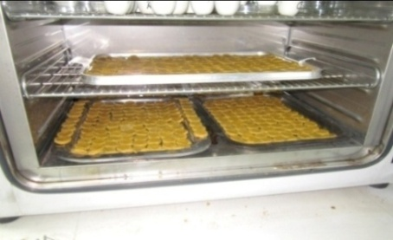 | 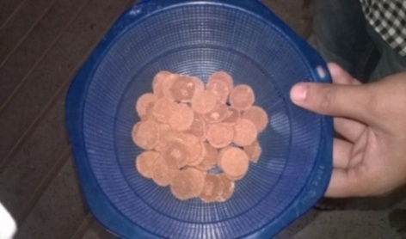
 | 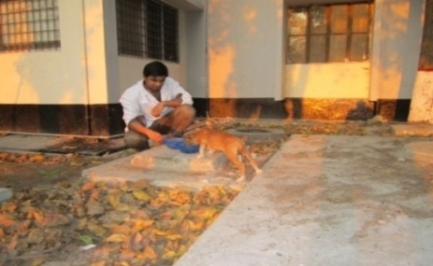
Figure 3 : Experimental feeding of newly formulated biscuits

Biography of the AUTHOR

Aditya Chowdhury Avi ; son of Milan Chowdhury and Metali Chowdhury has passed the Secondary School Certificate Examination in 2006 with GPA 5.00 followed by Higher Secondary Certificate Examination in 2008 with GPA 4.50. Now, he is a candidate for the degree of Doctor of Veterinary Medicine (DVM) from Chittagong Veterinary and Animal Sciences University (CVASU), Bangladesh. In future he would like to do Research work about animal welfare and zoonotic diseases those take public health significance in the world regarding one health constitution.

