Acknowledgement

The author is ever grateful and indebted to the Almighty God without whose grace it would have never been possible to pursue this study in this field of science and to complete this production report writing for the Degree of Doctor of Veterinary Medicine (DVM).

The author would like to thank his reverend and beloved teacher and Supervisor Md. Emran Hossain,Associate Professor Department of Animal Science Chittagong Veterinary and Animal Sciences, Chittagong for his scholastic guidance, uncompromising principles, sympathetic supervision, valuable advice and constant inspiration of this study and preparing the manuscript.

The author would like to express his deed sense of gratitude and heartfelt appreciation to Dr. Md. M Morshed Chowdury,veterinary officer cum Curator and Dr. Shahadat Hossain, Shuvo, Educatioal officer cum veterinarian, Chittagong Zoo, for their cordial help at Chittagong Zoo.

The author would like to express his sincere gratitude and gratefulness to Dr. Mostafizur Rahman, Veterinary surgeon, Bongobondhu Sheikh Mujibur Rahman safari park, Dulhazra, Cox’s-bazar for his valuable suggestion and cordial help for completion of the report work.

The Author would like to thank his sincere gratitude and gratefulness to DR. Anwar shahadat, Scientific officer , Bangladesh National zoo for his cordial help.

---------------------------------------
The Author

List of table…
Table No | Contents | Page
1 | Feeding practice (in gram) per at J.N Dairy Farm at Bohardarhat, Chittagong | 11
2 | Feeding practice (in gram) per deer at National Zoo, Dhaka | 12
3 | Feeding practice (in gram) per deer at Bongobondhu sheikh Mujibur rahman safari park, Dulhazara, Cox’s Bazar. | 13
4 | Feeding Budgeting of Spotted deer (Azad el al, 2005) | 14
5 | Recommended feed items for spotted (Azad et al, 2005) | 14
6 | The no of the male and female ratio | 15
7 | Schedule of day-to-day operation on spotted deer premises (Azad et al, 2005) | 16

List of figure….
Figure No | Contents | Page
1 | At B.S.M.R Safari Park, Cox’s Bazar | 19
2 | At Bangladesh National Zoo, Dhaka | 19
3 | At Chittagong Zoo Foy’s-Lake | 19
4 | At J.N. Dairy Farm, Bohardarhat, Chittagong | 19

Abstract

In this experiment housing, feeds and feeding, vaccination, deworming, production and reproduction profile and herd management of spotted deer were studied in captive condition at various zoo, safari park and farm. Data collection from 569 spotted deer at various captive areas consisting of adult male, adult female, juvenile and infant were studied 10th March to 10th November 2015 for period of eight months. Housing mainly intensive, semi intensive, scavenging were practice in there .Available feeds supplied to the spotted deer were maize fodder, Napier, yard long bean, Para and Bermuda grass, vine spinach, red spinach ,ash gourd leaves ,cabbages, carrot, pawruti, papaya, gram, wheat barn and soybean meal, amla, bit salt. The average CP and ME were 9.8% and 14.24 MJ per day, respectively The average birth weight of males and females were 3.0 and 2.5kg, adult males and females were 80.44 and 57.6kg, males and females weaning weights were 19.98 and 18kg, respectively. It also observed that average weaning age, length of estrus, first fawning and gestation lengths were 5.0months, 17.74day, 14.32 months and 230.74days respectively. From the study it may suggested that keeping nutritive status the reproductive and reproductive parameters of the spotted deer , recommended rations needs to be followed similarly efficient management systems needs to be developed.
Key words: Feeds and feeding, management, spotted deer

Chapter 1
Introduction

1.1 Management Practice
The act, manner, handling, supervision, and the technique, practice or science of managing or controlling, the skillful use of use of resources and time, the specific treatment of a disease or disorder is the literal meaning of management practices .The social, economic and landscape impacts of wild deer and the management of the wild deer population in the Bangladesh have not previously been the subject of sustained social science research and analysis. However, in recent years the challenges surrounding the management of deer have begun to attract the attention of academics (Bharat khadka et al,.2015).Using the integrated management of deer in the Bangladesh as a case study. This study reflects a growing concern on the ground about how to manage the increasing deer populations in a way which recognizes different legitimate interests. This study provides a social science perspective on deer management based on the case study of Bongobundhu Sheik Mujibur Rahman Safari Park, Chittagong Zoo, J.N dairy farm, National zoo. It focuses in particular on what kinds of individual and collective action is needed to improve the current situation.
In Bangladesh the following deer species occur:
1. Spotted deer or Chital (Axis axis)
2. Hog deer or Laguna (Axis porcinus)
3. Musk deer or Kasturi (Moschus chrysogaster)
4. Swamp deer or Barahsingha (Cervus devaucelli)
5. Sambar or Jarayo (Cervus unicolor)
6. Barking deer or Ratuwa(Muntiacus muntijak)

Here, I would like to discuss more about spotted deer.

1.2 Scientific classification
Kingdom: Animalia
Phylum: Chordata
Class: Mammalia
Order: Artiodactyla
Family: Cervidae
Genus: Axis
Species: Axis axis
The chital (Axis axis) also known as chital deer, spotted deer or axis deer is a deer which commonly inhabits wooded regions of Bangladesh, Bhutan, India, Sri Lanka, and Nepal and in small numbers in Pakistan. However it occupies a wide range of habitats from mainly grass, shrub vegetation in Wilpattu National Park, Sri Lanka (Esinberg et al., 1972) to denser areas in the Gir forest of India (Berwick et al., 1974). Although the deer is mainly a grazer in lowland Bangladesh, fruits, leaves and seedlings from a wide variety of tree, shrubs and forbs species are also utilized (Dinerstein et al., 1982).The spotted deer is found in large numbers in dense deciduous or semi-evergreen forests and open grasslands. They do not occur at higher elevation forests where they are usually replaced by other species such as the Sambar deer.

Chital are primarily grazers and feed on short, sprouting grasses. However, they will also browse as well as eat forbs, fruit and branches of trees, especially when they are thrown down by monkeys. Chital prefer to be near water and will drink mornings and evenings in hot weather. Predators of the chital include tigers, Asiatic lions, leopards, dholes and mugger crocodiles. Red foxes also sometimes prey on chital fawns. The chital can run up to 40 mph (65 km/h) to escape his predators. Axis deer most commonly occur in herds of ten to fifty individuals of both sexes. Chital hinds have three week long estrous cycles. A stag will follow and guard a hind in estrous. During this time the stag will not eat. The pair will do several bouts of chasing and mutual licking before copulation. Stags guarding estrous females will make high-pitched growls at lesser stags that hung about. When alarmed, chital will bark. These barks usually occur among females and juveniles and are repeated back and forth. Fawns that are separated from their mothers will squeal. When in danger, they run in groups. They will make bursts of high-speed running and then soon tire and dive into heavy cover to hide. The Chital is listed by the IUCN as Least Concern "Because it occurs over a very wide range within which there are many large populations”. However population densities are below ecological carrying capacity in many places due to hunting and competition with domestic livestock. Two primary reasons for its good conservation status are its legal protection as a species and a network of functioning protected areas. It seems success in rearing Chital in many parts of the country. In Private farm of Bohaddarhat in Chittagong district it was very successful. Although they have no formal record they had increased about three times in number of Chital within six years i.e. from 15 to 20. It is also in good condition in Bongobundhu sheik mujibur Rahman safari park, Dulahazara, cox’s bazar. Breeding in captivity at the center seems to be satisfactory (Gairhe et al,. 1988).
So, Chital is suitable species for breeding and farming in Bangladesh.

1.3 General Objectives
- To study the management practices

1.4 Specific Objectives
- To find the feeding schedule (feeding schedule and materials, security)
- To find the habitat situation
- To find the security situations
- To examine what practical action could be taken to improve their management.

Chapter 2
Materials and Methods

2.1 Study period
The study was conducted in various captive, zoo, and safari park in Dhaka, Chittagong and Cox’s bazaar from 10th March to 10th November in 2015.

2.2 Study area
Captive area for spotted deer mainly Chittagong, Cox’s-bazar and Dhaka. At Chittagong study was conducted at J.N. Dairy farm, Bohardarhat and Chittagong Zoo, Foy’s-lake. Bongobondhu Sheik Mujibur Rahman safari park, Dulhazara and Bangladesh National Zoo, Dhaka was included in this study.

2.3 Collection of Data
Data was collected from Md. Hossain, Shahed and Ataur Rahman at J.N Dairy Farm. At safari park data is collected from d. Mujtafizur Rahman, veterinary surgon, B.S.M.R safari park .At Chittagong zoo, DR. Shahadat Hossain, Shuvo and at Bnagladesh National zoo from Dr. Anower Shahadat, Scientific officer, Bangladesh National Zoo.

2.4 Study methods
- Direct Observation.
- Questionnaire to the management head and workers and,
- Data collected from J.N, Dairy farm, Chittagong Zoo, Bhongobondhu Safari park, Nationtal zoo.

Information about the management practices of Spotted deer were taken from field study and record from Md. Ataur Rahman, manager J.N Dairy Farm, DR Anowar Shahadat in National Zoo, DR. Shahadat Hossain Shuvo in Chittagong Zoo and Veterinarian Mustafizur Rahman, in Dulhazra safari park. Cost of expenditure was put according to the market rate in Chittagong.
Bongobondhu Sheikh Mujib Safari Park, Dulhazara, Cox’sbazar is the first Safari Park in Bangladesh. The nature of the forest is tropical evergreen and rich with Garjan, Boilam, Telsur and Chapalish along with herbs, shrubs and creepers.
Safari Park is a declared protected area where the animals are kept in fairly large area with natural environment and visitors can easily see the animal whenever they visit by bus, jeep or on foot. This park was established on the basis of South Asian model, with the major goal of serving the national need of biodiversity conservation education, research, recreation and in-situ and ex-situ conservation of the threatened, extinct and endangered animals. The park was established in 1998 the goal of conservation breeding, rescue and rehabilitating endangered wildlife species, enhance and provide conservation education to raise public awareness for the protection of wildlife, conducting research of flora and fauna for conservation and management, having successfully bred various exotic and indigenous wildlife including Indian Lion, Fishing cat, leopard cat, Palm and small Indian civet; Hippopotamus, Wildly beest, Wild Boar, Sambar deer, Barking deer, Hog deer and Spotted deer; Estuarine crocodile, rock python, reticulated python and Indian flap shell turtle; Indian pea fowl and jungle fowl etc in enclosures. Natural population of different endangered species increasing here day by day as a result, the park become a sound conservation breeding ground of endangered species in the country and planned to encounter the depletion of natural population and will rehabilitate the bred animal natural forest especially in protected areas.
In 1988 The Deputy Commissioner, Chittagong, Mr. M. A. Mannan and some other elites of Chittagong, primarily took initiative to establish a private Zoo at Foy’s lake, Chittagong for the purpose of Recreation, Education and Research on zoo animals which ultimately came into being on the 28th days of February 1989 and thereafter it was opened for the visitors.
Dhaka Zoo is a Zoo located in the Mirpur section of Dhaka, the capital city of Bangladesh. The Zoo contains many native and non-native animals and wild life, and hosts about three million visitors each year. In 26 December of 1950, then agricultural, cooperation and aid ministry officially declared to establish a zoo in Dhaka. The zoo is currently home to 2,150 animals from 134 species. The zoo exhibits 58 species of mammals, including elephants, cheetahs, rhinos, zebras, waterbucks, otters, hyenas, deer, giraffes, impala, black bears, tapirs, hippos, lions, many species of monkeys, chimpanzees, baboons, and Bengal tigers. The aviaries at the zoo house more than 1500 birds representing 91 species, including peacocks, rhea, African gray parrots, cassowary, owls, ostrich, emus, teals, finches, babblers, owls, vultures, and eagles. The two lakes at the zoo also host migratory water birds each winter. Visitors can also see 13 species of reptiles including snakes and crocodiles, and 28 species of fish.
J.N. Dairy is mainly a dairy farm that’s located at Bohaddarhat region in Chittagong .The owner of the farm Md. Hossain rear 10 more deer for exhibition purpose .The owner start his deer farm with three female and one male deer. The deer brought from Sundorbon with the proper approval of forestry department. After two years they add another four deer.

Chapter 3
Results and discussion
In Bangladesh, mainly in four places viz. Central zoo, Chittagong Zoo, Dulhazara safari park, and private farm (J.N dairy farm)in Boharadarhat , Chittagong for rearing Chital in enclosure.
Housing that’s proved the deer are different in different place. At J.N Dairy deer are rear at a fully confined area where as Chittagong zoo provide partially semi intensive, National Zoo provide semi intensive and Dulhazara safari park provide free range.
Feeding mainly grain and grass, Sometime vegetables, fruits are offered .In private farm, works used to mix. The mineral mainly NaCl with water, at Chittagong Zoo provide Bit salt. Other feeding materials were given in table.

Table 1: Feeding practice (in gram) per at J.N Dairy Farm at Bohardarhat, Chittagong

SL No | Item | Dry season | Amount(Rs)
1 | Gram | 150 | 3.5
2 | Wheat barn | 150 | 3.5
3 | Gram barn | 200 | 10
4 | Mineral | 010 | 0.005
5 | Green grass and vegetables | 40000 | 10
6 | Amla, Banana and other fruits | 100 | 6

Table2: Feeding practice (in gram) per deer at National Zoo, Dhaka

SL. No | Item | Dry season | Amount (Rs)
1 | Maize fodder | 3000 | 9
2 | Para grass | 3000 | 9
3 | Cabbage | 250 | 4
4 | Poi Shak | 250 | 5
5 | Carrot | 300 | 5
6 | Papaya | 200 | 3
7 | Soybean meal | 300 | 15
8 | Wheat bran | 700 | 20
9 | Common salt | 50 | 0.5
10 | Vit. premix | 1 | 1

Table 3: Feeding practice (in gram) per deer at Bongobondhu sheikh Mujibur rahman safari park, Dulhazara, Cox’s Bazar.

SL. No | Item | Dry Season | Amount(Rs)
1 | Wheat barn and other Conc. | 1000 | 28
2 | Green grass | 4000 | 12
3 | Vegetables | 2000 | 15
4 | Mineral | 55 | 2

Table4: Feeding Budgeting of Spotted deer (Azad el al., 2005)
Period of the year
Dry Season | Corn | Gram | Soybean | wheat bran | Min. Mix
Scale/day(gm) | 250 | 250 | 100 | 400 | 20
Qty. /month (kg) | 7.5 | 7.5 | 3 | 12 | 0.6
Qty. /6 month (kg.) | 45 | 45 | 18 | 72 | 3.6
Green Season
Scale/day (gm | 225 | 225 | 75 | 300 | 15
Qty. /month (kg) | 6.75 | 6.75 |  | 2.25 | 0.45
Qty. /6 month (kg) | 40.5 | 40.5 |  | 13.55 | 42,7
Total qty/year (kg) | 85.5 | 85.5 |  | 31.5 | 1266.3
Rating (NRs/kg) | 23 | 75 |  | 582195
Rating (NRs/kg) | 22137245 | 2064 |  | 2989675
Total cost/animal/year: 15,186(approx.)*VAT

In above calculation of feeding budgeting, it is assumed that dry and green season consists of the equal halves of the year. Feeding budget was calculated according to the local price in Chittagong. Scales haven’t been differentiated as per age, sex and status of the animal. All deer are given same diet.
This feeding practice prefer to the green fodder than other. In dry season, other diet will be increased due to the shortage of green fodder. Mostly local fodder will be provided. Fodder trees within in the enclosure must be wired because it checks the debarking by antler, when it became hard. It may better if we construct cement posts within the enclosure to rub the antler. Deer are feed daily two times a day during the time between 10:30-11am to 3:30-4:30pm. The diet which are given in wet form are soaked a day before feeding. The diets are half feed in the morning and half at the daytime.
An adult spotted deer require only for maintenance energy was 16-18 MJ where as a protein diet having 13-16% range is required for the successful growth, antler development and reproduction. A high level of crude protein (approximately 16%) is advantageous for fallow fawns to achieve their target live weights. In calves, hinds and stags for the season of autumn, winter, spring and summer CP is required as 17, 10, 12-17; 10, 14, 17 and 10, 12%, respectively. Estimates of dietary crude protein requirements for optimum growth vary within the range of 13 to 15%. Young male fawns (white-tailed deer) required 13 to 16% crude protein. Obtaining maximum growth on diets of 13% crude protein required for female fawns (white-tailed deer). The energy concentration for empty body weight is 17.5 and 21.7 MJ kg⁻¹ and protein content is 150 and 146 g kg⁻¹.The standard of nutritional requirement of spotted deer, it was observed that crude protein deficiency was 4.2% and the ME deficiency was 2 MJ per day that were supplied to the deer. There is an imbalance of crude protein and energy supply to the deer of Dhaka zoo. Proper growth and development of both productive and reproductive parameters were retarded due to insufficient protein supply and an imbalance of CP and ME.

Table5: Recommended feed items for spotted (Azad et al., 2005)
Name of feeds | Botanical Name | Amount supply(kg) | DM(kg) | %CP intake | ME  (kcal /kg)
Maize fodder | Zea mays | 2.50 | 0.45 | 3.44 | 575.00
Para grass |  | 2.50 | 0.38 | 2.94 | 500.00
Cabbage | Brassica oleracea | 0.25 | 0.03 | 0.05 | 65.00
Poi Shak | Brasella alba | 0.25 | 0.02 | 0.07 | 68.00
Carrot | Daucus carota | 0.20 | 0.03 | 0.03 | 114.00
Papaya |  | 0.30 | 0.04 | 0.08 | 126.00
Soybean meal |  | 0.25 | 0.22 | 1.60 | 625.00
Wheat bran |  | 0.25 | 0.22 | 0.50 | 350.00
Protein concentrate |  | 0.05 | 0.44 | 4.61 | 1250.00
Common salt |  | 0.50 | 0.05
Vitamin-mineral premix |  | 0.002
Total |  | 7.051 | 1.867 | 13.33 | 15.35MJ

DISEASES
Deer at low population densities on natural range are generally not affected by disease to any significant extent. Deer in their first 12-15months of life are more susceptible to disease than adults. Treatment of sick deer is analogous with that of domestic animals. Prevention of diseases by nutritional management, testing, vaccination, drenching and dipping, is more important than treatment. The deer in safari park, Chittagong zoo and National Zoo, veterinary facility is provided periodically or when necessary. So, cost of veterinarian services is no regular or uniform and it is mentioned under the heading contingencies. Any unwanted situation if seen is quickly reported by the security person recruited there. At the National Zoo, during 8-10am in the morning, the person recruited for management should look at the cleanliness and situation of deer in the cage. A vaccine is given which contains BQ, HS, and FMD within 3-4 days of newly born deer.

Table 6: The no of the male and female ratio
Name of farm/institution | Male | Female | Total
J.N Dairy Farm | 3 | 4 | 7
Chittagong Zoo | 5 | 4 | 9
National Zoo | 55 | 95 | 150
Safari park | 80 | 220 | 300

Table 7: Schedule of day-to-day operation on spotted deer premises (Azad et al, 2005)
Approximate time(h) | Farm operation
7.00-9.00AM | - Check all fences surrounded by deer premises  - Count the total numbers of deer and adjust previous numbers  - Find out or observe if any mortality occurred  - Inspection within the area if any hazard happened at sight  - Clean out the dumping wastage material such as cans, bottles or any plastic products  - Cleaning the equipment’s such as feeders, waterers  - Cleaning farm premises
9.00-12.00AM | - Feeding of concentrate feed to deer herd  - Feeding of dry/green fodder  - Isolation of sick deer  - Treating sick deer
12.00-3.00PM | - Lunch-cum-rest period for laborers
3.00-4.00PM | - Miscellaneous jobs of deer premises such as periodical vaccinations, repair of farm fences, fittings and repair of equipment, weekly scrubbing and washing of drinking water tank, attending to sale of deer and their transportation, periodical spraying of deer premises with suitable pesticides
4.00- 5.30 PM | - Feeding of concentrate feed to deer herd  - Feeding of dry/green fodder
5.30PM-7.00AM | - Night watchman duty

Herd management
Deer rapidly adapt to the presence of man and machinery when they are enticed with palatable feeds. When deer are confined, they should not be over-crowed, allowing the handler to easy move amongst them and carry out drenching, ear tagging, vaccination and pour-on dipping
Normally a supervisors of deer section maintains the following activities.

Chapter 4.
Conclusion

Spotted deer farming is growing industry in Indian subcontinent. Venison which having low calories ,fat, cholesterol ,high protein and iron, attractive skin and its esthetic velvet antler make the spotted deer more demandable to human. The acceptance of venison is much more than other meats .Only hygienic practice, proper management, skilled supervision and control monitoring can make farm profitable .If the govt. policy favor this farm, it will become high productive farm within 10years and also help to regulate the population, prevent damage and prevent the exploit the deer resource.

Chapter 5.
References

Ables, E.D., 1977. The Axis Deer in Texas. Texas A andM Press, USA.

Bhaktapur .,2012. A Case Study on management practices of spotted deer (Axis axis) in Godawri deer research center (GDRC) and central zoo-Bharat Khadka Khwopa College, Nepal.

Adam, C.L., 1994. Feeding. In: Management and Disease of Deer, Alexander, T.L. and D. Buxton (Eds.). 2nd Edn., The Veterinary Deer Society, London, Great Britain, pp: 44-54.

ARC., 1980. The Nutrient Requirements of Ruminant Livestock. Commonwealth Agricultural Bureaux, England.

Azad, M. A. K., Hossain, M. M. & Bhuiyan, A. K. F. H. 2005. Feeding and Management of Spotted Deer at Dhaka Zoo. International Journal of Zoological Research, 1(1), 48-52.

Denholm, L.J., 1984. The Nutrition of Farmed Deer. Sydney University Press, Sydney, pp: 662-691.

FAO, 1982, Deer Farming Guidelines on Practical Aspect.

Fennessy, P.F., G.H. Moore and I. D. Corson, 1981. Energy requirements of red deer. Proc. New Zealand Soc. Anim. Prod., 41: 167-173.

Flesch, J.S., R.C. Mulley and P.N. Mulley, 1999. The growth rate and metabolisable energy intake of farmed fallow deer between 12 and 25 weeks of age. Aust. Deer Farm.,10:14-17.

French, C.E., L.C. Meewan, N.D. Magruder, H. H. Ingram and R.W. Swift, 1956. Nutrient requirements for growth and antler development in the white-tailed deer. J. Wildl. Manage., 20: 221-221.
.
Hendricks, H.H., 1975. The status of the tiger (Panthera tigris Linne, 1758). Saaugetiere Mitteilungen, 23: 161-199.

Hudson, R.J., 1999. Wildlife production: Trends and issues. Diversified Livestock.

Kay, R.N.B. and B.W. Staines, 1981. The nutrition of the red deer. Nutr. Abst. Rev., 51: 601-622.

Kelly, R.W. and G.H. Moore, 1978. Reproductive Performance in Farmed Red Deer. In: Advances in Deer Farming, Drew, D.R. (Ed.). Editorial Services Ltd., Wellington, pp: 46.

Khan, M.A.R., 1986. Wildlife in Bangladesh mangrove ecosystem. J. Bombay Natl. Hist. Soc., 83: 32-40.

Lakhey, M. S. P. feasibility study and economic analysis of spotted deer (Axis axis) farming in nepal (Doctoral dissertation, Tribhuvan University).

Miao, Z.H., P.C. Glatz, A. English and Y.J. Ru, 2001. Managing fallow deer and red deer for animal house research. ANZCCART News, 14: 1-8.

Ministry of Agriculture and Forestry, 2003. Situation and outlook for New Zealand agriculture and forestry-dear. The Forestry Industry in New Zealand.

Mitchell, B. and D. Brown, 1974. The effects of age and body size on fertility in female red deer. XIth Int. Congr. Game Biol., 13: 89-98.

Chapter 6.
Photo Gallery

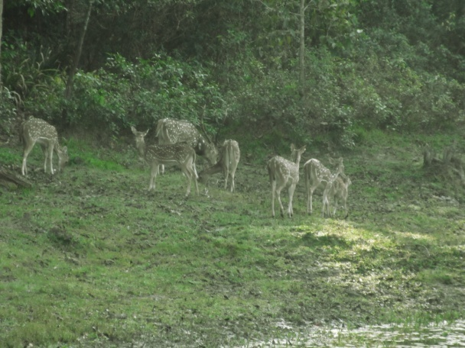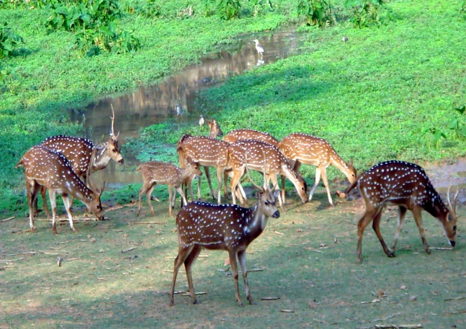
At B.S.M.R Safari Park, Cox’s Bazar At Bangladesh National Zoo, Dhaka

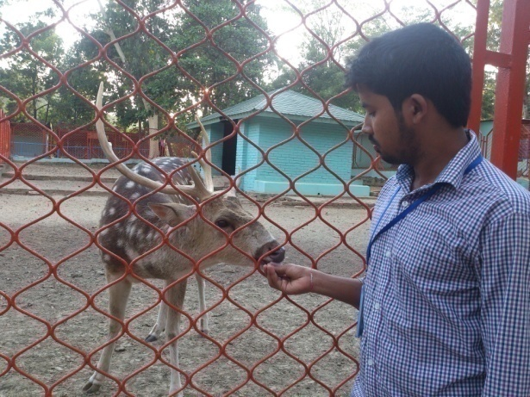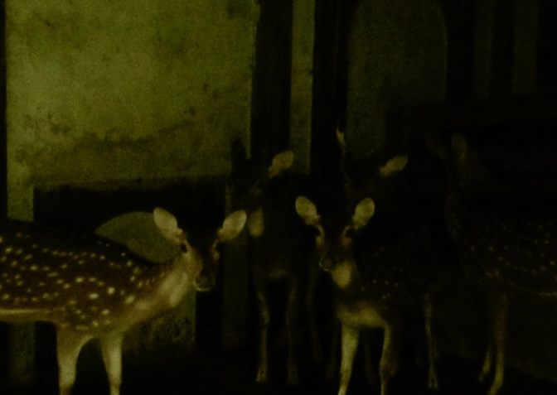
At Chittagong Zoo Foy’s-Lake At J.N. Dairy Farm, Bohardarhat, Chittagong

8. Biography

The author is a intern student of Chittagong Veterinary and Animal Sciences University, Origin from Kalipur, Banskhali Chittagong. By this December. He will receive my Doctor of Veterinary Medicine (DVM) degree, during this period of time. He attends so many training programme, seminar and conference in home and abroad related his degree for better exposure knowledge and experience. He finished his primary, secondary and higher secondary education from Chittagong Board and belonging within top five top students in my class. He is personally self dependent one, like to do his work with due response, active, punctually and dutifully.

