ACKNOWLEDGEMENT

The author wishes to acknowledge the immeasurable grace and profound kindness of Almighty “GOD” the supreme authority and supreme ruler of universe, who empowers the author to complete the research work successfully.
The author is grateful to honorable Professor Dr.Mohammad Alimgir Hossain, Professor, Department of pathology and parasitology and honorable professor Dr. Md. AhasanulHoque,, Dean, Faculty of Veterinary Medicine of Chittagong Veterinary and Animal Sciences University for arranging this type of research work as a compulsory part of this internship program.
The author wishes to express his deep sense of gratitude and thanks to Dr. Md. Abdul mannan, Veterinary sergeon,SAQTVH for his skillful supervision, kindful facilitation and guidance to make this report.
Special thanks to Professor Dr. Shafikul islam Assistant professor,Department of pathology and parasitology and also thanks to professor Dr.A.K.M. Saifuddin, Director of External Affairs Chittagong Veterinary and Animal Sciences University.
Finally the author expresses thanks and warmest sense of gratitude to his parents and all well-wishers.
The author,
September, 2015

LIST OF FIGURES
Figure No | Contents | Page No
Figure 1 | Gametocyte of Haemoproteus columbae in blood of pigeon.
Figure 2 | Gametocyte of H columbae .

LIST OF ABBREVIATION
Abbreviation and Symbol | Elaboration
% | Percent
et al. | And his associate
CVASU | Chittagong Veterinary and Animal Sciences University
SAQTVH | S A Quadery Teaching Veterinary Hospital.
100X | Hundred Magnification
40X | Forty Magnification
Hrs | Hours

Prevalence of Haemoproteus sp inDomestic
Pigeon at Chittagong District in Bangladesh
ABSTRACT:
A study was carried out to determine the prevalence of Haemoproteus sp in domestic pigeon at Chittagong district in Bangladesh. A total of 70 blood sample were collect from 3 different location in Chittagong(SAQTVH,cornealhat,Fatickchori).This study was performed between march 2015 to may 2015.blood smear was stained with Geimsa stain and examined under microscope using immersion oil. Mature and immature stages of Haemoproteus gamatocytes were found in 15.71% in Chittagong. A fluctuation observed in Chittagong district from 22.45% to 5%. However no pigeon showed infection with plasmodium but some pigeon show sign of Newcastle disease. some pigeon show drowsiness, neck bending ,weakness ,circling ,walking difficulty etc. Malaria of the pigeon is a fulminating and usually fatal infection lasting only a few days and characterized by greatly a similar hemoglubinuria and is accompanied by marked dieresis and a corresponding rise in water consumption. However , it appears likely that there are other causal factor as well as this one for the rise seen in malaria .Disease prevalence more in Chittagong town than fatickchori upazilla.
Key words: Pigeon haemosporidians,prevalence,microscopy , gametocyte.

INTRODUCTION:
Pigeon are used as pets, cultural and religious symbol. They also have value as a source of food hobby and experimental purposes. Pigeons are affected with several health problem, whereas parasite infections play a major role . Parasite infection can lead to retard growth ,low egg production and susceptibility to other infection in birds.
However, parasite protozoa Haemoproteus sp are widely distributed in tropical and subtropical region.In a taxonomic review of the haemoproteids parasites of columbids , only H. columbae and H sacharoyi are valid species . Among which H. columbae infects most commonly in pigeon and doves and transmitted by blood sucking louse fly Pseudolynchia canariensis , which is a proven vector of H columbae. Based on the morphological feature of the blood stage over 140 species of avian haemoproteus have been described . Some of which are responsible for severe pathology in birds and in pigeons only causes disease in stressed condition .Many recent studies have recorded on avian blood parasites in different area of the world . Based on microscopic examination of the prevalence of Haemoproteus sp was recorded on avian 20 in Mymensingh district in Bangladesh.
Birds haemosporidians are characterized by some unique , frequently fascinating properties and therefore they are important as models, of protistological studies .Birds haemosporidians are distributed worldwide and the family of Haemoproteidae, Plasmoium, and Leucocytozoidae ,are distributed in all zoogeographical region and use blood sucking dipteran insects as vectors. It should be kept in mind , however geographic location and genetic are the most important factors that determine resistance to bird haemosporidians , although the age of the birds ,strain of the parasite and stress may also play roles in the pathogenesis of the blood parasite. The role of haemosporidiosis in the pathology of birds in captivity cannot be currently estimated due to poor organization of the veterinary inspection of haemosporidians in many zoo ,aviaries and private collection.
It is noteworthy that due to the worldwide distribution , practical importance , and scientific appeal of the research conducted with birds and blood sucking dipteran insects , haemosporidians may be excellent objects for scientific research. Therefore, this research was conducted to determine the prevalence of the pigeon haemosporidians and effect of infection with Haemoproteus columbae on haematological and biochemical factors in pigeons in Chittagong district.

MATERIALS AND MATHOD
STUDY AREA:
The study was carried out from march 2015 to august 2015 involving randomly selected 70 domestic pigeon from different location at Chittagong. The pigeon are selected from 3 location of Chittagong such as SAQTVH, corneal hat and fatickchori.
SAMPLE COLLECTION AND IDENTIFICATION OF ORGANISM:
Blood sample for preparation of blood smear were obtained from the brachial vein and the pigeon then tagged and released. The air dried blood smear were subsequently fixed in absolute methanol 3-5 minutes and later stained with giemsa at least 30 minutes. All dried smear were examined under light microscope for the detection of blood protozoa and identify according to soulsby.

RESULTS
All sample were microscopically examined and gametocyte of Haemoproteus sp were seen within red blood cell. Diagnostic character included the elongated, crescent shaped forms of the gametocyte , its nucleus size and position in the cell. Mature gametocyte were circumnuclear and lightly staining with blue Giemsa , refractile granules were found in various sizes , generally moderately large and ovoid ,occasionally smaller.
In the current study ,out of 70 sample 11(15.71%)were found positive in Chittagong.

Table1:Overall percentage of Haemoproteus columbae in Chittagong.
Area | Location of farm | No. of pigeon | Haemoproteus (+e) | Percentage of positive | Overall percentage of positive(+e)
 | SAQTVH | 35 | 8 | 22.45%
Chittagong | Corneal hat | 15 | 2 | 13.33% | 15.71%
 | Fatickchori | 20 | 1 | 5.00%

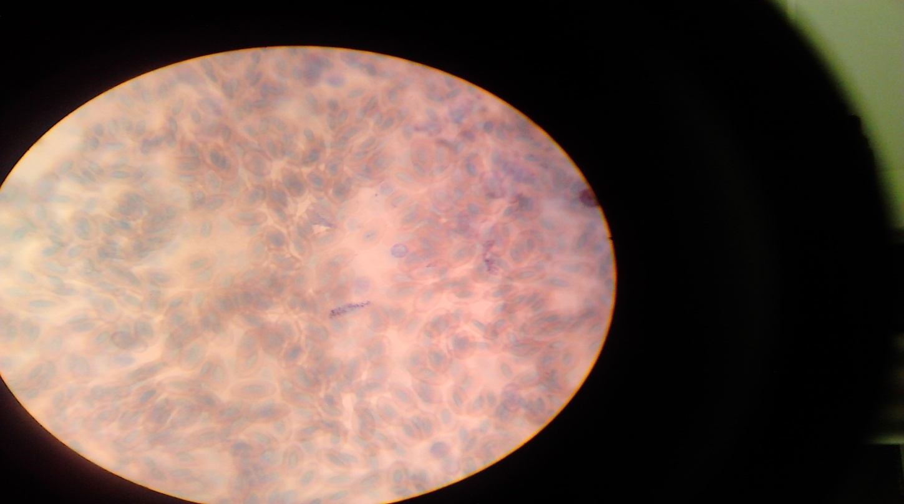
Figure 1: Gametocyte of Haemoproteus columbae in the blood of pigeon.
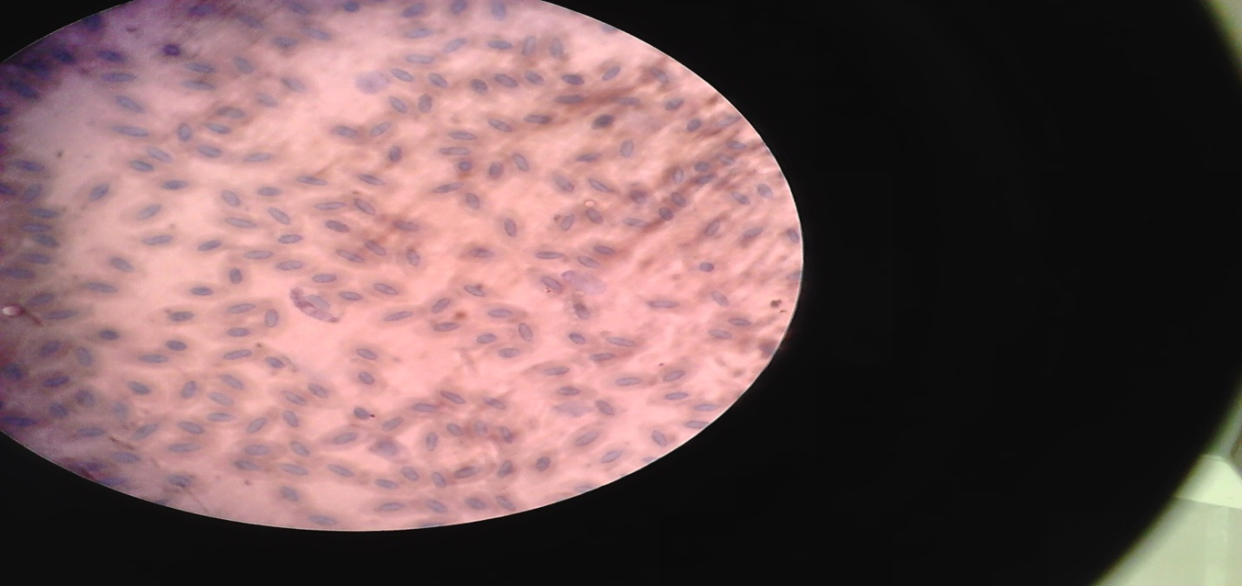
Figure 2: Gametocyte of Haemoproteus columbae.

DISCUSSION:
In the current study out of 70 sample, 11(15.71%) were found positive in Chittagong. In contrary , studies regarding Haemoproteus columbae infection conducted at Mymensingh district in Bangladesh (Dey et.al,2010),Bursa region (senlik, 2005)and (Madagascar(Raharimanga ey.al,2002)revealed prevalence rate ranges from 19-21% .However , the present study was corresponding with Dragona et.al, (1999);Orajaka and Neweze (1991) who reported that 76.5% and 37.5% pigeon are positive for Haemoproteus columbae respectively in Uganda and Nigeria . Infection load was highest in SAQTVH (22.45%) in comparison with corneal hat and faickchori. These difference might be due to climatic condition , population density and husbandry practices of pigeon. This high prevalence could be attributed to the presence of blood sucking vector flies Pseudolynchia canariensis (Bennet et.al ,1993). Dey et al, (2010) found utmost association of Pseudolynchia canariensis (90%) with the developmental stage of Haemoproteus sp in Mymensingh ,Bangladesh .In this study ,the sample are collected randomly from pigeon in three location in Chittagong. These pigeon show nervous sign like as pigeon malaria . In SAQTVH, out of 35 sample 8 are positive , in corneal hat out of 15 sample 2 sample are positive and in fatickchori out of 20 sample 1 are positive. This showed that infection in SAQTVH is more than other places in the Chittagong .
Many reports on the pathogenicity of avian haemoparasites have been based on evidence of high parasitemia in sick birds (Bennett and Bishop 1998)and few studies have compared the biochemical parameter between parasitized and nonparasitized birds . pigeon is one of the rare avian species that have been shown clinical disease following infection with Haemoproteus .
Further investigation are needed to identify the effect of Haemoproteus infection on food intake ,digestion and absorption processes on acute phage inflammatory responses on pigeon .
Our results demonstrates that infection by Haemoproteus might have a healthy impact on host pigeons ,or parasitemia is secondary to poor health state of certain individuals.

CONCLUTION:
Pigeon malaria is caused by a protozoa named Haemoproteus columbae which is carried by a mosquito . It is a mosquito borne disease. In Chittagong, there are huge number of drains . so mosquito grows easily and they transmitted the protozoa of pigeon malaria .
If we protect the disease first we should clean our house . Government should clean the drain regularly. Net should be used in pigeon house. Infected birds should be separated from healthy birds.

BIOGRAPHY:
I am Md mashudul alam . I study in Chittagong Veterinary and Animal sciences University. My father name is Md mahbobul alam and mother name is shahazadi begum. I completed my ssc examination in comilla zilla school in the year 2006 and hsc examination in comilla Victoria collegeinn 2008. Now I am intern student of Chittagong veterinary and animal sciences university in faculty of DVM .My home district Chittagong ,Upazilla fatickchori , lalang union and my village name is gopal gatta .I am 24 years old .My date of birth is 12 august 1991.

REFFERENCES:
Bennett GF , Pierce MA, Ashford RW (1993). Avian haematozoa-Mortality and pathogenecity .
Natur. Histo.27-193-1001.
Dey AR, Begum N, Paul SC,Noor M, Islam K (2010).Prevalence and pathology of blood protozoa
In pigeons reared at Mymensingh district , Bangladesh .Int.J.Bio.Res.2(12)
25-29.
Dragona C, Ocaido M ,Katete P (1999). The ecto-gastro intestinal and haemo-parasites of live
Pigeons (columva livia) in Kampala, Uganda.Avi. Pathol. 28(2)-199-124.
Orajaka L J ,Nweze LC (1991).Prevalence of blood protozoan parasite of avian species in Nsukka
Area of Anambra State , Nigeria. Beitr. Trop.Landwirtsch. Beterinarmed.29(1):
91-95.
Raharimanga V,Soula F,Raherilalao MJ ,Goodman SM ,Sadones H, Tall A, Rand rianarivelojosia
M, Raharimalala L, Duchemin JB ,Ariey F, Robert B(2002). Hemoparasites in
Wild birds in Madagascar . Archi. Insti.Paste. Madaga . 68(1-2):90-94
Senlik B . Gulegen E, Akyol V (2005), Prevalence and intensity of Haemoproteus columbae in domestic pigeon. Ind.Vet.J. 82(9) : 998-999.

.

