Detecting Salmonella from Egg shell of Backyard Chicken.

By
SANI SAHA
Roll No: 10/ 39
Reg. No: 00517
Intern ID. : C-28
Session :2009 – 2010

A clinical Report Submitted in partial satisfaction of the requirements for the degree of
DOCTOR OF VETERINARY MEDICINE
Faculty of Veterinary Medicine

CHITTAGONG VETERINARY AND ANIMAL SCIENCES UNIVERSITY, KHULSHI, CHITTAGONG.

Detecting Salmonella from Egg shell of Backyard Chicken

Approved:

…………………………………………………………….
Dr. Abdul Ahad
Professor
Head of the department,
Dept. of Microbiology and Veterinary Public Health
Chittagong Veterinary and Animal Sciences University

December, 2015

TABLE OF CONTENTS
Contents Page No

LIST OF TABLES…………………………………………………………………. 04
LIST OF FIGURES………………………………………………………………... 04
LIST OF ABBREVIATION………………………………………………………..04
ABSTRACT………………………………………………………………………....05
Chapter I: INTRODUCTION…………………………………………………….06-08
Chapter II: MATERIALS AND METHODS
2.1 Sample collection………………………………………………………………..09
2.2 Bacteriological method……………………………………………………….....09-10
2.3 Antimicrobial sensitivity test……………………………………………………10-11
2.4 Data Analysis…………………………………………………………………….11
Chapter III: RESULTS
3.1 Prevalence of Salmonella spp. in different sites…………………………………12
3.2 Effect of temperature…………………………………………………………….13
3.3 Antimicrobial resistance pattern of Salmonella isolates from egg storing place and egg shell ………………………………………………………………………………………13-14
Chapter IV: DISCUSSION
4.1 Prevalence of Salmonella spp. in egg shell surface and egg storing place ……...15
4.2 Temperature effect………………………………………………………………16
4.3 Antimicrobial resistance…………………………………………………………16
Chapter V: CONCULATION……………………………………………………. 17
REFFERENCES………………………………………………………… 18-20
ACKNOWLEDGEMENTS …………………………………………….. 21
BIOGRAPHY…………………………………………………………….21
LIST OF TABLES
Table No | Content | Page No
Table 3.1 | Prevalence of Salmonella in different sample and places | 12
Table 3.2 | Prevalence of Salmonella in different month | 13
Table 3.3 | Antimicrobial resistance pattern of Salmonella isolates from sample. | 13

LIST OF FIGURES
Figure No | Contents | Page No
Figure: 2.1 | Sample collection from different sites. | 09
Figure: 2.2 | Isolation of Salmonella by laboratory test. | 10
Figure:  2.3 | Antibiotic resistance test | 11
Figure:  3.3 | Resistance pattern of Salmonella isolates from egg storing place and egg shell | 14

LIST OF ABBREVIATION
Abbreviation and Symbol | Elaboration
% | Percent
et al. | And his associate
CVASU | Chittagong Veterinary and Animal Sciences University
Spp | Species
US | United States
WHO | World Health Organization
Hrs | Hours
°C | Degree Celsius
CDC | Centers for Disease Control
Gms | Grams
SS | Salmonella shigella
BG | Brilliant Green
MS | Microsoft word

Abstract
A study was conducted to determine the incidence of Salmonella spp. in egg shell surface and egg storing places of backyard chickens. A total of 45 egg shell surface and 35 egg storing places were examined in different areas of Comilla district, Bangladesh. Common culture methods used for the isolation of Salmonella from samples, nonselective pre-enrichment followed by selective enrichment and plating on selective and differential agars and expected colonies are then confirmed biochemically. Salmonella contamination was recorded in 6 of 80 samples (7.5%), of which 3 from egg shell surface (6.7%) and 3 from egg storing places (8.6%). Prevalence of Salmonella spp. in egg shell surface and egg containing place due to poor handling of eggs and reuse of egg storing places respectively. Salmonella contamination also recorded high in low temperature of January (15%) than high temperature of April (3.33%). Further examination of the Salmonella spp. was carried out by testing their antimicrobial sensitivity against 6 commonly used antibiotic in market. Among the antibiotics ciprofloxacin and gentamycin has the highest sensitivity and highest resistance was in tetracycline and ampicillin among the isolated sample.
Key words: Salmonella; Backyard chickens; antimicrobial resistance; Egg shell.

CHAPTER I: Introduction
In Bangladesh, there are about 210 million chickens (DLS, Bangladesh). Among this 50% are backyard chicken. Over 80% rural people rear chickens. Backyard poultry serves as a good source of egg in the rural areas. Chicken is the most important bird used to produce eggs for human consumption around the world, and eggs are a unique well-balanced source of nutrients in the human diet. Egg proteins have a high biological value, and are often used as a standard to compare the quality of other proteins in foods. In developing countries like Bangladesh, people take table eggs and food containing egg daily as a cheap source of protein. Poultry products have always topped the incidence of Salmonellosis in many developing countries including India, Egypt, Brazil and Zimbabwe (Henson, 2003). In Bangladesh, isolation of Salmonella spp. was reported in eggs shell of local chicken (Ahmed et al., 2010). Backyard hens can be infected through contact with wild animals, domestic mammals and commercial poultry that are carriers of Salmonella and consequently may take part in the shift of organism to other animals and human (Jafari et al., 2007). In Bangladesh consumption of the eggs gone up to considerably high due to easy availability and large source of protein. Vast ranges of poultry products have been contaminated with Salmonella spp. leading to outbreaks of salmonellosis (Messens et al., 2007). Salmonella is one of the major bacterial agents that cause foodborne infections in humans worldwide (Herikstad et al., 2002). Food-borne disease caused by Salmonella spp. occur at high frequency in industrialized nation and characterize as important public health problem worldwide (Braden, 2006). One possible cause of Salmonella contamination in developing countries is reusable egg trays (Utrarachkij et al., 2012). Outbreaks and sporadic cases of Salmonellosis are commonly associated with the intake of contaminated hen eggs with Salmonella spp. Therefore, awareness of the prevalence of Salmonella spp. is important to commence a control programmed. The disease is endemic in lots of developing countries particularly the asian subcontinent, south and central America (Miller and Pegues, 2000). Since food animals are the reservoir for most domestically acquired human Salmonella infections and transmission from animals to human occurs through the food provide. Infections with bacteria of the genus Salmonella are accountable for a range of acute and chronic disease of poultry has been reported in Bangladesh. Table egg contaminated with bacteria pathogens and consumed unprocessed or improperly cooked have been accountable for many epidemics of gastroenteritis (Nygård et al., 2004). Salmonellosis is a major food borne disease caused by Salmonella Spp., Which is a gram negative, non-spore forming and facultative anaerobic bacteria. Salmonellosis is an infectious disease in both humans and animals. Human infections are usually associated with animal contact and the consumption of unhygienic food products such as poultry, meat and other dairy products (Uyttendaele et al., 1998). Salmonellosis is usually considered as self-limiting illness, but it can also become persistent and fatal, especially for patients who are young or immune-compromised. Non-typhoidal Salmonella strains are significant causes of infections in both humans and animals. This disease is caused by Salmonella serotypes other than Salmonella typhi and Salmonella paratyphi. It is a major food-borne infection with worldwide distribution. Most of cases are self-limiting gastroenteritis (Kariuki et al., 2002). The clinical symptoms usually appear 8 to 72 hrs after contact with the pathogen. The typical symptoms are usually nausea, vomiting, abdominal pain and diarrhea with or without fever. During the past decade, there had been a considerable world-wide increase of non-typhoidal Salmonellosis especially in industrialized countries including, the United Kingdom, Germany, France, Austria, Denmark, and the United States of America. In the US, 1.3 million illnesses and 400 to 600 deaths were occurred in each year (Mead et al., 1999). The most common serotypes dependable for the disease are Salmonella enteritidis and Salmonella typhimurium (Herikstad et al., 2002). Common culture methods used for the isolation of Salmonella from eggs include, nonselective pre-enrichment followed by selective enrichment and plating on selective and differential agars. expected colonies are then confirmed biochemically. These methods are time consuming and take approximately 4-7 days.
In recent concern about poultry meats and other food stuffs contaminated with food borne organism has gained remarkable attention because of the increased occurrence of antimicrobial resistant bacteria associated with human illness. The administration of antimicrobial agents in chickens creates selection pressure that favors the survival of antibiotic resistant organisms. Drug resistance in food borne bacterial enteric pathogens is an almost unavoidable consequence of the use of antimicrobial drugs in food-producing animals, and particularly in the developing countries by use of medicines in humans (Threlfall et al., 2000). In recent years the emergence and global dissemination of multi-drug resistant typhoid strains has posed chief public health problems in the developing countries, and over the past decade it has assumed epidemic proportions in South Asia.
The identification of antimicrobial-resistant Salmonella in food has raised concerns on treatment of food borne Salmonellosis especially the development of Ceftriaxone and Ciprofloxacin-resistant Salmonella, as these are important in treating Salmonella infections. Multidrug resistant phenotypes have been found progressively more described among Salmonella spp. worldwide (Gyles, 2008). The common resistant antimicrobials were Streptomycin (41.3%), Tetracycline (31.9%), Gentamycin (28.2%), Ampicillin (25.4%) and Nalidixic acid were reported in many earlier studies in poultry in different countries including Bangladesh (Akter et al., 2007; Showkat et al., 2011; Ferdous et al., 2013). Several studies on antimicrobial sensitivity against Salmonella spp. at poultry farms have indentified the following sensitive antimicrobials in Bangladesh: Ciprofloxacin remained sensitive at 80-100% (Rahman et al., 2004; Kohinur et al., 2007; Akter et al., 2007; Ferdous et al., 2013), Amoxicillin 30-50% and Doxyclycline 13% (Nandi et al., 2004; Rahman et al., 2004; Akter et al., 2007; Ferdous et al., 2013).Outbreaks of Salmonella Enteritidis infection with a confirmed food vehicle from 1985-2003, 75% of outbreaks had vehicles that were either mostly egg based or that contained egg ingredients (Barden 2006). In the USA from 1985-1998, State and Territorial Health Department reported 796 Salmonella spp. outbreaks that accounted for 28,689 illness, 2839 hospitalized and 79 deaths. Of the 360 Salmonella outbreak with a confirmed source, 279 (82%) were associated with raw or undercooked egg shells (CDC 2000). In 1985-1998, State and Territorial Health Department reported 677 Salmonella spp. outbreaks that accounted for 23,366 illnesses, 988 hospitalized and 33 deaths. Of the 309 Salmonella outbreak with a confirmed vehicle, 241 (78%) were associated with shell eggs accounting for 14,319 illness (CDC 2000). A total of 565,042 human and 102,13 non- human Salmonella isolates were reported into the (WHO) in many countries in the world and found that, the most common Salmonella serotypes were Salmonella enteritidis and Salmonella typhimurium (WHO 2006). In developing country like Bangladesh there are no sufficient data available on Salmonella infection and the likely sources of salmonellosis due to limited epidemiological studies.
Hence the present study has been taken up to generate baseline data on prevalence and distribution of various Salmonella spp. in eggs from backyard hens, that are very consumed in the study area and to evaluate the risk associated with them by carrying out antibiotic resistant analysis.
Chapter II: Materials and Methods
2.1 Sample collection
Eggs were randomly collected from two villages of Chauddagram Upazila under Comilla district, over a period of four month (january2015-april2015).A total of 45 egg shell and 35 egg storing places were analyzed for presence of salmonella.
Egg storing place: In the city, eggs are stored in egg tray but in rural area eggs are stored in different places like- basket, rack, plate. Environmental samples were taken from the above mentioned egg storing places. A sterile cotton swab was used to wet in sterilized buffered peptone water solution to swab on egg storing places and then put the stick immediately into a sterile vial containing buffered peptone water. Individual sample in each vial was given unique identification number then immediately transferred to laboratory, Chittagong Veterinary and Animal Sciences University (CVASU) through ice bar.
Egg shell surface: A sterile swab, soaked in sterilized buffered peptone water was swabbed on egg surface and then put the stick immediately into a sterile vial containing buffered peptone water transport.
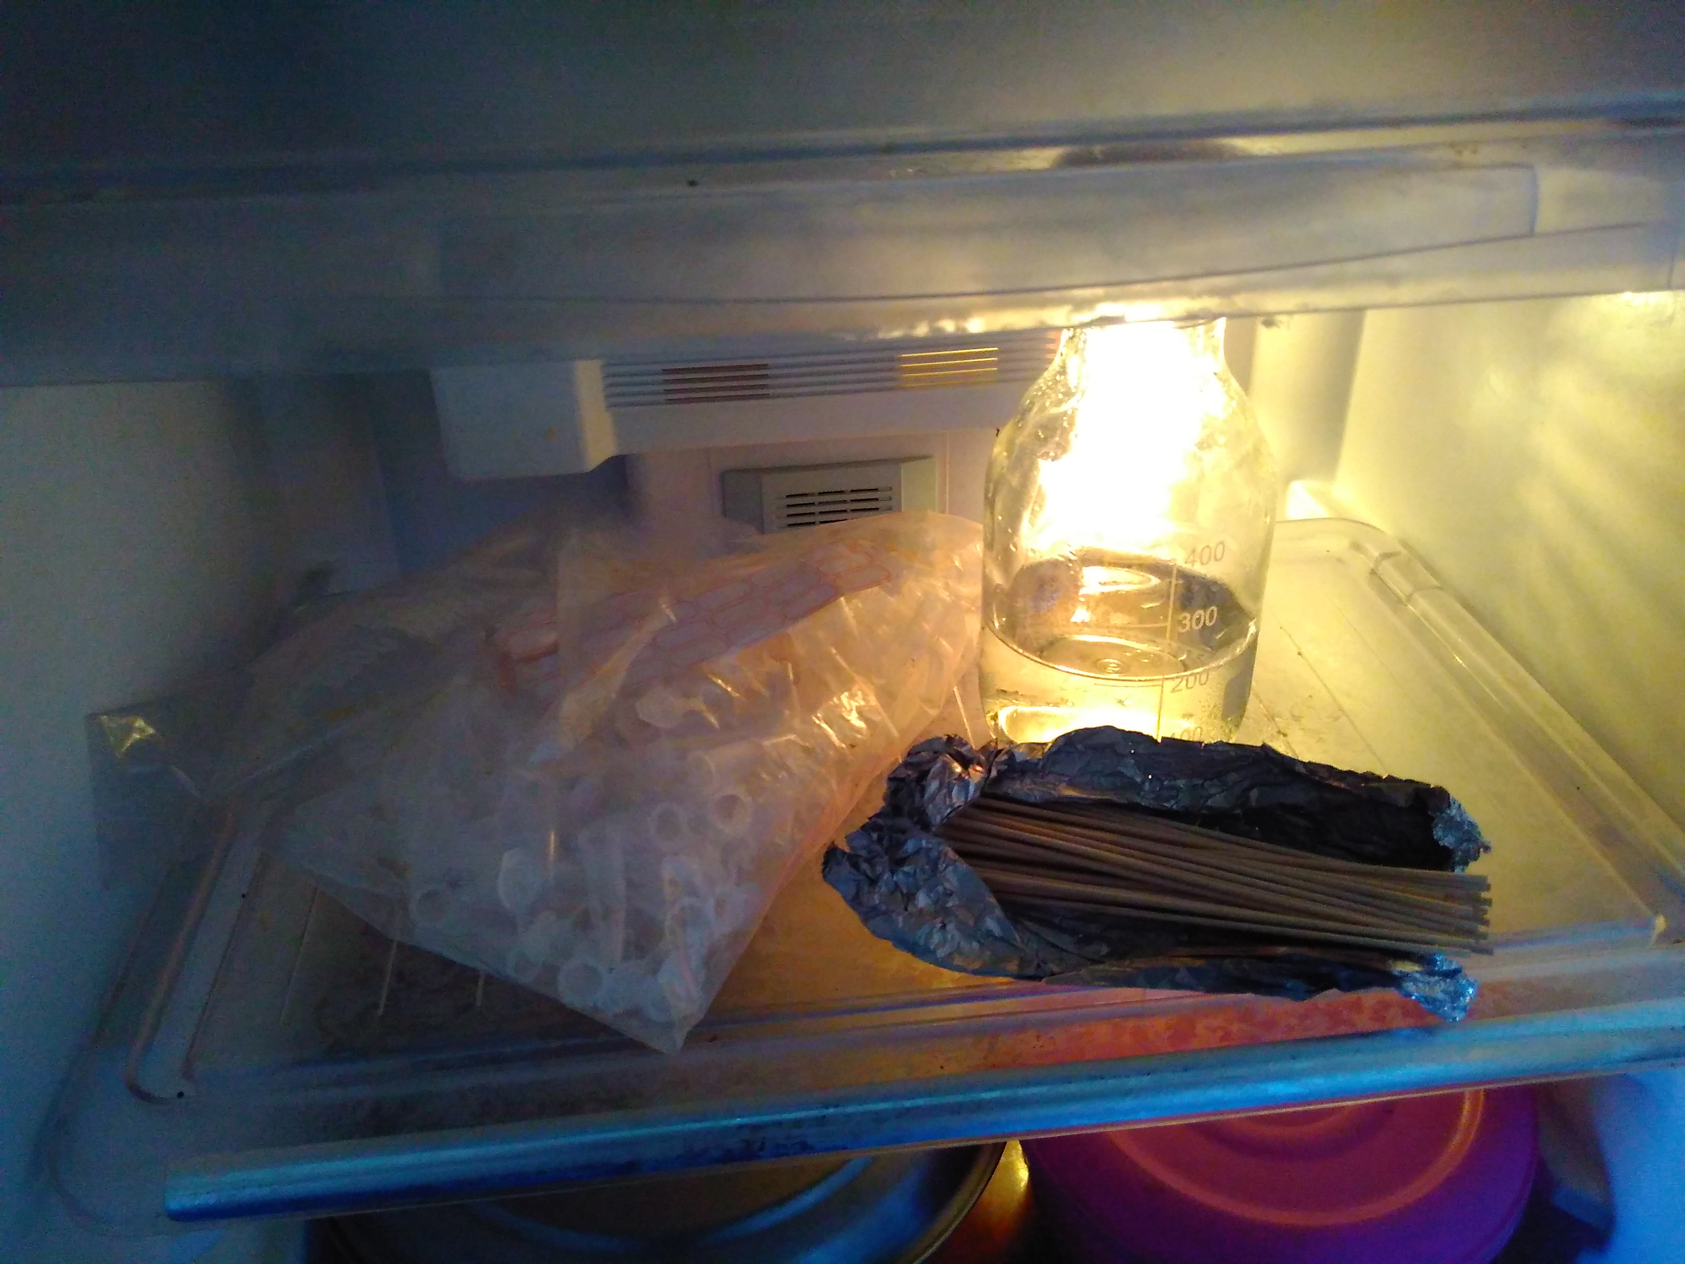
Materials for sample collection Sample from egg shell surface Sample soaked in vial
Figure 2.1: Sample collection from different sites.
2.2 Bacteriological method
The collected sample were than subculture at nutrient broth which are prepared by dissolving 25gms powder in one litter distilled water and dissolve the medium completely by heating then sterilize it by autoclaving at 10 lbs pressure (115°C) or alternatively at 15 lbs pressure (121°C) for 15 minutes or as per validated cycle. After sterilization ph of the medium should be 7.3±0.1. Normally each litter of nutrient broth medium contains 10gms peptone, 10gm beef extract and 5 gm sodium chloride. After giving subculture inoculation in nutrient broth, it was incubated at 35-37°C for 24 hours. Then subculture inoculums from nutrient broth are streaked in the Salmonella Shigella agar (SS agar) which is composed of lactose 10 gm, bile salts 8.5gm, sodium citrate 8.5 gm, sodium thiosulfate 8.5gm, beef extract 5gm, ferric citrate 1gm, brilliant green 0.33gm, neutral red 0.025gm, agar 13.5gm per liter of de-ionized water. Colonies of Salmonella spp. may appear with or without black centers. The suspected Salmonella colony then transferred to nutrient broth medium and incubated at 35-37°C for 24 hours. In the next step inoculums from nutrient broth again streaked in the BG Agar which is used for selective isolation of Salmonella spp. The medium also contains yeast extract, enzymatic digest of casein, enzymatic digest of animal tissue, NaCl, Lactose, Sucrose, Brilliant Green, Phenol red and Agar. Salmonella colonies can vary in color from red to pink-white, depending upon incubation time and strain. The agar around the colonies must be red. Finally, some basic biochemical profiling of Urease (-ve) and catalase (+ve) tests were applied.
Colonies on BG agar Catalase test (+)
Figure 2.2: Isolation of Salmonella by laboratory test.
2.3 Antimicrobial sensitivity test
Antimicrobial sensitivity testing against Salmonella isolates was performed by using antimicrobial disc according to Kirby- Bauer antimicrobial disc diffusion techniques. Mueller- Hinton agar was prepared in Petri- dishes as per the instruction of the manufacturer. Pure colonies of the Salmonella spp. Isolates were inoculated in nutrient broth and incubated in 37°C for overnight. The isolates were streaked thoroughly on the Muller Hinton agar by using sterile glass rod and antimicrobial discs like Ampicillin (30mcg), Ciprofloxacin (5mcg), Erythromycin (15mcg), Enrofloxacin (30mcg), Gentamycin (10mcg) and Tetracycline (30mcg). The Petri-dish and its content were incubated in an incubator at 37°C for 24 hrs. The plates were observed for antimicrobial susceptibility pattern by measuring the zone of inhibition developed against the Salmonella isolates on the plate.
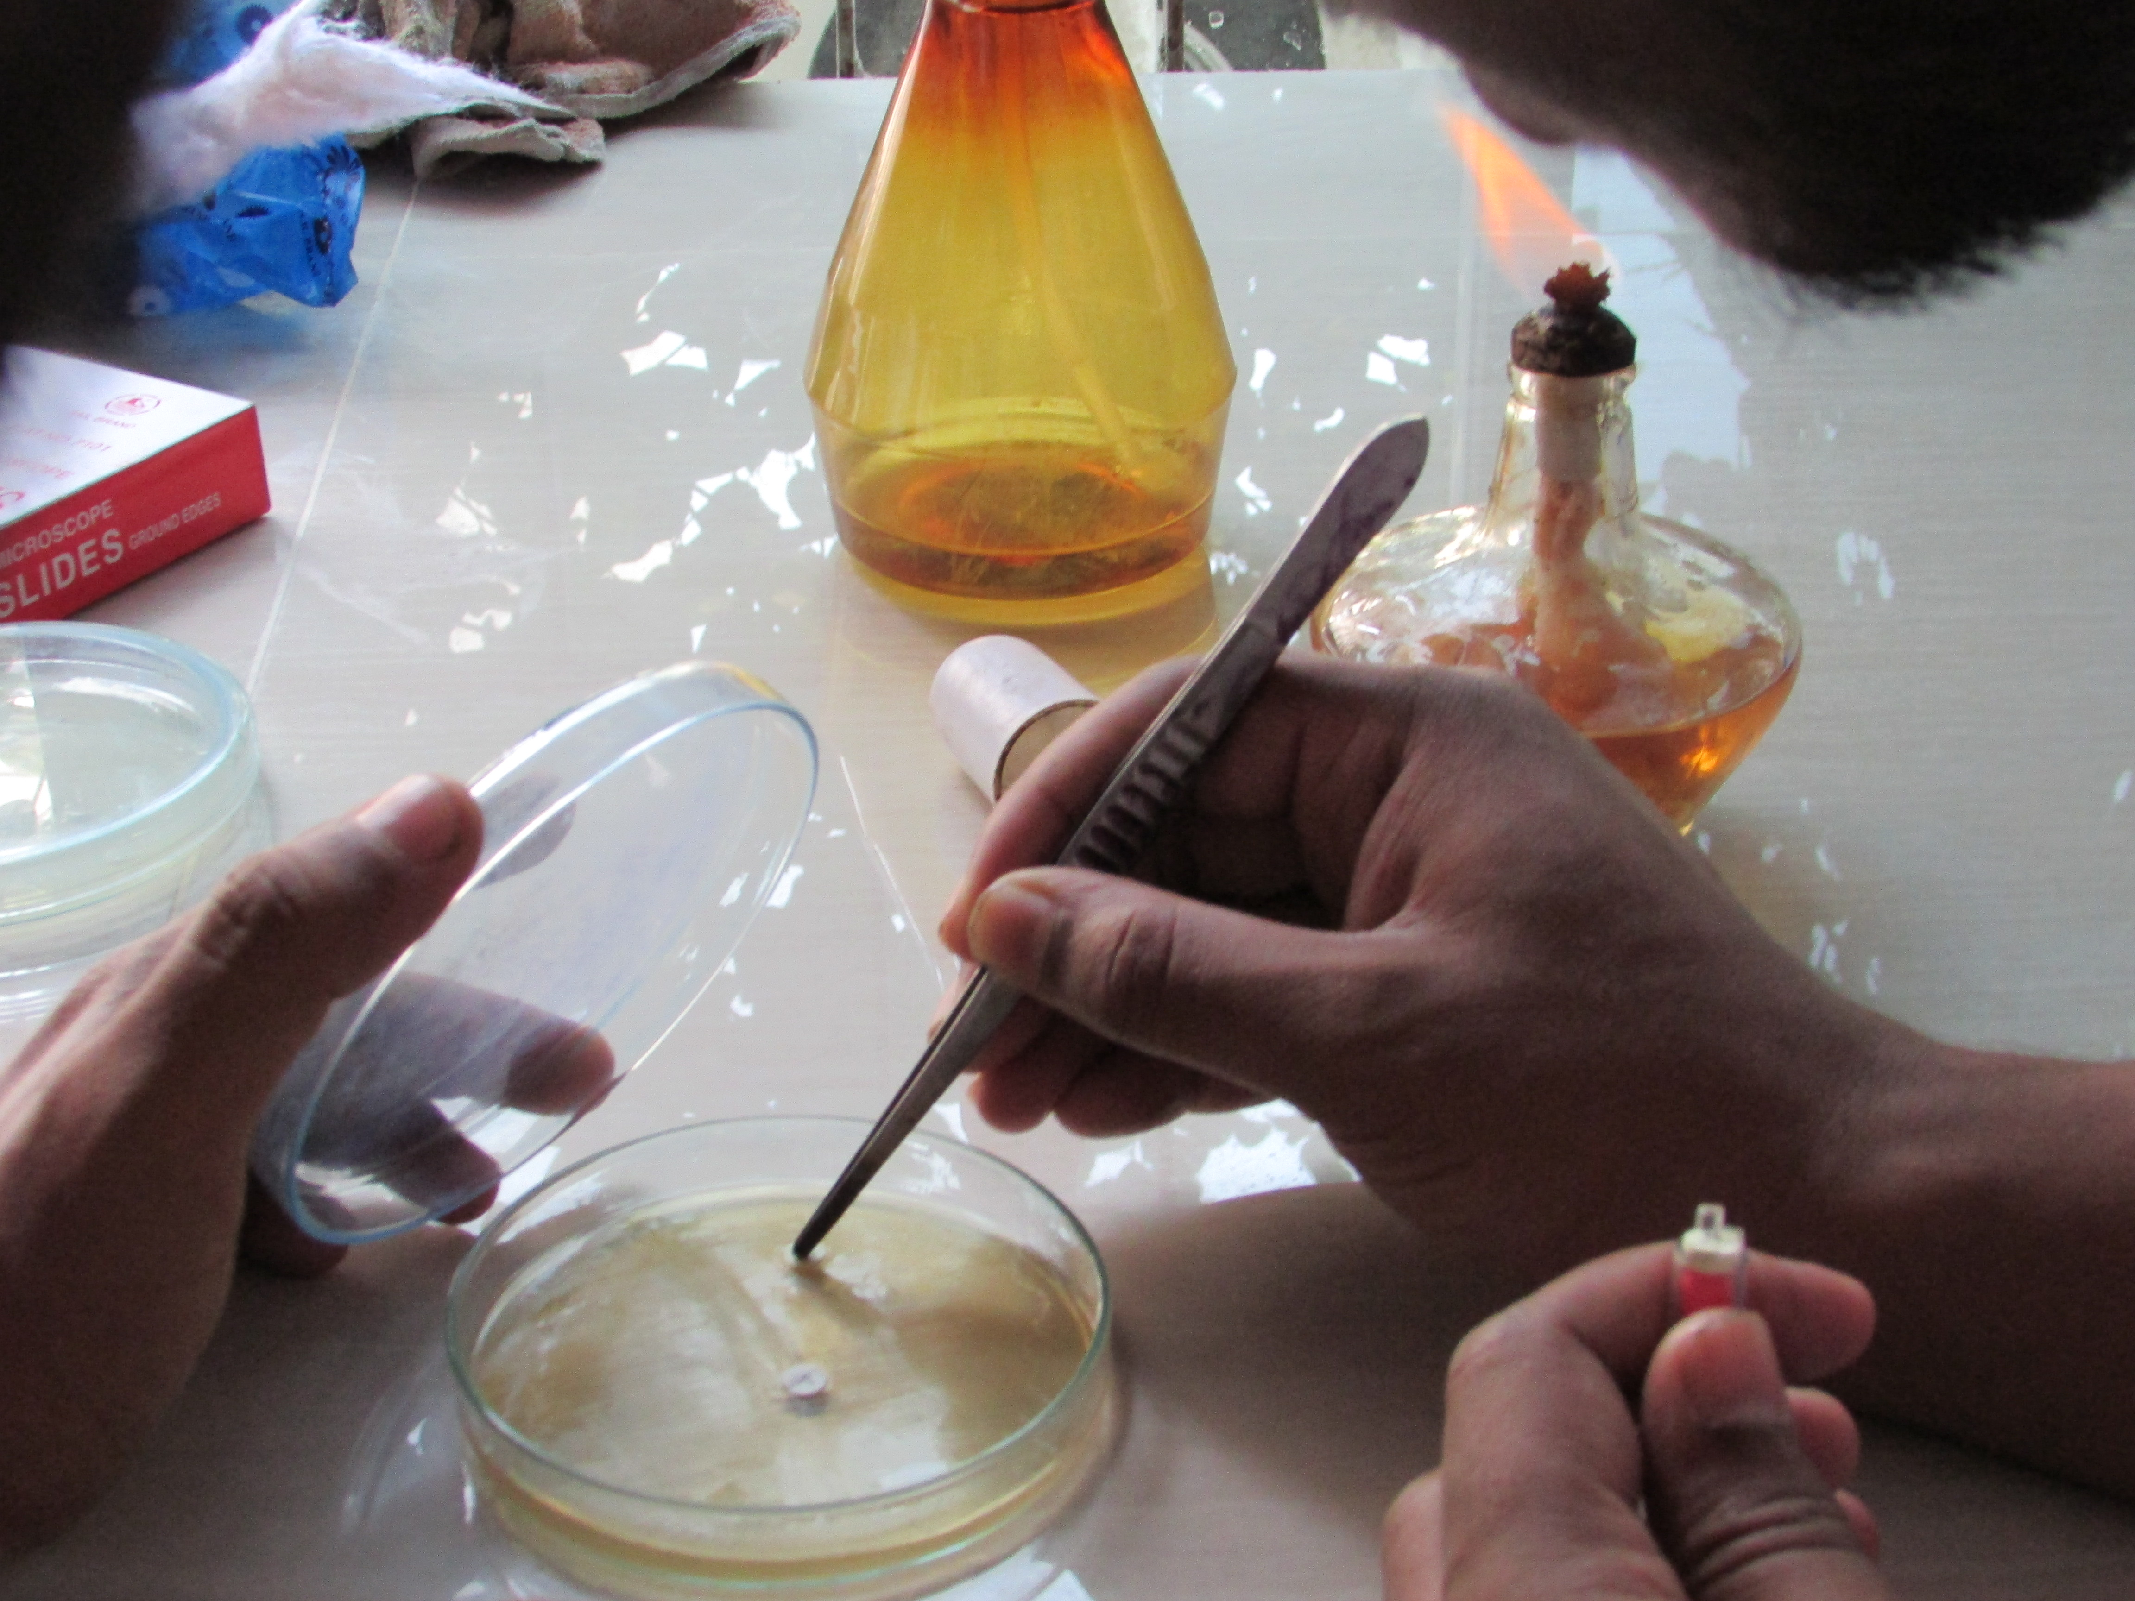
Figure 2.3: Antibiotic resistance test.
2.4 Data Analysis
Field and Laboratory data were stored and then cleaned in MS excel-2010 program before exporting to STATA/IC-11.0 for analysis. Descriptive analysis was performed to know the frequency and distribution of Salmonella and antibiotic resistance pattern.

Chapter III: Result
Salmonella spp. Isolated from egg storing place and egg shell surface from backyard chicken farm of two areas of Chauddagram Upazila, Comilla, Bangladesh were evaluated for estimate the prevalence and pattern of antimicrobial resistance and sensitivity among Salmonella spp. Isolates.
3.1: Prevalence of Salmonella spp. in different sites.
Table 3.1: Prevalence of Salmonella in different sample and places
variable | Categories | No of sample analysed | Positive(%) | Chi2-value | P-value
Sample | Egg shell | 45 | 3(6.7) | 0.1493 | 0.699
 | Egg storing place | 35 | 3(8.6)
Sites | Chandishkara(village) | 50 | 4(8) | 0.0480 | 0.826
 | Ramraigram(village) | 30 | 2(6.7)

Table 3.1 Shows that the prevalence of Salmonella spp. in different samples like egg storing place and egg shell surface. The highest prevalence was found in egg storing places (8.6%) and lowest (6.7%) in egg shell surface. Among the category of samples the variation in prevalence differs not significantly (p>0.05). On the other hand, prevalence was highest (8%) in samples of Chandishkara village and lowest (6.7%) in samples of Ramraigram village but the variation among the sites were not varied significantly (p>0.05).

3.2: Effect of temperature
Table 3.2: Prevalence of Salmonella in different month
Month | No of sample analysed | Positive(%) | Chi2-value | P-value
January | 20 | 3(15%) | 2.4024 | 0.301
February | 30 | 2(6.67%)
April | 30 | 1(3.33%)

Table 3.2 shows the prevalence of Salmonella spp. Isolated from egg shell surface and egg storing places in different month of study period. The highest prevalence was found in the month of January (15%) and lowest was in April month (3.3%). But the variation among the month was not varied significantly (p>0.05).
3.3: Antimicrobial resistance pattern of Salmonella isolates from egg storing place and egg shell
Table 3.3: Antimicrobial resistance pattern of Salmonella isolates from sample.
Antibiotics |  | Salmonella positive isolates | Pattern
 |  |  | Resistance (%) | Sensitive (%)
Erythromycin |  | 6 | 83.3 | 16.7
Tetracycline |  | 6 | 100 | 0
Enrofloxacin |  | 6 | 66.6 | 33.4
Gentamycin |  | 6 | 16.7 | 83.3
Ampicillin |  | 6 | 100 | 0
Ciprofloxacin | 6 |  | 16.7 | 83.3

Figure 3.3: Resistance pattern of Salmonella isolates from egg storing place and egg shell

Resistance pattern of Salmonella were highest in Tetracycline (100%) and Ampicillin (100%) followed by Erythromycin (83.3%), Enrofloxacin (66.6%), Gentamycin (16.7%) and Ciprofloxacin (16.7%). It was revealed that no isolated were found sensitive to Ampicillin and Tetracycline. Ciprofloxacin and Gentamycin showed highest level of sensitivity (83.3%) followed by Enrofloxacin (33.4%) and Erytheomycin (16.7%).

Chapter IV: Discussion
The aim of this study was to determine the occurrence of Salmonella spp. in egg shell surface and egg storing places along with estimating the prevalence of antimicrobial resistance against Salmonella spp. in some rural areas of Comilla district, Bangladesh to reduce this food borne disease. Another highlight of the investigation was to determine the relation of Salmonella spp. growth with temperature. We found that prevalence of Salmonella in environmental samples and egg shell surface was 7.5%. However prevalence was differ in egg shell surface (6.7%) and egg storing samples (8.6%). It indicates the environment sample was more infected than egg shell surface. It might be due to long time use of egg storing places and reuse of them.
4.1 Prevalence of Salmonella spp. in egg shell surface and egg storing place
Out of the 80 samples, 6 isolates (7.5%) of Salmonella were identified on the basis of biochemical tests from egg shell surface and egg storing place (table 3.1). Lower isolation rates were reported by previous worker, who found 6%, 5.8% and 3.5% Salmonella prevalence in backyard chickens in Iran((Jafari et al., 2007), Belgium(Namata et al., 2009) and Paraguay(Leotta et al., 2010) respectively. In Spain, contamination of Salmonella was reported around 1% in egg shell surface by (Perales and Audicana, 1989). In the United Kingdom, prevalence of Salmonella was reported to be ranging from zero to 7% (Humphrey, 1994) and (Evans et al., 1998). In India, contamination in egg shell surface and egg storing trays of commercial eggs was reported 6.1% and 8.5% (Suresh et al., 2006), which was quite similar with this study result (6.7% in egg shell surface and 8.5% in egg storing places)-table 3.1. In Dhaka city of Bangladesh, contamination in local chicken egg was reported as 8% (Ahmed et al., 2010). Prevalence of Salmonella in egg storing trays was reported 43.93% and 40% in egg shell of commercial eggs in Pakistan (Akter et al., 2007). This is further strengthened by our observation that egg shell contamination in backyard layer hen eggs was much lower than commercial eggs as these hens are maintained at the backyard at a much lower concentration. Contamination in egg storing places (8.6%) is higher than egg shell surface (6.7%) may be for long time preservation and large number of contamination in storing places. Egg shell surface infected during the storage at room temperature, and develop organism during transportation and handling.
4.2 Temperature effect
Variation was recorded in the prevalence of Salmonella in different months of the study period (table 3.2). A reduced temperature is preferred by many pathogens reported by (Feachem, 1974). Survival of Salmonella on egg shell is increased by low temperature (Lancaster and Crabb, 1953; Baker, 1990), which is the characteristics temperature (11-17°C) of the month of January in study area. In high temperature Salmonella on egg shell die rapidly reported by (Baker, 1990). In the study area there was high temperature (22-28°C) in April month.
4.3 Antimicrobial Resistance
The current study recorded multiple antimicrobial resistances against Salmonella spp. and in most cases, estimated 100% resistance across the study sites (table 3.3). Antimicrobials use in food animals has resulted in the development of antimicrobial resistance (White et al., 2001), through mutation and acquisition of resistance encoding genes (Fluit, 2005). Tetracycline antimicrobial use in day old chicks via the drinking water to control infection from Salmonella, E. coli and Mycoplasma (Lucas et al., 1970; Hamdy et al., 1982). This might have enhanced resistance against Tetracycline. Ampicillin resistant strains isolated from commercial eggs were in high proportion than broiler and environment (Suresh et al., 2006). Ciprofloxacine is a fluroquinolone, which use successfully for treatment of septicemic salmonellosis in human (Brown et al., 1994). Ciprofloxacin resistance in veterinary Salmonella isolates has occasionally found (Brown et al., 1994). Backyard hens are reared in backyard of household, where they might get exposure to strains from humans, where ciprofloxacin is widely used in treatment.

Chapter V: Conclusion
Salmonellosis is a egg borne disease and Salmonella is also an intestinal flora. In our study we did not analyze the surface of contamination, either it is vertically transmitted or it is due to fecal contamination.The result of the present investigation indicate that, there was prevalence of salmonella in egg shell and egg storing places of backyard poultry farms due to unhygienic condition like- egg shell contaminated with fecal matter, poor handling of egg, reuse and long use of egg storing places in favorable temperature. So increase of awareness and hygienic condition may lessen the prevalence. As the result from this single study is not formulating standards, further study with large size should require.
The level of resistance of salmonella to antibiotics may be a great threat to our livestock production; therefore it is necessary to inform people involved with food industry as well as distributors to take care in handling the food products. Salmonella has zoonotic importance. In this study we did not identify Salmonella in the species level. However, further study with bigger sample size is required to identify the source and cause of drug resistance.

References
Ahmed, M., Rahman, M., Mahbub, K., Wahiduzzaman, M., 2010. Characterization of antibiotic resistant Salmonella spp isolated from chicken eggs of Dhaka city. Journal of Scientific Research 3, 191.
Akter, M., Choudhury, K., Rahman, M., Islam, M., 2007. Seroprevalence of salmonellosis in layer chickens with isolation, identification and antibiogram study of their causal agents. Bangladesh Journal of Veterinary Medicine 5, 39-42.
Baker, R., 1990. Survival of Salmonella enteritidis on and in shelled eggs, liquid eggs and cooked egg products. Dairy, Food and Environmental Sanitation 10, 273-275.
Braden, C.R., 2006. Salmonella enterica serotype Enteritidis and eggs: a national epidemic in the United States. Clinical Infectious Diseases 43, 512-517.
Brown, N., Millar, M., Frost, J., Rowe, B., 1994. Ciprofloxacin resistance in Salmonella paratyphi A. Journal of Antimicrobial Chemotherapy 33, 1258-1259.
Evans, M.R., Lane, W., Ribeiro, C.D., 1998. Salmonella enteritidis PT6: another egg-associated salmonellosis? Emerging infectious diseases 4, 667.
Feachem, R., 1974. Faecal coliforms and faecal streptococci in streams in the new guinea highlands. Water Research 8, 367-374.
Fluit, A.C., 2005. Towards more virulent and antibiotic‐resistant Salmonella? FEMS Immunology & Medical Microbiology 43, 1-11.
Gyles, C.L., 2008. Antimicrobial resistance in selected bacteria from poultry. Animal Health Research Reviews 9, 149-158.
Hamdy, A., Saif, Y., Kasson, C., 1982. Efficacy of lincomycin-spectinomycin water medication on Mycoplasma meleagridis airsacculitis in commercially reared turkey poults. Avian diseases, 227-233.
Henson, S., 2003. Food safety issues in international trade. International Food Policy Research Institute (IFPRI).
Herikstad, H., Motarjemi, Y., Tauxe, R., 2002. Salmonella surveillance: a global survey of public health serotyping. Epidemiology and infection 129, 1-8.
Humphrey, T., 1994. Contamination of egg shell and contents with Salmonella enteritidis: a review. International Journal of Food Microbiology 21, 31-40.
Jafari, R., Ghorbanpour, M., Jaideri, A., 2007. An investigation into salmonella infection status in backyard chickens in Iran. Int J Poult Sci 6, 227-229.
Kariuki, S., Revathi, G., Gakuya, F., Yamo, V., Muyodi, J., Hart, C.A., 2002. Lack of clonal relationship between non‐typhi Salmonella strain types from humans and those isolated from animals living in close contact. FEMS Immunology & Medical Microbiology 33, 165-171.
Lancaster, J., Crabb, W., 1953. Studies on disinfection of eggs and incubators. Br. vet. J 109, 139-148.
Leotta, G., Suzuki, K., Alvarez, F., Nunez, L., Silva, M., Castro, L., Faccioli, M., Zarate, N., Weiler, N., Alvarez, M., 2010. Prevalence of Salmonella spp. in backyard chickens in Paraguay. International Journal of Poultry Science 9, 533-536.
Lucas, T., Kumar, M., Kleven, S., Pomeroy, B., 1970. Antimicrobial-resistant plasmids from chicken to chicken and from chicken to man. Nature 260, 40-42.
Mead, P.S., Slutsker, L., Dietz, V., McCaig, L.F., Bresee, J.S., Shapiro, C., Griffin, P.M., Tauxe, R.V., 1999. Food-related illness and death in the United States. Emerging infectious diseases 5, 607.
Messens, W., Grijspeerdt, K., De Reu, K., De Ketelaere, B., Mertens, K., Bamelis, F., Kemps, B., De Baerdemaeker, J., Decuypere, E., Herman, L., 2007. Eggshell penetration of various types of hens' eggs by Salmonella enterica serovar Enteritidis. Journal of Food Protection® 70, 623-628.
Miller, S., Pegues, D., 2000. Salmonella species, including Salmonella typhi, mandell, Douglas, bennette. Principle and practice of infectious diseases. Philadelphia: Chuchil Livingstone, 2346-2356.
Namata, H., Welby, S., Aerts, M., Faes, C., Abrahantes, J.C., Imberechts, H., Vermeersch, K., Hooyberghs, J., Méroc, E., Mintiens, K., 2009. Identification of risk factors for the prevalence and persistence of Salmonella in Belgian broiler chicken flocks. Preventive veterinary medicine 90, 211-222.
Nygård, K., De Jong, B., Guerin, P.J., Andersson, Y., Olsson, A., Giesecke, J., 2004. Emergence of new Salmonella Enteritidis phage types in Europe? Surveillance of infections in returning travellers. BMC medicine 2, 32.
Perales, I., Audicana, A., 1989. The role of hens' eggs in outbreaks of salmonellosis in north Spain. International Journal of Food Microbiology 8, 175-180.
Suresh, T., Hatha, A., Sreenivasan, D., Sangeetha, N., Lashmanaperumalsamy, P., 2006. Prevalence and antimicrobial resistance of Salmonella enteritidis and other salmonellas in the eggs and egg-storing trays from retails markets of Coimbatore, South India. Food microbiology 23, 294-299.
Threlfall, E.J., Ward, L.R., Frost, J.A., Willshaw, G.A., 2000. The emergence and spread of antibiotic resistance in food-borne bacteria. International journal of food microbiology 62, 1-5.
Utrarachkij, F., Pornraungwong, S., Siripanichgon, K., Nakajima, C., Suzuki, Y., Suthienkul, O., 2012. Possible horizontal transmission of Salmonella via reusable egg trays in Thailand. International journal of food microbiology 154, 73-78.
Uyttendaele, M., Debevere, J., Lips, R., Neyts, K., 1998. Prevalence of Salmonella in poultry carcasses and their products in Belgium. International journal of food microbiology 40, 1-8.
White, D.G., Zhao, S., Sudler, R., Ayers, S., Friedman, S., Chen, S., McDermott, P.F., McDermott, S., Wagner, D.D., Meng, J., 2001. The isolation of antibiotic-resistant Salmonella from retail ground meats. New England journal of medicine 345, 1147-1154.

Acknowledgements
The author is greatly thankful to Professor Dr. Abdul Ahad (Head, Department of microbiology and veterinary public health, CVASU) for his great support and providing the facilities. I am also thankful to the villagers of the Chandishkara village and Ramraigram village under Chauddagram upazila for their cordial support while collection of samples. I also like to give thanks to the department of Microbiology and Veterinary Public Health, CVASU for laboratory support and providing the materials needed for the study. I am thankful to my classmate Pronab Paul, Sharmin Zaman and Tariqul Islam for their help in conducting this report. Most importantly I am very much thankful to Chittagong veterinary and animal sciences university (CVASU) for given me opportunity for my study.
The Author

Biography
The author is now an intern student of DVM (Doctor of Veterinary Medicine) faculty of Chittagong Veterinary and Animal Sciences University, Bangladesh. He completed his S.S.C exam in 2006 and H.S.C exam in 2008 under comilla board, Bangladesh.

