ISOLATION OF Salmonella & E. coli FROM EGGSHELL SURFACE OF BACKYARD DUCKS
By
Pranab Paul
ID: C 26
Reg: O515
Roll: 10/37
Session: 2009-10
Submitted in partial satisfaction of the requirements for the degree of
DOCTOR OF VETERINARY MEDICINE
Faculty of Veterinary Medicine
Chittagong Veterinary & Animal Sciences University
Approved

………………………………………………
Supervisor signature
Professor Dr. abdul ahad
Head dept of microbiology and veterinary public health
Chittagong Veterinary & Animal Sciences University

December 2015
Contents………….
Sl No | Topics |  |  | Page
1. | Acknowledgement |  |  | 1
2. | Plagiarism Certificate |  |  | 2
3. | List of all abbreviation |  |  | 3
4. | Chapter I- Abstract |  |  | 4
5. | Chapter II- Introduction |  |  | 5-7
6. | Chapter III-Methods & Materials |  |  | 8-11
 |  | 3.1. Study area and duration |  | 8
 |  | 3.2. Study population |  | 8
 |  | 3.3. Collection of sample |  | 8
 |  | 3.4. Pre-enrichment of sample at nutrient broth medium |  | 9
 |  | 3.5. Isolation of Salmonella |  | 9
 |  |  | 3.5.1. Isolation of Salmonella in Salmonella Shigella agar (SS) | 9
 |  |  | 3.5.2. Isolation of Salmonella in Brilliant Green Agar (BGA) | 10
 |  |  | 3.5.3. Final identification of Salmonella through biochemical (Triple Sugar Iron) test | 10
 |  | 3.6. Isolation of E. coli |  | 10
 |  |  | 3.6.1. Isolation of E. coli in MacConkey agar | 10
 |  |  | 3.6.2. Isolation & final identification of E. coli in Eosin Methylene Blue (EMB) agar | 11
7. | Chapter IV- Results & Discussion |  |  | 12-16
 |  | 4.1. Proportion of Salmonella |  | 12-13
 |  | 4.2. Proportion of E. coli positive case |  | 14-15
 |  | 4.3. Discussion |  | 16
8. | Chapter V-Conclusion |  |  | 17
9. | References |  |  | 18-19
10. | Picture Gallery |  |  | 20
11. | Annex |  |  | 21
12. | Biography |  |  | 22

List of Tables & Graphs……
No | Topics | Page
Table 1 | Sample collected area | 9
Table 2 | Name of the breeds from which sample are collected | 9
Table 3 | Percentage of Salmonella according to different variables
Table 4 | Association of different categorical variables with Salmonella occurrences in ducks under the investigation | 13
Table 5 | Percentage of E. coli infection according to different variables | 14
Table 6 | Association of different categorical variables with Salmonella occurrences in ducks under the investigation | 15
Graph 1 | Proportion of Salmonella according to different variables | 12
Graph 2 | Proportion of E. coli infection according to different variables | 14

List of Figures……..
No | Figure | Page
1 | Soaking of swab before sample collection | 8
2 | Sample collected from eggshell | 8
3 | Collection of information to fill the | 8
4 | Salmonella on SS agar | 19
5 | Salmonella on BGA agar | 19
6 | SS & BGA agar | 19
7 | Salmonella on TSI | 19
8 | MacConkey & EMB | 19
9 | E. coli on MacConkey agar | 19
10 | E. coli on EMB agar | 19
Acknowledgement
Firstly, I would like to express my thanks full gratitude to the Almighty.
I would also like to express my sincere gratitude to my advisor Prof. Dr. Abdul Ahad for the continuous support of my study and related research, for his patience, motivation, and immense knowledge. His guidance helped me in all the time of research and writing of this report. Thanks him to gave me the golden opportunity to do this wonderful project on the topic, which also helped me in doing a lot of Research and I came to know about so many new things
I am really thankful to him. I could not have imagined having a better advisor and mentor for my report.
Besides my advisor, I would like to thank the rest of my report committee: Prof. Dr. Md. Ahasanul Hoque, and Prof. Dr. A K M Saifuddin, for their insightful comments and encouragement, but also for the hard question which incented me to widen my research from various perspectives.
I thank my fellow lab mates in for the stimulating discussions, for the sleepless nights we were working together before deadlines.
Last but not the least, I would like to thank my family: my parents and to my brother, sister and friends for supporting me spiritually throughout writing this thesis and my life in general.
I am making this report not only for marks but also to increase my knowledge.
THANKS AGAIN TO ALL WHO HELPED ME.

The Author

Plagiarism certificate………
This report is a significant new work/knowledge. No sentence, equation, diagram, table, paragraph or section has been copied verbatim from previous work unless it is placed under quotation marks and duly referenced. The work presented is original and own work of the author (i.e. there is no plagiarism). No ideas, processes, results or words of others have been presented as Author own work. There is no fabrication of data or results which have been compiled/analyzed. There is no falsification by manipulating research materials, equipment or processes, or changing or omitting data or results such that the research is not accurately represented in the research record.
The Author
List Of all abbreviation
Abbreviation | Elaboration
E. coli | Escherichia coli
SS | Salmonella Shigella
BGA | Brilliant Green Agar
EMB | Eosin Methylene Blue
TSI | Triple Sugar Iron
SC | Selenitecystine
TT | Tetrathinate
XLD | Xylose Lysine Desoxycholate
RVS | Rappaport Vassiliadis Soy
Vac | Vaccination
Sal. | Salmonella
% | Percentage
No. | Number
(+) | Positive
(-) | Negative

Chapter I - Abstract
This study was conducted to isolate Salmonella and E. coli from eggshell surface of ducks that reared in the backyard farming and determine the prevalence of detection in various area, breed and ages. A total number of forty samples were collected from upazila area of Sylhet division and examined over a period of three months. The entire samples were at first pre-enriched by using nutrient broth medium. Salmonella organisms were isolated in the Salmonella Shigella (SS) agar, Brilliant Green Agar (BGA) and finally identify through biochemical test in the Triple Sugar Iron medium. On the other hand E. coli was isolated through using MacConkey and Eosin Methylene Blue (EMB) agar. Out of this forty samples 3 (7.5%) were Salmonella positive and E. coli were found in 13 (33%) samples. High prevalence of Salmonella and E. coli was found in Nobigonj (20%) and in Bahubal (44%) respectively. Among the five breeds from which samples were collected the Pati ducks (The spot-billed ducks) shows high prevalence in both Salmonella (20%) and E. coli (20%) cases. The median age of both Salmonella and E. coli positive ducks are little bit higher than the age of ducks which were Salmonella and E. coli negative. Results also reveal that the prevalence of Salmonella and E. coli is higher among the diseased (20% & 50%) and non-vaccinated (14% & 43%) ducks rather than the non-diseased (3% & 27%) and vaccinated (0% & 21%) ones.
Keywords: Eggshell, Duck, Isolation, Salmonella, E. coli.

Chapter II – Introduction
Duck population in Bangladesh has been reported to be 45.12 million (BER, 2012). Duck’s ranks second, next to the chicken in the country in terms of total egg and meat production (Ahmed 1986). It has been stated that national share of egg production from commercial and family poultry is almost equal and that of meat production is 60:40 (Bhuiyan, 2011) in Bangladesh. Khaki Campbell, Zending, Pekin, Deshi white, Deshi black, Pati ducks and Muscovy are some common breeds of ducks which are mainly seen in different duck rearing parts of Bangladesh. In Bangladesh duck rearing is suitable in some northern and southern districts particularly in coastal and hoar areas for their geographical location, climate and environmental condition. This is due to availability of natural feed resources like aquatic weeds, different insects, earthworms, oyster, snail and crabs, and also variety of green forage, seeds, grain etc. Duck’s in Bangladesh are traditionally reared as family poultry following free range scavenging system. Farmers, who cannot afford to keep large animals because of the big investment required, can easily maintain a few chicken or ducks within their homestead premises (DAS et al., 2008). There are numerous advantages of duck rearing like duck’s need less expensive and non-elaborate housing facilities, due to their hardy structure need less care and management, ducks are less susceptible to many avian diseases and may feed a variety of foods.
In our country Salmonella and E coli infection is not a major cause of mortality in duck’s likes other viral diseases (Duck viral enteritis and Duck viral hepatitis) and poisoning causes. But those infections may contributes to other problems like loss of weight in effected birds, decrease egg production, misshapen egg’s etc. Salmonella infection may also transmit vertically to the ducklings. Both Salmonella and E. coli infections are common in duck’s which reared under crowded condition. Bisgaard, (1981) observed a high incidence of S. typhimurium in the intestinal tract of ducks reared in the field or in open houses and suggested that those holding and housing practices contributed to the spread of infection by enhancing feco-oral cycling. Additional sources of infection include feed and contamination of outdoor areas or open houses from free-flying birds.
Microbial contamination of eggshells is of growing concern to consumers of table egg. Salmonella and E. coli infection may also have a possibility to human transmission via consumption of contaminated eggs. These two organisms are a major food-borne bacterial pathogen, with poultry and poultry products being a primary source of infection to humans (Sharma and Carlson, 2000). It has often been associated with consumption of contaminated foods of animal origin, such as poultry. dairy, products and egg. Among zoonotic serovars, the most common bacteria are Salmonella isolated from birds. The frequency of occurrence of particular Salmonella serotypes varies in different parts of the world and changes over time. Eggs have a degree of notoriety as sources of Salmonella in large food borne outbreaks of Salmonellosis. Baker et al., (1980) studied the prevalence of salmonella on the shells of 100 eggs. Salmonella enteridis and S. typhimurium as well as other serotypes have been isolated from egg shells and content (Akhtar et al., 1982; Mayes and Takeballi, 1983; Jones et al., 1995; Rahman et al, 2006). The prevalence of E. coli in poultry and eggs has also been reported high (Doyle and Schoeni, 1987; Trampel et al., 2007; Sahilah et al., 2010).
Trongpanich and Dawson, (1974) did research on bacterial counts of duck eggs from one commercial farm but did not find Salmonella. Joyce and Chaplin, reported that duck eggs collected from nest boxes had lower surface contamination than floor eggs. Moats, (1979) determined bacterial loads both by a surface rinse method and by a method involving evacuating and blending of the shells (EB).
There is considerable disagreement on different procedures used for the detection and isolation of Salmonella and E. coli. There are many different procedures for the isolation of Salmonella. The ideal method has a high sensitivity and specificity, and the same time is simple, rapid and inexpensive. No single method fulfills all those criteria. The criteria for biochemical identification of those organisms are relatively standard, however the format varies. Molecular methods are increasingly being introduced as an alternative. These methods often lead to faster diagnosis and may be simpler to conduct, but they have the disadvantage that they may be expensive.
Selenitecystine (SC) and tetrathinate broths (TT) are the most widely used selective enrichment media for isolation of Salmonella (Cox and Mercuri, 1978), Cox et al., 1980, 1983; Bailey et al., 1981). Cox and Mercuri (1978) observed that SC was effective as direct enrichment broth for recovering pure cultures of four serotypes of Salmonellae (S. anatum, S. Montevideo, S. saint-paul, and S. typhimurium) subjected to sub lethal heat treatments. Cox et al. (1980) found that; direct enrichment in SC was as effective as preenrichment in lactose broth (LB) for recovering four different salmonella serotypes from deep-chilled broiler carcasses. Bailey et al. (1981) compared SC and TT enrichment broths for detecting Salmonellas with pure culture suspensions using samples of naturally or artificially-contaminated foods and with poultry feed. Selenite- cystine broth recovered higher numbers of Salmonellas from pure culture and ground beef, whereas TT broth recovered higher numbers from pork sausage and poultry feed. Bailey et al., (1983) recommended the use of both SC and TT for maximum recovery of those organisms. Cox et al., (1983) described a sensitive, rapid, and accurate procedure to detect Salmonella from poultry carcasses using concentrated SC broth incubated at 37 c for 24hr. The broth culture was streaked onto differential agar plates (brilliant green [BG] sulfa, bismuth sulfite and Hectoen enteric). Resulting colonies were transferred to triple sugar iron (TSI) agar and Li agar slants and then serotype. The procedures laid down by the Food protection Committee (1970) recommend the use of two selective plating media, namely BG and bismuth sulphite agars for the isolation of Salmonella. Moats, (1978) showed that the addition of novobiocin markedly improved isolations of Salmonellae and reduced the number of false positives. Media such as Xylose lysine deoxycholate (XLD) or tryptic soy-xylose-lysine (TSXL) supplemented with novobiocin are highly specific for hydrogen-sulphide positive Salmonellae. The appearance of Salmonella like colonies on these media can be considered a presumptive test for hydrogen sulfide positive Salmonellae. Recent procedure for isolation of Salmonella according to the ISO-6579:2002 standard (ref. 1). In this procedure Salmonella isolation involve pre-enrichment in non selective medium (Buffer peptone water) then selective enrichment in Tetrathionate broth and Rappaport Vassiliadis Soy peptone (RVS) broth or nutrient broth after that sub cultivation on Xylose Lysine Desoxycholate (XLD) agar and on Brilliant Green Agar (BGA) or another selective agar media. It is advisable to include an extra selective pre-enrichment medium other than RVS as this is a very selective media and may not propagate some Salmonella spp. In addition, RVS broth and XLD plates are already include in the Nordic standard for detection of Salmonella in food (ref. 2). Instead of BGA plates you may use other selective agar plates, e.g. Bismuth sulphite agar, Hektoen agar, Mannitol Lysine Crystal Violet Brilliant Green Agar, Deoxycholate-citrate agar or Salmonella Shigella agar (ref.3). Subsequently it is confirmed with biochemical tests whether the colonies resembling Salmonella on XLD and BGA are Salmonella. The ISO-6579 standard (ref. 1) recommends using the Triple Super Iron (TSI) agar, Urea agar (Christensen), L-lysine decarboxylase, Voges Proskauer and Indole tests in this order. In addition Salmonella colonies are serotyped and classified on subspecies level. The biochemical confirmation of Salmonella and the serotyping may be performed at the same time.
On the other hand several plating media have been shown to be adequate for selective enumeration of E. coli, but sorbitol MacConkey agar (SMA) supplemented with 4-methylumbelliferyl-D-glucuronide (MUG) (MSMA) has been recommended, Abdul-Raouf et al.
This present study was designated to isolate Salmonella and E. coli from egg shell surface of ducks which are reared in the backyard rural areas of Sylhet which is known as a duck belt area in Bangladesh. The main objective of this study was see the relationship of positive cases with the collected sample area, breeds of the duck, age of the ducks, effect of the vaccination, and presence of any diseases or not.

Chapter III - Methods & Materials
3.1. Study area and duration
Experiments were conducted over a five different upazila of greater Sylhet division (Bahubal, Nobigonj, Chunaroghat and Madhabpur). This study was conducted over a period of three month from Jan-2015 to Mar-2015 and it does involve from sample collection to laboratory isolation of Salmonella and E. coli.
3.2. Study population
The selected population was those ducks which are reared in backyard free scavenging farming system of these five villages. The various breeds reared in those areas are the target population. Some commonly found duck breeds of those areas are Khaki Campbell, Zinding, Deshi white duck, Pati duck, Muscovy etc. The sample was collected from ducks of various ages.

3.3. Collection of sample

Forty Swab samples are taken from the freshly laid duck eggshell surface with the help of sterile swabs from different houses of those five villages and which are suspended in 1ml buffer peptone water within an epindrof tube. At the mean time a developed questionnaire was filled up for each and every sample regarding with information of housing system, feeding system, rearing system, production state, clinical state, vaccination history etc. Those samples were brought to the laboratory for isolation of Salmonella and E. coli.

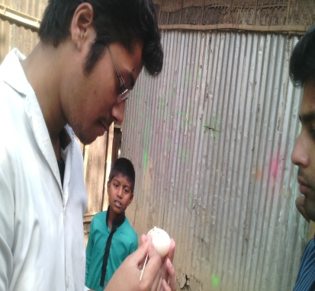
Fig 3: Collection of information to fill the questionnaire
Fig 2: Sample collected from eggshell
Fig 1: Soaking of swab before sample collection.

Table 1: Sample collected area
Name of the area | No of collected sample
Bahubal | 18
Nobigonj | 5
Chunaroghat | 5
Madhabpur | 12
Total | = 40

Table 2 : Name of the breeds from which sample are collected
Name of breed | No of collected sample
Khaki Campbell (KC) | 11
White Deshi Duck (WDD) | 10
Pati Duck(PD) | 10
Zending (Zn) | 6
Muscovy (Mus) | 3
Total | =40

3.4. Pre-enrichment of sample at nutrient broth medium
The collected sample were than subculture at nutrient broth which are prepared by dissolving 25gms powder in one litter distilled water and dissolve the medium completely by heating then sterilize it by autoclaving at 10 lbs pressure (115⁰C) or alternatively at 15 lbs pressure (121⁰C) for 15 minutes or as per validated cycle. After sterilization pH of the medium should be 7.3±0.1. Normally each litter of nutrient broth medium contains 10gms peptone, 10gms beef extract and 5gms sodium chloride. Beef extract and peptone provide the necessary nitrogen compounds, carbon, vitamins and also some trace ingredients to the non-fastidious organism and sodium chloride maintain osmotic equilibrium of the medium. After giving subculture inoculation in nutrient broth, it was incubated at 35-37°C for 24 hours.
3.5. Isolation of Salmonella
3.5.1. Isolation of Salmonella in Salmonella Shigella (SS) agar
For the isolation of Salmonella at first the subculture inoculums from nutrient broth are streaked in the Salmonella Shigella agar which is composed of lactose 10gm, bile salts 8.5gm, sodium citrate 8.5gm, sodium thiosulfate 8.5gm, beef extract 5gm, ferric citrate 1gm, brilliant green 0.33gm, neutral red 0.025gm, agar 13.5gm per liter of deionized water. The basis for differentiation on SS Agar depends on the fermentation of lactose and the absorption of neutral red as the bile salts precipitate in the acidic condition. Neutral red turns red in the presence of an acidic pH, thus showing fermentation has occurred. The inclusion of bile salts, sodium citrate, and brilliant green serve to inhibit gram-positive and coliform organisms. Salmonella, Shigella, and other non-lactose-fermenting organisms appear as transparent or translucent colorless colonies on SS Agar. Sodium thiosulfate is added to the medium as a hydrogen sulfide source, and ferric citrate is added as an indicator for hydrogen sulfide production. If lactose fermentation occurs, the medium will turn red due to the acidic pH. Salmonella, Shigella, and other non-lactose fermenters appear as transparent or translucent colorless colonies on SS Agar. Colonies of Salmonella spp. may appear with or without black centers. The suspected Salmonella colony then transferred to nutrient broth medium and incubated at 35-37°C for 24 hours.
3.5.2. Isolation of Salmonella in Brilliant Green Agar (BGA)
In the next step inoculums from nutrient broth which was inoculated with suspected Salmonella colonies again streaked in the Brilliant Green Agar (BGA) which is used for selective isolation of Salmonella spp. The medium also contains yeast extract, enzymatic digest of casein, enzymatic digest of animal tissue, NaCl, lactose, sucrose, brilliant green, phenol red and agar. The enzymatic digests provide sources of nitrogen, amino acids and carbon. The yeast extract supplies vitamins required for growth of bacteria. NaCl maintains the osmotic balance of the medium. Lactose and sucrose are the carbohydrates in the medium. Brilliant green (BG) inhibits gram-positive bacteria and most gram-negative rods other than Salmonella spp. The pH is 6.9. Phenol red is the pH indicator, which turns the yellow upon acidification due to fermentation of lactose and/or sucrose. Agar is the solidifying agent. Salmonella colonies can vary in color from red to pink-white, depending upon incubation time and strain. The agar around the colonies must be red.
3.5.3. Final identification of Salmonella through biochemical (Triple Super Iron) test
Finally the presence of Salmonella organisms in sample was confirmed by biochemical test in Triple Sugar Iron media. In Salmonella positive case the slants of the media become red, butt become yellow and gas was formed, blackish appearance may indicate the production of hydrogen sulfhide.
3.6. Isolation of E. coli
3.6.1. Isolation of E. coli in MacConkey agar
On the other hand for isolation of E. coli the initial pre-enriched nutrient broth inoculums are streaked into the MacConkey agar which is used for the isolation of gram-negative enteric bacteria and the differentiation of lactose fermenting from lactose non-fermenting gram-negative bacteria. It has also become common to use the media to differentiate bacteria by their abilities to ferment sugars other than lactose. MacConkey agar is a selective and differential media used for the isolation and differentiation of non-fastidious gram-negative rods, particularly members of the family Enterobacteriaceae. It contains Peptone 17.0gm, Lactose 10.0gm, Sodium Chloride 5.0gm, Proteose Peptone 3.0gm, Bile Salts 1.5gm, Neutral Red 30.0mg, Crystal Violet 1.0mg, Agar 13.5gm in per liter of deionized water. E. coli growing on the media is differentiated by their ability to ferment the sugar lactose. Fermentation of lactose cause the pH of the media to drop and the resultant change in pH is detected by neutral red, which is red in color at pH below 6.8. As the pH drops, neutral red is absorbed by the bacteria, which appear as bright pink to red colonies on the agar. Gram-negative bacteria that grow on MacConkey agar but do not ferment lactose appear colorless on the medium and the agar surrounding the bacteria remains relatively transparent. The suspected E. coli colonies then transferred to nutrient broth medium and incubated at 35-37°C for 24 hours.
3.6.2. Isolation & final identification of E. coli in Eosin Methylene Blue (EMB) agar
In the second and final step for confirmation of E. coli inoculums from nutrient broth contains suspected colonies of E. coli again streaked in the Eosin-Methylene Blue (EMB) composed of Enzymatic Digest of Gelatin 10g, Lactose 10g, Dipotassium Phosphate 2g, Eosin Y 0.4g, Methylene Blue 0.065g, agar 15g in per liter of deionized water. Enzymatic Digest of Gelatin is the nitrogen source Phosphate is the buffer. Eosin Y and Methylene Blue are the indicators. Methylene Blue is also a selective agent. During strong acidic conditions, the dyes impart a metallic sheen to certain lactose fermenters. The E. coli positive cases are confirmed by good growth of dark blue-black colonies with metallic green sheen indicating vigorous fermentation of lactose and acid production which precipitates the green metallic pigment.

Chapter IV - Results & Discussion
4.1. Proportion of Salmonella positive case
Proportions of Salmonella positive case according to the different explanatory variables are shown in Table 3. And graph 1.
Variables |  | Positive (%)
Area | Bahubal | 11
 | Nobigonj | 20
 | Chunaroghat | 00
 | Madhabpur | 00
Breed | Khaki Campbell | 09
 | White Deshi Duck | 00
 | Pati Duck | 20
 | Zending | 00
 | Muscovy | 00
Diseased | Yes | 20
 | No | 03
Vaccination | Yes | 00
 | No | 14
Vaccination
Diseased
Area
Breed
Graph 1: Proportion of Salmonella according to different variables

Table 3: Percentage of Salmonella according to different variables

The overall prevalence of Salmonella infection during the study period was estimated to be 7.5%. Prevalence of Salmonella infection in Khaki Campbell ducks was 9% where it is 20% in the Pati ducks (Spot-Billed). Between the five areas from where the sample was collected positive sample was belongs to only from two areas. Among this, the proportion of positive ducks was 11% in Bahubal and 20% in Nobigonj. No Salmonella infection was found in the sample from other three areas. Proportion of Salmonella positive ducks varied remarkably according to the disease status. Among the diseased ducks the proportion of Salmonella positive case were 20% where it is only 3% in the ducks which don’t have any diseases. Also vaccination shows wonderful effect, that no positive cases were found in the vaccinated ducks, where it is 14% in the non-vaccinated. Box plots (Figure 4) is portrayed with the median,minimum,maximum,25th and 75th percentile values of age between two groups of ducks ( Salmonella positive and negative) found that the median age of Salmonella positive ducks was little high than the age of Salmonella negative ducks.
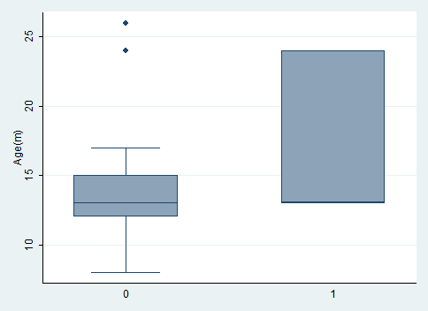
Sal (+)
Sal (-)
Fig: Box plot showing the median, minimum, maximum, 25th and 75th percentile values of age among Salmonella positive and negative ducks

Variables | Category | Number of observation (n) | Salmonella positive (n) (%) | Chi square value | P-value
Area | Bahubal | 18 | 2 (11) | 2.84 | 0.416
 | Nobigonj | 5 | 1 (20)
 | Chunaroghat | 5 | 0 (0)
 | Madhabpur | 12 | 0 (0)
Breed | Khaki Campbell | 11 | 1 (9) | 3.83 | 0.429
 | White Deshi Duck | 10 | 0 (0)
 | Pati Duck | 10 | 2 (20)
 | Zending | 3 | 0 (0)
 | Muscovy | 6 | 0 (0)
Diseased | Yes | 10 | 2 (20) | 3.00 | 0.085
 | No | 30 | 1 (3)
Vaccination | Yes | 19 | 0 (0) | 2.93 | 0.046
 | No | 21 | 3 (14)
Values at P< 0.05 are statistically significant
Table 4: Association of different categorical variables with Salmonella occurrences in ducks under the investigation.
The prevalence of Salmonella infection was not evenly distributed in all breeds of ducks (P=0.429). Its occurrence was proportionately but not significantly higher in Nobigonj (P=0.416). The rate of Salmonella infection in non-vaccinated ducks was 14% significantly higher compared with the vaccinated ones. Diseased ducks also shows proportionately higher rate of infection than non-diseased.

4.2. Proportion of E. coli positive case
Proportions of E. coli positive case according to the different explanatory variables are shown in Table 5. And graph 2.
Variables |  |  |  | Positive(%)
Area | Bahubal |  |  | 44
 | Nobigonj |  |  | 00
 | Chunaroghat |  |  | 20
 | Madhabpur |  |  | 33
Breed | Khaki Campbell |  |  | 27
 | White Deshi Duck |  |  | 30
 | Pati Duck |  |  | 40
 | Zending |  |  | 33
 | Muscovy |  |  | 33
Diseased | Yes |  |  | 50
 | No |  |  | 27
Vaccination | Yes |  |  | 21
 | No |  |  | 43
Table 5: Percentage of E. coli infection according to different variables
Graph 2: Proportion of E. coli infection according to different variables

Vac...
Diseased
Area
Breed

In case of E. coli infection here find a different scenario. Overall Prevalence of E. coli infection in ducks is 33% which rate is higher than the Salmonella infection. In case of areal distribution highest proportion was 44% in Bahubal. On the other hand 20% and 33% were recorded in the Chunaroghat and Madhabpur. No E. coli infected cases were identified in the Nobigonj region. As like as salmonella, most E. coli cases were identified in case of Pati ducks (Spot-billed) which is 40%. The prevalence in case of Khaki Campbell, White Deshi Duck, Zending and Muscovy were 27%, 30%.33% and 33% respectively. The proportions of E. coli infection in diseased ducks were 50% and 27% in the non diseased. In case of E. coli infection vaccination also shows a marked effect. Twenty one percent sample having infection after vaccination where 43% infection found in unvaccinated case. Box plots (Figure 5) is presented with the median,minimum,maximum,25th and 75th percentile values of age between two groups of ducks ( E. coli positive and negative) found that the median age of E. coli positive ducks little high than the age of E. coli negative ducks.
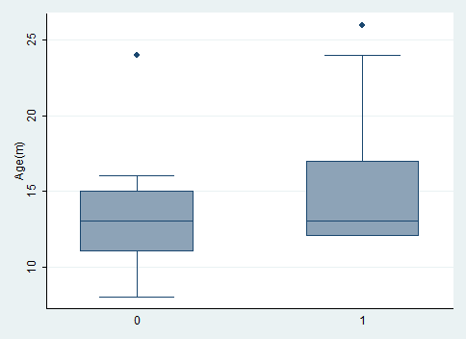
Fig: Box plot showing the median, minimum, maximum, 25th and 75th percentile values of age among E. coli positive and negative ducks

E. coli (+)
E. coli (-)

Variables | Category | Number of observation (n) | Salmonella positive (n) (%) | Chi square value | P-value
Area | Bahubal | 18 | 8 (44) | 3.93 | 0.268
 | Nobigonj | 5 | 5 (0)
 | Chunaroghat | 5 | 1 (20)
 | Madhabpur | 12 | 4 (33)
Breed | Khaki Campbell | 11 | 3 (27) | 0.4248 | 0.980
 | White Deshi Duck | 10 | 3 (30)
 | Pati Duck | 10 | 4 (40)
 | Zending | 3 | 1 (33)
 | Muscovy | 6 | 2 (33)
Diseased | Yes | 10 | 5 (50) | 1.86 | 0.172
 | No | 30 | 8 (27)
Vaccination | Yes | 19 | 4 (21) | 2.1618 | 0.141
 | No | 21 | 9 (43)
Values at P< 0.05 are statistically significant
Table 6: Association of different categorical variables with E. coli occurrences in ducks under the investigation.
As like as Salmonella prevalence of E. coli also not evenly distributed in all breeds; the rate is proportionately but not significantly higher in the Pati ducks (Spot-billed). E. coli infection more or less eventually distributed in the all areas from where samples were collected except Nobigonj (P=0.268). E. coli infection rate is also higher in diseased and non-vaccinated compared to the non-diseased and vaccinated but it was not significant (P=0.172) & (P=0.141).
4.3. Discussion
In our study it revealed that freshly laid duck eggs are contaminated with E. coli and Salmonella. The percentage of contamination with E coli is much higher than Salmonella. Salmonella is a vertical disease where E coli is an intestinal bacteria which may contaminate the egg during laying. In our study it is not evident the source of Salmonella whether it is from ovary or during laying. In the present study overall prevalence of Salmonella which was isolated from the duck eggshells is 7.5% which is very much similar to the results (6.1%) of T. Suresh et al. In many study prevalence levels were reported to be varying from zero (Mawer et al., 1989) to7 %( Humphrey, 1994a,b, Evans et al. ). The prevalence level in the present investigation is slightly higher than these observations. But in the case of commercial layer hen eggs around 20% of eggshells were contaminated with Salmonella which is much higher than the present observation. The incidence levels of Salmonella in eggshell reported earlier were variable. Singh, Yadava, Singh and Bharti6. The proportion of Salmonella infection in diseased and non-vaccinated ducks are much higher than the non-diseased and vaccinated ducks, also mention in the (Harsha HT et al. 2011) that Salmonella positive sample from eggshell is a case of horizontal transmission of the organism it was also reported that contamination of eggshell may also occur due to infection. The variation of proportion of Salmonella infection due to breed variation is a significant finding of present study. Among the five breeds of ducks from which sample were collected Pati duck shows the higher infection rate.
On the other hand E. coli infection is common in all poultry species, it also frequently found in the duck eggshell surface. D. Stępień-Pyśniak also stated that E. coli was the bacterium most often isolated, mainly from the shells of egg. Present study shows a prevalence of 32.5% which is much higher than the Salmonella prevalence rate, D. Stępień-Pyśniak was find 15.9% of E. -coli from the eggshells but it was 58.7% in the stored egg Adesiyun et al., (2005). There are no. of factor related with the increased E. coli prevalence rate in eggshell like storage condition, environment, housing system and others. In case of E. coli infection there also a marked effect of disease and vaccination. Vaccinated ducks have 22% less infection rate than the non-vaccinated and diseased ducks have 23% more infection rate than those ducks which don’t have any diseases. Likely to the Salmonella infection Pati ducks also received high degree of E. coli infection. In both Salmonella and E. coli positive cases the age of the duck is little higher than the negative cases.

Chapter V - Conclusion
The present study revealed that in vaccinated flock the contamination by both these organism are much lower than non-vaccinated flock. People used government supplied vaccine duck plague and duck cholera. It might be in vaccinated flock the birds remain healthy and there is less excretion of intestinal organism and in non vaccinated flock the birds are more susceptible to infection which leads to more excretion rate in their droppings.

References

Baker R. C, R. A. Qureshi, T. S. Sandhu, J. F. Timmoney, January 26, 1984. The Frequency of Salmonellae on Duck Eggs. Poultry Science 64:646-652.

Baker, R. C, J. P. Goff, and E. J. Mulnix, 1980. Salmonellae recovery following oral and intravenous inoculation of laying hens. Poultry Sci. 59:1067-1072.

Baker, R. C, J. P. Goff, and J. F. Timoney, 1980. Prevalence of salmonellae on eggs from poultry farms in New York State. Poultry Sci. 59: 289-292.

Bailey, J. S., N. A. Cox, and J. E. Thomson, 1981. Efficiency of selenite cystine and TT enrichment broths for the detection of salmonella. J. Appl. Bacteriol. 51:409-414.

Bisgaard, M., 1981. Arthritis in ducks. 1. Aetiology and public health aspects. Avian Pathol. 10: 11-21.

Cox, N. A., J. S. Bailey, J. E. Thomson, and M. O. Carson, 1980. Lactose preenrichment vs. direct

Moats, W. A., 1979. The effect of washing eggs under commercial conditions on bacterial loads of eggshells. Poultry Sci. 58:1228-1233.

Moats, W. W., 1978. A comparison of four plating media with and without added novobiocin for isolation of salmonellae. Appl. Environ. Microbiol.36:747-751.

Trongpanich, K., and L. E. Dawson, 1974. Quality and acceptability of brine pickled duck eggs. Poultry Sci. 53:1129-1133.

ISO 6579 :1993(E) 3rd ed. Microbiology - General guidance on methods for the detection of
Salmonella.

ISO 16654 :2001. 1st ed. Microbiology – Horizontal method for the detection of Escherichia coli O157, International Organization for Standardization, Geneve, Switzerland..

Akhtar, F., H. Afzal, M. Ashfaque and Z. Nasim, 1982.Egg-shell contaminations of human importance with reference to Salmonellae. J. Pak. Vet., 2: 10-11.

Alma, S., 1995. Livestock resources in Bangladesh Present Status and Future Potentials. The University Press Limited, 1st Edition, PP: 2-7, 24-29.

Knape K. D, C. Chavez, R. P. Burgess, C. D. Coufal, and J. B. Carey 2002. Comparison of Eggshell Surface Microbial Populations for In-Line and Off-Line Commercial Egg Processing Facilities. Poultry Science 81:695–698.
Martini E, K. A. Peter, 2010. Quantification and Identification of Culturable Airborne Bacteria from Duck Houses. Ann. Occup. Hyg, Vol. 54, No. 2, pp. 217–227.

Chalmers WSK, Kewley DR. (1985) Bacterial flora of clinically normal conjunctivae in the domestic duckling. Avian Pathol; 14: 69–74.

Harsha HT1, Reshmi R1, Rinoy Varghese1, Divya PS2, Mujeeb Rahiman KM2, Mohamed Hatha AA2,2011. Prevalence and antibiotic resistance of Salmonella from the eggs of commercial samples. December 2011 Journal of Microbiology and Infectious Diseases. 1 (3): 93-100 JMID doi: 10.5799/ahinjs.02.2011.03.0023.

Gupta BR, Verma JC. Prevalence of Salmonella from avian sources. Ind. J. Comp. Microbiol. Immunol. Infect. Dis. 1989; 11:169-174.

Singh S, Yadava AS, Singh SM, Bharti P. Prevalence of Salmonella in chicken eggs collected from poultry farms and marketing channels and their antimicrobial resistance. Food Res Int 2010;43:2027-2030.

Suresh T, Srinivasan D, HathaAAM, Lakshmanaperumalsamy P. A study on the incidence, antimicrobial resistance and survival of Salmonella and E. coli isolated from broiler chicken retail outlets. Microbes and Environ 2000;15:173-181.

Garrod LP, Mcllroy MB. Outbreak of enteritis due to duck eggs. Br Med J 1949;2: 1259-1261.

Suresha T, A.A.M. Hathab, D. Sreenivasanc, Nathan Sangeethac, P. Lashmanaperumalsamya, 2005. Prevalence and antimicrobial resistance of Salmonella enteritidis andother salmonellas in the eggs and egg-storing trays from retails markets of Coimbatore.

Baker, R.C., 1990. Survival of S. Enteritidis on and in shelled eggs, liquid eggs and cooked egg products. Dairy, Food Environ. Sanit. 10, 273–275.

Humphrey, T.J., 1994. Contamination of eggs with potential human pathogens. In: Board, R.G., Fuller, R. (Eds.), Microbiology of the Avian Egg. Chapman & Hall, London, pp. 93–116.

Feachem, R., 1974. Faecal coliforms and faecal streptococci in streams in the New Guinea High Islands. Water Res. 8, 367–374.

Mawer, S.L., Spain, G.E., Rowe, B., 1989. S. Enteritidis phage type 4 and hens eggs. Lancet I, 280–291.

Picture Gallery………
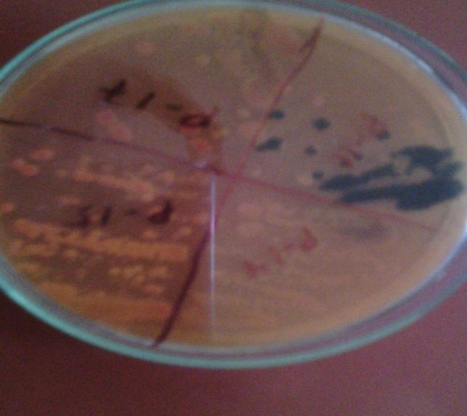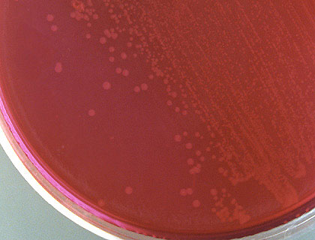
Fig: Salmonella on BGA agar

Fig: Salmonella on SS agar

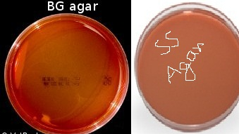
Fig : SS & BGA agar
Fig: MacConkey & EMB
Fig: Salmonella on TSI

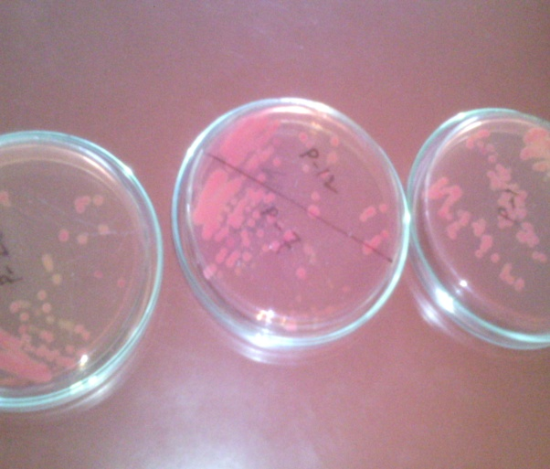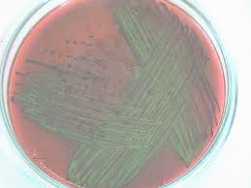
Fig: E. coli on MacConkey agar
Fig: E. coli on EMB agar

Annex
(The Questionnaire format for collection of data)
Collection of Bacteria From Shell Surface of Egg In Backyard Duck Farming
Date:
Collective Information
- Name of the Place?
Ans:
- Number of duck(s) rear?
Ans:
- Name of the breed (s) rear?
Ans:
- Feeding system of duck(s)?
Ans:
- Types of feed available?
Ans:
- Rearing system of duck(s)?
Ans:
Individual Information
- Age of the duck?
Ans:
- Number of eggs lay per week?
Ans:
- Number of eggs lay per month?
Ans:
- Any vaccine(s) given?
Ans:
- Name of vaccine(s)?
Ans:
- Is it suffering from any disease(s)?
Ans:
- Name of the disease(s)?
Ans:
- How much type time elapsed after laying upto sample collection?
Ans:

Biography
Pranab Paul is an intern at Chittagong Veterinary and Animal Sciences University (CVASU), originally from Madhabpur, Hobigonj. By this December he will receive his Doctor of Veterinary Medicine (DVM) degree with lots of real life experience. He finished his primary, secondary and higher secondary education from school of Sylhet and Comilla boards and belonged to the top 10 students of his class. He has more interest on theriogenology, microbiology, and epidemiological field area. He is a well rounded individual who lives with passion, dedication, and grace.

