Abstract

Reproductive disease is a generic term that refers to all diseases which affect the organs of reproductive system in animals. It occurs in cattle buffalo, sheep, goat, horse etc and causes heavy economic loss by reducing the reproductive activity of the animal along with calf mortality. The study was undertaken to know the proportionate prevalence of reproductive cases in cattle and buffalo in Veterinary College and Research Institute, Namakkal and Madras Veterinary College, Tamilnadu, India .The duration of the study was 1.5 months and total 286 of different cases were registered during the study period. Both retrospective and prospective reproductive cases were included in this study The proportionate prevalence of different reproductive cases were respectively 5.2% and 8.8% dystocia;4.6% and 5.3% respectively retained placenta; 3.5% and 7.9% abortion respectively; 2.9% and 2.7% cyst respectively in VCRI and MVC. Reproductive cases were more frequently occurred in cross-breeds. Older animals (42.1-87.5) % with higher parity (31-87.5) % was susceptible to reproductive cases. Antibiotics and hormonal drugs were used for the treatment of reproductive cases. Most of the reproductive cases were corrected manually where the complicated cases were performed by caesarean operation.

Key words: Reproductive disease, parity, services, management.

Chapter 1: Introduction
Reproductive diseases and disorders are frequently occurred in livestock in subcontinent and cause significant economic losses (Obese et al., 2013). Common reproductive cases are dystocia, retained placenta, abortion, ovarian cyst etc. Dystocia comes from a Greek word "Dys" meaning "difficult," and "Tokos" meaning "childbirth. When the first or especially the second stage of parturition is markedly prolonged or becomes difficult for the dam to deliver without intervention, the condition is termed as dystocia (Roberts, 2004). Retained placenta is a complication of dystocia which is defined as failure to expel fetal membranes within 24 hours after parturition. (Robert and Gilbert, 2014) Abortion in dairy cattle is commonly occured as a loss of the fetus between the age of 42 days and 260 days (Hovingh, 2009). Common causes of abortion includes infectious diseases such as brucellosis, genetic abnormalities, heat stress, toxic agents and ergot alkaloids (Hovingh, 2009; Ahmed, 2015). Cyst associated with ovary and surrounding structures are common which may be congenital or acquired and causes infertility of animal (Kesler and Garve, 1982).
Many previous studies reported that the incidence of dystocia is 6.9% in cattle (Gaafar et al., 2011); (Robert and Gilbert, 2014) and buffaloes (0.70-6.3) % in buffaloes (Buffalopedia, 2015).
Causes associated with the occurrence of dystocia are uterine inertia, ruptured uterus, insufficient pain, ruptured diaphragm, perforated trachea and insufficient dilatation of birth canal (Phogat et al., 1992); (Biggs and Osborne, 2003).
Risk factors involved with dystocia includes age of first calving, debility, cross breed, concentrate diet, diseases such as Leptospirosis, Brucellosis, schistosomiosis, mummificationof fetus, artificial insemination, prolonged gestation period etc (Sloss and Duftv, 1980);( Zaborski et al., 2009).
The consequences of dystocia develop vaginal prolapsed, uterine inertia, vaginal rupture, pyometra, retained placenta and endometritis (Phogat et al.,1992); (Biggs et al., 2003);(Rajala and Grohn, 1998).

The present study was conducted at Teaching Veterinary Hospitals (Veterinary College and Research Institute, Namakkal and Madras Veterinary College, Chennai). These two Veterinary Hospitals are well recognized hospitals for animal health care in India. Both pet and large animals are properly treated. The Madras Veterinary College Hospital has more than 100 years experience of animal health service history. These two veterinary hospitals play vital role to the economy of India.

Around 286 clinical cases of multiple species were handled during 1.5 months internship period at Veterinary Hospitals of VCRI and MVC in India. However this clinical report focused on reproductive cases in large ruminants with the following set objectives:

- To estimate the proportionate prevalence of reproductive clinical cases in cattle and buffaloes
- To know the clinical features of dystocia and its complications in cows and buffaloes
- To describe the management of dystocia in cows and buffaloes

Chapter 2: Materials and Methods

One and half month clinical study (May-July 2015) was carried out on reproductive and other clinical cases in cattle and buffaloes at Teaching Veterinary Hospital of VCRI, Namakkal and of MVC, Chennai, India. Each case was undergone clinical and physical examination. In some cases clinical diagnosis was performed by specialized diagnostic techniques such as ultransnography for ovarian cyst, hormone assay for pregnancy diagnosis and heat detection etc. Species, breed, age, no. of parity, body condition score and services were recorded for each case using internship log book. Close inspection and farmer’s interview were done for recording information and clinical diagnosis of cases.

Age was determined according to dentition, observing horn ring, and by interviewing to farmers. Breed was defined according to phenotypic characteristics of animal. Body condition score was assessed as per description of Nicholson and Butterworth (1986). Abortion is defined as when a pregnancy ends abruptly, either voluntarily or involuntarily, and the fetus is expelled from the womb before it can live on its own (Hovingh, 2009). Retained placenta is confirmed by failure to expel fetal membranes within 24 hours after parturition (Robert and Gilbert, 2014). Ovarian cyst was diagnosed by rectal palpation (Kesler and Garverick, 1982). On ultransnography ovarian cysts are follicular structures having a diameter of at least 2.5 centimeters (about 1 inch) that persist for 10 or more days on the ovaries in the absence of a functional corpus luteum.

Before handling reproductive cases (particularly dystocia) position of the fetus in the birth canal of the animal was determined. Rope, hook, snare, distortion pit etc. were used for manual removal of fetus. Cases were corrected as per approved methods (Agarwal and Tomer, 1998); (Narayan et al., 2011).

Types of treatment, intervention and types of drugs used for each case were also recorded.

Data obtained were entered into Microsoft Excel 2007 and exported to STATA (Stata Crop, 4905, Lakeway River, College Station, Taxas 77845, USA) for analysis. Descriptive statistics were performed. Proportionate prevalence of each reproductive case was calculated by a total number of particular reproductive events divided by the total number of clinical cases. Results were expressed as frequency number and percentage against each category of variable.

Chapter 3: Results

3.1. Proportionate prevalence of reproductive and other clinical cases

Regardless of species, the proportionate prevalence of different reproductive cases was respectively 5.2% and 8.8% dystocia in VCRI and MVC; 4.6% and 5.3% respectively retained placenta in VCRI and MVC; 3.5% and 7.9% abortion respectively in VCRI and MVC; 2.9% and 2.7% cyst respectively in VCRI and MVC (Table 1).

Table 1. Proportionate prevalence of reproductive and other clinical cases in VCRI and MVC, India
Diseases or Disorders | VCRI, Namakkal |  | MVC, Chennai
 | N | % | N | %
Dystocia | 9 | 5.2 | 10 | 8.8
Retained placenta | 8 | 4.6 | 6 | 5.3
Abortion | 6 | 3.5 | 9 | 7.9
Ovarian cyst | 5 | 2.9 | 3 | 2.7
Foot and Mouth Disease | 14 | 8.1 | 12 | 10.5
Mastitis | 8 | 4.7 | 11 | 9.6
Black Quarter | 3 | 1.7 | 1 | 0.9
Tetanus | 6 | 3.5 | 2 | 1.8
Pneumonia | 5 | 2.9 | 2 | 1.8
Fungal infection | 6 | 3.5 | 5 | 4.4
Babesiosis | 4 | 2.3 | 2 | 1.8
Endoparasitic infestation | 45 | 26.2 | 12 | 10.5
Ectoparisitic infestation | 18 | 10.2 | 9 | 7.9
Cornial opacity | 1 | 0.6 | 2 | 1.8
Conjunctivitis | 0 | 0 | 1 | 0.9
Acidosis | 14 | 8.3 | 13 | 11.4
General weakness | 20 | 11.6 | 14 | 12.3
Total | 172 |  | 114
VCRI: Veterinary College and Research Institute; MVC: Madras Veterinary College.
3.2. Distribution of reproductive cases by species and breed

Reproductive cases were more frequently occurred in cross-breed than in local breed in both species (Table2).

The proportionate prevalence of reproductive cases was 12.5 – 57.9% in young and 42.1-87.5% in older animals; 12.5-68.4% during the first parity and 31.6- 87.5% during the second and subsequent parities; 22.2-75% in normal body condition score and 25-77.8% in poor body condition score; 22.2-37.5% in natural services and 62.5-77.8% in artificial insemination (Table 3).

Table 2. Frequency distribution of reproductive cases in cows and buffaloes at Teaching Veterinary Hospital in India

Cases | VCRI, Namakkal |  |  |  | N | MVC, Chennai |  |  |  | N
 | Cows |  | Buffaloes |  |  | Cows |  | Buffaloes
 | Local | Cross | Local | Cross |  | Local | Cross | Local | Cross
Dystocia | 2 | 4 | 2 | 1 | 9 | 3 | 6 | 1 | 0 | 10
Retained placenta | 3 | 4 | 1 | 0 | 8 | 1 | 4 | 1 | 0 | 6
Abortion | 2 | 4 | 0 | 0 | 6 | 0 | 3 | 0 | 0 | 3
Ovarian cyst | 1 | 4 | 0 | 0 | 5 | 1 | 2 | 0 | 0 | 3
Total | 8 | 16 | 3 | 1 | 28 | 5 | 15 | 2 | 0 | 22

Table 3. Distribution of reproductive cases by types and different factors

Factor | Category | Dystocia |  | Retained placenta |  | Abortion |  | Ovarian cyst
 |  | N | % | N | % | N | % | N | %
Age (year) | ≤3 | 11 | 57.9 | 7 | 50 | 4 | 44.4 | 1 | 12.5
 | >3 | 8 | 42.1 | 7 | 50 | 5 | 55.6 | 7 | 87.5
Parity | First | 13 | 68.4 | 6 | 42.9 | 5 | 55.6 | 1 | 12.5
 | Second and subsequent | 6 | 31.6 | 8 | 57.1 | 4 | 44.4 | 7 | 87. 5
BCS | 3 | 14 | 73.4 | 5 | 34.7 | 2 | 22.2 | 6 | 75
 | ≤3 | 5 | 26.3 | 9 | 64.3 | 7 | 77.8 | 2 | 25
Service | Natural | 5 | 26.3 | 4 | 28.6 | 2 | 22.2 | 3 | 37.5
 | Artificial Insemination | 14 | 73.7 | 10 | 71.4 | 7 | 77.8 | 5 | 62.5
BCS=Body Condition Score

3.3. Treatment and Management of different reproductive cases.

Manual intervention with hormonal drugs was applied for 13 dystocial cases whereas surgical intervention was performed for 6 dystocial cases. After intervention 5% normal saline, Oxytetracycline @ 10 mg/kg body weight and vitamin AD3E were given for all cases.
Retained placenta was removed manually for all cases with oxytocin@ 20 mg/kg body weight used for same cases. After removal antibiotic –oxytetracycline @ 10 mg/kg body weight and vitamin were given.
Aborted cases were treated with antibiotics- oxytetracycline @ 10mg/kg body weight and vitamin
Cases of ovarian cyst were detected manually and GnRH@ 1500 mg/kg body weight and vitamin were given afterwards.

Table 4. Treatment and management of reproductive cases at Teaching Veterinary Hospital in India.

Treatment | Dystocia | Retained placenta | Abortion | Ovarian cyst
Mannual | 13 | 14 | 09 | 08
Surgery | 6 | 0 | 0 | 0
Drugs given | 5% Normal saline i/vly,oxytetracycline@ 10mg/kgbwt i/mly,vitamin | Oxytocin@20IU/Kg bwt,i/mly,i/vly. oxytetracycline@10mg/kgbwt i/mly  ,vitamin | oxytetracycline@10mg/kgbwt i/mly,  Vitamin. | GnRH@1500IU/kgbwt i/mly or i/vly.  vitamin

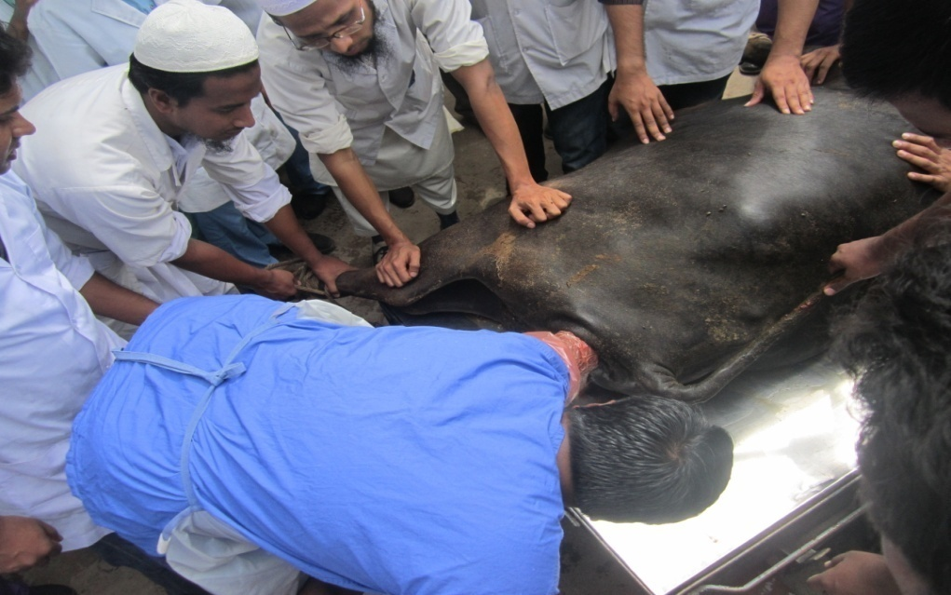

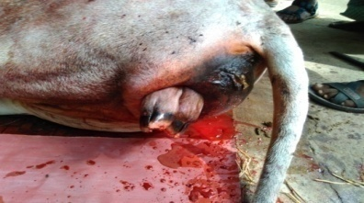 | 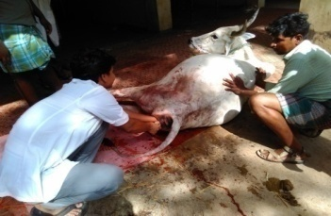
Figure1.1. Protrusion of fetal fore limb | Figure1.2. Pervaginal examination of animal.

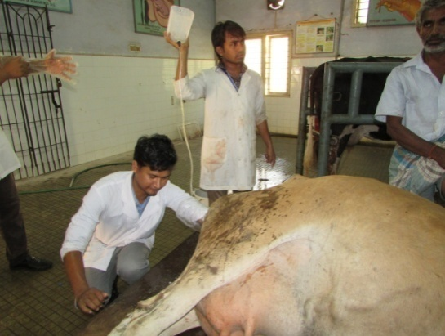
 | 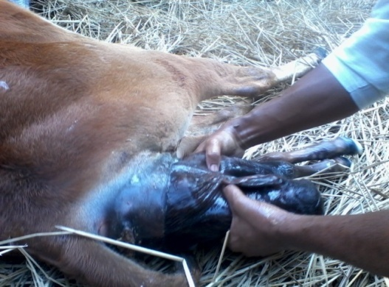
Figure1.3. Examination of fetal position | Figure1.4. Manually traction of fetus

Figure 1. Different images of correction of dystocia in a cow

 | 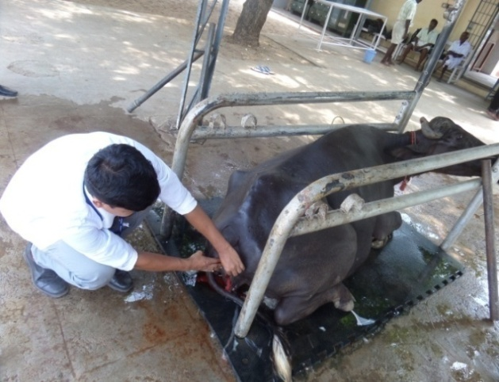
Figure 2.1. Animal on distortion pit | Figure 2.2. After correction of uterine torsion

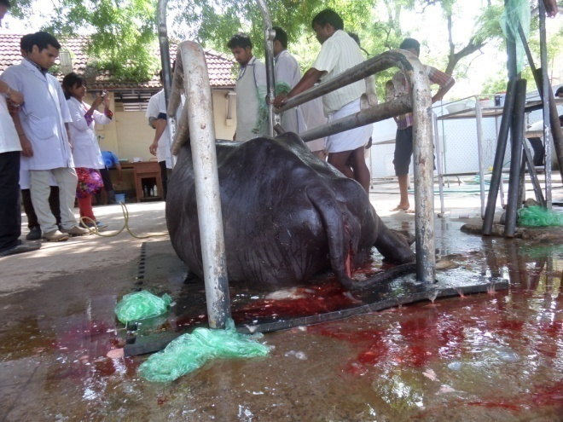 | 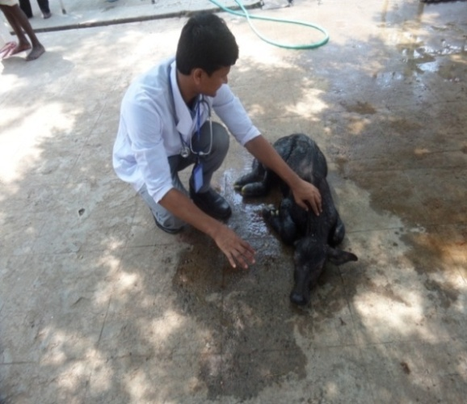
Figure 2.3. Animal after delivery | Figure 2.4. Care of new born calf

Figure 2. Different images of correction of dystocia in a buffalo

Chapter 4: Discussion

Reproductive cases are more frequently occurred in cows and buffaloes and causes heavy loses to the animals. The overall proportionate prevalence of dystocia; retained placenta; abortion and ovarian cyst in this study corresponds to earlier studies (Kesler and Garverick, 1982); (Gaafar et al., 2011); (Robert et al., 2014).

This study showed that the occurrence of reproductive cases commonly occurred in cross breeds (31.6-87.5) % which is supported by Ahmed, (1984); (Khair et al., 2013); (Esheti and Moges , 2014).The proportionate prevalence of reproductive cases in older animals (42.1-87.5) % with higher parity (31-87.5) % was higher in this study, is agreed with many studies (Gröhn et al., 1990); (Kaikini et al., 1983).

Animals with artificial insemination were more susceptible to reproductive cases in the previous study which is coincided with the result of (Boettcher and Perera, 2007); (Eaglesome and Garcia, 2008).

Most of the reproductive cases were corrected manually where the complicated cases were corrected by caesarean operation.
Either erythromycin or oxytetracycline along with other hormonal drugs were used for dystocia, retained placenta, abortion in this study which is supported other studies (Bartolome et al.,2005); (Braw-Tal et al., 2009); (Casida et al.,1944); (Kesler and Garverick, 1998). Erythromycin or oxytetracline was used to prevent secondary bacterial infection. Intravenous infusion of 5% normal saline to rehydrate the animal. Calcium therapy for contraction of muscle. Vitamin were given for proper growth and maturation of endometrial cells. Oxytocin was administered to increase uterine contraction so that the uterine debris come out quickly. Gonodotropin Releasing Hormone (GnRH) was applied for the treatment of ovarian cyst. These treatment rationale is supported by many studies (Bartolome et al., 2005); (Braw-Tal et al., 2009); (Bierschwal et al., 1975); (Kesler and Garverick, 1982); (Nanda et al., 1991); (Seguin et al., 1976).

Limitations
The number of clinical reproductive cases in this study was not big enough. Inclusion of retrospective reproductive cases was also a limitation as information of retrospective cases was not as accurate as prospective cases. The diagnosis of reproductive cases was based on clinical history, clinical signs.

Conclusion
Dystocia was higher in heifers than adult cattle and buffaloes. Older animals with higher parity were commonly affected with the reproductive diseases. Cross breeds were more prone to reproductive cases. Artificial insemination and poor body condition score leads to reproductive disorders. Dystocia, abortion and ovarian cyst causes heavy damage to the reproductive system and reduces the reproductive activity. Most commonly used drugs for reproductive cases were antibiotics, NSAID, oxytocin, GnRH and vitamins. Most of the dystocial cases were corrected manually.

References

Agarwal, S K. and Tomer, O S. 1998. Reproductive technologies in buffalo, Indian vet. J., 10: 342 – 351.
Ahmed, J.U. 1984. An abattoir survey of female reproductive disorders in cattle of in Sweden, Bangladesh Vet.J., 18: 55-58.
Bartolome, J. A., W. W. Thatcher, P. Melendez, C. A. Risco, and L. F. Archbald. 2005. Strategies for the diagnosis and treatment of ovarian cysts in dairy cattle, J. Ani. Sci., 277: 1409-1414.
Bierschwal, C.J., Garverick, H.A., Martin, C.E., Youngquist, R.S., Brown, M.D. 1975. Clinical response of dairy cows with ovarian cysts to GnRH, J. Ani. Sci., 42; 1660-1665.
Biggs, A. and Osborne, R. 2003. Uterine prolapsed and mid pregnancy uterine torsion in cows, Vet. Rec. 152: 91-92.
Braw-Tal, R., S. Pen, and Z. Roth. 2009. Ovarian cysts in high-yielding dairy cows, Vet. J., 72: 690-698.
Buffalopedia belongs to Central Institute for Research on Buffaloes, Indian Council of Agricultural Research.2015. Dystocia. http://www.buffalopedia.cirb.res.in/index.php?option=com_content&view=art icle&id=287&Itemid=210&lang=en.
Casida, L.E., McShan,W.H., Meyer, R.K. 1944. Effect of unfractioned pituitary extract upon cystic ovaries and nymphomania in cows, J. Ani. Reprod., 3: 273-282.
Eaglesom, M.D. and Garcia, M.M. 2008. Disease risks to animal health from artificial insemination with bovine semen, Vet. J., 16: 215-225.
Esheti,G. and Moges, N. 2014. Major reproductive health disorders in cross breed dairy cows in Ethiopia, Glob.Vete., 13: 444-449.
Fraser, C.M., Bergeron, A., Mays, A. 1991. The Merck Veterinary Manual, 7th edition, Part 1: 334-339.
Gaafar, HM., Shamiah, ShM., Hamd, MA., Shitta, AA. 2011 .Dystocia in Friesian cows and its effects on postpartum reproductive performance and milk production, Trop. Anim. Hlth. Prod., 43:229-234. .
Gröhn, Y.T., Erb HN, McCulloch, C.E., Saloniemi, H.S. 1990. Epidemiology of reproductive disorders in dairy cattle: associations among host characteristics, disease and production, Prev.Vet. Medi., 8: 25-39.
Hovingh, E. 2009. Abortion in dairy cattle, J. Ani. reprod., 7: 112-129.
Kaikini, A.S., Chikalikar, G.K. and Dindorkar, C.V . 1983. Reproductive disorders in Holstein-Friesian x Gir F1 crossbred cows, Indian J. Ani. Sci., 53: 556-558.
Kesler, D. J. and Garverick, H. A. 1982. Ovarian cysts in dairy cattle, J. Ani. Sci., 55: 1147-1159.
Khair, A., Alam, M.M., Rahm, A.K., Islam, A.A., Azim and Chowdhury. 2013. Incidence of reproductive and production diseases of cross bred dairy cattle in Bangladesh, Bangladesh. J., 11: 31-36
Robert O. Gilbert. 2014. Retained fetal membranes in large animal, J,Vet. reprod., 34:312-322.
Nanda, A.S.,Ward, W.R., Dobson, H. 1991.Lack of LH response to oestradiol treatment in cows with cystic ovarian disease and effect of progesterone treatment or manual rupture, Vet,J.,51:180-184.
Narayan, G., Yogesh, P.B., Barolia., Kumar,P 2011. Maternal dystocia in cows and buffaloes, Vet. Rec., 1:41-53.
Nicholson and Butterworth, M. H. 1986. A guide to condition scoring of zebu cattle, J. Ani. Sci., 29: 1-15.
Obese, F.A., Acheampong, D.A., Darfur, K.A., 2013. Growth and reproductive traits of friesian x sanga crossbred cattle in the accra plains of Ghana, Vet. Rec., 3:7357-7371.
Phogat, J. B, Bugalia, N. S. and Gupta S. L. 1992. Incidence and treatment of various forms of dystocia in buffaloes, Indian J. Ani. Reprod. 13: 69-70.
Rajala, P. J and Gröhn, Y. T. 1998. Effects of dystocia, retained placenta, and metritis on milk yield in dairy cows, J. Dai Sci., 81:3172-3181.
Roberts S. J. 2004. Veterinary obstetrics and genital diseases, 2nd edition. P-227.
Seguin, B.E., Convey, E.M., Oxender, W.D. 1976. Effect of gonodotropin releasing hormone and human chorionic gonadotropin on cows with ovarian follicular cysts, Vet. Reprod. J., 37:383-387.
Singh, P. and Nanda, A. S. 1996. Treatment of uterine torsion in buffaloes.Modification of Schaffer’s method, Indian J. Ani. Reprod., 17: 33-34
Sloss, V. A. and Duftv, J.H. 1980. Handbook of Bovine Obstetrics, 4th. edition 12:122-129.
Zaborski, D., Grzesiak, W., Szatkowska 2009. Factors affecting dystocia in cattle, J. Vet. Reprod., 44: 540-551.

Acknowledgements
The author wishes to acknowledge the immeasurable grace and profound kindness of Almighty “Allah” the supreme authority and supreme ruler of universe, who empowers the author to complete the work successfully.

The author feels proud in expressing his deep sense of great gratitude and indebtedness to respected teacher and tutor Prof. Dr. Md. Ahasanul Hoque, Dean, Faculty of Veterinary Medicine, Chittagong Veterinary and Animal Sciences University for his trustworthy and scholastic supervision.

The author would like to give special thanks to Dr. A K M Saifuddin, Director, External Affairs, CVASU for his valuable advice and constant inspiration.

The author like to express his heartfelt appreciation and thanks to Dr. K Ravikumar, Assistant professor, Department of Clinics, Veterinary College and Research Institute, Namakkal, India for his kind cooperation during the study period.

The author also like to give thanks to Dr. S. Balasubramanian, Professor, Department of Animal Reproduction, Gynaecology and Obstretics. Madras Veterinary College, Chennai, India for his kind cooperation during the study period.

The Author

Biography
This is Mahe Alam, son of Mr. Cherajal Haque and Mrs. Jahanara Begum. I passed Secondary School Certificate examination in 2007 followed by Higher Secondary Certificate examination in 2009. Now I am an intern veterinarian under the Faculty of Veterinary Medicine in Chittagong Veterinary and Animal Sciences University. In future I would like to work as a veterinary practitioner and do research on clinical animal diseases in Bangladesh.

