Clinical investigation of reproductive cases in cows and buffaloes at Teaching Veterinary Hospitals in India

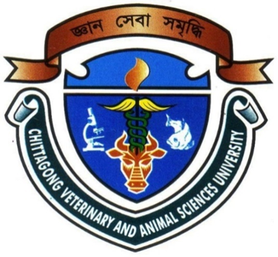

By:

Mahe Alam

Roll No: 10/ 32; Reg No: 00510

Intern ID: C – 24

Session: 2009 – 2010

A clinical report submitted in partial satisfaction of the requirements for the degree of
Doctor of Veterinary Medicine

Faculty of Veterinary Medicine

Chittagong Veterinary and Animal Sciences University
Khulshi, Chittagong, Bangladesh

Clinical investigation of reproductive cases in cows and buffaloes at Teaching Veterinary Hospitals in India

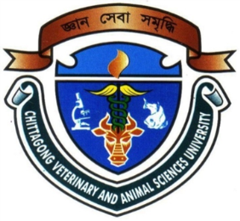

Approved by:

…………………………………………………………….
Professor Md. Ahasanul Hoque, PhD

Department of Medicine and Surgery

Dean, Faculty of Veterinary Medicine

Chittagong Veterinary and Animal Sciences University
Khulshi, Chittagong-4225, Bangladesh

September 2015

