ACKNOWLEDGEMENT

All thanks go to the Almighty Allah, the creator and utmost sovereign of the earth, who gave me the opportunity to complete the work fruitfully.
The author is thankful to Professor Dr. Goutam Buddha Das, Vice-Chancellor, Chittagong Veterinary and Animal Sciences University, Chittagong and Professor Dr. Md. Ahasanul Hoque, Dean, Faculty of Veterinary Medicine, Chittagong Veterinary and Animal Sciences University, Chittagong for their cordial suggestion and inspiration.
The author is so much grateful to the honorable internship supervisor Prof. Dr. Gouranga Ch. Chanda, MSc, Ph.D, MBA, Department of Dairy & Poultry Sciences, Chittagong Veterinary and Animal Sciences University, Chittagong for his kind supervision, excellent cooperation, sincere assist, valuable suggestions, inspiration and constructive criticism, who was involved with this study from its initiation.
The author is also grateful to DR. Md. Julkarnine Hussain Manik, Veterinary surgeon, Banga bandhu Sheikh Mujib Safari Park, Gazipur, Bangladesh for his dedicated help by providing necessary information, cooperation and valuable suggestions.
The author also grateful to all of his teachers of CVASU and his parents for their impressive support, suggestions, cordial help and inspiration regarding my study from its inception to the last.

Author
December, 2015

TABLE OF CONTENTS
Contents |  |  | Page
ACKNOWLEDGEMENTS------------------------------------------------------------------ |  |  | 1
TABLE OF CONTENTS--------------------------------------------------------------------- |  |  | 2-3
LIST OF TABLES---------------------------------------------------------------------------- |  |  | 4
LIST OF FIGURES--------------------------------------------------------------------------- |  |  | 4
LIST OF ABBREVIATION----------------------------------------------------------------- |  |  | 5
ABSTRACT------------------------------------------------------------------------------------ |  |  | 6
Chapter 1 | INTRUDUCTION------------------------------------------------------------ |  | 7-12
Chapter 2 | MATERIALS AND METHODS------------------------------------------- |  | 13
 | 2.1. | Study area------------------------------------------------- | 13
 | 2.2 | Study period----------------------------------------------- | 13
 | 2.3 | Source of photograph------------------------------------ | 13
 | 2.4. | Source of data--------------------------------------------- | 13
 | 2.5 | Observation----------------------------------------------- | 13
Chapter 3 | RESULTS AND DISCUSSION--------------------------------------------  3.1 Population of cattle egret---------------------------------  3.2 Morphology of cattle egret-------------------------------  3.3 Habitat and ecology---------------------------------------  3.4 Behavior of cattle egret-----------------------------------  3.5 Feeding of cattle egret-------------------------------------  3.6 Trophic strategy of cattle egret---------------------------  3.7 Breeding and reproduction of cattle egret--------------  3.7.1 Breeding characteristics-----------------------------------  3.7.2 Condition needed for breeding---------------------------  3.7.3 Reproductive behavior------------------------------------  3.8 Management of cattle egret-------------------------------  3.9 Migration of cattle egret----------------------------------  3.10 Conservation status of cattle egret------------------------  3.11 Disease susceptibility of cattle egret---------------------  3.12 Association of cattle egret---------------------------------  3.13 Life span of cattle egret------------------------------------  3.14 Threats for cattle egret------------------------------------- |  | 14-22  14  15  15  16  17  18  18  18  19  19  20  21  21  21  21  22  23
Chapter 4 | CONCLUSION--------------------------------------------------------------- |  | 24
Chapter 5 | REFERENCES---------------------------------------------------------------- |  | 25-27
Chapter 6 | BIOGRAPHY----------------------------------------------------------------- |  | 28

LIST OF TABLES
Table no | Contents | Page
1 | Biological parameters of Bubulcus ibis | 14
2 | Breeding parameters of cattle egret in different areas of the world | 19

LIST OF FIGURES
Figure no | Contents | Page
1 | Cattle egret in non breeding stage | 15
2 | Cattle egret in breeding stage | 15
3 | Cattle egret in tanguar haor of Shunamganj | 16
4 | Cattle egret in grassy land of Bhola dist. | 16
5 | Feeding frog by cattle egret | 17
6 | Feeding insects by cattle egret | 17
7 | Breeding colony of cattle egret | 20
8 | Chick of cattle egret with egg | 20
9 | Association of cattle egret with deer | 22
10 | Cattle egret in green grassy pasture | 22
11 | Association of cattle egret with cattle | 22
12 | Cattle egret cooccuring with wild deer | 22

LIST OF ABBREVIATIONS
SYMBOL/ ABBREVIATIONS | FULL MEANING
B | Bubulcus
I | Ibis
Etc | Etcetera
IUCN | International Union for Conservation of Nature
M | Meter
Cm | Centimeter
In | Inch
Gm | Gram
Km | Kilometer
Mm | Millimeter
% | Percent
< | Less then
> | Greater than
( ) | First bracket
[ ] | Third bracket
Fig  Dist. | Figure  District

ABSTRACT
A study was undertaken during the period of January to November 2015 to assess the status of cattle egret in with their feeding, breeding and behavioral characteristics. The study was conducted on the basis of information available on internet, books and direct observation of cattle egret along with their nesting and other behaviors in different roosting sites of cattle egret in different areas of Bangladesh. Banga bandhu Sheikh Mujib Safari park was visited for close observation of these birds. There are only one species of cattle egret in Bangladesh as well as in the world Bubulcus ibis. It has three subspecies where the only available subspecies in Bangladesh are Bubulcus ibis coromandus.. The population of cattle egret throughout the world is estimated to number (3,800,000-7,600,000) but its population in Bangladesh is still not estimated. Cattle egret is insectivorous in nature. They feeds on insects like beetles, adult and larval lepidoptera, Hemiptera, cricket, grasshoppers, frogs dragonflies etc. They are mostly habitat in livestock pastures, open savanna grassland, dry arable fields, freshwater swamps, rice-fields, wet pastures, shallow marshes, irrigated grasslands etc. Breeding season of cattle egret is October to January but it varies from November to february according to territorial change. The average clutch size was found two to four. The egg’s color was found pale sky blue to sea green. The average incubation period was 24 days with a range of 22 to 28 days. Cattle egret commonly affected by salmonellosis, collibacillocis, chlamydiasis and different parasitic infestations. This bird has been implicated in the spread of animal infections such as heartwater, infectious bursal disease and possibly newcastle disease. However Cattle egret helps to maintain food chain and food web, so conservation of this species is very important for maintaining the ecological balance.
Key words: Cattle egret, insectivorous, colony, clutch size.

Chapter-1

INTRODUCTION
The cattle egret (Bubulcus ibis) is a cosmopolitan species of heron (family Ardeidae) found in the tropics, subtropics and warm temperate zones. It is the only member of the monotypic genus Bubulcus, although some authorities regard its two subspecies as full species, the western cattle egret and the eastern cattle egret. Despite the similarities in plumage to the egrets of the genus Egretta, it is more closely related to the herons of Ardea. Originally native to parts of Asia, Africa and Europe, it has undergone a rapid expansion in its distribution and successfully colonised much of the rest of the world in the last century.
The cattle egret was first described in 1758 by Linnaeus in his Systema naturae as Ardea ibis, (Linnaeus, C. ,1758)but was moved to its current genus (Bonaparte, Charles Lucien,1855). Its genus name Bubulcus is Latin for herdsman, referring, like the English name, to this species association with cattle(Valpy,1828).
The cattle egret has two geographical races which are sometimes classified as full species, the western cattle egret, B. ibis, and eastern cattle egret, B. coromandus. The two forms were split by (McAllan and Bruce,1988) but were regarded as conspecific by almost all other recent authors until the publication of the influential Birds of South Asia.(Rasmussen,2005)The eastern subspecies B. i. coromandus, described by Pieter Boddaert in 1783, breeds in Asia and Australasia, and the western nominate form occupies the rest of the species range, including the Americas.
Despite superficial similarities in appearance, the cattle egret is more closely related to the genus Ardea, which comprises the great or typical herons and the great egret (A. alba), than to the majority of species termed egrets in the genus Egretta.(Sheldon, F.H,1987) Rare cases of hybridization with little blue herons Egretta caerulea, little egrets Egretta garzetta and snowy egrets Egretta thula have been recorded.
This species has a large range, with an estimated global extent of occurrence of 10,000,000 km² (3,900,000 sq mi). Its global population estimated to be 3.8–6.7 million individuals. For these reasons, the species is evaluated as least Concern. (BirdLife International, 2012) .
The taxonomy of cattle egret was first described in 1758 by Linnaeus in his book Systema naturae. Cattle egret belongs to the kingdom Animalia, its phylum is chordate, class is aves, and order is pelecaniformes. It belongs to the family Ardiedae, genus is Bubulcus and species is Bubulcus ibis. It has three subspecies which are Bubulcus ibis ibis, Bubulcus ibis coromandus and Bubulcus ibis seychellarum .
The family Ardeidae contains the bitterns, herons and egrets. Herons and egrets are medium to large wading birds with long necks and legs. Bitterns tend to be shorter necked and more wary. Members of Ardeidae fly with their necks retracted, unlike other long-necked birds such as storks, ibises and spoonbills. There are 61 species worldwide and 17 species which occur in Bangladesh. (In Bangla short-legged, short beaked herons and egrets are called Bok, all other herons egrets and storks are generically called Sarosh).
Cattle egret is a white bird adorned with buff plumes in the breeding season. It nests in colonies, usually near bodies of water and often with other wading. The nest is a platform of sticks in trees or shrubs. Cattle egrets exploit drier and open habitats more than other heron species. Their feeding habitats include seasonally inundated grasslands, pastures, farmlands, wetlands and rice paddies. They often accompany cattle or other large mammals, catching insect and small vertebrate prey disturbed by these animals. Some populations of the cattle egret are migratory and others show post-breeding dispersal. The cattle egret has undergone one of the most rapid and wide reaching natural expansions of any bird species (Telfair II, Raymond C, 2006). It was originally native to parts of Southern Spain and Portugal, tropical and subtropical Africa and humid tropical and subtropical Asia. In the end of the 19th century it began expanding its range into southern Africa, first breeding in the Cape Province in 1908 (Motis, A,1992).Cattle egrets were first sighted in the Americas on the boundary of Guiana and Suriname in 1877, having apparently flown across the Atlantic Ocean. It was not until the 1930s that the species is thought to have become established in that area (Crosby, 1972).
The species first arrived in North America in 1941 (these early sightings were originally dismissed as escapees), bred in Florida in 1953, and spread rapidly, breeding for the first time in Canada in 1962. It is now commonly seen as far west as California. It was first recorded breeding in Cuba in 1957, in Costa Rica in 1958, and in Mexico in 1963, although it was probably established before that. In Europe, the species had historically declined in Spain and Portugal, but in the latter part of the 20th century it expanded back through the Iberian, and then began to colonise other parts of Europe; southern France in 1958, northern France in 1981 and Italy in 1985. Breeding in the United Kingdom was recorded for the first time in 2008 only a year after an influx seen in the previous year. In 2008, cattle egrets were also reported as having moved into Ireland for the first time (Eric, 2008).
In Australia, the colonization began in the 1940s, with the species establishing itself in the north and east of the continent. It began to regularly visit New Zealand in the 1960s. Since 1948 the cattle egret has been permanently resident in Israel. Prior to 1948 it was only a winter visitor. The massive and rapid expansion of the cattle egret's range is due to its relationship with humans and their domesticated animals. Originally adapted to a commensally relationship with large grazing and browsing animals, it was easily able to switch to domesticated cattle and horses. As the keeping of livestock spread throughout the world, the cattle egret was able to occupy otherwise empty niches. Many populations of cattle egrets are highly migratory and dispersive, and this has helped the species' range expansion. The species has been seen as a vagrant in various sub-Antarctic islands, including South Georgia, Marion Island, the South Sandwich Islands and the South Orkney Islands. A small flock of eight birds was also seen in Fiji in 2008.
In addition to the natural expansion of its range, cattle egrets have been deliberately introduced into a few areas. The species was introduced to Hawaii in 1959 and to the Chagos Archipelago in 1955. Successful releases were also made in the Seychelles and Rodrigues, but attempts to introduce the species to Mauritius failed. Numerous birds were also released by Whipsnade Zoo in England, but the species was never established.
Although the cattle egret sometimes feeds in shallow water, unlike most herons it is typically found in fields and dry grassy habitats, reflecting its greater dietary reliance on terrestrial insects rather than aquatic prey.
Some populations of cattle egrets are migratory, others are dispersive, and distinguishing between the two can be difficult for this species. (Telfair II, Raymond C, 2006). In many areas populations can be both sedentary and migratory. In the northern hemisphere, migration is from cooler climes to warmer areas, but cattle egrets nesting in Australia migrate to cooler Tasmania and New Zealand in the winter and return in the spring. Migration in western Africa is in response to rainfall, and in South America migrating birds travel south of their breeding range in the non-breeding season. Populations in southern India appear to show local migrations in response to the monsoons. They move north from Kerala after September. During winter, many birds have been seen flying at night with flocks of Indian pond herons (Ardeola grayii) on the south-eastern coast of India (Santharam,V,1988) and a winter influx has also been noted in Sri Lanka.
Young birds are known to disperse up to 5,000 km (3,100 mi) from their breeding area. Flocks may fly vast distances and have been seen over seas and oceans including in the middle of the Atlantic (Wayne J, 1988).
The cattle egret nests in colonies, which are often, but not always, found around bodies of water. The colonies are usually found in woodlands near lakes or rivers, in swamps, or on small inland or coastal islands, and are sometimes shared with other wetland birds, such as herons, egrets, ibises and cormorants. The breeding season varies within South Asia. Nesting in northern India begins with the onset of monsoons in May. The breeding season in Australia is November to early January, with one brood laid per season. The North American breeding season lasts from April to October. In the Seychelles, the breeding season of the subspecies B.i. seychellarum is April to October.
The male displays in a tree in the colony, using a range of ritualized behaviors such as shaking a twig and sky-pointing (raising his bill vertically upwards) and the pair forms over three or four days. A new mate is chosen in each season and when re-nesting following nest failure. The nest is a small untidy platform of sticks in a tree or shrub constructed by both parents. Sticks are collected by the male and arranged by the female, and stick-stealing is rife. The clutch size can be anywhere from one to five eggs, although three or four is most common. The pale bluish-white eggs are oval-shaped and measure 45 mm × 53 mm (1.8 in × 2.1 in). Incubation lasts around 23 days, with both sexes sharing incubation duties. The chicks are partly covered with down at hatching, but are not capable of fending for themselves; they become capable of regulating their temperature at 9–12 days and are fully feathered in 13–21 days. They begin to leave the nest and climb around at 2 weeks, fledge at 30 days and become independent at around the 45th day. The cattle egret engages in low levels of brood parasitism, and there are a few instances of cattle egret eggs being laid in the nests of snowy egrets and little blue herons, although these eggs seldom hatch. There is also evidence of low levels of intra specific brood parasitism, with females laying eggs in the nests of other cattle egrets. As much as 30% extra-pair copulations have been noted.
The dominant factor in nesting mortality is starvation. Sibling rivalry can be intense, and in South Africa third and fourth chicks inevitably starve. In the dryer habitats with fewer amphibians the diet may lack sufficient vertebrate content and may cause bone abnormalities in growing chicks due to calcium deficiency. In Barbados, nests were sometimes raided by vervet monkeys, and a study in Florida reported the fish crow and black rat as other possible nest raiders. The same study attributed some nestling mortality to brown pelicans nesting in the vicinity, which accidentally, but frequently, dislodged nests or caused nestlings to fall. In Australia, Torresian crows, wedge-tailed eagles and white-bellied sea eagles take eggs or young, and tick infestation and viral infections may also be causes of mortality. The cattle egret feeds on a wide range of prey, particularly insects, especially grasshoppers, crickets, flies (adults and maggots), and moths, as well as spiders, frogs, and earthworms. In a rare instance they have been observed foraging along the branches of a banyan tree for ripe figs. The species is usually found with cattle and other large grazing and browsing animals, and catches small creatures disturbed by the mammals. Studies have shown that cattle egret foraging success is much higher when foraging near a large animal than when feeding singly.
When foraging with cattle, it has been shown to be 3.6 times more successful in capturing prey than when foraging alone. Its performance is similar when it follows farm machinery, but it is forced to move more. In urban situations cattle egrets have also been observed foraging in peculiar situations like railway lines.
A cattle egret will weakly defend the area around a grazing animal against others of the same species, but if the area is swamped by egrets it will give up and continue foraging elsewhere. Where numerous large animals are present, cattle egrets selectively forage around species that move at around 5–15 steps per minute, avoiding faster and slower moving herds; in Africa, cattle egrets selectively forage behind plains zebras, waterbuck, blue wildebeest and Cape buffalo. Dominant birds feed nearest to the host, and obtain more food.
The cattle egret may also show versatility in its diet. On islands with seabird colonies, it will prey on the eggs and chicks of terns and other seabirds. During migration it has also been reported to eat exhausted migrating land birds. Birds of the Seychelles race also indulge in some kleptoparasitism, chasing the chicks of sooty terns and forcing them to disgorge food.
The adult cattle egret has few predators, but birds or mammals may raid its nests, and chicks may be lost to starvation, calcium deficiency or disturbance from other large birds. This species maintains a special relationship with cattle, which extends to other large grazing mammals; wider human farming is believed to be a major cause of their suddenly expanded range. The cattle egret removes ticks and flies from cattle and consumes them. This benefits both species, but it has been implicated in the spread of tick-borne animal diseases.
A conspicuous species, the cattle egret has attracted many common names. These mostly relate to its habit of following cattle and other large animals, and it is known variously as cow crane, cow bird or cow heron, or even elephant bird, rhinoceros egret. Its Arabic name, abu qerdan, means "father of ticks", a name derived from the huge number of parasites such as avian ticks found in its breeding colonies. The cattle egret is a popular bird with cattle ranchers for its perceived role as a biocontrol of cattle parasites such as ticks and flies.

Objectives of this study:
However, the main objectives of this study were-
- To study the common biophysical characteristics of cattle egret.
- To address some fundamental questions of ecology, using reference studies in an environment largely untouched by civilization.
- To analyses the feeding and nutrition of cattle egret.
- To know the breeding parameters of cattle egret.
- To analyze the communities in primeval habitats as reference for the assessment of anthropogenic impact on species communities in Bangladesh.
- To determine the extent and location of existing habitat suitable for meeting the habitat requirements of individual populations of priority species group.
- To know the common diseases of cattle egret and their prevention.
Chapter-2

MATERIALS AND METHOD
2.1 Study area
The study was conducted in different areas in Bangladesh as per convenience. Along with some natural places the Banga Bandhu Sheikh Mujib Safari park, Gazipur was visited for direct observation of cattle egret.
2.2 Study period:
The study was conducted from January 2015 to November 2015.
2.3 Photography:
It was a very difficult task to taking photographs of cattle egret. They are speedy racer and intelligent. However some picture was taken from the wild animal conservation area of Banga Bandhu Sheikh Mujib Safari park, Gazipur. Sample picture was collected from different websites.
2.4 Data collection:
Many journals and magazines are available with various studies or experiments on Cattle egret. Web sites are also available about Cattle egret. Data was collected from these journals, magazines and by internet browsing of related websites. Data was also appraised by phone contact with different personals in different places of Bangladesh.
2.5 Observation:
Observation was also used as a tool for studying about cattle egret. This facilitates to study their body characteristics, habitats, feeds and feeding, breeding, diseases etc.

Body Length | Wing span | Body weight | Age at first breed | Clutch size | Num-ber of brood | Incub- ation period | Egg color | Egg length | Egg weight | Nest size | Conditi-on at hatchin-g
46-56 cm | 88-96 cm | 270-512 gm | 2 years | 2-4 eggs | 1 brood | 24 days | Pale sky blue to sea green | 3.5-5.2 cm | 2.8-3.6 cm | 17.8-61 cm long and 5.1-30.5 cm deep | Dark bluish or greenish skin partly covered with dawn
Chapter-3

RESULT AND DISCUSSION
There are only one species of cattle egret Bubulcus ibis found in Bangladesh as well as in the world. But it has three subspecies, the only subspecies that are found in Bangladesh are Bubulcus ibis coromandus. The morphological and other biological parameters of cattle egret differ from age, sex, ecology, availability of feed and nutrition.
Table 1: Biological parameters of Bubulcus ibis
3.1 Population of cattle egret
The population of cattle egret throughout the world is estimated to number (3,800,000-7,600,000) individuals. The overall population trend is increasing, although some populations may be stable or decreasing and others have unknown trends (Wetlands International 2006).
However in Bangladesh the actual population of cattle egret is still not estimated.
3.2 Morphology of cattle egret:
The cattle egret is a medium sized bird, with a 'hunched' posture, even when it is standing erect. In comparison to other egrets, it is short-legged and thick-necked. The total length of the bird ranges from 46-56 cm, and its wingspan averages 88-96 cm. The basic plumage of the adult of both sexes is pure white, with a dull orange or yellow bill, and dull orange legs. For a brief period of time during the breeding season, however, the plumage of the breeding adults is Buffy at the head, neck and back, and the eyes, legs and bill are a vivid red. Because of this coloration, it is sometimes called the Buff-Backed Heron. (Telfair, 1994, Hancock and Elliott, 1978).
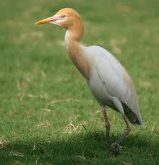 | 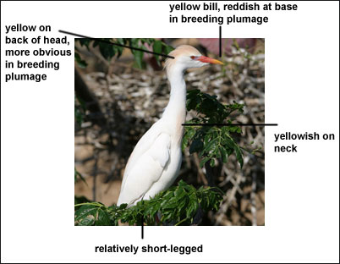
Fig 1: Cattle egret in non breeding stage Fig 2: Cattle egret in breeding stage
The average length of its body varies from 45 to 56 cm, the weight also differs from different age group approximately 270 to 512 gm. Wing span spread length is almost 88 to 96 cm.
3.3 Habitat and ecology:
In Bangladesh cattle egret inhabits in open grass land, marshy land area and also in water lodged areas. A great number of cattle egret are found in Hakaluki haor of sylhet, Tanguar haor in Sunamganj and swampy area of Bhola district which indicates its habitat in both grassy land and swampy area. This finding shows similarity with the findings of other studies on cattle egret.
The species inhabits open grassy areas such as meadows (del Hoyo et al. 1992), livestock pastures (Kushlan and Hancock 2005), semi-arid steppe (del Hoyo et al. 1992) and open savanna grassland subject to seasonal inundation (Kushlan and Hancock 2005), dry arable fields (del Hoyo et al. 1992), artificial grassland sites (e.g. lawns, parks, road margins and sports fields) (Kushlan and Hancock 2005), flood-plains (Hancock and Kushlan 1984), freshwater swamps, rice-fields, wet pastures (del Hoyo et al. 1992), shallow marshes (Kushlan and Hancock 2005), mangroves (Hancock and Kushlan 1984) and irrigated grasslands (with ponds, small impoundments, wells, canals, small rivers and streams) (Kushlan and Hancock 2005).
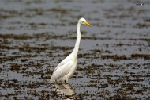 | 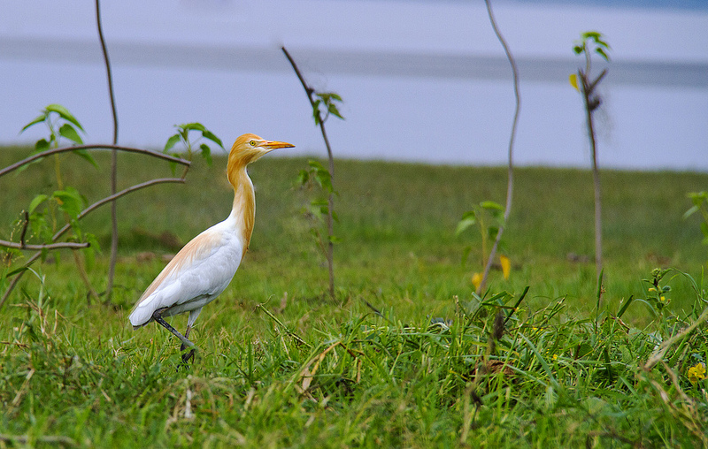
Fig 3: Cattle egret in Tangua haor of Sunamganj Fig 4: Cattle egret in grassy land of Bhola dist.
It rarely occupies marine habitats or forested areas (del Hoyo et al. 1992) although it may also use brackish or saline habitats (Kushlan and Hancock 2005). It occurs from sea-level up to 1,500 m (Kushlan and Hancock 2005) or locally up to c.4,000 m (del Hoyo et al. 1992).
3.4 Behavior of cattle egret:
Cattle egret breeds throughout the year in the tropics with different regional peaks (del Hoyo et al. 1992) depending on food availability (Kushlan and Hancock 2005). It breeds colonially, often with other species, in groups that number from a few dozen to several thousand pairs. (del Hoyo et al. 1992). The nesting effort of the species is related to rainfall patterns, leading to an annual variation in productivity (Kushlan and Hancock 2005). Outside of the breeding season the species remains gregarious (Brown et al. 1982, del Hoyo et al. 1992), feed in loose flocks of 10-20 individuals (Brown et al. 1982) and often gathering in flocks of hundreds or even thousands of individuals where food is abundant (del Hoyo et al. 1992). The species is a diurnal feeder (del Hoyo et al. 1992) and commonly associates with native grazing mammals or domesticated livestock (Kushlan and Hancock 2005).

3.5 Feeding of cattle egret:

Primarily the feed of cattle egret consists of insects such as locusts, grasshoppers (del Hoyo et al. 1992), beetles, adult and larval Lepidoptera, Hemiptera, dragonflies (Hancock and Kushlan 1984) and centipedes but worms (Brown et al. 1982), spiders (Hancock and Kushlan 1984), crustaceans, frogs, tadpoles, molluscs, fish, lizards, small birds, rodents and vegetable matter may also be taken (del Hoyo et al. 1992).

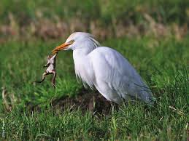 | 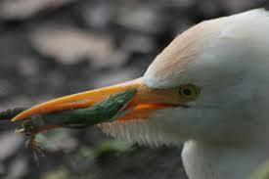

Fig 5: Feeding frog by cattle egret Fig 6: Feeding insects by cattle egret

In Bangladesh national zoo the cattle egret are supplied of different small fishes and aquatic insects for feeding whole in Banga bandhu Sheikh Mujib Safari park this birds use to take feed in natural habitat. Mainly cricket, grasshoppers, frogs, beetles and other different types of insects are consumed by this bird.
The presence of any one insect prey in the guts either by proportion, weight or volume gave credence to its relative abundance in the ecosystem, where the egrets fed. Nesting Cattle egrets parents forage and capture any available insect to feed their off-springs, thus making it easier to infer the diet of adult egrets from those of the chicks (Jenni, 1973).Seasonal changes, affect insect–prey population, particularly in this arid zone, with many species of insect prey disappearing after the rain. This has also affected the feeding behavior and ecology of the Cattle egrets as they change their ecosystem to some marshy and dry swamps by the end of the rains and roost in towns and villages (Elgood, 1979). Such seasonal changes, which also make scarce the availability of seasonal insect-prey species, influence the prey species (types) consumed by the Cattle egrets. The absence of some wet season predilected insects.
3.6 Trophic strategy of cattle egret:
It’s been estimated that an individual cattle egret can obtain up to 50% more food and use only two-thirds as much energy catching it by associating with cattle, as well as with other large ungulate species. Thus it is a very opportunistic and non-competitive feeder. It commonly associates with livestock, wild buffalo, rhino, elephant, hippo, zebra, giraffe, eland, and waterbuck. Due to their practice of perching on these animals backs. It is a very active forager, usually feeding in loose aggregations of small or large flocks of mixed sex and age, varying from tens to hundreds of individuals. It may forage in smaller groups or singly. When feeding, it usually walks in a steady strut, followed by a short dart forward, and a quick stab. If they prey animal is small, it is immediately swallowed. If it is larger, it may be jabbed or dipped in water a few times, but it is not dismembered. (Telfair, 1994; Hancock and Elliott, 1992)
3.7 Breeding and reproduction of cattle egret:
3.7.1 Breeding characteristics:
Colonial breeding (i.e. at a relatively small number of sites through the species' range) inherently makes the species vulnerable (Marchant & Higgins 1990). Eastern territorial colonies operate in a well defined period from October to January, occasionally extending by a month either side. In the Northern territorial colonies operate mainly November to February with smaller numbers breeding at other times (Chatto 2000).

3.7.2 Conditions needed for breeding
The Cattle Egret requires the availability of food for nestlings at nest sites. Regular breeding period (despite irregular inundation) and wide use of dry land feeding areas suggests this species is less dependent on those conditions than many other water birds (Marchant & Higgins 1990).

3.7.3 Reproductive behavior:
The cattle egret is seasonally monogamous. It pair-bonds, but at the start of the breeding season there can be a temporary group of 1 male and 2 females. Breeding starts when small groups of males establish territories. Soon after this, aggression increases, and they begin to perform various elaborate courtship displays, attracting groups of females. Immediately before pairing, a female will attempt to subdue the displaying male by landing on his back. Eventually, the male will allow one female to remain in his territory, and within a few hours, the pair-bond is secure. The female then follows the male to another site where the nest will be built. Copulation usually also takes place at this second site.

Table 2: Breeding parameters of cattle egret in different areas of the world
Location | Colony size | Clutch size | Nesting brood | Fledged brood | References
France | 107 | 4.8 | 3.9 | 3.1 | Hafner, 1978
Morocco | 107 | 3.4 | 2.3 | 0.8 | Franchimont, 1985
Brazil | 1222 | 2.5 | 1.9 | 1.1 | Petry and Fonseca, 2005
India | 550 | 3 | 2.5 | 1.9 | Hilaluddin et al, 2003
South Africa | 1416 | 2.9 | 1.7 | 1.1 | Siegfried, 1972
USA | 4500 | 2.4 | 0.7 | 0.4 | Dusi and Dusi, 1969

Cattle egrets nest is large colonies with other wading birds. Pairs sometimes reuse old nests, or build new ones with live or dead vegetation. They will build in any place that can support a nest. Both sexes participate in nest building the female usually builds with materials brought by the
male. They often steal sticks and other materials from neighbor’s unattended nests. Material is continuously added to the bulky nests during incubation and after hatching. Eggs are laid every 2 days, and the female does not become attentive to the nest until the last egg is laid. The eggs are light sky blue, turning lighter as time passes. Clutch size is usually 3-4 eggs, although extremes of 1 and 9 have been recorded. Incubation is carried out by both sexes, and lasts 24 days. During the first week, nestlings are easily overheated, and so the parents shade them from the sun beneath their wings. Both parents brood constantly for the first 10 days. The parents may accept chicks from other broods only if they are less than 14 days old.
Most of the chicks growth is completed in the nest, but by 14-21 days, the chicks are capable of leaving the nest and climbing in vegetation. At this stage, they remain nearby and continue to beg for food. At 45 days, they are independent, at 50 days they can make short flights, and at around 60 days, they fly to foraging areas. (Telfair, 1994)

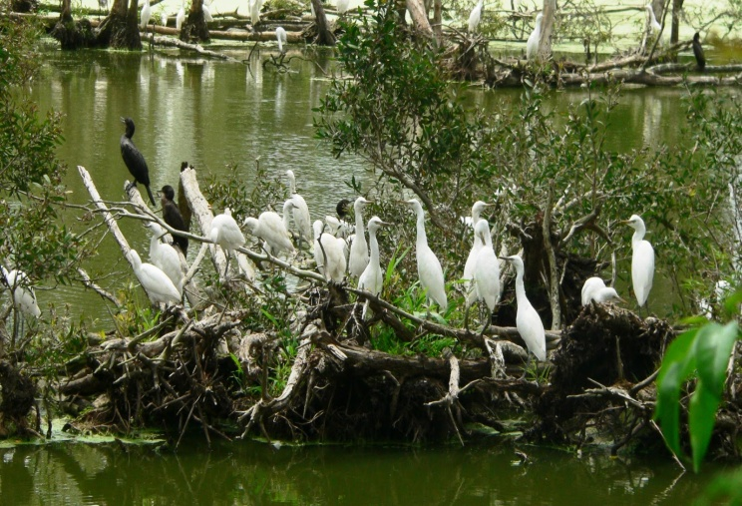 | 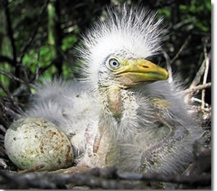
Fig 7: Breeding colony of cattle egret Fig 8: Chick of cattle egret with egg
Nest building and breeding is usually completed in three days, after which the birds begin to lose their breeding color. There is a degree of promiscuity in the species, with males frequently mating with more than one female during the breeding season (Kushlan and Hancock 2005).
3.8 Management of cattle egret:
The species can adversely affect the trees and bushes it uses for nesting, which may lead to the abandonment of the colony site if it is not managed (Kushlan and Hancock 2005).
3.9 Migration of cattle egret:
The remarkable migration of the Cattle Egret from its origins in Africa to its present range, including Asia, the Americas and Australasia, during the 20th century has been well documented (Siegfried, 1978). Usually some populations of this species make local extended movements (generally less than 200 km) at particular times of the year as to breeding or wintering grounds, to hibernation sites.
3.10 Conservation status of cattle egret:
Cattle egret has an extremely large range, and hence does not approach the thresholds for Vulnerable under the range size criterion (Extent of Occurrence <20,000 km2 combined with a declining or fluctuating range size, habitat extent/quality, or population size and a small number of locations or severe fragmentation). The population trend appears to be increasing, and hence the species does not approach the thresholds for Vulnerable under the population trend criterion. The population size is extremely large, and hence does not approach the thresholds for Vulnerable under the population size criterion (<10,000 mature individuals with a continuing decline estimated to be >10% in ten years or three generations, or with a specified population structure). For these reasons the species is evaluated as Least Concern.

3.11 Disease susceptibility of cattle egret:
Cattle egrets may transmit parasites and other disease organisms to livestock and people. It can be affected by salmonellosis, collibacillocis, chlamydiasis and different parasitic infestations. It has been implicated in the spread of animal infections such as heartwater, infectious bursal disease and possibly Newcastle disease (Fagbohun, 2000). Most of the disease spread occurs while foraging together with the native animals.

3.12 Association of cattle egret:
Cattle egret has a close association with other herbivores. In Banga bandhu Sheikh Mujib Safari park it was explored those cattle egret co-occur with wild beast, dear, giraffe and other harbivores. This findings match with the findings of Telfair and Ivory who stated that In the African portion of their native range, cattle egrets co-occur with elephants, rhinoceros, hippopotamus, and other large herbivores, and across much of their non-native range they associate primarily with cattle (Telfair 1994, Ivory 2000).
[All these pictures mentioned below are captured by author in Banga Bandhu Sheikh Mujib Safari park, Gazipur, Dhaka, Bangladesh ]
Fig 9: Association of cattle egret with deer  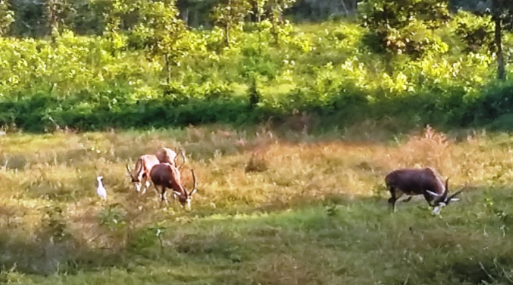 | Fig 10: Cattle egret in green grassy pasture  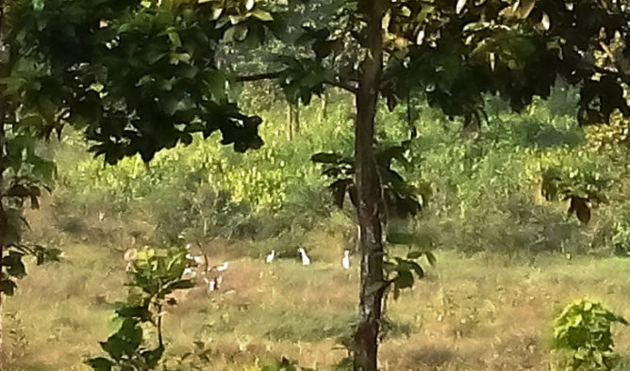
Fig11: Association of cattle egret with cattle  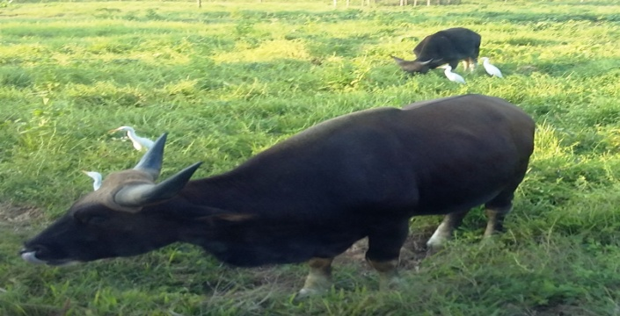 | Fig12: Cattle egret cooccuring with wild deer  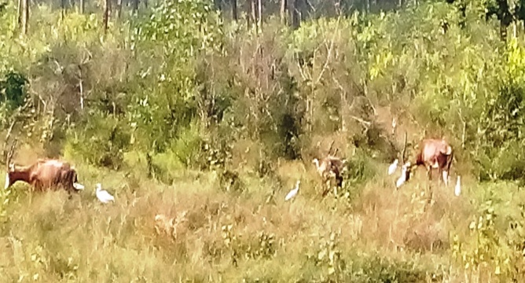
3.13 Life span of cattle egret:
It has been reported that the average longevity of cattle egret in wild environment is 23 years (Telfair, 1994). But in captive condition there is found sometimes more longevity of this bird than wild environment.

3.14 Threats for cattle egret:
The major threats for cattle egret are persecution of large colonies in urban areas as well as loss of breeding habitats through wetland degradation and destruction. In some area of the world this bird is hunted for production of medicine which results a great threat for cattle egret. The cattle roost both in tree and in the ground for vegetation, and thus easily predated by wild cat.

Chapter-4

CONCLUSION

Every animal and plants in this world has its significance. In Bangladesh cattle egret are not yet considered as endemic species but their population is declining. Cattle egret helps to maintain food chain and food web. So, any harm in any food chain, will affect complete food web. So if we don’t try to save this bird it will create ecological imbalance. We should know about their behavior, feeding, breeding, psychology, disease susceptibility, benefits and threats. It has a close association with wild animal in wild environment, so knowing its management has a great potentiality for conservation of wild species. Many people are fond of cattle egret. Though, it is generally considered as agricultural pest and sometime nuisance species, but they are also beneficial as they eat insects. Cattle egret eats larvae of many insects and mosquitoes and thus prevents the spreading of many diseases. So, cattle egret protects us from many life threatening diseases. So we all should contribute for the conservation of cattle egret in our country

Chapter-5

REFERENCES

Arendt. Wayne. J, (1988). "Range Expansion of the Cattle Egret (Bubulcus ibis) in the Greater Caribbean Basin". Colonial Waterbirds (Waterbird Society) 11 (2): 252–262.
Bird Life International (2012). "Bubulcus ibis". IUCN Red List of Threatened Species. Version 2013.2. International Union for Conservation of Nature. Retrieved26 November 2013.
Bonaparte. Charles Lucien (1855). "[untitled]". Annales Des Sciences Naturelles comprenant la zoologie (in French) 4 (1): 141.
Brown. L.H., Urban. E.K and Newman. K (1982) The Birds of Africa, Volume I. Academic Press, London.
Chatto. R, (2000). Waterbird breeding colonies in the Top End of the Northern Territory. Parks & Wildlife Commission of the Northern Territory Technical Report. 69.
Crosby. G (1972) "Spread of the Cattle Egret in the Western Hemisphere" (PDF). Journal of Field Ornithology 43 (3): 205– 212.
Del Hoyo, J. Elliot and Sargatal. J, (1992) Handbook of the Birds of the World, vol. 1: Ostrich to Ducks. Lynx Edicions, Barcelona, Spain.
Dusi. J.L and Dusi.R.D, (1970), Nestling success and mortality of nestlings in a Cattle egret colony. The Wilson Bulletin 82: 458-460.
Elgood, J.A, (1979), Birds of South Africa Towns and Gardens. In: Savory, H.J. (ed.), West African Nat Handbook. Longman GP. Ltd. London, Wahcheony Printing Pres Ltd, Hong Kong, China.
Fagbohun, O.A, Oluwayelu. D.O, Owoade. A.A and Olayemi. F.O, (2000). "Survey for antibodies to Newcastle Disease virus in cattle egrets, pigeons and Nigerian laughing doves" (PDF). African Journal of Biomedical Research 3: 193–194.

Franchimont. J, (1985) Biologie de la reproduction du heron gardeboeufs (Bubulcus ibis) dans une héronnière mixte du nord-ouest marocain. Aves 22: 225-247

Hafner. H (1980) Etude ecologique des colonies de hérons arboricoles en Camargue. Bonner Zoologische Beiträge 31: 249-287.
Hancock. J and Kushlan, J (1984). The herons handbook. Croom Helm, London.

Hilaluddin. K. R, Junid. N. S and Tahir. A.S (2003) Nest site selection and Breeding success by Cattle Egret and Little Egret in Amroha, Uttar Pradesh, India. Colonial Waterbirds 26: 444-448.
Jenni. D. A (1973) Regional variation in the food of nesting Cattle egrets. AUK, 95: 267–80
Linnaeus.C. (1758). Systema naturae per regna tria naturae, secundum classes, ordines, genera,species,cumcharacteribus,differentiis,synonymislocis.TomusI.Editiodecima,reformata. (inLatin).Holmiae[Stockholm]:Laurentii Salvii. p. 144. A. capite laevi, corpore albo, rostro flavescente apicepedibusque nigris.
Marchant. S. & P. J. Higgins (1990). Handbook of Australian, New Zealand and Antarctic Birds. Volume One - Ratites to Ducks. Melbourne, Victoria: Oxford University Press.

Martínez-Vilalta, A and Motis, A. (1992). "Family Ardeidae (Herons)". In del Hoyo, J.; Elliot, A.; Sargatal, J. Handbook of the Birds of the World. Volume 1: Ostrich to Ducks. Lynx Edicions. pp. 401–402.
McAllan. I.A.W and Bruce, M.D. (1988). The birds of New South Wales, a working list. Turramurra, N.S.W.: Biocon Research Group in association with the New South Wales Bird Atlassers.
Nightingale. B and Dempsey. E (2008). "Recent reports" (PDF). British Birds 101 (2): 108.
Petry. M. A and Fonseca. V. S .D. S (2005). Breeding success of the colonist species Bubulcus ibis and four native species. Acta Zoologica 86: 217-221.
Rasmussen. P. C. and Anderton. J. C. (2005) Birds of South Asia. The Ripley Guide. Smithsonian Institution and Lynx Edicions. p. 58.
Santharam. V (1988) "Further notes on the local movements of the Pond Heron Ardeola grayii". Newsletter for Birdwatchers 28 (1–2): 8–9.
Sheldon. F.H (1987). "Phylogeny of herons estimated from DNA-DNA hybridization data". The Auk 104: 97–108.
Siegfried. W. R (1972) Breeding success and reproductive output of the Cattle Egret. Ostrich 43: 43-55.
Telfair II and Raymond.C (2006). Poole, A., ed. "Cattle Egret (Bubulcus ibis)". The Birds of North America Online. Ithaca: Cornell Lab of Ornithology
Valpy, F. E. J (1828). An Etymological Dictionary of the Latin Language. London; A. J. Valpy, p. 56.

Chapter-6

BIOGRAPHY

I am Mohammad Wasiul Hasan from Gazipur, Dhaka, Bangladesh. I was born in twenty third January, 1991in North Chayabithi village of Gazipur district. I passed my S.S.C exam from Rani Bilash Moni Government Boys High School, Gazipur sadar, Gazipur in 2006 from Science and H.S.C from Milestone College, Uttara, Dhaka in 2008 from science as well. I admitted in Chittagong Veterinary and Animal Sciences University, Chittagong in 2009-10 session and at present I am doing my internship. This study was the very beginning of me in the path of research activities and I comprise a strong intention to involve myself with these types of works in future.

