Study on Status of Cattle Egret in Bangladesh
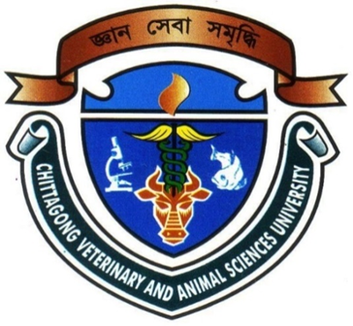

By
Mohammad Wasiul Hasan
Roll No: 2010/16
Reg. No: 0495
Internship ID: B-11
Session: 2009-2010

A production Report submitted in partial satisfaction of the requirements for the degree of
Doctor of Veterinary Medicine
Faculty of Veterinary Medicine
Chittagong Veterinary And Animal Sciences University, Khulshi, Chittagong, Bangladesh.
Study on Status of cattle egret in Bangladesh

Approved

…………………………………………………………….
Dr. Gouranga Ch. Chanda
Professor
Department of Dairy and Poultry Sciences
Chittagong Veterinary and Animal Sciences University,
Khulshi, Chittagong, Bangladesh.
December, 2015

