CHAPTER I

**INTRODUCTION**

Diseases and disorders of calves are thought to be the important constraints for cattle development in Bangladesh. It has been reported that 15-20% calves die every 3 year from various diseases (Anon, 1993). Congenital disorders in calves have been increasing alarmingly with the increase of crossbred animals. Umbilical hernia and atresia ani are among the major congenital disorders causing mortality in calves.

Genetic or environmental factors or their interactions cause congenital defects and those anomalies are abnormalities of structure or function present at births (Leipold et al, 1983). According to the location it may be –

1.Umbilical hernia 2. Inguinal hernia 3. Scrotal hernia 4. Diaphragmatic hernia 5. Perineal hernia 6. Ventral hernia 7. Femoral hernia

Umbilical hernia is one of the major congenital affections in animals particularly in the bovine. It also occurs in foals and pups (Priester et al,1970). In cattle the condition is comparatively more frequent in Holstein-Friesian breed (Zhigachev,1983). Congenital defects and disorders of domestic animals cause considerable economic loss to farmers. Improper closure of the umbilicus at birth due to maldevelopment or hypoplasia of the abdominal muscles has been found to be associated with umbilical hernia in calves (Singh et al,1989). The acquired umbilical hernia occurs primarily due to manual breaking or resectioning of the cord close to the abdominal wall.

This congenital defect may prove dangerous if not treated in appropriate time. The affected calves may only be salvaged through successful herniorrhaphy. Many factors eg., suture materials, suture pattern, degree if protrusion, body circumference, ring diameter etc. determine the success of herniorrhaphy (Peacock and Van winkle, 1976). Suture materials are selected on the basis of their physical and biological properties, condition of the wound and healing characteristics of the tissue to be apposed. Polypropylene is one of the potent secured knotable, flexible synthetic non absorbable suture materials frequently used in human practice. There is a lack of information based on a large number of cases on which to develop a rationale for the selection of specific surgical and non surgical techniques for the management of various types of umbilical hernia. Horizontal mattress and purse string suture patterns with catgut and silk are widely practiced in Bangladesh (Rahman *et al*., 2001). The modified suture pattern (myomattress) is an overlapping suturing technique that provides adequate support to the suture line (Knecht *et al*., 1987). If the degree of protrusions, body circumference and ring diameter of hernial swelling are large, appropriate suture material and pattern is to be needed to close the hernial ring (Wion 1957). Post operative complications like abscess, hemorrhage, myasis, peritonitis, recurrence etc. may be observed (Fretz *et al*, .1983). Once recurrence occurs, the prognosis is not satisfactory in maximum cases, which ultimately leads to death of the animal.

**Considering the above facts the present study was initiated to investigate the following objectives:**

1. To determine the effects of age, sex, breed and season on the occurrence of umbilical hernia in calves.
2. To evaluate the efficacy between catgut and polypropylene for the correction of umbilical hernia in calves.
3. To record the information about degree of protrusion, circumference and ring diameter of the umbilical swelling.
4. To observe the clinical management of umbilical hernia.
5. To observe the complications of umbilical hernia after herniorrhaphy.

CHAPTER II

**MATERIALS AND METHODS**

**2.1 Experimental animals**

The present investigation was conducted on 22 calves. These animals were apparently healthy other than the herniation. Out of 22 affected calves with umbilical hernia, 6 were indigenous (local) and 16 were crossbred. Total 13 of the experimental animals were male and 9 were female. Ages ranged from 3 days to 6 months and body weights from 20 to 40 kg. A total of 22 experiments were performed in these animals to investigate the comparative efficacy of different suture materials for the correction of umbilical hernia. The work was carried out (Upazilla veterinary hospital, Sandwip, Chittagong and S. A. Quaderi Teaching Veterinary Hospital, CVASU.)

**2.2 Suture materials**

i. ***Chromic catgut*** – Made from submucosa of small intestines, multifilament, breaks down by phagocytosis.

ii. ***Polypropylene*** – Monofilament, synthetic, won’t lose tensile strength over time, good knot security, very little tissue reaction.

**2.3 Design of experiment**

**The selected calves were divided into two groups as follows:**

|  |  |  |
| --- | --- | --- |
| **Group** | **Number of animal** | **Suture materials used** |
| A | 11 | Catgut |
| B | 11 | Polypropylene |

**2.4 History**

The age, sex and breed of every calf presented to the veterinary clinic affected with umbilical hernia were recorded properly. Occurrence of the disease with respect to season was also recorded.

|  |  |  |  |  |
| --- | --- | --- | --- | --- |
| **Calves** | **Breed** | **Age** | **Sex** | **Season** |
| 22 calves | 6(indigenous) | 3 days to 6 months | 13 (male) | Summer &  Rainy |
| 16 (crossbreed) | 9 (female) |

**2.5 Clinical examination of calves**

**2.5.1 *Diagnosis of hernia***

A preliminary diagnosis was made from the history and by palpation of the umbilical region. Diagnosis of the cases, however, was confirmed by exploratory puncture in the navel swelling and demonstration of intestinal contents. Detection of hernial ring with the index finger also aided diagnosis.

**2.5.2 *Reducibility***

The affected animal was placed in dorsal recumbence and the contents were pushed back into the abdomen. In case of reducible hernia, the contents went back to the abdominal cavity and the hernial ring became evident.

**2.5.3 *Measurement of hernial swelling***

i. The protrusion of hernial swelling was the length from its neck to the fundus and was measured in cm with a measuring scale

ii. Circumference of the swelling was taken at the level of its was measured in cm with a measuring tape

iii. The diameter of the hernial ring was measured after blunt dissection of the abdominal muscle during operation.

**2.6 Monitoring of clinical parameters**

Respiratory rate, heart rate and rectal temperature were recorded prior to surgery and thereafter daily until the 7th post-operative day.

**2.7 Radical operation for hernia**

**2.7.1 *Preparation of the patient***

The animal was placed on the operation table in dorsal recumbency and was restrained physically by the assistants. The operation site was clipped, shaved and drapped using sterile surgical towel. The site was finally painted with tincture of idodine.

**2.7.2 *Anesthesia***

Xylazine hydrochloride (Rompun®, Bayer Korea, Ltd.) was administered at a dose rate of 0.01mg/kg body weight through intramuscular route to calm down the calf. Later, 7 ml of 2% lidocaine hydrochloride (Jasocaine®, Jayson Pharmaceuticals Ltd., Dhaka, Bangladesh) was infiltrated in an inverted ‘V’ shaped manner from cranial to caudal aspect of hernial ring (Klein and Firth, 1988)

**2.7.3 *Operative procedure***

Two elliptical incisions were made on either side of the ring. In case of a male calf, the incisions were 2-3 cm apart to prevent possible contamination of wound with urine. Following blunt dissection of the abdominal muscles, diameter of the hernial ring was measured. Then loose connective tissue and fascia were removed to create a room for incision on hernial sacs. Hernial sac was grasped and the content was pushed back to the abdominal cavity. Some portion of the sac was removed and the edges of the ring were scratched and taken into apposition using the myomattress technique. Either catgut or polypropylene was used to close hernial ring. After closing the ring, skin edges were closed by horizontal mattress suture with nylon thread.

**2.7.4 *Postoperative management***

This consisted of a course of antibiotic for 5 days. The skin stitches were removed within 10-12 days after operation. The animals were kept under supervision for a month to observe any complication if there was any.

**2.8 Statistical analysis**

The data obtained in the present investigation were analyzed by CRD (Complete Randomized Design) one factor analysis.

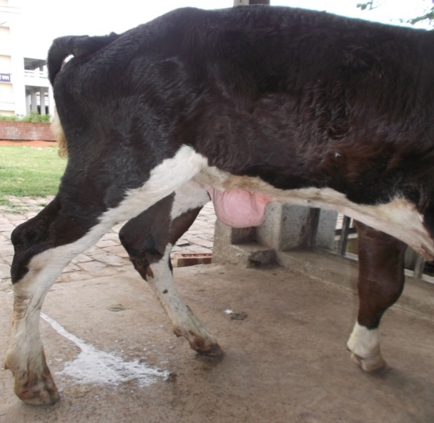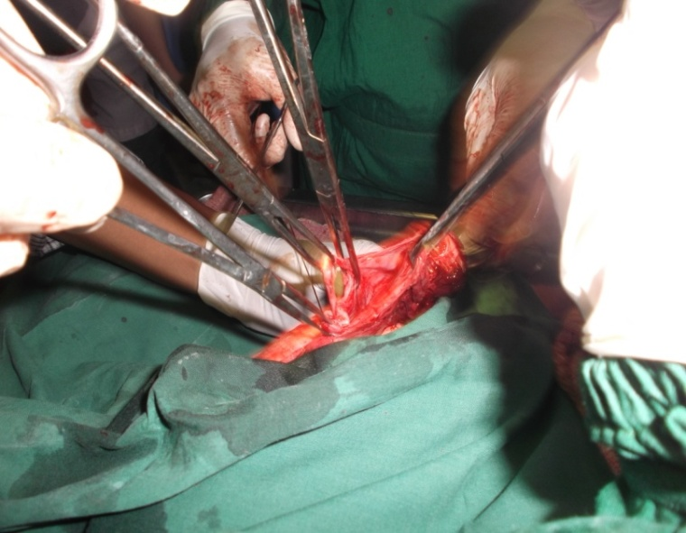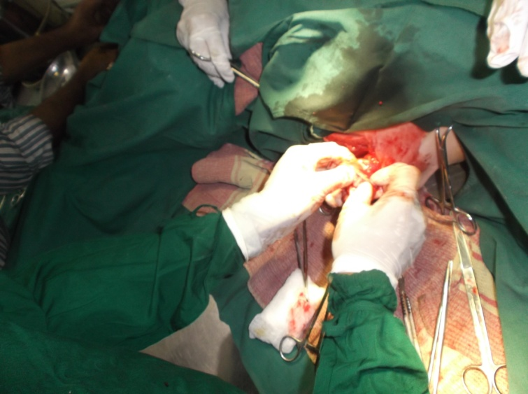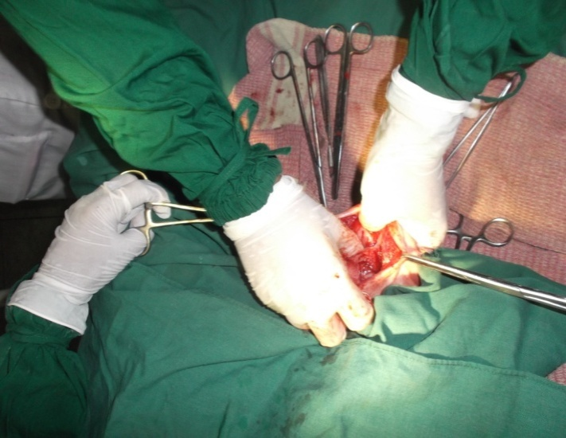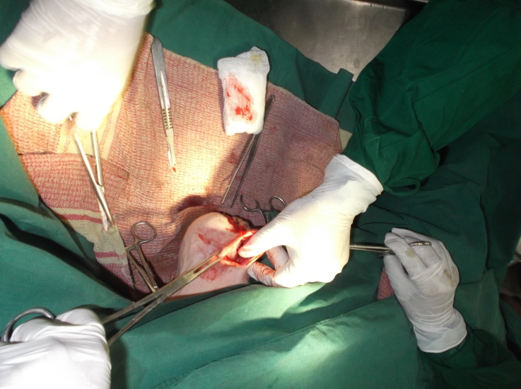**CHAPTER-III**

**Figure-2 : Typical cases of umbilical hernia in cross-bred.**

**Figure-1: Anatomy of Umbilical Hernia.**

**Figure-3(a-d) : Sequential proceedings of umbilical herniorrhaphy.**

b

d

c

a

**RESULT**

**3.1 Effects of different variables on the occurrence of umbilical hernia.**

**3.1.1 *Effects of age and sex***

The effect of age and sex on the occurrence of umbilical hernia in calves is presented in Table 3.1 in male animals, the highest incidence (27.27%) of the disease occurred in calves of 1-3 months old while the lowest incidence (9.09%) was observed in calves of 3-6 months. This difference in prevalence rate was statistically significant (p<0.01).

Besides the highest incidence (27.27%) of the disease in the female was also recorded in 1-3 months age group. The lowest incidence (4.55%) was observed in calves under 1 month of age. This different was statistically significant (P<0.01).

Of the three different age groups, the highest incidence (54.54%) was found in 1-3 months age group while the lowest incidence (18.18%) was observed in 3-6 months age group (Fig. 3.1)

Of the total 22 affected calves, 59.09% were male and 40.91% were female (Fig. 3.1). This difference was again significant (P<0.01). The individual values are shown in Appendices 1-3.

**Table 3.1 *Effects of age and sex on the occurrence of umbilical hernia in calves.***

|  |  |  |  |
| --- | --- | --- | --- |
| Age | Occurrence of umbilical hernia | | |
| Male (%) | Female (%) | Total (%) |
| <1 month (n= 6) | 22.73 ± 0.46 | 4.55 ± 0.65 | 27.28 ± 0.56 |
| 1-3 months (n=12) | 27.27 ± 0.42 | 27.27 ± 0.26 | 54.54 ± 0.40 |
| 3-6 months (n=4) | 9.09 ± 0.72 | 9.09 ± 0.46 | 18.18 ± 0.69 |
| Total | 59.09 ± 0.53 | 40.91 ± 0.46 | 100.00 ± 0.55 |

* P value = p<0.01
* Std. error = ±

**3.1.*2 Effects of breed***

The effect of breed on the occurrence of umbilical hernia in calves is shown in Table 3.2 Out of 22 affected calves, 6 were indigenous and 16 were cross bred, the incidence being 27.27% and 72.73% respectively,(Fig. 3.2). This difference was statiscally significant (P<0.01).

Among the indigenous calves 18.18% were male and 9.09% female while these values in the cross breds were 40.91 and 31.82% respectively. The individual values are shown in Appendices 1-3.

Table 3.2 ***Effects of breed on the occurrence of umbilical hernia in calves***

|  |  |  |  |
| --- | --- | --- | --- |
| **Breed** | **Occurrence of umbilical hernia** | | |
| **Male (%)** | **Female (%)** | **Total (%)** |
| Indigenous (n= 6) | 18.18 ± 0.29 | 9.09 ± 0.38 | 27.27 ± 0.29 |
| Cross (n=16) | 40.91 ± 0.19 | 31.82 ± 0.20 | 72.73 ± 0.18 |
| * P value = p<0.01 * Std. error = ± | |  |  |

**3.13 *The Effects of season***

The effect of season on the occurrence of umbilical hernia in calves is presented Table 3.3. The disease was found to occur throughout the summer and rainy season. The highest incident (59.09%) of umbilical hernia was in the summer season. The incidence of the disease in the rainy season was 22.73 (Fig – 3.3). This difference among various seasons was significant (p<0.01). The individual values are shown in Appendices 1-3.

Table 3.3 ***Effects of season on the occurrence of umbilical hernia in calves (n=22)***

|  |  |  |  |
| --- | --- | --- | --- |
| **Breed** | **Occurrence of umbilical hernia** | | |
| **Male (%)** | **Female (%)** | **Total (%)** |
| Summer  (January – April) | 36.82 ± 0.24 | 31.27 ± 0.33 | 68.09 ± 0.26 |
| Rainy  (May – July) | 22.27 ± 0.37 | 09.64 ± 0.58 | 31.91 ± 0.48 |
| * P value = p<0.01 * Std. error = ± | |  |  |

**3.2 Physical measurements of umbilical hernia in calves**

**3.2.1 *Degree of protrusion***

The degrees of protrusion of umbilical hernia in calves are presented in Table 3.4. The higher degree of protrusion (8.53 cm) was recorded in indigenous breed where the lower degree of protrusion (7.59cm) was observed in the cross bred calves. On statistical analysis, this different between indigenous and cross breed animals significant (P<0.01). The individual values are presented in Appendices 4.

**3.2.2 *Body circumference***

The body circumferences of the umbilical swelling are presented in Table 3.4. Mean body circumference of the umbilical swelling in the indigenous breed was 16.43 cm in contrast to cross breed calves where this value was 14.61 cm. These values were again statistically significant (P<0.01). The individual values are shown in Appendices 4.

**3.2.3 *Ring diameter***

The diameters of the hernial ring are presented in Table 3.4. The diameter of hernial ring was 5.32 cm in indigenous breed while that in the cross bred calves was 4.44 cm. These values were statistically significant (P<0.01). The individual values are shown in Appendices 4.

**Table : 3.4 *Physical measurements of umbilical hernia in calves.***

|  |  |  |  |
| --- | --- | --- | --- |
| **Breed** | **Degree of Protrusion (cm)** | **Body Circumference (cm)** | **Ring Diameter (cm)** |
| Indigenous (n=6) | 8.53 ± 0.38 | 16.43 ± 0.51 | 5.32 ± 0.29 |
| Cross (n=16) | 7.59 ± 0.23 | 14.61 ± 0.31 | 4.44 ± 0.18 |
| * P value = p<0.01 * Std. error = ± | |  |  |

CHAPTER IV

**DISCUSSION**

**4.1 Effects of age, sex, breed and season on the occurrence of umbilical hernia in calves**

**4.1.1 *Effects of age and sex***

Calves between 1 and 3 months were most frequently affected with umbilical hernia. This observation is agreeable to earlier reports (Field, 1988, Gadre *et al.,* 1989, Rahman *et al.,* 2001). However, Chuang *et al.,*(2000) reported that the diseases more prevalent in calves of below 1 month. In Bangladesh diagnosis of the affection may be delayed because animals are reared in backward system and owners are either ignorant or have less interest for their management.

Umbilical hernia occurred predominantly in male calves (59.09%) as compared to their female counterparts (40.91%). This finding is agreeable with those of Das and Hashim (1996) and Rahman *et al.,* (2001) but contradictory to Brem *et al.,* (1985) and Singh *et al.,* (1989) who indicated females to be more susceptible to umbilical hernia than males. Higher prevalence in males may be due to large swelling at umbilical region for preputial sheath. During development of such large preputial sheath, the ventral abdominal wall may not be properly developed and leads to the formation of hernial ring before birth (Rahman *et al.,*2001). Navel infection in the male is also more frequent due to continuous moistening by urine.

**4.1.2 *Effects of breed***

The hernia has been reported to be hereditary in origin and occur due to one or more pair of autosomal recessive genes found in cross bred animals (Angus and Young, 1972, Hayes, 1974, Baird, 1993). In the present study, incidence of umbilical hernia was significantly higher (P<0.01) in the crossbred calves than that in the indigenous breed. The higher incidence in cross bred calves may be due to preference of owners to inseminate their cows with these breeds. Pure Holstein cattle as well as the offspring of Holstein X indigenous cross are more likely to suffer from this congenital defect than the indigenous breed (Hayes, 1974, Kohli, 1999).

**4.1.*3 Effects of season***

Incidence of umbilical hernia was significantly higher (68.09%) in the summer (January-April). This observation was agreeable with earlier reports (Dehoux, 1992, Samad *et al.,* 2002). Various indigenous grasses amply grow in the summer season and the cattle widely graze or fed these fodder. Feeding of these grasses might explain the increased nutrition level, resulting increased conception rate. As a result, the calving rate is increased at the end of winter. This might contribute to the increased incidence of umbilical hernia in the summer season.

**4.2 *Physical measurements of umbilical hernia in calves***

The degree of protrusion, body circumference and ring diameter of umbilical swelling were significantly higher in indigenous calves than those of cross bred calves. The increased degree of protrusion, body circumference and ring diameter of umbilical swelling in indigenous calves are not available in literature. However, this may be due to ignorance of farmers who tend to bring their patients to the hospital at the advanced stage of the disease.

Fretz *et al.* (1983) found that most patients affected with umbilical hernia were less than 6 months old. The degree of protrusion in these cases was less than 10 cm. This is similar to the present findings. The diameter of hernial ring in the present study ranged from 3 to 8 cm. This finding is also agreeable with the previous reports (Muller *et al.,* 1988, Chaung *et al.* 2000).

**4.3 *Possible future studies***

i. Survey work about breed predisposition for umbilical hernia may also be studied.

ii. Evaluation of various patterns of suturing on wound healing may be another area of study.

iii. Hematobiochemical and histopathological changes during different stages of healing with different suture materials may be studied.

CHAPTER V

**CONCLUSION**

**The following conclusions may be drawn from the studies on umbilical hernia in calves:**

1. Umbilical hernia in calves is fairly prevalent in Chittagong district.
2. Umbilical hernia occurred mostly in calves of 1-3 months age group.
3. The prevalence of umbilical hernia is more common in male calves than that of female calves.
4. The higher incidence of umbilical hernia was encountered in the cross bred calves in contrast to indigenous calves.

**ACKNOWLEDGEMENT**

*At the inception, the author wishes to acknowledge the immeasurable grace, profound kindness and blessings of ´´Almighty Allah ´´ without whose desire the author could not have materealized his dream to complete this work successfully.*

*The author would like to express regards to his supervisor, Prof. Dr. Mohammad Lutfur Rahman, Head, Department of Anatomy and Histology for his guidance, valuable instructions, constant inspiration for successful completion of the report.*

*The author would like to express his deep sense of gratitude and gratefulness to the Prof. Dr. Mohammad Ahsanul Haque, Dean, Faculty of Veterinary Medicine, Chittagong Veterinary and Animal Sciences University for his constant inspiration and valuable suggestion for completion of the report work.*

*Thanks and appreciation are also extend to of my friends.*

**The Author**

**REFERENCES**

Adams, W.M. (1969). The elective induction of labor and parturition in cattle. *Journal of American Veterinary Medical Association* 154 (3); 261.

Anon (1993). Economic review Livestock Sub-sector, Directorate of Livestock Services, Bangladesh.

Baird, A.N. (1993). Omphalocele in two calves. *Journal of American Veterinary Medical Association* 202; 1480-1482.

Blaydes. J.E. and Berry, J. (1980). Comparative evaluation of coated and uncoated polyglactin 910 in cataract and muscle surgery. *Ophthalmic Surgery* 11:790.

Bouckaert; J. U. and De Moor, A. (1965). Surgical treatment of umbilical infections in calves. *Veterinary Record* 77:771-774.

Chunag, S.T., Chen, L.P. and Chan, P.W.J. (2000). Umbilical hernia and infection in calves. *Taiwan Journal of Veterinary Medicine and Animal Husbandry* 70 (3-4): 85-92.

Conn. J. Jr., and Beal. J.M. (1980). Coated vicryl synthetic absorbable sutures. *Surgery Gvnecology and Obstetrics* 150:843.

Das, B.R. and Hashim, M.A. (1996). Studies on surgical diseases in calves. *Bangladesh Veterinary Journal* 30:53-57.

Dawes, G.S. (1961). Changes in circulation at birth, foetal and neonatal physiology, *British Medical Bulletin* 17:2.

Dehoux, J.P. (1992). Clinical observation of umbhilical pathology in N’dama calves in Gabon. *Bulletin of Animal Health and production in Africa* 40 (3): 209-211.

Edlich. R.F., Panck, P.ll., Rodeheaver, G.T., Turnbull, V.G., Kurtz. I. D., and Edgerton. M.T., (1973). Physical and chemical configuration of sutures in the development of surgical infection. *Surgery* 177:679.

Edwards, B. (1992). Umbilcal herniasa and infections in calves. *In Practice pp.* 163-170.

Field, J.R. (1988). Umbilcal hernia with abomasal incarceration in a calf. *Journal of American Veterinary Medical Association* 192 (5): 665-666.

Fretz, P.B., Hamilton, G.F., Barber, S.M. and Ferguson, J.G. (1983). Management of umbilical Hernia in cattle and horses. *Journal of American Veterinary Medical Association* 183:550-552.

Gadre, K.M., Shingatger, R.K. and Ponchabhai, V.S. (1989). Biometry on umbilical hernia in cross breed calf. *Indian Veterinary JHournal* 66:989.

Ghalot. T.K., Singh. J. and Sharma. C.K. (1995). Hernia of digital cushion in camel. *Indian Veterinary Journal* 72:887-888.

Hayes, H.M. (1974). Congenital umbilical and inguinal hernia in cattle, horses, swine, dogs and cats: risk by bred and sex among hospital patients. *American Journal of Veterinary Research* 35:839-842.

Herrmann, R., Utz, J., Rasenberger, E., Doll, K. and Distl, O. (2001). Risk factors for congenital hernia in German Fleckvieh calves. *Veterinary Journal* 162 (3): 233-240.

Kliein, W.R. and Firth, E.C. (1988). Infection rates in contaminated surgical procedures: a comparison of proplylactic treatment for one day or for four days. *Veterinary Record* 123 :564-566.

Knecht, C.D., Allen, A. R., Williams, D. J. and Johnson, J. H. (1987). Suture materials and suture patterns. In: Fundemental Techniques in Veterinary Surgery. 3rd edition. Edited by Peterson, D., W. B. Saunders Company, Philadelphia. pp. 28-73.

Kohil, R. N. (1999). Indiecnce of veterinary congenital defects in Iran. *Indian Journal of Animal Science* 69 (10): 779-780.

Kumar, R.V.S (2002). Repair of umbilical hernia involving rumen in a cross bred calf. *Indian Journal of Veterinary Surgery* 22 (2): 134.

Leipold, H. W., Huston, K. and Dennis, S.M. (1983). Bovine congenital defects. *Advanced Veterinay Seienee and Compendium Medicine* 27:197-271.

Madsen, E.T. (1953). An experimental and clinical evaluation of surgical suture materials. *Surgery Gynecology and Obstetrics* 97:73-75.

Mayo, W. J. (1907). Radical care of umbilical hernia. *Journal of American Medical Association* 48: 1844.

Muller, W., F,. Haase, H.and Haase, G. (1988).Congenital umbilical hernia in the calf. Monatshefte fur Veterinarmedio in 43 (5): 161-163.

O’Connor, J.J. (1980). Affections of the abdomern. In: Dollar’s Veterinary Surgery. 4th edn. CBS publishers and distributors. New Delhi. pp. 661-683.

Postlethwait, R.W. (1977). Principles of operative surgery: antisepsis, technique, sutures and drains. In: Textbook of Surgery. Edited by Sabiston, D.C. and Davis-Christopher, J., W.B. Saunders, Philadelphia. pp. 330-334.

Priester, W.A., Glass. A.G. and Waggoner, N.S. (1970). Congenital defects in domesticated animal: general consideration. *American Journal of Veterinary Research* 31:1871-1879.

Rahman, M.M., Biswas, D. and Hossion, M.A. (2001). Occurrence of umbilical hernia nad comparative efficacy of different suture materials and techniques for its correction in calves. *Pakistan Journal of Biological Science* 4 (8): 1026-1028.

Ray, J.A., Doddi, N., Regula, D., Williams. J. A. and Melveger, A. (1981). Polydioxanone (PDS), a novel monofilament synthetic absorbable suture. *Surgery Gynecology and Obstetrics* 153: 497-498.

Roberts, S.J. (1999). Gestation period – embryology, foetal membranes and placenta-teratology and parturition. In: Veterinary Obstetries and Genital Diseases. 2nd edn. CBS publishers & distributors. India. 36-226.

Samad, M.A. and Hossain, M.A. (2002). Patterns of occurrence of calf diseases in the district of Mymensingh in Bangladesh. *Bangladesh Veterinary Journal* 36 (1-2):01-05.

Sharma, A.K., Kumar, A., Singh, H. and Sharma, S.N. (1990). Tissue reaction to non-absorbable suture materials in clean and infected wounds in buffaloes-histopathological study. *Indian Journal of Vetermary Surgery* 11 (1): 30-34.

Singh, A.P., Eshoue, S.M., Rifat, J.F. and Falehea N.G. (1989). Hernia in animals. A review of 59 cases. *Indian Vetermary Surgery* 10:28-31.

Tera, H. and Aberg, C. (1976). Tensile strengths of twelve types of knot employed in surgery, using different suture materials. *Acta Veterinaria Scandinavica* 142:1-4.

Van Winkle, W. Jr. and Hastings, J.C. (1972). Consideration in the choice of suture material for various tissues. *Surgery Gynecology and Obstetrics* 135:113.

Venugopalan, A. (2000a). Suture materials. In: Essentials of Veterinary Surgery. 8th edn. Oxford & IBH publishing Co. Pvt. Ltd. New Delhi. pp. 11-20.

Wion, J.E. (1957). A new technique for hernial repair in large animals. *Journal of American Veterinary Medical Association* 131:56-58.

Yeasmin, F. (1992). Wound healing in Black Bengal. Goats. M.Sc. Thesis. Department of Surgery and Obstetrics, Bangladesh Agricultural University, Mymensingh.

Zhigachev, A.l. (1983). The role of genetic factors in umbilical hernia in cattle 2. The inheritance and frequency of umbilical hernia in cross breeding. *Gentitea* 19:312-315.

**Appendix-1**

***Effect of age, sex, breed, body weight, season and recovery periods following umbilical herniorrhaphy in calves (Group A)***

|  |  |  |  |  |  |  |
| --- | --- | --- | --- | --- | --- | --- |
| Calf no. | Age | Sex | Breed | Body weight (kg) | Season | Recovery period (days) |
| 1 | 2 months | Male | Indigenous | 28 | Summer | 10 |
| 2 | 6 days | Male | Cross breed | 22 | Summer | 12 |
| 3 | 18 days | Male | Cross breed | 25 | Summer | 10 |
| 4 | 2 months | Female | Cross breed | 30 | Summer | 11 |
| 5 | 17 days | Female | Cross breed | 20 | Summer | 12 |
| 6 | 4 months | Male | Indigenous | 29 | Summer | 10 |
| 7 | 3 months | Female | Cross breed | 25 | Summer | 10 |
| 8 | 2.5 months | Female | Cross breed | 33 | Summer | 11 |
| 9 | 4 months | Male | Indigenous | 30 | Summer | 10 |
| 10 | 1.5 months | Male | Cross breed | 28 | Summer | 12 |
| 11 | 3 days | Male | Cross breed | 20 | Summer | 10 |

**Appendix-2**

***Effect of age , sex, breed, body weight , season and recovery periods following umbilical herniorrhaphy in calves (Group B)***

|  |  |  |  |  |  |  |
| --- | --- | --- | --- | --- | --- | --- |
| Calf no. | Age | Sex | Breed | Body weight (kg) | Season | Recovery period (days) |
| 12 | 1 months | Female | Cross breed | 25 | Summer | 8 |
| 13 | 22 days | Male | Cross breed | 23 | Summer | 8 |
| 14 | 2 months | Male | Indigenous | 26 | Summer | 8 |
| 15 | 1 months | Male | Cross breed | 28 | Rainy | 8 |
| 16 | 5.5 months | Female | Cross breed | 35 | Rainy | 8 |
| 17 | 1.5 months | Female | Cross breed | 30 | Rainy | 9 |
| 18 | 15 days | Male | Cross breed | 22 | Rainy | 12 |
| 19 | 2 months | Male | Cross breed | 27 | Rainy | 8 |
| 20 | 1 months | Male | Cross breed | 31 | Rainy | 8 |
| 21 | 3.5 months | Female | Cross breed | 35 | Rainy | 8 |
| 22 | 1.5 month | Female | Indigenous | 25 | Rainy | 8 |

**Appendix-3**

***Effects of age, sex, bred and season on the occurrence of umbilical hernia in calves***

|  |  |  |  |  |
| --- | --- | --- | --- | --- |
| Variables | | Occurrence of umbilical hernia | | |
| Male (%) | Female (%) | Total (%) |
| Age | <1 months | 5 (22.73%) | 1(4.55%) | 6 (27.28%) |
| 1-3 months | 6 (27.27%) | 6( 27.27%) | 12(54.54%) |
| 3-6 months | 2(9.09%) | 2(9.09%) | 4(18.18%) |
| Total | 13(59.09%) | 9(40.91%) | 22(100%) |
| Breed | Indigenous | 4(18.18%) | 2(9.09%) | 6(27.27%) |
| Cross | 9(40.91%) | 7(31.82%) | 16(27.73%) |
| Total | 13(59.09%) | 9(40.91%) | 22(100%) |
| Season | Summer(January-April) | 8(36.82%) | 6(31.27%) | 14(68.09%) |
| Rainy(May- July) | 5(22.27%) | 3(09.64%) | 8(31.91%) |
| Total | 13(59.09%) | 9(40.91%) | 22(100%) |

**Appendix- 4**

***Physical measurements of umbilical hernia in indigenous calves***

|  |  |  |  |
| --- | --- | --- | --- |
| Calf no. | Degree of protrusion (cm) | Body circumference (cm) | Ring diameter |
| 1 | 7.4 | 15.5 | 4.6 |
| 6 | 8.2 | 15.6 | 4.9 |
| 9 | 9.9 | 17.5 | 6.2 |
| 14 | 7.3 | 15.7 | 4.6 |
| 16 | 9.9 | 17.8 | 6.6 |
| 22 | 8.5 | 16.5 | 5.0 |
| Mean ± SE | 8.53 ± 0.38 | 16.43 ± 0.51 | 5.32 ± 0.29 |

* Std. error = ±

**Biography**

I’m Tareq Aziz. I’m from satkania, Chittagong. I completed my SSC and HSC from Chittagong with GPA-5 respectively. Now I’m a internship student of Veterinary Medicine, Chittagong Veterinary and Animal Sciences University. In future I want to work as a researcher. I’m interested to work in poultry & large animal sector. My aim is to establish a veterinary health complex in field level to serve the farmer and also create new techniques in veterinary profession.