**CHAPTER: 1**

**INTRODUCTION**

Dogs are belonging to those species of animals, which have been living in a close community with man for many thousands of years. As a consequence, contact between humans and dogs is numerous and the possibility of transmission of microorganisms between these two different host species is extremely high. Large populations of pet dogs are present in industrialized countries (Beutin, 1999). On the other hand, in developing countries like Bangladesh, the number of pet dog is not very high, but the number of stray dogs is very significant. Stray dogs are one of the vulnerable channels for the conduction of zoonotic organisms and *E. coli* is one of the leading organisms. The higher the prevalence of *E. coli* in stray dogs, the greater the likelihood of transmission of zoonotic diseases in the community (Nam *et al*., 2010). The genus Escherichia diverged around 102 million years ago (credibility interval: 57-176 mya), which coincides with the divergens of their hosts: the former being found in mammals and the later in birds and reptiles (Battistuzzi *et al*., 2004). It is commonly found in the lower [intestine](http://en.wikipedia.org/wiki/Gastrointestinal_tract) of [warm-blooded](http://en.wikipedia.org/wiki/Warm-blooded) organisms (endotherms) (Singleton, 2004). As other mammals, dogs are colonized with *E. coli* during the first days of their life (Smith, 1965). Most *E. coli* [strains](http://en.wikipedia.org/wiki/Strain_%28biology%29) are harmless, but some [serotypes](http://en.wikipedia.org/wiki/Serotype) can cause serious [food poisoning](http://en.wikipedia.org/wiki/Foodborne_illness) in their hosts, and are occasionally responsible for [product recalls](http://en.wikipedia.org/wiki/Product_recall) due to [food contamination](http://en.wikipedia.org/wiki/Food_contamination) (Vogt and Dippold, 2005). Most of them are known to cause enteric or extra intestinal infections in human and animals. Moreover, some pathogenic *E. coli* strains are transmitted between different host species and may cause disease in one host but not in the other (Broes, 1993 and Peeters, 1994).

To our knowledge, however, there has been no previous study on antimicrobial resistance in fecal indicator bacteria from stray dogs in Bangladesh. *E. coli* and other facultative anaerobes constitute about 0.1% of [gut flora](http://en.wikipedia.org/wiki/Gut_flora) (Eckburg *et al*., 2005) and [fecal–oral transmission](http://en.wikipedia.org/wiki/Fecal%E2%80%93oral_route) is the major route through which pathogenic strains of the bacterium cause diseases. Cells are able to survive outside the body for a limited amount of time, which makes them ideal [indicator organisms](http://en.wikipedia.org/wiki/Indicator_organism) to test environmental samples for [fecal contamination](http://en.wikipedia.org/wiki/Feces) (Thompson, 2007).

**Therefore, the objectives of this study were:**

1. To summarize the current state of knowledge regarding *E. coli* as a pathogen in stray dogs.
2. To assess the prevalence of *E. coli* in fecal isolates recovered from rectal swab samples of stray dogs in Chittagong City Corporation and to assess their significance as sources of infection.

**CHAPTER: 2**

**MATERIALS AND METHODS**

**2.1. Description of study area:**

Chittagong City Corporation area is located in the south-eastern part of Bangladesh, consists of 41 wards. There are lots of stray dogs without registration throughout the city. They have continuous access to abattoir, human food processing unit and also contact with children and adult. A total of 83 samples were collected from 12 locations of metropolitan area which were selected randomly.

**2.2. Study duration and sample collection:**

The study was conducted from February to August, 2015. The samples were collected as rectal swab with pre-sterilized cotton swab and immediately transferred into screw capped test tubes containing nutrient broth. Thermo flask containing ice was used to transport the samples from the collection site to Poultry Research and Training Center (PRTC) laboratory for analysis.

**2.3. Sample preservation:**

The collected samples were preserved in a refrigerator chiller at 40C during the research period at PRTC laboratory.

**2.4. Media used:**

Some animals are infected with E*. coli* without showing signs of the illness, i.e. they are sub-clinically infected. Faeces from these herds may contain  *E. coli* in low numbers (Handriksen, 2003). To diminish the risk of obtaining false negative results, a non-selective pre-enrichment of a large faeces sample and plating on two selective media were performed:

1. Primary enrichment media: Nutrient broth (Oxoid Ltd.).
2. Selective media:MacConkey agar and EMB agar (Oxoid Ltd).

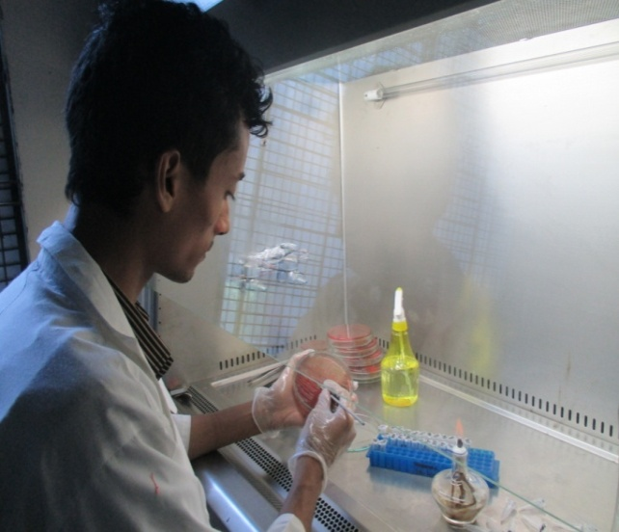

Pouring and solidification of agar in culture plate within laminar air flow.

Inoculation of culture agar plate with sample aseptically.

**Fig-1:** **Preparation and inoculation of agar plate.**

**2.5. Isolation and identification of *E. coli*:**

**2.5.1. Culture protocol for isolation and identification:**

The organism (*E. coli*) was isolated following the protocol described by Clinical and Laboratory Standard Institute (CLSI). At first the cotton swab was inoculated into the screw cap test tube containing nutrient broth (primary enrichment media) and incubated at 370C for overnight to facilitate resuscitation and multiplication of bacteria. After primary enrichment the culture was streaked on MacConkey agar and incubated for 24 hours at 370C. After 24 hours the colony characteristics on MacConkey agar was examined. The organism was suspected as *E. coli* based on pink colored large colonies on MacConkey agar. Later individual colony from MacConkey agar (suspected as *E. coli*) was streaked on EMB agar plate and performed 24 hours incubation at 370C. Based on green metallic sheen colony morphology the organism was confirmed as *E. coli*. It was further confirmed by biochemical test.

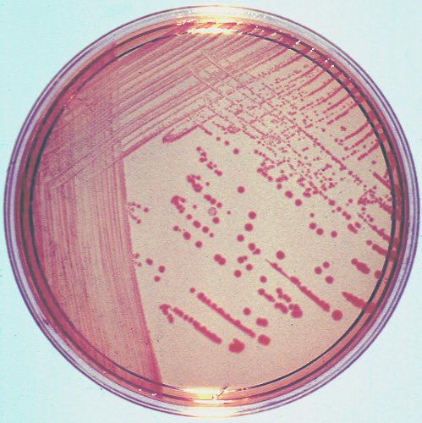

Metallic sheen colony on EMB agar.

Large pink color colony on MacConkey agar.

**Fig-2:** **Colony features of *E. coli* on EMB and MacConkey agar.**

**2.5.2. Biochemical (Indole) test:**

The tube of tryptone broth was inoculated with a small amount of pure culture at 370C for overnight. A positive Indole test was indicated by the formation of a pink to red color ring (cherry to red color ring) in the reagent layer on top of the medium within seconds of adding the Kovac’s reagent.

Cherry red ring in positive indole test.

**Fig-3: Indole test for *E. coli* by using Kovac’s reagent.**

**CHAPTER: 3**

**RESULTS AND DISCUSSION**

**RESULTS**

**Table-1: Prevalence of *E. coli* in total samples:**

|  |  |  |  |  |
| --- | --- | --- | --- | --- |
| **Total no of Samples** | **MacConkey Agar (+ve)** | **Prevalence (%)** | **EMB Agar (+ve)** | **Prevalence (%)** |
| 83 | 71 | 85.54 | 67 | 80.72 |

Table-1 shows the prevalence of *E. coli* in total samples. In MacConkey agar out of 83 samples 71 were found positive and prevalence was 85.54%. In EMB agar out of 83 samples 67 were found positive and prevalence was 80.72%.

|  |  |  |  |
| --- | --- | --- | --- |
| **Area** | **No. of sample** | **EMB Agar (+ve)** | **Prevalence (%)** |
| Pahartolli | 2 | 2 | 100 |
| Noyabazar | 7 | 5 | 71.43 |
| Jawtolla | 3 | 2 | 66.67 |
| Panchlaish | 9 | 7 | 77.78 |
| 2 No. Gate | 2 | 1 | 50 |
| Muradpur | 8 | 7 | 87.5 |
| Sholosahar | 10 | 10 | 100 |
| Alankar | 7 | 7 | 100 |
| Chawkbazar | 8 | 8 | 100 |
| Bahaddarhat | 1 | 0 | 0 |
| Bayezid Bostami | 17 | 12 | 70.59 |
| North kattoli | 9 | 6 | 66.67 |

**Table-2: Prevalence of *E. coli* in different sampling sites:**

Table-2 shows the prevalence of *E. coli* in different sampling sites. Out of the 83 samples the highest prevalence of *E. coli* was found in Pahartolli(100%), Sholosahar(100%), Alankar(100%), Chawkbazar(100%) area and lowest prevalence in Bahaddarhat(0%) area.

**Fig-4: Prevalence of *E. coli* in different sampling sites.**

**DISCUSSION**

In this study, we showed that stray dogs in different area of Chittagong City Corporation such as Pahartolli, Sholosahar, Alankar, Chawkbazar appear to be substantial reservoirs of *E. coli* except Bahaddarhat where the prevalence of *E. coli* was nil.

A study was conducted by Staats *et al*., 2003, where STEC occurrence in domestic dogs in the U.S. have focused on detection of shiga toxin genes among animals with and without gastroenteritis. In one survey, a higher prevalence of stx1 (3% and 15%) and stx2 (36% and 23%) was found in diarrheic and non-diarrheic greyhounds, respectively. In another study, there was no occurrence of stx1 or stx2 in 52 healthy Midwestern research colony dogs (Holland *et al*., 1999). For logistical reasons, we were not able to divide samples on the basis of healthy or unhealthy dogs with diarrhea because of lack of health status information, thus we collected only rectal swab samples from dogs. A survey in Japan revealed an extremely low prevalence of E. coli O157:H7 in dogs and cats, with only 1 of 614 (0.2%) fecal samples testing positive (Kataoka *et al*., 2010). But in our study the prevalence of *E. coli* was 100% in Pahartolli, Sholosahar, Chawkbazar and Alankar, which is extremely high from other studies, because here we only analysed for species specific prevalence not for gene specificity. On the other hand the prevalence was 0% in Bahaddarhat, which may be due to any of the epidemiological causes.

Some efforts have to be made to reduce the possibility of *E. coli* entering into and spread in the community from stray dogs and the most effective and direct approach is thought to be the hygienic rehabilitation of stray dogs other than by homicide or euthanatize them, which is unethical from the point of view of animal welfare but most popular way used in the most of the developing countries.

**CHAPTER: 4**

**CONCLUSION AND RECOMMENDATION**

*E. coli* infection is a leading food-borne and zoonotic disease worldwide. A wide range of foods and companion animals has been implicated in such disease. However, close living with animal especially pet animals and food animal products have been consistently implicated in sporadic cases and outbreaks of human infection. The results of the present study indicate that presence of *E. coli* in the rectal swab of stray dogs is common in the environment of Chittagong, Bangladesh. The poor sanitation and handling of sewage and slaughter house products in the city area could be source of contamination. In view of this research finding, there is a need to develop comprehensive policies to ensure stray dog health maintenance. The following recommendations should prove useful to prevent occurrence of *E. coli* in dog feces and its environment. 1. In order to control *E. coli* infection of dog in Bangladesh detailed epidemiological investigation and strain identification are prerequisites. 2. As the results from this single investigation is not sufficient for formulating standards by the regulatory agencies , more large-scale studies are required to explore prevalence of *E. coli* in stray dogs and their environment and anti-biogram against *E. coli* isolates. 3. All stray dogs should be registered and their health status should be evaluated routinely. 4. Further studies on the national level to identify *E. coli* serotypes and specific antimicrobial resistant gene of *E. coli* isolates should be needed.

**CHAPTER: 5**

**REFERENCES**

Battistuzzi, F.U., Feijao, A., Hedges, S.B., 2004. A genomic timescale of prokaryote evolution: insights into the origin of methanogenesis, phototrophy, and the colonization of land. BMC evolutionary biology4, 44.

Beutin, L., 1999. Escherichia coli as a pathogen in dogs and cats. Veterinary research30, 285-298.

Broes, A.L., 1993. Escherichia coli pathogènes du chien et du chat. Ann. Méd. Vét137, 377-384.

Eckburg, P.B., Bik, E.M., Bernstein, C.N., Purdom, E., Dethlefsen, L., Sargent, M., Gill, S.R., Nelson, K.E., Relman, D.A., 2005. Diversity of the human intestinal microbial flora. science308, 1635-1638.

Holland, R., Walker, R., Sriranganathan, N., Wilson, R., Ruhl, D., 1999. Characterization of Escherichia coli isolated from healthy dogs. Veterinary microbiology70, 261-268.

Kataoka, Y., Irie, Y., Sawada, T., Nakazawa, M., 2010. A 3-year epidemiological surveillance of Escherichia coli O157: H7 in dogs and cats in Japan. Journal of Veterinary Medical Science72, 791-794.

Nam, H.-M., Lee, H.-S., Byun, J.-W., Yoon, S.-S., Jung, S.-C., Joo, Y.-S., Lim, S.-K., 2010. Prevalence of antimicrobial resistance in fecal Escherichia coli isolates from stray pet dogs and hospitalized pet dogs in Korea. Microbial Drug Resistance16, 75-79.

Peeters, J., 1994. Escherichia coli infections in rabbits, cats, dogs, goats and horses.

Singleton, P., 2004. Bacteria in biology, biotechnology and medicine. John Wiley & Sons.

Smith, H.W., 1965. The development of the flora of the alimentary tract in young animals. The Journal of pathology and bacteriology90, 495-513.

Staats, J.J., Chengappa, M., DeBey, M.C., Fickbohm, B., Oberst, R.D., 2003. Detection of Escherichia coli Shiga toxin (stx) and enterotoxin (estA and elt) genes in fecal samples from non-diarrheic and diarrheic greyhounds. Veterinary microbiology94, 303-312.

Thompson, A., 2007. E. coli thrives in beach sands. Live Science.

Vogt, R.L., Dippold, L., 2005. Escherichia coli O157: H7 outbreak associated with consumption of ground beef, June-July 2002. Public health reports120, 174.

**BIOGRAPHY**

Md. Shahadat Hosen is a student of Doctor of Veterinary Medicine (DVM) at Chittagong Veterinary and Animal Sciences University (CVASU). He passed the SSC examination in 2006. He passed the HSC examination in 2008. He has a great interest in large animal medicine.