CHAPTER-3
Results

Prevalence of E. coli
The overall prevalence was 73.5%. The prevalence of E. coli in different chicken lines from two sources in this study are presented in Table 2.
Table 2. Prevalence of E. coli in broilers and indigenous chickens
Chicken lines (n) | Total no of sample | E. coli positive samples (n) | Prevalence  (%)  (95% CI) | Overall prevalence (%)
Broilers | 60 | 40 | 67(54.03-77.3) | 73.5
Indigenous | 60 | 48 | 80(68.07-88.320)

Cultural, staining and motility characteristics
E. coli on MC agar, produced bright pink color colonies which were, transparent, smooth and raised while On EMB agar produced greenish black colonies with metallic sheen.The organisms appeared Gram negative, small rod shaped and arranged in single, pair or short chain. All the isolates were found to be motile.

Biochemical tests
The five basic sugars (dextrose, sucrose, lactose, maltose and mannitol )were fermented by all the isolates with the production of acid and gas. Acid production was indicated by the color change from reddish to yellow and the gas production was seen by the appearance of gas bubbles in the inverted Durham's tubes. All E. coli isolates were catalase, indole and MR positive but VP negative.
Fig: Cherry red ring among Indole (+ve) isolates

Antibiogram of E coli
Antibiotic sensitivity tests of chicken E. coli isolates revealed as sensitive, intermediate and resistant which are shown in Table 3.

Table 3. Antibiotic sensitivity pattern of the E. coli isolates from healthy chickens

Name of antibiotics | Antibiotic sensitivity profiles
 | Sensitive | Intermediate | Resistant
Ciprofloxacin | 23 | 3 | 4
Gentamycin | 20 | 4 | 6
Chloramphenicol | 22 | 3 | 5
Cephalexin | 18 | 3 | 9
Kanamycin | 15 | 5 | 10
Cephradine | 17 | 5 | 8
Streptomycin | 11 | 3 | 6
Tetracycline | 4 | 1 | 25
Amoxicillin | 14 | 6 | 10
Nalidixic acid | 3 | 5 | 22

It can be said that, E. coli isolates were mostly sensitive to ciprofloxacin, chloramphenicol, gentamicin and cephalexin, where it is resistant to tetracycline, nalidixic acid, amoxicillin and streptomycin.
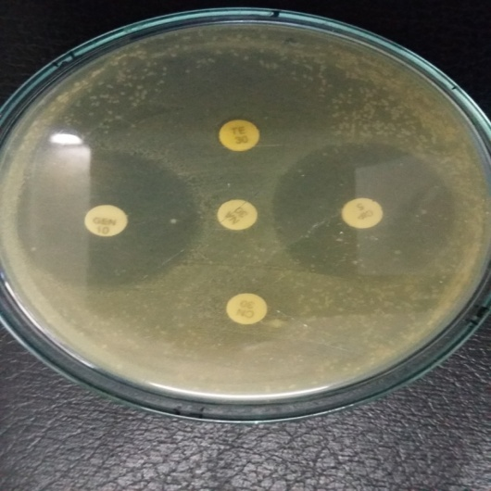
Figure-Sensitivity against antibiotic

