CHAPTER-2
Materials and Methods

Sample collection
2.1. Duration of study:
2 months long (February-April,2015)sample collection activities were performed at different markets named Jhaotola Bazar,Riyajuddin Bazar,Kazir Dewri Bazar and Bahaddarhat Bazar of chittagong Metropoliton area.

2.2. Selection of study area:
Total 120 no. of cloacal swab samples were aseptically collected from apparently healthy broilers (n=60) and indigenous chickens (n=60) of Chittagong metropoliton area and then the samples were packed individually in sterile poly bags using sterile latex gloves to avoid cross-contamination. Each sample was immediately placed in sterile collection tubes containing 5 ml sterilized Buffer Peptone Water (BPW) and tubes were kept in ice box. The samples were taken to the laboratory for microbiological analysis using standard isolation, culture and identification techniques within 12 hours.
2.3 Enrichment
Immediately after collection, samples were separately enriched in Nutrient Broth (NB) by incubating at 37°C for overnight.
2.4 Isolation of E. coli
After enrichment in NB, a small amount of inoculum from NB was streaked onto MacConkey (MC) agar media and incubated at 37°C for overnight.Characteristic colonies was picked up and then again inoculated onto eosin methylene blue (EMB) agar media and incubated at 37°C for overnight (Cheesbrough, 1985) for confirmation.
2.5 Characterization of E. coli
Characterization of the E. coli was performed on the basis of cultural characteristics, Gram staining, motility test and antibiogram profiles. Colonial morphology of E. coli such as- size, margin, elevation and color were recorded on EMB agar and MacConkey (MC) agar media to study cultural characteristics (Cheesebourgh,1985). Biochemical characterization of E. coli was performed by sugar fermentation reactions. Also, methyl red-Voges Proskauer (MRVP), catalase and indole tests were done according to the method described by Cowan (1985).

2.6 Antibiogram study
30 E. coli isolates were randomly selected for antibiotic sensitivity assay. Disc diffusion method described by Bauer and Kirby (Bauer et al2., 1966) was used to determine the susceptibility of E. coli isolates against antibiotic agents. In brief, the procedure involved measuring the diameter of the zone of inhibition that results from diffusion of the antimicrobial agents into the medium surrounding the disc. The reactions of test organisms to each antibiotic were classified as sensitive, intermediate and resistant according to the diameter of zone of inhibition recommended by NCCLS (2003). Ten commercially available antimicrobial discs (Oxoid Ltd, Baringstoke, Hampshire, England) were used in this study, which are mentioned with corresponding standard disc concentration in Table 1.

Table 1. Antibiotic concentration of discs used in antibiotic sensitivity assay for E. Coli
Name of antibiotic | Concentration per disc (µg)
Chloramphenicol | 30
Ciprofloxacin | 5
Gentamicin | 10
Cephalexin | 30
Kanamycin | 30
Cephradine | 30
Amoxicillin | 10
Streptomycin | 10
Tetracycline | 30
Nalidixic acid | 3

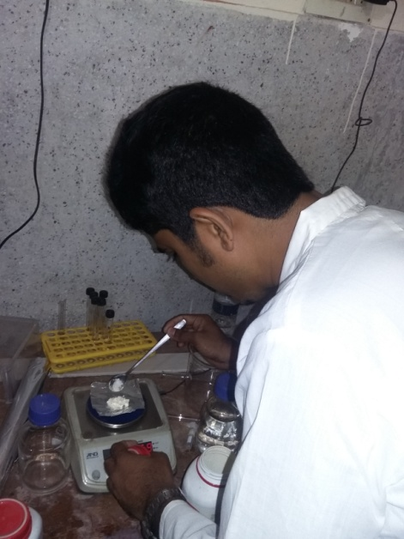 | 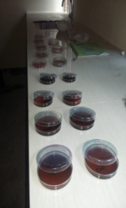 | 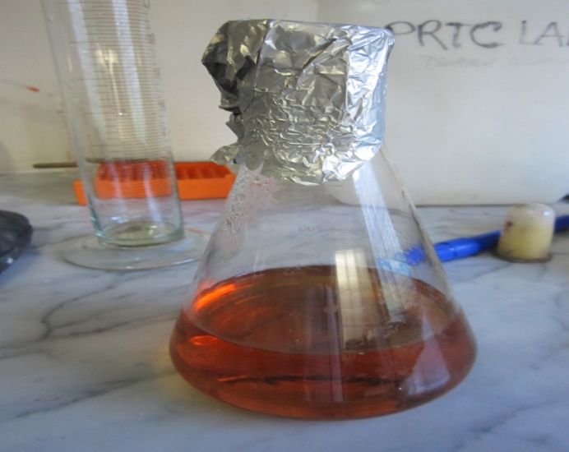
Figure 1: Preparation of MacConkey Agar |  | Figure 2: Preparation of Peptone Water

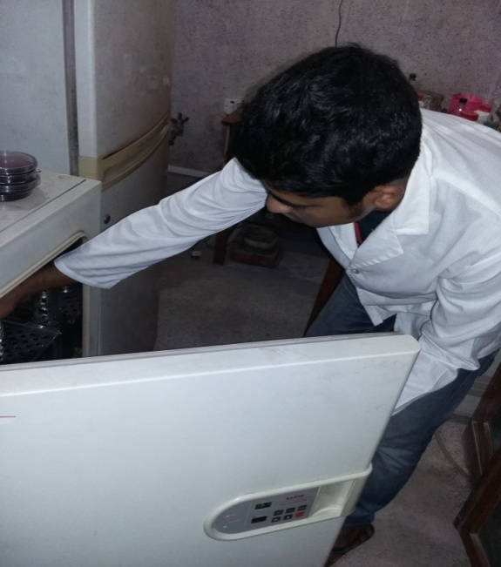 | 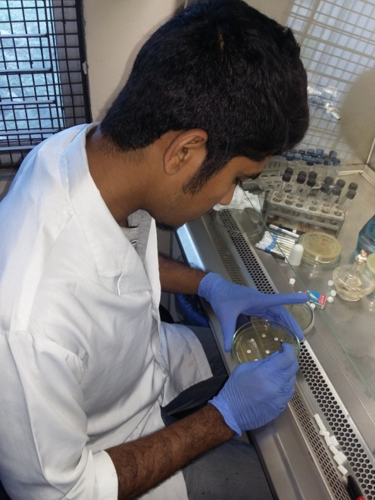
Figure 3: Incubation at 37⁰C | Figure 4: Perform Antibiotic Sensitivity Test

