HEMATOBIOCHEMICAL PROFILE AND URINALYSIS OF CROSSBREED PREGNANT CATTLE

A Clinical Report Submitted
By
Md. Saiful Islam
Roll No: 2009/109
Registration No: 473
Intern ID: G-62
Session: 2008-09

Clinical Report Presented In Partial Fulfillment of the Requirement for the Degree DVM (Doctor of Veterinary Medicine)

Faculty of Veterinary Medicine
CHITTAGONG VETERINARY AND ANIMAL SCIENCES UNIVERSITY, KHULSHI, CHITTAGONG-4225
SEPTEMBER, 2015
HEMATOBIOCHEMICAL PROFILE AND URINALYSIS OF CROSSBREED PREGNANT CATTLE

This clinical report submitted as per approved style and content

-----------------------------------------
Approved
Dr. Amir Hossan Shaikat
Assistant professor
Department of Physiology, Biochemistry and Pharmacology
Chittagong Veterinary And Animal Sciences University-4225.

SEPTEMBER, 2015

TABLE OF CONTENTS
LIST OF ABBREVIATION AND SYMBOLS 5
ABSTRACT 6
CHAPTER –I 7
INTRODUCTION 7
CHAPTER –II 9
MATERIALS AND METHODS 9
2.1 The study area 9
2.2 Sample collection 9
2.3 Sample preservation 9
2.4 Hematological examination 9
2.5 Boichemical assay 9
2.6 Chemical and physical examination of urine 10
2.7 Microscopic examination of urine 10
2.8 Data analysis 10
CHAPTER –III 12
RESULTS 12
3.1: Results of hematological parameter 12
3.2: Results of biochemical parameter 13
3.3 Results of urinalysis 14
CHAPTER IV 16
DISCUSSION 16
4.1 Discussion on Biochemical analysis 16
4.2 Discussion on Urinalysis 16
CHAPTER V 18
CONCLUTION 18
ACKNOWLEDGEMENTS 19
CHAPTER –VI 20
REFERENCE 20
BIOGRAPHY 22

LIST OF TABLES
Table 1: Hematological parameter of cattle of different trimesters (N=30) …… 12
Table 2: Biochemical parameter (N=15) …………………………………………. 13
Table 3: Table for urinalysis (n=30) ……………………………………………… 14
Table 4: Urine analysis table ……………………………………………………… 15
LIST OF FIGURES
Fig 1: Urinalysis with dip strip …………………………………………………… 11
Fig 2: Microscopic examination of blood ………………………………………… 12

LIST OF ABBREVIATION AND SYMBOLS
Abbreviation and symbols | Elaboration
% | Percent
-ve | Negative
> | Greater than
< | Less than
GDP | Gross Domestic Products
BLRI | Bangladesh Livestock Research Institiute
TLC | Total leukocyte count
DLC | Differential leukocyte count
TEC | Total erythrocyte count
PCV | Packed cell volume
Hb | Haemoglobin

HEMATOBIOCHEMICAL PROFILE AND URINALYSIS OF CROSSBREED PREGNANT CATTLE

ABSTRACT
The study was carried out at Military farm, Chittagong Cantonment in Chittagong to find out the haematobiochemical and urinary constituents of pregnant cows in different trimesters. The duration of study was two months (13 January, 2015 to 15 March, 2015). Thirty pregnant cows were selected to collect samples. The BCS of cows was 3-3.5. Age duration of animal was 4-12 years. Then the samples were taken in Physiology and Biochemistry laboratory of CVASU to test different parameters. Several haematobiochemical parameters observed in this study, such as Neutrophil, Eosinophil, Basophil, Moocyte, Hemoglobin, TLC, DLC, TEC etc. Many parameters also observed in urinalysis, such as Glucose, ketone, urobilinogen, HDL etc. It was demonstrated in this study that the mean values of the different parameters of haematological, biochemical and urinalysis showed significant changes during gestation. Monocyte, Total protein, Magnesium, Phosphorus, Urobilinogen level were significant in 1st, 2nd and 3rd trimesters of pregnancy as the value of p<0.05.

Keywords: Trimester, Pregnancy, Haematological, Biochemical, Monocyte

CHAPTER –I

INTRODUCTION
The economy of Bangladesh depends on agriculture. It is the single largest producing sector and comprises about 18.6% of the country’s Gross Domestic Products (GDP). Around 45% labors force employs on it (Central Intelligence Agency: Archived, 2011).
Livestock plays a very important role in the economy of Bangladesh. In Bangladesh, dairying is one of the prime components (Saadullah, 2001). About 14.1% of total GDP comes from milk and many small scale farmers get income through it (DLS, 2013). In Bangladesh daily requirements of milk is about 250 ml per person. The annual milk demand is 14.02 million tons. However, at present the country producing only 6.09 million tons of milk (DLS, 2013-14). There are 23.1 million cattle in the country (DLS, 2011-12). Among the population about 6 million are dairy cattle of which about 85-90% are indigenous and 10-15% are crossbreed.
Recent advances in the understanding of reproductive physiology of lactating dairy cows has led to the development of numerous management strategies and technologies aimed to improve overall reproductive efficiency of dairy herds (Thatcher et al., 2006).
Early identification of pregnant and non pregnant cows post breeding improves reproductive efficiency and pregnancy rate in cattle by decreasing the interval between services. Many new and old technologies are available to identify pregnant and non pregnant animals early post service and can play a key role in and overall reproductive management strategy to rapidly return these animals to the breeding program (Broaddus, 2005).
Highly significant negative correlation was seen between age and glucose, potassium, and phosphorus. Positive correlation was seen between age, globulin, total proteins, body weight/age ratio to glucose, total proteins and phosphorus (Bogin et al., 1988).
Some significant differences were also seen in the blood levels of various analytes in comparison to cattle in other countries, which were a result of genetic, climatic, nutritional and environmental conditions (Otto et al., 2010).
Hence, the biochemical values during different physiological situations should be known to set idea on changes in that time.
Urine analysis is not often part of a veterinary surgeon’s diagnostic armory but recent advances in interpretation of urinary p^{H} and macromolecule content make it an available and interesting investigative tool (Husband, 2010).
Therefore the present study was performed with the following objectives:
1. To find out the hematobiochemical values in different trimesters.
2. To analysis various urinary constituents and level in pregnant cattle of different trimesters.

CHAPTER –II

MATERIALS AND METHODS

2.1 The study area
Military farm, Chittagong Cantonment in Chittagong was selected for the collection of sample.

2.2 Sample collection
Thirty crossbreed pregnant cattle of three trimesters (10 in each trimester) were selected for taking sample. Blood was collected from jugular vein and urine from mid stream of micturition. Vacutainer with and without anticoagulant and falcon tube was used to collect blood and urine sample respectively. After collection, the samples kept in ice box and transported to Physiology Laboratory of Chittagong Veterinary And Animal Sciences University (CVASU).

2.3 Sample preservation
Urine samples were preserved in–20ºC until analysis.

2.4 Hematological examination
The following hematological analysis were performed: Total erythrocyte count (TEC), total leukocyte count (TLC), packed cell volume (PCV), and erythrocyte sedimentation rate (ESR) was performed according to Disease Investigation and Animal Nutrition Research Laboratory. TEC and TLC were determined by hemocytometer. All differential counts of leukocytes were prepared as thin blood smear stained by Wright’s method. MCV, MCH and MCHC values were calculated from the result of TEC, Hb concentration and PCV.

2.5 Boichemical assay
Serum sample obtained from clotted blood was used for biochemical assay of Glucose, total protein, albumin, cholesterol, triglyceride, HDL, calcium, magnesium, phosphorus using automated biochemical analyzer (Humalyzer®-3000, Germany).

2.6 Chemical and physical examination of urine
For chemical and physical examination of urine test strip was used (model: Uric 10 CF). By observing the color change of the strip presence of chemical and physical change was detected. Glucose, Bilirubin, Ketone body, Specific gravity, Blood, p^{H} Protein, Urobilinogen, Nitrite, Leucocytes was qualitatively test from urine. Different reading time was used for determination of the level.

2.7 Microscopic examination of urine
The samples were centrifuged at 3000 rpm for 30 minutes. Then supernatant was discarded. Sediment was mixed properly with vortex mixer. One drop of sediment was taken on a slide and using cover slip over the sample. Finally various constituents were identified at 10x, 40x magnifications.

2.8 Data analysis
All the recorded data was first stored, cleaned using Ms excel 2007. Data was analyzed using Stata-11. Result was expressed as mean±S.E of mean and P value.

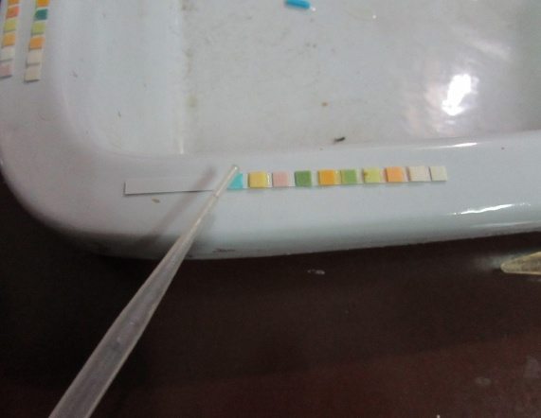
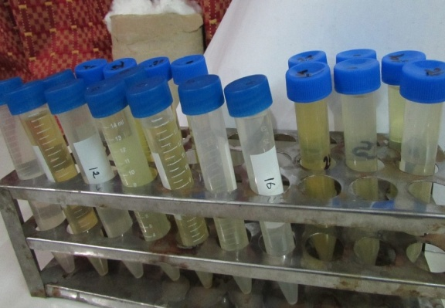
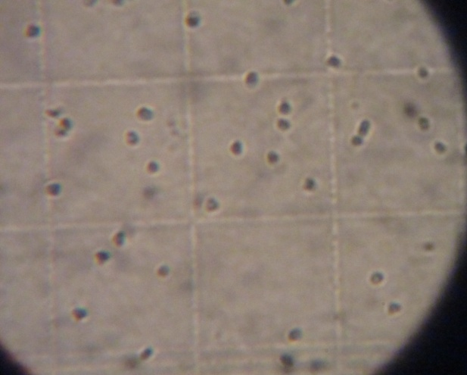
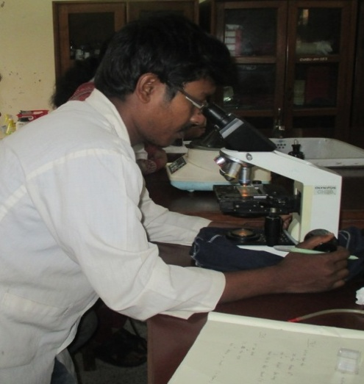
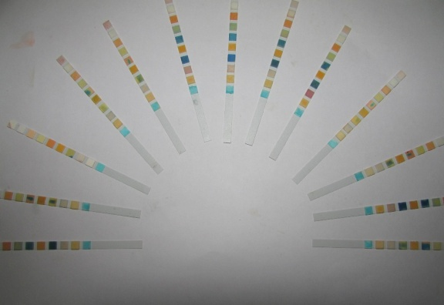
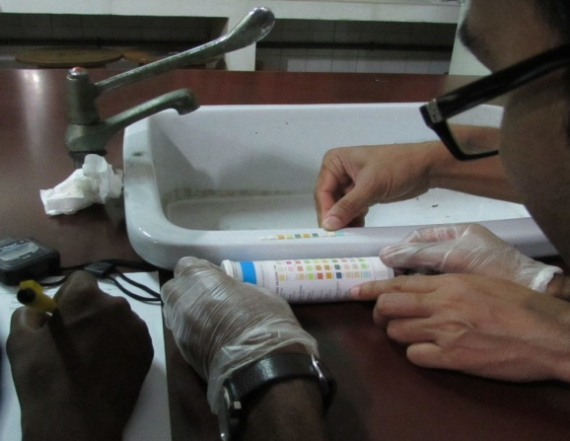
Fig 2: Microscopic examination of blood
Fig 1: Urinalysis with dip strip

CHAPTER –III

RESULTS

3.1: Results of hematological parameter
Table 1: Hematological parameter of cattle of different trimesters (N=30)
Parameters | 1st Trimester (n=10) | 2nd Semester (n=10) | 3rd Semester (n=10) | p-value
Neutrophil (%) | 26.5 ± 4.6 | 27.1 ± 8.8 | 29.9 ± 7.4 | 0.53
Eosinophil (%) | 6.1 ± 3.6 | 9.8 ± 5.1 | 7.6 ± 2.9 | 0.13
Basophil (%) | 0.6 ± 0.6 | 0.1 ± 0.3 | 0.7 ± 1.5 | 0.37
Lymphocyte (%) | 65.3 ± 4.6 | 60.6 ± 11.1 | 59 ± 9.2 | 0.26
Monocyte (%) | 1.5 ± 0.5 | 2.4 ± 1.1 | 2.8 ± 1.3 | 0.03
TEC (mill/cu) | 5.4 ± 0.8 | 6.1 ± 1.5 | 5.4 ± 1.1 | 0.36
TLC (thou/cu) | 8.4 ± 0.9 | 7.2 ± 3.8 | 6.8 ± 1.01 | 0.28
Hb (g/dl) | 6.9 ± 0.3 | 7.9 ± 1.8 | 7.5 ± 0.7 | 0.18
ESR (mm) | 0.6 ± 0.2 | 0.5 ± 0.4 | 0.4 ± 0.4 | 0.55
PCV (%) | 34 ± 4.3 | 32.7 ± 6.3 | 32.1 ± 4.9 | 0.71
MCV (fl) | 63.1 ± 11.6 | 59.1 ± 27.2 | 61.6 ± 16.9 | 0.89
MCH (pg) | 12.9 ± 1.6 | 13.3 ± 2.6 | 14.4 ± 3.5 | 0.43
MCHC (g/dl) | 207.6 ± 30.3 | 256.2 ± 92.3 | 239.1 ± 41.1 | 0.21

Eosinophil level was highest at 2nd trimester of pregnancy (9.8±5.1) %. Basophil level was lowest at 2nd trimester of pregnancy (0.1±0.3) %, Lymphocyte and TLC level ware highest at 1st trimester (65.3 ± 4.6) % and 8.4 ± 0.9, MCHC level was highest at 2nd trimester and lowest at 1st trimester. But these are not significant as p ˃0.05. Only the monocyte level was significant varied as p<0.05. The highest level of monocyte was 2.8 ± 1.3 at 3rd trimester and lowest at 1.5 ± 0.5 in 1st trimester.
3.2: Results of biochemical parameter
Parameters | 1st trimester (n=5) | 2nd trimester (n=5) | 3rd trimester (n=5) | p-value
Glucose (mg/dl) | 164.56±9.78 | 164.98±8.13 | 166.68±8.39 | 0.92
Total protein (g/dl) | 14.92±0.81 | 15.78±0.60 | 14.3±0.79 | 0.03
Albumin (g/l) | 6.66±0.36 | 6.76±0.31 | 6.8±0.57 | 0.87
Cholesterol (mg/dl) | 424.24±27.29 | 438.9±26.76 | 410.46±16.42 | 0.21
Triglyceride (mg/dl) | 472.54±18.79 | 471.60±13.73 | 465.90±19.05 | 0.81
HDL (mg/dl) | 190.62±53.45 | 159.38±35.90 | 135±16.91 | 0.11
Calcium (mg/dl) | 7.78±1.45 | 8.06±1.11 | 7.60±0.94 | 0.83
Magnesium (mg/dl) | 1.84±0.21 | 1.44±0.32 | 2.14±0.30 | 0.01
Phosphorus (mg/dl) | 5.8±1.00 | 7.52±1.31 | 7.26±0.74 | 0.05
Table 2: Biochemical parameter (N=15)

Total protein level was highest at 2nd trimester of pregnancy (15.78±0.60) g/dl and lowest was at 3rd trimester of pregnancy (14.3±0.79) g/dl. It was significant as was p<0.05. Cholesterol level was highest at 2nd trimester (438.9±26.76) mg/dl and lowest level was 3rd trimester (410.46±16.42) mg/dl but not significant as p ˃0.05. Glucose level was highest at 3rd trimester but not significant. Calcium level was highest at 2nd trimester and lowest at 3rd trimester which were (8.06±1.11) and (7.60±0.94) mg/dl respectively. Magnesium was highest at 3rd trimester (2.14±0.30) mg/dl and lowest was 2nd trimester (1.44±0.32) mg/dl. It was significant as p<0.05. Phosphorus level was lowest at 1st trimester (5.8±1.00) mg/dl and highest at 2nd trimester (7.52±1.31) mg/dl. HDL was highest at 1st trimester (190.62±53.45) mg/dl and lowest was at 3rd trimester (135±16.91) mg/dl. Both phosphorus and Magnesium were significant as p<0.05.

3.3 Results of urinalysis
Thirty urine samples were tested with dip stick. Blood, sp. gravity, ketone body, bilirubin, leukocyte, protein, protein code, p^{H} level was observed. From the test results we found different variations though they are not significant. Only urinobilinogen is significant as p-value <0.05. It goes pick level at 3rd trimester (Table 3 and table 4).
Parameter | 1st trimester (n=10) | 2nd trimester (n=10) | 3rd trimester (n=10) | p-value
Blood | 11.5±6.69 | 36.5±57.64 | 38±57.07 | 0.38
Sp. Gravity | 1.006±.002 | 1.006±0.001 | 1.005±0.00 | 0.35
Ketone | 5±5.77 | 9.5±5.99 | 12±11.35 | 0.16
Bilirubin | 0 | 0.6±1.26 | 0.4±0.52 | 0.24
Leukocyte | 16±20.25 | 7.5±7.91 | 13.5±4.74 | 0.32
Protein | 109±134.70 | 151±131.27 | 198±133.40 | 0.34
Protein code | 0.4±0.52 | 0.6±0.52 | 0.7±0.48 | 0.41
p^{H} | 8.7±1.57 | 9.5±0.97 | 8.8±0.92 | 0.28
Table 3: Table for urinalysis (n=30)

Parameter | Category | Prevalence % (No. of positive) | χ²- value | P- value
Nitrite | 1st trimester | 10% | 0.00 | 1.00
 | 2nd trimester | 10%
 | 3rd trimester | 10%
Urobilinogen | 1st trimester | 20% | 12.34 | 0.002
 | 2nd trimester | 10%
 | 3rd trimester | 80%
Glucose | 1st trimester | 0% | 0 | 0
 | 2nd trimester | 0%
 | 3rd trimester | 0%
Table 4: Urine analysis table

CHAPTER IV

DISCUSSION

4.1 Discussion on Biochemical analysis
Glucose level found in 1st, 2nd and 3rd trimester was (164.56±9.78) mg/dl, (164.98±8.13) mg/dl, (166.68±8.39) respectively was insignificant and higher than Roy et al. (2010). Biochemical changes of glucose in different trimester were (128.6±10.2) mg/dl, (129.8.±2.6) mg/dl and (127.6±34) mg/dl respectively (Roy et al., 2010).
Total Protein level found in pregnant cattle of 1st, 2nd and 3rd trimester was 14.92±0.81 (gm/l) and 15.78±0.60 (gm/l) and (14.3±0.79) gm/l respectively. It was significant and slightly increases from other author. Total protein level was increasing for optimize the gonadotropin release factor and other hormone for culmination of pregnancy (Yadav et al., 2006).
Phosphorus level of three trimesters was (5.8±1.00) mg/dl, (7.52±1.31) and (7.26±0.74) mg/dl. It was significant and this study is slightly similar to Roy et al. (2010).
Calcium level in my study of different trimester was (7.78±1.45) mg/dl, (8.06±1.11) and (7.60±0.94) mg/dl respectively. Roy et al. (2010) stated his study that the calcium level was (9.39±0.63) mg/dl, (9.52±0.30) mg/dl and (9.48±0.27) mg/dl respectively. This is somewhat similar to my study.

4.2 Discussion on Urinalysis
Specific gravity of cattle urine in different trimesters was somewhat similar to each other. In 1st and 2nd trimester it was 1.006±0.002 and 1.006±0.001 respectively. In 3rd trimester it was 1.005±0.00 what was similar to Kannan et al. (2010) who stated that the range of specific gravity of urine in normal cattle is 1.025-1.045 with an average of 1.035 and (Braun, 2006); also has shown in obstructive urolithiasis it ranges from 1.008 to 1.025.
p^{H} level found at 1st, 2nd and 3rd trimesters was respectively 8.7±1.57, 9.5±0.97 and 8.8±0.92; Similar result was described by (Mavangira et., 2010). On the other hand Seifi et al. (2004) stated that p^{H} ˃8.25 in the 48 hours prior to calving accurately predict that those cows will get clinical milk fever. So 2nd trimesters cow may affected with milk fever.
The Prevalence of Urobilinogen was 80% at 3rd trimester which was more higher than other trimesters and it was significant (P< 0.05) which support the result of Kimling (2008) who stated that higher percentage of Urobilinogen found at 3rd trimester.
Trace amount of protein found in this study. Siv-Aina et al. (2010) stated that low level of protein in urine are normal. Hohenberger and Kimling (2008) stated that ketone body level in urine 0 (-Ve), 25 (+), 100 (++) and 300 (+++) mg/dl. The presence of ketone body in three trimesters was less than 15 mg/dl which indicate animal was not suffered by abnormal charbohydrate metabolism.
No evidence of glucose was detected in thirty samples. Schultz et al (1993) reported that in pregnant cows glucose requirement increase due to fetal development and very trace amount of glucose may found in urine.

CHAPTER V

CONCLUTION
The haematobiochemical and urinalysis in pregnant cattle of different trimesters we found many alterations. We also found some significant changes in parameters. In haematological test we found monocyte level, in biochemical test total protein, magnesium and phosphorus levels are significant. In case of urinanalysis only the urinobilinogen are significant which goes pick level at 3rd trimester.

ACKNOWLEDGEMENTS
All the praises and deepest sense of gratefulness belongs to the Almighty Allah, the merciful, the Omnipotent and the Beneficent but the Supreme Ruler of the Universe who enabled me to complete my clinical report successfully for the degree of Doctor of Veterinary Medicine (DVM).
Cordial cooperation, friendly collaboration, fruitful advice and guidance were received from many persons throughout the experiment. The author is immensely grateful to all of them and regrets for inability to mention every one by name.
The author sincerely desire to express his deepest sense of gratitude to his teacher and report supervisor Dr. Amir Hossan Shaikat, Assistant professor, Department of Physiology, Biochemistry and Pharmacology, CVASU for his scholastic guidance, valuable advice, constant inspiration, affectionate feeling, radical investigation and constructive criticism in all phases of this study.
The author also expresses his good wishes to Professor Dr. Mohammad Rashedul Alam, Dept. of Physiology, Biochemistry and Pharmacology and Major Prakash Kumar Das, Military farm, Chittagong.
The author is grateful to Mr. Md. Enamul Hoque, Senior Laboratory Attendant (Physiology) and Mr. Rafiqul Islam Technical officer, CVASU for the help during laboratory work.
Author
September, 2015

CHAPTER –VI

REFERENCE
BLRI (2010). A study on conservation and improvement of potential native livestock through community entrepreneurship development. Animal Production Research. Bangladesh Livestock Research Institute, Savar, Dhaka.
Bogin, E., Seligman, N. G., Holtzer, Z., Avidar, Y. and Baram, M. (1988). Blood profile of healthy beef herd grazing seasonal Mediterranean range. Zbl. Vet. Med. 35: 270-276.
Britt (1985); Plaizier et al. (1997); Meadows et al. (2005). The profitability of dairy farms depends greatly on the reproductive efficiency of dairy cows.
Buttler, J.E., Hamilton, W.C., Sasser, R.G., Ruder, C.A., Hass, G.M. and Williams, R.J. (1982). Detection and partial characterization of two bovine pregnancy-specific proteins. Biology of reproduction, 26:925-933.
DLS (2013). Annual Report on Livestock, Division of Livestock Statistics, Ministry of Fisheries and Livestock, Farmgate, Dhaka, Bangladesh.
Doornenbal, H., Tong, A. K. W. and Murray, N. L. (1988). Reference Values of Blood Parameters in Beef Cattle of Different Ages and Stages of Lactation. Can. J. Vet. Res. 52: 99-105.
Food and Agriculture Organization (1999). Regional Office for Asia and the Pacific publication.
Lumsden, J. H., Mullen, K. and Rowe, R. (1980). Hematology and biochemistry reference values of female Holstein Cattle. Can. J. Com. Med. 44: 24-31.
Manzoor, R., Zahoor, A., Pampori, S. I., Javeed, I. A., Bhat, M. A. P. and Manzoor, A. K. (2008). Hemato-Biochemical Indices of cross breed Cows during different stages of pregnancy. Ind. J. D. Sci. 3: 154-159.
Otto, F., Ibanez, A., Caballero, B. and Bogin, E. (1992). Blood profile of Paraguayan cattle in relation to nutrition, metabolic state, management and race. Isr. J. Vet. Med. 47: 91-99.
Otto, F., Vilela, F., Harun, M., Taylor, G., Baggasse, P. and Bogin, E. (2010). Biochemical Blood Profile of Angora Cattle in Mozambique. Isr. J. Vet. Med. 55(3).
Pyne, A. K. and Maira, D. N. (1981). Physiological studies on blood of lactating Hariana and Sahiwal cattle. Ind. Vet. J. 58:526-528.
Roy, S., Roy, M. and Mishra, S. (2010). Hematological and biochemical profile during gestation period in Sahiwal cows. Vet. Worl. 3(1): 26-28.
Zvorc, Z., Matijatko, V., Beer, B., Forsek, J., Bedrica, L. and Kucer, N. (2000). Blood serum proteinograms in pregnant and non-pregnant cows. Veterinarski Arhiv. 70 (1): 21-30.

BIOGRAPHY
Md. Saiful Islam; son of Md. Najir Hossain and Mst. Amena Begum has passed the Secondary School Certificate with GPA-5, Sadakat Hossain High School and Higher Secondary School Certificate from Rajibpur Degree College with GPA-5 from Rajshahi education board. Now he is a interns’ student of Veterinary medicine, Chittagong Veterinary and Animal Sciences University. His favorite hobby is reading books, writing articles and he want to be an honest Veterinarian and researcher. He is interested for find out new techniques for the development of veterinary sciences.

