Effects of garlic (Allium sativum) extracts at different concentrations against Aspergillosis in Broiler

Chapter 1
Introduction

Fungal infections in poultry are less prevalent as compared to bacterial and viral infections. Fungi are eukaryotic organisms, comprising of both yeast and mold. Fungi produce diseases by invading and destroying body tissues of the host; also release some toxins known as mycotoxins (aflatoxins, ocharatoxins, ergot, fusarium toxins etc.) in food grains and feed during crop production, harvesting and storage (Dhama et al., 2007, 2011a; Rai et al., 2011; Singh et al., 2012). Sporadic infections are common but sometimes they may take the form of outbreaks (Dhama and Mahendran, 2008; Turner et al., 2009; Dhama et al., 2011a; Singh et al., 2012). Seasonal variation plays important role in spread of fungal infections. For example during summer fungal infection are more prevalent in closed housing and during autumn huge amount of fungal spores are found in the poultry litter (Soliman et al., 2009). This is happened due to inappropriate use of antibacterial agents which eleminate natural beneficial microflora that suppress the growth of fungi (De Lucca, 2007).

Fungal diseases of poultry include- Aspergillosis, Candidiasis, Dactylariosis, Flavus, Cryptococcosis, Rhodotorulosis, Torulopsis, Mucormycoses and Histoplasmosis. Among these, the first two (Aspergillosis and Candidiasis) are having much importance and the last two (Histoplasmosis and Cryptococosis) have some zoonotic significance (Dhama et al., 2013).Respiratory and nervous system of poultry are the main target of fungal pathogens and cause specific pathological changes in the host characterized by inflammation, lesion and sickness leading to death (Shivachandra et al., 2004).

Aspergillosis, the most common pathogenic fungal disease has economic impact on poultry industries (Singh et al., 2012) either due to their direct infectious nature (Dahlhausen, 2006) or production of mycotoxins on poultry feed (Dhama et al., 2013). It is commonly known as brooder’s pneumonia, mainly caused by Aspergillus fumigatus, which is the most pathogenic fungi that affect poultry (Arne et al., 2011) but A flavus has also been the offender associated with many cases. A fumigatus infection is predominant in poultry as the spores of this pathogenic species are smaller than those of other Aspergillus spp. (Arne et al., 2011). In food and feed-stuffs Aspergillus spp. are able to produce mycotoxins which are known to be potent carcinogens in animals and humans and bring about a reduction in quality of food through spoilage (Juglal et al., 2002; Soliman and Badeaa, 2002; Rasooli and Abyaneh, 2004). Poultry may get infection through contaminated feed and litter or itself in hatcheries as by the release of large number of spores in the environment (Oglesbee, 1997). In acute cases, during initial 1-3 weeks of age mortality range between 5-50% where as in chronic diseases survivors may become lethargic and stunted developing with pulmonary insufficiency or neurological fungal metastasis grouth(Beernaert et al., 2010). During first 3-5 days, dyspnoea is common in neonates as evidenced by open mouth breathing (gaspers) due to progressive airway obstruction. In eyes there may be evidence of cheesy materials deposition and blindness along with CNS abnormalities including torticollis (Throne Steinlage et al., 2003; Dhama et al., 2011a)

To control aspergillosis in birds various drugs like amohotericin-B, 5-fluorocytosine, ketoconazole are usually used (Dhama et al., 2012). On the other hand, over the years much effort has been devoted to the search for new antifungal materials from natural sources (Boyraz and Ozcan, 2005; Hacise-ferogullari et al., 2005). There are about 250,000-500,000 species of plant on earth (Borris, 1996).

Plant originated products that have been made into medicines and used in treatment of bacterial, viral and fungal diseases (Bernal et al., 2011). The use of plants is increasing day by day as they have minor or no side effects (Jordan et al., 2010; Tapsell et al., 2006).

Garlic is an economically important plant which belongs to the family Liliaceae, botanical name “Allium sativum”. Today there is rapidly increasing world-wide interest in Allium sativum, and the number of scientific studies performed every year is incresing exponentially (Borelli, 2007). Garlic has antibiotic, antibacterial and antifungal action (Ismaiel et al., 2012). It is a fungistatic substance, has proved itself against Aspergillus (An et al., 2009; Ogita et al., 2009). Alliums arouse significant importance because of their antibacterial and antifungal activities and including the powerful antioxidants, sulfur and other numerous phenolic compounds (Benkeblia, 2004; Haciseferogullari et al., 2005). Garlic having sulfur containing compounds which give a charecteristic flavour and exhibit potent antifungal properties (Lawson, 1991).

Previously comparative efficacy of different medicinal plants (Neem, Tulsi, Onion, and Garlic) has been investigated against aspergillosis in broiler where garlic showed better result compare to others plants but efficacy of specific concentration of garlic extract has not been carried out. Therefore this study was aimed to find out a specific concentration of garlic extract against aspergillosis in broiler.

1.1 Specific objectives
- To study the in vitro antifungal activity of aqueous garlic extracts at different concentrations in SDA (Sabouraud Dextrose Agar).
- To study the in vivo antifungal activity of aqueous garlic extracts at different concentrations in broiler.
- To evaluate the effects of garlic extracts on haematological parameters (Hb, ESR, PCV, TEC, DLC).
- To explore the effects of garlic extracts on biochemical parameters (Glucose, Creatinine, Cholesterol, SGOT and SGPT).
- To know the effect of garlic extract on feed conversion ratio and growth performance of broilers treated with garlic extracts.

Chapter 2
Review of literature

2.1 Aspergillosis
Aspergillosis is an infectious, non contagious fungal diseases mainly caused by species in the ubiquitous opportunistic saprophytic genus Aspergillus (Beernert et al., 2010). Aspergillus spp. contain approximately 184 species, 40 of which have been reported to cause human and animal infections and reproduce by producing conidia on inseriate or biseriate phialides (Verweij and Brandt, 2007).

2.1.1 Etiology
Aspergillosis is mostly caused by Aspergillus fumigatus,the most pathogenic fungai affecting poultry but Aspergills flavus, Aspergillus niger, Aspergillus glaucus, Aspergillus nidulans and other Aspergillus spp. also can play a role in the disease (Barton et al., 1992; Perlman and Kuttin, 1992; Joseph, 2000). The reason why A. fumigatus is the predominant species of fungal infections that might be the spores are much smaller than the spores of other Aspergillus species (Arne et al., 2011).

Common

Occasional

Infrequent

Aspergillus fumigatus

A.flavus

A.terrus, A. glacus

A.nidulans, A. niger

A.amstelodami, A. nigrescens

Figure-1: Primary causes of aspergillosis in birds.

2.1.2 Species affected
A wide variety of birds die by aspergillosis and it has been reported in almost all types of poultry whatever its age and production types: layer cockrels (Throne Steinlage, 2003), pullets in cages (Corkish, 1982), broiler breeders (Martin et al, 2007), growers of chicken (Zafra et al, 2008), turkey poulets (Olias et al., 2010), common duck breeders (Planel, 2001), goslings (Beytut et al., 2004), great rheas (Copetti et al., 2004), ostriches (Perelman and Kuttin, 1992), japanese quails (Olson, 1969) and pigeons (Tokarzewski et al., 2007).

2.1.3 Epidemiology
An increased concentration of spores in the environment may predispose a bird to aspergillosis. The diseases develop in brooder stages in chicks as well as passerine birds, especially below 3 days of age (Chauhan and Roy, 2008). The predisposing factors for spore generation and dissemination in the air include warm environment, humidity, poor ventilation (Phalen, 2000; Tell, 2005), poor sanitation (Oglesbee, 1997) and the long term storage of feed (Khosaravi et al., 2008). Factors impiring the bird’s immunity can also predispose to mycosis. It primarily causes high morbidity and mortality especially in young chicks (Arne et al., 2011; Redig, 2005). High humidity and moderate temperature contributes significantly towards the occurance and the spread of aspergillosis (Dhama et al., 2008). Contaminant like lead acts as a precipitating factors, especially in geese (Kapetanov et al., 2011).

2.1.4 Pathogenesis
Inhalation is considered the main route of infection for A fumigatus in birds (Oglesbee, 1997). As because A fumigatus spores are too small to be trapped completely in the nasal cavity or trachea and some are able to reach the lungs and air sacs (Fedde, 1998). Usually the air sacs are the primary infection sites, since inhaled air reaches the posterior thoracic and abdominal air sacs prior to contacting epithelial surfaces in the lungs (Nardoni et al., 2006). In the lung parenchyma, spores are getting embedded in the atria and parts of the infundibula in the parabronchus and are engulfed by phagocytic epithelial cells (Maina, 2002). The innate defense mechanisms do not succeed in eliminating infection at the site of the capillaries when bird has an impaired immune response or too many spores are there. This may causes development of loosely attached plaques, which may or may not become overgrown by connective tissue of the host. In the respiratory tract these plaques can obstruct the trachea or bronchi or fill up the air sacs (Oglesbee, 1997). Occasionally, sporulation occurs in the lungs and air sacs (Nardoni et al., 2006; Cacciuttolo et al., 2009). Hyphae containing fruiting bodies can fill the lumen and may penetrate the air sacs, causig serosities and superficial necrosis in the adjacent organs (Tsai et al., 1992). Besides, direct extension of the infection disseminated mycosis also occurs by heamatogenous spread. Hyphae as well as host cells play an important role in this mechanism (Dahlhausen et al., 2004).

2.1.5 Clinical sign
Clinical manifestations depend on the infective dose, the spore distribution, pre-existing diseases and the immune response of the host (Dahlhausen et al., 2004). Avian aspergillosis is classified as acute and chronic. Acute aspergillosis is thought to be the result of inhaling an overwhelming number of spores, while chronic aspergillosis is generally associated with immune suppression (Vanderheyden, 1993).

In acute aspergillosis affected bird show a variety of clinical signs: anorexia, lethargy, ruffled feathers, polydipsia, polyuria, stunting or sudden death. The diseases are commonly known as brooder pneumonia which is highly fatal in first ten days of life and results in a major respiratory distress (Kunkle et al., 2003). Respiratory sign include dyspnea, gasping, hyperpnoea with panting, non productive coughing, wheezing, cyanosis (Throne Steinlage et al., 2003) and sometimes nasal discharge (Singh et al., 2009). Affected birds show gasping along with respiratory rattle and milder form of anemia within 8-10 days in birds’ up to 2 weeks of age (Dhama et al., 2011; Atasever and Gumussoy, 2004). Yellow colored pin point lesions are visible in lungs, air sacs and various organs (Ganguly et al., 2011). Sometimes small yellow green fungus found in all body cavities with dry consistency of lungs, thickened air sacs and suppurate filled bronchioles. Cutaneous aspergillosis with necrotic granulometous dermatitis was observed in chicken and pigeon (Beernaert et al., 2010; Cacciuttolo et al., 2009; Nardoni et al., 2006).

In chronic form, dyspnoea, depression, dehydration and emaciation are described with including nervous sign- ataxia, tremor, opisthotonos, lateral recumbency, torticollis, seizures, convulsions, lameness and hind limb paresis (Throne Steinlage, 2003).

2.1.6 Diagnosis
The signs of aspergillosis are non specific, making diagnosis difficult (Dahlhausen et al., 2004). Individual test does not provide reliable diagnosis and therefore confirmatory diagnosis requires disease history, clinical signs, hematological and biochemical profile, serology, radiographic changes along with endoscopy and cultural examination of the fungus (Jones and Orosz, 2000).

The history of the bird can reveal a stressful event and or some underlying environmental factors and or an immunosuppressive condition (Jenkins, 1991). It may also reveal chronic debilitation, voice change or exercise intolerance (Oglesbee, 1997).
The clinical signs depend on the form of the disease and involvement of organ (Jones and Orosz, 2000), thereby requiring the disease to be differentiated from the other systemic diseases of respiratory tract (Jones and Orosz, 2000).

The results of haematological and biochemical examination can be considered indicative rather than diagnostic (Jones and Orosz, 2000). In aspergillosis case leukocytosis of 20,000 to more than 100,000 white blood cells per microlitre (Oglesbee, 1997), heterophilia with a left shift or degenerative shift, monocytosis and lymphopenia have been described (Forbes, 1992). In addition, non-regenerative anaemia, increased total protein and globulin fraction can be observed (Jones and Orosz, 2000).

The serological tests have been urbanized to confirm an early and more distinct diagnosis of aspergillosis (Peden and Rhoades, 1992). In acute cases, productin of antibody against antigen exposure by 10 to14 days (Brown and Redig, 1994); and if the bird is immunosuppressed, the low antibody production results in false negative results (Redig, 1994). In these cases, it may be more helpful to detect circulating antigen in the serum (Cray et al., 2006). A number of serological test methods like enzyme linked immunosorbent assays, counter immunoelectrophoresis, and agar gel immunodiffusion have been applied. But in general, negative serological tests do not rule out aspergillosis, only positive tests are considered diagnostic when back up by other evidence (Arca-Ruibal et al., 2006; Cray et al., 2006, 2009a).

On necropsy, varying degree of miliary granulomatus foci was noted (Vanderheyden, 1993). Definitive diagnosis requires demonstration of the organisms by cytology or histopathology and subsequent identification by culture (Dahlhausen et al., 2004). Isolation of the fungus alone does not confirm the infection status because Aspergillus organisms are ubiquitous contaminants (Flammer and Orosz, 2008). However, plentiful culturing from any organ should be considered for diagnosis (Redig, 2005). Heart along with organs of respiratory system like larynx, trachea and lungs are important for histopathological examination. Microscopic lesion is suggestive but not helpful in species identification because in vivo hyphae of hyaline filamentous fungi are very similar and their in situ manifestations are not pathognomonic (Cray et al., 2009a; Tekaia and Latge, 2005).
2.1.7 Treatment
Table 1: Administration routes and doses of some antifungals against avian aspergillosis.

Antifungal agent | Administration route | Dose
Amphotericin B | Intravenous  Intrathecal  Nebulization  Into air sac  Topical (Wound) | 1.5mg/kg every 8h interval 3-5 days (Joseph et al., 1994), 10-14 days (Jenkins, 1991)
 |  | 1.35mg/kg 24h interval (liposomally encapsulated amphotericin B) (Bonar and Lewandowski, 2004)
 |  | 1mg/kg 24h interval 10-14 days (Jenkins, 1991)
 |  | 1mg/ml 15min 5-7 days every other week (Orosz and Frazier, 1995) 12h interval (Joseph et al., 1994)
 |  | Dose not specified (Flammer, 1993)
Nystatin Sulphate | Oral | 20000IU/ml every 12h interval 4 days
Cotrimazole | Topical  Nebulization | Dose not specified (Flammer, 1993)
 |  | 10mg/ml polyethylene glycol for 30-45min 24h interval 3 days on/2 days off (1-4 months) (Orosz and Frazier, 1995; Joseph et al., 1994)
Enilconazole | Topical  Nebulization  Disinfection | Dose not specified (Flammer, 1993)
 |  | 0.1ml/kg for 30 min interval 24h 5 days on/2days off (raptors) (Heatly et al., 2007)
 |  | Environment: flush with solutions as recommended for use in poultry houses (Flammer, 1993)
Fluconazole | Oral, Intravenous | 5mg/kg 24h interval 7 days (Flammer, 1993)
 |  | 15mg/kg 12h interval (psittacines) (Pericard, 2005)
Itraconazole | Oral | 5-15mg/kg 12h interval with food for 7-21 days (Bauck et al., 1992)
 |  | 10mg/kg 24h interval 3 weeks (Verstappen and Dorrestein, 2005) (falcons) (Jones et al., 2000)
 |  | 15mg/kg per orally 12/24h interval (Abrams et al., 2001), 10-20mg/kg 12/24h interval (Arikan and Rex, 2000; Flammer, 1993)
 |  | 5mg/kg 24h interval 30 days (African grey parrots) (Orosz and Frazier, 1995)
 |  | 5-10mg/kg 24h interval (Amazon parrots) (Orosz et al., 1996), 6mg/kg 12h interval (pigeons) (Lumeij et al., 1995)
 |  | Preventive: 10mg/kg 24h interval 10 days (Forbes, 1992), 20mg/kg 24h interval (Meredith, 1997), 15-25mg/kg/day for 1 week (Xavier, 2008)
Ketoconazole | Oral | 10-30mg/kg 12h interval 21 days (re-suspending in orange juice 5 days interval) (Bauck et al., 1992)
 |  | 20-30mg/kg 12h interval (Flammer, 1993), 30mg/kg 12h interval 14-30 days (Orosz and Frazier, 1995)
Miconazole | Topical  Intrathecal  Nebulization | 12h interval (Suedmeyer et al., 2002; Abrams et al., 2001; Orosz and Frazier, 1995)
 |  | pH balanced solution, aqueous base, dilute in saline: 15-20min 12h interval (Arikan and Rex, 2000; Orosz and Frazier, 1995)
 |  | 5mg/kg, 10mg/ml, 12h interval (diluted to maximum 0.5ml with saline) (Westerhof, 1995)
Terbinafine | Oral  Nebulization | 10mg/kg 12-24h interval, 15mg/kg 12h interval (psittacines) (Flammer and Orosz, 2008)
 |  | Combined with itraconazole (Flammer, 2006).
Voriconazole | Oral | 10mg/kg 12h interval (pigeon) (Beernaert et al., 2009b), 24h interval (chickens) (Burhenne et al., 2008) (African grey parrots) (Scope et al., 2007)
 |  | 12-18mg/kg 12h interval (African grey parrots) (Flammer and Orosz, 2008)
 |  | 12.5mg/kg 12h interval, 3 days loading dose, then 24h interval (raptors) (Di Somma et al., 2007; Schmidt et al., 2007).
5-fluorocytosine | Oral | 50-100mg/kg 12h interval (Flammer, 1993)
 |  | 60-250mg/kg 12h interval (cage birds); 40mg/kg 6-8h interval (raptors) (Jenkins, 1991)
 |  | 150-250mg/kg for 21 days (Bauck et al., 1992)
 |  | 120mg/kg 12h interval 3 weeks (Westerhof, 1995)
 |  | 120mg/kg 6h interval (Joseph et al., 1994)

2.1.8 Prevention and control
For prevention of aspergillosis, various stress factors and spores exposure need to be minimized along with strict hygiene and sanitation measures in brooder and hatchery (Beernaert et al., 2010). Before setting in the incubator contaminated eggs must be eliminated. After transfer of hatching eggs an effective fungicide should be applied inside the setter (Wind and Yacowitz, 1960). Low moisture contend feed should be given and the littre should be kept dry. In turkeys, elevated platforms help to prevent picking up molds from feed container and waterer. Proper drainage system is necessary to prevent water logging (Chute and Richard, 1991). Good ventilation, hygienic and strees free environmental conditions must be maintain inside the poultry farm. To prevent the disease, a good litter management practice need to be followed and treatment of new litter with antifungal agent is mandatory (Shivachandra et al., 2004). Affected birds should be removed. Feeders should be kept dry and clean to limit the fungal development (Kunkle, 2003a).

2.2 Medicinal plants of Bangladesh
Herbs are plants of which leaves, stems, flowers, seeds and roots are use for flavoring dishes or for medicinal purposes (Hashemy and Davoodi, 2011; Sandhu and Heinrich, 2005). In Bangladesh, different parts of medicinal plants have been used to cure specific ailments. Bangladesh is endowed with vast resources of medicinal plants such as Neem (Azadirachta indica A. Juss), Tulsi (Ocimum sanctum), Sajna (Moringo oleifera), Pineapple (Ananas comosus), Custard apple (Annona reticulata), Onion (Allium cepa), Garlic (Allium sativum), Turmeric (Curcuma longa), Zinger (Zingiber officinale), Betel (Piper betle), Shatamuli (Asparagus racemosus), Sarpagandha (Rauvolfia serpentian benth), Ghritkumari (Aloe indica), Lajjabati (Mimosa pudica), Ulatkambal (Abroma augsta), Dadmardan (Cassia alata), Durba grass (Cynodon dactylon) etc. are using as anthelmintic, antimicrobial, antifungal, astringent and hemostatics (Akhtar et al., 2000). The knowledge of using herbal medicine was disseminated by local kabiraj (Amin et al., 2008).

2.3 Garlic (Allium sativum)
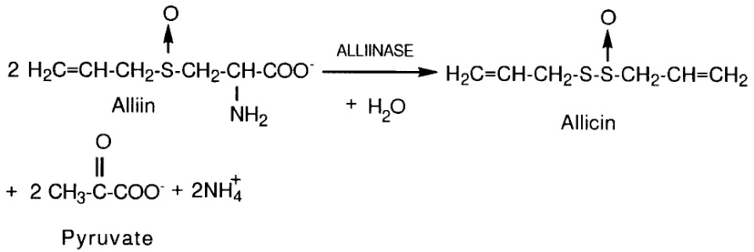
Garlic (Allium sativum) is one of the most trditionally used plants as a spice and herb. Garlic has been shown to inhibit the growth of a variety of microorganisms, not only bacteria (Cavallito et al., 1944) but also fungai (Prasad and Sharma, 1981) and viruses (Esanu and Prahoveanu, 1983). Garlic contains a lot of active components like: Ajone. S-allyl cycteine, Di allyl sulfide and the most active one is Allicin (Onu, 2010). It is believed that the antimicribial activity of garlic to be effect of allicin, the main ingredient in garlic which is generated by the phosphopyridoxal enzyme allinase (Adetumbi and Lau, 1983).

Figure 2: Generation of allicin in a garlic clove.

2.3.1 Antifungal activity of garlic
Allicin, is one of the active principles of freshly crused garlic and exhibit a variety of biological activities such as anti-microbial, anti-inflammatory, anti-thrombotic, anti- atherosclerotic, serum lipid lowering and anticancer activities (Harris et al., 2001). Garlic extract possesses in vitro antifungal activity against Cryptococcus neoformans (Davis et al., 1990), Candida (Ghannoum, 1998) and Aspergillus spp (Yamada and Azuma, 1997).
In many countries garlic is utilized as folk medicine because of its antimicrobial and other beneficial properties and the extract efficacy has been studied against Aspergillus spp (Pai and Platt, 1995). The minimal inhibitory concentration value against Aspergillus has been count 12.5 to 25 µg per ml by broth and agar dilution methods after 5 days of incubation (Yamada and Azuma, 1977). Garlic shows highest antifungal activity against three Aspergillus spp such as- A fumigatus, A niger, A flavas.The minimal inhibitory concentration of aqueous garlic extract has been observed about 325 mg per ml in disc diffusion method after 24 h of incubation (Irkin and Korukluoglu, 2007). Oil of Allium sativum has been showed significant growth inhibition of fungi and the minimal inhibitory concentration has been obtained >2% in disc diffusion method and >4% in broth micro dilution method (Bansod and Rai, 2008). 5% concentration of garlic extract completely inhibits the growth of Aspergillus in agar plate method (Mayah, 2005).

2.3.2 Effect of garlic on chicken’s growth performance
Garlic is one of the oldest cultivated plants (Ramaa et al., 2006). Many scientists investigated the effects of long term feeding of garlic and its’ preparations on the performance of broilers. Garlic was considered as antibiotic growth promoters and has been used for about 50 years to enhance growth performance in poultry and swine (Dibner and Richards, 2005). In broilers, it was reported that garlic as a natural feed additive, improved broiler growth and feed conversion ratio (FCR), and decreased mortality rate (Tollba and Hassan, 2003). Essential oils of garlic acts as a digestibility enhancer, balancing gut microbial ecosystem and stimulating secretion of endogenous digestive enzymes and thus improving growth performance in poultry (Williams and Losa, 2001).

Garlic increases growth and improves feed conversion ratio by increasing height of villus of small intestine and activation of absorption process (Tollba and Hassan, 2003).
Increase in growth, feed conversion and meat quality were obtained when broilers were fed diets containing 1% or 2% Garlic (Bampidis et al., 2005; Freitas et al., 2001). At the end of second week, the highest body mass was achieved in the control group while in the experimental groups with Garlic at 2% was slightly lower (Hernandez et al., 2004). That was probably due to reduced food consumption, resulting from the intense smell of garlic, which required a period of adaptation of chickens to this kind of feed. Body growth was raised and also developed the meat quality and feed conversion while pigs were fed with 1% Garlic (Cullen et al., 2005).

Garlic powder at different levels (0.5 to 3%) had no significant effect on weight gain during the first 21 days of feeding trial compared to that of control birds (Raeesi et al., 2010). However, for the period from 22-42 days, garlic level at 1% resulted in the highest weight gain. For the whole feeding period garlic levels of 1% and 3% significantly increased body weight gain as compared with 0.5% garlic supplemented groups but it was not significant in comparison with control group.

Supplementation of garlic at the rate of 1.5% and 3.0% respectively for a period of 8 weeks and there was no significant difference in feed intake in garlic supplemented groups as compared to control. However, the body weight gain in garlic supplemented groups was slightly higher than control (Prasad et al., 2009). A trial was carried out to study the possibility of using garlic paste as feed additive to high nutrients density broilers diets. There was a positive effect of adding garlic paste on the growth rate and FCR especially with 3% rate (Suliman et al., 2011). Adding 8% of garlic to the feed of broiler chickens did not have a significant effect on feed intake, body weight gain, FCR, the mean of chicken's weight, mortality percentage, dressing percentage, offal percentage, (Ziarlarimi et al., 2011).

2.3.3 Effects on Haematological and Biochemical parameters
The major phytogenic compound obtained from garlic is allicin. Allicin possibly reduces serum LDL, triglyceride and cholesterol and it has been used for cardiovascular diseases (Rahmatnejad et al., 2009). Garlic had been found to lower serum and liver cholesterol (Qureshi et al., 1983a), inhibit bacterial growth (Cavallito and Bailey, 1994), inhibit platelet growth and reduce oxidative stress (Horie et al., 1992).

It was suggested that garlic may decrease cholesterol (CHO) and triglyceride (TG) levels in patients with increased levels of these lipids (Zhang et al., 2001). Using garlic as natural feed supplement has several advantages as the inhibition of platelet aggregation (Apitz Castro et al., 1983) reduction of arterial blood pressure (McMohan and Vargas, 1993) prevention of fat infiltration of liver (Sand et al., 1995). Garlic paste diets in 3% rate significantly increases total protein, albumin and decreases serum cholesterol, glucose levels and triglycerides levels (Suliiman et al., 2011). Garlic supplementation in poultry feed imposes positive effects on hematological parameters of poultry birds. Garlic oil significantly increased white blood cell and reduced red blood cell counts, hemoglobin, hematocrit and mean corpuscular hemoglobin values in rats (Kung-chi et al., 2006). Addition of garlic in diet of fish increase the red blood cells and mean corpuscular volume when it was used at the concentration of 20, 30 40g per kg (Shalaby et al., 2006). Another experiment concluded that garlic supplementation increases the white blood cells, lymphocytes and immunoglobulin G in broilers (Hanieh et al., 2010). In contrast, it has been reported that garlic does not affect leukocyte numbers in broilers (Ao et al., 2011). With regards to WBC counts, it was reported that dietary addition of garlic increased lymphocyte concentration in peripheral blood of pigs. The enhanced lymphocyte proliferation by garlic treatment along with the possible protection of the cells from oxidative stress seemed to contribute for the increased WBC count (Jafari et al., 2008; Onu, 2010)

It was found that ALT and AST levels decreased when rats were fed diet containing 5% A. sativum (Elhaster et al., 1997). A. sativum supplementation significantly decreased ALT and AST in serum of rats (Augusti et al., 2005). Supplementation of garlic in rabbit observed that SGOT and SGPT decreased significantly (Ibrahim et al., 2000). Effect of garlic supplementation on SGOT and SGPT of rat found that there was significant decrease in ALT and AST of rats fed diet containing 4% garlic (Ganiyu, 2006). It was reported that when fish was orally given garlic and onion with feed, there was decrease in SGOT and SGPT (Salahy, 2003). About 50% of kidney function must be lost before a rise in the serum concentration of creatinine (Atef et al., 1994).

Chapter- 3
Materials and methods

3.1 Study area and study period
The study was conducted for a period of six months from July to December, 2015 at the department of Physiology, Biochemistry and Pharmacology, Faculty of Veterinary Medicine, Chittagong Veterinary and Animal Sciences University (CVASU), Bangladesh. The experimental farm shed was located at the 2nd floor, opposite to Physiology Laboratory in academic building No-1, CVASU. The shed was preferred based on location, easy for monitoring and data recording.

3.2 Study design
This experimental study was undertaken to appraise comparative efficacy of garlic extracts at different concentration against aspergillosis in broiler.

Figure 3: Flow chart of study design
Plant | References
Local name - Garlic | Bansod and Rai, 2008
Scientific name – Allium sativum
Family - Liliaceac
Plant part used - Bulb
Medicinal use - Expectorant, Antifungal, Antibacterial.
Water content - 76.1% | Irkin and Korukluoglu, 2007
3.3 Medicinal plant used

3.4 Aqueous Garlic Extract (AGE) Preparation
Collected garlic were peeled off all membranes to elicit the bulb and washed several times with water. Different proportions of garlic extract were prepared (100 %, 90%, 80%, 70%, 60%, 50%, 40%, 30%, 20%, 10% and 5%) by blending the fresh sample accordingly with 100 ml sterile distilled water (w/v ratio). Then prepared extract homogenized at 2000 rpm for 10 min by homogenizer (T₁₀, Germany) and stored at 4 ºC until used. Discs were prepared with collected extract.
3.5 Preparation of inoculums
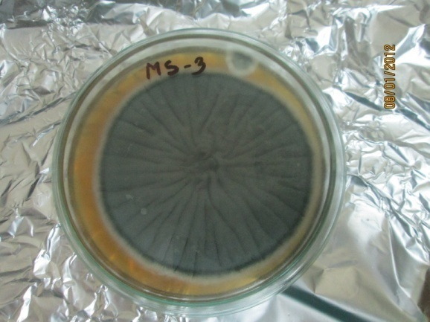
Aspergillus fumigatus isolate was collected from a repository of the Department of Microbiology and Public Health, CVASU. These collected samples were inoculated on to Sabouraud Dextrose Agar (SDA) (Oxoid) and growth of fungi, hyphal tips and spores were observed (Figure: 4) after incubation for 3 days at 37°C. This isolated strain of Aspergillus fumigatus was used for experimental purposes in the study.

Figure 4: Mother culture of Aspergillus fumigatus on SDA
3.6 Antifungal activity test
3.6.1 In vitro assays
Disc diffusion method was used for determination of antifungal activity of AGE. In brief, sterile Sabouraud Dextrose Agar (SDA) was poured into 2/3rd of petri plates. Then the agar was allowed to solidify at 4ºC for 1 hr. Aspergillus spp. inoculum was evenly spread on agar using cotton bud and petri dishes were left at 4ºC to allow agar surface to dry. Then disc impregnated with garlic extracts (100 %, 90%, 80%, 70%, 60%, 50%, 40%, 30%, 20%, 10% and 5%) were placed on the culture medium and a disc with sterile distilled water used as a control. After 5 minutes, plates were turned upside down and incubated at 30°C for 24 hours. At the end of the period, inhibition zones, formed in the medium were measured in millimeters (mm).

3.6.2 In vivo assays
In vivo antifungal trial was performed at different concentration of garlic extract against aspergillosis in broiler. The effect on weight gain, FCR, haematological and biochemical parameters were also studied.

3.6.2.1 Selection of study population
For this study, a total of 80 day-old “A” grade healthy chicks (Cobb- 500) were purchased from commercial breeder farm (Raufabad, Oxygen, Chittagong) as pre-contract basis.
3.6.2.2 Management of brooding chicks
By maintaining adequate biosecurity, chicks were placed in a chick guard and all the chicks were provided proper humidity and ventilation. Immediately after unloading from the chick boxes the chicks were given vitamin-C and glucose to prevent the stress occurring during transport. The floor of the chick guard was maintained by rice husk and paper materials which were replaced with every 8 hrs interval for first 8 days of brooding and only rice husk was used as bedding materials and changed every 12 hrs interval until day-14. Commercially available starter feed (M. M. Agha Poultry) were provided for 13 days (2950 Kcal/kg ME; 22.7% CP). Everyday adlibitum water mixed with various vitamins, minerals, electrolytes, enzymes, phytozyme, glucose were provided.
Vaccine name | Age
- Marek’s vaccine | 1 day
- BCRDV | 4 day
- Gumboro vaccine | 14 day
- BCRDV (booster) | 21 day
Table 2: Vaccination schedule in chicks

3.6.2.3 Management of grower chicken in cages
The 78 birds were divided into eight sub-groups, Groups-1consists of 15 chicks which is treated as control group (T₀) and remaining seven groups were considered as treatment (T₁ to T₇) respectively. Each group consists of 9 chicks. Temperature, humidity, light and ventilation were maintained as for birds comfort. Manually mixed balanced mash feed (3080 Kcal/Kg ME; and 21% CP) and water mixed with various vitamins, minerals, electrolytes, enzymes were provided from 14 to 28 days. Droppings of the birds from cages were carefully removed by washing the tray four times in a day. BCRDV boostering was performed on day 21.

3.6.2.4 Infection with Aspergillus fumigatus
The infection of Aspergillus fumigatus was introduced at day 12 to all birds with infective dose 5 ppm on water according to Moss, 1988. Beside, vitamin C was provided to prevent stress occurring during infection exposure.
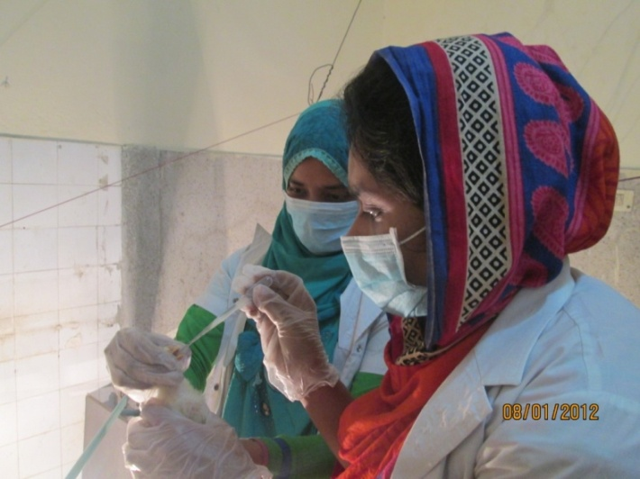

Figure 5: Challenging of the birds against Aspergillus spp.
3.6.2.5 Diagnosis
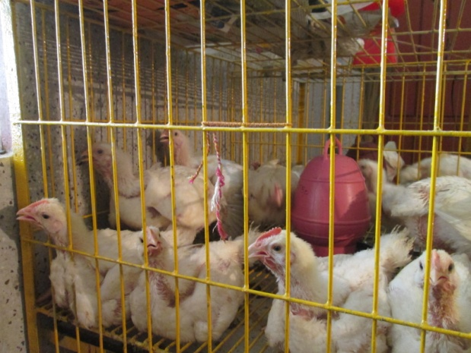
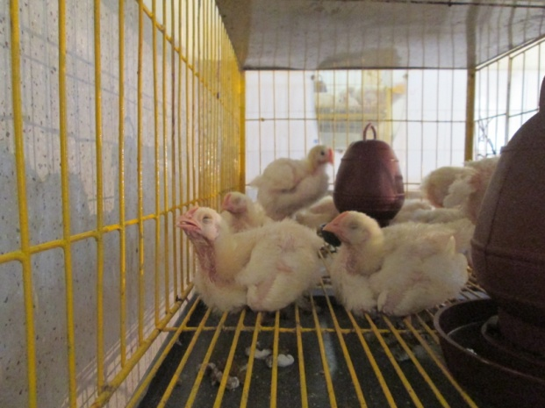
Clinical Sign – Three to six days of post infection, birds were suffering from dizziness, gasping, suffocation, dyspnoea with reduced feed intake and ruffled feather also seen among the infected chicks.

Figure 6: Infected birds with suffocation, dyspnoea and dizziness

Post Mortem Findings – After 7 days of infection a bird was dead. Upon post mortem examination different organs like heart, lungs were found congested. Two birds were dead after 14 days of post infection in which the post mortem findings of dead birds exposed the characteristics whitish/yellowish “sagu” like nodules in lungs with congested lungs and heart.
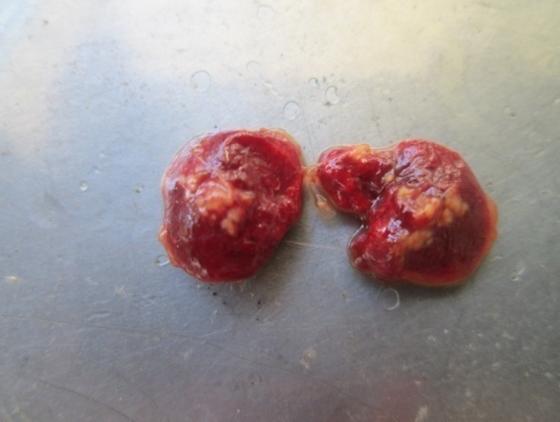
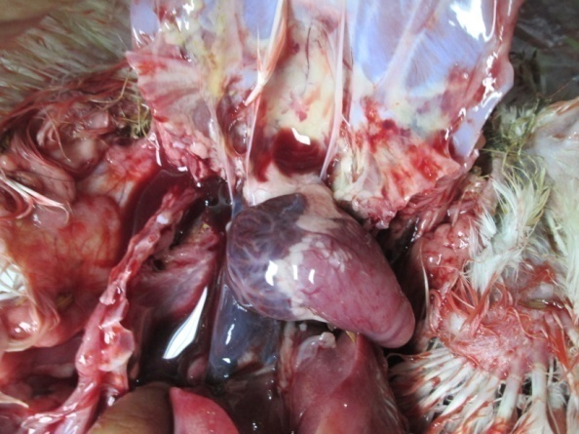

Figure 7: Yellowish nodules (Left figure) and congested heart and lung (Right figure)

3.6.2.6 Treatment intervention

Figure 8: Treatment of Aspergillosis infected chicks with various concentrations of garlic extracts.

3.6.2.7 Treatment and post monitoring
After observing sign-symptom, treatment of infected groups with garlic extracts was started from 23nd day age of the bird according to predesigned treatment layout. Each treatment group except T_{0,} 3 ml of extracts were provided through drinking water.

3.6.2.8 Collection of blood and preservation
Blood was collected at day 28 to study haematological parameter (Hb, ESR, PCV, TEC and DLC) and biochemical parameter (Glucose, TP, Albumin, TG, Cholesterol, ALT, AST, Creatinine. Three ml blood (3 in each group) was drawn from jugular vein of birds and divided into two (1.5 ml) parts equally. One part was taken in tube containing anticoagulants and other parts in tube without anticoagulant. Slide was also prepared from each sample and collected sample was given unique identity number. After collection, samples were immediately shipped to Physiology laboratory of CVASU for hematological evaluation and research laboratory of CVASU for serum separation and biochemical analysis.

3.7 Evaluation of Hematological parameters
EDTA containing blood samples were thawed by keeping at room temperature to determine the hematological parameters. ESR, PCV, TEC, DLC, Hb (Appendix-D) was determined by following the methods described by Lamberg and Rothstein, 1977.

3.8 Separation of serum
After 24 hours, the coagulated blood which in vacutainer with no anticoagulant was centrifuged (Capp Rondo, CR-68X, Denmark) for 20 minutes at 3000 rpm. Obtained serum samples were shifted to the eppendorf tube by using micropipette and given unique identification number. The obtained serum samples were stored in -20ºC until analysis for biochemical tests.

3.9 Evaluation of Biological parameters
Serum and all reagents were thawed by keeping at room temperature approximately for 30 minutes before the analysis. The serum samples were vortexed for mixing component of serum uniformly. The Serum Glucose, Total Protein (TP), Albumin (Alb), TriglycerideS (TG), Cholesterol, AST, ALT, Creatinine (Appendix-E) were assayed by using Automated Biochemical Analyzer (Humalyzer-3000, Germany) following manufacturers instruction. Glucose, TP, Alb, TG, Cholesterol, AST, ALT and Creatinine were determined by commercially available kits (Randox) according to their guide line of manufacturer.

3.10 Effect of garlic on body weight and FCR
3.10.1 Body weight gain
Body weight was measured for all birds at the beginning of the experiment and it was repeated weekly at the beginning of the week at the same time. Live weight gain was calculated by subtraction the live weight at the beginning of the week from the live weight of the next week.
3.10.2 Feed Conversion Ratio
Feed Conversion Ratio (FCR) of each bird was calculated in every week according to the following formula-

Unit of feed consumed
FCR=
Unit of weight increased

3.11 Statistical analysis
Data were arranged into a spread sheet of MS Excel-2007. The data were sorted, cleaned and coded using the excel program before exporting to STATA/IC-11.0 (STATA Corp, USA) for analysis. A T-test was performed to compare the result of different groups according to weight, hematological and biochemical parameters. p values of ≤0.05 were considered statistically significant.

Chapter-4: Results
This experiment was conducted to evaluate the antifungal efficacy of garlic extracts at different concentrations in broiler on the basis of growth performance, hematological and biochemical parameters alteration. It was conducted in two different ways.
4.1 In vitro assays
Different concentrations of garlic extracts exhibited antifungal activity against Aspergillus fumigatus (Figure 9). Various inhibitory concentrations of garlic extract with zone of inhibition against Aspergillus fumigatus. are illustrated in table 3. Highest zone was found in case of 100 % garlic extract and lowest zone was evident in 20% garlic extract. There was no inhibitory zone in case of 5% and 10% garlic extract.
Percent of AGE | Zone of inhibition ( mm)
100 | 20
90 | 18
80 | 18
70 | 16
60 | 15
50 | 11
40 | 9
30 | 6
20 | 5
10 | -
5 | -
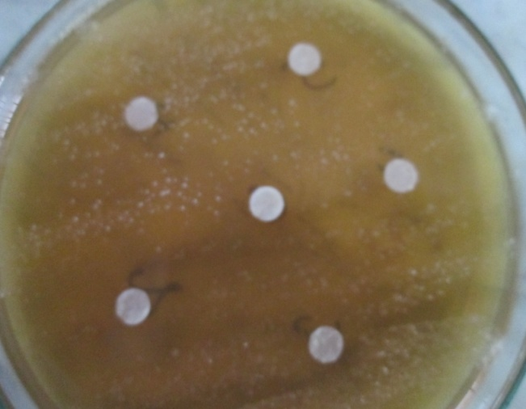

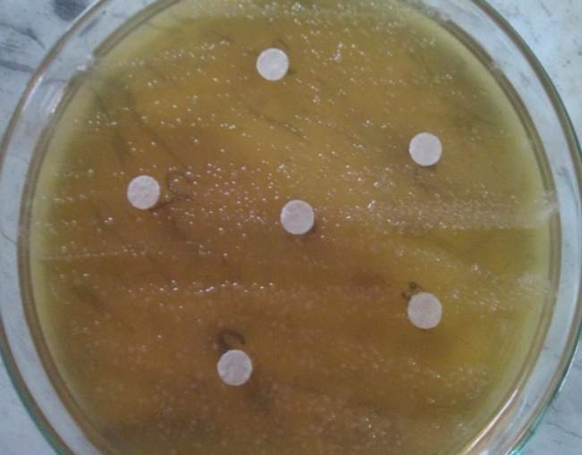

Figure 9: Zone of inhibition of Allium sativum (garlic) against Aspergillus spp.

Table 3: Sensitivity of A fumigatus to different concentrations of AGE

4.2 In vivo assays
During post treatment period, control group chickens were continually suffering from gasping, suffocation, dyspnoea, sitting silently and had a huge thirst. On day 29 after sacrificing control and treated group birds, only characteristics whitish/yellowish nodules or plaques within the lungs and congested lung and heart were found in both control group and 40% garlic treated group.
Category | Birds sacrificed (N) | Postmortem findings
 |  | Whitish/yellowish nodules | Congested lung and heart
Control(T₀) | 3 | +++ | +++
T₁ (100%garlic) | 3 | --- | ---
T₂ (90%garlic) | 3 | --- | ---
T₃ (80%garlic) | 3 | --- | ---
T₄ (70%garlic) | 3 | --- | ---
T₅ (60%garlic) | 3 | --- | ---
T₆ (50%garlic) | 3 | --- | +++
T₇ (40%garlic) | 3 | +++ | +++

Table 4: Post mortem findings on 28th days

4.3 Effect of garlic extracts on growth performances
4.3.1 Live weight
After infection, more or less similar live weight was observed in all groups of broiler. After treatment with garlic extracts, all treated groups significantly gained their body weight except T₁, T₂ and T₃. During post treatment period, the highest body weight gain was recorded in 70% garlic group (T₄) and the lowest body weight gain was recorded in control group (T₀) (Figure: 10).

Figure 10: Live weight variation among control and different treated groups

4.3.2 Total feed intake
In every group, feed intake differed throughout the observational period. In the present study, a significant (p ≤0.05) variation was present between control and different treated groups. In last week, however the lowest feed intake (1965.3g) was observed in T₀ group and the highest feed intake (2177.5) was recorded in T₆ group ( Figure: 11).

Figure 11: Feed intake variation among control and different treated groups

4.3.3 FCR on live weight
FCR of different treated groups or control group of broiler was depicted in figure 12. Insignificant (p ≥0.05) variation was evident between control and different treated groups. At the termination of the study, the highest FCR was observed in control group (T₀) and the lowest in 70% garlic group (T₄). On the other hand FCR value in control (T₀) group was 2.01 which showed inferior performance than treated groups.

Figure 12: FCR on live weight among control and different treated groups

Table 5: Effect of garlic extracts on growth performances in broiler
Parameters | Group – of broiler on day 28 (Mean±SD)
 | T₀ | T₁ | T₂ | T₃ | T₄ | T₅ | T₆ | T₇
Live Weight (g) | 1085.5 ± 63.5 | 1180.7 ± 156.6 | 1217.2 ± 76 | 1250.1 ± 136 | 1261.1 ± 82 | 1244.8 ± 81.9 | 1255.2 ± 67.3 | 1248.4± 92.2
 | P | 0.73 | 0.26 | 0.43 | 0.03 | 0.03 | 0.04 | 0.04
Total Feed Intake (g) | 1965.3 ± 65.2 | 2049.3 ± 44.4 | 2118.2 ± 100.4 | 2165.4 ± 67 | 2161.3 ± 68.6 | 2171.6 ± 42.4 | 2177.5 ± 75 | 2145.2± 69.3
 | P | 0.73 | 0.26 | 0.04 | 0.04 | 0.03 | 0.03 | 0.34
FCR (Live Wt) | 2.01 ± 0.03 | 1.90 ± 0.03 | 1.86 ± 0.03 | 1.84 ± 0.01 | 1.82 ± 0.03 | 1.84 ± 0.01 | 1.84 ± 0.03 | 1.84± 0.01
 | P | 0.26 | 0.24 | 0.20 | 0.17 | 0.20 | 0.20 | 0.20

T₀= Control group, T₁= 100% garlic group, T₂= 90% Garlic group, T₃= 80% garlic group, T₄= 70% garlic group, T₅= 60% garlic group, T₆= 50% garlic group and T₇= 40% garlic group.
SD= Standard Deviation
Significant variation (p≤0.05) and Highly significant variation (p≤0.01)

4.4 Effect of garlic extracts on selected Hematological parameters

4.4.1 Hemoglobin (Hb) concentration
After treated with garlic extract Hb (g/dl) level was decreased compare to control group and this was varied significantly (p <0.05).

4.4.2 Erythrocyte Sedimentation Rate (ESR)
The mean values of ESR were ranged from 1.5 to 2.5 (Table 6). No significant (p ≥0.05) variation was found in ESR (mm/1st hr) among the same studied groups, except T₁ group.

4.4.3. Packed Cell Volume (PCV)
Between infected (control T₀) and garlic treated groups, only significant (p <0.05) PCV (%) level was marked in T₄ group (Table 6).

4.4.4 Total Erythrocyte Count (TEC)
The deviation on TEC (million/mm³) among control and experimental groups were varied insignificantly (p ≥0.05) throughout the experiment period (Table 6).
4.4.5 Differentials Leukocytes Count (DLC)
Among the studied groups leukocytes numbers were varied but the variation was not significant comparing with control group. Only significant changed was found in case of heterophil.

Table 6: Effect of garlic extracts on selective hematological parameters
Parameters | Group –of broiler on day 28(Mean±SD)
 | T₀ | T₁ | T₂ | T₃ | T₄ | T₅ | T₆ | T₇
Hb (g/dl) | 8.3±0.5 | 6.4±0.5 | 7.1±0.7 | 6.3±0.6 | 6.4±0.7 | 6.9±1.1 | 6.7±1.3 | 6.4±0.7
 | P | 0.01 | 0.04 | 0.04 | 0.01 | 0.05 | 0.05 | 0.01
ESR (mm/1st hour) | 1.7±0.3 | 2.5±0.5 | 2±0.5 | 2.1±0.3 | 2±0.5 | 1.8±0.3 | 1.7±0.3 | 1.5±0
 | P | 0.04 | 0.52 | 0.23 | 0.08 | 0.42 | 1.00 | 0.42
PCV (%) | 25.7±2.5 | 36.3±3.8 | 35.3±1.5 | 34.3±3.5 | 35±4 | 36.3±3.1 | 33±2.6 | 27.3±2.1
 | P | 0.08 | 0.06 | 0.10 | 0.08 | 0.03 | 0.12 | 0.19
TEC  (million/mm³) | 2.7±0.1 | 2.4±0.2 | 2.3±0.4 | 2.5±0.1 | 2.4±0.2 | 2.6±0.2 | 2.5±0.2 | 2.7±0.2
 | P | 0.11 | 0.23 | 0.34 | 0.06 | 0.41 | 0.26 | 0.77
Lymph-ocytes (%) | 73.7±5.1 | 65±2 | 68±6.1 | 65.3±4.7 | 70±4.3 | 72±1.7 | 74.7±4.2 | 75.3±3.2
 | P | 0.09 | 0.39 | 0.24 | 0.09 | 0.62 | 0.23 | 0.76
Heterophil (%) | 27±2 | 12.3±3.1 | 13.7±4.0 | 12.7±1.5 | 13.7±3.8 | 13.4±2.3 | 12±3 | 12.3±1.2
 | P | 0.03 | 0.06 | 0.07 | 0.01 | 0.02 | 0.03 | 0.01
Eosino-phil (%) | 5±1 | 1.3±0.6 | 1.7±0.6 | 2±1 | 2±1.7 | 2.3±0.6 | 2.7±0.6 | 2.7±1.5
 | P | 0.05 | 0.06 | 0.09 | 0.18 | 0.05 | 0.07 | 0.19
Baso-phil (%) | 2.3±0.6 | 0.7±0.6 | 1±1 | 1.3±0.6 | 0.7±0.6 | 1.3±0.6 | 1.3±0.6 | 1.7±0.6
 | P | 0.12 | 0.23 | 0.14 | 0.24 | 0.23 | 0.23 | 0.42
Mono-cytes (%) | 7±1 | 4.3±2.1 | 4.3±0.6 | 5.7±1.5 | 6±1 | 5.3±1.5 | 6±0 | 6±1
 | P | 0.09 | 0.09 | 0.38 | 0.09 | 0.29 | 0.23 | 0.23

T₀= Control group, T₁= 100% garlic group, T₂= 90% Garlic group, T₃= 80% garlic group, T₄= 70% garlic group, T₅= 60% garlic group, T₆= 50% garlic group and T₇= 40% garlic group.
SD= Standard Deviation,
Significant variation (p≤0.05) and highly significant variation (p≤0.01)

4.5 Effect of garlic extracts on selected Biochemical parameters

4.5.1 Glucose
After exposure to infection, more or less similar glucose level was observed among the groups. Conversely, after treatment with garlic extracts significant variation (p≤0.05) were found between control and treated groups (Table 7).

4.5. 2 Total Protein (TP)
Total protein level had significantly upward trends between control and treated groups, only exception was found in T₆ group.

4.5. 3 Albumin
Though infected group (control T₀) albumin level was lower but it had upward trends among the treated groups with no significant variations (Table 7).

4.5.4 Aspartate Aminotransferase (AST) and Alanine Aminotransferase (ALT)
The liver functional enzymes AST and ALT both had significant (p ≤0.05) deviated between control and treated groups while ALT level was insignificant in T6 and T7 groups comparing with control (Table 7).
4.5.5 Creatinine
Creatinine (mg/dl) level was 0.4 to 0.6 (Table 7) among all the treated groups, this variation was significant (p ≤0.05) in T₄ and T₅ groups.

4.5.6 Cholesterol and Triglyceride level
After treatment with garlic extracts, cholesterol level was decreased significantly in groups T₂, T₃ and T₄. And significantly reduced level of triglyceride level was found in T₃, T₄, T₅, T₆ and T₇ groups (Table 7).

Table 7: Effect of garlic extracts on selective biochemical parameters
Parameters | Group – Day 28(Mean±SD)
 | T₀ | T₁ | T₂ | T₃ | T₄ | T₅ | T₆ | T₇
Glucose (mg/dl) | 328.6±12.3 | 310.3±12.2 | 306.1±5.6 | 308.2±5.1 | 311.6±28.9 | 312.3±24.1 | 310.9±16.8 | 303.6±3.6
 | P | 0.05 | 0.05 | 0.03 | 0.03 | 0.03 | 0.03 | 0.05
Total Protein (g/l) | 18±6.6 | 39.6±4.9 | 37.6±3.1 | 35±2 | 29±2 | 40.6±9.7 | 34.6±5.7 | 35.6±3.1
 | P | 0.04 | 0.04 | 0.03 | 0.04 | 0.06 | 0.11 | 0.06
Albumin (g/l) | 11.4±1.2 | 15±1.3 | 13.9±4.4 | 14.7±1.2 | 14.4±1.4 | 14.2±2.0 | 12.9±1.5 | 11.6±3.2
 | P | 0.12 | 0.36 | 0.09 | 0.18 | 0.24 | 0.43 | 0.94
AST (u/l) | 226.0±27.3 | 170.4±24.6 | 182.8±35.6 | 171.6±10.5 | 176.6±26.8 | 174.4±54.3 | 189.6±21.9 | 182.9±29.5
 | P | 0.01 | 0.01 | 0.01 | 0.01 | 0.03 | 0.04 | 0.04
ALT (u/l) | 12.1±2.7 | 9.9±2.4 | 6.7±3.2 | 7.4±2.3 | 7.9±1.5 | 7.0±3.8 | 6.9±1.9 | 7.2±1.9
 | P | 0.03 | 0.04 | 0.03 | 0.03 | 0.03 | 0.11 | 0.11
Creati-nine (mg/dl) | 0.4±0.1 | 0.6±0.1 | 0.6±0.1 | 0.6±0.1 | 0.6±0.5 | 0.5±0.1 | 0.5±0.1 | 0.6±0.1
 | P | 0.18 | 0.12 | 0.29 | 0.01 | 0.02 | 0.26 | 0.22
Cholesterol (mg/dl) | 126.8±5.2 | 110.9±9.3 | 109.4±13.5 | 102.0±1.2 | 110.8±3.6 | 110.7±11.3 | 114.9±9.1 | 113.7±10.4
 | P | 0.13 | 0.03 | 0.01 | 0.03 | 0.13 | 0.15 | 0.19
Triglycerides (mg/dl) | 222.4±11.2 | 199.3±3.2 | 175.4±60.7 | 205.3±8.5 | 212.3±7.9 | 202.2±8.3 | 211.2±10.7 | 213.5±115
 | P | 0.08 | 0.31 | 0.05 | 0.04 | 0.01 | 0.04 | 0.04
T₀= Control group, T₁= 100% garlic group, T₂= 90% Garlic group, T₃= 80% garlic group, T₄= 70% garlic group, T₅= 60% garlic group, T₆= 50% garlic group and T₇= 40% garlic group.
SD= Standard Deviation
Significant variation (p≤0.05) and highly significant variation (p≤0.01)

Chapter-5: Discussion
Aspergillosis is a great concern in almost all avian species especially commercial poultry which is more vulnerable, since it causes respiratory problem that leads to major economic impact by hindering the growth of birds. In the present study, both invitro and invivo assay of garlic extract showed activity against aspergillosis. Aspergillus fumigatus is considered as a major respiratory pathogen and cause brooder pneumonia in young poultry (Arne et al., 2011).-Apart from this, other specie of mould such as A. flavus, A. niger, A. nidulans and A. terreus were also isolated from avian species (Dhama et al., 2012; Beernaert et al., 2010; Martin et al., 2007).

In the current study, infected broilers were suffered from gasping, suffocation, dyspnoea, coughing and mucus discharge through nostrils which were coincided with the earlier studies and the observation was found similar to that previously identified in different birds by (Dhama et al., 2011; Cacciuttolo et al., 2009). Clinical signs associated with A. fumigatus infection were quite evident in this study showing clinical sign in 3-6 days post infection in different groups.

Upon postmortem examination, yellow colored uniform pin point lesions were visible on the lungs, which ranged from miliary to larger granulomatous foci as “Sagu” appearance. On the other hand, walls of air sacs were thickened and bronchioles filled with mucus and congested lungs were found. These lesions are similar to the post mortem findings of aspergillosis affected birds described in previous studies (Cacciuttolo et al., 2009; Nardoni et al., 2006). Control (T₀) group and 40% garlic extracts treated group of this study found similar whitish nodule in lung and air sacs after sacrificing of birds.

Garlic (Allium sativum) is a spice with global recognition. The action of garlic is fungistatic and it contains allicin and other sulfur compounds. The antibacterial and antifungal properties of garlic have been described in various in vitro or in vivo studies (An et al., 2009; Ogita et al., 2009; Tedeschi et al., 2007). Similarly in the present study, it has been shown to inhibit the growth of fungi both in vitro and in vivo study. In case of in vitro test there were observed inhibitory zones such as 20, 18, 18, 16 mm for 100, 90, 80, 70% garlic extracts respectively. Irkin and Korukluoglu (2007) stated that 15.5±0.9 mm zone in 32.5 % of aqueous garlic extract. However, Mayah (2005) reported that 5% garlic extract completely inhibit Aspergillus whether the extract was placed on the surface of the medium or mixed with it which is not coincided with the current study where 5% garlic extracts did not show any zone of inhibition.

Moreover, it has also been observed that alliicin, thiosulfonates and other compounds show fungistatic activities against A. niger, Rhodotorula nigricans, Penicillium italicum, Penicillium cyclopium, Aspergillus flavus, Cladosporium macro-carpum, Aspergillus fumigatus, Aspergillus alutaceus, Aspergillus terreus and Penicillium chryogenum (Harris et al., 2001). Yoshida et al (1987) reported that ajoene compound from garlic have stronger antifungal activity than alliicin. They are determined that ajoene damages the cell walls of fungi. According toYamada and Azuma (1997), garlic extract possesses in vitro antifungal activity against Aspergillus spp. where as Ismaiel et al (2012) reported antifungal activity of garlic extracts in in-vivo assay incase of rabbits both studies are corroborated with the current study.

Improved growth performance with a significant relationship between supplementation of garlic extract and final body weight, weekly body weight gain was also evident in garlic treated groups. Similar findings were also recorded in the former studies (Onyimonyi et al., 2012; Vidica et al., 2011).

Present study showed that there had significant effect on body weight gain compared with control group and this finding which was contradictory with Raeesi et al (2010). According to Tollba and Hassan (2003), garlic increases growth and improves feed conversion ratio by increasing height of villus of small intestine and activation of absorption process.

Lewis et al (2003) reported improved FCR in broilers between 7-27 days where Alcicek et al (2003) and Demir et al (2003) found lower FCR between 18-28 days. Birds received garlic, had higher feed consumption with lower FCR which is in agreement with Raeesi et al (2010). Garlic produces intense pungent smell in feed and chickens required a period to adapt which is not continued in this study and which is not in accordance with the earlier findings (Hernandez et al., 2004).

Garlic improved broiler growth and feed conversion ratio (FCR), and decreased mortality rate and these findings were supported by Tollba and Hassan (2003).Though birds were infected, FCR of garlic treated group more or less similar ranging from 1.82 to 1.9 that is abruptly higher in control group (2.01) and there is no significant relationship. In the present study, garlic supplemented groups have better growth rate and FCR compare to control group which are consistent with Bampidis et al., 2005 and Freitas et al., 2001, who reported as very few amount of garlic in broiler diet may increase growth, FCR and meat quality.

The present study, PCV and RBC showed a insignificant (P ≥ 0.05) variation between control and garlic supplemented groups and Hb content reduced significantly which is supported by Jawad (2007), who found that 10% garlic in chicken feed had no significant alteration in PCV and RBC count, while Hb were reduced significantly as compare with the control group. There was insignificant relationship between control and garlic treated groups in total leukocytes count which are in line with Ao et al (2011). According to Kung-chi et al (2006), garlic significantly increased white blood cell and reduced red blood cell counts, hemoglobin, hematocrit and mean corpuscular hemoglobin values and these findings are in agreement with the present study.

Serum glucose concentration in garlic supplemented group was reduced as compared to the control group. These findings are similar to those of Shalaby et al. (2006), Ibrahiem et al. (1995) and Kamal and Daoud (2003) where they observed significant reduction in serum glucose concentration due to garlic supplementation. However, total protein level had a significantly upward trends comparing with control group which were agreed by Suliiman et al (2011).

Garlic reduced-serum cholesterol and triglycerides of broiler chicken and similar result were also reported in the earlier study (Rahmatnejad et al., 2009). In the current study, total serum cholesterol showed a significant (p ≤ 0.05) reduction between control and treated groups. These findings were in agreement with earlier reports of Chowdhury et al (2002) who observed a marked decrease in total serum cholesterol and yolk cholesterol concentration due to supplementation of A. sativum in diet of broilers. According to Suliiman et al., 2011 albumin level was significantly increased with garlic extracts supplementation but this finding is not corroborated with present study. Chen and Li (2006) also observed that the addition of 1 to 2% garlic extracts reduced the serum and muscle cholesterol in broilers similarly. Mean values of SGOT decrease significantly between control and some garlic treated groups. These findings are in accordance with Elhaster et al (1997) who found that SGOT levels decreased when rats were fed with diet containing 5% A. sativum. In another study, Augusti et al (2005) also observed that the A. sativum supplementation significantly decreased ALT in serum of rats which is inconsistent with the current result. Ibrahim et al (2000) supplemented garlic in rabbit and observed that ALT decreased significantly. Present study, AST showed a significant (p < 0.05) reduction between control and garlic supplemented groups are similar to those of Elhaster et al (1997) who found that 5% A. sativum in rat diet significantly decreased AST. Augusti et al (2005) also observed that A. sativum supplementation decreased AST significantly in serum of rat.

Chapter-6: Limitations

Both in vitro and in vivo antifungal efficacy of garlic extracts had been performed throughout the study period where I faced following problems which are necessary to address in future study.

- Space limitation for brooding with large sample population.
- Lack of lab facility to find out active ingredients of garlic.
- There was no standard turbidity of Aspergillus spp.
- No Colony Forming Unit (CFU) for Aspergillus spp.

Chapter-7: Conclusion
In this experiment, both in-vitro and in-vivo antifungal activity of different aqueous garlic extracts against Aspergillus fumigatus was evident. There was also observed that garlic extract treated groups had improved growth performance than aspergillosis infected group. Among different garlic treated groups, better growth performance and FCR were marked in 70% garlic (T₄ group) treated group. Almost all hematological parameters not varied significantly in garlic treated groups but significantly increased PCV (%) was found in 60% garlic (T₅ group) where as significantly reduced Hb (%) and heterophil level were found in all treated groups. On selective biochemical parameters, Glucose, Cholesterol and TG were significantly decreased both in 80% garlic (T₃ group) and 70% garlic (T₄ group) groups where TP increased significantly. Both AST and ALT were significantly varied in all garlic treated groups. In conclusion it can be concluded that, different concentrations of garlic had better antifungal efficacy but 70% garlic extract was the best effective against aspergillosis in broiler with an improved growth performance among all other concentrations of garlic extracts.

Chapter-8: Recommendations and Future Perspective

Antifungal efficacy of garlic extracts at different concentrations was observed both in vitro and in vivo assays in broiler. On the basis of these experiments following recommendations are given-

- Exact active ingredients of garlic which act as antifungal need to be elucidate in future study.
- Toxicity studies of the plant should be done to establish the safety indices of the extracts.
- Carcass quality of treated birds would be evaluated by Association of Official Analytical Chemist (AOAC) methods which will be safe for consumers.
- Need to find out the mechanisms of the action, compatibility with other drugs, such as Amphotericin B, Itraconazole etc side effects and other important parameters.
- Future investigation is required for combined dosages of Garlic with others herbal extracts to provide a better therapy in the management of Aspergillus infection
- This study will facilitate to invent the first ever low cost herbal drugs for treatment o aspergillosis

REFERENCES
Abrams G. A, Paul-Murphy J, Ramer J. C, Murphy C. J. 2001. Aspergillus blepharitis and dermatitis in a peregrine falcon-gyrfalcon hybrid (Falco peregrinus X Falco rusticolus). Journal of Avian Medicine and Surgery. 15 (2): 114-120.
Adetumbi M. A. and Lau B. H. S. 1983. Allium sativum (Garlic)-a natural antibiotic. Med. Hypoth. 12: 227-237.
Ahmad S. 2005. Comparative efficiency of garlic, turmeric and kalongi as growth promoter in broiler. M.Sc. (Hons.) Thesis, Department Poultry Sciences, University of Agriculture, Faisalabad, Pakistan.
Akhtar M. S, Iqbal Z, Khan M. N, Lateef M. 2000. Anthelmintic activity of medical plants with particular reference to their use in animals in Indo-Pakistan subcontinent. Small Ruminant Research Journal. 38 (2): 99-107.
Alcicek A, Bozkurt M, Cabuk M. 2003. The effect of an essential oil combination derived from selected herbs growing wild in turkey on broiler performance. South African Journal of Animal Science. 33 (2): 89-92.
Amin M. R, Mostofa M, Awal M.A, Hossain A. 2008. Effects of neem (Azadirachta indica) leaves against gastrointestinal nematodes in cattle. Journal of Bangladesh Agricultural University. 6 (1): 87-99.
An M, Shen H, Cao Y, Zhang J, Cai Y, Wang R, Jiang Y. 2009. Allicin enhances the oxidative damage effect of amphotericin B against Candida albicans. International Journal of Antimicrobial Agents. 33 (3): 258-263.
Ao X, Yoo J. S, Zhou T. X, Wang J. P, Meng Q. W, Yan L, Cho J. H, Kim I. H. 2011. Effects of fermented garlic powder supplementation on growth performance, blood profiles and breast meat quality in broilers, Livest Sci. 141: 85-89.
Apitz-Castro R, Cabrera S, Cruz M. R, Ledezma E. and Jain M. K. 1983. Effects of garlic extracts and three pure components isolated from it on human platelet aggregation, arachidonate metabolism, release reaction and platelet ultrastructure. Throm. Res. 32; 155- 169.
Arca-Ruibal B, Wernery U, Zachariah R, Bailey T. A, Di Somma A, Silvanose C. and McKinney P. 2006. Assessment of a commercial sandwich ELISA in the diagnosis of aspergillosis in falcons. The Veterinary Record, 158: 442–444.
Arikan S, Rex J. H. 2000. New agents for treatment of systemic fungal infections. Emerging Drugs. 5 (2): 135-160.
Arne P, Thierry S, Wang D, Deville M, Le-Loc’h G, Desoutter A, Femenia F, Nieguitsila A, Huang W, Chermette R, Guillot J. 2011. Aspergillus fumigatus in poultry. International Journal of Microbiology. 2011: Article ID 746356, 14 pages. Available from http://dx.doi.org/10.1155/2011/746356.
Atef M, Youssef S. A, Ramadan A, Afifi N. A, Muity A. A. 1994. Interaction between lead toxicity and some sulphonamides in rabbits: effect on certain blood constituents and serum enzymes. Deutsche tierarztliche Wochenschrift. 101: 187-190.
Augusti K. T, Anuradha Prabha S. P, Smitha K. B, Sudheesh M, George A, Joseph M. C. 2005. Nutraceutical effects of garlic oil, its nonpolar fraction and a Ficus flavonoid compared to vitamin E in CCl₄ induced liver damage in rats. Ind. J. Exp. Biol. 43: 437-444.
Bampidis V. A, Christodoulou V, Florou-Paneri P, Christaki E, Chatzopoulou P. S, Tsiligianni T, Spais A. B. 2005. Effect of dietary dried oregano leaves on growth performance, carcass characteristics and serum cholesterol of female early maturing turkeys. British Poultry Science. 46 (5): 595-601.
Bansod S and Rai M. 2008. Antifungal activity of essential oils from Indian medicinal plants against human pathogenic Aspergillus fumigatus and A. niger. World Journal of Medical Sciences. 3 (2): 81-88.
Barton J. T, Daft B. M, Read D. H, Kinde H. and Bickford A. A. 1992. Tracheal aspergillosis in 6 1/2-week-old chickens caused by Aspergillus flavus. Avian Diseases, 36: 1081–1085.
Bauck L, Hillyer A, Hoefer H. 1992. Rhinitis: case reports. Proceedings of the Annual Conference of the Association of Avian Veterinarians New Orleans LA, USA 134.
Beernaert L. A, Pasmans F, Baert K, Van Waeyenberghe L, Chiers K, Haesebrouck F, Martel A. 2009b. Designing a treatment protocol with voriconazole to eliminate Aspergillus fumigatus from experimentally inoculated pigeons. Veterinary Microbiology. 139 (3): 393–397.
Beernaert L. A, Pasmans F, Van Waeyenberghe L, Haesebrouck F, Martel A. 2010. Aspergillosis infection in birds: A review. Avian Pathol., 39: 325-331.
Benkeblia N. 2004. Antimicrobial activity of essential oil extracts of various onions (Allium cepa) and garlic (Allium sativum).Lebensm.-Wiss.u-Technol. 37: 263-268.
Bernal J, Mendiola J. A, Ibanez E, Cifuentes A. 2011. Advanced analysis of nutraceuticals. Journal of Pharmaceutical and Biomedical Analysis. 55 (4): 758-774.
Beytut E, Ozcan K. and Erginsoy S. 2004. “Immunohistochemical detection of fungal elements in the tissues of goslings with pulmonary and systemic aspergillosis,” Acta Veterina Hungarica, vol. 52, no. 1, pp. 71–84.
Bonar C. J, Lewandowski A. H. 2004. Use of a liposomal formulation of amphotericin B for treating wound aspergillosis in a Goliath heron (Ardea goliath). Journal of Avian Medicine and Surgery. 18 (3): 162–166.
Boyraz N, Ozcan M. 2005. Antifungal effect of some spice hydrosols. Fitoterapia. 76: 661- 665.
Brown P. A. and Redig P. T. 1994 . Aspergillus ELISA: a tool for detection and management. Main conference . In M.J. Kornelsen (Ed.) Proceedings of the Annual Conference of the Association of Avian Veterinarians Reno NV, USA 295
Burhenne J, Haefeli W. E, Hess M, Scope A. 2008. Pharmacokinetics, tissue concentrations and safety of the antifungal agent voriconazole in chickens. Journal of Avian Medicine and Surgery. 22 (3): 199-207.
Cacciuttolo E, Rossi G, Nardoni S, Legrottaglie R. and Mani P. 2009. Anatomopathological aspects of avian aspergillosis. Veterinary Research Communications, 33: 521–527.
Cavallito C. J. and Bailey J. H. 1994. Allicin, the antibacterial principle of Allium sativum. Isolation, physical properties and antibacterial action. J.A.C.S., 66; 1950-1951.
Chen C. X, Li T. S 2006. Effects of garlic on blood lipid and tissue cholesterol contents in broilers. Chinese J. Nutri. 18(1):55-58.
Chowdhury S. R, Chowdhury S. D, Smith T. K. 2002. Effects of dietary garlic on Cholesterol metabolism in laying hens. Poult. Sci. 81(12):1856-1862.
Chute H. L. and Richard J. L. 1991. Aspergillosis. In: Disease of Poultry, Calnek, B.W., H.J. Barnes, C.W. Beard. W.M. Reid and H.W. Yoder Jr. (Eds.). 9th Edn., Iowa State University Press, Ames, Iowa, pp: 326-334.
Colic M, Savic M.2000. Garlic extracts stimulate proliferation of rat lymphocyte in vitro increasing IL-2 and IL-4 production. Immunopharmacol Immunotoxicol. 22: 163-181.
Copetti M. V, Segabinazi S. D, Flores M. L, Alves S. H and Santurio J. M. 2004.“Pulmonary aspergillosis outbreak in Rhea americana in Southern Brazil,” Mycopathologia. 157(3): 269–271.
Cray C, Reavill D, Romagnano A, Van-Sant F, Champagne D, Stevenson R. 2009a. Galactomannan assay and plasma protein electrophoresis findings in psittacine birds with aspergillosis. Journal of Avian Medicine and Surgery, 23: 125–135.
Cray C, Watson T, Rodriguez M. and Arheart K. 2006 . Assessment of aspergillosis diagnostics . In E. Bergman (Ed.) Proceedings of the 27th Annual Conference & Expo of the Association of Avian Veterinarians San Antonio TX, USA 59
Cullen S. P, Monahan F. J, Callan J. J, Odoherty J. V. 2005. The effect of dietary garlic and rosemary on grower-finisher pig performance and sensory characteristics of pork. Irish Journal of Agriculture and food Research. 44 (1): 57-67.
Dahlhausen B, Abbott R. and VanOverloop P. 2004 . Rapid detection of pathogenic Aspergillus species in avian samples by real-time PCR assay: a preliminary report . In E. Bergman (Ed.) . Proceedings of the 25th Annual Conference & Expo of the Association of Avian Veterinarians 37 . New Orleans, LA, USA .
Davis L. E, Shen J. K. and Cai Y. (1990). Antifungal activity in human cerebrospinal fluid and plasma after intravenous administration of Allium sativum.Antimicrobial Agents and Chemotherapy 34, 651–3.
De Lucca A. J, 2007. Harmful fungi in both agriculture and medicine. Rev. Iberoam. Micol., 24: 3-13.
Demir E, Sarica S, Ozcan MA, Suicmez M. 2003. The use of natural feed additives as alternatives for an antibiotic growth promoter in broiler diets. British Poultry Science. 44 (S1): 44-45.
Dhama K, Chakraborty S, Verma A. K, Tiwari R, Barathidasan R, Kumar A. and Singh S. D, 2013. Fungal/Mycotic Diseases of Poultry-diagnosis, Treatment and Control: A Review. Pakistan Journal of Biological Sciences, 16: 1626-1640.
Dhama K, Barathidasan R, Tiwari R, Singh S. D. 2012. Aspergillosis: An important fungal disease of poultry and other birds. Poultry World. 9: 7-9.
Dhama K, Anjaneya, Hansa A, Singh SD. 2011a. Fungal diseases of poultry. Poultry Fortune. 12: 30-35.
Dhama K, Mahendran M, Tomar S, Nandi S. 2008. Mycotoxicosis in livestock and poultry: An overview. Livestock Line. 2: 7-15.
Dhama K. and Mahendran M. 2008. Technologies and advances in diagnosis and control of poultry diseases: Safeguarding poultry health and productivity. Poult. Technol., 2: 13-16.
Dhama K, Chauhan R. S, Mahesh M, Singh K. P, Telang A. G, Lokesh S. and Simmi T. 2007. Aflatoxins-hazard to livestock and poultry production: A review. J. Immunol. Immunopathol. 9: 1-15.
Di Somma A, Bailey T, Silvanose C, Garcia-Martinez C. 2007. The use of voriconazole for them treatment of aspergillosis in falcons (Falco species). Journal of Avian Medicine and Surgery. 21 (4): 307–316.
Dibner J. J. and Richards J. D. 2005. Antibiotic growth promoters in agriculture: History and mode of action. Poult. Sci. 84: 634-643.
Elshater M. A, Sobby M. H, Shehab J. G. 1997. Some pharmacological and pathological studies on Allium sativum (garlic). Appl. Vet. Med. J. 36:264-83.
Esanu V, and Prahoveanu E. 1983. The effect of garlic, applied as much or in association with NaF, on experimental influenza in mice. Rev. Roum. Med. Virol. 34:11-17.
Fedde M. R. 1998. Relationship of structure and function of the avian respiratory system to disease susceptibility. Poultry Science, 77: 1130–1138.
Flammer K. 1993. An overview of antifungal therapy in birds. In: Jackson G. editor. Proceedings of the Annual Conference of the Association of Avian Veterinarians 1. Nashville, TN, USA.
Flammer K. 2006. Antifungal drug update. In: Bergman E. editor. Proceedings of the 27th Annual Conference and Expo of the Association of Avian Veterinarians. San Antonio, TX, USA. Abstract Book, p 3.
Flammer K. and Orosz S. 2008 . Avian mycoses: managing these difficult diseases. In E. Bergman . Proceedings of the 29th Annual Conference & Expo of the Association of the Avian Veterinarians with the Association of the European College of Avian Medicine and Surgery 153 . Savannah, GA, USA .
Forbes N. A. 1992. Diagnosis of avian aspergillosis and treatment with itraconazole. The Veterinary Record. 130: 519–520.
Freitas R, Fonseca J. B, Soares R. T. R. N, Rostagno H. S, Soares P. R. 2001. Utilization of garlic (Allium Sativum) as growth promoter of broilers. Revista Brasileira de Zootecnia. 30 (3): 761-765.
Ganguly S, Paul I, Mukhopadhayay S. K. 2011. Systemic impact of aspergillosis or brooder`s pneumonia in birds. Poultry Line. 11 (2): 49.
Ganiyu O. 2006. Tropical green leafy vegetables prevent Garlic-Induced Hepatotoxicity in the Rat. J. Med. Food 9(4): 545-551.
Ghannoum M. A. 1988. Studies on the anticandidal mode of action of Allium sativum (garlic). Journal of General Microbiology 134: 2917–24.
Haciseferogulları H, Ozcan M, Demir F, Calısır S. 2005. Some nutritional and technological properties of garlic (Allium sativum L.). J. Food Eng. 68: 463- 469.
Hanieh H, Kiyoaki N, Mingzi P, Chaogetu G, Asaki A, Yasuhiro K. 2010. Modulatory effects of two levels of dietary alliums on immune response and certain immunological variables, following immunization, in White Leghorn chickens. Anim Sci J. 81:673-680.
Harris L. C, Cottrel S. L, Plummer S. et al. 2001. Antimicrobial properties of Allium sativum (garlic). Applied Microbiology and Biotechnology 57, 282–6.
Hashemi S. R, Davoodi H. 2011. Herbal plants and their derivatives as growth and health promoters in animal nutrition. Veterinary Research Communications. 35 (3): 169-180.
Heatly J. J, Gill H, Crandall L, Hoerr F. 2007. Enilconazole for treatment of raptor aspergillosis. In: Bergman E. editor. Proceedings of the 28th Annual Conference and Expo of the Association of Avian Veterinarians with the Association of the European College of Avian Medicine and Surgery. Providence, RI, USA. Abstract Book, p 287.
Hernandez F, Madrid J, Garcia V, Orengo J, Megı´as MD. 2004. Influence of two plant extracts on broilers performance, digestibility and digestive organ size. Poultry Science. 83 (2): 169-174.
Horie T, Awazu S, Itakura Y. and Fuwa T. 1992. Identified diallyl olysulfides from an aged garlic extract which protects the membranes from lipid peroxidation. Planta Med. 58: 468-469.
Hubalek Z. 1978. Coincidence of fungal species associated with birds. Ecology, 59: 438-442.
Ibrahiem A, Ibrahiem M, Emara T, Mohamed K. El-M, Talib A. E, Azza K , Fathi F. M. 1995. Effect of feeding onion and garlic on carcass trait and on serum constituents of broiler muscovy ducks. Dept. Nutrition and Clinical Nutrition, Fac. Vet. Med. Cairo University 1-4.
Ibrahim S. A. M, Osfor M. M. H, Mallah G. M. 2000. Garlic and panax ginseng as dietary supplements against the contamination with mercuric chloride in New Zealand rabbits. Egypt J. Rabbit Sci. 10(2): 207-222.
Irkin R. and Korukluoglu M. 2007. Control of Aspergillus niger with garlic, onion and leek extracts. African journal of biotechnology. 6(4):384-387.
Ismaiel A. A, Rabie G. H, Kenawey S. E. M, Abd El-Aal MA. 2012. Efficacy of aqueous garlic extract on growth, aflatoxin B₁ production and cyto-morphological aberrations of Aspergillus flavus, causing human ophthalmic infection: Topical treatment of A. flavus keratitis. Brazilian Journal of Microbiology. 43 (4): 1355-1364.
Issa K. J, Omar J. M. A. 2012. Effect of garlic powder on performance and lipid profile of broilers. Open Journal of Animal Sciences. 2 (2): 62-68.
Jafari R. A, Jalali M. R, Ghorbanpoor M, Saraei M. R. M. 2008. Effect of dietary garlic on immune response of broiler chicks to live Newcastle disease vaccine. Pak J Biol Sci. 11: 1848-1851.
Jawad A. A. D. H. 2007. Some haematological and biochemical effects of garlic on broiler chicken. Bas. J. Vet.Res. 6(2).
Jordan S. A, Cunningham D. G, Marles R. J. 2010. Assessment of herbal medicinal products: Challenges, and opportunities to increase the knowledge base for safety assessment. Toxicology and Applied Pharmacology. 243 (2): 198-216.
Joseph V, Pappagianis D, Reavill D. R. 1994. Clotrimazole nebulization for the treatment of respiratory aspergillosis. In: Kornelsen MJ. editor. Proceedings of the Annual Conference of the Association of Avian Veterinarians. Reno, NV, USA. Abstract Book, p. 301.
Kamal A. M. and Daoud J. R. 2003. Effect of onion and garlic as feed additives on blood, tissue constituents and growth performance in Muscovy ducks. Vet. Med. J. Giza. 51(2):161-175.
Kapetanov M. C, Potkonjak D. V, Milanov D. S, Stojanov I. M, Balos M. Z, Prunic B. Z. 2011. Investigation of dissemination of aspergillosis in poultry and possible control measures. Zbornik Matice Srpske za Prirodne Nauke. 120: 269-278.
Khosravi A. R, Shokri H, Ziglari T, Naeini A. R, Mousavi Z, Hashemi H. 2008. Outbreak of severe disseminated aspergillosis in a flock of ostrich (Struthio camelus). Mycoses. 51 (6): 557-559.
Kung-chi C, Mei-chin Y, Wan-Ju C. 2006. Effect of diallyl trisulfide-rich garlic oil on blood coagulation and plasma activity of anticoagulation factors in rats. Food Chem Toxicol. 45: 502-507.
Kunkle R. A. 2003a. Fungal Infections. In: Saif YM, Barnes HJ, Fadly AM, Glisson JR, McDougald LR, Swayne DE, editors. Diseases of Poultry. 11th ed. Iowa State University Press, Ames, IA. pp. 883-902.
Lawson L. D, Wood S. G, Hughes B. G. HPLC analysis of allicin and other thiosulfinates in garlic clove homogenates. Planta Med. 1991;57:263-270.
Lewis M. R, Rose S. P, Mackenzie A. M, Tucker L. A. 2003. Effects of dietary inclusion of plant extracts on the growth performance of male broiler chickens. British Poultry Science. 44 (S1): 43–44.
Lumeij J. T, Gorgevska D, Woestenborghs R. 1995. Plasma and tissue concentrations of itraconazole in racing pigeons (Columba livia domestica). Journal of Avian Medicine and Surgery. 9 (1): 32-35.
MacMahon F. G. and Vargas R. 1993. Can garlic lower blood pressure? A pilot study. Pharmacotherapy. 13; 406-407.
Maina J. N. 2002. Some recent advances on the study and understanding of the functional design of the avian lung: morphological and morphometric perspectives. Biological Reviews of the Cambridge Philosophical Society, 77: 97–152
Martin M. P, Bouck K. P, Helm J, Dykstra M, Wages D. P, Barnes H. J.2007 . Disseminated Aspergillus flavus infection in broiler breeder pullets. Avian Diseases. 51 (2): 626-631.
Mayah A. A. S. 2005. Effect of garlic and fenugreek extract on Aspergillus fumigatus. Iraqi journal of veterinary madicine. 29(1).
Meredith A. 1997. Prophylactic administration of itraconazole for the control of aspergillosis in gentoo penguins (Pygoscelis papua). In: The 4th Conference of the European Committee of the Association of Avian Veterinarians. London, UK. Abstract Book, p 227.
Moss MO. 1998. Recent studies of mycotoxins. Journal of Applied Microbiology, 84 (Suppl.): 62S-76S.
Nardoni S, Ceccherelli R, Rossi G. and Mancianti F. 2006. Aspergillosis in Larus cachinnans micaellis: survey of eight cases. Mycopathologia, 161: 317–321.
Ogita A, Fujita K, Tanaka T. 2009. Enhancement of the fungicidal activity of amphotericin B by allicin: Effects on intracellular ergosterol trafficking. Planta Medica. 75 (3): 222-226.
Oglesbee B.L. 1997. Mycotic Diseases. In: Avian Medicine and Surgery, Altman, R.B. (Ed.). 1st Edn., W.B. Saunders Company, Philadelphia, PA, USA., pp: 323-361.
Olias. P, Hauck. R, Windhaus. H, Grinten. E, Gruber. A. D and Hafez. H. M. 2010.“Articular aspergillosis of hip joints in turkeys,” Avian Diseases, vol. 54, no. 3, pp. 1098–1101.
Olson L. D. 1969. “Case report—aspergillosis in Japanese quail,” Avian Diseases. 13(1): 225–227.
Onu P.N. 2010. Evaluation of two herbal spices as feed additives for finisher broilers. Biotech. In anim. Husb. 26(5-6), p 383-392.
Onyimonyi A. E, Chukwuma P. C, Igbokwe C. 2012. Growth and hypocholesterolemic properties of dry garlic powder (Allium sativum) on broilers. African Journal of Biotechnology. 11 (11): 2666-2671.
Orosz S. E, Frazier D. L, Schroeder E. C, Cox S. K, Schaeffer D. O, Doss S, Morris P. J. 1996. Pharmacokinetic properties of itraconazole in blue-fronted Amazon parrots (Amazona aestiva aestiva). Journal of Avian Medicine and Surgery. 10 (3): 168-173.
Orosz S. E, Frazier D. L. 1995. Antifungal agents: a review of their pharmacology and therapeutic indications. Journal of Avian Medicine and Surgery. 9 (1): 8-18.
Pai S.T. and Platt M. W. 1995. Antifungal effects of Allium sativum (garlic) extract against the Aspergillus species involved in otomycosis. Appl. Microbiol. 20(1):14-18.
Peden W. M. and Rhoades K. R. 1992. Pathogenicity differences of multiple isolates of Aspergillus fumigatus in turkeys.Avian Diseases, 36: 537–542.
Pericard J. M. 2005. Clinical assessment on the use of fluconazole per os in 24 African grey parrots (Psittacus erithacus): acceptance, side effects and efficiency. In: Bailey T, Chitty J, Harcourt-Brown N, Samour J. editors. Proceedings of the 8th European Conference of the Association of Avian Veterinarians, 6th Scientific ECAMS Meeting of the European College of Avian Medicine and Surgery. Arles, France. Abstract Book, p 222.
Phalen D. N. 2000. Respiratory medicine of cage and aviary birds. Veterinary Clinics of North America: Exotic Animal Practice. 3 (2): 423-452.
Prasad G, and Sharma V. D. 1981. Antifungal property of garlic (Allium satuvum Linn.) in poultry feed substrate. Poult.Sci. 60:541-545.
Prasad R, Rose M. K, Virmani M, Garg S. L. and Puri J. P. 2009. Effect of garlic (Allium sativum) supplementation on productional traits in chicken (Gallus domesticus). Haryana Veterinarian. 48: 23-25.
Qureshi A. A, Abuirmeileh N, Din Z. Z, Elson C. E. and Burger W. C. 1983a. Inhibition of cholesterol and fatty acid biosynthesis in liver enzymes and chicken hepatocytes by polar fractions of garlic. Lipids, 18; 343-348.
Raeesi M, Hoeini-Aliabad S. A, Roofchaee A, Zare Shahneh A, Pirali S. 2010. Effect of periodically use of garlic (Allium sativum) power on performance and carcass characteristics in broiler chickens. World Academy of Science, Engineering and Technology. 68: 1223-1229.
Rahmatnejad E and Roshanfekr H. 2009. Journal of Animal and Veterinary Advances, 8(9): 1757-1760.
Rai R. B, Rahman S, Dixit H, Sweta R. and Singh B. et al., 2011. Analysis of feed ingredients for Afla and T-2 mycotoxins by ELISA in rural areas of Uttar Pradesh. Ind. J. Vet. Pathol., 35: 238-240.
Ramaa C. S, Shirode A. R, Mundada A. S. and Kadam V. I. 2006. Nutraceuticals an emerging era in the treatment and prevention of cardiovascular diseases. Curr. Pharm. Biotech.; 7; 15-23.
Rasooli I, Abyaneh M. R. 2004. Inhibitory effects of thyme oils on growth and aflatoxin production by Aspergillus parasiticus. Food Control. 15: 479-483.
Redig P. T. 2005. Mycotic infections in birds I: Aspergillosis. Proceedings of the North American Veterinary Conference. 8th-12th January, 2005. Eastern States Veterinary Association, Orlando, FL, USA. p 1192-1194.
Redig P. T. 1994 . Diagnosis of avian aspergillosis Kornelsen M.J. Main Conference Proceedings of the Annual Conference of the Association of Avian Veterinarians 355 . Reno, NV, USA .
Salahy M. B. 2003. Some physiological studies on the effect of onion and garlic juices on the fish, Clarias lazera . J. Fish Physiol. Biochem. 90:129-142.
Sand J. K, Nam S. Y, Chung H. C, Hongand S. Y. and Jung K. H. 1995. Enhanced effectiveness of dimethyl-4,4, dimethoxyl-5,6,5’,6’-dimethylinedioxybiphenyl-2,2-dicarboxylate in combination with garlic oil against experimental hepatic injury in rats and mice. J. Pharmacol. 7; 678- 682.
Sandhu D. S, Heinrich M. 2005. The use of health foods, spices and other botanicals in the sikh community in London. Phytotherapy Research. 19 (7): 633-642.
Schmidt V, Demiraj F, Di Somma A, Bailey T, Ungemach F. R, Krautwald-Junghanns M. E. 2007. Plasma concentrations of voriconazole in falcons. The Veterinary Record. 161 (8): 265–268.
Scope A, Burhenne J, Haefel W. E, Hess M. 2007. Species dependent differences and evaluation of possible influences on the enteral absorption of voriconazole in birds. In Proceedings of the 9th European Conference of the Association of Avian Veterinarians, 7th Scientific ECAMS Meeting of the European College of Avian Medicine and Surgery. Zürich, Switzerland. Abstract p 236.
Shalaby A. M, Khattab Y. A , Rahman A. M. A. 2006. Effects of garlic (Allium sativum) and chloramphenicol on growth performance, physiological parameters and survival of Nile tilapia (Oreochromis niloticus). J. Venomous Ani Toxins including Tropical Diseases 12(2):172-201.
Shalaby A. M, Khattab Y. A, Rahman M. A. 2006. Effects of garlic (Allium sativum) and chloramphenicol on growth performance, physiological parameters and survival of nile tilapia (Oreochromis niloticus). J Venomous Anim Toxins Incl Trop Dis.12: 172-201.
Shivachandra S. B, Sah R.L, Singh S.D. Kataria J. M. and Manimaran K. 2004. Comparative pathological changes in aflatoxin fed broilers infected with hydropericardium syndrome. Indian J. Anim. Sci. 74: 600-604.
Singh S. D, Tiwari R. and Dhama K. 2012. Mycotoxins and mycotoxicosis - impact on poultry health and production: An overview. Poult. Punch, 28: 35-52.
Soliman E.S, Sobeih M. A. A, Ahmad Z. H, Hussein M. M, Abdel-Latiff H. and Moneim A. A. 2009. Seasonal epidemiological surveillance on bacterial and fungal pathogens in broiler farms in Egypt. Int. J. Poult. Sci., 8: 720-727.
Suedmeyer W. K, Bermudez A. J, Fales W. H. 2002. Treatment of epidermal cysts associated with Aspergillus fumigatus and Alternaria species in a silky bantam chicken. Journal of Avian Medicine and Surgery. 16 (2): 133-137.
Suliman A. J. C, Subah A. M, Dallah S. A. 2011. Using garlic paste as feed additive in high nutrients density broiler diets on performance and biochemical parameters. Assiut Veterinary Medical Journal. 57(129): 302-322.
Tapsell L. C, Hemphill I, Cobiac L. 2006. Health benefits of herbs and spices: the past, the present, the future. Medical Journal of Australia, 185 (4): 4-24.
Tekaia F, Latge J. P. 2005. Aspergillus fumigatus: Saprophyte or pathogen? Current Opinion in Microbiology. 8 (4): 385-392.
Tell L. A. 2005. Aspergillosis in mammals and birds: Impact on veterinary medicine. Medical Mycology. 43 (s1): 71-73.
the Association of Avian Veterinarians San Antonio TX, USA 59
Throne Steinlage S. J, Sander J. E, Brown T. P, Lobsinger C. M, Thayer S. G and Martinez A. 2003.“Disseminated mycosis in layer cockerels and pullets,” Avian Diseases, vol. 47, no. 1, pp. 229–233.
Tokarzewski S, Ziolkowska G, Lopuszynski W. and Nozdryn-Plotnick Z. 2007.“Aspergillus fumigatusinfection in a pigeon flock,” Bulletin of the Veterinary Institute in Pulawy, vol. 51, no. 4, pp. 563–567.
Tollba A. A. H. and Hassan M. S. H. 2003. Using some natural additives to improve physiological and productive performance of broiler chicks under high temperature conditions: Black cumin (Nigella sativa) or garlic (Allium sativum). Egyptian Poultry Science Journal. 23(2): 327-340.
Tsai S. S, Park J. H, Hirai K. and Itakura C. 1992. Aspergillosis and candidiasis in psittacine and passeriforme birds with particular reference to nasal lesions. Avian Pathology, 21: 699–709.
Turner N. W, Subrahmanyam S and Piletsky S. A. 2009. Analytical methods for determination of mycotoxins: A review. Anal. Chim. Acta, 632: 168-180.
Vanderheyden N. 1993 . Aspergillosis in psittacine chicks Jackson G. Proceedings of the Annual Conference of the Association of Avian Veterinarians 207 . Nashville, TN, USA .
Verstappen F. A. L. M, Dorrestein G. M. 2005. Aspergillosis in Amazon parrots after corticosteroid therapy for smoke-inhalation injury. Journal of Avian Medicine and Surgery. 19 (2): 138-141.
Verweij P. E. and Brandt M. E. 2007. Aspergillus, Fusarium and other opportunistic moniliaceous fungi. In P. R. Murray (Ed.), (9th ed., pp. 1802-1838). Washington D.C.: ASM Press.
Vidica S, Dragan G, Niko and Nada P. 2011. Effect of garlic (Allium sativum L.) in fattening chicks nutrition. African Journal of Agricultural Research. 4 (2): 11-21.
Westerhof I. 1995. Treatment of tracheal obstruction in psittacine birds using a suction technique: a retrospective study of 19 birds. Journal of Avian Medicine and Surgery. 9 (1): 45-49.
Williams P. and Losa R. 2001. The use of essential oils and their compounds in poultry nutrition. World Poult.-Else., 17(4); 14-15.
Wind S. and Yacowitz H. 1960. Use of mycostatin in the drinking water for the treatment of crop mycosis in turkeys. Poult. Sci., 39: 904-905.
Xavier M. O. 2008. A review of aspergillosis in penguins. Available from: http: www.aspergillus.org.uk/secure/articles/aspergillo.pdf.
Yamada Y. and Azuma K. 1977. Evaluation of the in vitro antifungal activity of allicin. Antimicrobial Agents and Chemotherapy 11, 743–9.
Yoshida A. S, Kasuga S, Hayashi N, Ushiroguchi T, Matsuura H, Nakagawa S. 1987. Antifungal activity of ajoene derived from garlic. Appl. Environ. Microbiol. 53:615-617.
Zhang X. H, Lowe D, Giles P, Fell S, Connock M. J. and Maslin D. J. 2001. Gender may affect the action of garlic oil on plasma cholesterol and glucose levels of normal subjects. J. Nutr. 131; 1471-1478.
Ziarlarimi A, Irani M. and Gharahveysi S. 2011. An investigation on the replacement of antibiotics by medicinal plants to control the infection of Escherichia coli in broiler chickens. African Journal of Biotechnology. 2011; 10(56): 12

Appendix-A
A
B
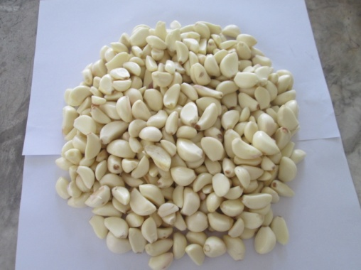
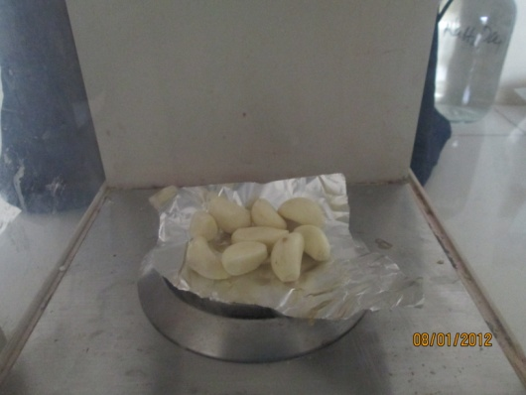
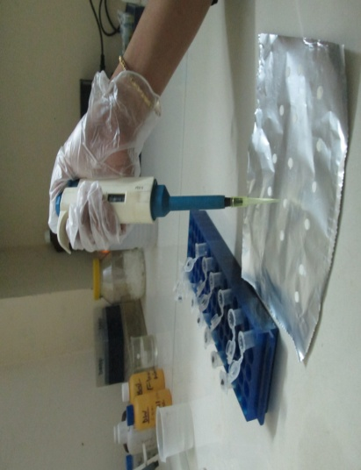
F
C

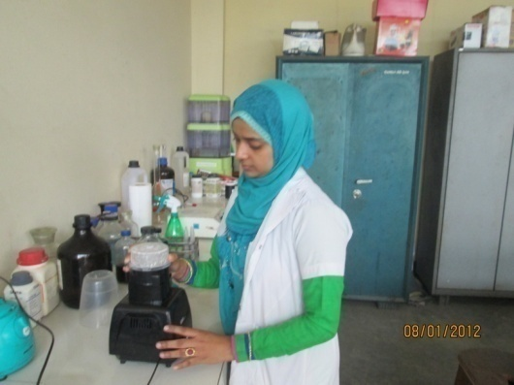
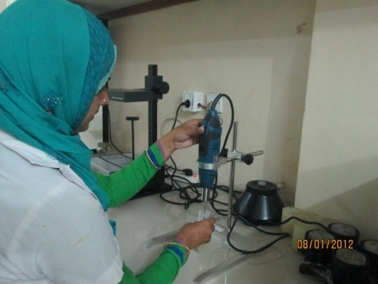
D

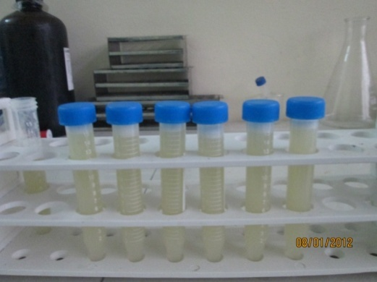
E

Figure 13: Preparation of aqueous garlic extracts
A. Peeled off garlic, B. Weighing of garlic, C. Blending, D. Homogenization, E. Final extract, F. Disc preparation.

Appendix-B
B
A
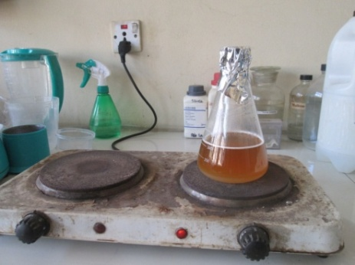
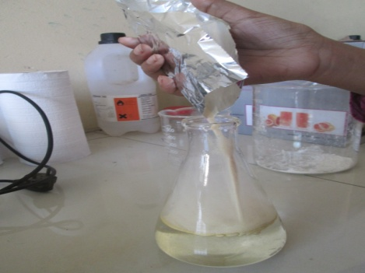

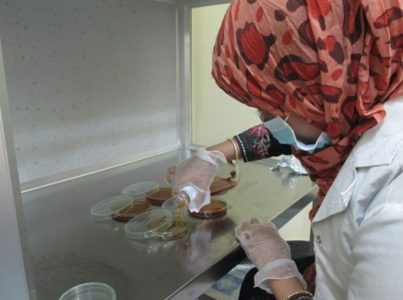
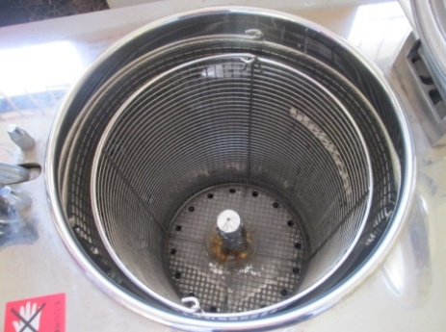
C
D

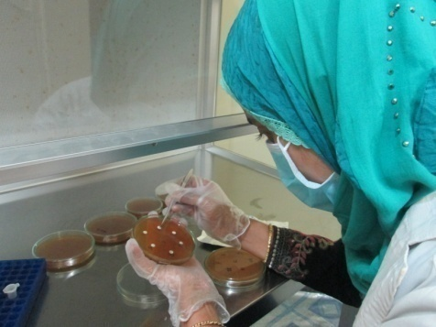
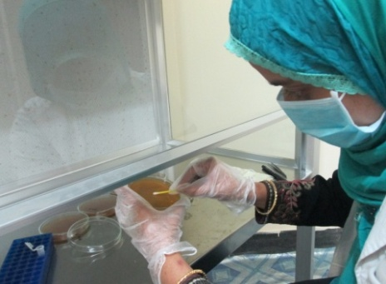
E
F

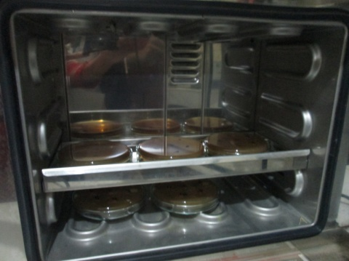
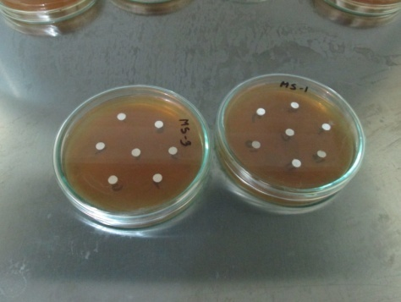
G
H

Figure 14: In vitro antifungal test
A. Sabouraud Dextrose Agar powder mixed with water, B. Heating, C. Autoclaving of agar, D. Agar poured into Petri plate, E. A fumigates inoculums spread on agar surface, F. Disc placed on culture medium, G. Prepared plate, H. Plate placed in incubator.

Appendix-C

Table 8: Composition of the experimental broiler grower diet

Ingredients | Grower ration (14-28 days) (Kg/100Kg)
Maize | 58.0
Auto Rice Polish | 3.75
Soybean oil | 3.2
Molasses | 0.6
Soybean Meal | 27.5
Protein Concentrate | 3.0
Meat and Bone meal | 2.0
Limestone | 1.0
DCP | 0.5
Salt | 0.25
Vitamin mineral premix | 0.25
Cholin Chloride | 0.10
L-lysin | 0.05
DL-Methionine | 0.10
Antioxidant | 0.0125
Total | 100.3125

Appendix-D
Hematological Parameters
Blood samples were collected from wing vein of chicken of both control and treated groups at day 28 to study the effect of garlic extract and the following parameters were tested:
1. Total Erythrocyte Count (TEC)
2. Hemoglobin estimation (Hb)
3. Packed Cell Volume (PCV)
4. Erythrocyte Sedimentation Rate (ESR)

Determination of Total Erythrocyte Count (TEC):
Total erythrocyte count was done following the method described by Lamberg and Rothstein (1977). Well-mixed blood sample was drawn with red blood cell diluting pipette exactly up to 0.5 marks of the pipette. Outside of the tip of the pipette was wiped with cotton. Then the pipette was immediately filled with the red cell diluting fluid (Hayem's solution) up to 101 marks. The free end of the pipette was wrapped around with the rubber tube stretching to both the ends and held with thumb and middle finger. The content of the pipette was mixed thoroughly by shaking with 8-knot motion for 3-5 minutes. Then the counting chamber was placed with special cover glass under microscope using low power (10x) objectives. After discarding 2 or 3 drops of fluid from the pipette, a small drop was placed to the edge of the cover glass on the counting chamber as the entire area under the cover glass was filled by the fluid. One-minute time was spared to allow the cells to settle on the chamber under the cover glass. Taking 5 larger squares (4 in the 4 corners and the central one) of the central large square, the cells were counted from all the 80 small squares (16 x 5) under high power objectives (45x). After completion of counting, the total number of RBC was calculated as number of cells counted x 10,000 and the result was expressed in million/cu.mm of blood.

Determination of Hemoglobin Concentrations (Hb):
The N/10 hydrochloric acid (Hcl) was taken in a graduated tube up to 2 marks with the help of a dropper. Well-homogenized blood sample was then drawn into the Shale pipette up to 20 cm. mark. The tip of the pipette was wiped with sterile cotton and the blood of the pipette was immediately transferred into the graduated tube containing hydrochloric acid. This blood and acid were thoroughly mixed by stirring with a glass stirrer. There was a formation of acid hematic mixture in the tube by hemolysing red blood cells by the action of Hcl. The tube containing acid hematic mixture was kept standing in the comparator for 5 minutes. After that distilled water was added drop by drop. The solution was mixed well with a glass stirrer until the color of the mixture resembled to the standard color of the comparator. The result was read in daylight by observing the height of the liquid in the tube considering the lower meniscus of the liquid column. The result was then expressed in g/dl. The above procedure was matched by the Hellige hemometer method as described by Lamberg and Rothstein (1977).

Determination of Packed Cell Volume (PCV):
The citrated well mixed blood sample was drawn into special loading pipette (Wintrobe pipette). The tip of the pipette was inserted up to the bottom of a clean, dry Wintrobe hematocrit tube. Then the Wintrobe tube was filled from the bottom by pressing the rubber bulb of the pipette. As blood came out, the pipette was slowly withdrawn but pressure was continued on the rubber bulb of the pipette so as to exclude air bubbles. The tip of the pipette was tried to keep under the rising column of blood to avoid foaming and the tube was filled 35 exactly to the 10 cm mark. Then the Wintrobe hematocrit tube was placed in the centrifuge machine and was centrifuged for 30 minutes at 3000 rpm. The PCV was determined as per method described by Lamberg and Rothstein (1977).

Determination of Erythrocyte Sedimentation Rate (ESR):
The fresh anticoagulant blood was taken into the Wintrobe hematocrit tube by using special loading pipette exactly up to 0 marks. Excess blood above the mark was wiped away by sterile cotton. The filled tube was placed vertically undisturbed on the wooden rack for one hour. After one hour the ESR was recorded from the top of the pipette. The result was expressed in mm in 1st hour.

Appendix-E

Serum Biochemical Assays
Glucose assay
Assay principle
The principles outcome of glucose is based on the principle of competitive binding between glucose in the test specimen and GOD-PAP reagent of glucose. The glucose is determined after enzymatic oxidation in the presence of glucose oxidase. The formed hydrogen peroxide reacts under catalysis of peroxidase with phenol and 4- aminophenazone to a red-violet quinoneimine dye as indicator.

Reaction
GOD
Glucose + O₂ + H₂O Gluconic acid + H₂O₂
POD
2H₂O₂ + 4-aminophenazone + Phenol Quinoneinine + 4 H₂O

Materials and reagents
1. Serum sample
2. Glucose conjugate reagent
3. Pipettes 10µl, 1.0ml
4. Eppendorf tube, eppendorf tube holder, disposable pipette tips, distilled water, 70% alcohol, absorbent paper or paper towel or cotton and gloves.

Procedure
The sterile eppendorf tubes were taken. 1000μl of Glucose conjugate reagent was taken each into each eppendorf tube. Then 10μl of Glucose standard was added in with the reagent in eppendorf tube and 10μl of samples serum were taken in each sample eppendorf tube. The eppendorf tube was then incubated at 37ºC for 10 minutes. Glucose standards with conjugate reagent were examined first to determine the standard value. Then all eppendorf tubes containing sample serum with Glucose conjugate reagent was examined by Biochemical analyzer and the reading was taken. The standard value was used as a compared tool.

Total protein assay
Assay principle
The principle outcome of total protein is based on the principle of competitive bindings between cupric ions react with protein in alkaline solution to form a purple complex. The absorbance of this complex is proportional to the protein concentration in the sample.

Materials and reagents
1. Serum sample
2. Total protein conjugate reagent
3. Pipettes: 20μl and 1.0ml
4. Eppendorf tube, eppendorf tube holder, disposable pipette tips, distilled water, 70% alcohol, absorbent paper or paper towel or cotton and gloves.

Procedure
This was a photometric colorimetric test for total proteins, called Biuret method. The sterile eppendorf tubes were taken. Then 20μl of total protein standards was taken in an eppendorf tube and 20μl of sample serums were taken in each 24 eppendorf tube. 1000μl of total protein conjugate reagent was then added to each eppendorf tube. The eppendorf tube was then incubated at 37ºC for 10 minutes. Total protein standards with conjugate.

Albumin assay
Assay principle
The principle outcome of albumin is based on the principle of competitive bindings between albumin and albumin reagent. Bromocresol green forms with albumin in citrate buffer a colored complex. The absorbance of this complex is proportional to the albumin concentration in the sample.

Materials and reagents
1. Serum sample
2. Albumin conjugate reagent
3. Precision pipettes
4. Eppendorf tube, eppendorf tube holder, disposable pipette tips, distilled water, 70% alcohol, absorbent paper or paper towel or cotton and gloves.

Procedure
This was a photometric colorimetric test for albumin is called Bromo Cresol Green method. The sterile eppendorf tubes were taken. Then 10μl of albumin standards was taken in an eppendorf tube and 10μl of sample sera were taken in each eppendorf tube. 1000μl of albumin conjugate reagent was then added to each eppendorf tube. The eppendorf tube was then incubated at 37ºC for 5 minutes. Albumin standards with conjugate reagent were examined first for determined of the standard value. Then all 100 eppendorf tubes containing sample serum with albumin conjugate reagent was examined using automated humalyzer and the reading was taken. The standard value was used as a compared tool.

Cholesterol assay
Assay principle
The principles outcome of cholesterol is based on the principle of competitive bindings between cholesterol and cholesterol reagent. The cholesterol is determined after enzymatic hydrolysis and oxidation. The indicator quinoneimine is formed hydrogen peroxide and 4-aminophenazone in the presence of phenol and peroxidase. The absorbance of this complex is proportional to the cholesterol concentration in the sample.

Reaction
Cholesterol esterage

Cholesterol ester +H₂O Cholesterol +Fatty acid
Cholesterol oxidase

Cholesterol+O₂ Cholesterol-3-one+H₂O₂
Peroxidase

2H₂O₂+Phenol+4-Aminoantipyrine quinoneimine+4H2O

Materials and reagents
1. Serum sample
2. Cholesterol conjugate reagent
3. Precision pipettes
4. Eppendorf tube, eppendorf tube holder, disposable pipette tips, distilled water, 70% alcohol, absorbent paper or paper towel or cotton and gloves.

Procedure
This was an enzmatic colorimetric test for cholesterol, called CHOD-PAP method. The sterile eppendorf tube was taken. Then 10μl of cholesterol standards was taken in an eppendorf tube and 10μl of sample serums were taken in each eppendorf tube. 1000μl of cholesterol conjugate reagent was then added to each eppendorf tube. The eppendorf tube was then incubated at 37ºC for 10 minutes. Cholesterol standards with conjugate reagent were examined first for determined of the standard value. Then all eppendorf tubes containing sample serum with cholesterol conjugate reagent was examined by automated humalyzer and the reading was taken. The standard value was used as a compared tool.

Triglyceride
Assay Principle
The triglycerides were determined after enzymatic hydrolysis with lipases. The indicator is a quinoneimine formed from hydrogen peroxide, 4 – aminophenezone and 4 – chlorophenol under the catalytic influences of peroxidease.

Materials and reagent
1. Serum sample
2. TG conjugate reagent
3. Precision pipettes
4. Eppendorf tube, eppendorf tube holder, disposable pipette tips, distilled water, 70% alcohol, absorbent paper or paper towel or cotton and gloves

Procedure
The sterile eppendorf tubes were taken. Then 1000μl TG standards was taken in an eppendorf tube and 10μl of sample serums were taken in each eppendorf tube The eppendorf tube was then kept in room temperature for 10 minute. TG standards with conjugate reagent were examined first for determined of the standard value. Then all eppendorf tubes containing sample serum reagent was examined by automated humalyzer and the reading was taken. The standard value was used as a compared tool.

AST (Aspartate Aminotransferase) or SGOT
Procedure:
Aspirate fresh ddH₂O and perform a new Gain Calibration in flow cell mode. Select AST in the Run Test screen and carry out water blank as instructed.

Pipette into a test tube:
Sample | 0.05ml
Reagent | 0.5ml
Mix and aspirate into the Rx Monza.

Pipette into cuvette:
 | Macro | Micro
Sample | 0.2ml | 0.1ml
R₁ Enzyme/ Coenzyme/ α-oxoglutarate | 2.0ml | 1.0ml

Mix, read initial absorbance after 1 min. Read again 1, 2 and 3 minutes. Note if the absorbance change per minute is between
0.11 and 0.16 at 340/Hg 334nm
0.06 and 0.08 at Hg 365nm
Use only the values for the first 2 minutes for the calculation.

ALT (Alanine Aminotransferase) or SGPT
Procedure:
Aspirate fresh ddH₂O and perform a new Gain Calibration in flow cell mode. Select ALT in the Run Test screen and carry out water blank as instructed.

Pipette into a test tube:
Sample | 0.05ml
Reagent | 0.5ml
Mix and aspirate into the Rx Monza.

Pipette into cuvette:
 | Macro | Micro
Sample | 0.2ml | 0.1ml
R₁ Enzyme/ Coenzyme/ α-oxoglutarate | 2.0ml | 1.0ml

Mix, read initial absorbance after 1 min. Read again 1, 2 and 3 minutes. Note if the absorbance change per minute is between
0.11 and 0.16 at 340/Hg 334nm
0.06 and 0.08 at Hg 365nm
Use only the values for the first 2 minutes for the calculation.

Reference: Randox Laboratories Limited, 55 Diamond Road, Crumlin, Country Antrim, BT29 4QY, United Kingdom. www.randox.com

Brief Biography

Chowdhury Sultana Sabrina passed Secondary School Certificate (SSC) examination from Chittagong Ideal High School in 2004 and then Higher Secondary Certificate (HSC) examination from Haji Mohammad Mohsin College in 2006. She obtained her Doctors of Veterinary Medicine (DVM) Degree in 2014 from Chittagong Veterinary and Animal Sciences University (CVASU), Bangladesh. Now, she is a Candidate for the degree of MS in Pharmacology under the Department of Physiology, Biochemistry and Pharmacology, Faculty of Veterinary Medicine, CVASU. She has immense interest to work in new drug discovery in veterinary field.

