Chapter-I
Introduction

Livestock is one of the most prospective sub sectors of agriculture in Bangladesh which plays an indispensible role in upholding human health and national economy of the country. Livestock not only assists to upgrade the financial condition but also makes substantial contribution to human nutrition. However livestock is an integral part of farming system which has a better contribution to enhance the economy of Bangladesh. The total contribution of livestock sub-sectors to gross domestic products (GDP) in Bangladesh is approximately 1.78% (DLS, 2014) and in agricultural products 13.3% (Anonymous, 2014). It also generates 13% of foreign currency and provides 20% fulltime employment and 50% partial employment of rural population (Alam, 1993).

Vector-borne diseases especially babesiosis, anaplasmosis and theileriosis is distributed worldwide. These diseases are considered as one of the major obstacle and burning veterinary problems in health and productive performance of cattle (Rajput et al., 2005). These diseases causes devastating looses to livestock industry throughout the world (Ananda et al., 2009) as they have got a serious economic impact due to obvious reason of death, decreased productivity, declined working efficiency (Uilenberg, 1995) and limits the introduction of genetically improved cattle in an area (Radostits et al., 1994).

In Bangladesh 80% rural people rear indigenous cattle (Siddiki et al., 2009) and many people are dependable on dairy farming under the traditional husbandry practices. But the production and productivity of animals are greatly hampered by different diseases including haemoprotozoan diseases (Ngole et al., 2004). Cattle infected with haemoprotozoan diseases are difficult to detect because of the low numbers of parasites that occur in peripheral blood. However, diagnosis of low-level infections with the parasite is important for epidemiological studies (Fahrimal et al., 1992). PCR has proven to be very sensitive particular in detecting Babesia bovis and Babesia bigemina in cattle (Calder et al., 1996).

To overcome the economic losses early proper diagnosis of haemoprotozoan diseases are important in cattle. The present study was aimed at the molecular detection of major important blood protozoa are Babesia sp, Theileria sp and Anaplasma sp by PCR technique for the early and accurate diagnosis of haemoprotozoan diseases in cattle and to differentiate Babesia sp and anaplasma sp by using species primers and to study the epideomological pattern of this disease in different agro-climate zones of Chittagong district under consideration of age, sex, breed, season for determination of prevalence of haemoprotozoan diseases in cattle. Considering the above facts, present study was undertaken to fulfill the following objectives.
- To investigate the prevalence of haemoprotozoan diseases in crossbred and local cattle in four representative areas of Chittagong district
- To determine the effect of different factors such as breed, age, sex, seasons in the occurrence of such diseases
- To develop a standard molecular diagnostic method for detection of Babesia sp, Theileria sp, Anaplasma sp and Trypanosoma sp from blood samples

Chapter-II
Review of Literature

Pertinent literatures on haemoprotozoan diseases along with their prevalence and diagnostic method in cattle were reviewed in this chapter. The main purpose of this chapter was to provide up-to-date information concerning the research work which is addressed here. Important information related to the present study was represented below under the following headings:
- haemoprotozoan diseases: Consecutive discussion on etiology, epidemiology and risk factors of babesiosis, anaplasmosis, theileriosis and trypanosomiasis
- Diagnosis of haemoprotozoan diseases
- Prevalence of haemoprotozoan diseases in Bangladesh
- Prevalence of haemoprotozoan diseases in other countries of the world

2.1 Babesiosis

Babesiosis is a tick-borne disease of domestic and wild animals and occasionally in human caused by intra-erythocytic protozoan parasites of the genus Babesia (Cynthia et al., 2011). The disease can be characterized by fever, erythrocyte destruction resulting anemia, anorexia, involvement and death in severe cases (Annetta et al., 2005)

2.1.1 Etiology
Babesiosis in cattle is caused by Babesia bovis including Babesia argentiana, Babesia berbera, Babesia bigemina, Babesia major, Babesia divergens, Babesia ovata, babesia ovata oshimensis (n.var) (Radostits et al., 1994). In the literature of the world, there is a tendency to call the organisms as Babesia argentina and Babesia bigemina (Hungerford, 1962). However, Babesia bigemina and Babesia bovis (Annetta et al., 2005) sometimes Babesia major (Hagan et al., 1961), Babesia divergens (Howard, 1985), Babesia argentiana (Soulsby, 1982) are important species cause Babesiosis in cattle (Cynthia et al., 2011).

2.1.2 Epidemiology

2.1.2.1 Geographical occurrence
The distribution of babesiosis is world wide which is related to the distribution of the causative protozoa. It is governed by the geographical and seasonal distribution of the insect vector transmits them. Usually, Babesia bigemina and Babesia bovis are infections of the tropics and subtropics (Annetta et al., 2005). Babesia major and Babesia divergens occurs in South America, the west Indies, Australia and Africa; Babesia agrentina in the tropics including South and Central America, Australia, Asia and Southern Europe. Babesia divergens occurs in North-West Europe, Spain and in the United Kingdom. Babeisa bovis occurs in Europe, South America and Africa. Babesia berbera in Mediterranean Europe and North Africa; Babesia major in the United Kingdom and Europe (Radostits et al., 1994).

2.1.2.2 Transmission
Under natural condition, the Babesia species are transmitted by ticks. The causative parasites persist and pass part of their life cycle in the vertebrate host (Soulsby, 1982 and Urquhart et al., 1996). development and transmission of Babesia spp in tick are either by transovarian (Babesia bigemina) (Hagan et al., 1961) or by state to stage transmission (Babesia bovis). The main vectors of Babesia bovis and Babesia bigemina are Boophilus microplus (Riek, 1964), Boophilus annulatus, Boophilus decoloratus (Soulsby, 1982). Ixodes ricinus and Haemaphysalis punctata are the common carrier of Babesia divergens in UK (Radostits et al., 1994 and Howard, 1985).

2.1.2.3 Risk factors

2.1.2.3.1 Susceptible host
European (Bos Taurus) sanga and Zebu (Bos indicus) are all susceptible to babesiosis but Bos indicus and their cross with Bos taurus often possess appreciable resistance (Howard, 1985). Cattle of all ages are equally susceptible to Babesia bigemina but Zebu and African cattle have a higher resistance to Babesis bovis (Radostits et al., 1994).

2.1.2.3.2 Age
Cattle of all ages are susceptible to babesiosis but it is frequently stated that there is an inverse age resistance to this infection where young animals are less susceptible to babesiosis than older (Urquhart et al., 1996 and Annetta et al., 2005). Calves under 2 months of age from previously unexposed cows are highly susceptible whereas the offspring from previously exposed cow show appreciable resistant to the infection as they receive antibodies via colostrums and this passive, innate immunity persist for next 3-4 months (Radostits et al., 1994 and Howard, 1985) or up to 9 months (Annetta, 2005). After the age of 2 months, all calves developed a natural, nonspecific, innate resistance that persists for at least a further 4 to 6 months. The greatest infection rate is found in animal at the age of 6-12 months and it is uncommon in animal over 5 years of age. Animal under 1 year of age are infected predominantly with Babesia bigemina and those over 2 years of age by Babesia bovis (Radostits et al., 1994).

2.1.2.3.3 Environmental factors
There is a seasonal variation in the prevalence of clinical babesiosis. Highest incidence occurs soon after the peck of the tick population. Temperature, humidity, rainfall, air are the most important factors which govern the activity of the tick population (Radostits et al., 1994). In endemic areas, where there are many infected ticks, the immunity of the host is maintained at a high level through repeated challenge and overt disease is rare. In contrast, where there are few ticks or when hosts are confined to limited areas, the immune status of the population is low and there is found clinical out break of Babesiosis (Urquhart et al., 1996).

2.1.2.3.4 Other factors
Endemic (enzootic) stability is achieved in an area where all calves are frequently exposed to the parasite while they are still protected by colostral and innate immunity (i.e. first 6 to 9 months of age) and endemic instability occurs if some animal fail to become infected for prolong period after birth. Various factors such as changes in climatic condition and frequency of acaricidal treatment can influence the tick population (Howard, 1985). Other factors like transportation, parturition, malnutrition and superimposed infection with different parasites especially Anaplasma marginale may contribute to this infection (Radostits et al., 1994).

2.2 Anaplasmosis
anaplasmosis is an infectious vector-borne rickettsial disease of cattle, sheep, goat, buffalo, and some wild ruminants caused by obligate intra-erythrocytic rickettsia like organism of the genus anaplasma (Cynthia et al., 2011). The disease is generally characterized by pyrexia, severe anemia, jaundice (Kuttler et al., 1988 and Magona et al., 2008), brownish urine, loss of appetite, drop in milk yield, muscular tremors, constipation, yellowing of mucous membrane and labored breathing (Bram, 1983 and Howard, 1985).

2.2.1 Etiology
There are many Anaplasma species parasites but Anaplasma marginale and Anaplasma centrale are the most important species (Radostits et al., 1994 and TFRC, 1996). Anaplasmosis in bovine and wild ruminants is caused by Anaplasma marginale and rarely caused by Anaplasma centrale (Bram, 1975; Radostits et al., 1994; Kocan et al., 2000 and Dumler et al., 2001).three species can cause anaplasmosis in cattle namely Anaplasma marginale, Anaplasma centrale and Anaplasma caudatum (Howard, 1985). Anaplasma centrale is closely related to Anaplasma marginale and causes mild anaplasmosis in cattle (Radostits et al., 1994 and Howard, 1985).

2.2.2 Epidemiology

2.2.2.1 Geographical occurrence
Anaplasmosis in cattle is common in all six continents. The disease is endemic in tropical and subtropical countries (Bowles et al., 2000) and sporadically occurred in temperate regions (Radostits et al., 1994). It occurs in Europe bordering on the Mediterranean, the Middle and Far East, South America, the Caribbean, the Soviet Union, Australia, North America, and large parts of the African Continents (Howard, 1985). In Asian sub-continent, Bovine Anaplasmosis is endemic in India and sub clinical infections along with mild clinical cases occur in indigenous cattle (Gautam et al., 1982).

2.2.2.2 Transmission
Anaplasmosis is transmitted by a diverse group of biological and mechanical vectors (Radostits et al., 1994). it is transmitted by at least 20 tick species including Argas persicus, Ornithodoros lahorensis, Boophilus annulatus, B. decoloratus, B. microplus, Dermacentor albipictus, D. andersoni, D. occidentalis, D. variabilis, Hyalomma excavatum, Ixodes ricinus, Rhipicephalus bursa, R. sanguineus and R. simus (Marchette and Stiller, 1982) but mostly Boophilus microplus causing Anaplasmosis (TFRC, 1996). Mechanical transmission of Anaplasmosis by hematophagous arthropods, blood sucking flies as horse flies (Tabanus spp), stable flies (Stomoxys spp), Musca, Chrysops, and Siphora and eye gants (Hippelates spp), mosquitoes of the genus Psorophora is considered in the maintenance of infection, even in the absence of tick vectors. mechanical transmission can also take place by iatrogenic means, through the unsanitary use of instruments employed for vaccination, dehorning, castration and tattooing that become contaminated with fresh infected blood (Cynthia et al., 2011; Radostits et al., 1994; Howard, 1985 and Soulsby, 1982). Transplacental transmission has been reported and is usually associated with acute infection of the dam in the second or third trimester of generation (Cynthia et al., 2011).

2.2.2.3 Risk factors

2.2.2.3.1 Susceptible host
The exotic and to lesser extent crossbred animals are fully susceptible to anaplasmosis. (Gautam et al., 1982 and McCosker, 1979). Although it is essentially a disease of cattle, potentially affecting animals of any age, breed or sex, (Howard, 1985) but in field condition, Bos indicus are not commonly affected as they show relative resistance to heavy tick infestation. Breeds with black or red coat color have a higher risk of infection than those with white coats in regions where biting flies are the insect vectors (Radostits et al., 1994).

2.2.2.3.2 Age
All cattle are susceptible to infection but age at infection is a major determinant of the severity of clinical disease. Calves up to 9 month or even 1 year of age usually show no clinical signs whereas cattle between 1 to 2 years of age may develop acute but rarely fatal disease symptom. Infection between 6 months to 3 years of age has increasing risk of clinical illness and animals infected after 3 years of age are commonly affected by a per acute fatal form of the disease (Radostits et al., 1994 and Howard, 1985).

2.2.2.3.3 Environmental factors
The disease is more prevalent in tropical and subtropical areas. in temperate climates, a seasonal occurrence of disease occurs in association with seasonal occurrence of the insect vectors. Winter outbreaks are likely associated with iatrogenic transmission or possibly by the winter tick (Radostits et al., 1994).

2.2.2.3.4 Nutritional and other factors
Clinical disease is less severe in cattle on a low plane of nutrition but shortage of food, stress of certain concurrent diseases, inclement weather, pregnancy and lactation enhances the disease condition (Radostits et al., 1994; Gautam et al., 1982 and McCosker, 1979).

2.3 Theileriosis

2.3.1 Etiology
Theileriosis is a group of tick-borne disease caused by Theileria spp (Urquhart et al., 1996) in cattle, sheep, and goats as well as in wild and captive ungulates. The diseases are characterized by fever and lymphoproliferative disorders which may associate with leukopenia and anemia. Theileria parva and Theileria anulata cause East Coast fever (ECF) and tropical Theileriosis (Mediterranean Coast fever) respectively. Theileria orientalis responsible for oriental Theileriosis/Benign Theileriosis (Radostits et al., 1994 and Howard, 1985). Both cause widespread death in cattle in tropical and subtropical areas of the world (Cynthia et al., 2011 and Soulsby, 1982).

2.3.2 Epidemiology

2.3.2.1 Geographical occurrence
Theileriosis is highly prevalent in tropical and subtropical regions of the world (Cynthia et al., 2011; Jongejan, 1994 and Soulsby, 1982). Within an enzootic area, Theileriosis is primarily a problem introduced non adapted animals, in which it may cause heavy mortality. ECF caused by Theileria parva mostly occurred in East and Central Africa. Theileria annulata causes tropical Theileriosis which is widespread through the Mediterranean basin, the Middle East and Asia (Radostits et al., 1994; Urquhart et al., 1996 and Howard, 1985).

2.3.2.2 Transmission
All species of Theileria are transmitted by multihostic ticks. Transtadial or transovarian transmission is very characteristic for this disease (Howard, 1985). The principal vectors for the transmission of Theileria parva is Rhipicephalaus spp especially Rhipicephalaus appendiculatus (Cynthia et al., 2011). Theileria annulata is transmitted by Hyalomma spp especially Hyalomma d. detritum (Mediterranean basin) and Hyalomma a. anatolicum (Asia and North Africa). Other species like Theileria mutans and Theileria orientalis carried by Amblyomma spp and Haemaphysalis spp respectively (Radostits et al., 1994; Urquhart et al., 1996 and Howard, 1985).

2.3.2.3 Risk factors

2.3.2.3.1 Susceptible host
young stocks are more susceptible to Theileriosis but a degree of innate resistance (Urquhart et al., 1996) usually limits mortality to a low level. The zebu (Bos indicus) in endemic areas has a high natural resistance to Theileria parva; however animals imported in to endemic areas are highly susceptible (Soulsby, 1982 and Howard, 1985).

2.3.2.3.2 Environmental factors
Areas that are too high or too cold or dry will not allow the tick to undergo more than one life cycle in a year, there by reducing the period of transmission of theilerial parasites by the nymphs or adults (Howard, 1985). However, where the survival of the tick vector is marginal, challenge is low and indigenous cattle may have little immunity. Such area, during prolong periods of rain, may become ecologically suitable for the survival and proliferation of the tick, ultimately resulting in disastrous outbreak of ECF (Urquhart et al., 1996).

2.4 trypanosomiasis
The trypanosomiasis is a group of diseases caused by the salivarian trypanosomes and characterized by an acute, subacute or chronic course, fever, anemia, emaciation and a heavy mortality rate. The diseases are transmitted principally by Glossina spp, the tsetse fly in Central and South America (Cynthia et al., 2011 and Radostits et al., 1994)

2.4.1 Etiology
Trypanosoma vivax, Trypanosoma congolense and Trypanosoma brucei are the four main species responsible for African trypanosomiasis. They cause disease in virtually all species of domestic animals but T. vivax and T. congolense are the most important species for cattle (Cynthia et al., 2011 and Radostits et al., 1994).

2.4.2 Epidemiology

2.4.2.1 Geographical occurrence
The trypanosomes are insect borne and their epidemiology is determined by the ecology of their insect vectors. The disease is mostly limited in their occurrence to Africa. T. vivax is mostly occurred in Central and South America, Africa, West Indies (Cynthia et al., 2011 and Radostits et al., 1994).

2.4.2.2 Transmission
Tsetse flies (genus Glossina) are restricted to Africa from about latitude 15°N to 29°S. (Cynthia et al., 2011). Cyclical African trypanosomes are transmitted by several species of the tsetse fly, found only in sub-Saharan Africa. There are 23 species of Glossina and they can be grouped according to their preferred habitats as forest species, riverine species and savannah species. The savannah species (including Glossina morsitans, G. austeni, G. pallidipes, G. swynnertoni and G. longipalpis) pose the greatest threat to the livestock industry in tropical Africa. Non-cyclical trypanosomes transmission is possible even in the absence of Glossina. Biting flies such as Tabanidae, Stomoxyinae and Hippoboscidae are capable of mechanical transmission of trypanosomes (Cynthia et al., 2011; Radostits et al., 1994 and Howard, 1985).

2.4.2.3 Risk factors

2.4.2.3.1 Susceptible host
In the mammalian host, the effect of the infection varies with the host. Also, some cattle breeds of Africa can tolerate light to moderate challenge with tsetse flies by limiting the multiplication of trypanosomes in their blood especially T. vivax. African native humpless or taurine cattle (N'Dama, Baoule) are naturally trypanotolerant (Radostits et al., 1994 and Howard, 1985).

2.4.2.3.2 Environmental factors
The density of tsetse fly population in the area and the level of their contact with the host will determine the level of infection. Suitable habitat like forest area prefers the occurrence of Tsetse fly rather than agricultural and industrial area (Radostits et al., 1994).

2.4.2.3.3 Immune mechanisms
Animals recovering from infection with one strain or species of trypanosome are not immune to infection with another strain or species. This is due to antigenic variation of trypanosomes. Following repeated episodes of infection and recovery (with or without treatment) in an enzootic area, animals will encounter a variety of antigenic types and therefore become less susceptible to strains in that area (Radostits et al., 1994).
  - diagnosis of haemoprotozoan diseases
Clinical history, clinical findings and the geographic regions are often suggestive for the diagnosis of haemoprotozoan diseases. Direct and indirect methods have been developed for the diagnosis of haemoprotozoan tick-borne diseases of livestock. to identify the parasites, the direct method involves microscopic examination of Giemsa-stained blood smears or lymph-node biopsy samples (Radostits et al., 1994; Urquhart et al., 1996 Howard, 1985). Direct methods are good for clinical diagnosis but less useful for determining the prevalence of haemoprotozoan diseases (Minjauw and McLeod, 2003). Indirect methods based on serology have been developed and give a more accurate diagnosis of such diseases. The indirect tests that can be used to detect and screen for TBDs in cattle of the world including the immunofluorescent antibody test (IFAT), enzymelinked immuno-sorbent assay (ELISA) and nucleic acid based tests. The indirect fluorescent antibody test (IFAT) is the standard test that is used to detect antibodies to Babesia parasites of cattle. This test has a high sensitivity, good specificity and is reproducible (Hunfeld et al., 2002; Radostits et al., 1994; Krause et al., 1994 and Howard, 1985). The IFAT is still used as the ‘gold standard’ to evaluate the sensitivity and specificity of other serological tests in the diagnosis of babesiosis (Ravindran et al., 2007). In the last decades, ELISA has replaced IFAT. The ELISA technique has advantages such as possibility of analysis of a large number of tests in a shorter time and the discrimination of positive from negative sera without subjectivity (Madruga et al., 2000). The complement ELISA which uses major surface protein-5 (MSP-5) as recombinant antigen (Molloy et al., 1998a) has been developed for the sero-diagnosis of Anaplasma marginale. This test has a specificity of 94% and sensitivity of 99% (Ndungu et al., 1995). It is thus useful for serological surveys of epidemiological studies and as an evaluation tool in deciding the preventive measures to be used (Barros et al., 2005). It has been suggested that application of ELISA for Babesia bigemina is still unreliable until a more purified Babesia spp specific antigen or specific monoclonal antibodies are available (El-Ghaysh et al., 1996). With the advent of molecular biology particularly the polymerase chain reaction (PCR), diagnosis of Babesiosis has been revolutionized. The first PCR test for Babesia spp was described by (Fahrimal in 1992). Since that time, a number of PCR based test have been developed (Calder et al., 1996). The majority of these tests have been based on 18S rRNA gene sequences, but other genes such as the internal transcribed spacer region, cytochrome b, and P50 have also been used as gene targets. Studies comparing the sensitivity of PCR tests for diagnosis of babesiosis to detection by microscopy have found that PCR is more sensitive in most cases (Krause et al., 1996). Primers used in the test can be designed to be genus specific or can amplify species-specific sequences of DNA, so can detect a single species. Sparagano et al., (1999) reviewed that PCR has also been applied to the detection of pathogen DNA within tick vectors. Babesia bigemina and Babesia bovis (Sparagano et al., 1999) documented that the main problem associated with PCR analysis on ticks is contamination by non-target organisms on the surface of the ticks, which can be overcome by ethanol sterilization. Quantative PCR or Q-PCR enables the estimation of the initial concentration of target DNA within a sample using various fluorescence technologies. Ikadai et al., (2004) developed a LAMP assay for the detection of Babesia bovis. The LAMP reaction requires one hour time limit whereas, PCR can take up to four hours (Ikadai et al., 2004). Nucleic acid-based diagnostic assays are very sensitive particularly in detecting Babesia bovis and Babesia bigemina in carrier cattle (Buling et al., 2007; Costa-Junior et al., 2006; Criado-Fornelio, 2007). Polymerase chain reaction PCR-based techniques are reported to be as much as 1000 times more sensitive than microscopy for detection of Babesia spp with detection at parasitaemia levels ranging from 0.001% to 0.0000001% (1 parasite in 10⁹ RBCs) (Criado-Fornelio, 2007).

2.6 Prevalence of haemoprotozoan diseases in Bangladesh
Several epidemiological investigations were carried out on common blood parasites in sub-clinically or clinically suspected cattle in Bangladesh but no molecular detection of haemoprotozoan diseases yet to be conducted. All the epidemiological studies were conducted based on blood smears examination from peripheral blood of animals. However, the prevalence of Babesia sp infection in cattle was 14.53 % (Samad et al., 1989 and Banerjee et al., 1983), 3.3% (Chowdhury et al., 2006), 2.29% (Shahidullah, 1983) 1% (Siddiki et al., 2009) in different regions of Bangladesh. On the other hand, prevalence of anaplasmosis in clinically suspected animal was 33% at Baghabari milk shed area (Talukdar and Karim, 2001) and 70% in Sirajgong district (Chowdhury et al., 2006). Sub-clinical cases of Bovine anaplasmosis were 5.93% (Samad et al., 1989) and 3% (Siddiki et al., 2009) whereas 4% Theileria spp infection was recorded by earlier authors. On the other hand, a few investigations were done on Bovine Trypanosomiasis and it was recorded at the north western region of Bangladesh (Samad et al., 1989) by reporting three clinical cases due to Trypanosoma theileri with their clinico-haematological features. It was also recorded that Trypanosoma theileri was prevalent in 5 out of 857 cattle in different parts of Bangladesh (Rahman et al., 1991).

According to the earlier reports, haemoprotozaon diseases especially babesiosis and anaplasmosis were more in crossbred cattle in compared to indigenous cattle of the country (Siddiki et al., 2009; Chowdhury et al., 2006 and Chakraborti, 2002). Lower prevalence of protozoan infection in native cattle might be due to constant exposure to infection and development of immunity against such parasitic infections. On the other hand, crossbred animals have less chance of pre exposure of vectors and develop no or less immunity against the diseases resulting higher susceptibility of haemoprotozoan diseases (Siddiki et al., 2009 and Chowdhury et al., 2006).

However, occurrence of babesiosis was more common in cattle age 6 months to 1 year (Chowdhury et al., 2006). Chakraborti (2002) recorded the greater infection rate of babesiosis in animal of 6-12 months age and infection is uncommon in animal over 5 years of age. Chowdhury et al., (2006) found high frequency of anaplasmosis in calf over one year of age. Coversely, Chakraborti (2002) observed that occurrence of anaplasmosis was more in adult; viz. cattle over 3 years of age are highly affected by it.

2.7 Prevalence of haemoprotozoan diseases in other countries
Various microscopical, serological examinations including IFAT, Agglutination test, Complement fixation test, Card Agglutination Test (CAT), ELISA along with molecular techniques like PCR, Reverse Line Blot (RLB) etc. were preformed to determine the prevalence as well as molecular differentiation of haemoprotozoan parasitic diseases in animals.

In India, the prevalence of haemoprotozoan diseases in clinically suspected cattle at Bangalore North was 43.18% where 71.92% cattle was infected with Theileria annulata and the remaining 28% were positive for Babesia bigemina. The highest prevalence was found in 4-6 year age group in monsoon months of the year (Ananda et al., 2009). In the Eastern region of India, Typanosoma evansi infection in different animals was confirmed by Giemsa-stained blood smear method and several serological investigations including animal inoculation tests. Examination by Giemsa-stained blood smears method detected 5.3%, 9.4% and 40.6% infection; the mouse inoculation test detected 18.4%, 15.6% and 46.9% infection whereas an in-house ELISA detected anti-trypanosomal antibodies in 42.1%, 43.8% and 65.6% infection in clinically ill buffaloes, cattle and horses, respectively (Laha and Sasmal, 2009).

In Pakistan, the prevalence of blood parasites was 27.69% and 16.12% in cattle and buffaloes, respectively maintained at Animal Science Institute, NARC, and Islamabad. It was 22.31% in cattle at Barani Livestock Production Research Institute, Kherimurat, and Attock district. On the other hand, Anaplasma marginale infection both in cattle (75.71%) and buffaloes (80%) was higher than other blood protozoa. Occurrence of mixed haemoprotozoan infection was 20% and 16% for cattle and buffalo, respectively (Khan et al., 2004).

In Thailand, several serological and molecular investigations showed the occurrence of haemoprozoan diseases in cattle and buffalos. In northern regions of the country, 73.8% and 69.1% of the dairy cattle (n=700) were positive for antibody against Babesia bovis and Babesia bigemina, respectively whereas 52.9% were positive for mixed infection tested by ELISA. In addition, IFAT detected 68.8% and 75.8% Babesia bovis and Babesia bigemina infection, respectively in the same cattle (Iseki et al., 2010). On the other hand, five provinces of northeastern region of the country showed the overall prevalence of B. bovis and B. bigemina was 11.2% and 3.6% by nPCR, 14.7% and 5.9% by ELISA, and 16.8% and 5.6% by IFAT, respectively (Terkawi et al., 2011).

In Malaysia, One hundred sera of Malaysian cattle were examined by IFAT kit for conducting a seroprevalence study of bovine Babesiosis.The results showed 17.0% were found to be positive for Babesia bovis, 16.0% for Babesia bigemina and 9.0% for both Babesia bovis and Babesia bigemina infections (Rahman et al., 2010).

In Turkey, the prevalence of haemoprotozoan diseases was 16% and the percentage of Theileria annulata and Theileria sergenti/orientalis were 39% and 7%, respectively (Aktas et al., 2006). On the other hand, in Sivas region, prevalence of Babesia spp was 5.83% by Giemsa staining and IFAT showed higher prevalence of Babesiosis which was 13.3% for Babesia bigemina and 37.5% for Babesia bigemina (Kalkan et al., 2010).

In Central and Southern Italy, prevalence of Babesia spp and Theileria spp was 4.95% and 6.50%, respectively detected by microscopical examination. The most likely levels of prevalence of infected herds and infected animals within herds found for the species observed were as follows: 20% for Babesia bigemina with a prevalence within herd of 27%, 11% for Babesia bovis (18% within herd), 63% for Theileria in cattle (66% within herd). sub-clinical infections increased from February till December (95.4%) even if the animals were indoors and no ticks were present. The prevalence dropped dramatically six months later (76.7%). In calves less than 1 year old, the prevalence of infection significantly increased with age (Savini et al., 1999). In Sicilian cattle herds, 66% blood samples were found positive for T. buffeli/orientalis by PCR (Maxia et al., 1999).

In Portugal, PCR-RLB method for the detection of Babesia and Theileria spp showed higher prevalence of hemoprotozon diseases in central and southern regions of the country which was 74.7%. Trypanosoma buffeli was the most frequently found species (69.9%), being present either as single infection (52.4%) or as mixed infection (17.5%). Babesia divergens was more prevalent (4.2%) than other species of Babesia (Silva et al., 2010).

In Norway, the prevalence of Babesia divergens was 27% detected by indirect immunofluorescence IgG antibody test (IFAT) in Southern Norwegian coast of the country (Hasle et al., 2010).

In south Africa, the prevalence of haemoprotozoan parasites like Babesia and Theileria species were recorded by PCR and RLB and Typanosoma specie by PCR-RFLP method, among the apparently healthy adult communally herded Nguni-type cattle at the northeastern edge of the Hluhluwe-iMfolozi Park. Results showed that 6.7% of the specimens were positive for Theileria parva. Other species identified were Theileria mutans (83.3%), Theileria velifera (70.0%), Theileria spp (sable) (46.8%), Theileria taurotragi (1.7%), Babesia bovis (3.3%) and 1.7% positive for Babesia bigemina and Babesia rossi, respectively. Mixed infections, of up to 4 species, were common (65.0%). Only 1 specimen was found to be positive for Trypanosoma vivax, and 2 for T. theileri (Yusufmia et al., 2010). the prevalence of mixed Trypanosoma congolense infections in livestock of Hluhluwe-iMfolozi Park, the St Lucia Wetland Park and Boomerang commercial farm was 6.6% by haematocrit centrifugation technique (HCT) and 50% by species specific PCR techniques (Seck et al., 2010). In North West Province of the country, the ELISA based seroprvalence of analplasma species ranged from 96.4-100% (µ=98.2%) indicating a state of endemic stability (Ndou et al., 2009). At north eastern Free State of the country, a total of 94% of the cattle were sero-positive for Babesia bigemina by IFAT while 87 % were sero-positive for Anaplasma spp by ELISA (Mtshalli et al., 2004).

In Mali and Nigeria, Trypanosoma infection rates in cattle determined by parasite detection in blood smears on a single occasion, were 5-10% in both countries (Radostits et al., 1994). In central Nigeria, the overall prevalence of hemoparasites of cattle in four states (Plateau, Bauchi, Nasarawa and Kaduna) was 25.7% Babesia bigemina and Babesia bovis accounted for 16.0%, followed by Theileria mutans 3.1%, Trypanosoma spp (T. vivax and T. congolense) 2.8%, Anaplasma marginale 1.9% and Microfilaria 1.4% (Kamani et al., 2010). However, the prevalence of trypanosoma was in Kaduna state was 8.4% (Enwezor et al., 2009)

In Kenya, trypanosome infections were detected 11.9% out of the 2773 livestock sampled in Busia district by PCR. It was also observed that susceptibility of Trypanosome infection increases with age specially cattle older than 18 months. Human infective Trypanosoma bruceirhodesiense were also detected in 21.5% of animals infected with T. brucei (Gillingwater et al., 2010).

In Senagal, an epidemiological investigation in the Niayes and La Petite Côte revealed that at the herd level, a mean parasitological prevalence was 2.4%, whereas a serological prevalence was 28.7%, 4.4% and 0.3% Trypanosoma vivax, T. congolense and T. brucei brucei, respectively. The observed infection risk was 3 times higher for T. congolense and T. vivax in the tsetse-infested than in the assumed tsetse-free areas (Wissmann et al., 2011).

In Mozambique, molecular detection of Babesia species in apparently healthy cattle within an endemic region of Maputo Province was carried out by using 2 techniques. The semi-nested hot-start PCR detection of Babesia bigemina ranged between 30% and 89% and Babesia bovis between 27% and 83% whereas RLB assay detection of Babesia bovis ranged from 0% to 17% (Martins et al., 2010).

In Cameron, the parasitological examinations by CAT revealed the prevalence of trypanosomasis was 16% and 11.20% for Babesiosis in western region of the country. Occurrence of mixed infection was very low at the same area which was 3.74% (Lako et al., 2007).

In Gambia, the prevalence of Babesia bigemina was 65% by fluorescent antibody (IFAT) techniques in N'Dama cattle of 2-7 years of age which indicated the endemicity of Babesiosis in the county (Kuttler et al., 1988).

in Uganda, The overall prevalence of haemoprotozoan infection in the cross-sectional studies in cattle blood was Anaplasma centrale 3.1%, Anaplasma bovis 2.1%, unidentifiable organism 1.6%, Anaplasma marginale 1% and Ehrlichia ruminantium 0.5% by RLB. Older cattle (>2.5) showed higher susceptibility to the infections than calves (<1year) (Kokas et al., 2009). At Butaleja district, eastern region of Uganda, the prevalence of bovine African trypanosomiasis was 8.9% by HCT, and 45.3% by the ELISA (Jing et al., 2009). In Mbarara district, prevalence of Ehrlichia spp and Anaplasma spp was 5.1% and 5.3%, respectively (Mahanguzi et al., 2010).

In Brazil, the PCR based detection technique revealed that the mean frequency of A. marginale infection was 98.6% at Rondonia and 92.87% at Acre, in south-western Brazilian Amazonia.The high frequency of Anaplasma marginale infections in 4 to 12-month-old cattle indicated enzootic stability in north-western Brizilian Amazonia (Brito et al., 2010). In Igarapé, Minas Gerais state, the seroprevalence of Trypanosoma vivax in a dairy cattle herd ranged from 7.4%-48% over the year and highest prevalence was recorded with an increased population of Stomoxys calcitrans flies in that region (Cuglovici et al., 2010).

Chapter-III
Materials and Methods

3.1 Description of study areas

The study was conducted in topographically four different areas of Chittagong district namely Jointika, Nasirabad, Bayezid and Patia. selection of study areas were done based on probabiliy of high prevalence of different vectors, the climatic condition and geographical location which might favors the occurrence of such diseases.
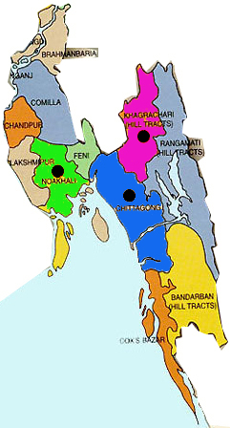

Chittagong District

Map of Bangladesh

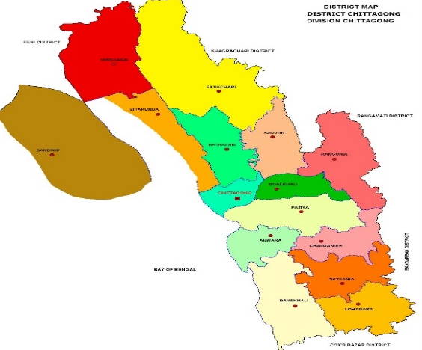

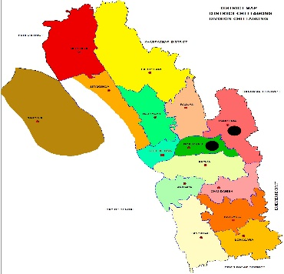
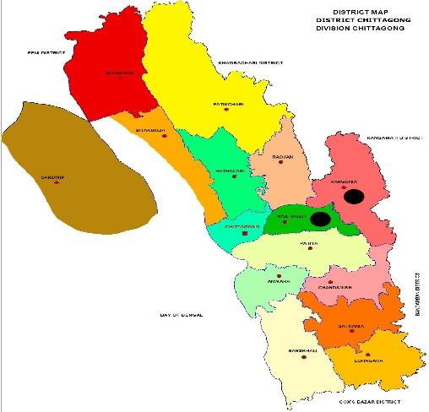
Nasirabad Patia Bayezid Jointika
Fig.1: Study areas (at a glance)

3.2 Study period
The study was undertaken for a period of 12 months starting from January’ 2014 to December’ 2014; where three seasons were included as Summer (March to May), Rainy season (June to august) and Winter season (October to December).

3.3 Selection of animals and Survey Design
3.3.1 Target animals
Crossbred and local cattle (Indigenous/ non descriptive/ Red Chittagong cattle) were selected for this study as target animals.

3.3.2 Selection of age groups
To determine the age and susceptibility for blood protozoa, cattle are categorized in the sub groups. The age limit for HF crossbred cattle was calf (≤1 year), young (>1 – < 2.5 year) and adult (≥2.5years). In local cattle, the age limit differs for calf (≤1 year), young (>1-3.5 years) and adult (≥3.5 years) only (Sastry and Thomas, 2005).

3.3.3 Target sampling
A total 300 blood samples were collected randomly from four different selected areas of Chittagong district. From each areas total 75 samples were collected in three different seasons which was cover 25 samples in each season.

3.3.4 Epidemiological Investigation
A prototype questionnaire was used to record the information like area, breed, age, body condition score, sex, season, floor condition and economic condition of owner etc.

3.4 Sample collection and preservation
Only one biological sample (blood) was collected during this study where an individual animal was considered as a sampling unit. Two thin blood smears were prepared from one sample. The slides were air dried and fixed by 100% methyl alcohol for 3-5 minutes (Cable, 1998).

3.5 Examination of the samples
The examinations were carried out at the parasitology laboratory, Chittagong Veterinary and Animal Sciences University (CVASU), Chittagong, Bangladesh. The wet blood smear was immediately examined under microscope to observe the undulating movement of Trypanosomes (Ulienberg, 1998). The prepared thin blood smears (Hendrix and Robinsin, 2006) were stained with the Giemsa stain (Richardson and Kendall, 1963) for 25-30 minutes. After rinsing with water, the stained blood smears were air dried and examined under a binocular microscope (X1000 magnification) with immersion oil for the identification of blood parasites (Urquhart et al., 1996; Soulsby, 1982; Benbrook and Sloss, 1962).

3.6 Protocol for isolation of DNA from Blood sample
Total genomic deoxyribonucleic acid (DNA) has been extracted from the whole blood samples by using PCI (Phenol, chloroform and Isoamyl alcohol ) method (Sambrook et al., 1989).
Blood samples typically were obtained as 1 ml of whole blood stored in EDTA vacutainer tubes which frozen at 4°C.
- The Blood sample was pipetted in a sterilized microcentrifuge tube containing 500µl of Lysis buffer.
- To the above sample, added 50µl of 10% SDS and mixed thoroughly for few minutes.
- Added 2-3µl of Proteinase-K.
- Mixed to the sample thoroughly by inverting the micocentrifuge tube for minutes.
- It is then incubated at 56°C for 30 minutes.
- Added equal volume of phenol: chloroform: Isoamylalcohol (25:24:1).
- Mixed thoroughly for few minutes.
- Centrifuged the sample for 10 minutes at 13,000 rpm centrifuge machine.
- Carefully removed the aqueous layer to a new sterilized microcentrifuge tube.
- Added 500 ml of Chloroform: Isoamyl alcohol (24:1).
- Mixed thoroughly by repeated inverting the microcentrifuge tube for few minutes.
- Centrifuged at 13,000 rpm for 10 minutes in a centrifuge machine.
- Transferred the upper aqueous layer in a fresh sterilized microcentrifuge tube and added double the volume of chilled absolute ethanol.
- The above sample was kept at -20°C for overnight for precipitation.
- The above sample was centrifuged at 13,000 rpm for 10 minutes.
- Decanted the supernatant and retained the pellet.
- To the pellet, added 500µl of 70% ethanol and again centrifuged at 13,000 rpm for 10 minutes and decanted the supernatant in -4°C temperature.
- The pellet was kept for air dry under laminar air flow.
- The pellet was resuspended in Nuclease free water stored either in -20°C or -86°C for immediate use or long preservation.
DNA extracted from the blood samples were processed for PCR detection and confirmation of the disease and works were undertaken in molecular biology laboratory of Poultry Research and Training Centre (PRTC), CVASU.

3.7 PCR amplification from extracted DNA
To detect the 16S rRNA of Anaplasma species and to detect the 18S rRNA of Babesia species from extracted DNA samples, PCR was also performed by using gene specific primer. PCR of the extracted DNA was conducted using the commercially available Intron ® PCR 2x master mix and primer provided in the table (1 and 2).

Table 1: PCR Master mix solution [Catalog no. 25027 (1ml); 25028 (5ml). Intron Biotechnology] used for PCR contained the following reagents:

2x PCR Master mix solution (i-TaqTM) | 0.5 ml x 2
TaqTM DNA polymerase (5U/µl) | 2.5 U
dNTPs | 2.5 mM each
PCR reaction buffer | 1X
Gel loading buffer | 1X

Table 2: Primers were used for PCR amplification as per the details given in the following
SL  NO | Gene | Primer name | Sequences (5ʺ-3ʺ) | Base pair (bp) | Reference
1 | 18S rRNA | Bab- F | GTTTCTGMCCCATCAGCTTGAC | 422-440 | Hilpertshauser et al.,(2006)
 |  | Bab- R | CAAGACAAAAGTCTGCTTGAAAC
2 | 16S rRNA | AE1-F | AAGCTTAACACATGCAAGTCGAA | 1406-1422 | Kim et al.,  (2010)
 |  | AE1-R | AGTCACTGACCCAACCTTAAATG

Table 3: Composition of reaction mixture for PCR
SLNO. | Components | Quantity | Total amount | Final Concentration (20 µl)
1 | 2X PCR master mix | 10 µl | 10.1 µl | --
2 | Forward Primer (10 pmole/μl) | 1μl | 1 µl | 10 pmole
3 | Reverse Primer (10 pmole/μl) | 1 μl | 1 µl | 10 pmole
4 | Water | 6 µl | 6 µl | --
Total volume |  | 18 μl | 18 µl | --
5 | DNA Template | 2 µl | 2 µl | --
Grand Total volume |  | 20 µl | 20 µl | --

3.8 PCR detection assay for Anaplasma sp
To detect the 16S rRNA of Anaplasma species, PCR was conducted from positive samples by using primer sets and PCR reaction mixture was performed using conditions which mentioned above (table 2 and 3). To identify the Anaplasma sp from DNA samples, 16S rRNA gene amplifications were performed at the following thermal conditions: 94°C for 5 min, followed by 40 cycles of 94°C for 1 min, 59°C for 1 min, 72°C for 2 min and followed the final extension step at 72°C for 10 min. Steps and cycling conditions used in this study are listed in (Table 4).

Table 4: Steps and conditions of thermal cycling for 16s rRNA gene PCR, according to kim et al., (2010)
SL No. | Steps | Temperature | Time
Step 1 | Initial Denaturation | 94°c | 5 min
Step 2 | Denaturation | 94°C | 1 min
Step 3 | Annealing | 59 C | 1 min
Step 4 | Extension | 72 °C | 2 min
Step 5 | 40 cycles from step 2 to step 4
Step 6 | Final Extension | 72 °C | 10 min

3.9 PCR detection assay for Babesia sp
To detect the 18S rRNA of Babesia species, PCR was conducted using primer sets which mentioned above (table 2). Fragment size (bp) is 422-440 and annealing temperature (°C) 61 and extension time (s) 45. Cycling conditions used in this study are listed in (Table 5).

Table 5: Steps and conditions of thermal cycling for 18s rRNA gene PCR, according to Hilpertshauser et al., (2006)
SL No. | Steps | Temperature | Time
Step 1 | Initial Denaturation | 94°c | 3 min
Step 2 | Denaturation | 94°C | 30 sec
Step 3 | Annealing | 61°C | 30 sec
Step 4 | Extension | 72 °C | 45 sec
Step 5 | 45 cycles from step 2 to step 4
Step 6 | Final Extension | 72 °C | 10 min

3.10 Agar gel electrophoresis
1.5% agarose gel was made by using 0.5 g agarose powder and 50 ml TAE buffer with ethidium bromide. The DNA amplicons were visualized using 4 μl of the final PCR product and 2 μl standard 100 bp plus DNA markers (Invitrogen) at 120 V/100 mA for 30 min. Gels were photographed using a gel documentation system. Positive or negative amplifications were evaluated as presence or absence of visible orange colour bands on agarose gels under UV light (O'Dwyer et al., 2008).

3.11 PCR product clean up (FavorPrepTM DNA purification Mini Kit)
The PCR products of representative strains were purified with the PCR Clean-up system kit (Fig.2).

Fig.2: PCR product clean up Mini Kit

3.12 Precautions followed in the PCR laboratory
All procedures were carried out under strict aseptic condition. Maximum precautions were taken to avoid contamination. Hand gloves and musk were used all time, nothing were touched in bare hands to avoid contamination with RNase from the skin. All the samples were processed under the Biosafety cabinet Class II. Isolation of DNA, preparation of PCR reaction mix, thermo cycling and analysis were performed in three separate rooms to avoid carry-over contamination. Eye protector was used while working with transilluminator (produces UV radiation) for documentation of PCR products.

3.13 Statistical analysis
The obtained information were imported, stored and coded accordingly using Microsoft Excel-2007 to STATA/IC-11.0 for analysis. Descriptive statistics were expressed as proportion with confidence interval.The result was expressed in percentage with p value for Chi-square test was used to evaluate the hypothesis for significant difference between the infection in different locations and cattle breed. P values less than 0.05 (P < 0.05) was considered statistical significant.

Chapter-IV
Results

A total 300 blood samples were examined by light microscope for detecting haemoprotozoa. Microscopy detected a total 22 positives (7.33%) samples, out of 22 microcopic positive samples, 14 samples for Anapalsma sp, 6 samples for Babesia sp and 2 samples for mixed infections were identified, respectively which was confirmed in 9 samples (3.00%) by PCR technique by using 18s rRNA gene of Babesia species and 16s rRNA gene of Anaplasma species (Fig. 4 and 6). Microscopy detected 13 (4.33%) showed negative result in PCR. Babesia sp in the cattle blood appeared as pyriform to rounded shaped and Anaplasma sp showed small, round dark red inclusion bodies within the RBCs in the Giemsa staining technique under microcopic examination which seen in (Fig.3 and 5).
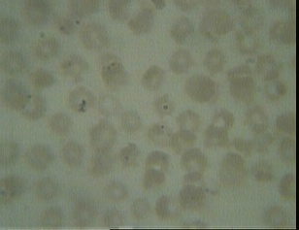

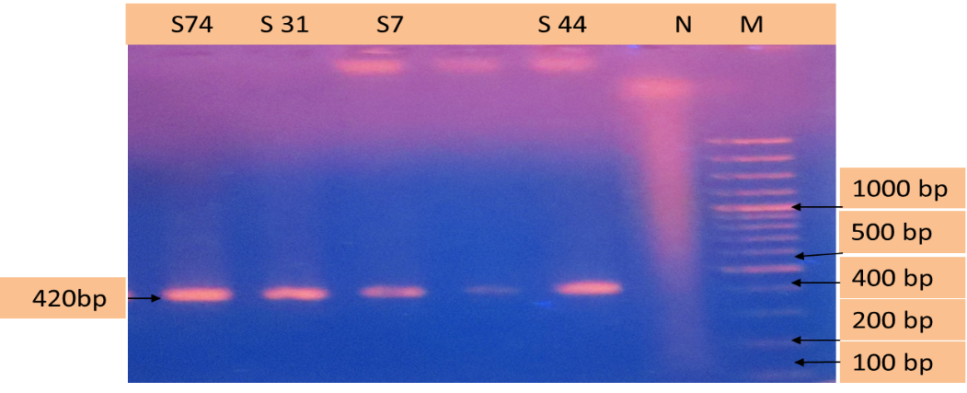
Fig.3: Microscopic pictures of Babesia sp (arrow) in thin blood smear (×1000 magnification).

Fig.4: PCR products amplified using bab- F & bab-R specific primers. Lane M: 100 bp plus DNA ladder (Invitrogen), lane N: negative control, lane: S 74, S 31, S 7,S 44 positive samples.
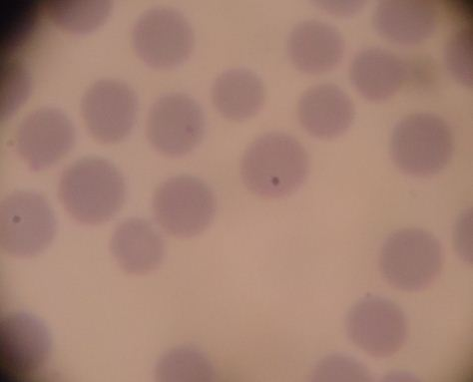

Fig.5: Microscopic picture of Anaplasma sp (arrow) in thin blood smear (×1000 magnification).
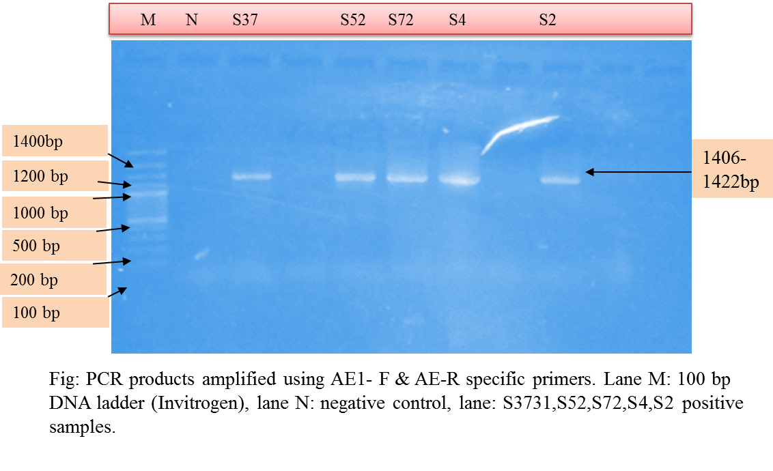

Fig 6: PCR products amplified using AE1- F & AE1-R specific primers. Lane M: 100 bp plus DNA ladder (Invitrogen), lane N: Negative control, lane: S 37,S 52,S 72,S 4,
S 2 positive samples.

4.1 Prevalence of haemoprotozoan diseases
4.1.1 Overall prevalence of haemoprotozoan diseases
The identified haemoprotozoan diseases were babesiosis, anaplasmosis and mixed infection (babesiosis and anaplasmosis) was also recorded but its frequency was very diminutive which seen in (Table 6 and table 7).

Table 6: Overall prevalence of haemoprotozoan diseases on the basis of Microcopic examination
haemoprotozoan  Diseases | Crossbred cattle  (n=150) |  | Local cattle  (n=150)
 | (%) | 95% CI | (%) | 95% CI
Babesiosis | 2.66 | 0.07-6.68 | 1.33 | 0.16-4.73
Anaplasmosis | 6.00 | 2.78-11.08 | 3.33 | 1.07-7.6
Mixed infection | 0.67 | 0.016-3.65 | 0.67 | 0.016-3.65
Trypanosomiasis | - | - | - | -
Overall | 9.33 | 5.19-15.16 | 5.33 | 2.33-10.23
n= Total no. of population, CI= confidence Interval

The overall prevalence of haemoprotozoan diseases on the basis of microscopic examination was 9.33% in crossbred and 5.33% in local cattle. The highest prevalence was recorded in anaplasmosis which was 6.00% and 3.33% for crossbred and local cattle, respectively. Occurrence of babesiosis was 2.66% in crossbred and 1.33% in local cattle. Mixed infections were less common and Trypanosoma sp infections were found negative during this investigation (table 6).

Table 7: Overall prevalence of haemoprotozoan diseases on the basis of PCR
haemoprotozoan  Diseases | Crossbred cattle  (n=150) |  | Local cattle  (n=150)
 | (%) | 95% CI | (%) | 95% CI
Babesiosis | 1.33 | 0.16-4.73 | 1.33 | 0.16-4.73
Anaplasmosis | 2.00 | 0.41-5.7 | 1.33 | 0.16-4.73
Mixed infection | 0.00 | 0.00 | 0.00 | 0.00
Overall | 3.33 | 1.00-7.6 | 2.66 | 0.07-6.68

Molecular detection technique (PCR) offer higher sensitivity and specificity than microscopic examination and overall prevalence of haemoprotozoan diseases on the basis of PCR was 3.33% in crossbred and 2.66% in local cattle. (table 7).

4.1.2 Area wise prevalence of haemoprotozoan diseases
The prevalence of haemoprotozoan diseases in crossbredand local cattle of four different areas were shown in figure 7. In crossbred and local cattle, it was revealed that Anaplasmosis was consistently prevalent in all the study areas and the highest overall prevalence was recorded in Patia (9.33%) followed by Bayezid (4.00%), Nasirabad (2.67%) and Jointika (2.66%). On the other hand, highest prevalence of babesiosis was recorded in Bayezid (4.00%) followed by Jointika (2.66%), Patia (1.33%) and Babesia is not prevalent in Nasirabad study area. Mixed infections were less common in the study areas (Fig. 7).

Fig.7: Area wise prevalence of haemoprotozoan diseases

4.1.3 Seasonal prevalence of haemoprotozoan diseases
The prevalence of haemoprotozoan diseases were more in summer followed by rainy and winter season. The highest prevalence of anaplasmosis was recorded 12.00% in crossbred cattle followed by 6.00% in local cattle in summer. Frequency of babesiosis was highest in summer which was 4.00% in crossbred cattle followed by 2.00% in local cattle. On the other hand, mixed infections were recorded very low in the study population (table 8).

table 8: Seasonal prevalence of haemoprotozoan diseases
haemoprotozoan  diseases | Crossbred cattle |  |  |  | Local cattle
 | Seasons |  |  |  | Seasons
 | Summer  (n=50)  % | Rainy  (n=50)  % | Winter  (n=50)  % | P  Value | Summer  (n=50)  % | Rainy  (n=50)  % | Winter  (n=50)  % | P  value
Babesiosis | 4.00 | 2.00 | 2.00 | 0.36 | 2.00 | 2.00 | 0.00 | 0.60
Anaplasmosis | 12.00 | 4.00 | 2.00 | 0.14 | 6.00 | 4.00 | 0.00 | 0.60
Mixed infection | 0.00 | 2.00 | 0.00 | 0.36 | 2.00 | 0.00 | 0.00 | 0.37

4.1.4. Age specific prevalence of haemoprotozoan diseases
Among three different age groups, adult cattle showed more susceptibility to different haemoprotozoan diseases than young and calf. it was also observed that prevalence of anaplasmosis increased significantly (P<0.05) with the increase of age in crossbred cattle.the highest prevalence of anaplasmosis was 13.72% and 6.94% in adult crossbred and local cattle, respectively. Occurrence of babesiosis was the highest in adult than young and calf. it was also recorded that prevalence of babesiosis increased with the increase of age. mixed infections were also varied according to the age of animals during the investigation (table 9).

Table 9: Age specific prevalence of haemoprotozoan diseases
haemoprotozon  diseases | Crossbred cattle |  |  |  | Local cattle
 | Age Group |  |  |  | Age Group
 | Calf  (n=63)  % | Young  (n=36)  % | Adult  (n=51)  % | P  value | Calf  (n=42) % | Young  (n=36)  % | Adult  (n=72)  % | P  value
Babesiosis | 1.58 | 0.00 | 5.88 | 0.42 | 0.00 | 2.78 | 1.38 | 0.73
Anaplasmosis | 1.59 | 2.78 | 13.72 | 0.016 | 0.00 | 0.00 | 6.94 | 0.12
Mixed infection | 1.58 | 0.00 | 0.00 | 0.50 | 0.00 | 0.00 | 1.38 | 0.78

4.1.5. Sex-specific prevalence of diseases
In this investigation, it was revealed that haemoprotozoan diseases were more common in female cattle. Higher prevalence of analpasmosis was recorded in female crossbred cattle which was 6.11%. However, male crossbred cattle showed a little more susceptibility to anaplasmosis and the observed prevalence was 4.76% and have not recorded babesiosis in local male cattle and prevalence of babesiosis was recorded in female local cattle which was 1.60%. Mixed infection also showed fluctuation in their occurrence in female crossbred and local cattle (table 10).

Table 10: Sex-specific prevalence of haemoprotozoan diseases
haemoprotozoan  diseases | Crossbred cattle |  |  | Local cattle
 | Sex |  |  | Sex
 | Male  (n=21) % | Female  (n=131) % | P  value | Male  (n=25)% | Female  (n=125)% | P  Value
Babesiosis | 0.00 | 3.05 | 0.47 | 0.00 | 1.60 | 0.67
Anaplasmosis | 4.76 | 6.11 | 0.43 | 0.00 | 4.00 | 0.39
Mixed infection | 0.00 | 0.76 | 0.92 | 0.00 | 0.80 | 0.91

Chapter-V

Discussion

5.1 Prevalence of haemoprotozoan diseases

5.1.1 Overall prevalence of haemoprotozoan diseases

Prevalence of haemoprotozoan diseases is variable and depends on a number of factors including age, sex, living conditions, diagnostic methodology employed and region studied (Mundim et al., 2007). In the present study, the overall prevalence of haemoprotozoan diseases was estimated 3.00% by PCR among which Babesia sp (1.33%) was lesser than Terkawi et al., (2011) where the overall prevalence of Babesia bovis and Babesia bigemina was 11.2% and 3.6% by nPCR in Thailand. Lower prevalence of haemoprotozoan diseases in the current study might be due to random sampling rather than selection of clinically susceptible cattle.The overall prevalence of haemoprotozoan diseases in the present study on the basis of microscopic examination (7.33%), which were inferior than those of Kamani et al., (2010) and Khan et al., (2004), who recorded 25.7% in North-Central Nigeria and 22.31% and 27.69% at two livestock research institute, Pakistan, respectively. Ananda et al., (2009) and Chowdhury et al., (2006) also documented higher prevalence of haemoprotozoan diseases in clinically susceptible cattle in India and Bangladesh, respectively. Lower prevalence of haemoprotozoan diseases in the present study might be due to random sampling, variation in geo-climatic condition, breed and exposure of vectors and age of the animals might contribute to variable prevalence of haemoprotozoan diseases in the study areas (Muhanguzi et al., 2010 and Khan et al., 2004). On the contrary, Khan et al., (2004) also found 16.12% blood parasitic infection in buffaloes which was advanced with the findings of crossbred cattle of this study. The previous results compared to the current study indicated a continuous threat of haemoprotozoan diseases in the study population.
In the present study, it was observed that haemoprotozoan diseases occurred more in crossbred than local cattle which was supported by the earlier reports of Muhanguzi et al., (2010); Minjauw (2003), Radostits et al., (1994); and Soulsby (1982), who reported that exotic breeds (Bos taurus) showed more susceptibility to haemoprotozoan diseases than local breeds (Bos indicus). constant exposure of infections and development of immunity against such infections might responsible for lower prevalence in local cattle (Siddiki et al., 2009). On the contrary, more attention in the management of HF crossbred cattle give less chance of pre exposure of vectors and develop no or less immunity resulting frequent occurrence of such diseases (Siddiki et al., 2009, Ananda et al., 2009 and Chowdhury et al., 2006).
The prevalence of Babesiosis of this study was related to the observation revealed by Siddiki et al., (2009); Chowdhury et al., (2006) and Shahidullah (1983), who recorded 1%, 3.3% and 2.29% infectons, respectively in different areas of Bangladesh. However, the prevalence of Babesiosis in local cattle was lower than those of Kalkan et al., (2010); Khan et al., (2004) and Savini et al., (1999), who recorded 5.83% in Sivas region of Turkey, 5.5% in Pakistan and 4.95% in Central and Southern Italy, respectively. The overall prevalence of Babesiosis in this investigation was poorer with the earlier report of Alim et al., (2012) who recorded 7.14% in indigenous cattle and 9.25 % in cross breed cattle in Chittagong. Findings of the prevalence of Babesiosis of this study in crossbred cattle was found worse with Kamani et al., (2010) and Samad et al., (1989), who reported more higher prevalence; viz. 16% in North-Central Nigeria and 14.53% in different areas of Bangladesh, respectively. The overall lower prevalence of Babesiosis of the present study which might be due to variation of study areas or unavailability of tick vectors. basic prevalence of Babesiosis in the study population suggested not to challenging to control of such infection in those areas.
Prevalence of anaplasmosis of this study was advanced with the reports of Siddiki et al., (2009) and consistence with the reports Samad et al., (1989), who recorded 3% and 5.93% in different areas of Bangladesh. Muhanguzi et al., (2010) also reported 3% Anaplasmosis in Mbarara district, Uganda. The observed result of the study indicated a constant drift of such infection in the study areas due to frequent transmission of organisms by tick vectors or mechanical means. However, the earlier findings greatly differed from the observation made by Brito et al., (2010); Ndou et al., (2010); Rikhotso et al., (2005); Khan et al., (2004) and Talukdar and Karim (2001), who recorded 98.6% infection in Brazilian Amazonia, 96.4-100% in Mafideng in the North West Province, South Africa, 56.6-82.7% in Limpopo Province, South Africa, 75.71% in Pakistan and 33% in Bangladesh, respectively. Higher prevalence of Anaplasmosis was clarified as endemicity of such diseases in those areas. Mixed infection (babesiosis and anaplasmosis) was also recorded but its frequency was very diminutive. Mixed infections were less common and Trypanosoma spp infections were found negative during this investigation.

5.1.2 Seasonal prevalence of haemoprotozoan diseases
The occurrence of haemoprotozoan diseases vary greatly according to seasons. observation of summer season of this research was in accordance with the report of Ananda et al., (2009) and and Radostits et al., (1994). In the present study, it was observed that haemoprotozoan diseases occurred more in summer season.The highest prevalence of Anaplasmosis was recorded 12.00% in crossbred cattle followed by 6.00% in local cattle in summer. Frequency of babesiosis was highest in summer which was 4.00% in crossbred cattle followed by 2.00% in local cattle. The former authors also observed that higher incidence of haemoprotozoan diseases were found soon after peck of tick population depending on temperature, humidity, rainfall etc. which might be accounted for higher prevalence of such infections in the study population. lower temperature and humidity of winter months were less favourable for the growth and multiplication of tick vectors which might contribute to lower frequency of such diseases in the study population (Zahid et al., 2005 and Muhammad et al., 1999).

5.1.3 Age specific prevalence of haemoprotozoan diseases
Age also inspirations the occurrence of haemoprotozoan diseases. In the current study, higher susceptibility of adult cattle to haemoprotozoan diseases were found consistent with the findings of of Ruprah (1985), who reported highest prevalence in animals aged more than 3 years followed by the lowest prevalence in less than 1 year of age. Ananda et al., (2009) also documented higher prevalence in animals aged more than 3 years followed by the lower prevalence in 1-2 years of age. observation of this study also supported by the findings of Khan et al., (2004) and Kamani et al., (2010), who observed higher prevalence in adult cattle (36.3%) than young-stock (30.76%).

Occurrence of Babesiosis of the present study was consistent with the observation of Annetta (2005); Urquhart et al., (1996) and Soulsby (1982), who reported an inverse age resistance of the disease where adult cattle showed more susceptibility than calves.This might be due to rapid immune responses to primary infection by the calves through a complex immune mechanism (Annetta et al., 2005).

In the current study, higher prevalence of Anaplasmosis in adult followed by young cattle was in accordance with the reports of Radostits et al., (1994) and Howard (1985). The earlier researchers reported that calves up to 9 months or even 1 year of age usually showed no clinical illness where as cattle 1 to 2 years or above 3 years of age may develop acute or fatal form of disease. Observation of this study also showed consistence with the findings of Chowdhury et al., (2006) and Chakraborti (2002), who observed comparatively higher prevalence in adult than calves. Endemic instability of the study areas might responsible for frequent infections in adult cattle where new born calves were protected by colostral immunity (Cynthia et al., 2011). On the contrary, earlier observation was in contrast with the observation of Muhanguzi et al., (2010), who found higher prevalence of Anaplasmosis in calves and lowest in young cattle in Uganda and the difference was explained by dominant immune responses to Anaplasma spp infection.

5.1.4 Sex-specific prevalence of diseases

Femininity of animals also has influences in the occurrence of haemoprotozoan diseases. The prevalence of such disease in female animals of this study showed consistency with the observation of Kamani et al., (2010), who recorded comparatively higher prevalence in female than male cattle of North-Central region, Nigeria. In this study, higher prevalence in female cattle might be due to stress condition as they were kept longer period for breeding and milk production purpose or supplied imbalance diet against their high demand (Kamani et al., 2010). On contrary, the occurrence of Babesiosis was found even in 15 days old calf to 1.5 year old young cattle in this study. This made to suggest that inverse age resistance may fail to protect if there is any problem in maternal antibodies. Most of the cross-bred animals aged around 7 years were in the stage of 3 or 4 lactation as peak milk yielders. The weakening of immunity during high milk yielding stage in addition to genetic make up and seasonal stress in summer months could be reason for high susceptibility to this haemoprotozoan diseases.

5.2 Molecular diagnosis by PCR technique
We compared conventional microscopy with giemsa staining with a recently developed PCR test for the detection of haemoprotozoan diseases and found microscopic to be considerably less specific than PCR analysis. Microscopic analysis of stained blood smears is the most widely used method for clinical diagnosis. Microscopy is considered to be a reliable diagnostic tool for the purposes of this comparative trial. Because it is sensitive and easy to use, PCR amplification is an obvious choice for improved detection of haemoprotozoa from blood. (Fayer et al., 2004). Through this study, it was confirmed that PCR is more sensitive and specific in detecting low level of infections in cattle as compared to light microscopy and the results of our study are also in observations that a total of 300 blood samples were examined by microscopy for detecting haemoprotozoa in Cattle. Microscopy detected a total of 22 positives (7.33%) samples which was confirmed in 9 samples (3.00%) by PCR technique. Fahrimal et al., (1992) who studied the carrier cattle infected with Babesia sp by using PCR amplification of a portion of gene from the parasite. Hermans et al., (1994) in Costarica where they assessed the infection of Babesia sp which transmitted from the ticks by the use of PCR analysis. Serological methods are employed in diagnosing subclinical infections in epidemiological studies, but false-positive and false negative results may be done due to cross-reactions or weakening of specific immune responses (Passos et al., 1998). So, a sensitive and highly specific method for the diagnosis of piroplasms is required. Recently, species-specific polymerase chain reaction (PCR) and PCR-based reverse line blot (RLB) hybridization methods have been developed for the detection and identification of Theileria and Babesia species (Altay et al., 2007). Babesia bovis, Babesia bigemina and Babesia divergens have been detected by microscopy and serological tests (Aktas et al., 2006). However, these methods are less sensitive and specific in the detection of carrier animals and do not generally distinguish between current infections and previous exposures. Identification of carrier animals is important for the assessment of infection risk. They serve as reservoirs of infection for ticks and cause natural transmission of the disease (Calder et al., 1996). PCR-based techniques provide an alternative method for the direct detection of piroplasms in carrier animals. In the present study, a molecular survey of Anaplasma and Babesia species, based on PCR techniques has been performed for detection of these haemoparasites have been developed in cattle and identifying Babesia and Anaplasma speices in the current study.That’s why we can say that molecular detection technique such as PCR, offer higher sensitivity and specificity than microscopic examination and serological tests for identify the haemoprotozoan parasitic diseases by detecting the causal agents in cattle. It is concluded that the methodology used in the current study seems to be helpful for the diagnosis of haemoprotozoan parasitic diseases in cattle in the early phase of infection and in carrier animals which might be used as a tool for epidemiological investigation and subsequent disease eradication.

Chapter-VI
Conclusion

The study was performed aiming to determine the prevalence and molecular identification of haemoprotozoan parasitic diseases in crossbred and local cattle. haemoprotozoan diseases were strongly associated with age of animals, Cattle of any age could be affected by haemoprotozoan diseases but inverse age resistance was noticed in the occurrence of babesiosis where crossbred cattle were more susceptible than local. Babesiosis and Anaplasmosis were predominant diseases in the study areas. Frequency of blood protozoan infections increased with weather change where summer season was found most vulnerable. Finally, we have able to detect molecular identification of haemoprotozoan diseases by PCR technique for the early and accurate diagnosis of haemoprotozoan diseases in cattle and to differentiate Babesia sp and Anaplasma sp by using species primers for taking further control strategies in the study areas.

Chapter - VII
Recommendation

Development and evaluation of nucleic acid-based approaches for the specific detection of haemoprotozoan parasitic diseases through genomic data analysis can be done in future for identification of genetic variation within and among species of Babesia sp and Anaplasma sp and phylogeny through sequencing and bioinformatics tools application.

Chapter - VIII

References

Aktas M, Altay K and Dumanli N. 2006. A molecular survey of bovine Theileria parasites among apparently healthy cattle and with a note on the distribution of ticks in Eastern Turkey.Veterinary Parasitology. pp.138 (3-4): 179-185.
Alam J. 1993. Livestock sector for more investment in Bangladesh. Asian livestock. 18: 77-78.
Alim MA, Das S, Roy K, Masuduzzaman M, Sikder S, Hassan MM, Siddiki AZ and Hossain MA. 2012. Prevalence of hemoprotozoan diseases in cattle population of Chittagong division, Bangladesh. Pakistan Veterinary Journal.
pp. 32:221-224.
Altay K, Aktas M and Dumanli N. 2007. Molecular identification, genetic diversity and distribution of Theileria and Babesiaspecies infecting small ruminants.Veterinary Parasitology. pp: 147: 161–165.
Ananda KJ, Placid E and Puttalak Shmamma GC. 2009. Prevalence of haemoprotozoan diseases in cross breed cattle in Bangalore northern Veterinary World. 2(1): 15-16
Annetta Z, Jeremy S, Gray Helen E, Skerrett and Grace Mulcahy. 2005. Possible mechanisms underlying age-related resistance to bovine babesiosis. Parasite Immunology. pp. 27:115–120.
Anonymous 2014. Bangladesh economic review. Economic advisers wing, finance Division, Ministry of Finance, Government of the Peoples Republic of Bangladesh. pp. 21 -22.
Banerjee DP, Prasad KD and Samad MA. 1983. Seroprevalence of Babesia bigemina infection in cattle of India and Bangladesh. Ind. Journal of Animal Science. 53: 431-433.
Barros SL, Madruga CR, Araújo FR, Menk CF, de Almeida MAO, Melo EPS and Kessler RH. 2005. Serological survey of Babesia bovis, Babesia bigemina, and Anaplasma 26 marginale antibodies in cattle from the semi-arid region of the state of Bahia, Brazil, by enzymelinked immunosorbent assays. Memoiras do Instituto Oswaldo Cruz. 100(6): 613-617.
Benbrook E and Sloss MW. 1962. Veterinary Clinical Parasitology, Lowa State, University Press. 3rd edn. pp. 113-114.
Bock RE and De Vos AJ. 2001. Immunity following use of Australian tick fever vaccine: a review of the evidence. Australian Veterinary Journal. pp. 79: 832–839.
Bose R, Jorgensen WK, Dalgliesh RJ, Friendhoff KT and De Vos A.J. 1995. Current state and future trends in the diagnosis of Babesiosis. Veterinary Parasitology. pp. 57: 61–74.
Bowles PM, Molloy JB, Blight GW, Singh S and Mabikacheche LG. 2000. Evaluation of a commercially available kit for detection of antibodies to Anaplasma marginale and A. centrale in cattle in Australia and Zimbabwe. Onderstopoort Journal of Veteterinay Research. 67: 83-86.
Bram RA. 1975. Tick-borne livestock diseases and their vectors. The global problem. 6: 15.
Bram RA. 1983. Tick-borne livestock diseases and their vectors: the global problem. Ticks and tick-born diseases, FAO Animal Production and Health Paper. World Animal Review. 36: 7-11.
Brito LG, de Sena Oliveira, MC, Rochal RB, da Silva Netto, F.G, Marim AD, de Souza GCR, Vendrame FB and da Fonseca Moura, MM. 2010. Anaplasma marginale infection in cattle from south-western Amazonia. Pesquisa Veterinaria. Brasileria. 30(3): 249-254.
Buling A, Criado-Fornelio A, Asenzo G, Benitez D, Barba-Carretero JC and Florin-Christensen M. (2007). A quantitative PCR assay for the detection and quantification of Babesia bovis and B. bigemina. Veterinary Parasitology.
pp. 147:16-25.
Cable RM. 1998. An Illustrated Laboratory Manual of Parasitology, 4th Ed. Burges Publishing Co. Minnesota, USA. pp: 114-115.
Calder JAM, Reddy GR, Chieves L, Courtney CH, Littell R, Livengood JR, Norval RAI, Smith C and Dame JB. 1996. Monitoring Babesia bovis infections in cattle by using PCR-based tests. Journal of Clinical Microbiology.
34 (11): 2748-2755.
Chakraborti A. 2002. A Textbook of Preventive Veterinary Medicine. 3rd edn. Kalyani Publishers, New Delhi. pp.683.
Chowdhury S, Hossain MA, Barua SR and Islam S. 2006. Occurrence of common Blood Parasites of Cattle in Sirajgong Sadar Area of Bangladesh. Bangl.Journal of Veterinary Medicine. pp. 4 (2): 143-145.
Costa-Junior LM, Rabelo EML, Martins Filho OA and Ribeiro MFB. 2006. Comparison of different direct diagnostic methods to identify Babesia bovis and Babesia bigemina in animals vaccinated with live attenuated parasites. Veterinary Parasitology. pp.139: 231–236.
Criado-Fornelio A. 2007. A review of nucleic acid-based diagnostic tests for Babesia and Theileria, with emphasis on bovine piroplasms. Parassitologia (Rome). pp. 49: 39–44.
Cuglovici DA, Bartholomeu DC, Reis-Cunha JL, Carvalho AU and Ribeiro MF. 2010. Epidemiologic aspects of an outbreak of Trypanosoma vivax in a dairy cattle herd in Minas Gerais state, Brazil. Veterinary Parasitology.
pp.11: 169(3-4): 320-326.
Cynthia M, Kahn MA, Scott Line, Susan E and Aiello BS. 2011. Marck Veterinay Manual. 9th edn. Merck Sharp & Dohme Corp, a subsidiary of Merck & Co, Inc. Whitehouse Station, NJ, USA. All rights reserved. pp. 68-69, 77-80.
DLS 2014. Directorate of Livestock Services, Khamerbari Rd. Dhaka.Personal Communication.
Dumler JS, Barbet AF, Bekker CP, Dasch GA, Palmer GH, Ray SC, Rikihisa Y and Rurangirwa FR. 2001. Reorganization of the genera in the families Rickettsiaceae and Anaplasmataceae in the order Rickettsiales: unification of some species of Ehrlichia with Anaplasma, Cowdria with Ehrlichia and Ehrlichia with Neorickettsia, descriptions of six new species combinationsand designation of Ehrlichia equi and “HGEagent” as subjective synonyms of Ehrlichia phagocytophila.Internatioal Journal of Systematic and Evolutionary. 51: 2145-2165.
El-Ghaysh A, Sundquist B, Christensson DA, Hilali M and Nassar AM. 1996. Observations on the use of ELISA for detection of Babesia bigemina specific antibodies. Veterinary Parasitology. 62 (1-2): 51-61.
Enwezor NC, Umoh JU, Esievo KA, Halid I, Zaria LT and Anere JI. 2009. Survey of bovine trypanosomosis in the Kachia Grazing Reserve, Kaduna State, Nigeria. Veterinary. Parasitology.159: 121-125.
Fahrimal Y, Goff WL and Jasmer DP.1992. Journal of clinical Microbiology.
30: 1374-1379.
Fayer R, Morgan UM and Upton SJ. 2004. Epidemiology of Babesia spp: transmission, detection and identification. International Journal of Parasitology.
30(12-13): 1305-1322.
Figueroa JV, Chieves LP, Johnson GS and Buening GM.1992. Detection of Babesia bigemina-infected carriers by polymerase chain reaction amplification. Journal of clinical Microbiology. pp. 30, 2576–2582.
Friedhoff K and Bose R.1994. Recent developments in diagnostics of some tick-borne diseases. In: Use of Applicable Biotechnological Methods for Diagnosing Haemoparasites. Proceedings of the Expert Consultation, Merida, Mexico, 4–6 October 1993, Uilenberg G., Permin A. & Hansen J.W., eds. Food and Agriculture Organisation of the United Nations (FAO), Rome, Italy. pp. 46–57.
Gautam OP and Banerjee DP. 1982. Anaplasma in cattle with reference of the disease in India. Indian Journal of Parasitology. 6(2): 169-181.
Gillingwater K, Mamabolo MV and Majiwa PA. 2010. Prevalence of mixed Trypanosoma congolense infections in livestock and tsetse in KwaZulu-Natal, South Africa.Journal of South African Veterinay Association. 81(4): 219-223.
Goff WL, Molloy JB, Johnson WC, Suarez CE, Pino I, Rhalern A, Sahibi H, Ceci L, Carelli G, Adarns DS, Mcguire TC, Knowles DP and Mcelwain TF. 2006. Validation of a competitive enzyme-linked immunosorbent assay for detection of antibodies against Babesia bovis. Clinical Vaccine and Imunology.
pp.13, 1212–1216.
Gubbels JM, de Vos AP, van der Weide M, Viseras J, Schouls LM, de Vries E and Jongejan F. 1999. Simultaneous detection of bovine Theileria and Babesia species by reverse line blot hybridization. Journal of clinical Microbiology. pp. 37, 1782–1789.
Hagan WA and Bruner DW.1961. The infectious diseases of domestic animals, 4th edn. Comstock Publishing Association, Ithaca, New York. pp. 652-686.
Hasle G, Bjune GA, Christensson D, Røed KH, Whist AC and Leinaas HP. 2010. Detection of Babesia divergens in southern Norway by using an immunofluorescence antibody test in cow sera, Acta. Acta vetenarian Scandinavica. 6: 52-55.
Hendrix CM and Robinson E. 2006. Diagnostic Parasitology for Veterinary Technicians. 3rd Ed, Mosby Inc. and affiliated of Elsevier Inc, China. pp: 246-247.
Hermans P, Dwinger RH, Buening GM and Herrero MV.1994. Revista de biologia tropical. 42: 623-632.
Hilpertshauser H, Deplazes P, Schnyder M, Gern L and Mathis A. 2006. Babesia spp identified by PCR in ticks collected from domestic and wild ruminants in southern Switzerland. Applied and environmental microbiology. pp.72, 6503-6507.
Howard JL. 1985. Current Veterinary Therapy-3, Food Animal Practices. Texas A&M Veterinary Medicine Diagnostic Lab, Amarillo, Texas, USA. pp. 584-86, 588-591, 627-628.
Hunfeld KP, Lambert A, Kampen H, Albert S, Epe C, Brade V and Tenter AM. 2002. Seroprevalence of Babesia infections in humans exposed to ticks in Midwestern Germany.Journal of clinical Microbiology. 40: 2431-2436.
Hungerford TG. 1961. Disease of livestock. 5th edn. Angus and Robertson Ltd., Sydney. pp. 201-207.
Irfan M. 1984. Key note address on effect of parasitism in lowering livestock population. Pakistan Veterinary Journal. 4: 25-27.
Iseki H, Zhou L, Kim C, Inpankaew T, Sununta C, Yokoyama N, Xuan X, Jittapalapong S and Igarashi I. 2010. Seroprevalence of Babesia infections of dairy cows in northern Thailand. Veterinary Parasitology. 24; 170(3-4): 193-196.
Jing Z, Magona JW, Sakurai T, Thekisoe OM, Otim CP, Sugimoto, C and Inoue N. 2009. A field study to estimate the prevalence of bovine African Trypanosomosis in Butaleja District, Uganda. Journal of Veterinary Medicine Science.71(4): 525-227.
Jongejan F and Uilenberg G.1994. Ticks and control methods. Revue Scientific technique, Office International des Épizooties. 13: 1201-1226.
Jorgensen WK, Waldron SJ, Mcgrath J, Roman RJ, De Vos AJ and Williams KE. 1992. Growth of Babesia bigemina parasites in suspension cultures for vaccine production. Parasitology Research. pp.78, 423–426.
Kalkan K, Ozçelık S and Malatyali E. 2010. Seroprevalence of Babesiosis in Cattle in Sivas, Turkey.Turkish journal of Parasitology. 34(1): 11-16.
Kamani J, Sannusi A, Eqwu OK, Dogo GI, Tanko TJ, Kemza S, Takarki AE and Gbise DS. 2010. Prevalence and Significance of Haemoparasitic Infections of cattle in North-Central, Nigeria. Veterinary World. 3(10): 445-448.
Khan MQ, Zahoor AM and Jahangir Ashraf Mirza M. 2004. Prevalence of Blood Parasites in cattle and Buffaloes. Pakistan Veterinary Journal. 24(4): 193-195.
Kim CM, Kim MS, Park MS, Park JH and Chae JS. 2010. Identification of Ehrlichia chaffeensis, Anaplasma phagocytophilum and Anaplasma bovis in Haemaphysalis longicornis and Ixodes persulcatus ticks from Korea. Vector Borne Zoonotic Diseases. 3:17-26.
Kocan KM, Blouin EF and Barbet AF. 2000. Anaplasmosis control: past, present and future. Annals of the Newyork Academy of Science. 916: 501-509.
Kokas MN and Kakarsulemankhel JK. 2009. Prevalence of parasites in cows and buffaloes of Quetta, Pakistan. Pakistan Veterinary Journal. 28(1): 34, 34-36.
Krause PJ, Telford SR, Ryan R, Conrad PA, Wilson M, Thomford JW and Spielman A.1994. Diagnosis of babesiosis: evaluation of a serologic test for the detection of Babesia microti antibody. Journal of Infecious diseases. 169: 923-926.
Kuttler KL, Clifford DJ and Touray BN.1988. Prevalence of anaplasmosis and babesiosis in N'Dama cattle of the Gambia. Tropical Animal Health Production. 20(1): 37-41.
Laha R and Sasmal NK. 2009. Detection of Trypanosoma evansi infection in clinically ill cattle, buffaloes and horses using various diagnostic tests. Epideomology and infection. 137 (11): 1583-1583.
Lako NJ, Tchoumboue J, Payne VK, Njiokou F, Abdoulamouminim and Awah-Ndukum J. 2007. Prevalence of Trypanosomosis and Babesiosis among domestic ruminants in the Western Highlands of Cameroon. Proc of the 12th International conference of the Association of Institutions of Tropical Veterinary Medicine, Montpellier, France. pp. 405-410.
Madruga CR, Marques AP, Leal RB, Carvalho, ME, Araújo FR and Kessler RH. 2000. Evaluation of an enzyme-linked immunosorbent assay to detect antibodies against Anaplasma marginale. Pesquisa Veterinária Brasileira, 20(3): 10.
Magona JW, Walubengo J, Olaho-Mukani W, Jonsson NN, elburn SC and Eisler MC. 2008. Clinical features associated with sero-conversion to Anaplasma marginale, Babesia bigemina and Theileria parva infections in African cattle under natural tick challenge. Veterinary Parasitology. 155: 273-280.
Mahanguzi D, Ikwap K, Picozzi K and Waiswa C. 2010. Molecular Characterization of Anaplasma and Ehrlichia Species in Different Cattle Breeds and Age Groups in Mbarara District (Western Uganda). International Journal of Animal and Veterinary Advance. 2 (3): 76-88.
Marchette N and Stiller D. 1982. The Anaplasmataceae, Bartonellaceae, and Rochalimaea quintana . In: Marchette NJ, editor. Ecological Relationships and Evolution in the Rickettsiae. Florida, USA: CRC Press, Boca Raton; pp. 98-106.
Martins TM, Neves L, Pedro OC, Fafetine JM, Do Rosário VE and Domingos A. 2010. Molecular detection of Babesia spp and other haemoparasitic infections of cattle in Maputo Province, Mozambique. Parasitologia. 137(6): 939-346.
Maxia L, Reale S, Loria GR, Greco A, Vitale F and Glorioso NS. 1999. Characterization of Theileria species by PCR using specific target sequences, Parassitologia. 41(l 1): 69-72.
McCosker PJ.1979. Global aspects of the management and control of ticks of veterinary importance. Recent Advances in Acarology.11: 45-53.
Minjauw B and McLeod A. 2003. Tick-borne diseases and poverty, the impact of tick and tick-borne diseases on the livelihood of small-scale and marginal livestock owners in India and eastern and southern Africa Research report, DFID Animal Health Program, Centre for Tropical Veterinary Medicine, University of Edinburgh, UK.
Molloy JB, Bowles PM, Bock RE, Turton JA, Katsande TC, Katende JM, Mabikacheche LG., Waldron SJ, Blight GW and Dalgliesh RJ.1998a. Evaluation of an ELISA for detection of antibodies to Babesia bovis in cattle in Australia and Zimbabwe. Preventive Veterinary Medicine. pp.33, 59–67.
Molloy JB, Bowles PM, Jeston PJ, Bruyeres AG, Bowden JM, Bock RE, Jorgensen WK, Blight GW and Dalgliesh RJ. 1998b. Development of an ELISA for detection of antibodies to Babesia bigemina in cattle in Australia. Parasitology Research. pp. 84, 651–656.
Molloy JB, Bowles PM, Jeston PJ, Bruyeres PG, Bowden JM, Bock RE, Jorgensen WK, Blight GW and Dalgliesh RJ. 1998. Development of an enzyme-linked immunosorbent assay for detection of antibodies to Babesia bigemina cattle. Parasitology Research. 84: 651-656.
Mtshalli MS, Waal DE, DT and Mbati PA. 2004. A sero-epidemiological survey of blood parasites in cattle in the north-eastern Free State, South Africa. Onderstepoort J. Veterinary Research. 70: 67-75.
Muhammad GM, Saqib M, Athar MZ and Khan MN. 1999. Clinicoepidemiological and therapeutic aspects of bovine theileriosis, Pakistan Veterinary Journal.19: 64-69.
Mundim MJ, Rosa LA, Hortencio SM, Faria ES, Rodrigues RM and Cury MC. 2007. Prevalence of Babesia spp in cattle from different living conditions in Uberlandia, Brazil. Veterinary Parasitology. 144(4): 356–359.
Ndou RV, Diphahe TP, Dzoma BM and Motsei LE. 2010. The Seroprevalence and Endemic Stability of Anaplasmosis in Cattle around Mafideng in the North West Province, South Africa. Veterinary Research. 3(1): 1-3.
Ndung'u LW, Aguirre C, Rurangirwa FR, Mcelwain TF, Mcguire TC, Knowles DP and Palmer GH. 1995. Detection of Anaplasma ovis infection in goats by major surface protein 5 competitive inhibition assay.Journal of clinical Microbiology. 33(3): 675-679.
Ngole IU, Ndamukong KJN and Mbuh JV. 2004. Internal parasites and haematological values in cattle slaughtered in Buea Subdivision in Cameroon. Trop. Animal Health Production, 34: 1-5.
O'Dwyer LH, Lopes VVA, Rubini AS, Paduan KDS and Ribolla PEM. 2008. Babesia spp. infection in cattle from rural areas of São Paulo State, Brazil. Revista Brasileira de Parasitologia Veterinaria. pp.18, 23-26.
Passos LM, Bell-Sakyi L and Brown CG. 1998. Immunochemical characterization of in vitro culture-derived antigens of Babesia bovis and Babesia bigemina. Vet. Parasitol. 76, 239–249.
Radostits OM, Blood DC and Gay CC. 1994. Veterinary Medicine: A text book of disease of cattle, sheep, pigs, goats and horse. 8th edn. Baillere Tindall Publication, London. pp. 1171-1179, 1207-1212, 1221-1278.
Rahman MF and Ahmed Z. 1991. Final report of Pilot Project for the control of parasitic diseases of animal in Bangladesh. Bangladesh Livestock Research Institute.
Rahman WA, Lye YP and Chandrawathani P. 2010. The seroprevalence of bovine babesiosis in Malaysia. Tropical Biomedicine. 27 (2): 301-307.
Rajput ZI, Song-hua Hu, Arijo AG, Habib H and Khalid K. 2005. Comparative study of Anaplasma parasites in tick carrying buffaloes and cattle. J. Zhejiang University Science. 6B (11): 1057-1062.
Ravindran R, Mishra AK and Rao JR. 2007. Slide enzyme-linked immunosorbent assay for the diagnosis of Babesia bigemina infection in bovines.Veterinary Research Communications. 31(8): 999-1004.
Riek RF. 1964. The development of Babesia spp and Theileria spp o in tick with special reference to those occurring in cattle. In Biology of Parasites, 2nd edn. E.J.I. press.
Richardson, U.F. and Kendall, S.B. 1963. Veterinary Protozoology. 3rd Edn, Oliver and Boyd publisher, Edinburge and London. pp. 263.
Rikhotso BO, Stoltsz WH, Bryson NR and Sommerville JE. 2005. The impact of two different dipping strategies on endemic stability of bovine babesiosis and anaplasmosis in cattle at four communal grazing areas in Limpopo Province, South Africa. Journal of South African Association. 76 (4): 217-223.
Ruprah NS. 1985. Text book of Clinical Protozoology. Oxanian Press Pvt. Ltd. New Delhi.
Salem GH, Liu X, Johnsrude JD, Dame JB and Roman GR. 1999. Mol. Cell Probes,
3: 107-113.
Samad MA and Goutam OP. 1984. Prevalence of Theileria annulata infection in cattle of Bangladesh. Indian Journal of Parasitology.7: 61-63.
Samad MA, Bashar SA, Shahidullah M and Ahmed MU. 1989. Prevalence of hemoprotozoan parasites in the cattle of Bangladesh. Indian Veterinary Medicine. 13: 50-51.
Sambrook J, Fritsch E and Maniatis T. 1989. Molecular cloning: a laboratory manual. Cold Spring Harbor Laboratory Press New York. Pp. 237-256.
Sastry NSR and Thomas CK. 2005. Livestock Production management. Kalyani Publishers, Newdelhi, India, 4th revised and enlarged edn. pp. 21.
Savini G, Conte A, Semproni G and Sacaramozzino P. 1999. Tick-borne diseases in ruminants of Central and Southern Italy: epidemiology and case reports. Parassitologia. 1: 95-100.
Seck MT, Bouyer J, Sall B, Bengaly Z and Vreysen MJ. 2010. The prevalence of African animal trypanosomoses and tsetse presence in Western Senegalogy.
17 (3): 257-65.
Shahidullah. 1983. Studies on haemoprotozoan disease of goats and cattle with their vector ticks. M. Sc. Thesis, Dept. of Medicine., Bangladesh Agricultural University, Mymensingh. pp. 12-16.
Siddiki AZ, Uddin MB, Hasan MB, Hossain MF, Rahman MM, Das BC, Sarker MS and Hossain MA. 2009. Coproscopic and Haematological Approaches to Determine the Prevalence of Helminthiasis and Protozoan Diseases of Red Chittagong. Pakistan Veterinary Journal. 30(1): 1-6.
Silva MG, Marques PX and Oliva A. 2010. Detection of Babesia and Theileria species infection in cattle from Portugal using a reverse line blotting method, Veterinary Parasitology.174 (3-4): 199-205.
Soulsby EJL. 1982. Helminths, Arthropods and Protozoa of Domesticated Animals, 7thedn. Baillere Tindall, London.pp:707-717, 729-735.
Soundararajan C and Rajavelu G. 2006. Prevalence of haemoprotozoan among cattle and buffaloes. 83: 1258-1260.
Sparagano O. 1999. Molecular diagnosis of Theileria and Babesia species. Journal of Veterinary Parasitology. 13 (2): 83-92.
Talukdar MH and Karim MJ. 2001. Subclinical Anaplasma infection in crossbred cattle in Bangladesh. Bangladesh Veterinary Journal. 35: 159-160.
Terkawi MA, Huyen NX, Shinuo C, Inpankaew T, Maklon K, Aboulaila M, Ueno A, Goo YK, Yokoyama N, Jittapalapong S, Xuan X and Igarashi I. 2011. Molecular and serological prevalence of Babesia bovis and Babesia bigemina in water buffaloes in the northeast region of Thailand, Veterinary Parasitology.
pp. 305-311.
TFRC (Tick Fever Research Center). 1996. Tick Fever and Disease Diagnosis. Department of Primary Industries, Queensland, Australia.
Uilenberg G. 1995. International collaborative research: significance of tick-borne hemoparasitic diseases to world animal health. Veterinary Parasitology. 57: 19-41.
Ulienberg G. 1998. A field guide for the diagnosis, treatment and prevention of African Animal Typanosomosis. FAO Corporate Document Repository, FAO of the United nations, Rome.
Urquhart GM, Armour J, Duncan JL and Jennings FW. 1996. Veterinary Parasitology. Black well Science Ltd., 2nd edn.pp. 242-251.
Wissmann VB, Machila N, Picozzi K, Fèvre EM, de Bronsvoort BM, Handel IG and Welburn SC. 2011. Factors associated with acquisition of human infective and animal infective trypanosome infections in domestic livestock in Western Kenya. PLoS neglected tropical diseases. 18: 5(1):941.
Yusufmia SBAS, Collins NE, Nkuna R, Troskie M, Van den Bossche P and Penzhorn BL. 2010. Occurrence of Theileria parva and other haemoprotozoa in cattle at the edge of the Hluhluwe-iMfolozi Park, KwaZulu-Natal, South Africa Journal of South African Association.1(1): 45-49.
Zahid IA, Latif M and Baloch KB. 2005. Incidence and Treatment of Theileriasis and Babesiasis. Pakistan Veterinary Journal. 25 (3): 137-139.
.

Annex
Quesionnaire for data Collection

Date of Surveying:
Name of The farm:
Farm Id:
Address:
Type of Animal: Cattle

SL NO. | Farm Id | Breed | Age | Sex | BCS | Parity | Current status | History of Floor condition

Photogallery
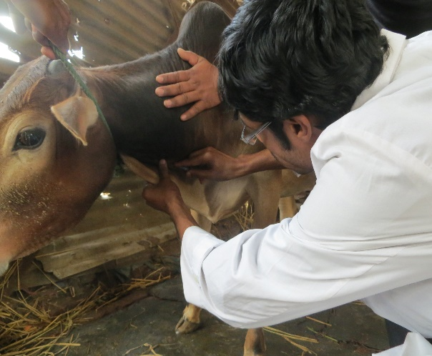
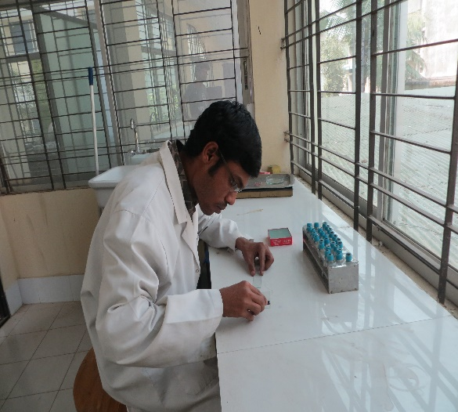
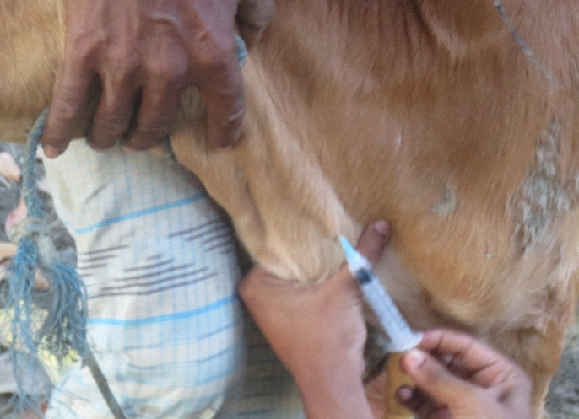

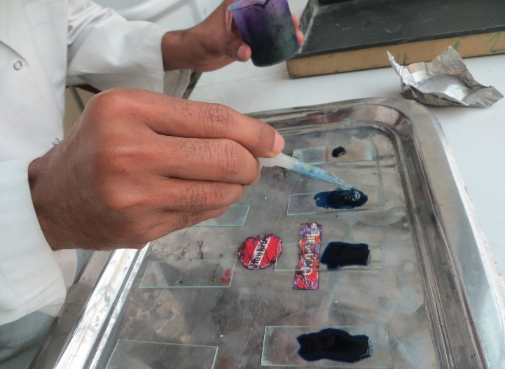
Fig: A Fig: B

Fig: C Fig: D
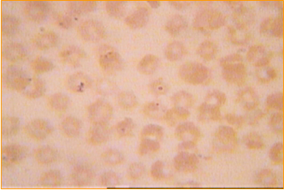
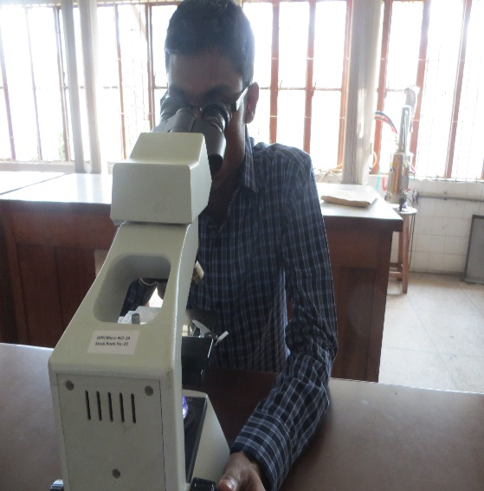

Fig: E Fig: F
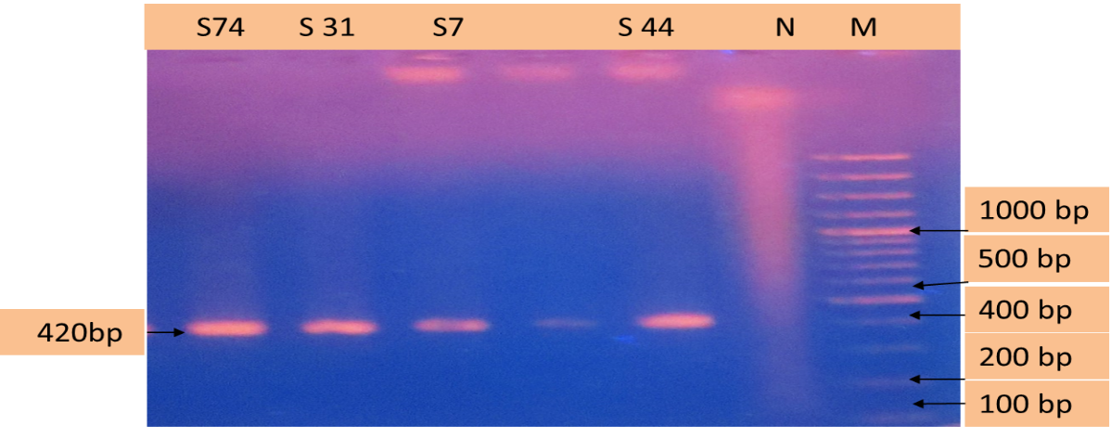

Fig: G

Fig: H

Fig: I

A. Restraining B. Blood collection C. Smear preparation D. Staining E. Microscopic detection F. Microscopic Babesia sp picture G. Babesia sp positive band in agar gel electrophoresis H. Microscopic Anaplasma sp positive picture I. Anaplasma sp positive band in agar gel electrophoresis.

