CHAPTER-I
GENERAL INTRODUCTION

Quail is the smallest and latest domesticated poultry species. There are about 131 species and 17 to 18 varieties of wild quail found all over the world, of which Japanese, Bobwhite, King and Stable quail are most important. Japanese quails are natural inhabitant of Japan. Quails are reared in Japan from the time immemorial. The scientific name of Japanese quail is Coturnix coturnix japonica under the class aves and family Phasianoidea (Hashanuzzaman, 2013).

Poultry eggs and meat provide approximately 38% of total animal protein in Bangladesh. The protein consumption from animal origin in Bangladesh is significantly lower than in other countries of the world. The annual average deficit of meat is 3.81 million metric ton and the annual avg. deficit of chicken egg is 6939 million numbers (Andrew, 2003). With the rapid increase in total population the demand for poultry products has been increasing. To meet up the growing demand for poultry products, the development of poultry industry is very important.

The popularity of quail husbandry is increasing all over the world. In Bangladesh quail was introduced for the first time in 1988 (Das, 2004). Quail farming for egg and meat is quite popular in Japan, Hongkong, Korea, China, Singapore, India, Thailand, Malaysia, Indonesia, France, Italy, Germany, Britain and Russia. Only Bobwhite quail and Japanese quail have been domesticated for commercial purposes and in Bangladesh these two are commercially available. Besides, scientists developed many quail lines e.g. white egg shell line, meat line etc.

Japanese quail, a recently introduced economic avian species is ideally suited for meat and egg under intensive management due to their low maintenance cost, early sexual maturity, higher exponential growth, higher heat tolerance, fitness for higher density rearing, higher disease resistance and higher egg production than that of other poultry species. Short generation interval and quick business return and the requirement of low investment attracting people to rear them. It appears that quail rearing may be an important to chicken when chicken survived in hostile climates and also for havoc like avian influenza and salmonellosis. The climate and natural condition of Bangladesh is very suitable for quail rearing. Quail can be reared in this country throughout the year with good performance in meat and egg production. It has a shorter life cycle and its production requires less capital and land (Vali et al., 2005). Being an agricultural country the government of Bangladesh has shifted policy emphasis on poultry rearing. Quail does not only supply animal protein in the form of meat and eggs, but also provides a source of income. The quail farming as a supplement to chicken and duck farming has the unique advantage of tapping the growing market demand for poultry products (Sultana et al., 2007).

In recent years, a large number of small scale commercial quail farms or 'QUAILARY' have been established in Bangladesh to raise quails mainly for hotels, shops and household consumption. Japanese quail is the smallest avian species farmed for meat production (Vali, 2008). The meat from broiler quail is very delicate and tasty. It is considered as a superior item in different restaurant and homes. One five week old broiler quail attains 140-150 gm body weight within 5 weeks of age and yields 72.5 % carcass for consumption (Das, 2004).

Success in poultry farming depends on scientific breeding, feeding, management and disease control of the flocks. There is a relationship of Japanese quails (heavy body weight) line to dietary energy levels and graded essential amino acid levels on growth performance and immuno-competence (Kaur et al., 2008).

Santos et al., 2011 worked with growth of quail broilers to establish the nutrient requirements and feeding practices suitable for quail under tropical and subtropical countries. For optimum growth of quail broilers, a diet containing 27% CP with 11.72 MJ ME/ Kg is recommended up to 2 weeks of age & a diet containing 24% protein with the same energy for birds from 3 to 5 weeks.

Genchev, 2012 reported that Japanese quail requires 14-18 hours of light per day to maintain maximum egg production and fertility. This means that supplementary lighting must be provided in the autumn, winter and spring months to maintain production. It was also observed that the storage length influenced the rates of egg mass loss during incubation and the hatching time (Romao et al., 2010).

Yalcin et al., 2006 studied the inheritance of carcass and meat quality of Japanese quail. According to this study heritability’s of carcass and meat quality traits in Japanese quail (Coturnix coturnix japonica) are moderate to high. Selection for increased and/ or decreased quail body weight has some correlated effects on meat quality trait.

The profitability in quail farming is possible by better management due to the above reasons. Reports on quail growth and body composition are numerous. The better growth performance and meat quality of broiler quail (Japanese quail) are supported by the findings of (Kaur et al., 2008 and Vali, 2008). The findings of their study clearly indicate that quail farming is a promising sector in poultry meat production.

In public sector limited scope is given to a large number of educated people are looking for self-employment. The time has now come for creating alternative employment opportunities for these educated people. The self-employment scheme is one probable answer and quail farming seems to be a promising enterprise in this direction. It is hoped that quail farming will be recognized as popular poultry sector one day in our country.

Therefore the objectives of the present study were,
- To know the growth and production performance of Japanese quail under controlled housing.
- To determine the cost effectiveness.
- To observe the total management of controlled housing system of quail rearing.
CHAPTER-II
MATERIALS AND METHODS

2.1 LOCATION AND DURATION OF THE EXPERIMENT:
The study was conducted at a local Quail farm & hatchery known as Khaza quail farm & hatchery Ltd., Moij-jartack, potia, Chittagong. It is a small local quail farm which includes three rearing units and one hatchery. During observation, the total numbers of broiler quails were 650.

2.2 HOUSING AND MANAGEMENT:
Housing system is most important. In case of quail farming, housing system should be wire floor or battery or cage system. In that farm,

2.2.1 Floor space
The floor management for rearing broiler was 55 ft long and 20 ft wide. The floor space for day old chicks up to 3 wks was 100 sq cm/ bird and from 3 weeks up to 6 wks (marketing age) it was 170 sq cm/bird.

2. 2. 2 Litter materials
Wood shaving was used as litter material at the depth of 7 cm over the floor.

2. 2. 3 Pre incubation care of egg
Eggs were collected from own hatchery, stored at a temperature 15°C and were fumigated after they are collected. Fumigation was done by using 25gm of potassium permanganate and 35 ml of formalin (40%) for each cubic meter of incubator space.

2. 2. 4 Incubation and hatching
The incubation period for quail is 17-18 days, depending on the strain and the incubation procedures. Successful hatches depend upon a good understanding of incubator controls. A still-air incubator was used. The incubation temperature was 38.3°C (101°F) which did not exceed 39.5°C (103°F) temperature until hatching was completed. Temperature was measured at the top of the eggs. Humidity was less than 70%. The eggs were turned by hand at least three, and preferably five, times in a day. A pencil mark on the side of each egg helped to ensure proper turning. The eggs were hatched at 17th to 18th day of incubation.

2. 2. 5 Brooding
The chicks were brooded under continuous lighting for the first two weeks and were kept within a case. Papers were used as litter and were changed every day. During brooding 100 sq cm space was maintained per bird. 95°F temperature was maintained for 24 hrs as brooding temperature from the day of hatching up to 2 wks.

2. 2. 6 Lighting management
During brooding period (0-2 wks) 24 hours lighting was ensured. After the brooding period (0-2 wks), lighting program normally changed depending on the purpose of production. As those birds were reared for meat production so they were exposed to 23 hours lighting with 1 hour darkness.

2. 2. 7 Temperature schedule
During brooding period (0-2 wks), 95°F temperature and from 3 wks to marketing age (6 wks) 75°F temperature was maintained.

2. 2. 8 Feeder and waterer
Adult quail need 1.25-2.5 cm of feeder space per bird. Ample feed should be present, but if the trough is too full, excessive wastage will occur. Clean, fresh water should be provided at all times with a minimum of 0.6 cm of trough space per quail. Nipple drinkers and cups are suitable for adult quail. One nipple or cup should be provided for every 5 birds.

TABLE 2.1: THE FOLLOWING FEEDER AND WATERER SPACES WERE AVAILABLE IN THE FARM:

Items | Brooding period (0-2 wks) | Growing period (3-6 wks)
- Feeder | 1 linear cm/ bird | 1 round feeder/ 25 birds
- Plastic drinker | 0.5 linear cm/ bird | 1 plastic drinker/ 30 birds

2. 2. 9 Feeding and nutrition
In the farm, controlled packaged ready feed was provided to birds. Per chicks were supplied with 2 gm feed daily on avg. in (0-1) wks. However, 18.75 gm feed per bird daily were supplied to birds on avg. form 3 wks to the marketing age (6 wks).

TABLE 2.2: NUTRITIONAL LEVEL OF FEED:

Type of ration | ME(Kcal/kg) |  | CP% |  | Ca% |  | Avg. P%
 | SD.  value | PGT.  pellet feed | SD.  value | PGT.  pellet feed | SD. value | PGT.  Pellet  feed | SD.  value | PGT.  pellet feed
Starter (0-2 wks) | 3200 | 3000 | 25 | 22 | 0.95 | 1.15 | 0.45 | 0.50
Finisher(3-6 wks) | 3200 | 3050 | 20.5 | 20 | 0.95 | 1.05 | 0.42 | 0.44
SD. =Standard value, PGT. =Progoti feed company, CP=Crude protein, Ca=Calcium, P=Phosphorus.
Source of the standard value: (Larbier and Leclercq, 1994).

The table shows that, the ME of starter (0-2 wks) and finisher feed (3-6 wks) was 3000 and 3050 Kcal/kg respectively which was lower than the standard ME requirement. Likewise, the supplied CP in the starter feed was 22% and in the finisher it was decreased to 20% which were also lower than the standard CP% (25% & 20.5% respectively). But the Ca% & P% of supplied feed was slightly higher than the standard levels.

2. 2. 10 Body weight, weight gain and feed conversion ratio
Body weight gain:
Average daily gains (ADG) were estimated using the formula
ADG = (W2−W1)/N
Where W2 is the final weight
W1 is the initial weight
W2 -W1=Live weight gain
N is the number of days taken from initial weight to the present weight.

Live weights of the birds were recorded weekly from 0-6 wks. From this live weight, the live weight gain was calculated. And then, avg. daily weight gain (ADG) was calculated by dividing the every obtained value per wk. with 7. Such as the hatch weight of chick was 10gm and the weight of 1st week was 20 gm. So, live weight gain of 1st week = (live weight of 1st week – hatch weight).
Now the ADG at 1st wk. = (live wt. gain at 1st wk. /7). Similarly, live weight gain of 2nd week= (live weight of 2nd week – live weight of 1st week).

Feed Conversion Ratio (FCR):
The gain per feed intake was estimated for the first 6 weeks on weekly basis. This was estimated using the formula:
Feed conversion ratio = Feed intake/ Avg. daily weight gain.

2. 2. 11 Medication
TABLE 2.3: MEDICATION ROUTINE:
For the starter (0-2 wks):
Age (days) | Medicines | Amount (in 1 litre water)
1-2 | Glucolyte | 10-20 gm
3-8 | Doxyoxy | 5 gm
 | Gluco-C | 10 gm
9-14 | Thiamix-RP | 1 gm
 | Sancal-P | 1 gm
 | Vitamina AD3E | 1 ml

For the finisher (3-6 wks):
Age (days) | Medicines | Amount (in 1 litre water)
15-18 | Pulv. Starcox | 1 gm
 | Calplex Liq. | 2.5 ml
19-23 | Chick tonic Liq. | 1 ml
 | Calplex Liq. | 2.5 ml
 | Thiavitamin plus | 2 ml
24-28 | Moxicol | 1 gm
 | Chick tonic liq. | 1 ml
29-42 & onwards | Doxyoxy WSP | 5-10 gm
 | Pulv. Star Cox | 1gm
 | Chick tonic liq. | 1ml
 | Gluco-C | 10gm

2. 2. 12 Data collection:
I visited the farm and collected the data by own observation & interviewing the owner Abu Sadek of respective farm from 9th September 2015 to 17th November 2015.
CHAPTER-III
RESULTS

The farm is a potential commercial farm for quail rearing. The adult birds were sold after 6 weeks of age when the expected weight is acquired i.e. about 120-130 gm. During this study, the average body weight of the targeted batch of 6 weeks aged birds were 130 gm and FCR were 4.55:1. Feed intake was 5 gm per bird daily on average up to 2 weeks and 18.75 gm per bird daily on average from 3-6 wks. Mortality rate was higher at (0-2) wks.
The results of my study are based on the following data:
3.1 HATCHABILITY:
Total number of fertile eggs settled in setter was 910.
Total number of chicks hatched after 18th day of incubation was 650
So, the hatchability= (Total no. of chicks hatched / Total no. of fertile eggs settled) × 100
=71.42 %

3.2 FEED INTAKE:
Feed intake was recorded for the first 6 weeks. This was estimated on daily basis. The birds were supplied balanced pellet feed from the Progoti poultry feeds ltd.

  - BODY WEIGHT, WEIGHT GAIN AND FEED CONVERSION RATIO:
The body weight was calculated by weighing the birds in a weighing tool. The hatch weight (avg.) was 10 gm. The avg. body weight and avg. weight gain at marketing age (6 wks) were 130 gm and 22 gm respectively. The feed conversion ratio (FCR) was reported 4.55:1.

3.4 MORTALITY:
The percentage mortality was estimated for the first 6 weeks on weekly basis. This was estimated using the formula:
Mortality rate = (No. of dead quail over the week/ No. of quail at the beginning of the week) ×100.

TABLE 3.1: THE OVERALL PERFORMANCES OF THE KHAZA QUAIL FARM & HATCHERY LTD. IN RELATION TO THE STANDARD VALUE FROM LITERATURE SHOWN IN THE FOLLOWING TABLE:

TIME (WK.) | FI (gm) / day (avg.) |  | LW  (gm) | LWG (gm) | ADG (gm) | FCR (gm) |  | MY  (%)
 | SD. | Achieved | Achieved |  |  | SD. | Achieved | Achieved
0-1 | 3-4 | 2 | 20 | 10 | 1.43 | 1.33 | 1.40 | 4.62
1-2 | 7-9 | 8 | 38 | 18 | 2.57 | 1.93 | 3.11 | 4.03
2-3 | 11-14 | 15 | 58 | 20 | 2.86 | 2.34 | 5.24 | 2.02
3-4 | 15-18 | 20 | 83 | 25 | 3.57 | 2.93 | 5.60 | 1.89
4-5 | 18-20 | 20 | 108 | 25 | 3.57 | 3.44 | 5.60 | 1.22
5-6 | 20-24 | 20 | 130 | 22 | 3.14 | 4.01 | 6.37 | 0.71
Total- 6 wks. |  | 14.2 (avg.) |  |  |  | 2.66 (avg.) | 4.55  (avg.) | 2.42  (avg.)

FI= Feed intake, LW=Live weight, LWG=Live wt. gain, ADG= Average daily gain, FCR= Feed Conversion Ratio, MY=Mortality, SD. = Standard value, WK. = Week.
Source of the standard feed intake value: (Das, 2004) and
Standard FCR by: (Naim, 2012).

According to the above table, the feed intake of chicks at 1st and 2nd weeks were 2 gm and 8 gm/bird/day respectively, where at 1st week given 2 gm feeds were below the standard feed intake levels (3-4 gm). Although, the feed intake at 3rd wk. was 15gm but at 4-6 wks and onward in every wk. per birds were given 20 gm (avg.) feeds/ day. The live weight of birds at (0-6) wks were 20 gm, 38 gm, 58 gm, 83 gm, 108 gm and 130 gm respectively and ADG at (0-6) wks were 1.43, 2.57, 2.86, 3.57, 3.57 and 3.14 gm respectively. The table shows that, live weight gain was increasing gradually with the live weight and age up to 5 wks of age. The average weight gain of birds at marketing age (6 wks) was 130 gm. The FCR was 1.4, 3.1, 5.24, 5.6, 5.6 & 6.37 at 1st to 6th wks respectively with an avg. of 4.55:1. The mortality % (4.62 & 4.03) was higher within 0-2 wks of age. After that, mortality rate was decreased at a decreasing rate with an avg. mortality of 2.42% after 6 weeks.

3. 5 COST EFFECTIVENESS OF PER BIRD REARING:

The feed and water cost per bird up to 6th weeks = 29 Tk

Litter materials= 500 Tk

Cost of equipment & electricity = 1400 Tk

Depreciation cost = 500 Tk

Total medicine cost =1120 Tk

Total Cost per bird = 34.41 Tk

The price of bird at market age = 45 Tk

Total profit from per bird production = (45 – 34.41) Tk

= 10.59 Tk /per bird.

CHAPTER-IV
DISCUSSION

From the technical and economic points of view, quail rearing is attractive due to their rapid growth and early onset of lay, high reproduction rates and low feed intake (Seker et al., 2004). In an observational study by Dauda et al., 2014 it was found 70.48 % hatchability of Japanese quail eggs which was slightly lower than this study of 71.42 % hatchability. The storage of quail eggs at tropical temperature seems to be suitable up to 6 days when hatchability remains 70 %. After one week of storage there is an increasing rate of unhatched eggs, mainly due to pre-incubation mortality or early embryonic death. In the study, the birds were fed formulated diet containing (20-22) % crude protein and (3000 -3050) Kcal/Kg metabolizable energy, both of which were higher than earlier study of Begum and Howlider, 2000 where, 18 % CP & 2800 Kcal/Kg ME were provided but in the study the found value is lesser than the recommendation (3200 Kcal/Kg from 0-6 wks and 25 % ME in 0-2 wks) of (Larbier and Leclercq, 1994). After all, the present findings indicate that Japanese broiler quail needs diet containing 3200 kcal ME/kg and (24.5-25) % CP during the first two weeks of age to achieve optimum growth performance. Similarly, dietary level of 3200 kcal ME/ Kg and (20.5-21) % CP should be offered at the finisher (3-6 wks) stages. Birds should also provide appropriate amount of feed in every wks as mentioned by (Das, 2004). Daily feed intake recorded in study of control feeding & choice feeding of adult quail was 24.92 gm in control feeding & 24.38 gm in case of choice feeding (Canogullare et al., 2004). Adult Japanese quail eat between 14 to 18 gms of feed per day (Sakunthala et al., 2010). In an experimental study, Rahman et al., 2010 reported that average daily feed intake of Japanese quails were increased with increasing dietary CP level. Here, although the feed intake (FI) from 4th - 6th wks were 20 gm average, but in (0-1) wks it was 2 gm/bird only where, the FI value in 1st wk does not support the recommendation by (Das, 2004). Santos et al., 2011 reported that Feed intake was higher in broiler quails than in egg- type quails due to their higher body weight (140-150 gm) as compared to that of egg-type quails (120-140 gm). However, feed intake increased with advancement in age and ranged from 3.1 gm in week 1 to 15.2 gm at the 6th week of age in a study by (Dauda et al., 2014). In the study, the average daily gain (ADG) and live weight gain (LWG) in 1st wk. was 1.43 gm & 10 gm respectively and recorded maximum LWG of 25 gm and ADG of 3.57 gm in between (3-5) wks of age. The marketing age was (40-45) days after gaining 130 gm body weight. The average daily gain & live weight gain increased with chronological age up to 5 wks. The study showed that, the avg. FCR (4.55) was found much higher than the standard FCR value 3:1 for broilers (Das, 2004). Earlier, in a study by Dauda et al., 2014 feed conversion ratio estimated 3.01:1 at week 2 resembling to my findings (3.1:1) in the same age and 7.08:1 at week 6, which was slightly higher in contrast to my study. Here, feed conversion ratio increased gradually from initial stage of life (1.4) up to 6th weeks (6.37) of age. The higher FCR may be due to lower intake of energy and CP in the regular feeds and also due to less feed intake (<3 gm) in the early stage supporting statement of (Hashanuzzaman, 2013). However, an improvement in FCR in growing quails with increasing dietary energy level or increasing dietary energy to protein ratio have been mentioned by (Gheisari et al., 2011). The mortality rate decreased with age and was relatively higher in 0-2 wks (4.62, 4.03%), with average of 2.42 % after 6th wks. Naim, 2012 also found relatively higher mortality in 0-2 wks of age with an avg. of 2.57 % expressing similarity to my result. The study also showed that total profit from per bird production was more than cost of production. Therefore, quail farming is profitable. The findings on growth and productive performance of Japanese quails in this study suggest that although the housing and hatchery management is favorable to the birds but daily feed intake must follow standard Japanese broiler Quail feeding guideline and ready feeds should be checked for ME and CP for their proper maintenance, optimum growth and production. Above all, Quail rearing can serve as an alternative source of protein to the populace, thus adequate publicity is required to propagate the production of this bird to increase animal protein intake in Bangladesh.

CHAPTER-V
CONCLUSION AND RECOMMENDATION

CONCLUSION:
Bangladesh has nearly achieved self-sufficiency in staple food. But still the country
suffers from animal protein deficiency. Quail raising has strong potentiality for reducing protein deficiency as well as unemployment problem. It has an unique advantage of tapping the vast market potential for chicken and duck products, especially in the urban areas. It is now actual time to make quail farming as a major profession for growth of livelihood and sustainable development. The policy makers should, therefore, take necessary measures which would encourage development of quail farming. Thus, this farming site will quickly spread all over the country which will make an example for this sub-continent. By combining mental strength, physical effort with few basic technical knowledge one can easily become a successful quail farmer. It is no doubt, that quail farming will become one of the main poultry industries of our country in the near future. The major advantage of quail rearing is its low investment compared to other poultry farming. The management system and performance of the studied farm is surprising. However, the quail farming is profitable and it may be an income generating source by alleviating unemployment burden, enrich our poultry meat supply and thus will meet the daily protein requirement of the nation.

RECOMMENDATION:
- Further study should be conducted with adequate time.
- Proper management study is recommended.
- Owner should be trained up for scientific way of quail rearing.

CHAPTER-VI
REFERENCES

Andrew, S. W. "Global production and consumption of animal source foods." The Journal of Nutrition 133, no. 11 (2003): 4048S-4053S.

Begum, R and M. A. R. Howlider. "Effects of dietary protein on egg production performance of Japanese quail under Bangladesh condition." Bangladesh Veterinarian 17, no. 2 (2000): 106-110.

Canogullare, S., B. Mikail and C. Ahmet. "Diet Selection by Japanese Quails (Coturnix Coturnix japonica) Offered Grounded Wheat and Concentrate Feed as a Choice." Journal of Animal and Veterinary Advances 3, no. 7 (2004): 419-423.

Das, G. B. "Quail management". In: Poultry production, 1st ed., Bangla Academy Press, Dhaka 1000, Bangladesh (2004). P: 237-245.

Dauda, G., O. M. Momoh, N. I. Dim and D. M. Ogah. "Growth, production and reproductive performance of Japanese Quails (Coturnix coturnix japonica) in humid environment." Egyptian Poultry Science Journal 34, no. 2 (2014): 102-107.

Genchev, A. "Quality and composition of Japanese quail eggs (Coturnix japonica)." Trakia Journal of Sciences 10, no. 2 (2012): 91-101.
Gheisari, A., H. Allah, G. H. Maghsoudinegad, M. T. Alibemani and S. E. Saeid. "Effect of different dietary levels of energy and protein on performance of Japanese quails (Coturnix coturnix Japonica)." International Conference on Agricultural and Animal Science, Singapore, vol. 4 (2011): 54-58.
Hashanuzzaman, M. "Growth, egg production potential and reproductive fitness of six different mutants of Japanese Quail isolated at BAU ". M.Sc. Thesis, Bangladesh Agricultural University, Mymensingh-2202, Bangladesh (2013).

Kaur, S., A. B. Mandal, K. B. Singh and M. M. Kadam. "The response of Japanese quails (heavy body weight line) to dietary energy levels and graded essential amino acid levels on growth performance and immuno-competence." Livestock Science 117, no. 2 (2008): 255-262.

Larbier, M and B. Leclercq. "Nutrition and feeding of poultry". Edited. Julian Wiseman. Nottingham University Press (1994).

Naim, M. "Management and growth performance of Japanese Quail in a local Quail farm at Noakhali, Bangladesh." Intern report (2012).

Rahman, M. S., K. M. G. Rasul and M. N. Islam. "Comparison of the productive and reproductive performance of different color mutants of Japanese quails (Coturnix japonica)". Proceedings of the Annual research Review Workshop-BLRI, Savar, Dhaka, Bangladesh 3, no.1 (2010): 50-56.

Romao, J. M., T. G. V. Moraes, E. E. Silva, R. S. C. Teixeira and W. M. Cardoso. "Incubation of Japanese quail eggs stored at tropical temperatures." Livestock Research for Rural Development 22, no. 1 (2010): 22-27.
Sakunthala, D. K., G. B. Ramesh, P. M. Gnana and S. Qudratullah. "Genetic studies on growth and reproduction traits in two strains of Japanese quails." Tamilnadu Journal of Veterinary and Animal Sciences 6, no. 5 (2010): 223-230.

Santos, T. C., A. E. Murakami, J. C. Fanhani and C. A. L. Oliveira. "Production and reproduction of egg-and meat-type quails reared in different group sizes." International Journal of Animal Science 13, no. 1 (2011): 9-14.

Seker, I., S. Kul and M. Bayraktar." Effects of parental age and hatching egg weight of Japanese quails on hatchability and chick weight." International Journal of Poultry Science 3, no. 4 (2004): 259-265.

Sultana, F., M. S. Islam and M. A. R. Howlider. "Effect of dietary calcium sources and levels on egg production and egg shell quality of Japanese quail." International Journal of Poultry Science 6, no. 2 (2007): 131-136.

Vali, N., M. A. Edriss and H. R. Rahmani. "Genetic parameters of body and some carcass traits in two quail strains." International Journal of Poultry Science 4, no. 5 (2005): 296-300.

Vali, N. "The Japanese quail: A review." Interenationals Journal of Poulry Science 7, no. 9 (2008): 925-931.

Yalcin, S. I., I. Oguz and S. Otles. "Carcass characteristics of quail (Coturnix coturnix japonica) slaughtered at different ages." British Poultry Science 36, no. 3 (2006): 393-399.

CHAPTER-VII
APPENDIX-I
QUESTIONNAIRE

Farm information’s....... Date…
Basic information:
1. Name and address of the farm:
2. Name of the owner:
3. Type of farm (Broiler/ layer/ breeder).
4. Housing system (Litter floor/ battery/ cage).
5. Floor type (Litter/ concrete/ slat/ mud/ others).
6. Litter materials………..
7. Vaccination schedule: (Good/ moderately practiced/ not performed).
8. Biosecurity: A). Access: (not restricted/ restricted).
B). Foot bath: (present/ absent).
C). Wild birds/ animal access: (yes/ no).
D). Sanitation: (good/ moderate/ poor).
9. No. of birds….
10. Rearing unit (1/2/3...).
11. Feed intake…..; feeding system……and feed conversion ratio….
12. Body weight gain……….
13. Fertility……..%
14. Hatchability…..%
15. Mortality …..%.
APPENDIX-II
FIGURES
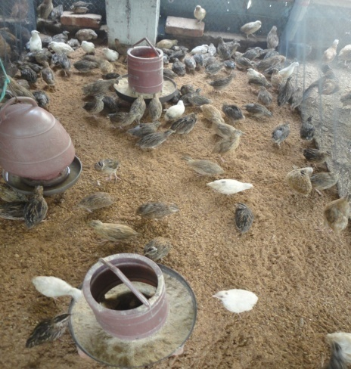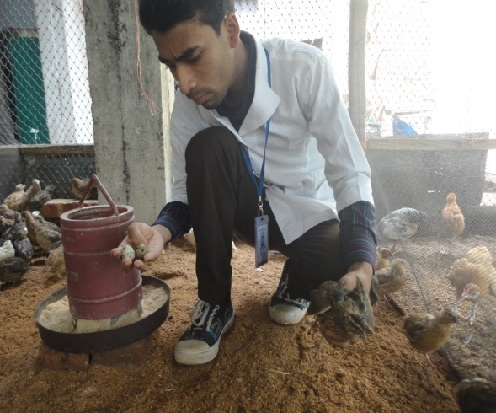
Fig: 2.2: Observation of egg, litter, mixed feed, feeder and waterer.
Fig: 2.1: Picture of litter floor rearing of quail.

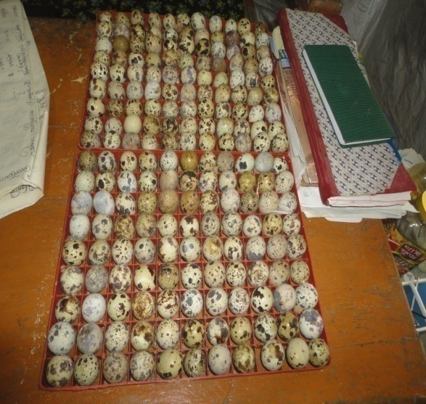
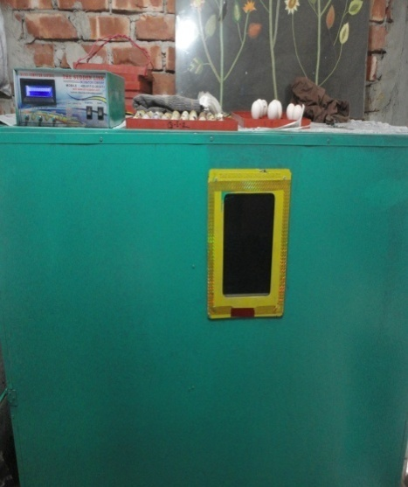
Fig: 2.3: Incubator machine.
Fig: 2.4: Quail eggs on tray.

Fig: 2.4: Quail eggs on tray.
Fig: 3.1: Three days old chicks.
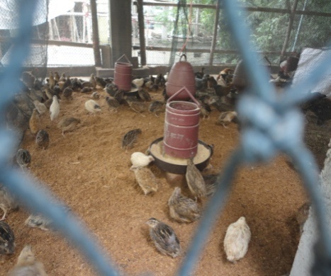
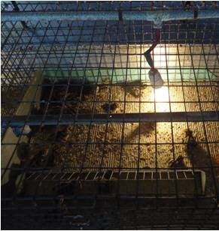
Fig: 2.6: Brooding of chicks.
Fig: 2.5: Feeding of quails.

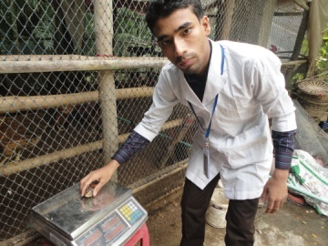
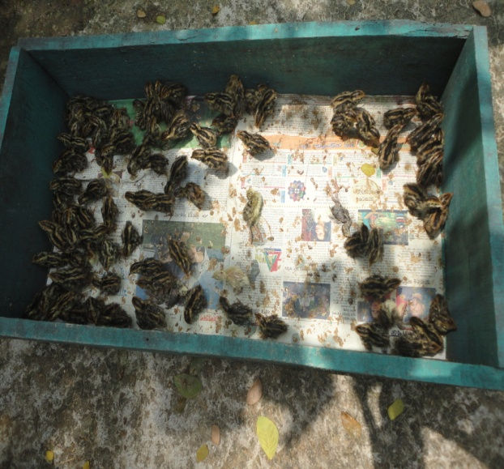
Fig: 3.1: Three day old chicks.
Fig: 3.2: Weighing of chicks.

BIOGRAPHY

I am Tapas Roy Barman. Home district is Chittagong; Bangladesh. I was born on 8th October, 1992. I completed my S. S. C in 2007 obtaining G. P. A 5.00 from kalakakoli high school; Chittagong and H. S. C in 2009 from Govt. City College; Chittagong with G. P. A. 5. 00. At present, I am continuing internship in Chittagong Veterinary and Animal Sciences University. My research interest is in theriogenology.

