CHAPTER-I
INTRODUCTION
In Bangladesh, poultry is one of the most important sectors in the context of agricultural growth. Poultry egg and meat are important sources of high quality proteins, minerals and vitamins to balance the human diet.
Depending on the farm size, layer (for eggs) farming can be main source of family income or can provide income and gainful employment to farmers throughout the year.
One of the major problems of the development of the poultry sub-sector in Bangladesh relates to the lack of sufficient and appropriate feeds (Mitchell 1997; Alam 1997). It is suggested by researcher that, if high priority is given to the improvement of the feed supply, then it will help in developing resistance to disease, on one hand, and production of quality products, on the other. It was reported in 1999 that there were 40 feed mills with 900 dealers within the private sector that were producing and distributing poultry feed all over the country (Latif 1999). In Bangladesh poultry farms are growing fast in recent time. Due to the high population growth and demand elasticity, the demand for poultry is expected to increase. So, to meet this demand poultry farms are also expected to increase over time. Commercial layer strains are now available with traits of high egg production and high feed conversion efficiency. Chicks will double their weight four to five times in the first six weeks of life. This tremendous growth demands proper nutrition. A commercially prepared chick starter – or crumble is the best way to provide a complete nutritional package at all times. In the first six weeks, feed consumption will be approximately 1 kg for each egg-producing chick and 4 kg for each meat producing chick. Layer can produce about one kg of eggs by consuming about 2.25 kg of food during their egg laying period. The starter should contain a coccidiostat to stop intestinal damage caused by one of the common types of chicken parasites. Wheat and maize together constitute over half of total poultry feeds, of which over four-fifths is maize and less than one-fifth is wheat. Although the use of wheat and maize for livestock and poultry feed is growing rapidly in developing countries in general (Sarma 1997), this has not yet reached a significant proportion in Bangladesh. Maize in Bangladesh is still a minor crop in terms of acreage, accounting for only 3 percent of wheat and 0.2 percent of rice. Maize is currently produced in the country largely in winter season, though it is possible to produce maize throughout the year. Poultry production is an important part of animal agriculture. By increasing the productivity of poultry meat and eggs, the existing gap between supply and demand of animal protein can be bridged. Poultry meat contributes around 37% of the total animal protein supply of Bangladesh (Ahmed and Islam, 1990). The estimated contribution to GDP during FY 2012-13 from livestock subsector was 3.49% (DLS, 2012-2013). As an important sub sector of livestock, the poultry industry plays a vital role in economy and simultaneously creates numerous employment opportunities. In Bangladesh, small and large scale poultry farms are expanding rapidly, providing meat, eggs and employment. According to DLS, the production of poultry (projected) rose to 29, 32, 35, 000 in 2012-13. There are 24, 66, 00, 000 chickens (DLS, 2012-13) and about 50,000 poultry farms (FFYP, 2003) available in Bangladesh presently.
Though presently only 15% of the total poultry products are coming from commercial farms, poultry industry has established its position as the fastest growing segment in the agricultural sector. Bangladesh Government has also come forward for the improvement of this sector and offering training and financial assistance to marginal entrepreneurs. Broiler meat contains high quality protein and micro-nutrients which has had a tremendous impact on health and nutrition for the poor people in rural areas (Neumann et al., 2002; Barroetoa, 2007). Again, another study reported that it can be the main source of family earning or can provide sufficient income and gainful employment opportunity to rural farmers throughout the year (Bhende, 2006). For this reason, broiler farming has been playing a key role in providing meat to overcome the malnutrition and serve as a tool for employment generation and poverty alleviation (Raha, 2007). For commercial poultry farming, feed serves as the largest cost of operation. According to (McNab, 1999), this cost lies between 65 to 75%. So any improvement in the performance of layers due to their diet can inevitably have a profound effect on profitability. Healthy poultry needs a sufficient amount of protein, carbohydrate, along with the necessary vitamins, dietary minerals and adequate supply of water. It should be dry, clean and contamination free.

Layer feeding
Chicken feed shall be in the form of pellets, crumbs or mash. The feed should be free from rancidity, musty odour, toxic ingredients, adulterants, moulds and insect infestation .Feed in mash form is suitable for layer. The advantage of mash feed is each bite of feed containing all of the known nutrients in finely ground form. But birds find the finely ground mashes unpalatable, they are too dry or sticky. Therefore, mashes composed of materials of medium particle size improve the birds’ ability to eat them readily. Dry mash is better than wet mash due to wet mash feeding will not increase egg production, egg weight, growth and feed conversion ratio as dry mash (North and Bell, 1990).Egg production, to be profitable, must continue at a reasonably high level through most of the year. Hens turned loose to forage in the spring and only grain fed, soon lay themselves thin, cease laying, moult and spend the summer and fall growing new feathers; moreover any eggs they lay are likely to be of low quality. Laying hen require some form of protein supplement in addition to grain and chop. Similarly they need more vitamin and mineral materials than grains.
Larbier and Leclerck, (1994) stated that dietary energy concentration is 2700-2900 kcal of metabolized energy/kg may be recommended to the laying hen according to cost of minarels. A level of 15% crude protein appears to be sufficient on condition that the diet is balanced with respect to sulphur amino acid and lysine. The dietary level of calcium must be equal to 3.5% to obtain strong shells. At the end of lay, when shell strength tends to fail, the dietary levels of calcium may be reduced. The egg shell contains calcium carbonates and very little phosphorus. The yolk contains the majority of phosphorus but the amount deposited daily is much lower than calcium. So phosphorus requirement of layer is less than calcium. Recommended dietary level of phosphorus is 0.30 to 0.35%. Leghorn and medium sized layers producing brown shelled eggs require a diet with about 2860 kcal/kg of ME. CP% required for laying hens is closely related with the rate of egg production. 18-20% protein needed for early growth. When egg production reaches to peak, the protein requirement may be as 17-19%.

Proximate Analysis
Wilhelm Hennenberg and Friedrich Stohmann devised a method called proximate analysis. Weende or proximate analysis is partitioning of compounds in a feed into six categories based on the chemical properties of the compounds. The six categories are: Moisture, Total Ash (TA), Crude Protein (CP), Crude Fibre (CF), Ether Extract (EE), Nitrogen Free Extract (NFE). The proximate principles are expressed in percentage by weight basis and more commonly on dry matter basis (Reddy, 2008).

Main objectives of my study are:
- To compare between the company standard value and observed value of nutrients in layer layer ration in different companies.
- To suggest which one (layer feed) is the best on the basis of quality of feed.

CHAPTER - II

MATERIALS AND METHODS

Study area

From three different layer farm three feed samples were collected randomly. These farms are located scattered in different areas of Chittagong district. The collected feed samples were in the form of mash. All these feeds were commercial feeds – CP, Nourish and Paragon. From those three layer farm production data were also collected.

Table 2.1: Name of the feeds used in study
Sl. No | Name of the feed | Parameter
1. | CP Feed | Proximate Analysis
2. | Paragon Feed | Proximate Analysis
3. | Nourish Feed | Proximate Analysis

Study Period
The study was conducted from 1st November, 2015 to 30th November 2015 for collecting feed samples and data of above companies and for performing proximate analysis of feed samples and for statistical analysis of data.

Collection of samples
Samples were collected from three different poultry farm by using simple random sampling technique to investigate their nutrient value and compare the results among them. Several physical characteristics were seen during collection. The feed samples were brownish color with good flavor, free from foreign particles (soil, dust, weeds, iron, nails etc) and no offensive odor was present. Samples were wrapped up by polythene bags and preserved in the laboratory for proximate analysis.

Preparation of samples
Before undertaking an analysis the results of which are to be used to represent the composition of a consignment of a feedstuff, it is important that the sample is sufficient in amount and that it is selected properly from the bulk so as to be fairly representative of it. The feed samples were ground by using micro grinder to make it homogenous powder. Then mixing was done properly and exposed to cool down.

Nutrient content determination

Proximate Analysis
The proximate analysis of feeds showed the following composition: Dry Matter (DM), Moisture, Total Ash (TA), Crude Protein (CP), Crude Fibre (CF), Ether Extract (EE), Nitrogen Free Extract (NFE) in Animal Nutrition Lab and in Feed Analysis Lab of PRTC in Chittagong Veterinary and Animal Sciences University, Chittagong.

Estimation of DM and Moisture
In oven the enamel disc or crucible was dried which was regulated at 105°C and was cooled in a desiccators and weighted. 5 gm of feed sample was weighted into the enamel disc and kept into the oven for 24 hours. The enamel disc was removed from the oven with metal tong. After that it was cooled in desiccator and the final weight was taken after getting constant weight (AOAC, 1990).

%DM =$\frac{Weight of crucible with dry sample - Weight of empty crucible}{Weight of feed sample} ×100$
%Moisture = 100 - %DM

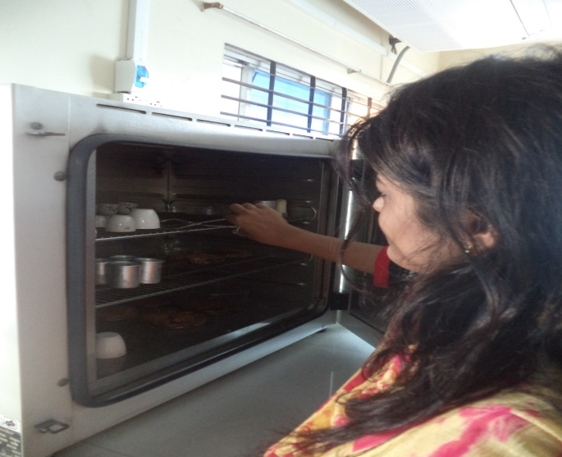

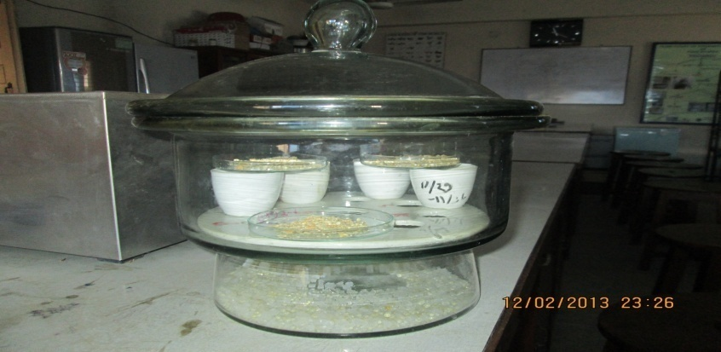
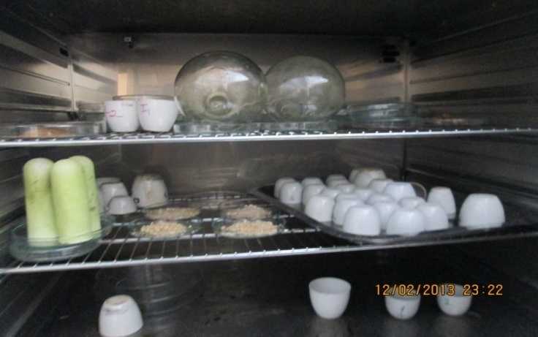

Figure 1: Estimation of DM in Hot air oven & Dessicator

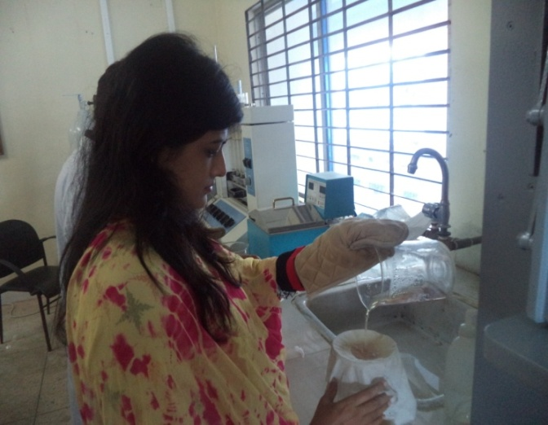
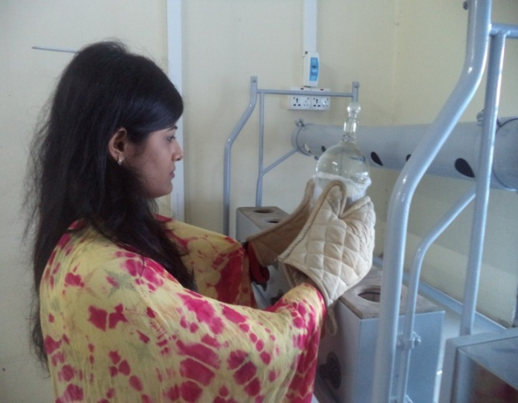

Figure 2: Estimation of Crude Fibre (CF)
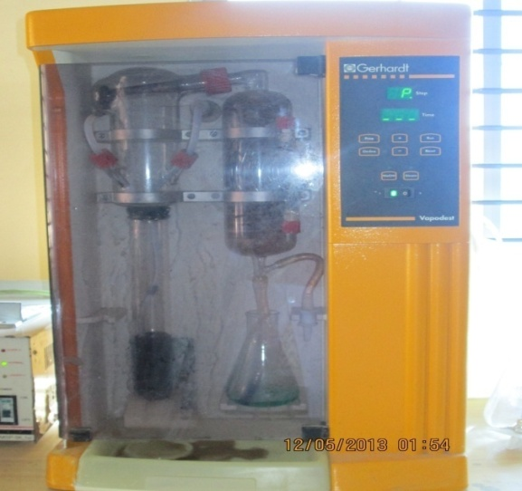
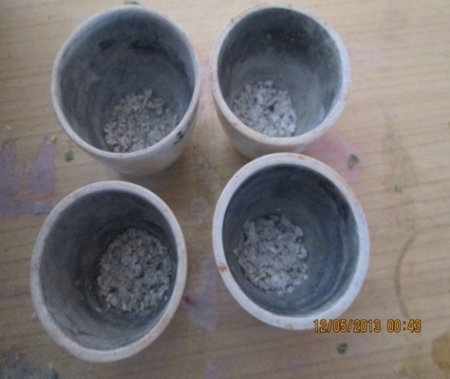

Figure 3: Estimation of Ash Figure 4: Distillation of Crude Protein

Estimation of Ash
The crucible was cleaned with water. Then dried in hot air oven.Iit was cooled in Dessicator. After that the weight of the empty crucible was taken. 5gm of feed sample was placed in the crucible and it was burned. Burning was done until no smoke was produced in heater. Then the sample with crucible was cooled and transferred to the muffle furnace. After that sample was ignited at 550-600°C for 6-8 hours until white ash is produced. The furnace was cooled at 150°C and the sample was transferred to the dessicator and weight was taken. (AOAC, 1990).

%Ash = $\frac{Weight of crucible and ash-Weight of crucible}{Weight of feed sample} ×100$

Estimation of Crude Fibre (CF)
Feed sample was weighted and 2gm sample was taken into a beaker. 125 ml of 1.25% H₂SO₄ was added in that beaker. After that it was fitted in condenser and placed on heater. It was cooled and filtered by using cloth. The sample was then washed until it was free from acid. After washing the residue of sample was transferred into same beaker. Then 125 ml of 1.25% NaOH was added there and again fitted in condenser and placed on heater. It was boiled for 30 minutes and removed from heater. After removing from heater it was cooled and filtered through filtering cloth. The sample was washed until it was free from alkali. After washing the residue of sample was transferred in a previously weighted crucible. The crucible was placed into the muffle furnace and ignited at 600⁰C temperature for 5 hours. Then it was cooled and weight was taken.

%CF = $\frac{Wt of CF}{Weight of feed sample} ×10$0
= $\frac{Wt of crucible with dry sample-Wtbof crucible with ash}{Wt of feed sample} ×100$

Estimation of Crude Protein (CP)
0.5 gm of sample was weighted and taken into a digestion tube. Then one spoonful of catalyzer mixer (KOH, NaOH, Se) was added there. 10 ml concentrated H₂SO₄ was also added and the digestion flask was placed in Kzeldhal Digestion Set. After that heat was increased gradually and continued until clear residue (45 min to 1 hr) is formed. The flask was removed from the digestion set and then cooled. 10 ml 2% boric acid solution, 2 drops mixed indicator were taken in a conical flask. The conical flask was fitted in the collection arm of distillation set. 50 ml distilled H₂O was added in the digestion tube and fitted in the distillation flask. 40 ml of 40% NaOH was added there and the distillation was continued up to 100ml. Then it was titrated against 0.1 N HCl. Titration was continued until the color was changed into pink. Then the reading of titration was taken. (AOAC, 1990).
% CP = $\frac{\left(Titre-Blank\right)×Normality of HCl ×14.007 ×6.25}{Wt of sample} ×100$

Estimation of Ether Extracts (EE)
One gram dry sample was taken in an extraction thimble having porocity, then placed in the Soxhlet flask. The cork of thimble was above the syphone tube. A receiving flask was weighted and fitted with Soxhlet apparatus and was placed in water bath at 50⁰ to 60⁰ C. Ether extract was poured down in to the soxlet falsk. The flask was filled up to ¾th portion with ether and it was sured that water was running through the condenser. When extraction was over, the thimble with sample was removed and heated in the water bath to remove all the ether from receiving flask. The receiving flask was placed into the oven at 105⁰C to eliminate left of the ether and water. After drying, the flask was taken out and weighted (AOAC, 1990).
%EE = $\frac{Initial wt-Weight after extraction}{Sample wt} ×100$

Calculation of Nitrogen Free Extracts (NFE)
NFE can not be estimated directly. The NFE was calculated by excluding the sum of the values of moisture, crude protein, crude fibre, ether extracts, total mineral matter from 100. (Raghuramulu et al., 1983).
%NFE = 100 – (%Moisture +%CF + %CP + %EE + %Ash)

Metabolizable Energy (ME)
The ME was calculated by using following formula (Lodhi et al., 1976).
ME (Kcal/kg) = 32.959 {%CP + (%EE × 2.25) + %NFE} – 29.20

CHAPTER- III

RESULTS AND DISCUSSIONS
Egg layers are known to have a high requirement for nutrients, especially calcium, magnesium and phosphorus (NRC, 1977). The results of chemical analysis and also of statistical analysis of data are given below in tabulated form
Table 4.1 : Proximate components of feeds of two companies with company standard
Parameters | CP |  | Paragon |  | Nourish
 | Observed values | Company values | Observed values | Company values | Observed values | Company values
Moisture % | 11.3 | 12 | 10.5 | 11 | 11.2 | 12
ME(Kcal/kg) | 2685 | 2800 | 2647 | 2800 | 2645 | 2750
Ash% | 6 | - | 6.8 | - | 6.3 | -
CP% | 16.9 | 17.5 | 16 | 17 | 16.8 | 18
CF% | 5.2 | 6 | 5 | 5 | 5.2 | 6
EE% | 3.3 | 4 | 3.2 | 3.5 | 3.3 | 4
NFE% | 53.2 | 55.5 | 58.3 | 58.6 | 56.2 | 57.5

Source of company report: Specification attached with the collected feed bag

Table 4.2: Standard values for nutrients of layer layer diet recommended by different researchers
References | ME (Kcal/Kg) | CP (%) | CF (%) | EE (%) | Moisture  (%)
Larbier, M. and Leclerc, B. (1992) | 2750-2900 | 17-18 | 4 | 3.5-4.0 | 12
Banerjee, G.C.(1995) | 2700 | 18 | 8 | - | 10
Verma D.N. (2006) | 2700 | 18 | - | - | -

DISCUSSIONS
From above study (Table 4.1), it can be said that there are no major differences among the nutrient compositions of layer layer diet with different types of feeds.

4.3.1: Graphical presentation of Moisture% of layer layer diet with different types of feeds
From the above chart we saw that the percentage of moisture which we found in laboratory that is the observed value is higher in CP feed (11.3%), then the Nourish Feed (11.2%), and lower in Paragon feed (10.5%). The company value of CP, Paragon, and Nourish feed are 12, 11 and 12 respectively.

4.3.2: Graphical presentation of metabolizable energy (ME Kcal/Kg) of layer layer diet with different types of feeds
Here we found that the metabolizable energy (ME Kcal/Kg) we found in Laboratory, the observed value is higher in cp Feed (2685 Kcal/Kg). Then the Paragon feed (2647 Kcal/Kg) and lowers in Nourish feed (2645 Kcal/Kg). The company value of CP, Paragon and Nourish feed are 2800, 2800, 2750 Kcal/Kg respectively.

4.3.3: Graphical presentation of Ash% of layer layer diet with different types of feeds
From above chart we saw that the Ash% we found in Laboratory the observed value is higher in Paragon feed (6.8%). Then the Nourish feed (6.3%) and lowers in cp Feed (6%). But we do not found any company value in the feed manual provided by the company.

4.3.4: Graphical presentation of Crude Protein (CP%) of layer layer diet with different types of feeds
From above chart we saw that the Crude Protein (CP%) Percentage we found in laboratory the observed value is higher in CP feed (16.9%), then the Nourish Feed (16.8%), and lower in Paragon feed (16.0%). The company value of CP, Paragon, and Nourish feed are 17.5, 17 and 18 respectively.

4.3.5: Graphical presentation of Crude Fibre (CF%) of layer layer diet with different types of feeds
From above chart we saw that the Crude Fibre (CF%) Percentage we found in laboratory the observed value is higher in CP feed & Nourish Feed (5.2%), and lower in Paragon feed (6.0%). The company value of CP, Paragon, and Nourish feed are 6, 5and 6 respectively

4.3.6: Graphical presentation of Ether extract (EE%) of layer layer diet with different types of feeds
From above chart we saw that the Ether extract (EE%) Percentage we found in laboratory, the observed value is higher in CP feed & Nourish Feed (3.3%), and lower in Paragon feed (3.2%). The company value of CP, Paragon, and Nourish feed are 4, 3.5and 4 respectively.

4.3.7: Graphical presentation of Nitrogen-free extract (NFE%) of layer layer diet with different types of feeds
From above chart we saw that the Nitrogen-free extract (NFE%) Percentage we found in laboratory the observed value is higher in Paragon feed (58.3%), then the Nourish Feed (56.2%), and lower in CP feed (53.2%). The company value of CP, Paragon, and Nourish feed are 55.5; 58.6 and 57.5 respectively.

CHAPTER – IV
CONCLUSION
As a developing country we have to focus on our agricultural & livestock sector. As a part of livestock the poultry occupy a great part. So development of poultry sector is dependent on availability of day old chick, low cost feed, and infrastructure. In this study we try to find out the comparative nutrient value of different feed.
We have selected 3 different company feed (CP, Nourish, Paragon). After ending the study we saw the nutritive value of CP is comparatively better than the other 2 feed. But all the feed can be up to the standard if the farmer can maintain a good management on his farm. The existing information about the composition and nutritive value of the layer feed permits the layer farmers to select the best one for the better growth and health of the poultry on the basis of cost and profitability.

Limitations of the study
- The selected study area was restricted
- It is not possible to evaluate vitamins and minerals by this technique.
- In this method, %CP is calculated from N₂ multiplying by 6.25 assuming that all protein contain 14-18% N_{2.} Hence over estimation and under estimation can be happened.
- In this method, we can not estimate the accurate protein and NPN.

CHAPTER - V

REFERENCES

Ahmed, S. and Islam, I., (1990). Backyard Poultry Development Project in 100 village proceeding of the 1st conference of Bangladesh Animal Husbandry Association, Dhaka, Bangladesh. Pp: 133-138.
Banerjee, G.C., (2005). Poultry, A Textbook of Animal Husbdndry, 8th edition, Raju Primlani for Oxford and IBH Publishing Company Private Limited, New Delhi. Pp: 858-931.
Barroetoe, A.C., (2007). Nutritive value of poultry meat: relationship between vitamine E and PUFA, World Poultry Science Journal Vol. 63.
Bhende, M.J., (2006). Production and cost of broiler meat: A case study of Karnataka, Agricultural Development and Rural Transformation Centre. Research Report: 9/ADRT/118, Institute for Social and Economic Change, Bangalore, India.

DLS (Department of Livestock Service)., (2012-2013). Ministry of Fisheries and Livestock, economic review, Chapter-7, Pp: 103.
FFYP., (2003). The Fifth Five Year Plan, planning commission, Ministry of Planning, Govt. of Peoples Republic of Bangladesh.
Larbier, M. and Leclercq, B., (1992). The egg and feeding of laying hen, Nutrition and Feeding of Poultry, Midlands Books Typesting Company, Leicestershire. Pp:189-196.
Latif, M., (1999). History of Poultry Industry in Bangladesh, Proceeding of the seminar of International Poultry Show, WPSA, Bangladesh Branch. Pp: 11-17.
Lodhi, G.M. Singh, D. and Ichponani, J.S., (1976). Variation in nutrient content of feeding stuff rich in protein and reassessment of the chemical methods of metabolizable energy estimation, Journal of agricultural science, vol: 86 Pp: 293-303.
Mitchell, D., (1997). The Livestock and Poultry Sub-Sector in Bangladesh, Mission Report, World Bank.
McNab, J., (1999). Advance in poultry nutrition in the world, Proceeding of the seminar and international poultry show, WPSA, Bangladesh Branch. Pp: 52.

Neumann, C. Harris, D.M. and Rogers, L.M., (2002). Contribution of animal source foods in improving diet quality and function in children in the developing world. Nutrition Research, Volume 22, Pp. 193-220

North, M.O. and D.B. Donald., (1990). Commercial chicken production manual,Van, Nostrand Reinhold, New York.

Raghuramulu, N. Nair, M.K. and Kalyansundaram, S., (1983). A Manual of Laboratory Techniques, NIN, ICMR, Hyderabad, India.
Raha, S.K., (2007). Broiler industry in Bangladesh: some issues, Proceedings of the 5th International Poultry Show and Seminar, Organized by World’s Poultry Science Association, Bangladesh Branch, Dhaka, Bangladesh.

Reddy, D.V. and Elanchezhian, N., (2008). Evaluation of tropical tree leaves as ruminant feedstuff based on cell contents, cell wall fractions and polyphenolic compounds.

Sarma, J.S., (1986). Cereal Feed Use in the Third World: Past Trends and Projections to 2000, Research Report 57, International Food Policy Research Institute.

Verma, A.R. and Pillai, A.G.R., (1998). Economics of layer and broiler farming. Poultry Guide, 26 (7).

