Microscopic identification and PCR based detection of Haemoproteus columbae (pigeon malaria) in Chittagong and Khulna district in Bangladesh

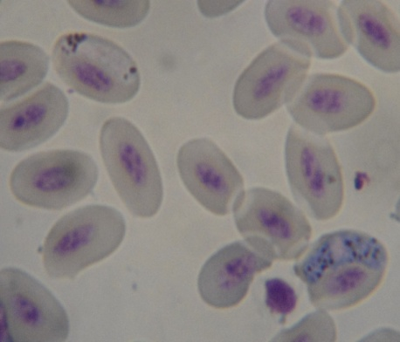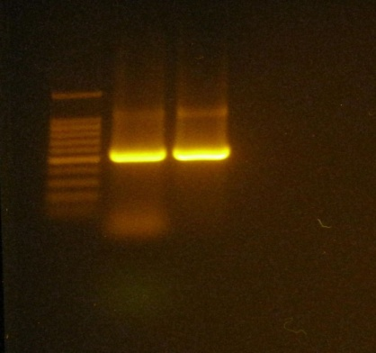
A Clinical Report Submitted
By
Roll No: 2007/27
Registration No: 313
Intern ID: C-24
Session: 2006-2007

Report Presented In Partial Fulfillment of the Requirement for
the Degree of Veterinary Medicine(DVM)

Chittagong Veterinary and Animal Sciences University
Khulshi, Chittagong-4202
June, 2013

CHITTAGONG VETERINARY AND ANIMAL SCIENCES UNIVERSITY

KHULSHI, CHITTAGONG- 4202

Internship clinical report

Title: Microscopic identification and PCR based detection of Haemoproteus columbae (pigeon malaria) in Chittagong and Khulna district in Bangladesh

.
Clinical report submitted in partial fulfillment of the requirements for the Degree of Veterinary medicine

…………………………………………………..
Signature of Supervisor

Name: Dr. Mohammad Alamgir Hossain
Designation: Professor
Dept. of Pathology and parasitology
Chittagong Veterinary and Animal Sciences University.

………………………………………
Signature of Author

Name: Afroza sultana
Roll No : 2007/27
Reg. No : 313
Intern ID: C-24
Session: 2006-2007

Date of submission: 13-06-2013

