MICROSCOPIC IDENTIFICATION & PCR BASED DETECTION OF Haemoproteus columbae (PIGEON MALARIA) IN CHITTAGONG & KHULNA DISTRICT IN BANGLADESH 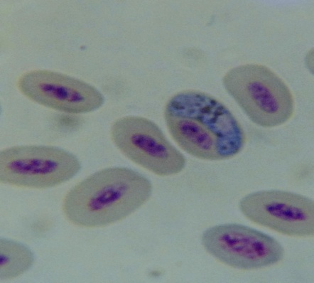 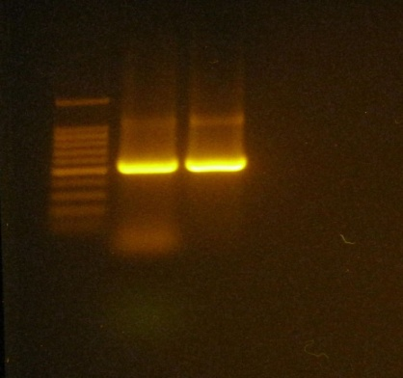
A Clinical Report Submitted
By
Roll No: 07/27
Registration No: 313
Intern ID: C-24
Session: 2006-2007

Report Presented In Partial Fulfillment of the Requirement for
the Degree of Veterinary Medicine

Chittagong Veterinary and Animal Sciences University
Khulshi, Chittagong-4202
June, 2013

CHITTAGONG VETERINARY AND ANIMAL SCIENCES UNIVERSITY

KHULSHI, CHITTAGONG- 4202

Internship clinical Report

Title: MICROSCOPIC IDENTIFICATION & PCR BASED DETECTION OF Haemoproteus columbae (PIGEON MALARIA) IN CHITTAGONG & KHULNA DISTRICT IN BANGLADESH

Clinical report submitted in partial fulfillment of the requirements for the Degree of Veterinary medicine

…………………………………………………..
Signature of Supervisor

Name : Dr. Mohammad Alamgir Hossain
Designation: Professor
Dept. of Pathology and parasitology
Chittagong Veterinary and Animal Sciences University. Khulshi, Chittagong-4202

………………………………………
Signature of Author

Name : Afroza sultana
Roll No : 2007/27
Reg. No : 313
Intern ID : C-24
Session : 2006-2007

Date of submission: 13-06-2013

