CHAPTER-I

INTRODUCTION

Poultry industry is an emerging agribusiness started during 1980th in Bangladesh. Broiler and layer farming is an important part of commercial poultry enterprise. It provides a large part of increasing demand for animal protein, cash income and creates employment opportunities. Broiler production in Bangladesh is increasing day by day. The higher price and non-availability of feed ingredients are two major limitations to the growth of commercial broiler enterprises. The feed cost alone accounts 60-70% of total production cost and the broiler farming requires quality feed at reasonable cost to make farming profitable (Bulbul and Hossain, 1989).

In the poultry ration, the farmer has to consider first protein and energy & their ratio to each other (known as Calorie Protein ratio). Protein again should be provided that it satisfies the requirement in terms of amino acids with particular reference to lysine, methionine and cystine. Then the ration should also fulfil the requirement of mineral with particular reference to calcium and available phosphorus. It should also satisfy the requirement of both fat soluble and water soluble vitamin. Feeding regiment is more important in layer than the broiler because it is not only required for growth & maintenance but also for egg production and yolk color and the daily feed requirement for egg production is based on the energy & protein diet (Banerjee, 2005).

Many feed industries in various part of the country have been producing & marketing different types of compound feeds. Feed supplements and other feed materials intended for feeding different species of livestock & poultry birds. The source of feed ingredients also varies greatly which will ultimately lead to the variation in the quality of finished products. Quality of these feed materials produced by various feed manufacturers should be required of standard before & after reaching to the farmers for a certain period of time so that farmers get their intended benefit from their animals by feeding these feeds or feed ingredients. Farmers are unable to formulate the balance diet for their birds by using the common feed ingredients such as maize, wheat, wheat bran, rice polish, soybean meal, meat & bone meal, linseed meal, cotton seed meal etc. As a result quality status of these feed ingredients & their effect on animal performance is not known properly. Scientific study on the evaluation of the quality of such feeds & feed ingredients thus becomes necessary to satisfy the farmers, scientists & the feed manufacturers for various purposes.
The number of feed mills is increasing rapidly throughout the country to meet the high demand. It was reported in 1999 that there were 40 feed mills with 900 dealers within the private sector that were producing and distributing poultry feed all over the country (Latif, 1999). Few of the feed mills are serious in maintaining the quality of products. On the other hand, farmers do not have access to adequate facilities to analyze and monitor the quality of the commercial feeds. In view of the limited availability and varying sources of different feed ingredients, the level of nutrients in the prepared feeds may differ from what is actually required( Roy et al., 2004). In view of the above situation, the present study was undertaken to ascertain the variations in the nutrient status of feeds collected from three different feed mills located in Bangladesh. The categories were dry matter, moisture, crude ash, crude protein, ether extracts, crude fiber and nitrogen free extractives to be analyzed.

CHAPTER-II

REVIEW OF LITERATURE

Poultry feed:
Poultry feed is food for farm poultry, including chickens, ducks, geese and other domestic birds. Feed for poultry mostly consists of grain (Mark, 2008). A portion of commercial feed, typically around a quarter, is known as bulk and is indigestible. The amount of bulk is referred to as bulk density (Malcom, 2004). The quantity of feed and the nutritional requirements of the feed, depend on the weight and the age of the poultry as well as the season (Gail, 2012). Healthy poultry require a sufficient amount of protein and carbohydrates, along with the necessary vitamins, dietary minerals, and an adequate supply of water (James, 2010). Certain diets also require the use of grit, tiny rocks such as pieces of granite, in the feed. Grit aids in digestion by grinding food as it passes through the gizzard. Grit is not needed if commercial feed is used (Gail, 2010).

It is reported that low-ME and high-CP diets promised optimum performance for broiler chicks at both starter and finisher (Nawaz et al., 2006).It is reported that feed efficiency was improved with increasing dietary CP levels for broiler chicks (Onwudike, 1983).In case of pellet feed, Pelleting improves feed handling characteristics (i.e. dustiness and flowability) and reduces the incidence of pathogenic organisms (Fairfield, 1994). A general definition of the pelleting process is “The agglomeration of small particles into larger particles by the means of a mechanical process in combination with moisture, heat, and pressure (Falk, 1985)’’.

Importance of feeding standard:
Most of the commercial poultry farmers depend on commercial feeds for their stocks. It is expected that poultry nutritionist have to quantify resultant losses in birds performance when birds are fed sub standard commercial diets compared to the standard ones (Addas et al., 2010).

Dick suggested that harmonization of feed quality can only be possible when a given standard is adopted nationwide (Dick, 2002).

In recent times it has been noted that most commercial feeds failed to meet up with the rational requirement of birds.
Ogunwolere & Onwuka reported that apart from the highest crude fiber contents in most commercial feed, the recommended & noticeable low crude protein observed in some commercial livestock feeds, the finished feed & feed ingredients are adulterated with saw dust, sand & maize bran (Ogunwolere & Onwuka, 1997).

Wiebe stated that the recommended nutrients level in Nigeria, the poultry industry has continued to decline as a result of feeding low quality feed as well as high cost of feeds which account for about 75% of the total cost of production (Wiebe, 2002).

This research work intended to evaluate the nutrients qualities of the most common 3 different commercial poultry feeds on broiler performance so as to make practical recommendations to poultry farmers regarding these feeds in the study area.

It is generally agreed that feed represents the major cost of the poultry production. According to McNab this cost lies between 65 and 75% to (McNab, 1999). So, any improvement in the performance of broilers and layers due to their diet can inevitably have a profound effect on profitability

Nutritional requirement of birds:
Chickens of different ages require different levels of nutrients. The Indian Standard Institute (ISI) has prescribed the standard specifications for starting, growing & laying chicken feeds to serve as a guide for the feed manufacturers & poultry keepers in the country in their publication number ISI: 1974-1977. The nutrient requirements of chicken feeds are detailed in table 1(Banerjee, 2005).

Table (1): ISI requirements for chicken feeds (as %)
parameters | Broiler starter | Broiler finisher | Chick (0-8 wks) | Grower (8-20 wks) | Layer (20-80 wks) | Breeder (20-80 wks)
ME(kcal/kg)** | 2900 | 3000 | 2700 | 2700 | 2700 | 2800
CP** | 22 | 19 | 22 | 16 | 18 | 18
CF* | 6 | 6 | 7 | 8 | 8 | 8
DM | 90 | 90 | 90 | 90 | 90 | 90
MOISTURE* | 10 | 10 | 10 | 10 | 10 | 10
acid insoluble ASH* | 3 | 3 | 4 | 4 | 4 | 4
*=maximum, **=minimum

The following nutrient specifications given in this page are intended to optimize the performance at varying ages of the birds and in different seasons. The tables should be used as a guide to determine the nutrient requirements of broilers and in consultation with the local Vencobb nutritionist. The formulations may be designed to meet the market requirements (Vencobb, 2010).

Table (2) : Suggested Nutritional Requirements by Vencobb nutritionist
 | Age in Days
Nutrients | Prestarter | Starter | Finisher
 | 0 – 10 | 11 – 21 | 22 – Finish
M.E. Kcal/kg | 2900 – 2950 | 3050 | 3150
Crude Protein % | 22.00 – 22.50 | 21.50 | 20.00
Ether Extract % > | 3.50 | 4.50 | 6.50
Crude Fiber % < | 4.00 | 4.00 | 4.00

CHAPTER-III

MATERIALS & METHODOLOGY

Location: The experiment was conducted at Animal Nutrition lab under the department of animal science & nutrition of Chittagong Veterinary and Animal Sciences University, Chittagong.
Objectives: To ascertain the variation in the nutrient status of feeds collected from three different feed mills located in Bangladesh.

STUDY PERIOD: The study period was from mid January to last February of this year (2013).

Selection of feed samples: Out of many feed mills engaged in production and marketing of poultry feeds, three were selected randomly (Table: 3), and considered as the experimental treatments.
Table : 3

Treatments | Name and address
CP® | C.P. Feed Limited,  Kumira, Shetakundu, Chittagong
RF | Renalayer feed, RENATA agro industries limited, Valuka, Mymensingh
AF | M M Agha limited, Raufabad, Chittagong

Collection of feed samples: Feed samples were collected from the dealer of three feed mills. Samples were collected by using simple random sampling technique. Approximately 250 grams of poultry feeds were purchased for each feed items. Samples were wrapped up by polythene bag and preserved in the laboratory for chemical analysis.

Evaluation of the quality of compound feeds: After reception of the feeds, the following two types of tests were performed.

Visual observation
Physical characteristics (color, particle size, texture, flavor, odor, and taste, presence of foreign particles, mould, fungus, insects and pests) were observed carefully during collection of the feeds.

Approximate analysis
Proximate analysis of feed was done according to the following procedure (as per AOAC, 2000):
Dry matter (DM) & moisture: It was the constant weight of the sample attains when heated at 100 C to 105 C temperatures. The determination of dry matter of feed sample involved the determination of moisture of the sample by heating in an oven (105˚C temp) to a constant weight for a period of time about 24 hours.
The loss of weight of the sample during heating was considered as the amount of moisture & remaining residue left was the dry matter.
Formulae:
Initial weight (g) – Final weight (g)
Moisture % = ------------------------------------------× 100
Sample weight (g)
ASH (total mineral matter): The feed or fecal matter contains both organic & inorganic matter in it. When such sample is heated at 550˚C for 6-8 hrs the organic matter get oxidized as CO2. The remaining material is the inorganic matter.
I have used muffle furnace for estimating the ash percentage by this principle.
Formulae:
Weight of crucible with ash (g)
Total mineral matter % = -------------------------------------------- × 100
Weight of crucible with sample (g)
Crude Protein (CP): The nitrogen content of the sample determined by a method was first discovered by a Danish scientist name kjeldahl. Determination of crude protein actually involved the determination of the nitrogen content of the sample which is then multiplied by the factor 6.25 by considering two assumptions-
- All nitrogen present in the sample are protein
- All feed protein content 16% nitrogen.
Protein & NPN substances present in the sample were oxidized to (NH4)2SO4 by digestion with conc. H2SO4. The digestion was made with alkali conc. NaOH (40%) & the ammonium was distilled & trapped by the saturated solution of boric acid & formed ammonium borate. The ammonium borate was titrated with standard HCl solution. The amount of N2 obtained was multiplied by the factor 6.25 to get crude protein content of the sample. This method was consisted of 3 steps-
Digestion
Distillation
Titration

Formulae:
(ml required for titration) × Normality of HCL × 0.014× 6.25
% Crude Protein = ------------------------------------------------------------- × 100
Sample weight (g)
Crude fiber (CF): Crude fiber was that portion of carbohydrate (organic substance) which was not dissolved in dilute acid (1.25% H2SO4) or dilute alkali(1.25% NaOH) & is resistant to usually enzymes produced by monogastric animals. It includes cellulose, hemicelluloses & lignin.
Formulae:
Weight of crude fiber (g)
%Crude fiber =-------------------------------------------------------------------- ×100
Weight of sample (g)
Ether Extract (EE): Ether extract is that portion of feed which is soluble in ether, benzene, chloroform, CCl4, acetone etc. It is also called crude ether, crude fat include true fat, fat soluble vitamin, carotene, wax, steroid & also phospholipids. Ether Extract was extracted with the help of di-ethyl ether from the feed sample using Sox test apparatus which extract the ether by boiling the ether to its vapor stage & then condensing in the way of siphoning.
Formulae:
Weight of EE (g)
% EE = --------------------------------------------------------- × 100
Sample weight (g)
Nitrogen Free Extract (NFE): It is not an extract actually. It represents the water soluble CHO fraction of feed such as glucose, fructose, starch & other substances. Therefore the value of NFE was derived by deducting the value of CP, CF, EE, Moisture & ash from 100.

Formulae:
For fresh sample, %NFE=100-(moisture+CP+CF+ASH+EE)
For dry sample, % NFE=100-(CP+CF+EE+ASH)
Metabolizable energy (ME): The metabolizable energy content was calculated by using the following formula (Lodhi et al, 1976).
ME=32.95(% CP + % EE * 2.25 +% NFE) -29.20

Data ENTRY: Data related to chemical composition of commercial poultry feeds were compiled by using descriptive statistical analysis.

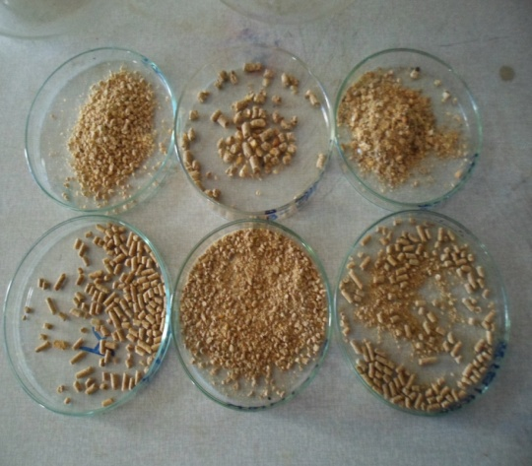
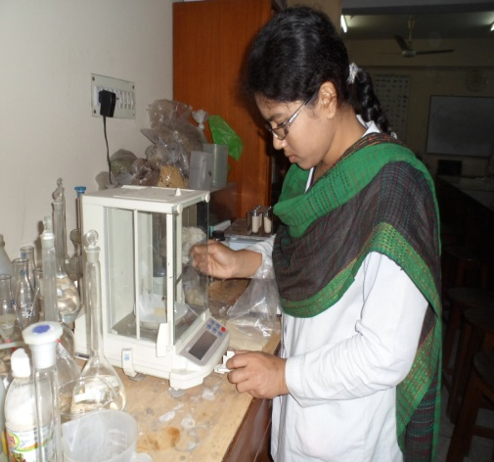

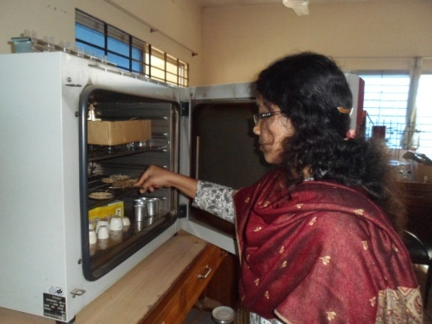
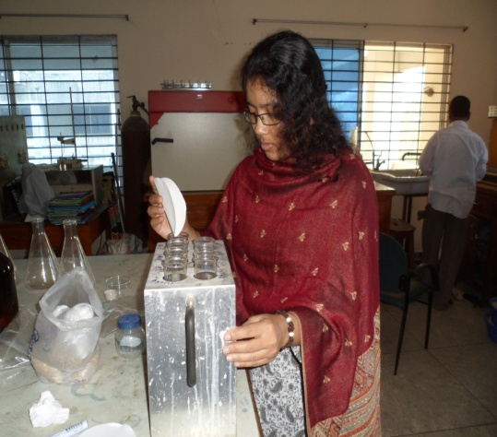
Fig: Approximate Analyses of commercial poultry feeds
Fig 2: Taking the weight of feed sample
Fig 1: Feed samples
Fig 4: Digestion chamber for CP
Fig 3: Determination of DM by hot air oven
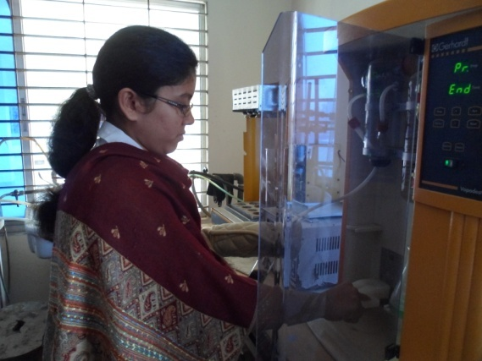
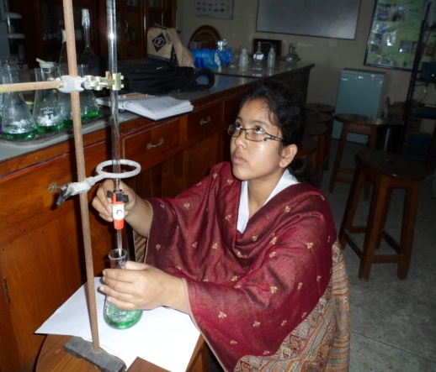

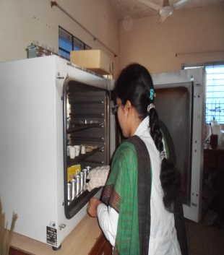
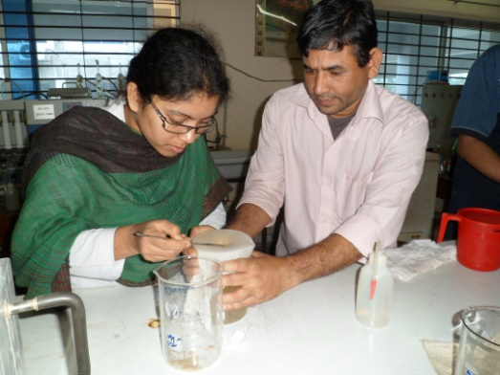
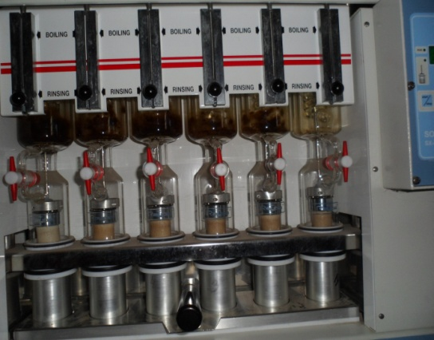
Fig 8: Keeping the enamel disc in hot air oven for EE
Fig: Approximate Analyses of commercial poultry feeds
Fig: Soxtest apparatus for Determination of EE
Fig 7: filtration for CF
Fig 6: Titration for CP
Fig 5: Distillation chamber for CP
CHAPTER:IV

RESULTS AND DISCUSSION

RESULTS:
Nutrients concentration of commercial poultry feeds such as dry matter (DM), crude protein (CP), crude fiber (CF), nitrogen free extracts (NFE), ether extracts (EE) and total ash contents have been presented in this chapter.

Table (4): Nutrients concentration of feeds from different feed mill:
(in %)

Diet | DM | CP | CF | EE | ASH | NFE | ME(kcal/kg)
RF | 88.06 | 16.3 | 5.5 | 12.5 | 14.4 | 39.61 | 2735
AF-S | 91.38 | 20 | 3.8 | 6.65 | 8.10 | 52.83 | 2870
AF-G | 89.90 | 19 | 4 | 7.5 | 6.34 | 53.06 | 2910
CP®-S | 89.00 | 21 | 5.1 | 8.2 | 11.45 | 43.25 | 2696
CP®-G | 89.40 | 20 | 6.8 | 9.7 | 9.2 | 44.07 | 2801
CP®F | 88.94 | 20 | 7.2 | 10.7 | 6.94 | 44.10 | 2877
Here, S=starter, G=grower, F=finisher
There were differences in the proximate composition of the feeds among samples from the different feed mill company.

COMPARISON OF LABORATORY VALUE WITH COMPANY STANDARD:
TABLE: (5) RENALAYER FEED (in %)
PARAMETERS | COMPANY STANDARD | LABORATORY VALUE
ME | 2750 kcal/kg | 2735 kcal/kg
CP | 17 | 16.3
CF | 3.5 | 5.5
EE | 9.0 | 12.5
DM | 88 | 88.06
MOISTURE | 12 | 11.94

TABLE: (6) AGHA FEED (GOLD STARTER)
PARAMETERS | COMPANY STANDARD | LABORATORY VALUE
ME | 3000 kcal/kg | 2870 kcal/kg
CP | 20 | 20
CF | 3.45 | 3.8
EE | 5 | 6.65
DM | 89-90 | 91.38
MOISTURE | 10-11 | 8.62

TABLE :( 7) AGHA FEED (GOLD GROWER)
PARAMETERS | COMPANY STANDARD | LABORATORY VALUE
ME | 3100 kcal/kg | 2910 kcal/kg
CP | 19 | 19
CF | 3.45 | 4.0
EE | 5 | 7.5
DM | 89-90 | 89.9
MOISTURE | 10-11 | 10.1

TABLE: (8) CP® 510 (O-15 DAYS BROILER):
PARAMETERS | COMPANY STANDARD | LABORATORY VALUE
ME | Not mentioned | 2696kcal/kg
CP | 21.50 | 21
CF | <5 | 5.1
EE | >3.5 | 8.2
DM | 88 | 89
MOISTURE | 12 | 11

TABLE: (9) CP® 510_{S} (11-21 DAYS BROILER):
PARAMETERS | COMPANY STANDARD | LABORATORY VALUE
ME | Not mentioned | 2801 kcal/kg
CP | >20 | 20
CF | <5 | 6.8
EE | >3 | 9.7
DM | >88 | 89.77
MOISTURE | <12 | 10.23

TABLE: (10) CP® FINISHER FEED:
PARAMETERS | COMPANY STANDARD | LABORATORY VALUE
ME | Not mentioned | 2877 kcal/kg
CP | 19 | 20
CF | <5.6 | 7.2
EE | >3.5 | 10.7
DM | >88 | 88.94
MOISTURE | <12 | 11.06

DISCUSSIONS:
In this study, we can see that the ME, DM, CF, and moisture content of renalayer mash feed is quite satisfactory but EE is slightly higher & CP content of the mash feed is slightly lower than the company standard.
In case of Agha starter and grower feed we can see that, the CP value are similar to the company standard but ME value are very lower while other parameters (DM, EE, CF etc.) are quite satisfactory.
In case of CP® starter, grower & finisher feed we can see that, DM, CP, CF & moisture content are closer to the company standard but ME are quite lower & EE are quite higher than the company standard.
In present study, ME content of the commercial broiler feeds were 2870(AF-S), 2696(CP®-S), 2910(AF-G), 2801(CP®-G) & 2877(CP®-F) kcal/kg. According to National Research Council, ME requirement for broiler-starter, grower & finisher is same, 3200 kcal/kg (NRC, 1994). So the present result is inconsistent with NRC standard. According to Vencobb nutritionist, ME requirements for the broiler- starter, grower & finisher are 2900-2950, 3050 and 3150 kcal/kg respectively. So ME content of agha feed starter (AF-S) & grower (AF-G) are somewhat similar with Vencobb nutritionist standard and also with Indian Standard institute but ME content of CP® starter, grower & finisher feed is inconsistent with Vencobb nutritionist standard as well as inconsistent with Indian Standard Institute (Banerjee, 2005) which showed ME requirement for commercial broiler-starter & finisher is 2900 & 3000 kcal/kg respectively.

ME content of renalayer feed was 2735 kcal/kg is consistent with ISI value which showed the ME requirement for layer is 2700 kcal/kg but inconsistent with NRC standard which showed the ME requirement for leghorn layer is 2900 kcal/kg (NRC, 1994).
In present study, CP content of the commercial broiler feeds were 20% (AF-S), 21% (CP®-S), 19% (AF-G), 20% (CP®-G), and 20% (CP®-F) respectively. According to Vencobb nutritionist, CP requirement of broiler-starter, grower & finisher are 22-22.50%, 21.50% & 20% respectively. So, CP content of all broiler feed is inconsistent with Vencobb nutritionist standard as well as ISI standard which showed the CP requirement for broiler-starter & finisher is 22% & 19% respectively. According to NRC, CP content for commercial broiler-starter, grower & finisher are 23%,20% &18% respectively. So the present result is similar with NRC standard except the starter feed which are slightly lower (NRC, 1994).
In present study, CP content of renalayer feed was 16.3%. According to Indian Standard institute (Banerjee, 2005), CP requirement of layer is 18% & According to NRC, CP requirement of leghorn layer is 14.5%. So the CP content of renalayer feed is lower than ISI standard but higher than NRC standard (NRC, 1994).
In present study, CF content of commercial layer & broiler feeds were 5.5% (RF), 3.8% (AF-S), 4% (AF-G), 5.1% (CP®-S), 6.8% (CP®-G) and 7.2% (CP®-F) respectively. CF content of renalayer feed was 5.5% which is slightly lower than ISI standard. CF content of agha starter & grower feeds are similar to the Vencobb nutritionist standard but lower than ISI standard & CF content of CP® starter, grower & finisher feeds are similar with ISI standard but higher than Vencobb nutritionist standard.
In present study, EE content of commercial layer & broiler feeds were 12.5% (RF), 6.65% (AF-S), 7.5% (AF-G), 8.2 %(CP®-S), 9.7% (CP®-G) and 10.7% (CP®-F) respectively. According to Vencobb nutritionist, the EE requirement for broiler- starter, grower & finisher are 3.5%, 4.5% and 6.5%, so the results are inconsistent with Vencobb nutritionist standard.
In present study, DM content of commercial layer & broiler feeds were 88.06% (RF), 91.38% (AF-S), 89.90% (AF-G), 89% (CP®=S), 89.4% (CP®-G) & 88.94% (CP®-F) respectively are closely similar to ISI standard (Banerjee, 2005), which showed the DM content of poultry feed should be 90%.

CHAPTER-V

CONCLUSION

Finally it can be said that, Renalayer feed, Agha starter & grower feed, CP® starter, grower & finisher feeds are recommendable for layer & broiler production in Bangladesh. But it is suggested that, high quality feed ingredients should be chosen & ME,CP ratio should be maintained properly during feed formulation. Feed mill industries are advised to be produced feeds of good quality as such research is also being recommended to be staged from time to time by animal scientists to check for the uncertainty of some feed millers.
CHAPTER-VI

LIMITATIONS

- The method used in this study was approximate analysis not exact analysis of feed, so appropriate result was not found.
- We could not determine the Vitamin content of commercial poultry feed in this method.
- It has given the value of total ash content but it was unable to estimate the mineral matter of feed such as calcium & Phosphorus.
- Any deviation in results may be due to environmental or experimental error.

CHAPTER-VII

RECOMMENDATIONS

- Standard should be maintained properly during commercial feed formulation
- High energy diet should be included
- Protein level of feed should be maintained strictly
- Feeding trial should be done before using a commercial poultry feed
- Feed analytical services should be provided more

CHAPTER-VIII

REFERENCES

AOAC, 2000. Official Methods of Analysis. Association of Official Analytical Chemists. 17th Ed., Gaithersburg, Maryland, USA.

Banerjee G.C., 2005. Poultry. In : A Textbook of Animal Husbandry. Eighth edition.Raju Primlani for Oxford & IBH publishing Co. Pvt. Ltd. New delhi.Pp:904-917.

Bulbul S.M. and Hossain, M.D., 1989. Probable problems of poultry feed formulation in Bangladesh. Poultry Adviser, 12(3): 27-29. Dafwang, I.I. and E.B.N. Shwarmen. 1996.

Dick Z., 2002. Safe feed with the Codex Alimentations. Feed Tech, 6:19.

Gail D., 2010. Starey’s Guide to raising Chickens : 4th edition, Storey publishing .p.96.

Gail D., 2012. The chicken Encyclopedia: An Illustrated References. Storey Publishing. Pp. 118-119, 135-136(for grit).

James R.G., Frank B.F., 2010. Modern Livestock & Poultry Production. Cengage learning p.693.

Latif M.A., 1999. History of Poultry Industry in Bangladesh. Proceeding of the seminar of International Poultry Show, 1999. WPSA. Bangladesh branch. Pp. 11-17.
Lodhi G.M., Singh D. and Ichponani J.S., 1976. Variation in nutrient content of feeding stuff rich in protein and reassessment of the chemical methods of metabolizable energy estimation. Journal of agricultural science 86, (293-303).

Malcolm F. F., 2004. The Encyclopedia of Farm Animal Nutrition CABI. p.68.

Mark P., 2008. Poultry diseases 6e.Elsevier health sciences.p-550.

McNab J., 1999. Advance in poultry nutrition in the world. Proceeding of the seminar and international poultry show (1999). WPSA Bangladesh branch. p. 52.

Ogunwolere Y.O. and Onwuka C.F.I, 1997. Assesment of some qualities of commercial livestock feed. Nigerian. J., Animal production 24;137-142

Wiebe V.S., 2002. Your health world poultry,18:714.

Roy B.C., Ranvig H., Chowdhury S.D., Rashid M.M., Chwaalibog A., 2004. Evaluation of compound broiler feeds manufactured in Bangladesh. Livestock Research for Rural Development 16(11).

Addas P.A., Elijah A., Midan A., & Lawan A.U., 2010. Assessment of some common commercial poultry feed on Broiler Performance in Mubi Adamawa State Nigeria. Global Veterinaria 4(2):160-163.

Vencobb, 2010. Broiler & Broiler breeder bred by Venco Research & Breeding farm limited. Nutrient level, table no.15.

NRC, 1994. Nutrient Requirements of Poultry. 9th Edition, National Academy Press, Washington, DC, USA.

Nawaz H., Mushtaq T. and Yaqoob M., 2006. Effect of varying levels of energy and protein on live performance and carcass characteristics of broiler chicks. The Journal of Poultry Science. 43:388–393.

Onwudike O.C., 1983. Energy and protein requirements of broiler chicks in humid tropics. Tropical Animal Production. 8:39–44.

Falk D., 1985. Pelleting cost center. In: Feed Manufacturing Technology. III. Ed. R. R. McEllhiney. American Feed Industry Association. Arlington, VA.

FairField D., 1994. Pelleting cost center. In : Feed Manufacturing Technology IV. Ed. R. R. McEllhiney. American Feed Industry Association. Arlington, VA.

ACKNOWLEDGEMENTs

All praises are due to Almighty Allah, the creator & supreme authority of the universe; who enabled me to complete this work successfully.

It is deemed as a proud privilege and extra terrestrial pleasure to express author ever indebtedness, deepest sense of gratitude, sincere appreciations, profound regards to reverend and beloved teacher and supervisor Professor Dr. GOUTAM BUDDHA DAS, Dept. of Animal Science & Nutrition , Chittagong Veterinary and Animal Sciences University for his scholastic guidance , sympathetic supervision, valuable advice, constant inspiration, affectionate feeling, radical investigation and constructive criticism in all phases of this study .

I also thanks to honorable teacher Professor Ashraf Ali Biswas, head of the dept., Animal Science & Animal Nutrition, Chittagong Veterinary and Animal Sciences University, who gave me the permission to use Nutrition lab of the same university.

I also thanks to honorable teacher Professor Zannat Ara Khatun, Dept of Animal Science & Nutrition, Chittagong Veterinary & Animal Sciences University, who gave me the permission to use PRTC (feed analytical) lab.

I also thanks to all staffs (especially Md. Khorshed Alam, lab technician) in NUTRITION LAB, friends and well wishers for their help, encouragement and inspiration during the study period and preparing this report.

The Author

