INTRODUCTION

ANIMAL WELFARE is not a new concept to us. It persists from the very beginning of civilization. The modern world is very much concern about this topic, but what our situation. In this paper, I want to show the present status of Animal Welfare in our country. Bangladesh is a developing country; Chittagong is one of the biggest city of this country. Most of the people of our country are Muslim and we have one of the lowest per capita meat consumption levels in the world. This is not possible to fulfill our animal protein requirement by our indigenous production. So, every year huge number of cull draught cattle (mainly Haryana steer) and water buffalo imported from India. The cattle are mostly imported from different part of India such as Rajasthan, Haryana, Kolkata and other part of India. Then these animals gather in Petrapole and other border area between India and Bangladesh. Bangladeshi cattle traders then gathered these animals into Beanapole or other cattle market close to the border area. Then, they load these animals into vehicles such as open-top truck, pick-up, but sometimes in train and send to Dhaka, Chittagong and other cattle markets of Bangladesh. Normally 16-18 cattle and 12-14 buffaloes are loaded in a truck and it is obvious from visual inspection of the vehicles that there is overcrowding in relation to the surface area available for each animal (Alam et al., 2008). It takes normally 16-18 hour to reach Chittagong at Sagorica cattle market. But, in case of strike, traffic jam or any kind of problem during transportation this time getting prolonged. These transport vehicles are open-top, no cushion is applied around the side to protect the injury. The animals are tied to the vehicles sides to control their movement and ropes are secured at the neck, legs or nose. This condition leads to respiratory problems, discomfort, rope, rubbing injuries, and abrasion, laceration injuries from rubbing against the vehicle wall (Alam et al., 2010). The tail injuries occurred due to tail twisting, which is one of the methods to control the movement of animals such as cattle and water buffalo, the other method is nose piercing frequently used in countries of Asia (Alam et al., 2010). In this journey they are exposed to heat, cold and rain. These conditions vary depends upon the season. Normally in this journey they don’t get any kind of feed, water or rest. This prolonged fasting from feed and water cause dehydration, metabolic depletion in their body and results in reduction of carcass weight and change in meat quality (Alam et al., 2010). If any necessary happened then they unload the animals and provide inadequate amount of feed, water and rest. After reaching into the cattle market at Sagorica in Chittagong, at the unloading bays the trucks are backed onto a raised straw pad and the animals are walked off. Loading and unloading can be two of the most stressful stages during animal transport (Kober et al., 2012). Inappropriate behavior by the animal handlers has often been observed, particularly at the time of unloading, involving the frequent use of sticks, which might explain some of the skin injuries. The behavior of personnel who are involved with loading and unloading, or who drive the vehicles, is one of the most important factors that affect the welfare of animals. The stay period of cattle and water buffaloes varies depend upon their sell to the buyer, usually the time varies 4 to12 days. Mostly the buyers are butcher. In the cattle market normally there is no shed to protect them from heat, cold and rain. They offered insufficient feed, water and rest. Moreover they are taken to a water trough once or twice in a day, which may not be sufficient because of high ambient temperature of Bangladesh. Dark coat color animals, usually buffaloes suffer much more from the heat than cattle (Alam et al., 2010). Recent days some of cattle traders provide shade to the animal usually in winter. The animals don’t get proper handling and care in the cattle market. Disease like Foot and Mouth disease is frequently found in the animals but they are not treated properly. Normally, animals are driven by feet to the slaughter house in the evening or night. A total number of 50-60 and 18-28 numbers of animals are daily slaughtered in Firing bazar and Pahartali slaughter house respectively. In the slaughter house they experienced much more rough behavior than cattle market. Before slaughter they don’t get proper rest and any kind of feed and water. The floor is slippery to move. During the time of slaughter, animals are handled roughly and watch other animals being killed; stunning is not practiced. Animals are kept lying down several times on the floor by tying their legs. Frequently sick and injured animals are slaughtered. Handling and approaching is very much cruel. The animals are frequently injured during the time of slaughter in their skin, muscles and bone. All these conditions are against to animal rights. To my knowledge, however, very few literatures are available regarding animal welfare in Bangladesh. Therefore, the present study was undertaken for assessment of animal welfare in selected market of Bangladesh during animal transport and slaughter.

OBJECTIVES:
1) To assess the welfare of transported cattle and water buffalo in terms of different types of injuries in animal body at Sagorica cattle market, Chittagong, Bangladesh.
2) To assess the welfare of transported cattle and water buffalo in terms of different types of injuries in animal body at Firingi bazar slaughter house, Chittagong, Bangladesh.
REVIEW OF LITERATURE
Skin injury:
Alam et al. (2010) reported that, the prevalence of skin injuries was 89 per cent, with 84 per cent of the cattle and 99 per cent of the water buffaloes having obvious skin injuries. The most common types of injury were abrasions that were found in 73 per cent of the animals, followed by scars (50 per cent), and lacerations (41 percent). Buffaloes had more abrasions (95 percent), lacerations (57 percent), swelling (15 percent) and hyperkeratosis (32 per cent) compared with cattle, whereas scars (60 per cent) were more common in cattle (P<0.001). The causes of these injuries included rubbing against the inside wall of vehicles used for transportation and stock-handler abuse (59 per cent and 13 per cent, respectively). Buffaloes sustained more transport injuries than cattle, and the number of injuries was higher in imported than local animals.

Nose and tail injuries:
Alam et al. (2010) stated that, the frequency of nose piercing was 64%, and 69% of the cattle and 54% of the water buffalo had rubbing or tearing injuries at the nostrils from nose ropes fitted through the pierced hole. Almost half of the nose-pierced animals (47%) had lacerations and ulcerations where the nose rope had rubbed against the nose. Pus at the nostril was observed in 56% of the animals, and 57 and 58% had severe and extended nose injuries, respectively. Nose injuries were more severe in imported Haryana cattle compared with exotic and local breeds. In cattle plus water buffalo, 39% had tail injuries of which the two major abnormalities were absent tail end (2%) and kinked tail (98%). Tail injuries were more common in cattle (51%) than water buffalo (15%). Among the cattle breeds, the frequency of tail injuries in Haryana was 65%.

Heat stress:
Alam et al. (2010) reported that, in the cattle mean skin temperature exposed to the sun, skin temperature not exposed to the sun, rectal temperature and respiratory rate were 38.9°C, 36.9°C, 38.8°C and 42.7bpm, and for water buffalo they were 40.8°C, 38.1°C, 39.5°C and 95.8bpm respectively and the differences for each measure between two species were significant (p<0.001). Rectal temperature and respiratory rate were positively correlated (r=0. 216 and 0.630, p<0.001) both in cattle and water buffalo. Water buffalo had signed (p<0.001) higher frequency of heat stress signs than cattle. Higher percentages of open mouth panting, drooling of saliva, tongue protrusion and neck extensions (29, 56, 27 and 27% respectively) were recorded in water buffalo than cattle. During the hot season some water buffalo were not able to maintain normal rectal temperatures and respiratory rates and some animals showed heat stress signs such as panting, drooling and neck extension. This demonstrates that the high heat loads were noticeably uncomfortable for the water buffalo.

Dehydration and metabolic depletion:
Alam et al. (2010) reported that, in all the cattle, total plasma protein concentration, serum NEFA concentration and serum CK activity were higher than the normal range and these values were higher than normal in over 84% of the buffalo. Seventy-two percent of all the animals were hypernatremia. About 90% of the buffalo and 86% of the cattle were hypoglycemic. There were no differences in total plasma protein and serum sodium between cattle and water buffalo. By contrast, cattle had significantly higher NEFA and CK and lower glucose than water buffalo. It was evident that this long distance export trade was associated with dehydration, lipolysis and muscle injury or activation.

Rahman et al. (2005) reported that, in Asia and the Far East, livestock undergoes major suffering due to malnutrition, overloading, and ill-treatment. Transport and handling methods are primitive and crude. Slaughter animals are made to walk long distances or transported in overcrowded trucks and trains. At the slaughter itself animals are handled roughly and animals awaiting their turn watch other animals being killed.

Manteca (1998) stated that, concern for animal welfare is a major consideration in meat production and is based upon the belief that animals can suffer.

Grandin (1997) discussed that, to determine the amount of stress on farm animals during routine handling and transport often have highly variable results and are difficult to interpret from an animal welfare standpoint.

Minka N. S. and Ayo J. O. (2010) stated that, the stress factors acting on animals during road transportation are numerous and the responses of the animal to them are complex, non-specific and often detrimental to their health and productivity.
Swanson J. C. and Morrow-Tesch J. (2001) stated that, transport of cattle can result in immune suppression, which can lead to increased susceptibility to disease and might result in increased pathogen shedding.
MATERIALS AND METHODS

Selection of the study site:
This study was undertaken firstly in the Sagorica cattle market which is managed by the Chittagong Metropolitan City Corporation in Bangladesh. This is the second largest livestock market in Bangladesh, where cattle and water buffalo from different regions of Bangladesh and imports from India are presented by local traders for sale to slaughterers in Chittagong. Secondly, two slaughter houses (Firingi bazar slaughter house at Firingi bazar and Pahartali slaughter house at Pahartali, where cattle and water buffalo are slaughtered. These two slaughter houses also managed by the Chittagong Metropolitan City Corporation. In this study, these three places were selected for reflection of animal welfare in the Chittagong city corporation.

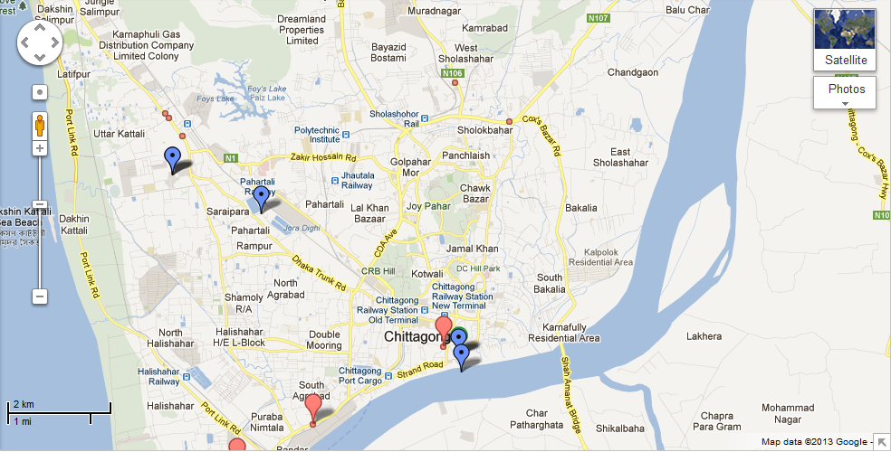
Fig: Study site

Duration of the study:
20, January to 31 January, 2013.

Study animals:
In this study of Sagorica cattle market we only considered the imported animals (cattle and water buffalo) from India. A total number of 290 cattle and water buffalo are selected randomly for our study. And, in Firingi bazar slaughter house all the cattle and water buffalo are selected, among them 24 cattle and 33 water buffalo.

Examination of different type of injuries:
Among the selected animals different type of injuries in body area are observed carefully such as abrasion, laceration, bleeding, swelling, penetration and scarification. And in tail area kinked tail and detailed condition are observed. The different types of injuries and their complications were examined closely and defined.

Abrasions
In dermatology, an abrasion is a wound caused by superficial damage to the skin, no deeper than the epidermis. An example of abrasion injury shown in Fig 1.
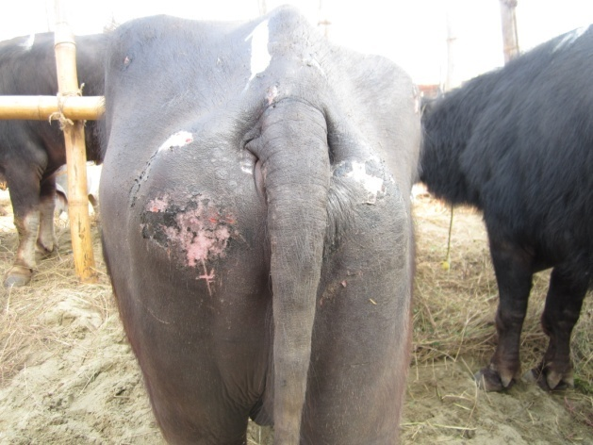
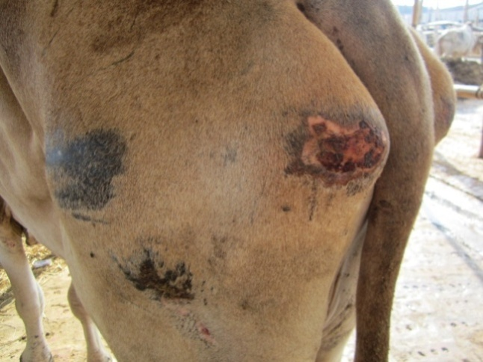

Fig 1: Abrasion

Lacerations
Laceration is a type of injury in which skin is torn, cut, or punctured (an open wound), or where blunt force trauma causes a contusion (a closed wound). In pathology, it specifically refers to a sharp injury which damages the dermis of the skin. An example of laceration injury shown in Fig 2.
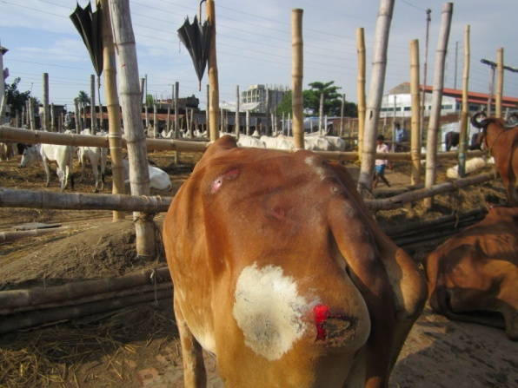
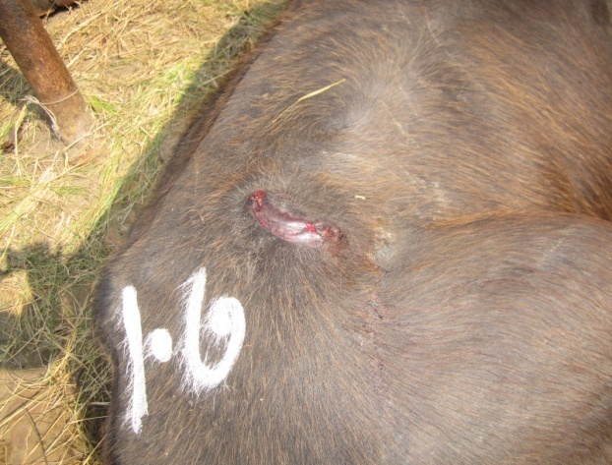

Fig 2: Laceration

Swelling
Swelling is a transient abnormal enlargement of a body part or area not caused by proliferation of cells. An example of swelling shown in Fig 3.

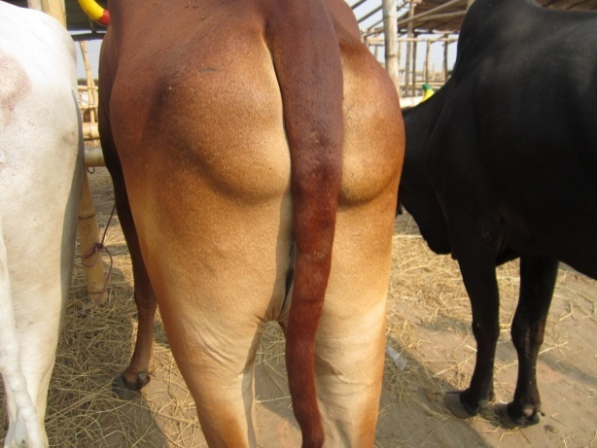
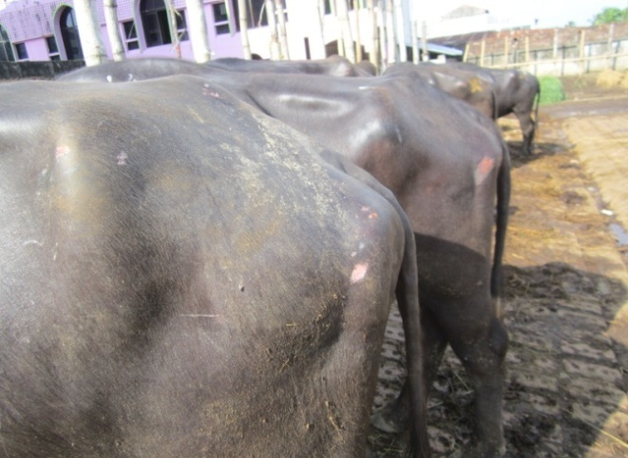

Fig 3: Swelling

Scar tissue
Scars are areas of fibrous tissue (fibrosis) that replace normal skin after injury. A scar results from the biological process of wound repair in the skin and other tissues of the body. An example of scar tissue shown in Fig 4.

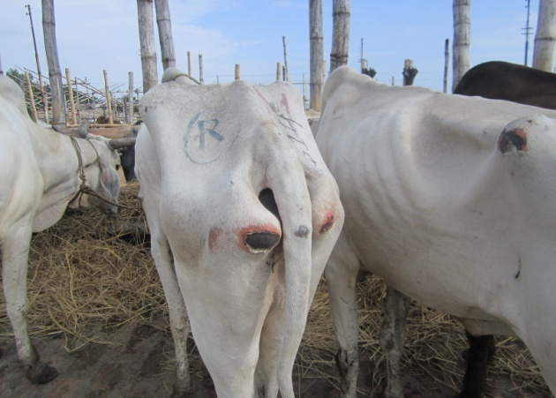
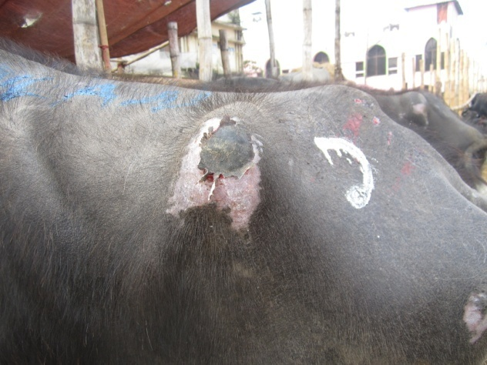
Fig 4: Scarification.

Penetration injuries
Penetrating trauma is an injury that occurs when an object pierces the skin and enters a tissue of the body, creating an open wound. An example of penetrating injury shown in Fig 5.

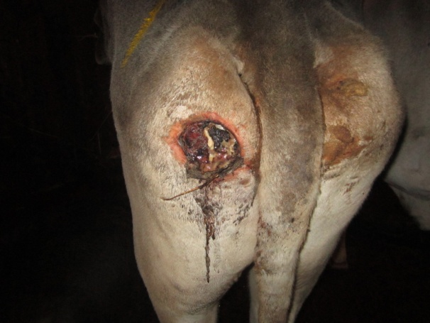

Fig 5: Penetrating injury.

Assessment of the tail
Tails were examined for kinks (twist or bend in tail) (Fig 6) and detailed condition (Fig 7).
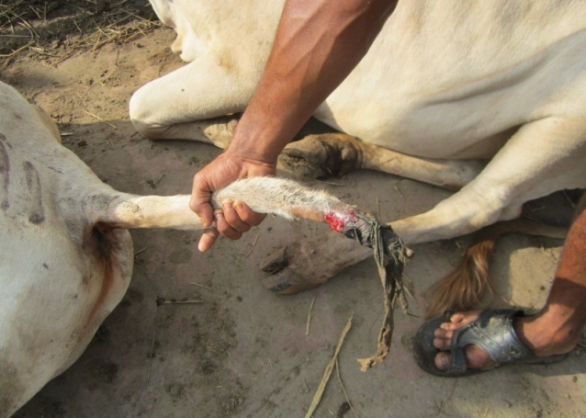
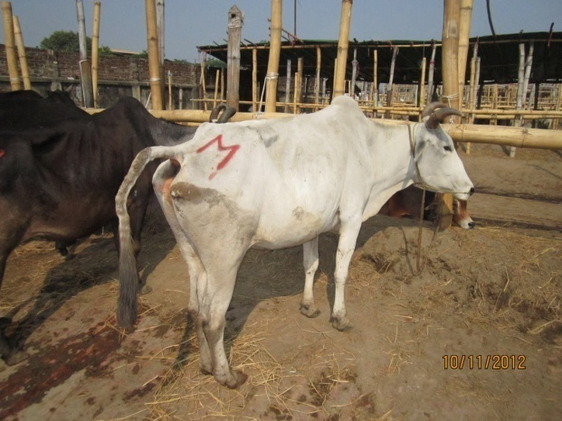

Fig 6: Kinked tail. Fig 7: Detailed.

Possible cause of injuries
The possible cause of an injury was recorded either as the stock handler, yoke rubbing, vehicle friction, sharp objects, goad use, and rope rubbing or indeterminable. This list of possible causes was developed and evaluated by observing the animals, asking questions and discussing animals with the traders and the animal handlers, reviewing the literature and taking into account the experience of the researchers in observing the shape and depth of the injuries.

RESULTS & DISCUSSION

From table-1 it is clearly indicated that, the percentage of all injuries were always higher in buffalo than cattle except in the scar where in cattle 66.51% and in buffalo 41.03%. Frequency of abrasion, laceration, bleeding, and swelling percentage of cattle and buffalo were 72.64%, 44.81%, 4.24%, 66.51% and 87.18%, 70.51%, 8.97%, 23.07%, respectively. (Alam et al., 2010) found that, the frequency of abrasion, laceration, bleeding, swelling and the scar percentage of cattle and buffalo were 61.7%, 32.3%, 2.0%, 4.9%, 59.5% and 95.3%, 57.3%, 15.1%, 31.8%, 31.6%. Our result is almost close to this result. Among the different cattle breeds, Haryana had more abrasion (81.13%) laceration (62.89%) bleeding (4.40%) swelling (4.40%) scar (76.73%). (Alam et al.,2010) found that, frequency of abrasion, laceration, bleeding, swelling and scar percentage in Haryana 73.3%, 39.5%, 2.9%, 6.2%, 70.8%. This variation occurred due to handling and approaching during transportation. Abrasion percentage in Shahiwal (65.63%), Rajasthani (69.23%) Exotic ND (62.50%). Laceration percentage in Shahiwal (40.63%), Rajasthani (46.15%) Exotic ND (62.50%). Swelling percentage in Shahiwal (12.50). And, frequency of scar in Shahiwal (18.75%), in Rajasthani (61.54%) and in Exotic ND (50.00%).
Table 1: Different types of injuries in animal body at Sagorica cattle market (n=290).
Variable | Animal Type | Abrasion (%) | Laceration (%) | Bleeding (%) | Swelling (%) | Scar (%)
Species | Cattle (212) | 154(72.64) | 95(44.81) | 9(4.24) | 7(3.30) | 141(66.51)
 | Buffalo (78) | 68(87.18) | 55(70.51) | 7(8.97) | 18(23.07) | 32(41.03)
Breed of cattle | Haryana (159) | 129(81.13) | 100(62.89) | 7(4.40) | 7(4.40) | 22(76.73)
 | Shahiwal (32) | 21(65.63) | 13(40.63) | 2(6.25) | 0 | 6(18.75)
 | Rajasthani (13) | 9(69.23) | 6(46.15) | 0 | 0 | 8(61.54)
 | Exotic ND (8) | 5(62.50) | 5(62.50) | 0 | 1(12.50) | 4(50.00)
ND = Non descriptive
- In this report only the imported cattle and water buffalo (which came from India) were considered.
From table -2, it is found that, frequency of kinked tail in cattle and buffalo were 65.09% and 23.04%. And frequency of detailed in Cattle (23.08%) and buffalo 0.00%. Among the different breeds of cattle Haryana showed more kinked tail (72.33%) and detailed (2.52%). Tail injuries is more common in cattle than buffalo. (Alam et al., 2010) stated that, in both buffalo and cattle kinked tail (98%) and detailed or absent tail (2%). Our findings showed lower value might be due to somewhat good handling and approaching.

Table -2: Different types of Tail injuries found in cattle and water buffalo at Sagorica cattle market.

Species | Animal type | Number of animals | Tail injured animals
 |  |  | Kinked tail  (%) | Detailed  (%)
Breed of Cattle | Haryana | 159 | 115(72.33%) | 4(2.52%)
 | Shahiwal | 32 | 14(43.75%) | 1(3.13%)
 | Rajasthani | 13 | 4(30.77%) | 0
 | Exotic ND | 8 | 5(62.50%) | 0
 | All cattle | 212 | 138(65.09%) | 5(2.36%)
Water buffalo | All water buffalo | 78 | 18(23.08%) | 0
ND = Non descriptive

From table -3 it is clearly indicate that, the frequency of abrasion, laceration, penetration and scar percentage of cattle and buffalo was 79.17% 75.00%, 8.33%, 75.00% and 84.85%, 69.70%, 0.00%, 66.67%. To my knowledge, however, no literatures are available regarding to slaughter house injuries in Bangladesh. So, I am unable to compare with other repot.
Table -3: Different types of injuries found in animal body in slaughter house.
Species | Animal type | Number of animals | Type of injury (%)
 |  |  | Abrasion | Laceration | Penetration | Scar
Cattle | Haryana | 22 | 17(77.27) | 16(72.73) | 2(9.09) | 18(81.82)
 | Others | 2 | 2(100) | 2(100) | 0 | 0
 | All cattle | 24 | 19(79.17) | 18(75.00) | 2(8.33) | 18(75.00)
Buffalo | All buffalo | 33 | 28(84.85) | 23(69.70) | 0 | 22(66.67)

These types of injury seen in this study are the indication of poor welfare because they were potentially painful. Thoughts need to be given to reducing the risk of these injuries during transport and routine handling procedures. Only better welfare can promote better quality of meat and skin.

CONCLUSION

It is suggested that, vehicles which used for transportation should be fitted during construction with standard or appropriate stocking density. Although enforcement of law is very difficult in Bangladesh, so that animal must be provided minimum stress during loading, unloading at slaughter house. By providing proper training and raising awareness among people and develop an acceptable moral attitude, who directly or indirectly related to this business. The following suggestions could be to improve welfare of this animal and reduce their suffering.
- Governments should take initiatives to establish Animal Welfare Boards and enact laws for the prevention of cruelty to animals.

- Legislation to safeguard the welfare of animals should be introduced and old legislation amended.

- Transport vehicles should be well designed and enlarged.

- Appropriate loading, unloading and handling facilities should be introduced to reduce damage and sufferings.

- Feeding and watering arrangements during transport should be made compulsory, and surveillance arranged to ensure compliance.

- Transporting animals for long distances on foot to abattoirs should be banned by law.

- Proper planning and supervision need to reduce the injuries and sufferings.

REFERENCES

ALAM, M. R., GREGORY N. G., JABBAR, M. A., UDDIN, M. S., KIBRIA, A. S. M. G. and SILVA-FLETCHER, A. 2010. Skin injuries identified in cattle and water buffaloes at livestock markets in Bangladesh. Veterinary Record, 167: 415-419.

ALAM, M. R., GREGORY, N. G., JABBAR, M. A., SILVA-FLETCHER, A., KEMPSON, A. G. C. and SAIFUDDIN, A. K. M., 2010. Frequency of heat stress in cattle and water buffalo at livestock markets in Bangladesh. The Journal of Cardiothoracic and Vascular Anesthesia, 13-17.

ALAM, M. R., GREGORY, N. G., JABBAR, M. A., UDDIN, M. S., WIDDICOMBE, J. P., KIBRIA, A. S. M. G., KHAN, M. S. I. and MANNAN, A. 2010. Frequency of dehydration and metabolic depletion in cattle and water buffalo transported from India to a livestock market in Bangladesh. Animal Welfare, 19: 301-305.

ALAM, M. R., GREGORY, N. G., UDDIN, MS., JABBAR, M.A., CHOWDHURY, S. and DEBNATH, NC. 2010. Frequency of nose and tail injuries in cattle and water buffaloes at livestock markets in Bangladesh. Animal Welfare, 19: 295-300.

ALAM, M. R., UDDIN, M. S., KIBRIA, A. S. M. G., JABBAR, M. A., HASSAN, M. M. and SULTANA, S. 2008. Animal transport and slaughter: an animal welfare in Bangladesh. In proceedings of the Fifth Annual Scientific Conference of Chittagong Veterinary and Animal Sciences University, Chittagong, Bangladesh. pp 24-33.

BROWN-BRANDL, T. M., NIENABER, J. A., EIGENBERG, R. A., MADER, T. L., MORROW, J. L. and DAILEY, J. W. 2006. Comparison of heat tolerance of feedlot heifers of different breeds. Livestock Production Science, 105: 19-26.

CHOWDHURY, S., SAIFUDDIN, A. K. M., DEBNATH, N. C., ARAFAT, M.Y. and SILVA-FLETCHER, A. 2008. Welfare of cattle and water buffalo at livestock market in Bangladesh. In Proceedings of the Sixth Annual Scientific Conference of the Chittagong Veterinary and Animal Sciences University, Chittagong, Bangladesh. pp 94-113.

GRANDIN, T. 1997. Assessment of stress during handling and transport. Journal of animal science, 75: 249-257.

JACOBSON, L. H. and COOK, C. J. 1998. Partitioning psychological and physical sources of transport-related stress in young cattle. Veterinary Journal 155, 205-208.

KOBER, A.K.M.H., AOYAMA, M., TSUKAHARA, N. and SUGITA, S. 2011. The effects of acute transportation stress on the adrenal gland of the domestic chicken (Gallus domesticus). Animal Behaviour and Management 47 (3), 97-103.

MANTECA, X. 1998. Neurophysiology and assessment of welfare. Proceedings of international congress. Meat Science and Technology, 44: 146-153.

MINKA, N. S. and AYO, J. O. 2010 Physiological responses of food animals to road transportation stress. s African Journal of Biotechnology Vol. 9(40), pp. 6601-6613.

RAHMAN, S.A.,WALKER, L., & RICKETTS, W. 2005 Global perspectives on animal welfare: Asia, the Far East, and Oceania. Revue Scientifique ET Technique-Office International Des Epizooties, 24 (2): 597-610.

SWANSON, J. C. and MORROW-TESCH, J.2001. Cattle transport: Historical, research, and future perspectives. Journal of Animal Science, 79(E): 102-109.

