ASSESSMENT OF ANIMAL WELFARE IN SELECTED MARKET OF BANGLADESH DURING ANIMAL TRANSPORT AND SLAUGHTER.
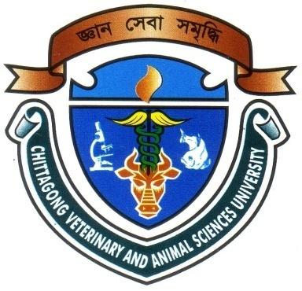

A Production Report Submitted by
Roll No: 2007/42
Reg. No: 329
Internship ID: D-38
Session: 2006-07

Report Presented in Partial Fulfillment of the Requirement for the Degree of Doctor of Veterinary Medicine

Faculty of Veterinary Medicine
Chittagong Veterinary and Animal Sciences University
Khulshi, Chittagong-4202

February 2013

ASSESSMENT OF ANIMAL WELFARE IN SELECTED MARKET OF BANGLADESH DURING ANIMAL TRANSPORT AND SLAUGHTER.

A Production Report Submitted as per approved style and content

….........................................  Signature of Author  Md. Rezwanur Rakib  Roll No. 2007/42  Reg. No. 329  Internship ID: D-38  Session: 2006-2007  Date: | ….......................................  Signature of Supervisor  Dr. A. K. M. Humayun Kober Associate Professor Dept. of Dairy and Poultry Science  Chittagong Veterinary and Animal  Sciences University  Khulshi, Chittagong – 4202  Date:

Faculty of Veterinary Medicine
Chittagong Veterinary and Animal Sciences University

February 2013

CONTENTS

SI. NO. | SUBJECT | PAGE NO.
01 | Acknowledgement | i
02 | Abstract | ii
03 | Introduction | 01-02
04 | Objectives | 02
05 | Review of Literature | 03-04
06 | Materials and Methods | 05-09
07 | Result and Discussion | 10-12
08 | Conclusion | 13
09 | References | 14-15

ACKNOWLEDGEMENT

This production report is the part of my internship program under Chittagong Veterinary and Animal Sciences University (CVASU), Khulshi, Chittagong.

I want to take the privilege to acknowledge the Almighty ALLAH, who enables me the opportunity to accomplish the report.

I would like to express my gratefulness to my supervisor, Dr. A. K. M. Humayun kober, Associate Professor, Department of Dairy and Poultry Science, CVASU, for his sympathetic supervision, inspiration, constructive criticism, valuable suggestion and providing important information throughout the course work and reach towards the preparation of the manuscript in time.

I would like to give my special thanks to my friends Md. Moksedul Momin, Md. Imran Ahmed, Khaled Bin Amin, Helal Uddin, Mahabub Alam, Md. Rokibul Hassan, Taohid Wasim Shaon and others who helped me to complete this report.

I convey thanks to those who help me in various aspects to complete this report.

The Author
February, 2013.

i
ABSTRACT

A total number of 290 cattle and water buffalo were examined at Sagorica cattle market in Bangladesh. Along with this, a total of 57 cattle and buffalo were examined in Firingi bazar slaughter house. The aim was to assess the frequency of different body injuries during handling and transport, and present condition of animal welfare in Bangladesh. The frequency of abrasion, laceration, bleeding, swelling and the scar percentage of cattle and buffalo was 72.64%, 44.81%, 4.24%, 3.30%, 66.51% and 87.18%, 70.51%, 8.97%, 23.07%, 41.03%, respectively. Among the all cattle breeds comparatively all types of injuries were higher in Haryana. Frequency of tail injury in cattle and buffalo was 65.09% and 23.08%, respectively. In the slaughter house the frequency of abrasion, laceration, penetration and scar were 79.17%, 75.00%, 8.33%, 75.00% and 84.85%, 69.70%, 0.00%, 66.62%, respectively. In conclusion, the cattle and water buffalo affected a number of serious injuries during handling and transportation. This is clearly indicating the poor condition of Animal Welfare in selected market of Bangladesh. For this reason greater attention need to pay during handling and transportation of livestock.

ii

