CHAPTRE- 3

Materials and Methods

3.1 Study area/ Locale of the study

The study was conducted at Gazipur district in Bangladesh. This district consists of 5 upazila: Gazipur Sadar Upazila, Kapasia Upazila,Tongi town (Upazila), Sripur Upazila, Kaliganj Upazila and Kaliakior Upazila. The place of my study is the Kaliganj Upazila. From Kaliganj upazila 5 union named, Kaliganj proper, Baktarpur, Bahadursadi, Mokterpur and Jangalia union were selected for study. The district Gazipur was selected due to availability of large number of broiler and layer farms (Poultry belt) and good communication facilities.
The geographical location of Gazipur district is 25°15'0" N (North) and 89°30'0" E (East) in DMS (Degrees Minutes Seconds) or 25.25 and 89.5 (in decimal degrees).

3.2 Study period
The study was conducted between the period of 16 July, 2012 to 7 September, 2012, when I was in Upazila Veterinary Hospital (UVH) internship placement at Kaliganj Upazila Veterinary Hospital under Gazipur district of Bangladesh.

3.3 Sources of data

Data for this study was obtained from both primary and secondary sources. The primary data were collected from the production performance, activities and economic condition of the chicken producers using structured questionnaires and the secondary data was obtained from Upazila Livestock Office at Kaliganj upazila under Gazipur district.

3.4 Research design

The research design adopted for this study was of ex-post-facto in nature since the phenomenon has already occurred. According to Sevilla et al., (2007) ex-post facto research is a systematic empirical inquiry in which the researcher does not have direct control over independent variables, because their manifestation has already occurred or because they are not inherently manipulated.

Figure 3.1: The figure shows the Study area. ( Yellow marks indicate the particular union: Kaliganj, Baktarpur, Bahadursadi, Mokterpur and Jangalia union).
3.5 Sampling Procedure
In an empirical investigation, it is impossible to collect information from the whole population. Therefore, the researchers are often forced to make inferences based on information derived from a representative sample of the population. The sample size and the degree of variation usually affect the quantity and quality of information obtained from the survey. Using appropriate sampling methods, both factors can be controlled (Scheaffer, 1986).
The aim is to devise a sampling scheme which is economical; easy to operate; and, provides unbiased estimates with small ‘variance’ (Barnett, 1991). Given limitations in terms of money; time; efforts; and, data management - sampling is more appropriate method. Further, sampling not only saves cost and time but can also give more accurate results than a census which are more acceptable (Kinnear and Taylor, 1987; Casley and Kumar, 1988). Following steps have been involved in the sampling procedure:
3.5.1 Defining the Population

Classification of the population is the first step in the sampling procedure, namely, the sector or element under investigation, the sampling unit, the area or extent of investigation, and the duration of investigation (Kinnear and Taylor, 1987). All the poultry farms of the district engaged in poultry production were classified as population of the study.

3.5.2 Sample size

Casely and Kumar, (1988) suggested that a good survey sample should have both a small sampling error and minimum standard error. This can be obtained if one has unlimited resources. However, given constraints, such as finance, time and data management compromises have to be made in selecting the sample size (Poate and Daplyn, 1993).
Thus on the basis of - nature of research and analysis; number of variables; resource constraints; and, the importance of decision, a sample size of 40 (20 broiler and 20 layer farms) poultry
farms engaged in poultry production was selected.

3.5.3 Sampling methods:

Gazipur district and Kaliganj upazila were selected biasly (Non random selection). Kaliganj upazila has eight unions. From these unions’ five unions was randomly selected and from these five unions’ two villages from each union was randomly selected (Multi-stage random sampling). From these selected villages two farms of each category (Broiler and Layer) were selected randomly (Stratified random sampling). Each farm rearing at least 1000 bird is taken under consideration.

Figure 3.2: Sampling methods used in current study.

3.6 Methods of data collection
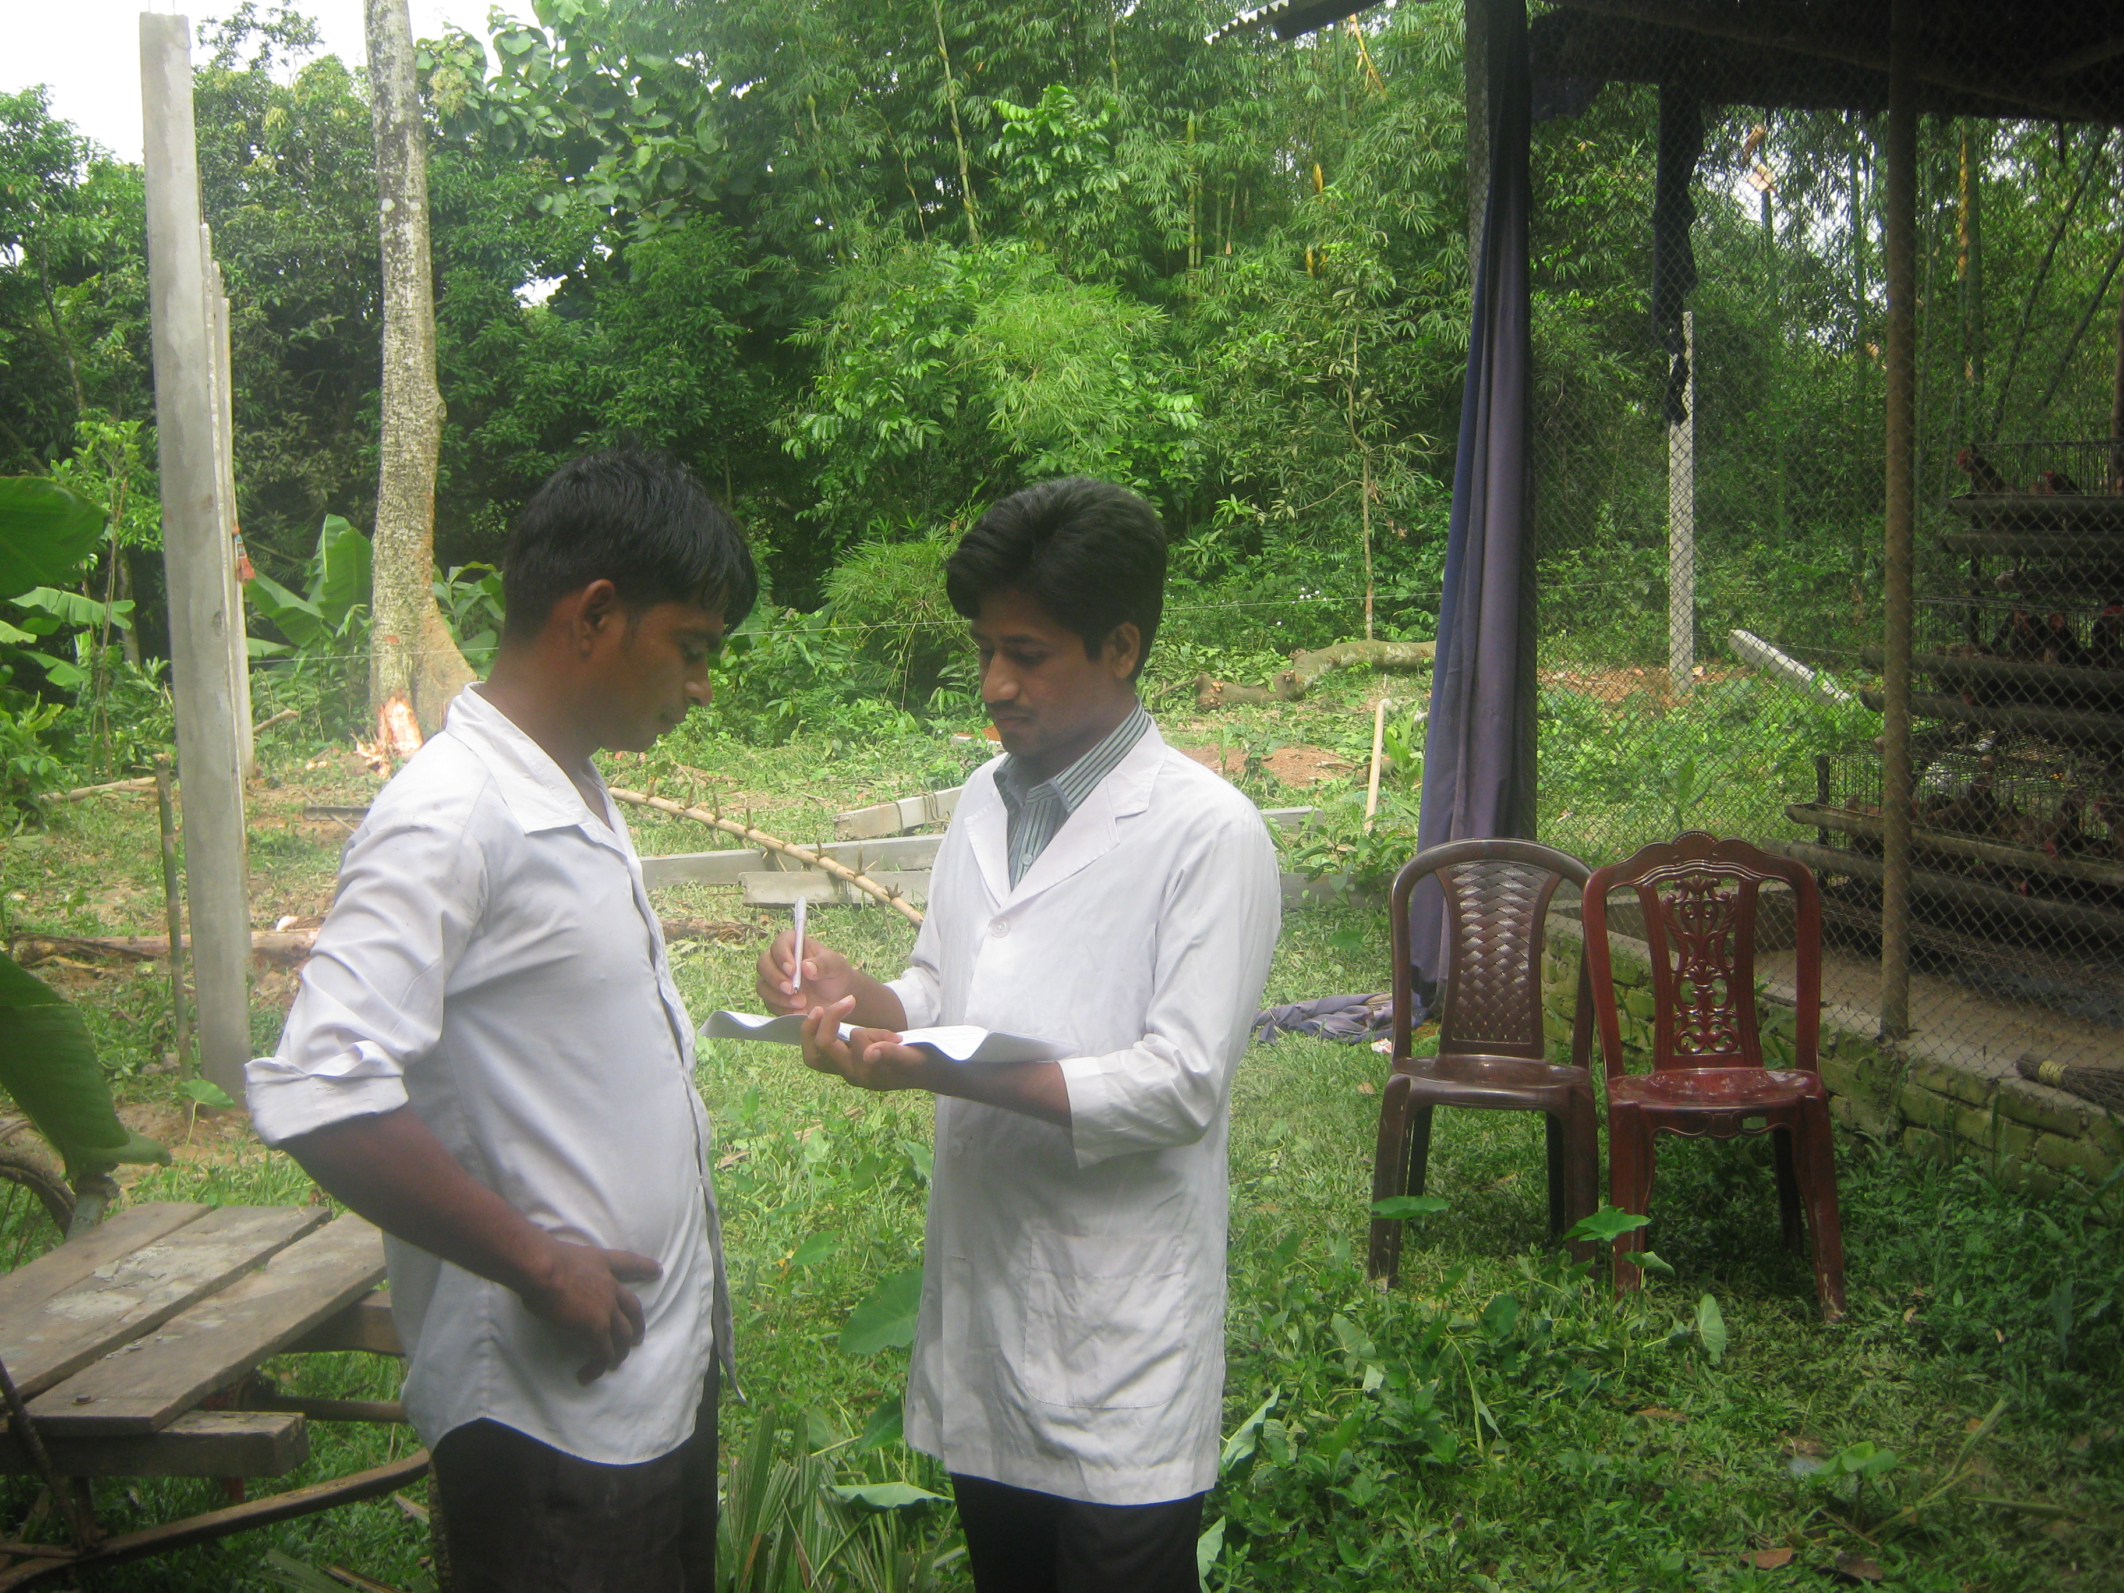
Data were collected through direct interview schedule and recorded in a questionnaire/interview schedule. The schedule was prepared maintaining relevance with the objectives of the study. Before launching the survey, the questionnaire was pretested and improved accordingly. In order to collect the more purified data of various farms an organized questionnaire was formatted (Nauta et al., 2001; De Jong and Van Soest, 2001). Key informant technique was also employed to get the basic relevant information of the proposed study.

Figure 3.3: Data collection by farmer’s
interview.
3.7 Analytical techniques
The data were put on the master sheet in Microsoft Office Excel 2007 and were arranged in tabular form. The obtained data imported to software STATA/IC-11.0 for analysis. Descriptive statistics (i.e. means, frequencies etc) was done to estimate the different variables. Unpaired unequal t-test was used to determine the level of significance (p<0.05 and p<0.01) between categorical variables ( Uddin et al., 2012 ).

