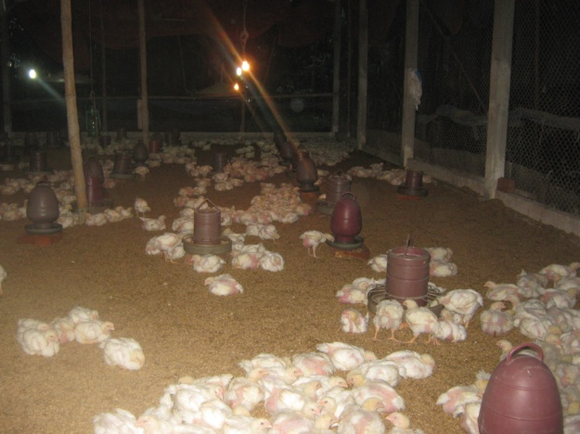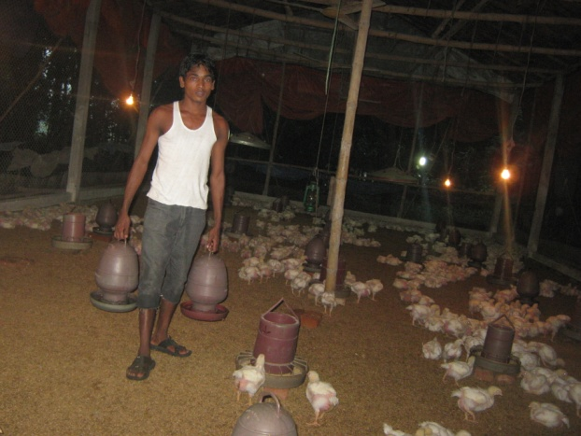
a.Floor rearing of broiler b. Manually water supply by labor
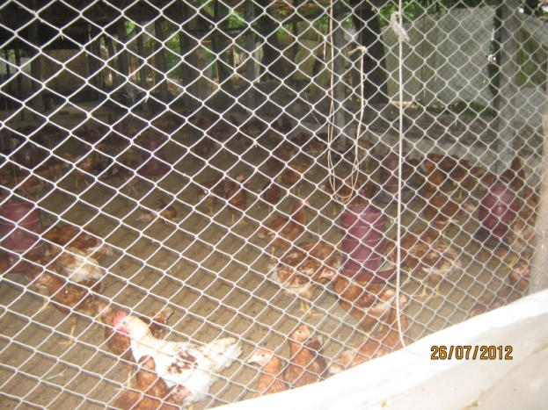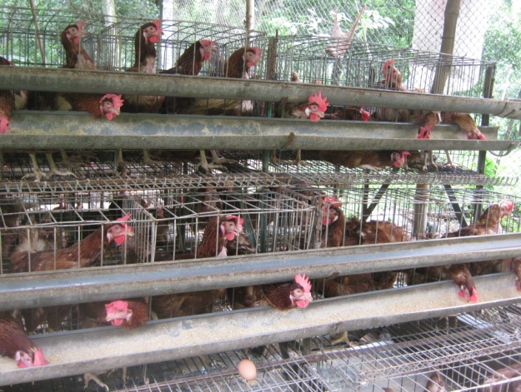
c.Floor rearing of layer d.Cage rearing of layer
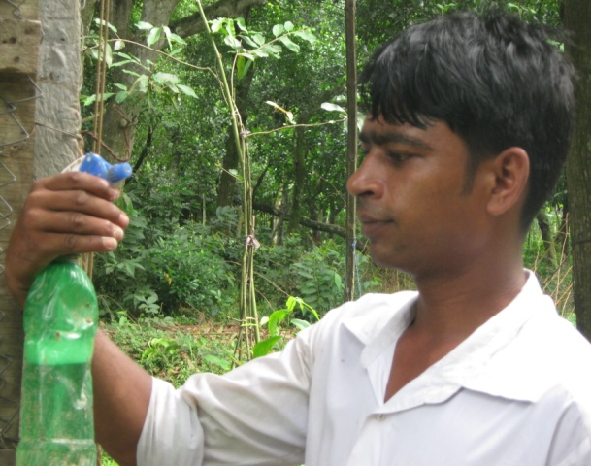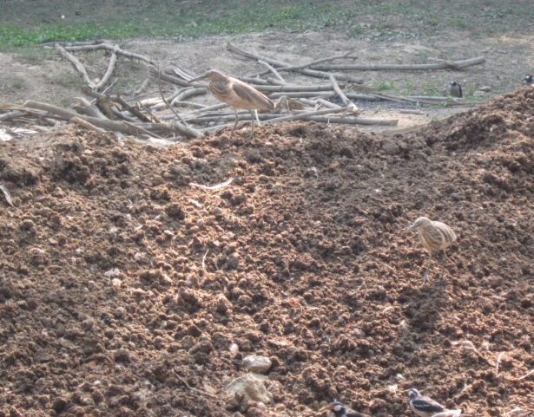
e.Farmer spray on his body before enterinng the farm f.Throwing the dropings into open air
Figure 4.2: Activities in the poultry farms of gazipur district.

