CHAPTER-3

MATERIALS AND METHODS

The study work was divided into two experiments:
I. Baseline survey on nutrient properties of existing concentrate feed offered in peri-urban areas farm.
II. Effect of feeding existing ration to the animals at CVASU.

EXPERIMENT- I

3. A. Proximate Analysis of concentrate feed samples

3. A.1. Study area
It was a bare necessity to select the areas, which should provide maximum information regarding nutritive value of concentrate feed that is regularly fed to the dairy farm animals. The selection of study area depends on the objectives of the research.

Chittagong is well known for dairy farming. Most of the dairy farm of Chittagong district is situated in the peri-urban area. Mainly Sikalbaha areas (potia upazila); Latitude 22.3206, Longitude 91.8658, Altitude (feet) 16, Lat (DMS) 22° 19' 14N, Long (DMS) 91° 51' 57E, Altitude (meters) 4. Therefore ten dairy farms (denoted as F₁, F₂, F₃, F₄, F₅, F₆, F₇, F₈, F₉, and F₁₀) were selected as the study area for collection of sample.

Keeping view the main objectives of the study the above mentioned area was also chosen for the following reasons:

- Very good transportation facilities of the selected area which caused fewer expenses as well as less time consuming in conduction the study.
- Researcher’s perception about better cooperation from the owners of dairy farms.

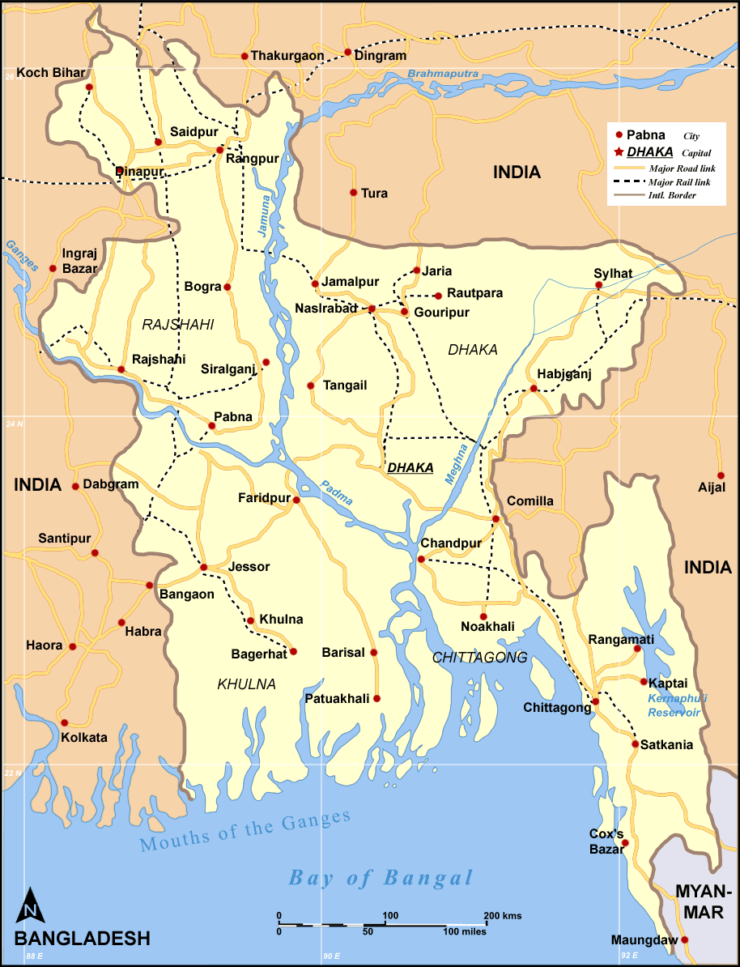
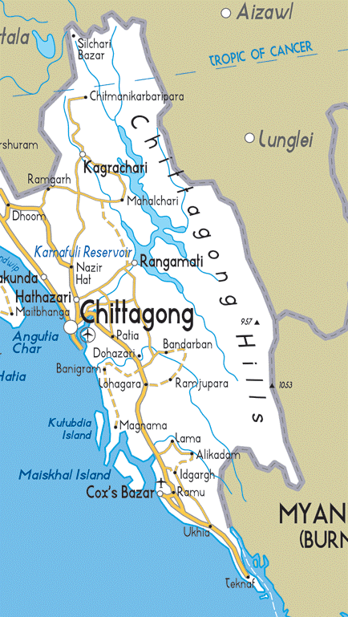
Fig 2: Study area map.

3. A.2. Collection of sample
Samples were collected by using simple random sampling technique. Ten concentrate mixture samples of different farms were selected randomly. Approximately 500 grams of sample was collected as for individual farm. Sample were wrapped up by polythene bag and preserved in the laboratory for chemical analysis.

3. A.3. Preparation of sample
Samples were subjected to grind to make it homogenous powder. Later on, it was mixed properly and exposed to shade to cool down for better sampling.

3. A.4. Analysis of sample
The experimental samples were subjected to proximate analysis for moisture, dry matter (DM), crude protein (CP), ether extracts (EE) total ash and insoluble ash in the animal nutrition laboratory and PRTC (Poultry Research and Training Center), Chittagong Veterinary and Animal Sciences University, Chittagong, Bangladesh in accordance with Standard methods described by the A.O.A.C, 2005. All analysis was done in triplicates.
3. A.4.1. Determination of Dry Matter (DM)
About 20 g sample of feed was taken in a previously weighed moisture cup (petridishes) and were kept in an electric oven for 24 hours at 100±1⁰c. The dried samples then were cooled in desiccators and weighed till the constant weight was obtained. The percentage of dry matter was calculated by the following formula:

Dry matter (%) = {(W2-W) / (W1-W)}
Where:
W = Weight of empty crucible (g)
W1 = Weight of crucible + sample before drying (g)
W2 = Weight of crucible + oven dried sample (g)

3. A.4.2. Estimation of Crude Protein (CP)
Crude protein was determined by the routine semi-micro Kjeldahl procedure. The percentage crude protein was calculated by multiplying the total nitrogen by a factor of 6.25. %Nitrogen (N) = Titre value x atomic mass of Nitrogen x Normality of HCl used x 4. For this 0.5g of sample was transferred to the digestion tube. 10 ml of concentrated sulphuric acid and 3-5g of digestion activator was added to the sample. Then the digestion tube was loaded into digester and the digestion block was heated by maintaining the temperature between 369 ⁰c and 410 ⁰c. The sample turns colorless or light green color at the end of complete digestion. After digestion, 40 ml distilled water was added then100 ml 40% NaOH solution was added and condenser was setted. Then the digested sample was heated by passing steam and the ammonia liberated was trapped in 20 ml of 2 per cent boric acid and mixed indicator (0.3 g of bromocresol green and 0.2 g methyl red in 400 ml of 90 per cent ethanol). The 100 ml of distillate was collected in conical flask and was titrated against 0.1 N sulphuric acid solutions. The percentage of nitrogen was calculated by the following formula:
Nitrogen (%) =$\frac{A x B x 0.014}{W}x 6.25 x 100$
Where,
A= Volume of standard HCL solution
B= Normality of standard HCL solution
W= Weight of sample
1 ml N/ 10 H2SO4 = 0.00014g nitrogen

3. A.4.3. Estimation of Ether Extract (EE)
For this 2 g of oven dried sample was taken in a thimble. This was placed in the extraction tube of the Soxhlet’s apparatus. The extraction tube was connected with the water condenser from the above and below with the oil flasks through standard joints. The flask was then put on a hot plate. Extraction was done with petroleum ether (AR grade). Of boiling point at 40-60 ºc, at the rate of 6-8 extractions per hour for 2-3 hours. At the end of complete extraction, the thimble was removed from the apparatus. The thimble was oven dried along with the residue and weighed after cooling in the desiccators. The difference in the two weights referred the amount of ether extract in the sample. The results were expressed on percentage basis. The ether extract was calculated as follows:
Ether Extract (%) = {(W1-W2) / (W)} x 100
Where,
W1 = Weight of the thimble along with the sample before extraction (g)
W2 = Weight of the thimble along with the sample after extraction and drying (g)
W = Weight of original sample
3. A.4.4. Estimation of Crude Fiber (CF)
2 gm of ground sample was weighed carefully and transformed to 1000 ml spout less beaker. To this beaker 125 ml of 1.25 per cent sulphuric acid was added. The content was then brought to boiling by placing beaker on an electric heater. Beakers were covered with round bottom reflex condenser flask for condensation. After boiling for 30 minutes contents of beaker were filtered through muslin cloth having mesh size of 18 x 18 per centimeter square in Buchner’s funnel. The residue on the cloth was washed to remove the acid and was transformed back to the same beaker. 125 ml of 1.25 per cent sodium hydroxide solution was then added into the beaker and the content was brought to boiling in the manner as mentioned for sulphuric acid digestion above. After 30 minutes of boiling, the content were filtered through the muslin cloth and washed with hot water to remove all alkali,. The residue was transferred to the crucible which was then kept in a hot air oven at 100±1 ⁰c for drying. It was then cooled in desiccators and weighed. This was repeated until a constant weight was obtained. The content were ignited in a muffle furnace at 600±5 ⁰c for 5 hours and cooled till constant weight of ash was obtained. The crude fiber was calculated as follows:
Crude Fiber (%) = {(W1-W2) / (W)} x 100
Where,
W1 = Weight of the crucible along with the sample before ignition (g)
W2 = Weight of crucible after ignition (g)
W = Weight of original sample (g)
3. A.4.5. Estimation of Total Ash (TA)
A 5 g of dried sample of feed was taken in a pre- weighed silica crucible. It was make smoke free by burning slowly in electric heater. Then it was transferred in muffle furnace and ignites at 550-600 ⁰c for 6-8 hours to obtain uniform ash color free of black residue. It was then cooled in desiccators and weighed. Total ash value was obtained by subtracting the weight of empty silica crucible from the weight of the crucible containing the ash. The ash contain was calculated as follows:
Total ash (%) = {(W2-W1) / (W)} x 100
Where,
W1 = Weight of crucible (g)
W2 = Weight of crucible with ash (g)
W = Weight of original sample (g)
3. A.4.6. Estimation Acid Insoluble Ash (AIA)
About 50 ml of 50 per cent hydrochloric acid was added to total Ash in the above mentioned crucible and contents were boiled in the water bath for 10 minutes, filtered through Whattman’s filter paper no.42 after giving washings with the distilled water to washout the crucible completely. Filter paper along with the residue was transformed to the same crucible again and it was burnt on the heater and ignited in the muffle furnace at 600 ±5ºc for 2 hours to obtain uniform color. Crucible was cooled in a desiccators and its weight was recorded again.

Acid insoluble ash (%) = {(W2-W1) / (W)} x 100
Where,
W1 = Weight of crucible (g)
W2 = Weight of crucible with acid insoluble ash (g)
W = Weight of original sample (g)
3. A.4.7. Calculation of Nitrogen Free Extract (NFE)
The amount of nitrogen free extract on dry matter basis was calculated by following equation:
Nitrogen Free Extract (%) = 100-(%CP + %EE + %CF + % TA)
Where,
CP = Crude Protein
CF = Crude Fiber
EE = Ether Extract
TA = Total Ash

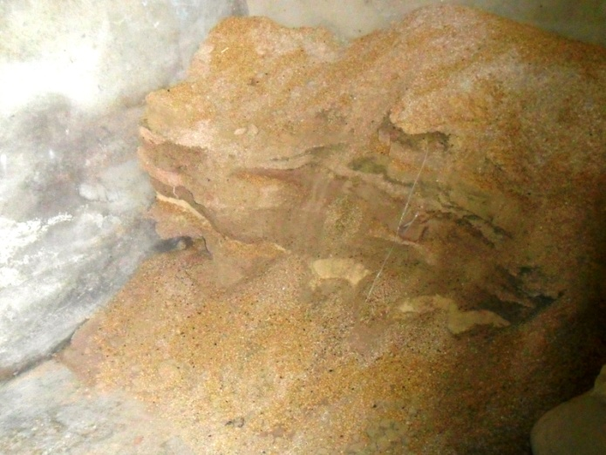
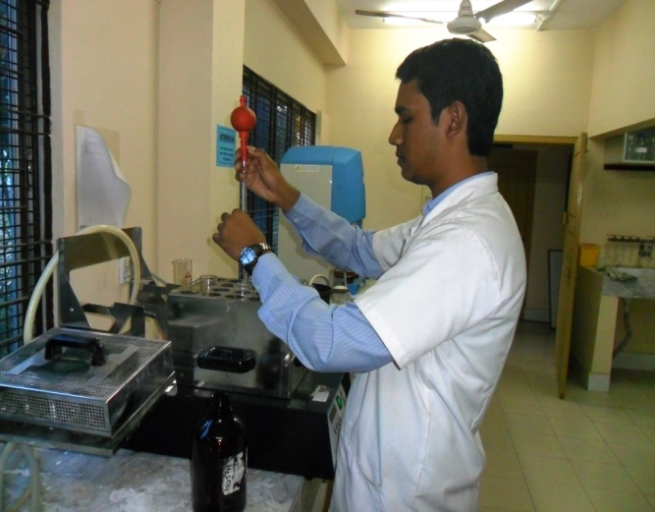
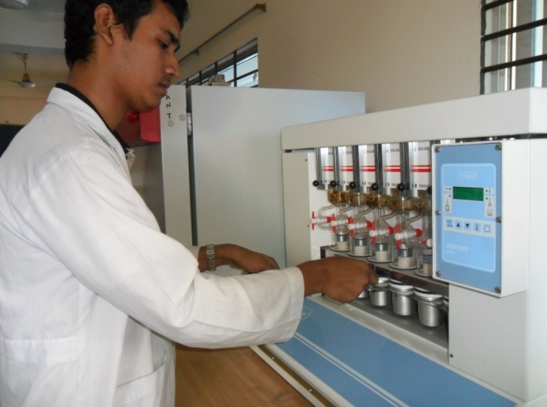
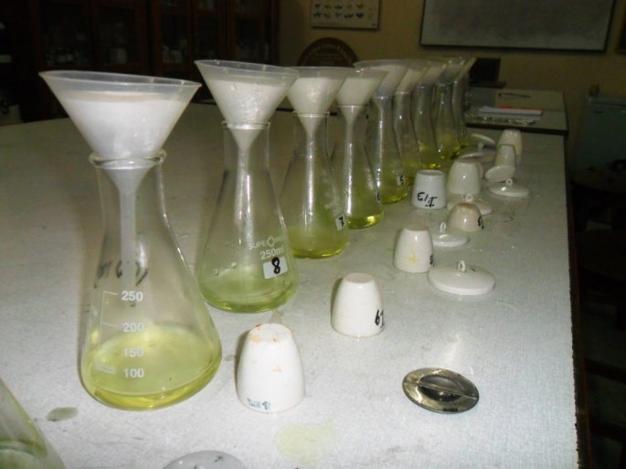
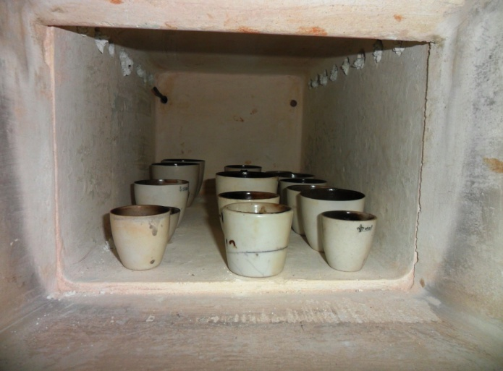
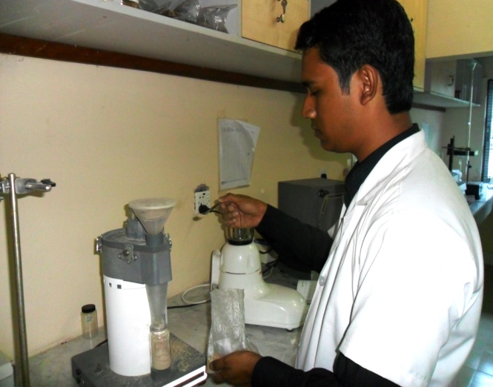
Fig 4: Grinding of sample
Fig 3: Concentrate feed in farm
Fig 6: Estimation of CP
Fig 5: Estimation of EE
Fig 8: Estimation of AIA
Fig 7: Estimation of TA

EXPERIMENT-II
3. B. Feeding of Ruminants
Feeding of ruminants is much more complicated than simple stomach animals as they require a large amount of roughage and concentrates feed for their maintenance and production. Well grown heifers and yearling bulls are the best foundation stock of a herd. But in many farms, heifers (and/or bulls) become the most neglected group which leads to a poor growth rate and age at first calving greater than 24 months. The main objective of heifer rearing program is to be achieved appropriate body weight (300kg in Friesian breed) at the breeding age and attaining 1st calving at 24 month of age. There are few major factors affecting on proper growth and feeding becomes the most critical factor to achieve this target. Underfeeding of causes stunted growth and can delay or suppress reproductive behaviors. Hence, rations must be balanced to ensure adequate growth rates, to maintain proper body condition, and to achieve desired height and weight. Therefore, well balanced nutritious feeding system is essential for maintaining profitable and effective dairy farm (Nissanka et al., 2010). The value of any livestock feed is the multiple of three factors: nutrient or energy content, feed intake, and digestibility. Nutrient and energy content of grain at harvest is influenced by genetic (hybrid and grain type) and environmental (soil fertility, growth conditions, maturity) factors and the interaction between genetics and environment.
3. B.1. Study area
A dairy farm is situated in Chittagong Veterinary and Animal Sciences University (CVASU) campus having a total of 14 animals of which three are cows denotes as Group: I, two yearling bulls as Group: II and three heifers denoted as Group: III based on age and sex. Therefore this farm was selected as the study area for feeding trial with conventional concentrate ration for a time period of 60 days (10.11.2012 to 07.01.2013)
3. B.2. Selection of animals
The animals were selected in healthy condition having shiny body coat ,active and alert movement, normal feeding, rumination, eructation, defecation, urination and other physical parameters ( Rectal temperature, heart rate, pulse rate, respiration rate etc.).

3. B.3. Preparation of experimental shed
The experimental shed for cows was properly washed and cleaned by using tape water every morning during experiment. Ceiling, walls and floor were also thoroughly cleaned. Sometimes the whole shed washed with antiseptic solution. Cow-dung and other dirt were regularly cleaned.

3. B.4. Coproscopy
In the early morning the feces of the animal were collected by using rectal palpation technique with gloves. The feces were packed separately for individual animal and transported immediately in sterilized sachet to the laboratory.

3.B.4.A. Direct smear (wet mount)
a) Saline wet mount: Small amount of feces was taken on a fresh, grease free glass slide. 2-3 drops of saline solution was added to dilute the feces. A cover slip was paced over the smear. Then observed under microscope.
b) Iodine wet mount: With an applicator stick a small portion of feces was pickedup on a fresh, grease free glass slide.1-2 drops of iodine were added and the smear was made. A cover slip was paced over the smear. Then observed under microscope.
2.4.B. Float : sample of feces was placed in vial with solution and mixed throughly. Then the vial was filled again with the same floatation solution until meniscus was formed. A cover slip was placed on meniscus and wait for 10-15 minutes. After that the cover slip was removed and observed with microscope.

3. B.5. Deworming
The animals were make endoparasite free by using broad spectrum anthelmentics (albendazole @ 10mg/kg body weight) to groups II and III. And combined preparation {(Triclabendazol +Levamisole) (900+600)} @ 1bolus/ 70 kg of body weight to group I. The drug was administered orally with molasses to lick.
3. B.7. Examination of ruminal fluid
3. B.7.1. Aspiration of ruminal fluid/ rumenocentesis (needle puncture)
Ruminal fluid collection was carried out by means of rumenocentesis. The puncture site was located 12 to 15 cm caudal to the costochondral junction of the last rib, on a horizontal line level with the top of the patella. Before rumenocentesis, the puncture site was shaved, disinfected (scrubbing with povidone-iodine and disinfection with 70% Ethanol). The puncture was done using an 18 gauge, 120 mm long, stainless steel needle and 5-10 ml of ruminal fluid was aspirated with a 20 ml syringe. When a sufficient volume of ruminal fluid was obtained, a small volume of air was forced through the needle. Finally, the needle exit site was wiped with povidone-iodine. During rumenocentesis, the cow was restrained by tying the hocks together and the tail was elevated.
3. B.7.2. Physical characters
The color, consistency and odor of individual animal ruminal fluid were examined organoleptically.
3. B.7.3. Chemical characters
P^{H}: Normal p^{H} of rumen liquor varies from 5 to 7. However, under pathological conditions it may decrees towards acidic or it may increase towards alkaline side. Therefore, p^{H} of rumen liquor was studied to know the effect of different feeds.
Procedure
The ruminal fluids P^{H} of selected animals were measured by using P^{H} paper.

3. B.7.4. Microscopic examination
A) Protozoal Motility
Rumen contains a large population of rumen protozoa which are ciliated and motile. They are anaerobic in nature and they live at p^{H} between 5 to 7, temperature 39-40 ⁰c and in presence of moderate concentration of volatile fatty acids along with billions of rumen bacteria. Since the protozoa motility gives a tentative idea about the digestion of feed in rumen, therefore, it was studied for the protozoal motility in rumen liquor to know the feed effect.
Procedure
Extract volume of 0.5 ml of stained rumen liquor (SRL) was transferred on a clean glass slide and was covered with cover slip. The movement of protozoa was examined under low power of microscope immediately.
The movement of protozoa was rated as follows:

++++ = Very rapid movement, whole mass is moving.
+++ = Rapid movement, very large population of protozoa showing their motility.
++ = Moderate movement, less number of protozoa is moving moderately.
+ = slow movement, very few protozoa showing their slow movement.
0 = No movement, all the protozoa are dead.

B) Estimation of Total Protozoa in Rumen Liquor
Population of protozoa varied with types of ration. Holotrichs predominant on green fodder while Entodiniomorphs on concentrate ration. Normal population of rumen protozoa varied from cells x 10⁵ to cells x 10⁶ per ml of rumen liquor.

Apparatus required
- Glass slide, cover slip, microscope, rumen liquor, test tube, test tube rack, pipette, muslin cloth and funnel.
- Lugol’s Iodine solution was prepared by dissolving 5 g of iodine and 10 g potassium iodide in 60 ml of distilled water and 10 ml of formalin and 30 ml of glycerol was added. Finally the volume was made 100 ml.
Procedure
1 ml of SRL was placed into a test tube through a wide bore pipette. Exact volume of 9 ml of Lugol’s Iodine solution was added and mixed gently. Then 0.1 ml of sample was transferred swiftly to a dry clean slide and spread under a glass cover of known area (24 x 60 mm). Counting of protozoa was done under low power of microscope in a zig zag manner. Thirty fields were counted per slide both for ease, accuracy and average count per field was calculated. Total protozoal count per ml was calculated by following formula:
Total protozoa per ml rumen liquor =
{(Average No. of protozoa count per field) x (Microscopic factor) x (Dilution factor)}
3. B.8. Feed Offered
Amount of concentrate feed offered to the cattle was done on the basis of the body weight of the animal and, roughage as grazing with stall feeding and water was offered ad-lib. The concentrate ration was offered to the cattle at 9AM daily (once only).

Table 1: The composition of the concentrate mixture
SL. NO. | Feed ingredient | Percentage
1 | Wheat bran | 24.5
2 | Rice polish | 17.0
3 | Broken rice | 06.0
4 | Maize | 13.0
5 | Molasses | 02.0
6 | Pea bran | 20.5
7 | Soybean meal | 07.0
8 | Soybean oil cake | 08.5
9 | Salt | 01.5

Table 2: Nutritive value of the concentrate mixture
Ingredients | DM (%) | Moisture (%) | CP (%) | EE (%) | Ash (%)
Soybean meal | 89.0 | 11.0 | 42.44 | 01.2 | 6.97
Maize | 85.2 | 14.8 | 07.00 | 03.6 | 3.11
Wheat bran | 89.0 | 11.0 | 12.14 | 04.2 | 5.44
Rice polish | 97.2 | 02.8 | 12.25 | 18.5 | 8.10
Broken rice | 87.8 | 12.2 | 07.00 | 04.6 | 1.09
Til oil cake | 98.6 | 01.4 | 10.50 | 06.3 | 6.40
Pea bran | 91.4 | 08.6 | 22.75 | 01.7 | 3.70

Table 3: Animal groups with amount of feed offered
Group | Animal  NO. | Body weight (Kg) | Concentrate feed (kg) | Grazing (hours) | Straw  (Kg)
Group: I | 1 | 200 | 4.00 | 3 | 4.0
 | 2 | 130 | 2.00 | 3 | 3.0
 | 3 | 150 | 3.00 | 3 | 4.0
Group: II | 4 | 107 | 1.20 | 3 | 3.0
 | 5 | 60 | 0.60 | 3 | 1.5
Group: III | 6 | 149 | 2.25 | 3 | 4.0
 | 7 | 146 | 2.20 | 3 | 4.0
 | 8 | 79 | 1.20 | 3 | 1.5

3. B.9. Body weight gain
The regular body weight gain of animals was recorded in 15 and 60 days interval by using digital weight machine.
3.10. Statistical analysis
Statistical analysis to analyzed data of this study was done by Statistical software packages R 2.14.0, SAS 9.2, SPSS 16. during analysis and all analyses were considered at 5% level of significance.

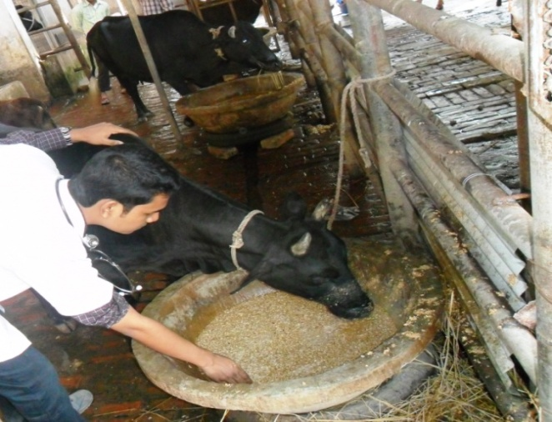
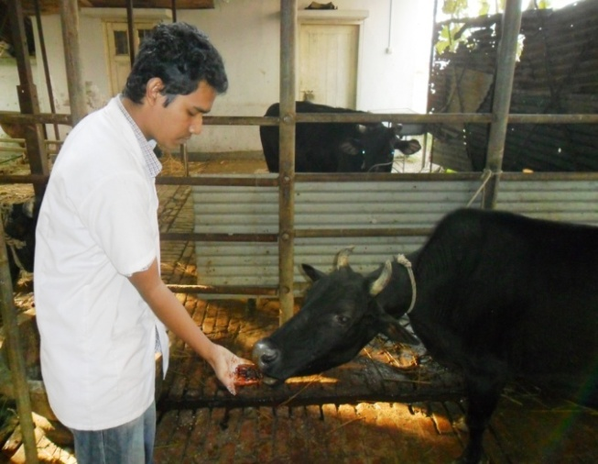
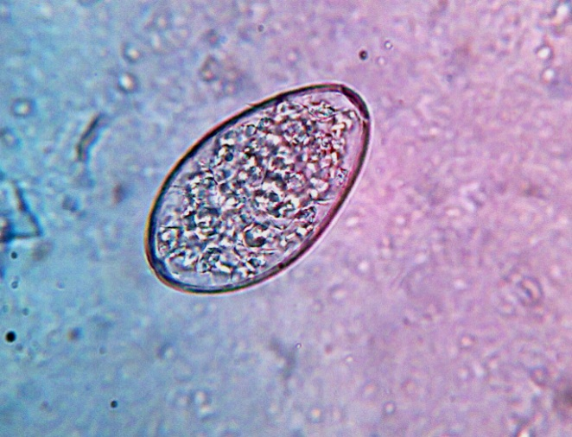
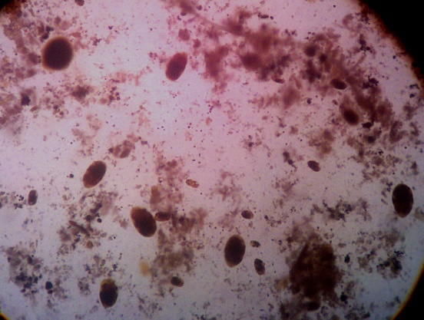
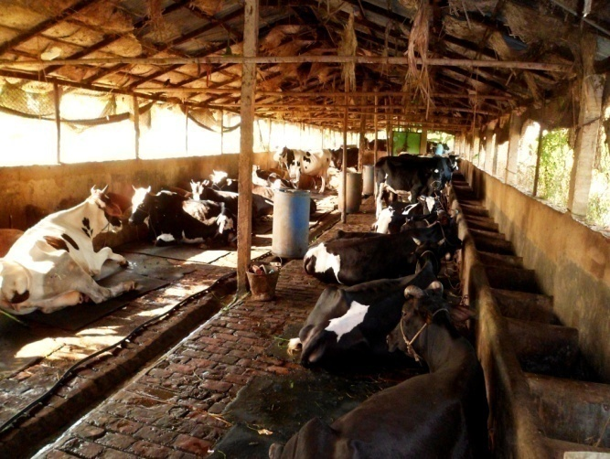
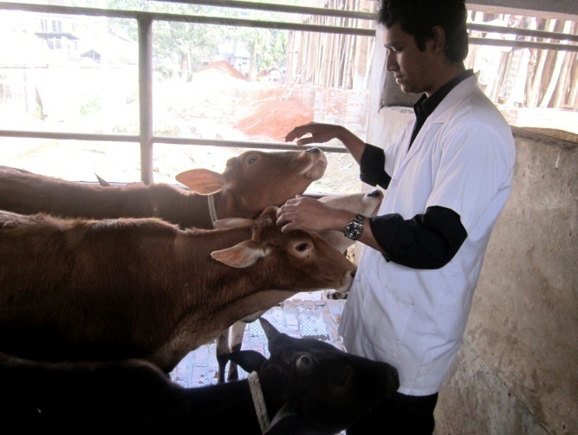
Fig 10: CVASU Dairy Farm
Fig 13: Rumen protozoa
Fig 9: Commercial Dairy Farm
Fig 13: Concentrate feeding
Fig 14: Deworming
Fig 12: Parasitic egg

