CHAPTER I

INTRODUCTION

Bangladesh is a small country but over burned with large number of gradually increasing population. Among her various problems food shortage top the list. Bangladesh is also a country of serious malnutrition where about 48 per cent of the population lives below the poverty line (BBS, 2007). Protein deficiency has been taken as the major contributory factor in malnutrition. The per capita consumption of animal protein in Bangladesh is only 11.8 g per day (BBS, 2001) whereas the standard requirement of 36 g is recommended by UNO (Ahmed and Islam, 1985). Food security of the country has been significantly and adversely affected by recent rising of food prices, and the amount of food insecure populations increased. The country’s food insecure population is now estimated to be 65.3 million people; nearly half (45%) of the country’s 145 million population is now food insecure (< 2122 kcal/person/day), and nearly one-quarter (23.9 %) of the population is understood as severely food insecure (consuming less than 1 805 kcal/person/day).

In order to maximize food production in Bangladesh, all reasonable options must be considered and evaluated. Meat produced by different conventional source like poultry, cattle, sheep & goat quite insufficient to meet up the growing demand of animal protein. Developing of specialized beef and swine industries in the country are not promising. It, therefore, necessitates exploitation of alternative meat source like rabbit for increasing population. So, small herbivorous and unconventional species of livestock like “rabbit” should be included in her livestock. Rabbit which has come as micro livestock (Vietmeyer, 1985) may be promising source of protein in Bangladesh. Rabbits are characterized by small body size, short gestation period, high reproductive potential, rapid growth rate, genetic diversity, their ability to utilize forages (Mailafia et al, 2010) and disease tolerance (Begensel, 2008). In addition, rabbits require small amounts of feed and use inexpensive, easily constructed housing (Cheeke, 1986). Furthermore, rabbits do not compete with humans for grains as strongly as chickens (Price and Regier, 1982; van Dijk, 2003; Moreki, 2007a). Rabbits compliment well with vegetable production as garden wastes are fed to rabbits, whereas the manure is used to fertilize the soil (Price and Regier, 1982). Unlike poultry manure, rabbit manure will not burn the plants and can be applied directly to the plant or its roots. In the opinion of Schiere (2004), rabbit farming exposes children to learning to tend for and appreciate animals. Additionally, rabbits can relief stress and tension when they are watched jumping and vibrating noses or by touching their smooth furs (Ramodisa, 2007). Unlike bigger animals such as cattle, rabbits can be tended by women, children or men as they do not need force to be restrained (Schiere, 2004). Domestic rabbits (Oryctolagus cuniculus) are ubiquitous, providing protein, fibre, research models, and companionship. Rabbits have high reproductive potentials and fast growth rate (Hassan et al, 2012), utilize low grain and high roughage diets and breed all year-round (Irlbeck, 2001). Other attributes of rabbit are short gestation period, early sexual maturity, ability to rebreed shortly after kindling (Hassan et al, 2012). These qualities confer on rabbits a potential to bridge the shortage of animal protein in developing countries, where grain can only be justified for human use (Irlbeck, 2001; Hassan et al, 2012).Rabbits are commonly kept as pets, however in various regions of the world; rabbits are kept in farms for their meat and fur. In South Asia, New Zealand and Europe, rabbit farming is very common. . Increased in population and cultivated lands, the space occupied by any farm is one of the major decision that farmer has to make before starting investment. The space required for rabbit farming is comparatively very small than sheep and cows. Labor cost is also low for a rabbit farmer. (Muhammad Ansar, 2009). It is raised for several purposes including meat and fur production, for use as laboratory animals, for show purpose and as pets (Cheeke, 1989). The reason for selecting rabbits as a source of meat is that, rabbit converts about 20 percent of food consumed into meat, while chicken converts about 23 percent of its food consumption into meat.(Mohammad Ansar, 2009). Rabbits will consume a variety of vegetables and grasses and even kitchen waste, which can be obtained at relatively low price. They can be farmed in back yards, garden or even indoor. Rabbit meat is a lean meat rich in proteins of a high biological value and it is characterized by high levels of essential amino acids (Dalle Zotte, 2004). Moreover rabbit are induced ovulators and bred within 24h of parturition. There is an increase interest in the diversification of animal production system in Bangladesh to produce product which are not surplus nationally. The climatic condition, commercial factors, legal environment, religious and social practices and technological aspects support the rabbit raising potential in Bangladesh (MIDAS, 1992).

Furthermore, meat is also an important source of highly available micronutrients, such as vitamins and minerals. Also, rabbit meat does not contain uric acid and has a low content of purines (Hernández, 2007). Their meat contains less cholesterol and is very nutritious. The bone content is also less than chicken. The investment required in rabbit farming is very low as compared to other sources of meat. The return from a rabbit farm will start in about seven or eight months. Rabbits will grow up to three or six kilograms in just three months time, depending on the breed. As compared to chickens they are very cheap source of protein as they eat variety of things like grass, alfalfa, kitchen waste etc.Rabbit manure is a good fertilizer and can be sold for a relatively good price. Rabbit fertilizer increases ventilation in soil. Their skin is also a source of income for a farmer. Rabbit farms provide raw material to many industries concerned with such a business. Rabbits don't need care like chickens, they just need clean water, feed and a ventilated cage; they don't make noise like chickens or cattle. Except for meat rabbits, can be farmed for pet shops. If the space for a farm is limited than the best choice is to establish a rabbit farm. For farmers, who want to increase their income without investing a lot, rabbit farming is an ideal investment. Many house wives and school children are having their small farms in homes, making good money for children and extra income for the family by rabbit farming. Angora rabbits produce wool which is very fine, warm and light, fetching good price.

A lot of works have been done regarding the feed, of breeding of rabbit. But very less work has been covered regarding the potentiality of rabbit farming as a meat animal. Depending upon this statement current case study was under taken to explore the prospect of rabbit farming in Bangladesh.

OBJECTIVES:
1. To observe the growth performance of rabbit.
2. To observe the reproductive performance of rabbits.
3. To assess the cost of rabbit rearing.

CHAPTER II

REVIEW OF LITERATURE

Mailafia et al., (2010) stated that rabbit production could be an effective means of converting forages and by-products into high quality animal protein for human consumption. The study provides a bench mark for the understanding of prospects of rabbit production in Nigeria. Rabbit meat is of high quality, being high in protein and low in fat content. Rabbit production can be integrated into small farming systems, with the rabbits being fed on crop residues, weeds, waste fruits, vegetables and poultry droppings. The manure can be used as fertilizer for crops and gardens.

Kalio et al., (2008) Structured a questionnaires that were administered to 200 respondents to elicit consumers’ preference for rabbit meat vis-à-vis its production and protein intake in selected rural communities of Ekpeye Kingdom, Ahoada East local government area (LGA) of Rivers State, Nigeria. Data were analyzed using simple statistics and Chi-square test (X²) analysis. The preference ranking of animal protein sources in the study area gave grasscutter > bush fowl > rabbit > cattle > goat > sheep, with an assessed availability of 28.8%, 24.6% and 22.0% respectively for grasscutter, bush fowl and rabbit.

Dairo et al.,(2008) made a survey in eight local council areas were randomly selected out of 16 that exist in Ekiti State, Nigeria and 240 respondents were administered structured questionnaires and personal interviews. The study examined the acceptability of meat, socio-economic characteristics of rabbit farmers and rabbit meat consumers. Results showed that 0.80% of the respondents raised rabbit only, 17.1 % were rabbit meat consumers and 60% indicated awareness of rabbit production. About 66.7% of the respondents produced rabbits for sales while 29.6 % raised them strictly for meat consumption. The order of preference for rabbit meat consumption is farmers > traders > civil servants > artisans > students and relished for its palatability. Feedstuff used is in the order of forage > kitchen wastes + forage > kitchen wastes > pellet + forage. Bamboo/wood cages constituted 65.8% of housing type, wood cages reinforced with wire mesh (32.9%) and welded iron cages (1.3%). Labour was sourced mainly from the family (96.30%) with no credit facility. Production challenges identified were housing, diseases, non-availability of breeding stock and lack of government support.

Lukefahr (2008) stated that the ideal small-scale rabbit production model (SSRPM) represents an alternative and self-supporting system, based on renewable farm resources, that embodies the greatest potential for achieving a favourable, sustained impact (chiefly nutritional and economic) on limited-resource farm families who are mostly from the lesser-developed countries. In summary, as rabbit scientists, we should share a common mission of promoting appropriate - environmentally-friendly, economically sound, and socially acceptable - SSRPM’s, designed to meet the forecast of increasing pressures on natural resources and greater demands for food for the rising world population. In this mission, if success is realized, we can claim that meat rabbit production, in part, indeed sustained humanity.

Phil Potter and Mary Danks (2012) reported that a rabbit liver protein can effectively activate the promising anti-cancer drug CPT-11, according to scientists at St. Jude Children’s Research Hospital. This discovery could lead to more effective treatment for patients using CPT-11, improving therapy of solid-tumor cancers in adults and children.. The study describes the structure of a rabbit liver protein, called a carboxylesterase, which activates CPT-11 (Camptosar, Irinotecan). Rabbit proteins and human proteins are similar, so the rabbit protein can be used to predict the structure of the human enzymes that might activate the drug.

Muhammad Ansar (2009) Stated that, return from a rabbit farm will start in about seven or eight months. Rabbits will grow up to three or six kilograms in just three month time, depending on the breed. As compared to chickens they are very cheap source of protein as they eat variety of things like grass, alfalfa, kitchen waste etc.

Mostafizur et al., (2011) reported that meat protein content is significantly higher in the 1 year age-group rabbit than those from 2-year age group rabbit irrespective of variety and sex .Conversely total lipid, total cholesterol and moisture contents are significantly lower in age-1 group. The protein content in male rabbit is higher, however total lipid and cholesterol content are lower than those of female rabbit .thus the one year aged rabbits are suitable than two years for meat yield and quality and quality of male rabbit is superior to female rabbit meat. NzR varieties appear to be best variety for meat production, irrespective of age and sex.

Mmereole1 et al., (2011) Carried out an experiment on growth performance and cost benefit implications of feeding weaner rabbits on concentrate diets supplemented with T. procumbens ad lib. was investigated in a Completely Randomized Design (CRD)experiment .The data collected were subjected to cost/benefit evaluation and statistical analysis using S.A.S. (2002) software package. Dietary treatments produced significant (p<0.05) effects on feed consumption, body weights and weight gains, FCR, production costs and profit margins. Rabbits fed concentrate diets containing 14% CP+Tridax supplement had the best feed conversion ratio, least production cost/per kg of body weight gain and highest profit formulated on 14% CP supplemented with Tridax ad lib if the producer’s objective is to maximize profit.

Leng (2008) reported that rabbits are hind gut fermentors that, because of their high surface to body weight ratio, have a relatively high maintenance energy requirement. Rabbits given concentrate based diets (energy dense) need to consume 5% or more but with forage alone this is increased to over 8% of body weight on a dry matter basis. Rabbits efficiently utilise fibrous feed by courtesy of their feeding and digestive strategies. They are highly selective when given forage, free choice and in quantity. Their digestive strategies include initial enzymic digestion in acidic followed by alkaline medium of the stomach and small intestines respectively, followed by fermentation of feed residues in the caecum large intestines.

Nguyen et al., (2009) carried out an experiment and found that rabbits had higher feed intake and live weight gain when: they were supplemented with paddy rice and when they had access to cabbage, cauliflower and Chinese cabbage as well as water spinach.

Le Thi Thu Ha( 2008 ) stated that the concentrate component of the diet for growing and reproducing rabbits can be replaced by a block based on molasses and rice bran, supplemented with fodder tree foliage; and that bamboo leaves can replace guinea grass in this feeding system.

Thi Luyen and T R Preston(2012) Conducted an experiment at the Goat and Rabbit Research Centre to determine effects on feed intake, average daily gain (ADG), feed conversion ratio (FCR) and economic returns of New Zealand White rabbits raised on two feeding systems: sweet potato (Ipomoea batatas) vines with supplementation of paddy rice and Guinea grass plus commercial concentrate. The system of sweet potato vines and paddy rice supported higher growth rates and better feed conversion than Guinea grass plus concentrate. In the Guinea grass-concentrates system the feed conversion became worse as the level of supplement increased; in contrast on the sweet potato vine-paddy rice system, feed conversion was the same irrespective of the level of supplementation.

Mehrez and Mousa (2011) designed a research to study the effects of partial replacement of barley grains by olive pulp in the diets of growing rabbits on their performance the digestibility of organic matter, crude protein, crude fiber and nitrogen free extract significantly (p<0.05) decreased with increasing olive pulp level. Nutritive value of the diets in terms of digestible crude protein, total digestible nutrients and nitrogen balance were not significantly affected by olive pulp inclusion. Final body weight and daily weight gain along with carcass traits, carcass weight, dressing percentage, head and liver weights were not significantly (p<0.05) affected by olive pulp inclusion.. Rabbits fed diets containing olive pulp recorded lower feed costs to produce one kg gain. Accordingly, olive pulp without nucleolus could be used successively and safely in feeding growing rabbits up to 25% without adverse effects on performance and carcass traits.

Jiya ( 2011) reported that the average body weight, body weight gain and feed conversion ratio showed no significant differences (P>0.05). While the values of feed intake and digestibility were significantly (P<0.05) affected by the dietary treatments Palm Kernel Cake (PKC) replaced withTallow (Detarium microcarpum)). The results suggest that Cooked Tallow Seed Meal can be used to replace PKC at 100% in the diets of Rabbits.

Bamikole et al., (2005) stated that mulberry leaves can support good feed intake, digestibility and satisfactory weight gain in rabbits, and could reduce reliance on and cost of expensive concentrate diets. However, some level of concentrate feeding is necessary to reach potential weight gains.

Haque et al., (2006) stated that early-weaned rabbits showed poorer body weight gain. The body weight gain per day was higher in young rabbits if the rabbits were free from weaning shock.

L. Ondruska et al., (2011) conducted a study to investigate the effect of heat stress (i.e., elevated ambient temperature– Ta; 36 °C ± 3 °C) on growth performance, mortality rate, and on some hematological and biochemical parameter sin different categories of gender and age of New Zealand White (NZW) rabbits. Results revealed that total and daily feed intake, feed conversion ratio, and total and daily gain in body weight for growing NZW rabbits were affected negatively by elevated Ta. Decreases in feed intake led to less protein biosyntheses and less fat deposition, which led to lower body weight gain. These observations were made in growing and adult rabbits of both genders.

Zita1 et al., (2007) carried out an experiment to know the effect of weaning age on growth, feed consumption, digestibility of nutrients, carcass yield, mortality and parasite incidence was studied in a balance experiment. The digestibility of Nutrients was higher in rabbits weaned at 25 days of age in comparison with the other groups. The age of weaning did not influence carcass characteristics. Dressing percentage was insignificantly higher in rabbits weaned at 25 and35 days of age (53.11 and 53.07%, respectively) in comparison with rabbits weaned at 28 and 31 days of age(50.89 and 52.67%, respectively). There was no significant effect of weaning age on mortality. The incidence of Eimeria ssp. was the highest after weaning in rabbits at the age of 35 days.

Elgaafary (2007) stated that Following HCG injection, live body weight, weight gain and testes weight inaeased significantly (P< 0.01 or 0.05) and ovaries weight was not affected in the pre-pubertal rabbits. The concentration of testosterone in the males and progesterone in the females inaeased significantly (P< 0.01) by HCG injection.. Semen quality was improved following injection of the bucks with HCG. Considerable improvement was also observed in the doe traits when mating was carried out between injected males and injected females.

El-Badawin (2007) conducted an experiment through Untreated sugar beet pulp (USBP) or fungal treated sugar beet pulp (TSBP) with Trichoderma reesei were introduced in rabbit’s diets at 25and 50 %. All experimental diets were manipulated to be iso-caloritic and iso-nitrogenous. The results showed that the rabbits fed either 25 or 50 % TSBP were significantly (P<0.05) better than those fed control or 25 and 50 % USBP in daily weight gain, nutrients digestibility and dietary nitrogen utilization. Results of carcass characteristics showed higher dressing percentage and significantly (P<0.05) higher yield of edible giblets for rabbits fed 25 and 50 % TSBP.
Amao et al., (2012) reported that the CSC(Cotton seed cake) level had no significant (p > 0.05) effect on feed intake, final body weight, weekly weight gain and feed efficiency. Also, vitamin E supplementation did not affect (p > 0.05) the growth parameters. All the growth parameters measured were not affected (p > 0.05) by the interaction between CSC and vitamin E supplementation. Mortality was high for the bucks that were fed CSC irrespective of vitamin E supplementation.

Lukefahr et al., (1985 ) stated that percentage of survival of kits from birth to weaning and doe and pre weaning litter feed intake and efficiency were greater from Newzeland white than Californian does (all P<.01).Numbers born and reared/litter to weaning at28 d were likewise greater for NN vs CC straight bred does.

Oguike and Okocha (2008) conducted an Investigations on post-partum re-mating intervals using 27 primiparous Dutch and Chinchilla crosses. Three treatments comprising re-mating intervals at 3, 4 and 5 weeks designated Ta, Tb, and Tc, respectively were used for the investigations. Results of the study showed that receptivity was higher in Ta and Tb than Tc. Conception rate was significantly higher (P<0.05) for T(100.00%), than Tb (56.17%) and Tc (44.53%). Stillbirth recorded significantly higher (P<0.01) value fordoes re-mated at 3 week intervals (Ta, 3.70%) while Tb and Tc recorded 0.00 and 0.33%, respectively. Litter birth weight of Ta (45.21 g) was significantly lower (P<0.05) than those of Tb (65.53 g) and Tc(63.19 g). Also litter weaning weights of Tb (152.22 g) and Tc (147.22 g) were significantly higher (P<0.05) than that of Ta (101.66 g).

Ajayi et al., (2005) included autoclaving maize milling waste to diet to improve the nutritional value of the diets and neither abortion nor still births were seen for the second parity period. Therefore, simple diet comprising maize-milling waste and groundnut cake can support normal growth and reproduction of rabbits for meat production.

Tuma1 et al., (2010) evaluated the effect of season and parity order on doe fertility and rabbit growth weight. The season of the year significantly affected service number of pregnancy, litter size, litter weight at birth, litter weight at 21 days, litter size at weaning as well as live weight at 77 days. Parity order affected service number of pregnancy and litter weight at 21 days in a more limited way.

CHAPTER III

METRIALS AND METHODS

The study was carried out at the Rabbitry unit, Department of Animal science and Animal Nutrition, Chittagong Veterinary and Animal Sciences University over a period from November 2012 to January 2013 to observe the growth performance and reproductive performance of Crossbred New-Zealand White rabbit as well as to assess the cost of rearing of NZW rabbit.
The details of the study approach and methodology for study presented in this chapter.

3.1 Study area and study Period
The experiment was conducted for three months period from November, 2012 to January, 2013 at the Rabbit Unit, Department of Animal Science And Animal Nutrition, Chittagong Veterinary and Animal Sciences University, Chittagong, to know the growth and reproductive performance of rabbit as well as cost-benefit evaluation of rabbit farming.

3.2 Source of Experimental Animal
A total 12 adult Cross-bred New-Zeeland White rabbit aged about 6 months(10 adult does and 2 adult male) were selected from the rabbitry unit, Department of Animal Science& Animal Nutrition, Chittagong Veterinary and Animal Sciences University, Chittagong to conduct the experiment.

3.3 Selection of Experimental Animal
Uniformity plays a vital role in any research work. Uniformity in age, sex and weight was the basic criteria to select the experimental animal along with the following criteria: Healthy, alert, shiny body coat, disease free animal.

3.4Analysis of Ingredients’ of Ration
Ingredients of ration that provided to the rabbit were analyzed by AOAC method of proximate analysis (1984). The ingredients and proximate composition are shown in table 3.1

Table3.1 Chemical value of ingredients of concentrate mixture that offered to experimental rabbit
Composition (%)  Ingredients | ME  (kcal/kg) | DM | CP | CF | EE | Ash
Maize | 3309 | 85.2 | 7.88 | 2.60 | 3.6 | 6.97
Wheat bran | 1085 | 89.0 | 11.0 | 12.2 | 4.2 | 5.44
Rice polish | 2987 | 97.2 | 11.9 | 12.4 | 18.5 | 8.10
Broken rice | 2200 | 87.8 | 7.00 | 2.80 | 4.6 | 1.07
Pea bran | 1080 | 91.4 | 11.38 | 6.35 | 1.9 | 3.70
Soybean meal | 2240 | 89.0 | 42.00 | 6.00 | 1.2 | 6.97

3.5 Formulation of Ration
After analysis of the proximate compound of the individual feed ingredients ration was formulated for the experimental animal. Formulated ration for experimental animal are shown in the table 3.2

Table 3.2 Chemical composition of ration
Ingredients | % of amount | DM (%) | ME(kcal) | CP (%) | CF (%) | EE (%) | Ash (%)
Maize | 29.85 | 25.43 | 98773.65 | 2.35 | 0.716 | 0.776 | 2.08
Wheat bran | 14.93 | 13.28 | 16199.05 | 1.64 | 1.82 | o.567 | 0.812
Rice polish | 14.93 | 14.53 | 44595.91 | 1.77 | 1.851 | 1.896 | 1.209
Broken rice | 9.95 | 8.73 | 21890 | 0.70 | 0.27 | 0.099 | 0.106
Pea bran | 9.95 | 9.09 | 10746 | 1.13 | 0.63 | 0.189 | 0.368
Soybean meal | 19.90 | 17.71 | 44576 | 8.85 | 1.94 | 0.577 | 1.38
Salt | 0.5 | 0.49
Total | 100 | 89.26 | 2368 kcal/kg | 16.44 | 6.019 | 4.10 | 5.955

3.6 Management Procedure
3.6.1Preparatory management
Before starting of the experiment, the animals were kept for 1 week to adopt with the experimental feeds and environment. Coproscopy was done to find out any parasitic infestation. All the animals were treated with broad spectrum anthelmentic drug (Albendazole, 10mg/kg body weight) to make them free from all kind of internal parasite.

3.6.2. Housing and Sanitation
The experiment animals were housed in all-steel made cage individually in a well ventilated place, measuring 1.95mx1.3mx2.1m .A nest box was placed before 3-4 days of parturition, which provided natural light and ventilation. Each cage is about 43cm x 20cm x 62cm in dimension. A rectangular metal feeder and a waterer were provided in each cage. All cages are located in open sided place. Cages and floor of the room were cleaned with antiseptic in every morning. All of the equipment like feeders, waterer etc. were also cleaned regularly in the morning and disposal of waste material to a safety place in order to prevent them from disease.

3.6.3 Feeding management
The formulated concentrate mixture (table no.3.2) along with ad-libitum green grasses were provided to the experimental animal. The locally available green grasses were collected in every morning, cleaned, chopped, weighed and then supplied adequately to the animal. The required quantity of concentrate feed (70-100 gm) was supplied in the morning at 9.00AM and then in the evening at 4.00 PM. Clean, fresh water was made available to rabbits all the time. In the following day feed refusal was collected, weighed and recorded.

3.6.4 Breeding management
3.6.4.1 Mating of the animal
After few days of starting experiment, does were transferred to buck cages for mating and kept for 2 hours and returned to their own cage. After 2 days, all the rabbits were allowed for mating again for confirmation of pregnancy and the date, buck number and other particular were recorded.
3.6.4.2 Maternity care
Doe required special care to their diet to ensure that they are getting adequate nutrition during pregnancy; a doe with nutritional deficiencies may abort or reabsorb the fetuses. Due to her carrying more weight, extra nutrition to her eating habits was provided in her ration. At the last few days of pregnancy extra energy cut out and adequate water supply continued. Adequate fresh and clean water was provided. Careful observation of each pregnant doe was done to find out any problem and to cheek health status throughout the pregnancy period. A nest box was set in the cage with adequate cotton before 3-4 days of the parturition.

3.6.4.3 CARING OF NEW BORN KIT
After birth special care was provided to the kit. Close observation was given to find any new natal problem. Nest box was filled with adequate cotton to prevent new natal injury.

3.7Parameter recorded
3.7.1 Feed intake
A measured concentrate mixtures was supplied to the animal in each cage in the morning and green grasses were given ad-libitum. The refusals of the subsequent days were collected, weighed and recorded in the following morning before new feeding. The daily feeding intake (green grass and concentrate) was calculated by subtracting the refusals from the supplied diet.

3.7.2. Live Weight
Rabbit were weighed individually by using a weighing balance on two consecutive days at the beginning of the experiment and the average was recorded as the initial live weight and thereafter at the end of every week before morning feeding. The weight change was calculated by subtracting the initial live weight from final live weight.

3.7.3 Average daily weight gain
Average daily weight gains for the different periods were separately recorded and calculated as follows:
ADG= (Final live weight-Initial live weight)/

3.7.4Feed Conversion Ratio (FCR)
Feed conversion ratio is very important thing to assess the economical aspect of rearing. Feed conversion ratio can be measured through dividing daily dry matter intake by daily body weight gain. The feed conversion ratio was calculated as follows
FCR =DM intake / Daily average gain

3.7.5 Reproductive Performance
To study the reproductive performance the following parameters were recorded..
- Percent of does kidded
- Gestation period
- Total No. of kit
- Litter size at birth
- Individual kit weight at birth
- Litter weight at birth

3.7.6Mortality Kit mortality also Keep count in account during experimental period.

3.7.7 Cost assessment
Different type of feed cost such as total feed cost during experimental period; feed cost of feed offered to animal, per day feed cost for individual animal was calculated to know the economics of rabbit farming. Price of the feed ingredients was collected from local market.

3.7.8 Profit determination
Profit also determined through deduction of total cost from total investment. By the following formula profit was determined.
Profit=Total return –total cost of rearing
Profit can be determined by subtracting the total investment from total return such as return from selling of meat, selling of young rabbit. Cost of rearing include buying cost of adult rabbit, feeding cost , labor cost, electricity cost, housing cost etc. although labor cost, housing cost ,electricity cost was not included in calculation.

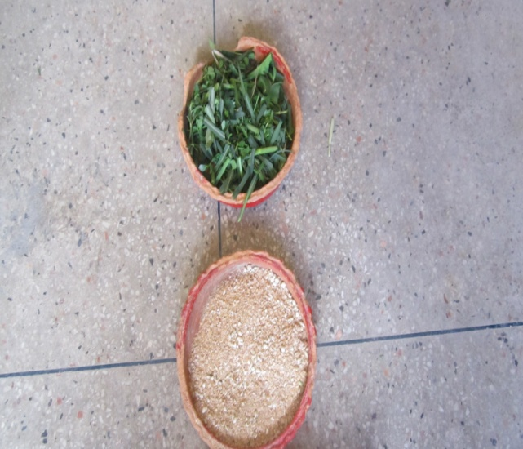
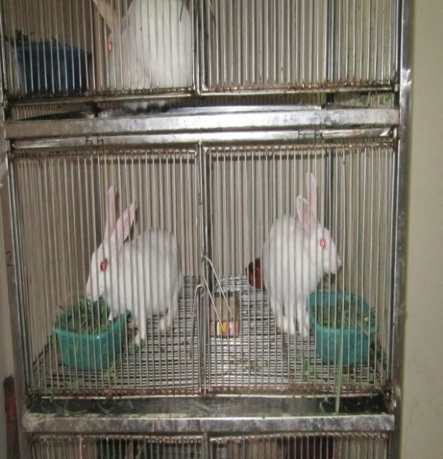
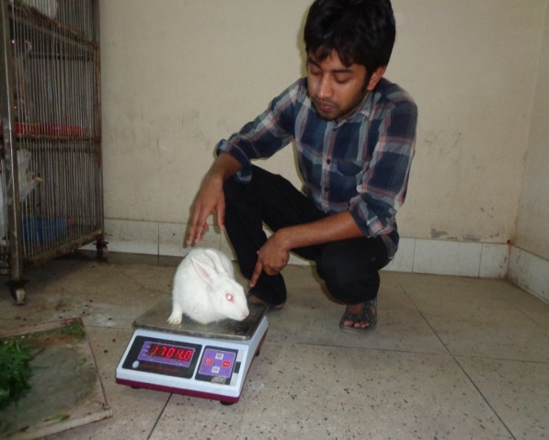
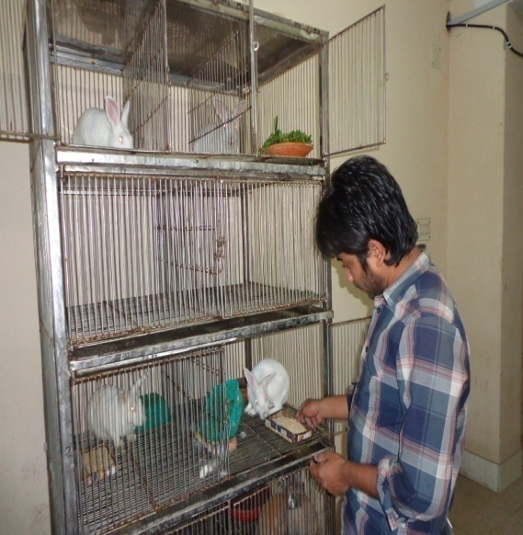
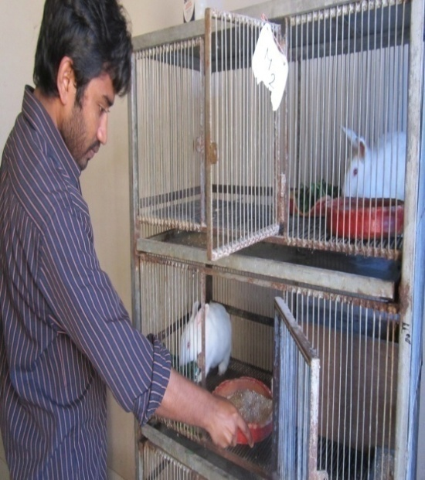
Fig 5: Weighing of new born kit
Fig 4: Weighing of adult rabbit
Fig 3(a): Feeding system
Fig 3(b): Feeding system

Fig 2: Concentrate mixture and green grass
Fig 1: Rabbit steel cage house
CHAPTER IV

RESULT AND DISCUSSION

4.1 GROWTH PERFORMANCE
The feed intake and average daily gain of rabbits were calculated and the data is shown in Table 4.1.1
Table 4.1.1Growth performance of rabbit does and bucks
Parameter* | Female | Male | Level of significance
Initial live weight (kg) | 1.25$±$0.08 | 1.57$±$0.1 | NS
Final live weight (kg) | 2.45$±$o.16 | 2.87$±$0.2 | NS
Total live weight gain (g) | 1200$±$110 | 1230$±$100 | NS
Weekly live weight gain (g) | 93.31$±$0.12 | 101.08$±$0.15 | NS
Daily live weight gain (g) | 13.33$±$0.07 | 14.44$±$0.09 | NS
Daily feed intake (g) | 100$±$10 | 100$±$10 | NS
DM intake (g/d)  Green grass  Concentrate  Total | 30.5$±$1.5  89.0$±$4.35  119.5$±$5.05 | 30.5$±$1.5  89.0$±$4.35  119.5$±$5.05
Feed conversion ratio(FCR) | 11.15 | 12.08 | NS
*Parameter indicates the mean of 10 female rabbit and 2 male rabbit
*NS=Not significant.

4.1.1Live weight
The total live weight gain during the 90 days experimental period of rabbit was 1200$±$ 110 g and that of the male rabbit was 1230$±$100 g. Similarly daily live weight of rabbit does increase at the rate of 13.33 $±$0.07 g/day and in male rabbit increased at the rate of 14.44$±0.09$g/day. The findings of the experiment is closely related with Farinu (1994) who found average daily live weight gain of rabbit was 15.2gm/day in compound diet containing 30% soybean meal. However, this result does not support the observation of Poet et al, 1980 who found growth rate to be 25g/day when rabbits were fed with fresh green clover vegetable leaves with no supplements. The weekly live weight of rabbit does increased up to whole study period at the rate of 93.31$±$0.12 gm/week and in male rabbit at the rate of 101.08$±$0.15 gm /week.

Fig-1Body weight (Kg/week)

Fig-2 Body weight gain (gm/wk)

4.1.2Dry matter intake
The level of energy were 2367 kcal/kg feed in diet of experimental animal. The average dry matter intake from green grass was 30 $±$ 1.5g/day both in male and female. The dry matter intake from concentrate was 89 g/day which is similar in male and female. And total dry matter intake was 119.5$±$5.05. Singh et al. (1994) reported that 152.69g/day DM taken by does ration containing concentrate and 25 percent Kudzuvine hay compared to ray grass. This was a bit higher than the current findings. This may be due to the breed difference as at CVASU, we had NZW rabbit.

4.1.3 Feed conversion ratio
FCR was 11.15 and 12.08 in female rabbit and male rabbit respectively with the energy level of 2367 kcal/kg diet. Omar et al, (1997) recorded the higher feed conversion efficiency when fed diet containing 2700 kcal/kg diet compared to 2400, 2500 and 2600 kcal/kg diet.

4.2 REPRODUCTIVE PERFORMANCE OF DOES
Following table represent the Reproductive characteristics and kit performance.
Table 4.2 Reproductive performance of rabbit does and kit performance.
Parameter* |  | Amount
% of does kidded |  | 100
Gestation period (days) |  | 31 $±$0.30
Total no. of kit born (for 2 breeding ) |  | 68$±$0.05
Litter size at birth |  | 3.4$±$0.45
Litter weight at birth (g) |  | 240$±$15.25
Individual kit weight at birth (g) |  | 70.59$±$3.3
Kit mortality (%) | 10.5
*parameter indicates the mean of ten (10) rabbit does.

Table 4.3 Total no. of kit
 | Adult |  | Kit
 | Female | Male | New born | 1 month age | 2 month age | No.  of dead kit | Total
Initial | 10 | 02 | 0
After 1st kindling | 10 | 02 | 40 | 0 | 0 | 04 | 36
After 2nd  kindling | 10 | 02 |  | 36 | 0 | 04 | 68

From the table 4.2.1, it was found that percent of does kidded was 100% and all does of study gave birth within expected time of parturition. The average gestation periods of study animal were 31$±0.30$ days. The gestation period of rabbit is in close agreement with those reported by Yono et al. (1986) of 31-32 days. The litter size at birth, litter weight at birth and individual kit weight at birth were 3.4$±$0.45 g, 240$±$15.25 g and 70.59$±$3.3 g respectively. Litter size at birth mostly depends upon the ovulation rate.. In this study kit mortality were found 10.5% which is due to environmental stress as the experimental period was during mid winter. Omar et al (1997) recorded the least kit mortality in rabbits fed diet containing 2700 kcal/kg. Total number of kit was 68$±0.05$ at the end of the study.

4.3 COST OF PRODUCTION
Table 4.4 shows the total feed cost of experimental animal through the experimental period, feed cost for per animal, feed cost of per animal per day.

Ingredients | Amount used  (per 100kg) | Market price(Taka/Kg) | Total cost of individual ingredients (Taka) | Total cost per kg feed (Taka)
Maize | 29.85 | 30 | 895.50 | 33.58
Wheat bran | 14.93 | 30 | 447.90
Rice polish | 14.93 | 23 | 343.39
Broken rice | 9.95 | 32 | 318.40
Pea bran | 9.95 | 35 | 348.25
Soybean meal | 19.90 | 50 | 995.00
Salt | 0.5 | 20 | 10.00
Total | 100 | - | 3358.44
Table 4.4 Total cost feed (taka/kg)

4.4 Calculation of feed cost (cost benefit ratio)
Total no. of animal = 12
Total amount of feed offered per day = 12x100=1200 g
Total cost of feed per day = 33.58$×$1.2=40.62 Taka (33.58Taka/kg feed)
Cost of feed per day per animal =40.62/12=3.39 Taka (40.62 taka for 12 animals)
Total cost of feed for 90 days period for individual animal =3.39$×$90= 305.1 Taka/animal
Total cost of feed during experimental period = 40.62 $×$90 =3655.8 Taka

Feed cost for kit:
Total No. of kit =68
Average feed consumption per day=25 g
Cost of feed per a day per animal=0.25$×$33.58=0.84 Taka ( 1 kg feed =33.58 Taka)
Total cost of feed per day=0.84$×$68=57.12 Taka
Total cost of feeds foe 30 days=57.12$×$30=1713.6 Taka

Result revealed that cost of feed per kg was 33.58 taka and total cost of feed, cost of feed per animal per day ,total cost of feed per animal were 3655.80 tk, 3.385 tk,304.65 tk respectively.

4.5 Profit
Usually the profit of a farm is being determined on the basis of the investment (different cost) and returns. Here only the feed cost is used to determine the profit assuming that the farmer might have its own house where they are living thus the labor and other overhead cost have also been excluded from the calculation.
Profit=Total return –Total expenditure
If all the rabbits will be sold after the experiment then
The total Return will be as follows:
From selling of adult male @400 BDT = 400x2 = 800 taka
From selling of adult female @500 BDT = 500x10=5,000 Taka
From selling of young rabbit @150 BDT =150x68=10,200 Taka
Total =16,000 Taka
Total expenditure
Buying cost of adult rabbit @ 300 BDT = 300x12 = 3600 Taka
Feed cost for adult=3655.80 Taka
Feed cost for young=1713.6 Taka

Total expenditure=8969.4 Taka
Net profit=total return - total expenditure
=16,000-8969.4
=7030.6 Taka
Monthly profit= 7030.6$÷$ 3
=2353.53 taka

CHAPTER V

SUMMARY AND CONCLUSION

A study was conducted to know the growth and reproductive performance of rabbit as well as to assess the cost of rabbit rearing. The study carried out in the rabbitry unit, Department of Animal science and Animal Nutrition, CVASU. For this study 12 adult rabbit were selected and fed concentrate mixture containing 2369 Kcal/kg energy and 16.44 % CP and green grasses. The entire animal was tried to keep in same management system for the entire period weekly body weight of the all animals were recorded. The fed intake and reproductive performance of all adult animals were recorded. Total cost of rearing was also calculated recorded.Net profit was calculated and explored.
The overall findings from the work is as follows
- The average daily weight gain were numerically lower (13.33$±$0.07 g) in female and higher (14.44$±$0.09g) in male.
- Total average dry matter intake of male and female was 119.5$±$5.05g.
- The feed conversion ratio was numerically lower in female (11.15) and higher (12.08) in male rabbit.
- The reproductive performance recorded in the study includes percent of does kidded, gestation period, litter size at birth, litter weight at birth, average individual kit weight and kit mortality and those were 31$±$0.3 days, 3.4$±$0.45 g,240$±$15.25 g,70.59$±$3.3 g and 10.5% respectively.
- The daily average feed cost for each animal was 3.39 Taka.
- Finally, Total profit from rearing of 12 adult rabbits was 10,116 taka. Although feed cost only included in expenditure.
From above discussion we may summarized that, rabbit have great potentiality in growth and reproduction. Rabbit can be reared in least cost and it’s a profitable species. Although rabbit
farming as a source of income has not yet gained popularity among the common people of our country. The rural people of our country can be involved in rabbit farming for changing their socio-economic status. As rabbit farming is easily manageable and sustainable it has a bright future potential in our country as a source of income generation as well as a source of animal protein.
Therefore, the livestock departments of Government should necessary steps to trainee up and motivate the farmers and provide incentives to them for the promotion rabbit rearing and developing it as an industry.
REFERENCE

Ansar M 2009. Advantages of rabbit farming. (www.helium.com/items/1526163-advantages-of-rabbit-farmingbenefits-of-rabbit-farming). On :31.01.2013.at :20:30 PM

Amao OA, Adejumo DO, Togun VA and Oladunjoye IO 2012.Growth response and nutrient digestibility of pre-pubertal rabbit bucks fed cottonseed cake-based diets supplemented with vitamin E. African Journal of Biotechnology, 11(76):1402-1410.

Ajayi FO, Balogun OO, Ovuru SS and Mgbere OO 2005. Reproductive performance of rabbits fed maize-millingwaste based diets. African Journal of Biotechnology, 4 (5) : 439-443.

AOAC 1984. Official Metods of Analysis (14th Ed.).Association of Official Analytical Chemists.Washington D.C USA
.
Bamikole MA, Ikhatua MI, Ikhatua UJ and Ezenwa IV 2005. Nutritive Value of Mulberry (Morus Spp.) Leaves in the Growing Rabbits in Nigeria. Pakistan Journal of Nutrition 4 (4): 231-236.

Begense F 2008. Rabbit production gives Mahomed a new lease of life. Agrinews Magazine, 39(4): 6.

Cheeke PR 1986. Potentials of rabbit production in tropical in and subtropical agricultural systems. Journal of Animal Science, 63:1581-1586.

Dalle Zotte A 2004. Dietary advantages: rabbit must tame consumers. Viandes et Produits Carnés, 23: 161-167.

Dairo FAS, Abi HM and Oluwatusin FM 2012. Social acceptability of rabbit meat and strategies for improving its consumption in Ekiti State Southwestern Nigeria, Livestock research for rural Development 24 (6).

El-Badawi AY, Hassan AA and Abedo AA 2007.Growth performance of New-zealand white rabbits feddiets containing different levels of untreated or fungal treated sugar beet pulp. 58th EAAP Meeting, Dublin Sess.22 Abst. No.1170.

Elgaafar MN, Marair IF, Amin S, Egkelawy HM. Yamani AO, ABD-ALLd FR 2010. Growth performance and reproductive efficiency ofweaned NZW rabbits as affected by HCG injection

Farino GO 1994.Effect of fedding a compound diets based on non-conventional feed –stuffs on growth and characteristics of rabbits.World Rabbit Sci.2 (4):123-126.

Hassan HE, Elamin KM,Yousif IA, Musa AM and Elkhairey MA 2012. Evaluation of body weight and some morphometric traits at various ages in local rabbit s of Sudan. Journal of Animal Science Advances, 2(4): 407-415.

Hernández P 2007. Carne de conejo, ideal para dietas bajas en ácido úrico. Revista científica de nutrición. Nº 8 Septiembre.Boletín de cunicultura, 154 : 33-36.

Haque A, Das A and J Bordoloi JP 2007. Effect of Early Weaning On The Growth performance Of Soviet Chinchilla Rabbits Under Two Feeding Regimes. Indian J. Anim. Res., 40 (2): 135 – 138.

Irlbeck NA 2001. How to feed the rabbit (Oryctolagus cuniculus) gastrointestinal tract. Journal of Animal Science, 79(E. Suppl.): 343–346.

Jiya EZ, Ijaiya AT, Oguche KO, Afolayan FO, Abdulkadir B and Shehu BM 2011. Growth Performance and Nutrient Utilization of Weaned Rabbits Fed With Diets in Which Palm Kernel Cake(PKC) was Replaced with Cooked Tallow (Detarium microcarpum) Seed Meal. Continental J. Animal and Veterinary Research 3: 7 – 10.

Lukefahr SD and Cheeke PR 1990. Rabbit project strategies in subsistence farming systems (1) Practical considerations. World Animal Review, 68(3): 60-70.

Lukefahr SD and Cheeke PR 1990. Rabbit project planning strategies for developing countries. (1) Practical considerations. Livestock Research for Rural Development, 2 (2).

Lukefahr S , Hohenboken WD, Cheeke PR and Patton NM 1983. Doe Reproduction And Preweaning Litter Performance Of Straightbred and Crossbred Rabbits. Journal Of Animal Science, 57:. 5.

Ly Thi Luyen and T R Preston 2007. Growth performance of New Zealand White rabbits fed sweet potato (Ipomoea batatas) vines supplemented with paddy rice or Guinea grass supplemented with commercial concentrate.Livestock research for rural Development 24 (7)

Lukefahr SD 2010.Role of organic rabbit farming for poverty alleviation. Mekarn Msc 2008-10; Miniprojects

Leng RA 2008 .Digestion in the rabbit –a new look at the effects of their feeding and digestive strategies, MEKARN Workshop 2008: Organic rabbit production from forages

Lukefahr SD 1995. Rabbit production in Uganda,World rabbit Science 6(3-4),331-340.

Le Thi Thu Ha 1997-1998.lternative feeding and housing systems for rabbits

Mailafia S, Onakpa MM and Owoleke OE 2010. Problems and prospects of rabbit production in Nigeria – A review. Bayero Journal of Pure and Applied Sciences, 3(2): 20–25.

Moreki JC 2007. Commercial rabbit production. Agrinews Magazine, 38(10): 2-12.

MIDAS 1992. Prospects of commercial rabbit raising in Bangladesh a survey report. Micro Industries Development Assistance Society. National Academy Press,Washington, DC.

Mustafizur R, Rezia k, Mousumi T ,Ibrahim K, Sohel A and Borhan U 2011 .Measurement of carcass and chemical parameters for meat yield and quality analysis of rabbits: a systemic research for alternative source of complete protein. Global Veterinaria 7(11); 83-88.

Mehraz MZ and Mousa MRM 2011.Growth performance of Rabbits Fed olive Pulp in North Sinae.Asian journal of animal science.(5), 317-329.

Mmereole FUC, Egoh JO and Obinne JI 2011. Growth Performances and Cost Analysis of Weaner Rabbits Fed Varying DietaryLevels of Crude Protein Supplemented with Tridax procumbens. Pakistan Journal of Nutrition ,10 (2): 120-123

Nguyen Huu Tam, Vo Thanh Tuan, Vo Lam, Bui Phan Thu Hang and T R Preston 2009.Effects on growth of rabbits of supplementing a basal diet of water spinach (Ipomoea aquatica) with vegetable wastes and paddy rice, Livestock research for rural Development 21 (10).

Oguike MA and Okocha NL 2008 .Reproductive performance of rabbits re-mated at Different intervals post-partum. African Journal of Agricultural Research . 3(6) :412-415.

Ondruska L, Rafay J,Okab AB, Ayoub MA, Al-Haidary AA, SamaraEM, Parkanyi , Chrastinova VL, Jurcik R, Massanyi P,Lukac N, Supuka P 2005. Influence of elevated ambient temperature uponsome physiological measurements of New ZealandWhite rabbits Veterinari Medicina, 56, (4): 180–186.

Omar NE, Ghazalah AA, Soliman AZ and Radwan NL 1997. Effect of dietary energy and protein levels and their intetaction on reproductive performance of NZW rabbit does.Egypt.rabbit Sci. 7 (1):35-46.

Pote LM, Cheeke PR and Potton NM 1980. Use of greens grass as a supplement to a pelleted diet for growing rabbits.Journal of Applied Rabbit Research,3 (4);15-20.

Tawfeek MI 1996. Effect of fedding system and supplemented diet with kemzume on growth,blood constituents,carcass traits and reproductive performance in rabbits,undert intensive production condition.Egypt.J.rabbit.Sci

Potter P and Danks M 2002. Rabbit Liver Protein Provides Clues to Improving Cancer Therapy.

Schiere JB 2004. Agrodok 20 Backyard rabbit farming in the tropics (4th Edition). Agromisa Foundation, Wageningen, The Netherlands. 71 pp.

Singh R, Sawal RK, Hasin VI and Bhatia DR 1994.Nutrient utilization by rabbits on diets containing kudzubine gay.Indian J.Anim.Nutr.,11(4):255-258.

Tuma J, Tumova E, Valasek V 2010. The effect of season and parity order on fertility of rabbit does and kit growth. Czech J. Anim. Sci,55, (8): 330–336.

Van Dijk L (2003). Rabbit production guidelines for the Malawi Prison Service. Penal Reform International. Lilongwe, Malawi.

Vietmeyer ND 1985. Potentials of micro livestock in developing countries. Journal of Applied Rabbit Research 8:16.

Yono C, Raharjo c ,Cheeke PR and Patton NM (1986).Growth and reproductive performance of rabbits on a moderately low crude protein diet with or without methionine or urea supplementatiuon.J.Anim.Sci.63:795-803.

APPENDICES

Appendix table 1

Weekly live weight and live weight gain of experimental animal.
 | Body Weight |  | Body Weight Gain
No. of week | Female  (Kg/week) | Male  (kg/week) | Female (g/week) | Male (g/week)
1st | 1.25 | 1.57 | 90 | 110
2nd | 1.34 | 1.68 | 100 | 120
3rd | 1.44 | 1.80 | 90 | 120
4th | 1.53 | 1.92 | 110 | 110
5th | 1.62 | 2.03 | 100 | 120
6th | 1.72 | 2.15 | 90 | 130
7th | 1.81 | 2.28 | 90 | 130
8th | 1.90 | 2.41 | 120 | 130
9th | 2.02 | 2.54 | 140 | 110
10th | 2.16 | 2.65 | 160 | 110
11th | 2.32 | 2.75 | 130 | 100
12th | 2.45 | 2.87 | 130 | 120

Appendix table 2
Live weight of rabbit does
SL. No | Initial live weight(gm) | Final live weight (gm) | Total Live weight gain (gm)
1 | 1220 | 2500 | 1280
2 | 1350 | 2290 | 940
3 | 1200 | 2450 | 1250
4 | 1170 | 2385 | 1215
5 | 1400 | 2620 | 1220
6 | 1330 | 2590 | 1260
7 | 1280 | 2570 | 1290
8 | 1100 | 2200 | 1100
9 | 1200 | 2445 | 1245
10 | 1250 | 2450 | 1200

Appendix table 3
Live weight of male rabbit
SL. No | Initial live weight(gm) | Final live weight (gm) | Total Live weight gain (gm)
1 | 1580 | 2900 | 1320
2 | 1560 | 2840 | 1280

Appendix table 4
Reproductive performance of does
No. of does | Gestation period(DAYS) | Litter size | Litter weight  (gm) | Average Individual litter weight  (gm)
1 | 32 | 4 | 281 | 69
2 | 32 | 3 | 215 | 73
3 | 30 | 3 | 210 | 70
4 | 31 | 4 | 282 | 69
5 | 30 | 4 | 280 | 71
6 | 32 | 3 | 214 | 70
7 | 32 | 4 | 279 | 72
8 | 29 | 3 | 210 | 71
9 | 31 | 3 | 215 | 72
10 | 31 | 3 | 214 | 69

Appendix Table 5
WEEK NO. | ROUGHAGE  (gm) |  |  | CONCENTRATE  (gm)
 | Offered | Refused | Intake | Offered | Refused | Intake
1st | 1000 | 160 | 840 | 1000 | 300 | 700
2nd | 1050 | 200 | 850 | 1000 | 310 | 710
3rd | 1050 | 210 | 840 | 1050 | 300 | 750
4th | 1000 | 150 | 850 | 1100 | 350 | 750
5th | 1000 | 180 | 820 | 1000 | 300 | 700
6th | 1000 | 155 | 845 | 1050 | 350 | 700
7th | 950 | 140 | 810 | 1050 | 380 | 670
8th | 1000 | 180 | 820 | 1100 | 400 | 700
9th | 1000 | 170 | 830 | 1050 | 400 | 650
10th | 1050 | 200 | 850 | 1000 | 320 | 680
11th | 1050 | 185 | 865 | 1000 | 300 | 700
12th | 1050 | 190 | 860 | 1050 | 360 | 690
Feed Intake

