PROSPECTS OF RABBIT FARMING: A CASE STUDY AT CVASU

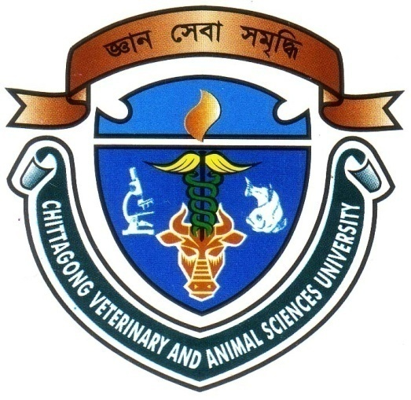

A PRODUCTION REPORT SUBMITTED

BY

Intern ID: D-42
Roll No: 2007/46
Registration No: 333

Report Presented In Partial Fulfillment for the Degree of Veterinary Medicine.

Chittagong Veterinary and Animal Sciences University
Khulshi, Chittagong.

February, 2013
PROSPECTS OF RABBIT FARMING: A CASE STUDY AT CVASU

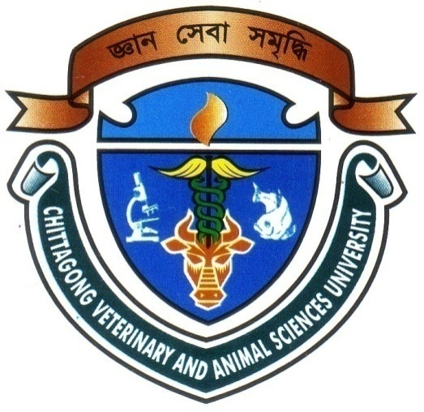

A PRODUCTION REPORT SUBMITTED

BY

Intern ID: D-42
Roll No: 2007/46
Registration No: 333

Approved as to style and content by

………………………………
Signature of Supervisor
Name: Dr. Md. Hasanuzzaman
Designation: Associate Professor
Dept. of Animal Science & Nutrition
Chittagong Veterinary and Animal Sciences University

……………………………..
Signature of Author
Khaled Bin Amin
Roll No: 2007/46
Reg. No: 333
Intern ID: D-42
Date of submission: 14th February, 2013

CONTENTS

Serial no. | Title | Page
 | ACKNOWLEDGEMENT | i
 | LIST OF ABBREVIATIONS | ii
 | ABSTRACT | iii
CHAPTER 1 | INTRODUCTION | 01-03
CHAPTER 2 | REVIEW OF LITERATURE | 04- 09
CHAPTER 3 | MATERIALS AND METHODS. | 10-15
CHAPTER 4 | RESULTS & DISCUSSION | 16-21
CHAPTER 5 | SUMMARY&CONCLUSION | 22
 | REFERENCE | 23-27
 | APPENDIX | 28-31

LIST OF TABLES

SL No. | Title | Page No.
1 | Table3.1 Chemical value of ingredients of concentrate mixture that offered to experimental rabbit | 11
2 | Table 3.2 Chemical composition of ration | 11
3 | Table 4.1 Growth performance of rabbit does and bucks | 16
4 | Table 4.2. Reproductive performances of rabbit doe’s | 19
5 | Table 4.3 Total no. of kit | 19
6 | Table 4.4 total cost of feed(Taka/kg) | 20

LIST OF FIGURES

SL. No | Title | Page No.
1 | Body weight (kg/week) | 17
2 | Body weight gain (gm/week) | 18

LIST OF PHOTOGRAPH

SL. No | Title | Page No.
1 | Steel cage house of rabbit | 15
2 | Concentra mixture and green grass | 15
3 | Feeding of rabbit | 15
4 | Weighing of new born kit | 15
5 | Weighing of adult rabbit | 15

Acknowledgements

The author bends his heads to the Almighty who is omnipotent, omniscient and omnipresent for His endless blessing to conduct this research work for the fulfillment of the requirement for the degree of Doctor of Veterinary Medicine (DVM).

The author desires to express his earnest gratefulness and profound appreciation to the following persons for the accomplishment of this dissertation.

The author convening his gratitude and great appreciation to the venerable internship supervisor Dr.Md.Hasanuzzaman , Associate Professor, Department of Animal Sciences & Animal Nutrition, Faculty of Veterinary Medicine for his valuable guidance, suggestion, supervision and encouragements during the entire period of this study to complete this report.

I take the opportunities to express my deepest sense of respect and appreciations to the honorable Professor Dr. A. S. Mahfujul Bari, Vice-Chancellor and Professor Dr. Md. Masuduzzaman, Dean, Faculty of Veterinary Medicine, Chittagong Veterinary and Animal Sciences University. I highly express my sincere gratitude and gratefulness to the internship coordinator and Director of External Affairs, Dr. Bibek Chandra Sutradhar, Associate Professor, Department of Medicine and Surgery, Chittagong Veterinary and Animal Sciences University, for his constant inspiration, cordial co-operation, and valuable suggestion for completion of the research work.

Last but not least, the author is profoundly grateful to all of his well wishers, roommates and close friends for their encouragements and inspiration during the study period and preparation of this report at this level.

The Author
February,2013

i
LISTS OF ABBREVIATION

AOAC | ASSOCIATION OF OFFICIAL ANALYTICAL CHEMIST
DM | Dry matter
Kg | kilogram
gm | Gram
mg | Milligram
Tk | Taka
FCR | Food Conversion ratio
CP | Crude protein
ME | Metabolizable Energy
CF | Crude fiber
EE | Ether extract
Kcal | kilocalorie
% | Percentage
/ | Per
± | Plus-minus
= | Equal
BDT | Bangladesh Taka

ii
Prospects of Rabbit Farming: A Case Study at CVASU

ABSTRACT

A study was conducted on 12 cross breed New-Zeeland white rabbits aged about 6 months to know their growth and reproductive performance for a period of 3 months at the Rabbitry unit under the Department of Animal science and Animal Nutrition, CVASU. All rabbit were provided about 100 g concentrate mixture having 2369 kcal/kg energy and 16.44 % CP and ad-lib. green grasses twice daily. It was found that the daily average bodyweight gain, DMI and FCR in females were 13.33$±$0.07g, 119.5$±$5.05g, 11.15; and in males were 14.44$±$0.09g, 119.5$±$5.05g, 12.08g respectively. The reproductive performance of the adults in the form of per cent of does kidded, average gestation period, litter size at birth, litter weight at birth, individual kit weight at birth and kit mortality were 100%, 31$±$0.30 days, 3.4$±$0.45 Nos., 240$±$15.25g, 70.59$±$3.3g and 10.5% respectively. The daily average feed cost of rabbit rearing was also calculated and found as BDT. 3.39 for each animal. Furthermore, the total cost of rabbit rearing and overall profit was also calculated in this study. It was again found that the total profit from rearing of 12 adult rabbits in three months was 7030.6 taka. In this regards, it may be recommended that rabbit has great potentiality in growth and reproduction as it can be reared with a very minimal cost.

Key word: Rabbit, concentrate mixture, growth, reproduction,

iii

