CHAPTER 2
REVIEW OF LITERATURE
2.1 Concept of Animal Husbandry:
The word “Animal Husbandry” is a broad term definition of this term indicates a lot of activities of rearing animal with care and management, specially the domesticated one.
‘Animal Husbandry’ may be defined as a science as well as an art of management including scientific feeding, breeding, housing, health care of common domestic animals aiming for maximum return ( Banerjee, 2007 ).
‘Animal Husbandry’ is that branch of Agricultural Science which deals with the housing, feeding, breeding, development, production, care & management & evaluation of domesticated animal farming ( Louis, 2002 ).
‘Animal Husbandry’ is the control cultivation, management & production of domestic animals including improvement of the qualities considered desirable by human by means of breeding ( Haldmen & Julius, 2009 ).
‘Animal Husbandry’ also called animal science, stock breeding or simply husbandry is the agricultural practice of breeding & raising livestock generally domesticated animals.
2.2 Site selection of dairy farm:
Place & soil quality is an important factor before establishment of dairy farm. Comparatively high land where stagnant of water don’t occur this means easy slop out of excess water is quit suitable for dairy farm establishment ( Banerjee, 2007 ). Sandy-clay soil is good enough for a dairy farm as it has both absorbable as well as fertility quality which facilitates the fodder cultivation.
Essential Site Factors:
Potential sites should be eliminated if we cannot provide these four essential factors:
1. Water: A year-round supply of potable water is essential for watering animals and sanitation. Water is also needed for fire protection and cooling cows and milk. Between 40 to 50 gallons of fresh water per cow are needed daily for lactating cow consumption and milking center cleaning.
2. Drainage: Proper surface and subsurface drainage are required to divert storm water away from animal housing units and to help prevent frost heaving of foundations. Select an elevated building site with a slope of 2 to 6% to provide adequate drainage while minimizing erosion.
3. Required area: The site should provide an area that is several times larger than the size of the animal housing unit. Assume the operation will double in size and plan accordingly. Make room for feed areas, machine storage, vehicular traffic and water and electricity upgrades. The site should allow for adequate manure storage. In Virginia, large operations that confine 300 animal units (200 dairy cows) or more are required to provide 120 to 150 days of manure storage capacity. This is in addition to the depth of storm water expected in a 24-hour, 25-year design storm and one foot of freeboard at all times. The site should also provide space for the collection and control of contaminated water from the animal housing units. Allow for adequate separation between buildings to prevent the spread of fire and to enhance natural ventilation.
4. Off-farm factors: The site must meet local building codes and pollution requirements. It should also provide adequate setback distances from neighboring residences to avoid nuisance problems such as noise and odor. A site that is isolated from the residence and sensitive environmental habitats is ideal ( Susan, 2004 ).

2.3 Housing system of Dairy farm:
There are mainly two type of housing system is practiced throughout the world. Loose housing system (Single row) & Stanchion barn system (Double row) ( Samad, 2001 ). One more that is cubical housing system ( Leaver, 2003; Krarmer, 2004 ) is now very popular in Britain. Very small farm ( Herd size <5 ) single row housing pattern of Suitable but in case large farm fermers have to choose either face-in or face-out pattern of Stanchion barn housing system( Samad,2001 ). Dimension of cattle house should be north to southern way for adults cow ( Susan, 2004 ). Because, most quantity of air access flow through this dimension. But eastern dimension is preferred for calf ( Samad, 2008 ).
An ideal dairy farm must have minimum the following sheds like milch cow shed, milking barn, dry cow shed, heifer shed, calf pen, maternity barn, isolation ( Separately for calf & adult cow ) shed, feed store room, bull shed ( in case of natural mating ) individually ( Tyson & Graves, 1995). It is essential having an accommodation for employees to keep 24 hrs supervision.
The following housing systems will be discussed:

• enclosed free stall barn system for temperate and cold climates.
• roofed open free stall system for Mediterranean and arid climates.
• open air corral system for tropical climate.

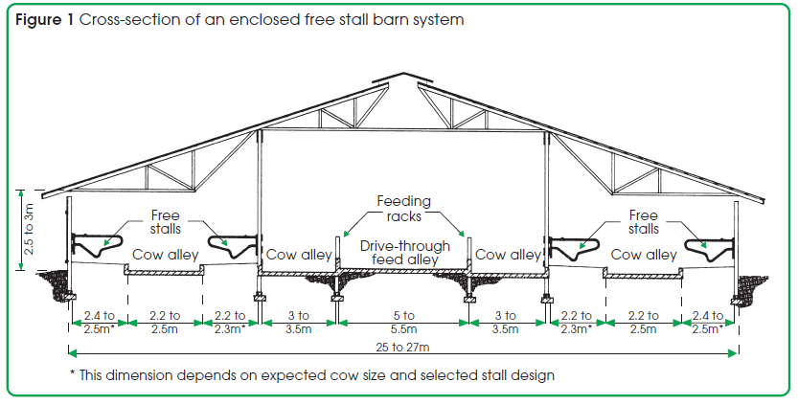
( Courtesy: Susan,2004 )
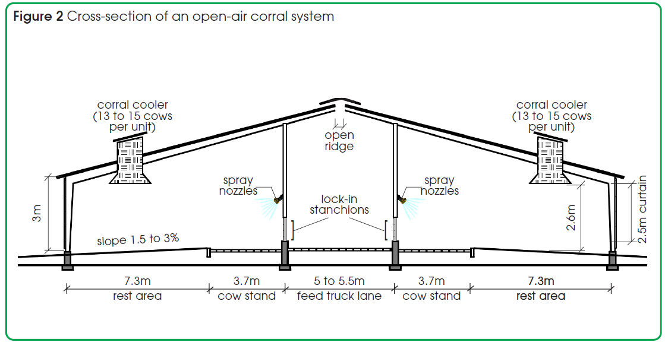
( Courtesy: Susan, 2004 )
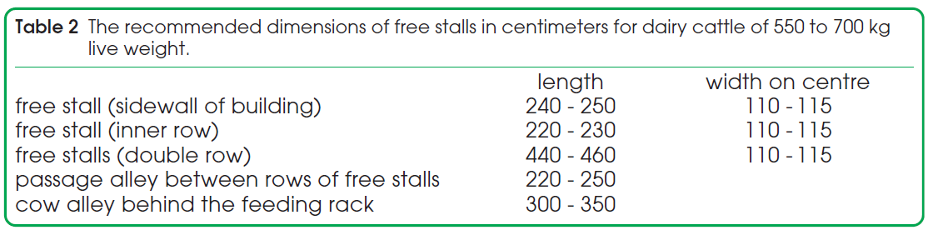
( Courtesy: Albright, 1983 )
Enclosed free stall barns
These barns have a self-contained system combining all basic facilities in either an insulated (warm) or uninsulated (cold) barn structure. The decision as to whether a cold or warm barn is to be built should be based on complete appraisal of environmental conditions and management goals to be met. Nowadays, many dairy farmers worldwide find enclosed, well-ventilated cold dairy barns adequately suitable for moderate and cold climates.

Roofed open free stall housing
The roofed free stall housing system is an ideal system for both the Mediterranean and arid climates. If properly designed, this system offers a very efficient method for handling small and large dairy herds at a low investment per cow. It is easily expandable as the herd increases. The design should vary according to climatic conditions, so the main emphasis should be on offering protection from rain, snow, wind, sun and heat.

Open-air corral housing
The design of open air corral systems depends largely on the climatic condition in the dairy farming area. Prevailing problems in heat stress and muddy conditions have compelled dairy farmers in certain areas, especially in hot and humid climates, to provide more protection in the form of shade and paving of high cow-traffic areas. Shade to protect against solar radiation will improve cow comfort and reduce stress. Figure 2 shows a typical barn cross-section for open-air corral housing.
Housing and handling systems vary widely, depending on the particular use of the cattle in research and teaching ( Albright, 1983, 1987). Recommended facilities for dairy cattle range from fenced pastures, corrals, and exercise yards with shelters to insulated and ventilated barns with special equipment to restrain, isolate, and treat the cattle ( Bickert, 2003 ).

Table 1: Space requirement for calf according to age:

Age of Calf | Space required
< 3 month | 20-25 sqft
3-6 month | 25-30 sqft
6-12 month | 30-40 sqft
>1 year | 40-50 sqft
( Banerjee, 2007; Mahanta, 1987 )

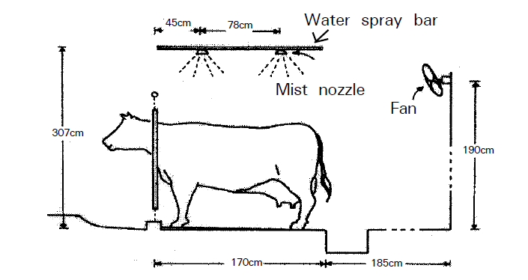
( Courtesy: Aii et al., 1998)
Fig. 3. Mist and fan system for cooling dairy cattle
Mist and fan system:
Aii et al., (1998) have described an evaporative system which uses water mist and a fan (Fig. 3). Mist particles are sprayed onto the cow’s body to wet the hair. A fan is then used to evaporate the moisture, as a way of cooling the cows. The results showed an increase in milk production of 0.66 – 1.90 kg/ day for cows producing 20 – 25 kg/day. An economic analysis showed that the break-even point of this system in Japan would be a 0.81 kg/day increase in milk production.

2.4 Feeding of Dairy Cattle:
Dairy animal rearing is an inseparable and integrated part of smallholder subsistence farming system. Dairy cattle production in the country is characterized by low productivity levels due mainly to genetic and nutritional constraints. Quantitative and qualitative shortage of feeds and fodder affects the performance of milking animal. Local cows yield on average 1.5 Lit. milk per day against 5-8 Lit. in cross bred cows, require better feeding mainly concentrates, which is not available to the farmers at the affordable prices. But income of farmers can be increased up to two fold (Tk.58 vs 115) by rearing cross bred cows. Since feed cost is becoming the most important factor in livestock production, increasing self sufficiency in feed production will be an important factor in future development programs ( Khan et al., 2009 ). Feeding is the predominant behavior of ruminants, as illustrated by the observation that feeding activity has priority over rumination whenever the causal factors of the two activities conflict ( Metz, 1975 ).
The design of the feeding system, feeding management and dietary formulations must recognize the dynamic nature of dairy cow psychology and physiology, nutrient requirements and variability in feedstuff composition ( Sniffen et al., 1993 ). Improperly grouping dairy cows may perturb their normal behavioral routines and time budgets. In essence, dairy cows spend 3 to 5 h/d eating, consuming 9 to 14 meals per day. In addition, they ruminate 7 to 10 h/d, spend approximately 30 min/d drinking, 2 to 3 h/d being milked and require approximately 10 h/d of lying and (or) resting time ( Grant and Albright, 2000 ).
Space should be adequate for feed and water. Feeders or mangers should be designed with smooth surfaces for easy cleaning and increased feed consumption. The recommended linear space per cow at the feed bunk is 61 to 90 cm (2 to 2.5 ft), which should allow every animal uninterrupted feeding ( Malloy and Olson, 1994 ). Feeder design should permit a natural head-down grazing posture to promote intake, improve digestive function, facilitate normal tooth wear, and decrease feed-wasting behavior ( Albright, 1993a ).
All calves should consume colostrum in amounts of 8 to 10% of body weight (or 2 to 3 L) within 4 to 5 h after birth always before milk is fed and another 2 to 3 L within 24 h of birth for a 36- to 45-kg (80- to 100-lb) calf ( Stott et al., 1979; Stott and Fellah, 1983; Hunt, 1990; Pritchett et al., 1991; Mechor et al., 1992 ). Fresh water should be provided at all times. Replenishment of water should follow milk or milk feeding by at least 15 minutes ( Davis and Drackley, 1998 ). Calves being raised as replacement heifers or for beef should be fed enough dry feed with sufficient fiber preweaning to stimulate normal rumen development ( McGavin and Morrill, 1976 ). Calf research guidelines have been reported that permit uniformity in measuring and reporting experimental data ( Larson et al., 1977 ). Water intake affects consumption of dry matter ( Kertz et al., 1984; Milam et al., 1986 ) and is itself influenced by individual behavior, breed, production rate, type and amount of feed consumed, water temperature, environmental temperature, atmospheric vapor pressure, water quality and physical facility arrangement (Atkeson and Warren, 1934; Murphy et al., 1983; Andersson, 1985; Lanham et al., 1986 ).Nonlactating cows consume 3 to 15 kg of water/kg of dry matter consumed, depending on environmental temperature. Lactating cows consume 2 to 3 kg of water/kg of milk produced plus that required for maintenance ( Little and Shaw, 1978 ). Water should be available at all times (NRC, 2001); it should be checked daily for cleanliness and monitored regularly to ensure that it is free of contaminants that could potentially put zoonotic agents into the human food chain ( Johnston et al., 1986 ).

Table 2 : Daily nutrient requirements for maintenance of mature lactating cows.
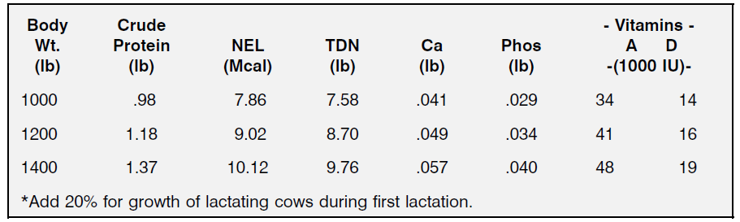
(Courtesy: Harris, 2010 )
Daily feed intake comprises the number of meals eaten daily, the length of each meal, and the rate of eating. By adjusting the number of daily meals and the average meal size (length x rate of eating), the cow can adjust daily DMI. High-producing cows allowed continuous access to TMR ate 9 to 14 meals/d ( Vasilatos and Wangsness, 1980 ); lower-producing cows consumed 7 to 9 meals daily ( Heinrichs and Conrad, 1987 ). Daily feed intake reflects the number of meals consumed daily, the length of each meal, and the rate of eating. By altering the number of daily meals and the average meal size (length × rate of eating), the dairy cow can adjust daily DMI ( Grant and Albright, 2000 ). High-producing dairy cows allowed continuous access to TMR consumed 9 to 14 meals daily, whereas lower-producing cows consumed only 7 to 9 meals per day ( Heinrichs and Conrad, 1987 ). The eating patterns of high-producing cows differ substantially from those of lower producing cows. During the first 5 wk of lactation, dairy cows with the highest eating and ruminating rates had the greatest DMI ( Coulon et al., 1987 ).
Sinde et al., (1994) reported that the food intake (dry matter (DM) basis) of cows which ate more than 20 kg of feed (DM basis) per day started to decrease at25 of ET. The ratio of forage to concentrates also decreased. However, the feed intake of cows with a feed intake of less than 20 kg/day (DM basis) was relatively constant. These cows were fed a high-quality diet of corn silage, timothy hay and concentrates, in which the level of total digestible nutrients (TDN) was 75 – 77%. NDF, the level of neutral detergent fiber (NDF) supplied by roughage, was less than 35%.

2.5 Bedding of Dairy Cattle:
Resting dairy cattle should have a dry bed. Stalls ordinarily should have bedding to allow for cow comfort and to minimize exposure to dampness or fecal contamination. When handled properly, many fibrous and granular bedding materials may be used ( MWPS, 2000 ) including long or chopped straw, poor-quality hay, sand, sawdust, shavings and rice hulls. Inorganic bedding materials (sand or ground limestone) provide an environment that is less conducive to the growth of mastitis pathogens. Sand bedding may also keep cows cooler than straw or sawdust. Regional climate differences and diversity of bedding options should be considered when bedding materials are being selected. Bedding should be absorbent, free of toxic chemicals or residues that could injure animals or humans, and of a type not readily eaten by the animals. Bedding rate should be sufficient to keep the animals dry between additions or changes. Any permanent stall surfaces, including rubber mats, should be cushioned with dry bedding ( Albright, 1993b ). Shredded rubber may be used and is recommended as a mattress filler ( Underwood et al., 1995 ).
2.6 Ventilation of a Dairy Farm:
Ventilation permeates all aspects of the animal environment ( Bickert, 2005 ). Most often, ventilation is associated with respiratory health of animals: the quality of the air that animals breathe directly influences animal health and disease. Nevertheless, ventilation—directly and indirectly—affects many other aspects of animal health as well. Under ventilation in winter is one of the most serious threats to the environment of animals. Improper design and improper management of the ventilation may be reasons that wintertime ventilation is lacking, compromising animal health. Problems are most likely during winter, spring, and fall, especially during rainy weather and warmer days coupled with cold nights. Specific recommendations for ventilation system design are available ( MWPS, 2000 ).

2.7 Social environment of Dairy Farm:
Dairy cattle are social animals that exist within a herd structure and follow a leader (e.g., to and from the pasture or milking parlor). Cows exhibit wide differences in temperament, and their behavior is determined by inheritance, physiology, prior experience, and training. Cattle under duress may bellow, butt, or kick; however, cows are normally quiet and thrive on gentle treatment by handlers. Cows learn to discriminate among people and react positively to pleasant handling. Aversive handling leads to more incidents during handling and transport for calves than positive handling ( Lensink et al., 2001 ). Similarly, heifers and cows exposed to aversive handling took longer to traverse and more force to move than those handled more gently ( Pajor et al., 2000 ). Although the presence of an aversive handler reduced kicking during udder preparation, residual milk was 70% greater than for the control milkings ( Rushen et al., 1999a). Cows have higher milk yields if handlers touch, talk to, and interact with them frequently ( Albright and Grandin, 1993; Seabrook, 1994 ). Cows should have visual contact with one another and with animal care personnel. Handling procedures are more stressful for isolated cattle; therefore, attempts should be made to have several cows together during medical treatment, artificial insemination, or when cows are being moved from one group to another ( Whittlestone et al., 1970; Arave et al., 1974 ). This was verified by increased heart rate, hypothalamic-pituitary- adrenocortical axis activity, and vocalizations. Pain sensitivity is reduced during isolation, suggesting a stress-induced analgesia ( Rushen et al., 1999b ).
2. 8 Milking Machine and Udder Sanitation:
The milking facility should have a program for regular maintenance of milking machines and follow the recommended mastitis control program of the National Mastitis Council ( NMC, 2007 ). Appropriate equipment and competent personnel should be available for milking. Personnel responsible for milking should receive ongoing training about proper milking procedures as the frequency of training has been associated with adequacy of milking performance ( Rodrigues et al., 2005 ). The removal of foremilk (“forestripping”) before teat disinfection is encouraged as a means to detect mild cases of clinical mastitis. Teat sanitation, predipping, and wiping immediately before machine attachment reduce udder infection caused by environmental pathogens ( Bushnell, 1984; Pankey et al., 1987; Galton et al., 1988; Pankey, 1992; Malloy and Olson, 1994; Reneau et al., 1994 ).

2.9 Night grazing:
Although air temperature and the level of solar radiation begin to fall after about 2 pm, the temperature of the roof remains high. As a result, the body temperature and respiration rate both rise. Cattle kept in ashed maintained a rapid heart beat during the night. However, when the cattle were allowed out into a pasture at night, these physiological responses decreased immediately. This is the result, both of the reduction in radiation heat from the surrounding cattle, and the rise in heat loss from the cattle ( Kurihara and Shioya, 2010 ).
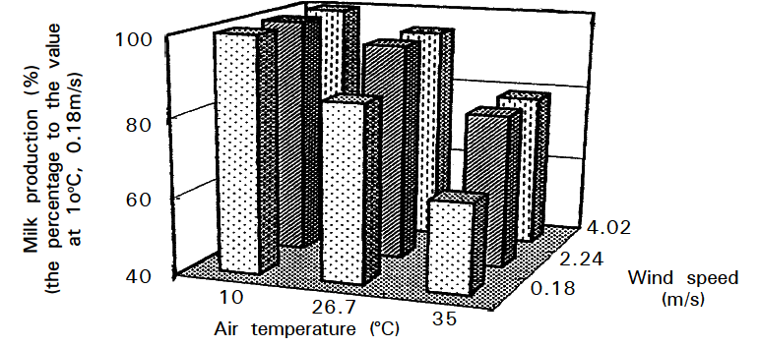
Fig.4. Effect of air temperature on milk production.
( Courtesy: Johnson and Vanjonack, 1976)

