CHAPTER-I

INTRODUCTION

1.1 Background of the Study
The research is conducted on indigenous and cross breed bull (Sahiwal, Jersey, Holstein Friesian) separately for fattening to find out the Benefit Cost ratio (BCR). In Bangladesh, livestock is one of the most potential sub-sectors of agriculture which plays an indispensable role in promoting human health and national economy of the country. Large ruminants are cattle and buffalo and small ruminants are sheep and goat constitutes the major portion of livestock. The present population of livestock is 24.54 million cattle, 1.5 million buffalo, 26.64 million goat and 3.67 million sheep (DLS, 2020-21).
More than 75 percent of Bangladesh's population resides in the country's rural areas, a factor that contributes to the country's high poverty rate of 20.5%, of which 10.5% are regarded as living in severe poverty. More than 150 million people call the low-lying nation of Bangladesh home. Bangladesh has a very high population density (Hodson, 2006 and the daily Prothom alo, 2014).
The practice of beef cattle fattening serves to meet the growing demand for foods that are high in protein, plays a significant part in the improvement of food security, and contributes to the expansion of our nation's gross domestic product.
In addition to this, it plays an important role in the following areas: (i) Increasing food security. (ii) Offering families work chances, a source of income, opportunity to invest, and a value-preserving asset. (iii) Providing power for plowing and manure for farming to be sustainable agriculture and (iv) Livestock serving cultural purposes. The region of Northern Bangladesh is putting forth a lot of effort right now to expand its agriculture potential, primarily in the area of cattle fattening. Cattle fattening, which is usually done through activities including microcredit, If implemented properly, it has the potential to be a powerful weapon for reducing poverty and increasing food availability for the general population.( Jean, 1993; Uza et al.,1999 and Maikasuwa et al.,2012). The increased demand for ruminant foods from city people presents not only potential for improving the animals' markets but also for fattening them up, as the growing demand creates more options.
Yet, Bangladesh's meat producers are of the opinion that the country's slaughter houses need up to 3.5 million beef cattle annually in order to satisfy Bangladeshi tastes. The holy celebration of Eid al-Adha causes an enormous spike in demand for cattle, especially beef cattle, which is several times more than the average level. Within two or three days of this event each year, over 1.7 million cattle are put to death as a sacrifice (Sujan et. al., 2016). In preparation for this holiday, a huge number of low-income people engage in the practice of bull fattening in the three to nine months leading up to Eid al-Adha. At that time, they are able to sell the animals at rates that result in a significant profit margin. A method of keeping cattle for the purpose of producing meat commercially and profitably is known as cattle farming. The cattle fattening package is a four-step rearing program that is administered to underweight cattle in order to harvest the animal's compensatory development within a time frame of sixty to one hundred and twenty days. The fattening package can be made profitable by collecting animals while taking their body characteristics into consideration, then deworming them, feeding them for an effective period of time up to a considerable level of live weight gain, and marketing them in a convenient manner. These are the four primary factors. For the purpose of beef cattle fattening, farmers feed their animals traditional rice straw varieties, green grass, sugarcane tops, wheat and rice bran, molasses, pulse bran, and other locally available resources such as vegetable by-products, rice polish, boiled rice bran, oil cakes, and other foods. When applied to beef cattle, the treatment of straw with urea and molasses results in increased body weight, a higher dressing %, and improved carcass quality as compared to untreated straw. It has been known for a long time that one of the most significant obstacles to achieving maximum livestock production in Bangladesh is the severe lack of feeds and fodder (Saadullah, 1995). Cattle raising is a very simple and lucrative strategy that can help rural people lift themselves out of poverty and unemployment and produce income for themselves. In addition to the cultivation of crops, rural communities often engage in the practice of cattle fattening as a secondary kind of economic activity. Cattle management methods include feeding, housing, breeding procedures including artificial insemination, health care including cleaning and sanitation activities, selling beef cattle, and waste management. These tasks are directly handled by individuals who live in rural regions. (Barman et al., 2017; Kawsar et al., 2006; Mazed et al., 2004; Rahman et al., 2002; Islam et al., 2004; Sarkar et al., 2008; Sarker et al., 2018; Quddus and Rahman, 1998). People who live in rural areas often engage in beef fattening businesses since these endeavors enable them to bring in supplemental revenue and to keep their family members gainfully employed throughout the year.

1.2 Objectives of the Study
The overall objectives of the study is to assess the profitability on beef fattening practices and makes possible recommendations for improvement of the safe, healthy and profitable beef cattle rearing system in the study areas of Bangladesh. The specific Objectives of the study are to:
(i) To describe the socio-economic characteristics of beef fattening entrepreneurs.
(ii) To identify the modern & scientific system for producing safe and healthy beef through introducing better production, housing, treatment and management practices.
(iii) To assess the Benefit Cost Ratio (BCR) of the selected beef fatted farms.
(iv) To identify the constraints and make policy guidelines for safe and sustainable of beef cattle fattening.

CHAPTER-II

REVIEW OF LITERATURE

2.1 Beef Cattle Production System in Bangladesh

In Bangladesh, Livestock often consumes fibrous plant matter and other byproducts of agricultural production that are indigestible to humans. Feeds of lower quality may be transformed into foods (meat, milk, and eggs) of superior quality by being consumed by livestock. Animals may get their food from crop leftovers and cereal by-products, as well as grasses, tree leaves, and aquatic plants. Crop residues are the most common source of animal feed. The animals will forage on grasses and any other feeds that could be present in the uncultivated areas, as well as along the roadside and in the bunds. Rice straw, wheat straw, grasses growing along roadsides and fields, agricultural weeds, aquatic plants, and fodder for trees make up the bulk of the roughage used for feeding cattle. In addition to straw as the primary component of their food, straw-based diets may also include water hyacinth, banana leaves, and the tops of sugarcane when available. There is a limited supply of grains available in the nation for the purpose of feeding cattle. Straw may be obtained on a daily basis at a rate of around 2 kilograms per head, but supplementing is insufficient at about 1 kilogram of green fodder, with tiny amounts of grain and oilseed by-products (Saadullah, 1995). Rice bran is what makes up the concentrate, while wheat bran, oil cakes, pulse bran, cotton seed cake, molasses, and fish meal are some of the other ingredients that constitute 6.8% of the total dry matter. At the present day, on a situational and temporary basis, for instance, small-scale farmers who raise animals for fattening purposes use anabolic steroids and feed additives according to the suggested level in order to achieve higher levels of production from the animals they raise. Antibiotics are often employed in the food production process as a way to regulate the growth of potentially harmful bacteria. This is done so in order to avoid the spread of foodborne illness. The prevention of infections, an increase in the animal's capacity to consume food and water, and an improvement in its digestive efficiency are all potential benefits that might result from the use of antibiotics.

2.2 Importance of Cattle Rearing for Beef

Cattle fattening is the practice of increasing the quantity of meat produced in animals by supplementing their diet with urea molasses block (UMB), urea-treated straw, or the administration of steroid hormones. Cattle are responsible for about 95% of the demand for draught, 98% of the milk produced, and 56% of the meat supplied in the market (BBS, 2001). In Bangladesh, cattle, bullocks, and other farmyard animals that are no longer productive are often used to produce the majority of the nation's beef. Imported animals from the adjacent countries also contribute to the beef supply in Bangladesh. The raising of cattle for the purpose of beef production has emerged as a significant economic activity for small farmers in Bangladesh. Beef fattening has been adopted by the Directorate of Livestock Services (DLS) of the Government of Bangladesh as an action program to produce revenue for the rural poor farmer. Farmers often begin purchasing cattle 36 months in advance of the Muslim holiday of Eid-ul-Adha, at which point the animals are fattened up and eventually sold during the Eid celebration. The livestock of all the farmers were pampered by being bathed in ponds and rivers. Only 8% of the farmers had received instruction on livestock raising from local youth training institutions, and around 92% of the farmers had no training whatsoever on the subject of cattle fattening. Prior to beginning their fattening operations, about 61.2% of farmers dewormed their cattle. The majority of farmers, around 72.8%, did not get vaccinated against infectious illnesses. A total of 245 farmers had sought the assistance of a veterinary surgeon for the purpose of treating their livestock. There was a scarcity of animal feed, which was cited by about 96.8 percent of farmers, as well as a lack of financing, which was cited by 84.0 percent of farmers. A research project on the agribusiness of cattle and beef products was carried out in Dhaka City by Halim (1998). He demonstrated the many sources of beef supply, the present marketing structure, the cost and margin, as well as beef marketing-related issues and potential remedies. Recently, in our own nation of Bangladesh, the government has made efforts to grow beef cattle in order to meet the demand for them. Cattle fattening is already being implemented as an action program by the government's Department of Livestock Services (DLS), with the goal of increasing revenue for less fortunate farmers in rural areas. The essential information is being disseminated to the small-scale farmers via the Upazila livestock offices, and the youth training centers run by the government are instructing farmers in the relevant skills.

The proportion of beef that comes from growing animals ranges from roughly 10 to 12 percent of the total. The act of sacrificing a growing animal as part of Eid ul-Adha is often seen as the most significant tradition associated with this religious holiday. However, the raising of cattle for the sake of beef production has emerged as a significant enterprise for the smaller farms. Although there are variations in the rates of population growth across nations, the overall population of key livestock species has been growing in tandem with the swiftly rising demand for meat. This is despite the fact that the growth rates of their populations vary from country to country. The number of cattle in the Asian country's herds is growing on a daily basis.

2.3 Cattle Fattening
Cattle fattening is the practice of increasing the quantity of meat produced in animals by supplementing their diet with urea molasses block (UMB), urea-treated straw, or the administration of steroid hormones. It is a well-known fact that rice straw is the primary crop leftover that is utilized in Bangladesh as the only source of nutrition for cattle and buffaloes. Rice straw is of poor quality, meaning it has a low nitrogen content and a low digestibility as a result of high lignin and silica content. However, the productivity of cattle, particularly beef cattle production, is heavily dependent on the effective use of rice straw. Cattle are responsible for about 97% of the demand for draught, 98% of the milk produced, and 52% of the meat supplied in the market (BBS, 2021). In Bangladesh, cattle, bullocks, and other farmyard animals that are no longer productive are often used to produce the majority of the nation's beef. Imported animals from the adjacent countries also contribute to the beef supply in Bangladesh. Because of the increasing need for food all over the world, there has been a shift toward raising cattle that are capable of producing both milk and meat for human use.
Prucsasri et al. (1987) reported that at two different farms in Thailand, a useful resource about the process of beef cattle fattening was discovered. Each farmer was responsible for raising two Brahman x Charolaise x native steers that were between 17 and 18 months old and weighed between 200 and 250 kg each. During the first six months of their lives, the steers were given concentrate in addition to new grass. The daily increase was an average of 1.09 kg per day per bull. They stated that fattening cattle on a modest scale might be a possibility for farmers to boost their revenue.
Caton et al. (2002) reviewed the metabolic factors that contribute to the increase in the amount of energy that developing beef cattle spend. The goal of this research was to improve the energetic efficiency of the manufacture of a food product.
Begum et al. (2007) conduct a field investigation to determine how rural farmers in the Panchagarh area of Bangladesh are bringing their cattle to market weight. According to this research, forty percent of farmers had completed their elementary school, while twenty percent had no formal education. About 56.7% of farmers used cattle that were between the ages of 2-3 years, while another 36.7% of farmers utilized cattle that were between the ages of 1-2 years. Approximately 70% of farmers used bulls, and approximately 70% of farmers maintained an average herd size of 1-4 animals for finishing. Sixty percent of farmers indicated a fattening time of three to six months, whereas thirty percent reported a period of seven to twelve months. More than eighty-six percent of the farmers had separate housing for their livestock. A total of around 63.4% of farmers routinely cleaned their livestock in ponds and rivers. Almost 76.7% of farmers had received brief instruction on livestock husbandry from Rangpur, Dinajpur Rural Service (RDRS), and Panchagarh Youth Training Centre. Additionally, approximately 80% of farmers had dewormed their animals before to beginning the fattening program. Approximately 96.6% of farmers said that there was a scarcity of animal feed, and 86.6% reported that there was a lack of financing as the primary challenges associated with cattle fattening. The average purchase price was 7528 yen, the average selling price was 9542 yen, and the average net profit was 2055 yen per cow. The rural residents of Bangladesh may benefit by participating in income-generating activities, such as the establishment of small-scale cattle fattening initiatives.

2.4 Cattle Fattening by Farmers in Bangladesh

Indigenous cattle (Bosindicus) are breed and raised by farmers in Bangladesh for the primary purpose of obtaining draught power, milk, calves, and meat. Cattle are responsible for about 98% of the required draught, 99% of the milk produced, and 50% of the meat sold at the neighborhood market (BBS, 1991). The fattening of cattle by rural farmers is a topic about which there is very little information accessible.
Hossain (1986), worked on management techniques for fattening cattle in the Cumilla area, including feeding, housing, illness control, and marketing of the finished product.
Hossain et al. (1997) also an investigation on the process of beef fattening was carried out in the Manikganj district. According to Huq et al. (1997), the sale of fattened cattle in the Mymensingh district before to the Eid-ul-Adha resulted in significant financial benefits for the local farmers. According to Hossain et al. (1996b), the outcome of cattle fattening periods comprising 4.5 months and 5.7 months respectively was observed to be the same.
Hossain et al. (1986) showed that the high cost in a period of 5.7 months resulted in a net revenue of Taka 7745/- per head of cattle. According to the reports of Jahurul and Abdul Jobbar, the most significant challenge that farmers face when it comes to the raising of cattle is the scarcity and high cost of animal feed.
Hashem et al. (1999) via field research, we looked at the cattle fattening programs that rural farmers in many different areas of Bangladesh were employing. It was determined that around 51.2% of farmers had completed their elementary school, while the remaining 28% had no formal education. About 60.4% of farmers employed cattle that were between the ages of 2-3 years, while 32.2% of farmers used calves that were between 1 and 2 years old. Approximately 70.4% of farmer’s utilized bulls, while just 5.2% used females in their operations. About 71.20% of farmers had an average of 2 cattle for fattening, whereas 28.8% of farmers had an average of cattle fattening times of 3-6 months and 7-12 months were reported by 42% and 30% of farmers, respectively. About 71.20% of farmers had an average of 2 cattle for fattening. The majority of farmers, around 86.40 percent, provided their own funding for their cattle fattening operation. Eighty-six percent of the farmers had separate stalls or barns for their livestock. The livestock of all the farmers were pampered by being bathed in ponds and rivers. Only 8% of the farmers had received instruction on livestock raising from local youth training institutions, and around 92% of the farmers had no training whatsoever on the subject of cattle fattening. Prior to beginning their fattening operations, about 61.2% of farmers dewormed their cattle. The majority of farmers, around 72.8%, did not get vaccinated against infectious illnesses. A total of 245 farmers had sought the assistance of a veterinary surgeon for the purpose of treating their livestock. Cattle fattening by large scale commercial fattening farms in our nation are few and far between. Approximately 96.8% of farmers said that there is a scarcity of animal feed, and 84% reported that there is a lack of financing as the biggest challenges for cattle fattening. Financial institutions like as Sonali Bank, Janata Bank, Agrani Bank, and Bangladesh Krishi Bank provided funding for the establishment of large-scale fattening farms during the 1999-2000 fiscal year.

2.5 Animal Feed Resources
The acute shortage of for a long time, feeds and fodder have been recognized as a significant obstacle to the achievement of optimal livestock production in Bangladesh. It is generally agreed that nutritional issues are the most significant barrier to increased animal output. A viable plan for the growth of livestock has to take into account national requirements in terms of feed supplies, types of animals, and goods derived from animals (Devendra, 1993). By-products of cash crops are the primary source of feed supplies for livestock such as cattle, buffalo, goats, and sheep. The animal will graze on grasses or any other feeds that may be present on the roadside and in the uncultivated parts of the landscape. Rice straw, wheat straw, sugarcane tops and wayside grasses, aquatic plants, and tree fodder make up the bulk of the roughage used for feeding animals. Other sources of roughage include tree fodder. When they are accessible, water hyacinth, banana leaves and stems, tree leaves, and sugarcane tops also make up a green supplement that may be added to a diet based on straw. Based on the production of rice and assuming an extraction rate of between 100 and 150 percent, the total output of rice straw is estimated to be somewhere about 16.9 million tons across all rice kinds (Tareque and Saadullah, 1988).

2.6 Feeding System of Cattle Fattening

2.6.1 Availability of rice straw and its use in Bangladesh
Rice straw is the primary component of the traditional diet that is consumed in Bangladesh and is used in the country's feeding system. According to Islam et al. (1993), about 87 percent of rice straw is used in the production of dry feed for cattle. According to Saadullah (1995), gathered straw is utilized for feeding animals between 65 and 75 percent of the time, while the remaining 25 to 30 percent is used for various other uses such as fuel, construction materials, etc. Rice straw is notoriously difficult to dry, and as a result, vast amounts of it decompose during the monsoon. In the conventional feeding method, farmers provide an average of 1.5–2.0 kg of straw per head of cattle each day, which is incapable of providing the fundamental nutrients necessary for their productivity performance.
According to Tareque (1985), out of the 29.1 million tons of accessible roughage for ruminants in Bangladesh, rice straw alone supplies around 23.5 million (81%) of those tons, whilst green grasses only contribute 1.6 million tons. According to the findings of Ali et al. (1993), Aman and Boro straw were discovered to be used in almost every production system at all times of the year. The quantity of straw produced is often determined by extrapolating data on grain output; however, this is not always the case. Calculations like this are based on the ratio of grain to straw, and when it comes to rice, a ratio of one to one is often considered (Doyle et al., 1986).

2.6.2 Feeding of urea treated straw for cattle fattening
It has been observed that urea treated straw was just as excellent as green sorghum and that it could sustain a satisfactory rate of weight growth in crossbred heifers of 300g per day with the addition of a moderate amount of concentrate (Banerjee, 1998).The treatment of straw with urea, which works on roughage by cleaving ester bonds between cell wall porosity and therefore making polysaccharides more accessible to enzymatic hydrolysis, has been shown to be the most effective approach (Herber et al., 1982; Gato, 1995).
Rafiq et al. (2002) shown that medicated Urea-Molasses-Mineral blocks increased milk output and live weight in dairy cows despite the fact that balanced feeds for dairy cows are rare in the rural circumstances of Bangladesh. The levels of urea in milk and serum of indigenous dairy cows are favorably affected by various amounts of urea in blocks. It has been calculated that the available feed supplies are sufficient to meet 44% of the dry matter needs, 26% of the crude protein requirements, and 17% of the energy requirements (Saadullah, 1995).
Rice bran, wheat bran, oil cake, and pulse bran are the components that make up concentrates. Molasses and, in rare instances, fish meal make up 6.8% of the total dry matter. Traditional grazing fields are hard to come by, with the exception of a few isolated areas in the Pabna and Sylhet districts (in winter season only). In addition, during the monsoon these regions become very inundated for agricultural purposes, and during the dry season they are put to use for the production of fodder.
Ahmed et al. (2002) out an experiment that lasted for 105 days with six indigenous bull calves in order to examine the viability of cattle fattening as a means of revenue generation for the farmers. Six young bulls were divided equally between the two treatments. The animals in the control group were given untreated rice straw and green grass with concentrate as their diet, whereas the animals in the treatment group were given Urea Molasses Straw (UMS) and green grass with concentrate. Both the daily amount of feed consumed and the weekly total live weight were recorded. The first live weight of the calves in the control group was 134 kilograms, whereas the calves in the treatment group weighed 159 kilograms. The total final live weight of the calves in the control group was 189 kilograms, whereas the calves in the treatment group weighed 226 kilograms. We assessed things like socioeconomic characteristics, the engagement of members of the family, and the cost return from the animals. During the process of cattle fattening, problems and recommendations to farmers were discussed. The fattening of cattle led to an increase in the utilization of local feed resources, as well as an increase in revenue, job opportunities, and income for farmers. Utilizing urea, molasses, and straw in the proportions of 3:15:82, Hague and Chowdhury (1995) conducted an experiment in which they analyzed the chemical make-up of the mixture.

2.6.3 Vitamin-mineral premix as growth promoters

James Parish and Justin Rinehart designated vitamins and minerals to be forgotten about in the course of a herd's nutritional plan since they only account for a very little portion of the daily dry matter intake in beef cattle feeding. Although vitamins and minerals are required in very small quantities as dietary nutrients, they are of the utmost significance in the nutritional regimen of beef cattle for proper animal function such as the development of bones, the operation of the immune system, the contraction of muscles, and the operation of the nervous system. If an excellent mineral program is not in place, there is a possibility that the growth and reproductive performance of cattle would suffer.

2.7 Other Management of Cattle Fattening
The way in which each bull was managed was essentially identical to the way in which the others were managed. Both the daily amount of feed consumed and the weekly gain were recorded. The intake of roughage was marginally greater in the treated group than in the control group, and this difference was significant at the 1% level. The bulls in the control group had a finishing live weight of 153.50-L17.29, whereas the bulls in the treatment group had 170.88+2.86. This difference was significant at the 1% level. For each of the treatment groups, a concentrate supplement consisting of rice polish, wheat bran, and soybean meal was administered at a rate of 1.25 kg per day per bull.
Pervez et al. (2001) conducted an investigation of the impact that varying amounts of energy and protein have on the rate of development and the efficiency with which nutrients are used by bull calves. Rice straw, fodder maize, rice polish, wheat bran, soybean molasses urea, bone meal, and table salt were used in the formulation of three distinct meals, each of which included a unique combination of caloric and protein content. According to NRC recommendations, Diet A was designed to meet the needs for both calorie and protein intake (1976). Diets B and C, on the other hand, were designed to provide the subject with an amount of calories and protein that was 10 and 20 percent below the NRC norm, respectively. In a study using a randomized block design, the animals' live weights were used to determine which of the three diets they would receive at random. Diet A had the highest daily consumption, with 5.01 kg DM, followed by diet B with 4.61 kg DM, and diet C with 4.29 kg DM. When compared to diet C, the digestibility of DM and OM in diet A was considerably (P 0.05) greater than in diet B, but it was not statistically different from diet B. The amounts of DCP, DOM, and ME that were included in each diet, on average, were essentially identical. The average daily live weight increase recorded for diet A was found to be the greatest (0.39 kg), followed by 0.35 kg fix for both the diets B and C; however, the difference was not significant across the three diets. Those bull calves who were fed diet C (12.2) had a higher feed conversion efficiency (DM/LWG) than those bull calves that were fed diets A (12.9) and B. (13.1). Those bull calves who were fed diet C (1.22) had a higher protein conversion efficiency (CPI/LWG) compared to those bull calves that were fed diets A (1.28) and B. (1.3). The amount spent on food to produce one kilogram of additional living weight was less expensive with diet C (Tk. 42.9/-) compared to diets A (Tk. 49.9/-) and B (Tk. 49.2/-). According to the findings, it seems that diet C, which has an energy and protein content that is 20% lower than the NRC norm, may be suggested for feeding local bull calves.
Rahman et al. (2001) performed a second experiment with six developing bulls of two years of age, each weighing 95.3 0.14 kg live weight, in order to study the impact of feeding urea molasses straw on the intake, growth, and nutritional digestibility of bulls. The bulls were separated into two groups, each of which would get a therapy, and each group would include three animals. The group that served as the control was given rice straw and green grass, whereas the group that was treated was given UMS and green grass. In each of the treatment groups, the concentrate supplements were administered at a rate of 1.35 kg per bull each day. A total of five months were devoted to carrying out the experiment.
The health and management of all of the bulls were excellent, and they were all stall-fed. Towards the end of the experiment, a digestion test was carried out, and throughout the experiment, daily feed intake as well as weekly weight increase were recorded. The findings indicate that the roughage and total intake of the bulls in the treated group was statistically significantly (P 0.05) greater than that of the bulls in the control group. The bulls' final live weights were 150.2 9.78 and 169 3.06 kg for the control group and treated group, respectively, and there was a statistically significant difference between the two groups (P 0.05). The difference in DCP between the treatment group (5.2 0.74) and the control group (9.25 1.53) was determined to be statistically significant (P 0.05), with the treated group having a higher value.
2.8 Marketing of Cattle for Beef
There is neither a structured marketing network nor a market intelligence system in place to assist the smallholder dairy producers who are located in rural regions. At the regional markets, there is a significant and growing demand for meat. In the past, there was a ready supply of cattle coming from countries that were nearby, which kept the price of beef at a relatively low level. Recently, there has been a restriction on the supply, which has led to a significant rise in the price of meat. The absence of better breeds, poor meat quality, and restricted access to financing and insurance among smallholders are some of the factors that are preventing the beef sector from developing in the long term.
A marketing system covers all of the actions that are engaged in the flow of commodities from the point of original production to the customers who buy the product in its final form. It encompasses the activities of exchanges that are associated with transferring property rights to commodities, physically purchasing and allocating resources, handling products, disseminating information to participants, and making institutional arrangements for the purpose of facilitating these activities (Amir and Knipscheer, 1989). The marketing of beef cattle begins with the producers, who either sell the animals on their own homesteads or at livestock selling markets, and concludes with customers buying meat from butchers. The producers sell the animals either at their own homesteads or at the markets.
In a research that Shamsuddin (1969) did on main livestock markets in the districts of Mymensingh, he found that the gathering of cattle in the market was at its maximum during the winter season. The study was performed in 1969. Farmers, wholesalers, middlemen, and other types of non-farmers made up the many links in the livestock's distribution chain. It was also discovered that the majority of animals were carried by either walking or driving on foot, although trains and vehicles were also used in the process of moving livestock.
Wahiduzzaman (1981) carried out research on the marketing of meat and the consumption pattern of it in the town of Mymensingh. He demonstrated the marketing mechanism that was in place, the costs and margins, and the various consumption patterns that the people had. The meat that he demonstrated was beef and mutton. According to the findings of this investigation, the majority of cattle were moved by foot.

2.9 Cost and Income Generation from Cattle Fattening
People who live in rural areas and are less fortunate, particularly in developing nations, place a significant importance on their livestock (Delgado et al., 1999; FAO, 2002). Especially in pastoral regions, the majority of a household's yearly cash income as well as their capital assets come from the sale of livestock.
In agricultural systems that combine crop production with livestock production, cattle are often the sole source of draught power and fertilizer for the crops, and they also make use of crop wastes after harvest (Lid, 1999; Stein field et al.,2006). When crops are unsuccessful, there is a safety net provided by livestock; nevertheless, there is a danger of illness, and either cash or credit is necessary to establish businesses (Dolberg, 2001). Recent study on the success of programs reveals little evidence of broad influence on the livelihoods of the poor, despite the fact that the goal of international livestock research and development programs is to alleviate poverty (Lid, 1999; Scoones and Wolmer, 2006). Inappropriate technology, an inability to supply services to the poor, and the dominance of richer, more capable, or higher status farmers are cited as reasons for this phenomenon. Due to the fact that participation in development initiatives is, for the most part, optional, the families who are already in a position to participate often end up receiving the greatest benefits. Those who already own livestock or have the financial resources to purchase animals, as well as those who have access to land and labor, are the ones who are most likely to embrace new techniques and see an increase in revenue as a result of livestock intensification (Dolberg, 2001; Whittaker, 2006). Households who have limited access to labor resources are forced to make choices between intensifying their animal output (which comes with its own set of disease concerns) or sustaining their crop production. Moving away from conventional rice farming in the uplands of Asia is a long-term process that may be more difficult for lower-income or disadvantaged people to undertake if land, labor, or financing are not easily accessible (Alexander, et al; 2006, Nath et al., 2005; Whittaker, 2006). It may be difficult for low-income families to grow their livestock beyond a few pigs and chickens, which are then sold to pay for their children's schooling or medical problems. This is because these families do not have the required initial capital (Whittaker, 2006).
In a study that was conducted by Ahmed et al., (2002), the researchers used eight bulls that were around 2.5 years old and had an initial body weight of 152 kilograms on average for each bull. They discovered that the control group (which consumed rice straw and green grass) had a final body weight of 153.5 kg 17.3, whereas the treatment group (which consumed urea molasses straw and green grass) had a body weight of 170.9 kg 12.9. The expenses incurred and profits made from the animals were tallied. The fattening of cattle not only increases the farmer's revenue but also improves their socioeconomic situation. Cattle fattening is a win-win situation.
According to Hossain et al.,(1986) the results of cattle fattening periods spanning 4.5 months and 5.7 months respectively were reported. He demonstrated that the high cost of raising one cow resulted in a net revenue of Tk. 7745/- over a period of 5.7 months. The individual records indicated that two of these nine women brought in an average net income of Tk. 650/- every season, whilst the other four women had an average income of 48,000/- per season. On the other hand, the other three ladies made a net income that ranged between Tk. 11,700 and 16,500 every season, and 21,000 per season, respectively. The increased quantities of cash earned by these three ladies may be attributed to the fact that they increased the amount of money they invested in the fattening program per animal and that they did an excellent job managing the operation as a whole.

2.10 Livelihood of Farmers through Cattle Fattening in Bangladesh
The great majority of people living in rural areas of Bangladesh rely on the agriculture industry as their primary means of subsistence. It is responsible for around 52 percent of the country's employment and accounts for approximately 21 percent of the country's GDP (BER, 2011). In order to put an end to poverty in rural areas, then, considerable focus needs to be paid to making agricultural sectors more viable. In the past, Bangladesh had a problem with not producing enough food for its population. However, in recent years, as a result of the efforts of agriculturists and farmers, it has become a nation that has a food grains surplus. As evidence of this, during the fiscal year 2004-2005, Bangladesh had a surplus of 5.83 million tons of food grains (the country produced 28.384 million tons of food while there was a need for 22.55 million tons), as well as 4.98 million tons of excess rice (26.13 million tons produced compared with a demand of 21.15 million tone).
In the Madaripur area, twenty different low-income women participated in a field research that took place between 1999 and 2001 under the auspices of MUK. According to the findings of the investigation, the use of urea molasses straw (UMS) as a feed for fattening cattle was an economical option. The nearby thirty farmers' decision to participate in the fattening program was affected by the cash earned from that initiative.
Hossain et al., (1996b) evaluated the link between the amount of land available for livestock, the level of adoption of enhanced feeding technology, and the usage of credit for the development of cattle. A questionnaire that had been pretested was used to conduct interviews with eighty-six (86) farmers from four different districts in Bangladesh. Farmers with land sizes of 1.6 acres or more had the biggest number of bullocks and cows at their disposal than any other group. There is a statistically significant disparity (P less than 0.01) between the total land area and the number of cattle being raised on the property. To keep cattle, around 73% of the farmers chose urea-treated straw, which was the greatest number (48%), and they obtained loans from a variety of various sources. Feeding cattle with urea molasses block supplements and rice straw that has been treated with urea is a lucrative feeding strategy that is helping farmers improve their animals.

CHAPTER-III

MATERIALS AND METHODS

3.1 Introduction
The many methods that the expert used in order to successfully direct this inquiry are broken down and discussed in more detail in the next section. During the course of this investigation, the researcher evaluates the financial profiles, analyses the taking care of housing, the executives, meat promoting channels, monetary benefit, and issues a conflict of interest regarding limited scope business of beef cattle endeavours in some selected north Bengal regions in the country of Bangladesh. This is done by utilizing appropriate strategies and methods based on the recorded information yield information that is collected throughout the course of the investigation time frame.

3.2 Selection of Study Areas
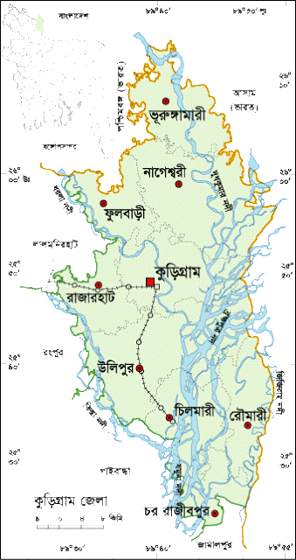
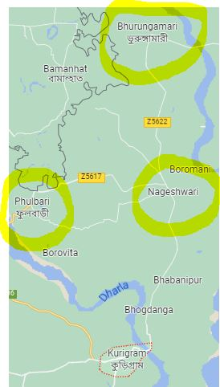
The purpose of this research was to analyze the cattle fattening program that is often used by rural farmers in the Kurigram areas of Bangladesh. The information was gathered via an interview schedule administered to respondents from these districts and three various upazilla that were engaged in the process of beef cattle fattening in preparation for Eid-ul-Azha. The majority of the responders came from the following three upazila Phulbari, Nageswari and Bhurungamari. Before Eid-ul-Azha, the interview was conducted in a number of different farms. For the purposes of data collection to meet the goals, a total of 100 farms were selected. The goals of the research is to find out the benefit cost ratio of those farm, identified farm`s problem and it`s solutions.

Figure 1: Map of the study area
3.3 Sampling Procedures
It is not feasible to conduct a survey that is comprehensive enough to surround all of the farms in the study regions. As a result of this, sampling was carried out in order to identify the beef fattening farms that were typical of the whole in order to cut down on the amount of time and money needed for the research. Therefore, out of the farms that are typical of the area, some should be chosen to participate in a sample survey that will only collect the necessary information from the chosen the beef fattening farms. This will ensure that the results are as accurate as possible.
3.4 Sample Characteristics
About 100 beef fattening farms are randomly selected from three upazila (Phulbari, Nageswari and Bhurungamari) at Kurigram district. Among them 74 farms are small that have less than equal 5 cattle, whereas 21 farms are medium which holds 6-10 no. of cattle and lastly 5 farms are large that containing more than 10 cattle.

3.5 Selection of Farmers
The farmers that were engaged in the process of beef cattle fattening were chosen. Respondents were selected at randomly from three upazila within the Kurigram district. In order to gather enough data to achieve the goals, a total of 100 farmers from three different upazila (Almost 33 farmers from each upazila) were recruited. The methodology for the experiment is described here.
Table 3.1 Selection of the study area
Division | District | Upazila | No. of farms
Rangpur | Kurigram | Phulbari | 34
 |  | Nageswari | 33
 |  | Bhurungamari | 33
Source: Field survey, 2022

3.6 Selection of Sample Farms for the Study

The commercially managed the beef fattening farms that were chosen for the research were purposefully picked from the study locations. In the Kurigram district of Bangladesh, selected commercial the beef fattening farms were categorized as small, medium, or large based on the number of fattened cattle that they had. Small farms had fewer than equal five fattened cattle, while medium farms had 6-10 cattle and large farms had more than 10 fattening cattle. An important trip was taken to the local DLS offices in order to collecting information about beef fattening farms in accordance with the thoughts and population density of these farms. For the purpose of conducting an in-depth research at each site, a total of 100 commercial beef fattening farms, 74 farms of a small size, 21 farms of a medium size, and 5 farms of large size were purposefully selected using purposive sampling technique.

3.7 Study Type and Information Assortment
It was decided to develop an analytical cross sectional research along with a detailed survey procedure. A structured questionnaire that included closed, semi-open, and open-ended questions was used to gather information by conducting guided interviews with the farm owner, manager, and/or farm personnel. The questionnaire was used to collect information. The questionnaire was designed in accordance with the goals of the research and was meant to gather information on significant topics such as farmers' socioeconomic status, farm resources, management techniques, productivity, and farm profitability.

3.8 Technique for Information Assortment, Time and Dependability of Information
The named field agents, under the supervision of a private investigator, interviewed the particular ranch proprietors while directly visiting the example ranches on broad homestead attributes profiles, production, the executives, marketing, and financial perspective during the trial time frame prior to August 2022 in each area. This was done in order to collect the important information related to the examination's predetermined objectives. For the purpose of complete data collection, the information that was obtained was changed and coded by the other expert in CVASU and by myself. The information was then cross-verified against the information that had been gathered to ensure its consistency.

3.9 Method of Data Collection
The success and validity of the investigation are inversely proportional to the reliability of the data. The author gathered all of the research material for this paper on his own. The author spent twice as much time in each research location in order to collect data that was both fair and accurate. Before and throughout the data collection process, the respondents were given a transparent and in-depth explanation of the goals of the data collection, which allowed them to freely reply to the questions. The interviews with the respondents were place during their free time so that they would be more comfortable answering questions. Both primary and secondary sources were mined for information for this study's collection of data. The secondary data were compiled using information from a variety of published sources, including books, papers, journals, theses, bulletins, BBS, and official records of the government obtained from their individual DLS offices.

3.10 Period of Data Collection
The researcher personally contacted the farm owners and/or farm managers and asked them to fill out a questionnaire that administered during the months of May to August of 2022. This data collection took place throughout this time period. The secondary data were gathered beginning in January 2022.

3.11 Parameters studied
Below is a list of the information that was included in the interview schedule:
- Socio-economic factors related to cattle fattening:
    - Gender
    - Age of the farmers
    - Education level
    - Household size
    - Occupation
    - Land size
    - Source of capital
    - Number of cattle
xi. Description of the cattle like breed, age, sex, weight, Purchase time.

- Check list of cattle fattening:
  - Types of feed
      - Roughage
      - Concentrate
  - Sources of feed
      - Naturally found
      - Market feed
    - Preservation or Treatment
d) Use of hormones and feed additives
      - Types of feed additives used
      - Types of hormones used
    - Marketing channel
      - For farmer
      - For Company
  - Manure management
C. Public perception and suggestions to improve cattle fattening.

3.12 Processing of Data
The acquired data were coded, assembled, tabulated, and evaluated when data collection was complete. Standard units were created from the local units. In order to enter the data into the computer, the replies of the respondents that were noted in the interview schedule were transferred to a excel sheet.

3.13 Data Tabulation and Analysis
To accomplish the goals of the study, data were meticulously recorded and statistically evaluated. To make the necessary tabulation easier, the acquired data were first converted to master sheets and assembled in excel sheet. A tabular method was used to analyze the data using basic statistical techniques like average, standard deviation, percentages, total variable cost, total fixed cost, total cost, gross return, net return and Benefit Cost Ratio. Total cost (TC) is calculated by summation of total variable cost and total fixed cost. Cattle purchasing cost, feed cost, treatment and medical cost, labor cost and others are in variable costs. On the other hand house rent and minor instrument costs are in fixed costs. Gross return comes from selling cattle, cow dung and other materials. Net Return is calculated by subtract from Total Return (TR) to Total Cost (TC). The benefit cost ratio (BCR) is a ratio used in a cost benefit analysis to summarize the overall relationship between the cost and benefits of an enterprise. BCR can be expressed total benefit divided total cost.

CHAPTER-IV

RESULTS AND DISCUSSION

4.1 Socio-economic Condition of the Cattle Farmers
Interviews with all 100 participants were conducted with the purpose of determining the socio-economic status of the participants in this research. For the purpose of determining the socio-economic standing of the farmers, this research chose to focus on a few of the most significant features of the respondents. Age of the farmers, size of their families, education level, profession, amount of land, source of capital, and training were some of the variables that were considered.
Table 4.1 displays the number of respondents along with the percentage distribution of their responses based on the age of the farmers, the size of their families, the amount of education they have received, the occupation they hold, the size of their land, the source of their capital, and their level of training in cattle fattening.

Table 4.1 Socio-economic profile of beef fattening farmers
Parameters | Categories | Frequency  (n=100) | Percentage (%)
Educational status | Illiterate | 13 | 13
 | Primary | 34 | 34
 | Secondary | 32 | 32
 | Higher secondary | 11 | 11
 | BA/above | 10 | 10
Occupational status | Agriculture | 65 | 65
 | Livestock | 15 | 15
 | Service | 07 | 07
 | Business | 11 | 11
 | Others | 2 | 2
Level of income | Less than 100000/= | 21 | 21
 | 100001-150001/= | 48 | 48
 | 150001-200000/= | 20 | 20
 | Above 200000/= | 11 | 11
Age | 21-30 years | 9 | 9
 | 31-40 years | 50 | 50
 | Above 40 years | 41 | 41
Sex | Male | 90 | 90
 | Female | 10 | 10
Family size(person) | Small( less than 5) | 69 | 69
 | Medium(6-8) | 23 | 23
 | Large( above 9) | 8 | 8
Land size(acre) | Marginal(less than 1) | 22 | 22
 | Small(1-3) | 51 | 51
 | Medium(4-8) | 16 | 16
 | Large(above 9) | 11 | 11
Source of capital | Own | 62 | 62
 | Bank | 24 | 24
 | Ngo | 13 | 13
 | Lend | 11 | 11
Training | Have | 35 | 35
 | Have not | 65 | 65
Fattening experience | Less than 5 years | 32 | 32
 | 5-10 years | 40 | 40
 | Above 10 years | 28 | 28

Source: Field survey, 2022

4.1.1 Level of education
The farmers' educational backgrounds varied widely, ranging from having no formal schooling to having a high school diploma or higher. On the basis of the respondents' levels of education, they were divided into the following five categories: illiterate, primary, SSC, HSC, and graduate. 13% of the total respondents were illiterate (they could only sign their names), 34% had completed elementary school, 32% had completed secondary school, 11% had completed upper secondary school and 10 % had complete graduation. According to the findings, the vast majority of the farmers had only completed basic school. The findings of this research are comparable to those found in Begum et al. (2007), who found that 20 percent of farmers lacked an education, while 40 percent, 30 percent, and 10 percent of farmers had elementary, secondary, and higher levels of education, respectively. Sarker (2014), Hosain (2013), Kumar (2014) and Sharmin (2010) all came to almost identical conclusions in their work. According to Hossain et al. (2021), the majority of livestock producers have only completed basic school.

4.1.2 Age of the farmers
According to the collected data, the ages of the farmers varied anywhere from 21 to 62 years, and the vast majority of them (90%) were men. On the basis of the respondents' ages, they were sorted into one of three categories: young age (up to 30 years), middle age (31-40 years), and old persons (above 40 years). According to the data, the group of middle-aged farmers made up the largest percentage (50%) of those working in the agricultural sector within the research region. This was in comparison to the categories of young farmers (9%) and elderly farmers (41%). The findings of this research are comparable to those found in Rahman et al. (2012), who found that 45.3% of farmers were in the middle-aged group, while 16.0% and 38.7% of farmers were in the young and elderly age categories, respectively. Begum et al. (2007), Sharmin (2005), Sarker (2014), and Hossain all came at conclusions that were almost identical to one another. When it came to cattle fattening activities, it was anticipated that younger and middle-aged farmers, who made up around 76% of the total, would be more active, energetic, and passionate than older farmers.

4.1.3 Family size
The family sizes of the farmers varied anywhere from three to twelve members, and those numbers were divided into three groups. These were small families with up to five members, medium families with six to eight members, and big families with more than eight people (above 8 members). It was discovered that the majority of farmers had relatively small families (69%), while some had medium-sized families (23%), and the remaining farmers had big families (8%). The findings of this research are consistent with those found in Rahman et al. (2012), who found that 52% of farmers had small families, 31% had medium families, and 17% were in big families. The results of this study are comparable. Results from previous studies carried over to this one include those from Sharmin (2010), Hossain (2013) and Sarker (2014).

4.1.4 Land size
According to the findings of the current research, the total land (both homestead and cultivable) owned by the respondents may be divided into four distinct categories: marginal, small, medium, and big farmers. The marginal class of the farmers had 22% of the total, and the small land size had hold 51% which was the highest class, 16% had medium amounts, and 11% had huge amounts of land, which is virtually identical to Kumar's(2014) results.

4.1.5 Training
The amount of information gained and the skills acquired about the many facets of agricultural technology were both significantly improved as a result of the participant's participation in training. The current research revealed that 35% of beef fattened farmers had previous experience with cattle fattening training that lasted for a shorter period of time typically between three and seven days—at a variety of government and non-government organizations. The remaining 65% had no previous experience or instruction in the aim of cattle fattening. According to Sarkar (2014) and Hossain (2013), 97 percent of farmers have no training in the production of sheep or goats respectively. According to Ahmed et al. (2010)'s research, just 20.5% of farmers had received training, while the remaining 79.5% had not. According to Barman et al. (2017), just 3% of farmers have received instruction on the proper methods for the raising of animals.

4.1.6 Source of capital
Where farmers get their money to finance the fattening of cattle might vary widely from one another. Farmers were divided into four groups, according to the information provided by the capital source about the fattening of cattle. About 62% of respondents used their own funds for fattening purposes, 24% of farmers took out loans from banks, 13% of farmers took out loans from non-governmental organizations, and 11% of respondents borrowed money from other persons. The findings of this research are comparable to those found by Sarkar (2014), who indicated that 57% of respondents used their own cash, 10% utilized a bank loan, and 33% used funds from other sources, such as loans from NGOs and financing for the goal of fattening.

4.2 Factors Associated with Beef Fattening
Table 4.2 Different factors that effect in beef fattening
Parameters | Categories | Frequency(n=100) | Percentage (%)
Breed type | Local | 35 | 35
 | Crossbred | 18 | 18
 | Both | 47 | 47
Sex of animal | Male | 86 | 86
 | Female | 0 | 0
 | Both | 14 | 14
No of cattle for fattening | ≤ 5 | 74 | 74
 | 6-10 | 21 | 21
 | Above 10 | 5 | 5
Fattening period | Less than 3 M | 03 | 3
 | 3-6 m | 34 | 34
 | Above 6 M | 63 | 63
Type of farm | Traditional | 7 | 7
 | Scientific | 16 | 16
 | Semi-scientific | 77 | 77
Pattern of beef fattening | Just before Eid Ul Adha | 32 | 32
 | Round the year | 59 | 59
 | Seasonal | 09 | 9
Marketing | Direct sale | 87 | 87
 | Through Butcher/others | 13 | 13
Manure management | Produce biogas from manure | 11 | 11
 | Produce compost from manure | 14 | 14
 | Used as fuel | 10 | 10
 | Directly used to the land | 65 | 65
Source: Field Survey, 2022.

Table 4.2 illustrates the factors farmers face while fattening cattle. According to this study, the most essential factors of small-scale beef fattening are capital, feeds and fodder, grazing area, availability of animals and the price of those animals, labor and labor management, health care and treatment, training on cattle fattening, and location of market.

4.2.1 Breed type
Table 4.2 displays the current state of beef cattle as well as the actions that farmers engage in regarding their management of these animals. It was shown that 35% of farmers raised indigenous bulls while only 18% raised crossbred bulls. Furthermore, 47% of farmers raised both indigenous and crossbred cattle on their farms. According to Rahman et al., (2012), over 60% of farmers raised both native and crossbred cattle for fattening purposes, but only 28% of farmers raised native bulls and 12% of farmers raised crossbred bulls. According to Hossain et al. (2019), around 12% of cattle were native to the area, while the remaining 88% were the result of crossbreeding.

4.2.2 Sex of animal
The buyer will almost always select meat from a bull or steer over beef from a cow, therefore the sex process is an extremely important part of the fattening process. In the region under investigation, the vast majority of the farmers (86%) fattened male cattle (bulls), whereas just 14% of the farmers fattened both male and female cattle, and not a single farmer fattened only cows or heifers. The beginning age at which farmers begin to fatten cattle also differed from one another. According to research done by Islam et al. (2012), the majority of beef fattened farmers (81%) grew uncastrated male cattle, while the remaining 19% of those farmers fattened steers before Eid-ul-Adha.

4.2.3 Farm size
Farm size is also a significant problem in rural cattle fattening program. Landless and marginal farmers couldn’t raise significant quantity of cattle. According to the findings of the present research, the majority of farmers (68%) raised between two and four beef cattle, while 27% of farmers raised between five and ten beef cattle, 5% of farmers raised more than ten cattle for fattening. The socioeconomic standing of the farmers has a significant impact on the amount of beef cattle that are used for fattening. Farmers who were doing well financially raised a larger number of cattle, whereas farmers who were struggling raised a lesser number of cattle. According to Begum et al. (2007), 70% of farmers raised between one and four cattle, 27% of farmers raised between five and eight cattle, and just 3% of farmers raised more than eight cattle. The researchers Islam et al. discovered a pattern of farm size that was similar for the fattening of beef cattle (2012). They indicated that 79% farmer raised 2 to 5 cattle, 17% farmers reared 6-9 cattle and just 3% farmer reared more than 12 cattle.

4.2.4 Pattern of the program
According to the findings of the present study, the pattern of cattle fattening showed that 32% of farmers only practiced fattening their cattle before Eid-ul-Adha, 59% of farmers practiced fattening their cattle throughout the entire year, and the remaining farmers practice seasonal fattening .
According to research done by Islam et al., (2012), the vast majority of respondents (53.3% of them) begin fattening before Eid-ul-Adha, while the remaining respondents practice it year-round.

4.2.5 Period of fattening
The gaining of weight during the course of the fattening phase is the single most essential component since it determines the profit percentage for the farmers. According to the findings of the current study regarding fattening duration, the majority of beef fattened farmers (63%) practiced fattening for a period of above 6 months, 34% farmer practiced fattening for a period of 3-6 months and 3% farmer only practice fattening for less than 3 months. According to research done by Islam et al. (2012), the majority of farmers begin fattening their animals three to six months before Eid-ul-Adha (58%), while 24% of farmers fattened their animals for six months to one year, and 7% of farmers fattened their animals for less than three months. Begum et al. (2007) also reported that sixty percent of cattle farmers tended to fatten their animals in the three to six months leading up to Eid-ul-Adha. According to Rahman et al. (2012), the majority of beef farmers (44.7% of them) fattened their cattle for a period of three months, while the remaining farmers fattened their cattle for a period of either six months or one year.

4.2.6 Marketing
After the end of the fattening procedure, beef cattle producers either sold their animals directly to the local market or went via the butchers to make the sale. According to the findings of this particular survey, 87% of farmers sold their fattened cattle in the regional cattle market. On the other hand, the butchers and people living in the surrounding area ate the rest of the cattle that were fattening up.

4.2.7 Manure management
In beef cattle fattening, one of the most essential concerns is the control of manure. Nobody in the region under investigation was discovered to be producing biogas from animal dung, as expected. About 14% of farmers made compost using dung from beef cattle. 10% of the farmers said that they utilized the manure in their kitchens (as fuel) 65% of farmers used the dung from their animals as fertilizer on their agricultural land. According to Rahman et al. (2002), just 10% of cattle farmers in the Sylhet region utilized cow dung as a source of fuel, whereas 19% of farmers utilized it as a source of manure. The practice of spreading manure on cropland without first preparing the soil is not recommended. Before applying manure to the ground, it must first be broken down by the processes of composting, vermicomposting, or anaerobic digestion (Al Amin et al., 2020; Rahman et al., 2020a, 2020b; Rana et al., 2020; Roy et al., 2013; Sarker et al., 2021). By undergoing the appropriate processing, manure has the potential to be turned into useful resources; but, if this is not done, it may contribute to the contamination of the surrounding environment (Ahsan et al., 2013; Alam et al., 2013; Lee et al., 2009; Islam at al., 2010; Rahman et al., 2013; Sarkar et al., 2009; Won et al., 2016).

4.3 Feed and Cattle Management

4.3.1 Roughage
About 5% of farmers cited grass growing along roadsides as their source of roughage, 60% cited straw as their source and 35% cited farmed fodder as their source of roughage, as shown in Table 4.3. According to Hossain et al. (2016), the majority of farmers (83%) utilized cultivated fodder, but during the wet season just 17% of farmers used cultivated fodder and roadside grass.

4.3.2 Concentrate
About 55% of the animals were fed commercial pellets as their source of concentrate, 15% were given hand-mixed feed that was created from a variety of locally sourced raw materials, and 30% of the animals were given both pellets and hand-mixed feed (Table 4.3)

Table 4.3 Distribution of responders by management of feed and cattle.
parameters | Categories | Frequency  (n=100) | Percentage (%)
Roughage | Straw | 60 | 60
 | Fodder | 35 | 35
 | Roadside grass | 5 | 5
Concentrate | Compound feed/ Pellet | 55 | 55
 | Hand mixed feed | 15 | 15
 | Both | 30 | 30
Preservation/Treatment | Urea treatment | 38 | 38
 | Urea molasses block | 0 | 0
 | Silage | 6 | 6
 | Hay | 2 | 2
 | None | 54 | 54
Rearing system | Intensive | 90 | 90
 | Semi-intensive | 10 | 10
 | Extensive | 0 | 0
Sources of water | Safe (Tube well) | 100 | 100
 | Unsafe (Pond, river) | 0 | 0
Ration formulation | By own | 95 | 95
 | Consultant/Technical people | 5 | 5

Source: Field Survey, 2022

4.3.3 Treatment of straw
Only 38% of the farmers treated their straw with urea, while the other farmers didn't follow any treatment at all (Table 4.3)
4.3.4 Rearing system
In terms of the kind of raising system, 90% used an intensive management approach, while 10% used a semi-intensive management approach (Table 4.3)
4.3.5 Ration formulation:
The vast majority of farmers (95%) came up with their own ration formulation, while the others got help from a technical expert (Table 4.3)

4.4 Information about Steroids and Feed Additives

Table 4.4 Details about steroid and nutritional supplements
Parameters | Categories | Frequency  (n=100) | Percentage (%)
Use of steroid and growth hormone | Yes | 0 | 0
 | No | 100 | 100
Awareness of the adverse health effects of steroid use | Have | 40 | 40
 | Have not | 60 | 60
Growth promoter &feed additives | Yes | 65 | 65
 | No | 35 | 35

Source: Field Survey, 2022

4.4.1 Use of steroid
During the period in which animals were getting fat, farmers did not use any form of steroid and growth promoters (Table 4.4)
According to the findings of Rahman et al. (2012), around 34.7% of farmers utilize beef fattening pills. According to research conducted by Islam et al. (2012), anabolic steroids were used by 70.6% of the respondents as a growth promoter, while the remaining respondents did not use any form of growth promoter. The education of farmers led to a gradual reduction in the amount of growth promoters that were used. Only 40% of farmers were aware of the potential dangers that steroid use posed to their health (T- 4.4).

4.4.2 Growth promoter & feed additives
About 65% of farmers were under the impression that growth promoters and feed additives were necessary, whereas the remaining farmers did not utilize either (Table 4.4)
According to the findings of Nichols et al. (2002), the use of steroid implants in an intensive beef cattle production system resulted in an increase of 15 to 25 percent in the average daily gain of the cattle as well as an increase of 10 to 15 percent in the efficiency with which they used their feed. However, a decrease in marbling was observed due to the longer use of steroid implants. According to the findings of Platter et al. (2003), the use of growth implants enhanced (P 0.05) the average daily gain of steers by anywhere from 11.8 to 20.5%. According to Asem-Hiablie et al. (2017), an average of thirty percent of the ranches located in the northwest and southwest regions of the United States employed growth implants for the production of beef cattle.
4.5 Costs, Returns and Profitability of Beef Fattening System
In this section estimated the costs, returns and net profitability per cattle under 3 categories of beef fattening practices in Table-4.5, Table -4.6 and Table-4.7 respectively. Table 4.5 Estimated per cattle cost, benefit and profitability under in small (≤ 5 cattle) farming system
Particulars of item | Amounted Cost  Mean ± SD  (BDT/Cattle) | Range BDT per Cattle |  | Percentage in TC
 |  | Maximum | Minimum
A. Estimation of Costs:
a. Variable Costs:
1. Heifer/cattle purchasing cost | 50662.2 ± 9750.7 | 75000 | 38000 | 52.89%
2. Feed Cost:
Roughage | 4198.92 ± 1276.01 | 7200 | 1000 | 4.38%
Concentrates | 16270.3 ± 4982.24 | 30000 | 2800 | 16.98%
Feed additives | 10695.9 ± 881.46 | 27500 | 2100 | 11.16%
Salt | 321.08 ± 101.20 | 550 | 90 | 0.33%
3. Medicine +treatment cost | 1143.24 ± 476.598 | 3500 | 400 | 1.19%
4. Vaccine+ deworming  cost | 381.081 ± 147.049 | 1000 | 100 | 0.39%
5. Labour cost | 8945.95 ± 3065.01 | 20000 | 2000 | 9.34%
6. Others: | 261.486 ± 98.119 | 500 | 100 | 0.27%
Total Variable Costs | 92880.1 ± 17490.7 | 152500 | 61340 | 96.97%
b. Fixed Costs:
Approx. House rent | 2244.59 ± 762.322 | 3500 | 300 | 2.34%
Minor instrument charges | 650.676 ± 162.281 | 1000 | 400 | 0.67%
Total Fixed Cost (b) | 2895.27 ± 834.454 | 4500 | 1000 | 3.02%
Total Cost (TC) a+b) | 95775.4 ± 17761.5 | 155700 | 62440 | 100%
B. Estimation of Returns:
(i) Return from selling cattle | 108955 ± 20282.1 | 180600 | 70200 | 99.38%
(ii) Return from selling  cow dung | 589.865 ± 167.982 | 1000 | 150 | 0.53%
(iii) Return from selling  other materials | 86.62 ± 23.48 | 110 | 30 | 0.08%
Gross Return | 109632 ± 20365.9 | 181410 | 70480 | 100%
Net Return (TR-TC) | 13856.5 | 29100 | 6190 | -
Benefit Cost Ratio | 1.144
Source: Field survey, 2022
Table 4.6 Estimation of cost, returns and profitability of medium (6-10 cattle) farming system.
Particulars of item | ALL (N=21)  Mean ± SD  (BDT/cattle) | Range BDT per Cattle |  | Percentage
 |  | Maximum | Minimum
A. Estimation of Costs:
a. Variable Costs:
1. Heifer/cattle purchasing cost | 57762 ± 4206 | 66000 | 51000 | 59.85%
2. Feed Cost:
Roughage | 3097.6 ± 1561 | 6500 | 800 | 3.21%
Concentrates | 13719 ± 7227.7 | 30000 | 4000 | 14.21 %
Feed additives | 10036 ± 6050 | 25000 | 3000 | 10.51 %
Salt | 258.33 ± 128.25 | 500 | 90 | 0.27 %
3. Medicine +treatment cost | 1104.8 ± 471.67 | 2500 | 500 | 1.11 %
4. Vaccine+ deworming cost | 328.57 ± 141.93 | 600 | 100 | 0.34 %
5. Labor cost | 7357.1 ± 3778.7 | 15000 | 2000 | 7.62 %
6. Others: | 276.19 ± 83.095 | 400 | 100 | 0.29 %
Total Variable Costs | 93939 ± 18529 | 133800 | 68910 | 97.33 %
b. Fixed Costs:
Approx. House rent | 1942.9 ± 882.93 | 3000 | 600 | 2.01 %
Minor instrument charges | 635.71 ± 119.52 | 800 | 400 | 0.66 %
Total Fixed Cost | 2578.6 ± 869.56 | 3700 | 1100 | 2.67 %
Total Cost (TC) | 96518 ± 19322 | 137450 | 70010 | 100 %
B. Estimation of Returns:
Return from selling cattle | 110455.95±24228.526 | 163800 | 75600 | 99.47 %
Return from selling cow dung | 485.71 ± 192.45 | 800 | 200 | 0.43 %
Return from selling other materials | 105.71 ± 37.759 | 160 | 40 | 0.10 %
Gross Return | 111047.4 ± 24423.08 | 164560 | 75850 | 100 %
Net Return (TR-TC) | 14530 ± 7657.4 | 27125 | 5130
Benefit Cost Ratio | 1.16

Source: Field survey, 2022

Table 4.7 Estimated per cattle cost, benefit, and profitability under in large (˃ 10 cattle) farming system

Particulars of item | Amounted Cost  Mean ± SD  (BDT/Cattle) | Range BDT per Cattle |  | Percentage in TC
 |  | Maximum | Minimum
A. Estimation of Costs:
a. Variable Costs:
1. Heifer /cattle  purchasing cost | 61200 ± 12153 | 80000 | 48000 | 64.35 %
2. Feed Cost:
Roughage | 3200 ± 5137.12 | 7000 | 1200 | 3.36 %
Concentrates | 11700 ± 5137.12 | 20000 | 6600 | 12.30 %
Feed additives | 7760 ± 5167.978 | 16000 | 2400 | 8.16 %
Salt | 780 ± 375.566 | 1300 | 390 | 0.82 %
3. Medicine +treatment  cost | 1080 ± 645.76 | 2000 | 500 | 1.03 %
4. Vaccine+ deworming  cost | 520 ± 192.35 | 800 | 300 | 0.55 %
5. Labour cost | 5000 ± 2915.48 | 10000 | 3000 | 5.26 %
6. Others: | 630 ± 120.42 | 800 | 500 | 0.66 %
Total Variable Costs | 91870 ± 19723 | 122500 | 72890 | 96.60 %
b. Fixed Costs:
Approx. House rent | 2600 ± 1474.79 | 5000 | 1500 | 2.73 %
Minor instrument charges | 630 ± 97.47 | 750 | 500 | 0.66 %
Total Fixed Cost (b) | 3230 ± 1496.50 | 5600 | 2000 | 3.39 %
Total Cost (TC) a + b) | 95100 ± 20803.56 | 128100 | 74990 | 100 %
B. Estimation of Returns:
Return from selling cattle | 108100 ± 23288.84 | 144000 | 81700 | 99.39 %
Return from selling cow dung | 440 ± 230.21 | 800 | 200 | 0.404%
Return from selling other materials | 226 ± 48.79 | 300 | 180 | 0.21 %
Gross Return | 108766 ± 23441.94 | 144980 | 82200 | 100 %
Net Return (TR-TC) | 13666 ± 3929.93 | 16880 | 7210
Benefit Cost Ratio | 1.141

Source: Field survey, 2022

Table 4.8 Comparative cost, benefit and profitability per cattle considering all farms.
Particular of item | Farm size |  |  | ALL  (N=100) | Maximum | Minimum
 | Small farm( ≤5 cattle,  n=74) | Medium farm(≤ 6-10 cattle,  n=21) | Large farm  (>10 cattle  n=5)
Total cost | 95775.4 | 96518 | 95100 | 95797.8 | 155700 | 62440
Gross return | 109632 | 111047.4 | 108766 | 109815.13 | 181410 | 70480
Net return | 13856.5 | 14530 | 13666 | 14017.5 | 29100 | 6190
Average rearing time | 8.64 M | 6.48 | 5.2 | 6.77 | 11 M | 2 M
Benefit Cost Ratio (BCR) undiscounted | 1.14 | 1.16 | 1.14 | 1.15 | 1.14 | 1.16

Source: Field Survey, 2022
The total number of respondents were 100. These 100 farms are divided into 3 categories according to no. of cattle. Small farm holds less than equal 5 cattle, medium farm 6-10 cattle and large farm holds higher than 10 cattle.74 beef fattening farms are listed in small farm of Table 4.5's data. Overall cost per cattle BDT 95775.4 includes the price of the calf, which is the most variable cost at 52.896%, the price of feed at 32.87%, the price of labor at 9.36%, and the price of medicine, treatment, vaccine, deworming, and other expenses. The fixed costs, which account for 3.02% of the total cost, are roughly the house rent and a small instrument charge. 99.38% of the gross return came from selling livestock, with the balance coming from selling dung and other items. The Benefit Cost Ratio (BCR) undiscounted is 1.14, and the net return is BDT 13856.5. Under medium farm of Table 4.6's data, 21 cattle fattening farms are included. The price of the calf, which is the most variable cost at 59.84% which is higher than small farm. The price of feed at 28.19% that is lower than the feed cost from small farm, the price of labor at 7.62 % and the price of medication, treatment, vaccination, deworming, and other expenditures contribute to the overall cost of BDT 95775.4 per head of cattle. The fixed cost, which account for 2.67% of the overall cost, are approximately the rent and a modest instrument fee. Selling cattle accounted for 99.46% of the overall profit, with the remainder coming from selling manure and other goods. Undiscounted, the Benefit Cost Ratio (BCR) is 1.15, and the net return is BDT 14530. Table 4.7's data includes information on 05 cattle fattening farms under large farm. The cost of the calf, which is the most variable cost and is greater than small and medium farm at 64.35% is more expensive. The total cost of BDT 95100 per head of cattle includes the price of labor at 5.25 %, the cost of feed at 24.64% less than the cost of feed from small and medium farm, the price of medicine, treatment, vaccination, deworming, and other expenses. The rent plus a little instrument charge make up the fixed costs, which make up 3.39% of the total cost. 99.387 % of the total return was generated by the sale of cattle, with the remaining portion coming from the sale of manure and other products. The benefit cost ratio (BCR) is 1.143 and net profit BDT 13666. All 3 categories (table 4.5, 4.6, 4.7) are summarized and express with table 4.8. According to table 4.8 we can say that net return comes BDT 14017.5 from all 100 farms and average rearing time 6.77 months where net profit BDT 14530 (medium farm) is the highest from other two categories. Medium farms are more beneficial than small and large farm and optimum rearing time for more profit is 6 months.

Figure 2 Comparative cost, return and profit of different categories of farms.
4.6 Farmer’s Perception and Opinion on Beef Fattening Practices
The farmers are more conscious about their cattle health condition. They want to get more profit within short time with minimum investment. Find some farmer’s perception and opinion that is given below.
Table 4.1 Farmer’s perception and opinion on Beef fattening practices.
Particulars of Farmer’s perception and opinion | Frequency  (n=100) | Percentage (%)
Want to get more profit within short time | 90 | 90
Feeding local grass, straw and low amount of concentrate | 30 | 30
Idea about health status | 80 | 80
Knowledge on deworming and vaccination program | 60 | 60
Utilization of growth promoter | 35 | 35
Knowledge on carcinogenic effect of steroid hormone | 5 | 5
Used harmful feed additives | 0 | 0

Source: Field Survey, 2022

Figure 3 Perception and opinion of farmers about beef fattening.

CHAPTER-V
IDENTIFIED PROBLEMS AND REMEDIAL MEASURES

5.1 Introduction
In the cattle fattening business, danger and vulnerability are everyday realities that must be avoided. In addition to these problems, beef fattening company practices have been dealing with a variety of other amazing concerns. The chosen ranch owners in the study areas have significant experience in dairy farming and were facing a variety of genuine production and marketing concerns at the time of the investigation. In this section, an effort has been made to recognize the significant imperatives and issues faced by the ranchers in dairying practices and to examine the potential solutions to these issues in the hopes that the ranchers will be able to obtain a better financial return from the goat cultivating business. In order to identify the many challenges associated with cow husbandry and the solutions to those challenges, questions were posed to the concerned homestead proprietors/chiefs, and this chapter examines the possible discoveries that were made.

5.2 Problems Faced by the Beef Fattening Farmers
The problems that arise with cattle fattening practices within the various classifications of restricted scope businesses that beef fattening farms fall under, as detailed by the homestead proprietors, are presented in Table 5.1. The following is a condensed description of the problems that have been raised by several categories of restricted scope proprietor's beef fattening farms in connection to the production and marketing.
5.2.1 High price of straw and concentrate feeds
In the rural area of Bangladesh, access to the touching offices or field land is extremely restricted, particularly during the trimming season, the stormy season, and the dry period. Quite some time ago, there were plenty of brushing grounds all around the estate in the investigation territory. Because of the introduction of vegetable, banana, and boro rice development, as well as other fundamental framework advancement activities, the touching area (field place that is known for) the investigation regions has been diminishing of the most recent long term. This has been occurring currently, in the present day. The vast bulk of the requirement for feeds and grain, particularly focuses, was met by purchasing directly from neighborhood markets; however, in recent years, the costs of feeds and feed have been increasing. Taking into account the current state of affairs, more than 100 percent of the owners of the selected cattle fattening farms have spoken out against this matter (Table 5.1).
Table 5.1 Identified major beef fattening problems
Management problems | Number of  respondents | % of total  respondents
High price of straw and concentrate feeds | 100 | 100
Fluctuation of the fattened cattle price | 78 | 78
Complexity of Bank loan | 58 | 58
Cattle theft problem | 14 | 14
Shortage of green grass and straw | 100 | 100
Lack of extension services | 38 | 38
High cost of labor | 28 | 28
Disease attack | 69 | 69
High price of medicine | 71 | 71
Inadequate understanding of fattening | 21 | 21
Lack of cattle shed | 13 | 13
Housing problem during rainy season | 22 | 22
Non availability of pasture land | 82 | 82

Source: Field Survey, 2022
5.2.2 Shortage of green grass and straw
Both the well-being of the animals and the production of high-quality beef are dependent on the availability of feeds of sufficient quality, correct rationing, and conventional animal husbandry procedures. On the other hand, in our country there has been a growth in the animal feed business as well as feed shops that have ineffective administration and quality assurance offices. There is no genuine public position held by them that would allow them to inspect the type of animal feed stuffs and exercise their authority to maintain quality consistently. If there is an incidence of human food providing enterprises or shops in Bangladesh, the government law enforcement office does not apply their force in many circumstances. On the other hand, animal welfare in Bangladesh has been subpar for a considerable amount of time. That is a significant restriction of the limited breadth of business dairying practices in Bangladesh, and it is a limitation that has to be addressed. Almost 100% of beef fattening ranch owners mentioned problems of this nature in their statements (Table-5.1).
5.2.3 Fluctuation of the fattened cattle price
The price of beef cattle is suddenly fluctuating in rural and urban areas that dishearten the farmers for rearing of beef in a commercial manners. There are many causes of fluctuating price of beef cattle such as disaster, pandemic, drought, syndicate of dishonest businessman. 78% respondents are agreed with this problem.
5.2.4 Disease attack
The rearing of beef cattle in the examination zones has an effect on the prevalence of disease, particularly foot and mouth disease (FMD), bacterial diarrhea, and metabolic diseases. Infections have an effect on the process of gaining body weight and can reduce the efficiency of a herd, both of which can lead to financial difficulties for a beef fattening farmer. It is a significant imperative of the raising of cows, and approximately 69% of beef fattening ranch proprietors in general investigated events of infections as an issue. They found that the incidence of infections was lower if there should be an occurrence of small sizes ranches than that of different classes of homesteads due to better administration and management of ranch cattle (Table-5.1).
5.2.5 High price of medicine
The price of medicine, feed additives like vitamin, mineral, probiotics, prebiotics are increasing day by day. That’s impact the profitability of farmers. Due to high price of medicine, sometime farmers hesitate to treatment their sick cattle. 71% farm owner claim this problem.
5.2.6 Lack of extension services
It was a considerable problem to transport beef fattening cattle up into the area that was being examined. The vast majority of beef fattening cattle owners were of the opinion that inadequate government veterinary care and services were available in the region, despite the fact that the vast majority of beef fattening ranches are registered with DLS. The majority of beef fattening ranches are enrolled in DLS. Due to the information provided by this connection with nature, the growth administrations can be handled by the DLS crew to the cattle for such administrations. Nevertheless, there was only one veterinarian specialist working at the Thana level, therefore the government of Bangladesh was unable to provide the usual high-quality services required for the development of the beef fattening business in Bangladesh. In addition, the amount of medication and vaccines that was available at the Thana office was quite inadequate. Almost 38 percent of homestead owners mentioned this concern in their responses.
5.2.7 Lack of training
DLS and a few non-governmental organizations, led by BRAC in particular, organize training sessions all throughout Bangladesh on beef fattening techniques and the management of beef cattle. It is of assistance to the farmers in increasing their output. It was discovered that around 39 percent of cattle fattening farm owners coped with the problems (Table 5.1).
5.2.8 Complexity of bank loan
One of the obstacles that stood in the way of the development of beef fattening businesses was the absence of available finance facilities. The majority of farms are able to stay in business because banks and non-governmental organizations (NGOs) provide them with loans at high interest rates. On the other hand, a select few farms are unable to access the institutional loan system due to illiteracy and a lack of political support. This problem was noted by approximately 58% of cattle fattening farm owners, and it was found to be higher in the case of large farm owners (Table 5.1).
5.2.9 Feed poising and mineral deficiency
In a small-holder farming system, one of the challenges of economically rearing cows is discovering that there is an imbalance in the feed or an inadequate supply of minerals. This problem arises due to a shortage of high-quality dairy feed as well as minerals in both the feed and the water. On occasion, it made conditions difficult for animal health on the ranch, which resulted in decreased milk production from the cows. This problem was reported by approximately 16% of dairy ranch owners, and it was discovered to be higher in the event that there should be an occurrence of small sized ranch owners (Table 5.1).

5.2.10 Marketing Problems
It was discovered that 12% of the admission of Indian cattle, 54% of the high market Tax, 41% of the unfair pricing from dalal, and 66% of the higher transportation cost were among the issues with marketing (Table 5.2)
Table 5.2 Problems in marketing of Beef cattle.
Marketing problems | Frequency  (n=100) | Percentage  (%)
Higher transportation cost | 66 | 66
Unfair price from dalal | 41 | 41
High market Tax | 54 | 54
Entrance of Indian cattle | 12 | 12

Source: Field Survey, 2022

5.3 Suggested Measures to Tackle the Problems
In order to solve the issues that arise from the operations of small-scale commercial beef fattening enterprises in rural areas and to make the operations of such beef fattening enterprises more profitable, the owners of beef fattening enterprises in the study area were surveyed and asked for their suggestions on how to solve the issues that were discovered. The owners of beef fattening farms provided the following proposals for the general growth of small scale beef fattening operations practices as a sustainable level. These suggestions were organized according to the different sizes of beef fattening farms and their respective herd sizes. Table 5.3 displayed the ideas that were dreamt of by the owners of the cattle fattening farms.
5.3.1 Lowering the feed cost
In Bangladesh, the normal available green grasses and grain production will decrease as a direct result of the individual land going under development and the rapid implementation of implicit lodging systems. The clearing of land also increased so that we could meet the growing demand for food stuffs among the people in our country. Therefore, in order to present sustainable and profitable dairy farming practices by people in the domestic animal business, HYV grain production ought to be expanded all over the country. This can be accomplished by providing cutting-edge information to the owners of beef fattening businesses in individual land and along expressways and nearby streets. It is necessary to take the necessary steps to develop their understanding on a long-term basis in order for them to accept and adopt improved practices with relation to commercial beef fattening businesses. In order to satisfy the demand for feeds and fodder from beef fattening businesses operating on a small scale, commercial beef fattening farms, special focus and attention should be directed toward motivating farmers to grow more fodder crops such as para, Napier, maize, Jamboo, and German grasses on neighboring land and road sides close to their homes. This is necessary in order to meet the requirements of beef fattening enterprises. Over one hundred percent of farm owners reported taking these preventative actions in order to solve this issue (Table-5.3).
Table 5.3 Possible suggestions for enhancing the process of beef cattle fattening practices.
Suggestions | Number of  Respondents | % of total  respondents
Provide subsidy on concentrate feeds | 100 | 100
Lowering the feed cost | 100 | 100
Providing bank loan facilities | 70 | 70
Fluctuation of beef cattle price should be monitored and checked | 55 | 55
Beef cattle price should be fixed according to live weight throughout the country | 45 | 45
Cattle feed should be made available with a reasonable price by establishing cattle feed market | 30 | 30
Proper feeding, housing and management practices | 60 | 60
Providing regular training & Vet. Extension services | 55 | 55
Ensuring adequate Veterinary services and health care Facilities | 40 | 40

Source: Field Survey, 2022

5.3.2 Ensure regular supply of quality feeds & fodders
The majority of proprietors of small-scale cattle fattening farms get their feeds and feed materials from the market or shop in the surrounding region. Yet, there were instances when the store's supply of feeds and feed ingredients were not accessible to purchase. As a direct consequence of this, beef fattening farm owners were presented with a significant challenge in terms of the nutrient feeding of cattle on their farms. Therefore, if ensured regular supply of quality feeds and feed invariants in the study areas by promoting market facilities and training about feed technological knowledge to the owners of local feed enterprises and increasing the amount of government controlling systems for maintaining quality of feeds and feeds ingredients of dairy cows. Nearly one third of the owners of dairy farms in the study areas suggested making sure there was a consistent supply of high-quality feed and fodder (Table-5.3)
5.3.3 Made available with a reasonable price of cattle feed
Cattle feed should be made available with a reasonable price by establishing cattle feed in market .government should give subsidy in cattle feed and routine monitoring the feed market so that the corrupt driller cannot increase the price of feed by making shortage of feed in the market. If farmers cannot get feed proper time, the production will be hampered. 30% of responders are agreed with his suggestions.
5.3.4 Ensuring adequate veterinary services and health care facility
The vast majority of the small-scale dairy farms that were examined did not employ a full-time veterinarian; instead, these farms only consulted a medical professional or compounder when it was absolutely necessary to treat their cows for illness. Diseases have a little impact on the herd productivity of dairy farms, which in turn has a negative impact on the economic viability of the farms. Hence, in order to make sustainable the opportunities of veterinary services and health care facilities, both on the private and the public level, should be available simultaneously. A total of approximately 40% of dairy cow owners said that they ensure proper veterinary services and health care Facilities by DLS and related Organizations who give respective services in the study areas (Table 5.3).
5.3.5 Proper feeding, housing and management practices
The productivity of the herds under farms is dependent on the use of appropriate feeding, housing, and management procedures for the beef cattle that are being fattened up. Hence, scientific feeding, housing, and management procedures ought to be used for the purpose of achieving the highest possible production from beef fattening animals. In Bangladesh, approximately 60% of beef fattening cow owners have claimed that they assure correct feeding, housing, and management techniques for the purpose of building a sustainable and lucrative dairy farm business (Table-5.3).
5.3.6 Providing regular training & vet. extension services
Training makes a person perfect and increases the amount of work-based, genuine information that can be applied in the domains. The Department of Livestock Services (DLS) and other non-governmental organizations (NGOs) have been providing veterinary extension services in Bangladesh, but their reach is quite restricted when it comes to helping individual farms. So, it is vital to provide necessary Training and Vet. Extension services for trained farm people in order to develop their knowledge and abilities in order to ensure the smooth operation of the farms. In Bangladesh, approximately 55% of dairy cow owners have claimed that they offer regular training and veterinary extension services in order to enhance expertise regarding the running of farm businesses (Table 5.3).
5.3.7 Providing bank loan facilities
Young people were found to be the majority of beef fattening cow farm owners. In some instances, just a small number of women were identified to be the entrepreneurs of the farms. The owners of the farms do not have the funds to expand or operate their farms, and the fact that they always lacked sufficient funds made it difficult for the farms to function efficiently as businesses. In the study areas in Bangladesh, around 70% of dairy cow owners offered their opinion that financing facilities should be made available by the government and NGOs to farm owners for the purpose of developing a sustainable and lucrative beef fattening cattle farm operation (Table-5.3).

CHAPTER-VI

SAMMARY AND CONCLUSION

The research was carried out in Phulbari, Nageswari and Bhurungamari upazila of Kurigram district. In preparation for the selection of the research area, preliminary site inspections were carried out. The time frame for the gathering of the data was from the May to August, 2022. The information was gathered via an interview schedule, with a total of 100 participants coming from three different upazila that were engaged in the fattening of cattle.
The cattle fattening business has risen to prominence in Bangladesh as an essential part of the country's agricultural industry, and it offers a viable and efficient choice for mostly Bangladesh's poor and extreme poor. The farmer has a consistent source of revenue and employment throughout the year as a result of this. According to the Table 4.8 of this research, the net profit of each fattened cow from all fattened farm (n=100) over the course of an average of six months is BDT14017.5. whereas the net profit of each cattle BDT13856.5 earn over the course of an average 8.5 months from that farm which hold small farm of ≤5 cattle (n=74), net profit BDT 14530 comes from medium farm of 6-10 cattle (n=21) rearing average 6.5 months and BDT 13666 earned in per cattle rearing average 5.2 months of large farm of ˃ 10 cattle. In a conclusion we can say that 6-10 cattle holding farms are more profitable than the others and 6 month is an optimum rearing time of fattening for comparatively more profit. This suggests that the cattle fattening business is profitable and worth venturing into as a source of income throughout the year.
Additionally, it plays an important role in the alleviation of poverty, the creation of opportunities for self-employment in rural areas, and the provision of animal protein. A Farming beef cattle helps directly to a rise in the local production of beef meat, indirectly to a reduction in the importation of beef cattle (smuggling), and also to an improvement in the income of farmers, particularly in the Phulbari, Nageswari and Bhurungamari of Kurigram district. The respondents' ages varied anywhere from 21 to 60 years old, and the vast majority of them were men. The respondents were divided up into three distinct age brackets: young, middle-aged, and senior citizens. The group of middle-aged farmers made up the largest percentage (50%) of those who farmed in the region under investigation, in comparison to the categories of young farmers (9%) and elderly farmers (41%). 13% of them could not read or write (they could only sign their names), 34% had completed elementary school, 32% had completed secondary school, 11% had completed upper secondary school and 10% had completed their graduation. Approximately 62% of respondents utilized their own capital for fattening purposes, 24% of respondents took out a bank loan for fattening purposes, 13% obtained funding from other sources such as an NGO loan, and 11% borrowed money for fattening purposes.
Every one of the farmers employed native species on their farms, with 35% choosing local varieties, 18% choosing crossbreds, and 47% choosing a combination of local and crossbred varieties. According to the findings of the current research about the pattern of cattle fattening, 32% of farmers exclusively practiced fattening their cattle before Eid-ul-Adha, 59% of farmers practiced fattening their cattle throughout the year, and the remaining farmers engage in seasonal fattening. Approximately 14% of farmers made compost using dung from beef cattle. 10% of the farmers said that they utilized the manure in their kitchens (as fuel), 11% produce biogas from manure and 65% of farmers used the dung from their animals as fertilizer on their agricultural land. The majority of respondents (60%) identified farmed straw as their primary source of roughage, while 35% of farmers supply cultivated fodder as a source of roughage. 55% of the feed used was commercial pellet feed, 15% of the feed was hand mixed feed that was prepared by combining various basic materials available locally, and 30% of the feed was a combination of commercial pellet feed and hand mixed feed. Throughout the period of time when animals were becoming fat, farmers did not use any form of growth promoters. Because of the presence of steroid hormone residue in the meat, this activity poses a threat to the general population's health. Steroid hormones may enter the human body and have negative effects on health.

REFERENCE

Ahmed S (2010). DNA zip codes control an ancient mechanism for gene targeting to the nuclear periphery. Nat Cell Biol, 12(2), 111-8.

Ahmed S, Khan MJ, Shahjalal M & Islam KMS (2002). Effect of feeding urea and soyabean meal treated rice straw on digestibility of feed nutrient and growth performance of bull calves. Asian-Australasian Journal of Animal Sciences, 15 (4), 522-527.

Alexander, K., Millar, J., Lipscombe, N., & Spennemann, D. H. R. (2006, March). Changes to Agricultural Production and Livelihoods in Xieng Ngeun District, Luang Prabang Province, Lao PDR. In International symposium towards Sustainable Livelihoods and ecosystems in Mountainous Regions (pp. 7-9).

Ali AY, Ahmed A & Huq MF (1993). A socio-economic profile of farmers of the Ganges Char Area. The Journal of Rural Development, 23(2), 71-79.

Ali, M. A., & Anwar, A. B. M. N. (1987). Cattle problem confrontation in a union of Mymensingh. Bangladesh Journal Extension Education, 2(1), 41-49.

Ali, M. A., & Shahzaman, K. (2011). Study on growth promoters used for cattle fattening in Bangladesh (Doctoral dissertation, MS Thesis. Department of Animal Nutrition, BAU, Mymensingh, Bangladesh).

Amanullah, S. M., & Huque, K. S. (2008). Study on the effect of using different forms of vitamins and minerals on cattle fattening. Bangladesh Journal of Livestock Research, 15, 53-58.

Amanullah, S. M., Huque, K. S., & Sunarna, R. N. (2007). Study on existing cattle fattening and marketing systems in some selected regions of Bangladesh (pp. 42-43). Annual Research Report.

Amir P, Knipscheer HC (1989). Conducting on-farm animal research: procedures and economic analysis, Singapore National Printers Ltd.

Amir, P., & Knipscheer, H. C. (1989). Conducting On-Farm Animal Research: Procedures & Economic Analysis.

Animal health institute (USA), (1998). Antibiotics resistance back in the news. AHI Quarterly, 19, 1-4.

Asem-Hiablie S, Rotz CA, Stout R, Fisher K (2017). Management characteristics of beef cattle production in the western United States. The Professional Animal Scientist, 33(4), 461-471.

Agwu, A. E., & Anyanwu, A. C. (1996). Socio-cultural and environmental constraints in implementing the NALDA programme in southeastern Nigeria: A case study of Abia and Enugu States. Journal of agriculture and education, 2, 68-72.

Baah, J., Wang, Y., & McAllister, T. A. (2009). Impact of a mixed culture of Lactobacillus casei and L. lactis on in vitro ruminal fermentation and the growth of feedlot steers fed barley-based diets. Canadian journal of animal science, 89(2), 263-271.

Balandrin, M.F., Klocke, J.A., Wurtele, E.S. & Bollinger, W.H. (1985). Natural plant chemicals: Sources of industrial and medicinal materials Science, 228, 1154-1160.

Balci, F., Dikmen, S., Gencoglu, H., Orman, A., Turkmen, I.I. & Biricik, H. (2007). The effect of fibrolytic exogenous enzyme on fattening performance of steers. Bulgarian Journal of Veterinary Medecine, 10(1-2), 113–118.

Banerjee GC (1998). A text book of Animal Husbandry, 8th Edition. Oxford and IBH publishing Co. Pvt. Ltd. New Delhi, India, 405-409.

Rahman, M. M. (2021). 7. Socio economic status of beef fattened farmers of Kaunia upazila at Rangpur district of Bangladesh. Journal of Agriculture, Food and Environment (JAFE)| ISSN (Online Version): 2708-5694, 2(3), 38-44.

Baset, M.A., Rahman, M.M., Islam, M.S., Ara, A., Kabir, A.S.M. (2003). Beef Cattle Production in Bangladesh- A Review. Online Journal Biological Science, 3(1), 8-25.

BBS (Bangladesh Bureau of Statistics) (1991). Preliminary Report of Agricultural Census, Bangladesh Bureau of Statistics, Ministry of Planning, Government of the People’s Republic of Bangladesh.

BBS (Bangladesh Bureau of Statistics) (2001). Statistical Pocket Book of Bangladesh. Statistic’s Division, Ministry of Planning, Government of the People’s Republic of Bangladesh.

BBS (Bangladesh Bureau of Statistics) (2008). Preliminary Report of Agricultural Census, Bangladesh Bureau of Statistics, Ministry of Planning, Government of the People’s Republic of Bangladesh.

BBS (Bangladesh Bureau of Statistics), (2021). Statistical Pocket Book of Bangladesh. Statistics Division, Ministry of Planning, Government of the Peoples’ Republic of Bangladesh.

BBS (Bangladesh Bureau of Statistics). (2020). Agricultural Statistical Yearbook of Bangladesh. Statistics Division, Ministry of Planning, Government of the Peoples’ Republic of Bangladesh.

Beauchemin, K. A., & Holtshausen, L. (2010). Developments in enzyme usage in ruminants. Enzymes in farm animal nutrition, 206-230.

Beauchemin, K. A., Colombatto, D., & Morgavi, D. P. (2004). A rationale for the development of feed enzyme products for ruminants. Canadian Journal of Animal Science, 84(1), 23-36.
Beauchemin, K. A., Jones, S. D. M., Rode, L. M., & Sewalt, V. J. H. (1997). Effects of fibrolytic enzymes in corn or barley diets on performance and carcass characteristics of feedlot cattle. Canadian Journal of Animal Science, 77(4), 645-653.
Beauchemin, K.A., Rode, L.M. & Karren, D. (1999). Use of feed enzymes in feedlot finishing diets. Canadian J. Animal. Science.79, 243– 246.

Beeson, W.M. (1959). Professor of Animal Science, Purdue University. Presentation at the National Feed Ingredients Association Convention October 1-2, 1959, Chicago, Illinois. Canadian Journal of Comparative Medicine, 24-26.

Begum, M. A. A., Hossain, M. M., Khan, M., Rahman, M. M., & Rahman, S. M. E. (2007). Cattle fattening practices of selected farmers in Panchagarh district. Bangladesh Journal of Animal Science, 36(1-2), 62-72.

Begum, M.A.A., Hossain, M.M., Khan, M., Rahman M.M. & Rahman, S.M.E. (2007). Cattle Fattening Practices of Selected Farmers in Panchagarh District. Bangladesh J. Animal. Science, 36 (1&2), 62-72.

Benchaar, C., Duynisveld, J.L. & Charmley, E. (2006). Effects of monensin and increasing dose levels of a mixture of essential oil compounds and intake, digestion and growth performance of beef cattle. Canadian J. Animal Science, 86, 91–96.

BER 2011, Bangladesh economic review, Finance Division, Ministry of Finance, Government of the People’s Republic of Bangladesh.

Berger, L. L., Fahey Jr, G. C., Bourquin, L. D., & Titgemeyer, E. C. (1994). Modification of forage quality after harvest. Forage quality, evaluation, and utilization, 922-966.

Abebe, B., & Urge, M. (2014). Small Scale Beef Cattle Fattening Practices on farm Performance Evaluation and Opportunities for Market Orientation in Western Hararghe Zone Chiro District (Doctoral dissertation, Haramaya University).
Binnert, C., Ruchat, S., Nicod, N., & Tappy, L. (2004). Dexamethasone-induced insulin resistance shows no gender difference in healthy humans. Diabetes & metabolism, 30(4), 321-326.
Boerner, B. J., Byers, F. M., Schelling, G. T., Coppock, C. E., & Greene, L. W. (1987). Trona and sodium bicarbonate in beef cattle diets: Effects on pH and volatile fatty acid concentrations. Journal of animal science, 65(1), 309-316.
Brethour, (1972). Effects of acute injections of dexamethasone on selective deposition of bovine intramuscular fat. Journal of Animal Science, 35(2), 351-356.

Broadway, P.R., Carroll, J.A. & Burdick-Sanzhez, N.C. (2015). Live yeast and yeast cell wall supplements enhance immune function and performance in food-producing livestock, a review, Microorganisms, 3(1), 417-427.

Buanafina, M.M., Langdon, Hauck, T., Dalton, B.S. & Morris, P. (2008). Expression of a fungal ferulic acid esterase increases cell wall digestibility of tall fescue (Festucaarundinacea). J. Plant Biotechnology, 6(2), 264–280.

Burdick Sanchez, N.C., Young, T.R., Carroll, J.A., Corley, J.R., Rathmann, R.J. & Johnson, B.J. (2014). Yeast cell wall supplementation alters the metabolic responses of crossbreed heifers to an endotoxin challenge. Innate Immunity, 20(3), 104–112.

Burroughs, W.W., Woods, S.A., Ewing, J. Greig. & Theurer, B. (1960). Enzyme additions to fattening cattle rations. Journal of Animal Science 19(2), 458-464.

Business and Entrepreneurial Review (2007). Graduate Program Trisakti University, 6(2), 114-118.

Business and Entrepreneurial Review (2011). Graduate Program Trisakti University, 11(1), 67-92.

Busquet, M., Calsamiglia, S., Ferret, A. & Kamel, C. (2005). Screening for the effects of natural plant extracts and secondary plant metabolites on rumen microbial fermentation in continuous culture. Animal Feed Science Technology, 123(3), 597–613.

Callaway, T.R., Edrington, T.S., Rychlik, J.L., Genovese, K.J., Poole, T.L., Jung, Y.S., Bischoff, K.M., Anderson, R.C. & Nisbet, D.J. (2003). Ionophores: their use as ruminant growth promotants and impact on food safety. Current Issues Intest Microbiology, 4(1), 43-51.

Calsamiglia, S., Busquet, M., Cardozo, P.W., Castillejos, L. and Ferret, A. (2007).

Cardozo, P.W., Calsamiglia, S., Ferret, A. & Kamel, C. (2006). Effects of alfalfa extract, anise, capsicum and a mixture of cinnamaldehyde and eugenol on ruminal fermentation and protein degradation in beef heifers fed a high concentrate diet. Journal of Animal Science, 84(5), 2801–2808.

Caton, J. S., Bauer, M. L., & Hidari, H. (2000). Metabolic components of energy expenditure in growing beef cattle-review. Asian-Australasian Journal of Animal Sciences, 13(5), 702-710.

Chaucheyras, F., Fonty, G., Gouet, P., Bertin, G. & Salmon, J.M. (1996). Effects of a strain of Saccharomyces cerevisiae (Levucell SC1), a microbial additive for ruminants, on lactate metabolism in vitro. Canadian J. Microbiology, 42(6), 927–933.

Church, D.C. & Pound, W.G. (1988). Basic Animal Nutrition and Feeding. John U'iley and sons. New York, pp. 267- 273.

Delgado C, Rosegrant M, Steinfield H, Ehui S & Courbois C (1999). Livestock to (2020). The Next Food Revolution. Food, Agriculture and the Environment Discussion Paper 28. Washington: International Food Policy Research Institute.

Devendra C (1993). Sustainable Animal Production from farm system in South East Asia, FAO Animal Production and health paper, 106, FAO, Rome, Italy.

DLS (2004). Annual Report. Department of Livestock Services, Government of the People’s Republic of Bangladesh.

DLS (2011). Annual Report. Department of Livestock Services, Government of the People’s Republic of Bangladesh.

DLS (2015-2016). Annual Report. Department of Livestock Services, Government of the People’s Republic of Bangladesh.

Dolberg F (2001). A livestock development approach that contributes to poverty alleviation and widespread improvement of nutrition among the poor Livestock Research for Rural Development, 13 (5). http://www.cipav.org.co/lrrd/lrrd13/5. Accessed 06. 09.07.

Doyle FT, Devendra C & Pearce GR (1986). Rice straw as a feed for ruminants. International Devlopment Program of Australian University and College Ltd. (IDP), Canberra, Australia.

El-Ashry, M.A., El- Serafy, El-Basiony, A.Z. & Sadek M.F. (1993). Probiotic (LB in buffalo heifer’s rations: 1- Effect on productive and reproductive performance. Egypt J. Animal Production, 30(2), 103-115.

El-Basiony, A.Z., Ragheb, E.E., Nahas, H.M.E & Abdel–Rahman, G.A. (2003).A comparison among some growth promoters for fattening Egypt. Buffalo calves Egypt I. Nutrition and Feeds, 6(2), 685-692.

El-Basiony, A.Z. (1994). Performance of growing lambs and buffalo calves given flavomycin as feed supplement. Annuals of Agriculture Science Moshtohor, 32 (4), 1511-1520.

Eltahir, I.E, Babiker, S.A., El Khidir, O.A. (2000). Feedlot performance and carcass characteristics of Western Baggara and Friesian crossbred bulls. 1. Slaughtered at 300-kg live weight. J. Animal Production, 3(1), 1-10.

Aydin, E., YEŞILYURT, C., & Sakarya, E. (2014). Measuring the performance of cattle fattening enterprises with data envelopment analysis: Comparative analysis of enterprises in the Northeast Anatolia Region (TRA) between the years 2009-2010. Kafkas Universitesi Veteriner Fakultesi Dergisi, 20(5), 719-725.

FAO (1998). Production Year Book. Food and Agriculture Organization of United Nations, FAO Statistics Series, Vol. 52. pp. 64, Rome Italy.

FAO (2002). Some Issues Associated with the Livestock Industries of the Asia-Pacific

FAO (2003). Production Year Book. Food and Agriculture Organization of United Nations, FAO Statistics Series, Vol. 57. pp. 211, Rome Italy.

FAO (2004).Selected indicators of Food and Agriculture Development in Asia-pacific region, (1993-2003).Food and Agriculture Organization of the United Nations. Bangkok, Thailand. pp. 119-121.

Fossler, C.P., Wells, S.J., Kaneene, J.B., Ruegg, P.L., Warnick, L.D., Bender, J.B., Eberly, L.E., Godden, S.M. & Halbert, L.W. (2005). Herd-level factors associated with isolation of Salmonella in a multi-state study of conventional and organic dairy farms I. Salmonella shedding in cows. Prevtion Veterinary Medicine, 70(6), 257-277.

Gato M (1995). Ammonization of barely straw effect on anatomical and physiochemical characteristics of the cell walls. Vol. 52. P. 64, Rome, Italy.

Haque KS & SA Chowdhury (1995). Study on the supplementary effects or feeding system of molasses and Urea on methane and microbial nitrogen production in the rumen and growth performances of bulls fed a straw diet. Asian Australasian Journal of Animal Science, 10 (2), 206-209.

Harber, Kreitner LHGL, Davis GV, Rasmussen MA & Corah LR (1982). Ruminal digestion of ammonia hydroxide treated wheat straw observed by scanning electron microscopy. Bangladesh Journal Animal Science, 25 (6), 1309-1319.

Hashem, M. A., Moniruzzaman, M., Akhter, S., & Hossain, M. M. (1999). Cattle fattening by rural farmers in different districts of Bangladesh. Bangladesh Journal of Animal Science, 28(1-2), 81-88.

Hodson R (2006). The Char Livelihood Program, the story and strategy so far. CLP Secretariat, RDA Campus, Bogura.

Hossain KM, Nahar TN, Talukdar AI & Kibria SS (1996). Beef fattening by rural women. In the proceeding of a national workshop on case studies "Success stories of women in Agriculture". 27-28 August, 1995, BARC, Dhaka, Bangladesh.

Hossain MA (2016). Posttranscriptional Regulation of Gcr1 Expression and Activity is Crucial for Metabolic Adjustment in Response to Glucose Availability. Molecular Cell biology, 62(3), 346-358

Hossain MD (2013) Present Status of Organic Beef Cattle Production in Shahjadpur Upazila of Sirajganj District. MS thesis, Department of Animal Science, Faculty of Animal Husbandry, Bangladesh Agricultural University, Mymensingh.

Hossain MM (1986). Study of cattle fattening program by landless and youth. Bangladesh Journal of Animal Science, 15 (1-2), 85-88.

Hossain MS, Hossain MM, Hashem MA & Ali RN (1996). Transfer of feeding technology to promote cattle production of village level. Bangladesh Journal of Animal Science, 25 (1-2), 51-56.

Hossain, M. M.; M. A. Karim & M. A. Hossain (1986). Performance of some tomato lines planted at different dates. Bangladesh Horticulture, 14 (1), 25-28.

Hossain, M.A.; Nahar, N. & Kamal, M., (1997). Nutrient digestibility coefficients of some plant and animal proteins for rohu. Aquaculture, 151 (1/4), 37-45.

Huq MA, Mondal MMH, Collard RV & Huq MA (1997. Integrated Farming Development project in Bangladesh. First Annual Report 1995-96, pp.18.19.

Islam FAMN, Miyan MAH & Gaznabi ASMH (1993). Livestock as a component of rural development bin Bangladesh. A research report sponsored by center for integrated Rural Development in Asia and Pacific (CIRDAP), Dhaka, Bangladesh and guided by Bangladesh Academy for Rural Development (BARD) Comilla, Bangladesh.

Islam R (2012). A neuro-productive role of the human uncoupling protein 2 (Hucp2) in a Drosophila Parkinson disease model. Neurobiological disease, 46 (1), 137-146.

Kumar A (2014). Present status of organic goat production at Bhaluka upazila in Mymensingh District. MS thesis, Department of Animal Science, Bangladesh Agricultural University, Mymensingh.

Livestock in Development (Lid) (1999). Livestock in Poverty-Focused Development.

Ministry of Finance (2013). Bangladesh Economic Review, Finance Division, Government of the People’s Republic of Bangladesh.

MUK (1999-2001). Cost effective urea Molasses Straw UMS Preparation for Beef Fattening. Final progress Report Madaripur Unnayan Kendra (MUK) Madaripur, Bangladesh.

Nath TK, Inoue M & Chakma S (2005). Shifting cultivation (jhum) in the Chittagong Hill Tracts, Bangladesh: Examining its sustainability, rural livelihood and policy implications. International Journal of Agricultural Sustainability, 3(2), 130–142.

Nichols CD, Ronesi J, Pratt W & Sanders-Bush E (2002). Hallucinogens and Drosophila. Linking serotonin receptor activation to behavior.

NRC (1976). Nutrient requirements of beef cattle (7th Edition). National Academy press, Washington DC.

Parvez MS, Shahjalal M & Akbar MA (2001). Effect of different levels of energy and protein on growth and nutrient in local bull calves. Bangladesh Journal of Animal Science, 30(1-2), 107-113.

Platter W J, Tatum J D, Belk K E, Scanga J A & Smith G C (2003). Effects of repetitive use of hormonal implants on beef carcass quality, tenderness, and consumer ratings of beef palatability. Journal of Animal Science, 81(5), 984-996.

Prucsasri P, Lisiricul S, Yimmonkol S & Kuntong S (1987). Beef production on small farms in Thailand. In: On farm Animal Research/Extension and its Economic Analysis (Eds.P Amir and HC Knipscheer). Wipro International, USA. p. 91-96.

Rafiq K, Mostofa M, Awal MA & Hossain MM (2002). Effect of mediated block licks the performance of indigenous dairy cows of Bangladesh. Asian Australasian Journal of Animal Science, 13(6), 774-780.

Rahman SME, Hossain MM, Majumder S & Samad MA (2001). Cattle fattening with urea molasses straw and its effect on intake, growth and digestibility. Bangladesh Journal of Animal Science, 30(12), 99-105.

Rahman Z, Hossain MM & Hashem MA (2012). Cattle fattening program in Dinajpur district of Bangladesh. Progressive Agriculture, 23(1-2), 1-13.

Region. RAP publication no. (2002/06). On WWW at http://www.fao.org/ DOCREP/005/ AC448E/ac448e02.htm#bm2. Accessed8.11.06.

Saadullah M (1995). Integrated Farming for Rural Poor. Rural Poor Program Task Force of BRDB/SIDA. Dhaka.

Saadullah M, MM Hossain (2000). Quantification of locally available feed resources and feeding systems of animal in different regions of Bangladesh. BARC, Dhaka and BAU, Mymensingh.

Scoones I, Wolmer W (2006). Livestock, Disease, Trade and Markets: Policy choices for the Livestock Sector in Africa. IDS Working Paper 269. Institute of Studies, UK.

Shamsuddin (1969). A Study on Primary Livestock Markets in the District of Mymensingh. An Unpublished MS. Thesis, Department of Cooperation and Marketing, Bangladesh Agricultural University, Mymensingh, Bangladesh.

Sharmin H (2005). Rural Women’s Perception of Benefits of involvement in Income Generating Activities under a non-government Organization (unpublished master’s thesis). Department of Agricultural Extension Education, Bangladesh Agricultural University, Mymensingh, Bangladesh.

Sharmin J (2010). Knowledge and attitude of farmers towards the rearing of Red Chittagong Cattle in an area of Mymensingh district. An unpublished MS Thesis, Department of Agricultural Extension Education, Bangladesh Agricultural University, Mymensingh, Bangladesh.

Steinfield H, Wassenaar T & Jutzi S (2006). Livestock production systems in developing countries: status, drivers and trends. Revue scientifiqueet technique office international des epizooties, 25 (2), 505–516.

Tareque AMM, Saadullah M (1988).Feed availability, requirement for animal and current patterns of utilization of Bangladesh. In: Non-conventional feed resources and fibrous agricultural residues-Study IDRC<Canada.

Wahiduzzaman M (1981). An economic study of meat marketing in Mymensingh town and the pattern of consumption. MS. Thesis, Department of Cooperation and Marketing, Bangladesh Agricultural University, Mymensingh, Bangladesh.

APPENDIX I
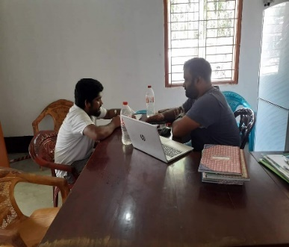
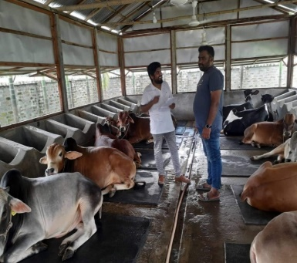
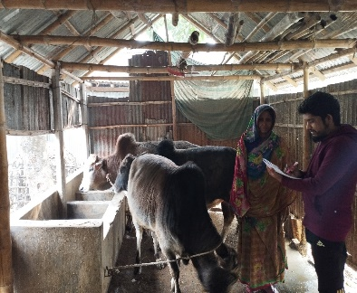

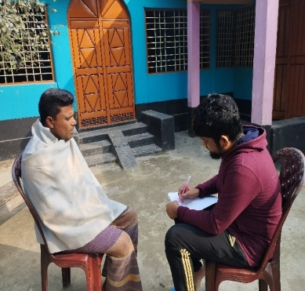
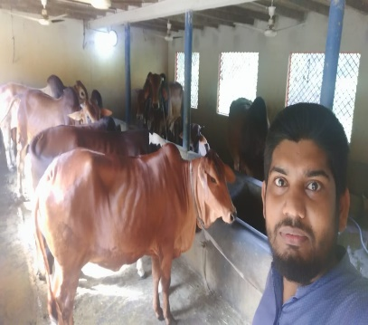
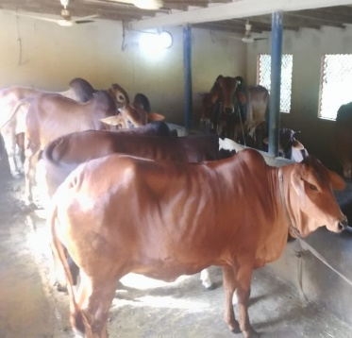

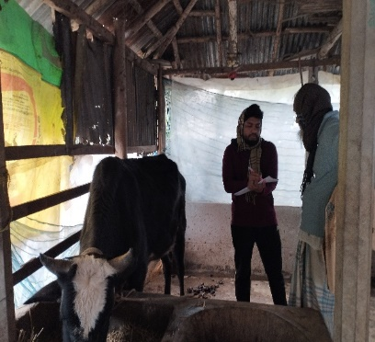
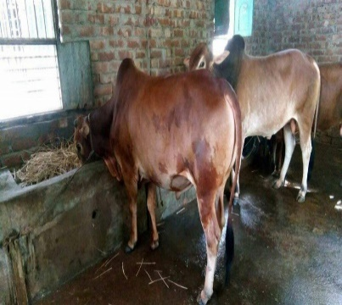
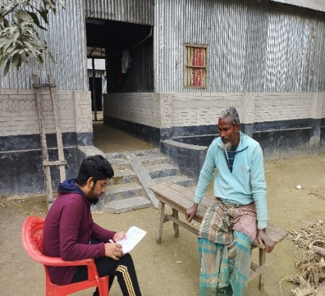

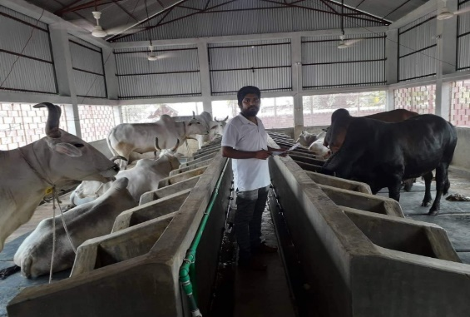
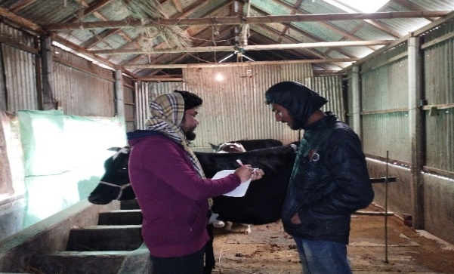

Figure 4 Pictorial view of data collection

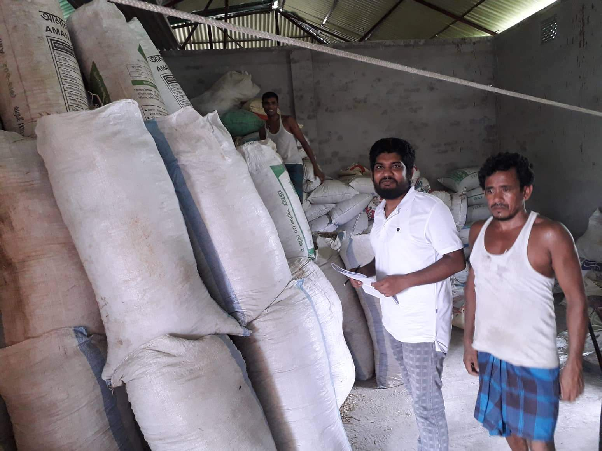
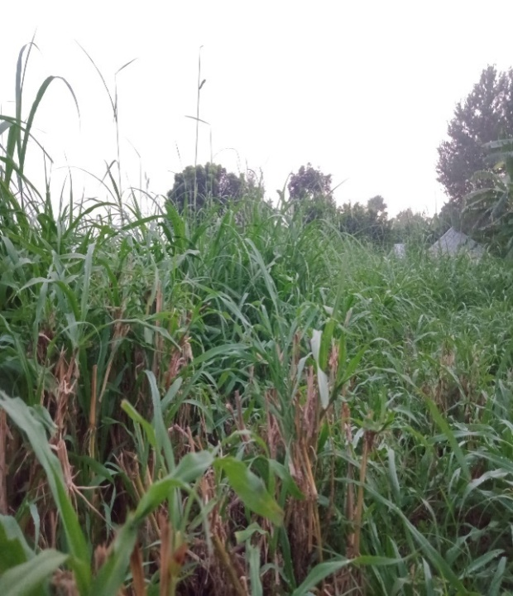
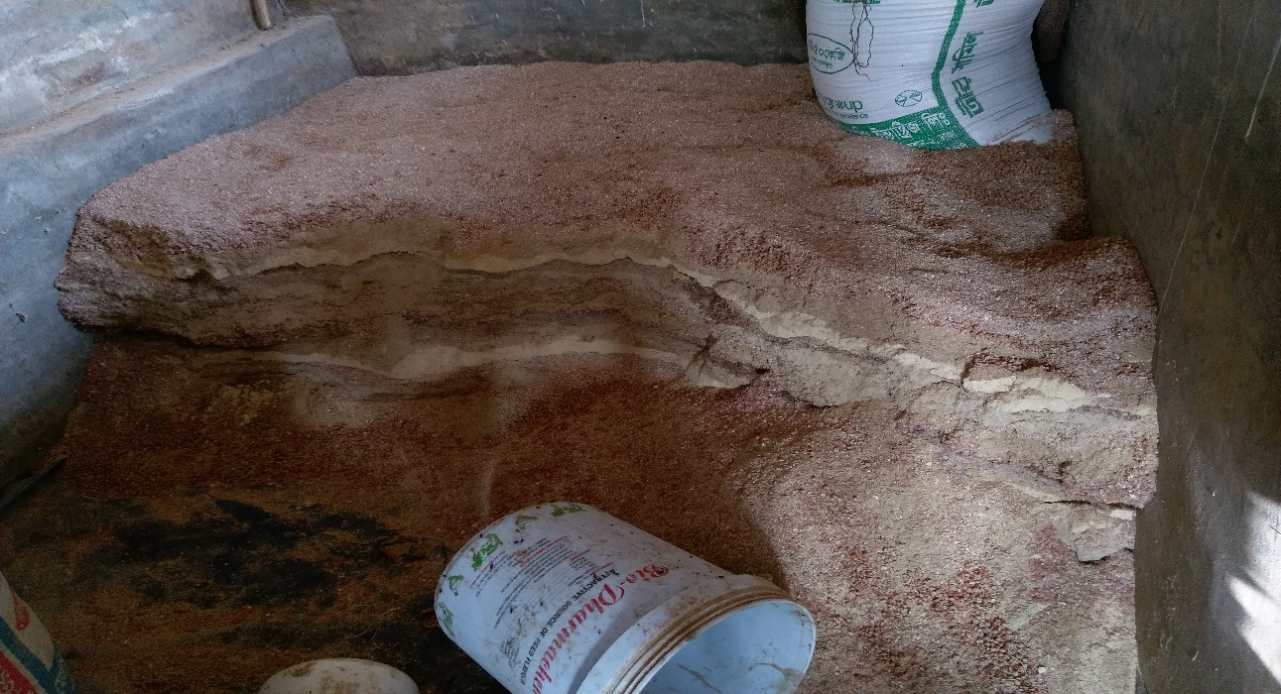
Figure 5 Roughage and concentrate for fattened cattle
APPENDIX II
FARM ID NO.:---------------

Questionnaire for beef fattening Study

Title of the Study: “A SOCIO-ECONOMIC STUDY ON BEEF FATTENING FARMING SYSTEM AT SOME SELECTED AREAS OF KURIGRAM DISTRICT”

- Farmer’s Brief:

- Name of farm owner: Address: Mobile no:

- Educational Status: Illiterate: Primary: Secondary: Higher Secondary: BA or Above

- Occupational status:
Main: Subsidiary: Others:

- Per year income level of household members:
Less than Tk. 100,000/= Tk.100001/=-Tk.150,000/= Tk. 150001/=- Tk.200000/=
Above Tk. 200000/=.

- Age distribution of the Farm owners:
Less than 20 years 21-30 Years 31-40 Years Above 40 Years

- Training of cattle fattening: Yes No. If yes than where you got training? .Duration of training:

- Type of Farm: Traditional: Scientific way: Others (Specify):

- What type of house you use? Rented : Owned:
- No of cattle for fattening: Cattle less than 5 Cattle 6-10 Above 10 cattle

- Type of cattle breed : Local: Cross-breed: Pabna cattle:
Others (specify)

- Fattening period: Less than 5 years: 5-10 years: Above 10 years:

- Sex of animal: Male: Female:

- Cattle stock description: Calf purchase: Yes: No. If yes than purchase price per calf/cattle: Tk. Approx. Weight:

- If own farm calf then its market price: Tk. Approx. Weight:

- How many days do you rear cattle? Less than 3 month 3 months to 6 months
Above 6 months.

- Farm management /Rearing system (Please mention): Per day labor per cattle (approx.) in minutes/hour: Farm labor per hour wages: Tk.

- What types of feed do you given per cattle per day? Ready feed or Mesh feed: Ready price per Kg.: If adopt mesh then-(a) Roughage: kg and price per kg (approx.): Tk. (b) Concentrate : kg and price per kg:
(c) Vitamin minerals/preservatives/ feed additives (Approx.) if adopted: Tk.

- Source of water (specify) :

- Ration formulation (specify):

- Use of steroid: Yes or No. If yes then what types of steroid you use? Specify:
- Source of Farm operation Fund: Own: Lend: Both:
- If lend than what sources: Bank: NGO Others (Specify):

- Tentative live weight during selling time (Specify): kg.

- Per kg live cattle Selling price (approx.):

- Mention at least 5 major Beef fattening problems:

- How Problems to be overcome? (please mention):

Signature of Enumerator
Brief Bio-data
Nazmul Hossain, the author of this manuscript, was born on 2 June 1994 in the Kurigram district of Bangladesh. He is the son of Alep Uddin and Laizu Begum. He passed Secondary School Certificate (SSC) Examination in 2010 from Anantapur Adarsha High School, Phulbari and Higher Secondary School Certificate (HSC) Examination in 2012 from Rangpur Government College, Rangpur. He obtained his Doctor of Veterinary Medicine (DVM) degree in 2018 from Chattogram Veterinary and Animal Sciences University (CVASU). He did his clinical training in Veterinary Clinical Medicine from Tamil Nadu Veterinary and Animal Sciences University (TANUVAS), India in the year of 2019. Now, he is a candidate for the Master Degree in Agricultural Economics under the Department of Agricultural Economics and Social Sciences, Faculty of Veterinary Medicine, CVASU. The author got NST Fellowship for his MS research.

