Chapter-1: Introduction
1.1 Background:
The ocean covers about 72% of the earth surface. With the largest flooded wetland in the world and Asia's third-highest concentration of aquatic species after China and India, Bangladesh is regarded as one of the world's best places for fishing. With a 710 km-long coastline, Bangladesh is one of the Bay of Bengal's periphery countries. Millions of people's livelihoods and work depend heavily on fish which is the second- most valuable agricultural crop of Bangladesh. Fish culture and consumption thus have significant effects on the economy and availability of food (Ghose, 2014)."Mache Bhate Bangali" or "Fish and Rice Makes a Bengali" is a common nickname for people of Bangladesh. Bangladesh's fishing industry faces both opportunities and difficulties. Since a few decades ago, the economy has been more and more dependent on the fishing industry, one of the most productive and dynamic sectors. Since gaining its independence in 1971, Bangladesh has made impressive advancements in the fishing industry. Its agricultural sector contributes 14.2% of GDP, employing 47% of the working population with 17 million people (1.4 million women) depending on fisheries sector for their livelihoods through fishing, farming, fish handling, and processing (CIA, 2018). Agricultural sector has experienced significant growth over the last couple of decades, with the Bangladesh fisheries sector following suit (WBD, 2017). According to the data from the Yearbook of Fisheries Statistics (2020-21), it adds 3.52% to our country's GDP, more than a quarter (26.37%) to the agricultural GDP and 1.39% to export revenues. The majority (60%) of all animal protein consumed is supplied by this industry (MOFL 2020-21).
The countries vast and diverse fisheries resources can be roughly classified into two categories: inland fisheries and marine fisheries. The two sub-groups of inland fisheries are again designated as inland capture and inland culture. Rivers and estuaries, beels, floodplains, the Sundarbans, and Kaptai Lake are included in the inland capture fisheries. The inland culture fisheries include ponds, seasonal cultured water bodies, baor, shrimp/prawn farms, crab, pen cultures, and cages. Once more, industrial (trawl) and artisanal fishing are included in marine fisheries. With a total production of 46.21 lakh MT in 2020–21, Bangladesh is one of the world's top fish

producing nations. Inland open water (catch) accounts for 28.16% (13.01 lakh MT) and inland closed water (culture) accounts for 57.10% (26.39 lakh MT) of the total fish production. Consequently, inland fisheries account for 85.26% of global fish production. Inland capture and inland culture fisheries have growth rates of 4.23 and 2.12%, respectively. The production of marine fisheries, on the other hand, is 6.81 lakh MT, with a growth rate of 1.51% and a contribution to overall fish production of
14.74 percent. In the year of 2020–21, the global growth rate of fish output is 2.62%. The overall growth performance of inland aquaculture shows a moderate upward trend (MOFL, 2020-21). Fish production has increased nearly six fold over the last 37 years (from 7.54 million MT in 1983-84 to 46.21 million MT in 2019-20). Bangladesh's coastal and marine environment, blessed with a mild tropical climate and abundant rainfall, is rich in nutrients from the land, creating one of the richest and most productive ecosystems in the world (Hossain, 2001; Islam, 2003). Exploration, development and management of bio- and abiotic resources in the Bay of Bengal have the potential to contribute significantly to the economy of Bangladesh. In particular, following the recent 2012 International Tribunal for the Law of the Sea (ITLOS) ruling on the Bangladesh-Myanmar maritime border and the 2014 UNCLOS Court of Arbitration ruling on the India-Bangladesh maritime border, more than 118,813 sqkm people have Sovereignty-established territorial waters and exclusive economic zones (EEZ) of 200 nautical miles (NM) and all kinds of living and non-living resources under the continental shelf from the coast of Chittagong to 354 nautical miles (Ministry of Foreign Affairs, 2014).
In Bangladeshi waters, fish stocks are extracted at the following three levels: (1) Up to a depth of 40 m from the shore where normal fishing vessels operate; (2) Water depths of 40 m to 200 m in which medium water trawlers operate; (3) from 200 m depth to the edge of the EEZ where long liners operate (Islam et. al., 2017). There are only 242 trawlers licensed by the government to fish in these areas (Ministry of Foreign Affairs, 2014). The Bay of Bengal is blessed with a rich coastal and marine ecosystem that hosts a wide variety of species such as fish, shrimp, mollusks, crabs, mammals and algae. Among 511marine organisms inhabit the waters of Bangladesh.

Along with shrimp (Murshed-E- Jahan et. al., 2014) lobster is one of the most attractive and expensive crustaceans on the national and international market. Lobsters are classified into 149 different species worldwide (Holthuis, L.B. 1991). Only four species of crayfish (Panulirus homarus, Panulirus ornatus, Panulirus polyphagus and Panulirus versicolor) and two species of slipper lobster (Thenus orientalis and Scyllarus depressus) have been recorded from Bangladesh (Siddiqui et. al., 2007). Although Scyllarus depressus is a western Atlantic species, it is found in St. Martins Island, the Naf River mouth (Teknaf) and shallow reefs and reefs off the coast of Bangladesh (Siddiqui et. al., 2007). Slipper lobsters, on the other hand, are bottom-dwelling lobsters that prefer sandy or muddy environments and rest in very shallow water. Lobster is more frequently caught in Bangladesh during winter season. Availability and potentiality of lobster fishing in Bangladesh's coastal waters have yet to be determined. Lobster, on the other hand, is primarily caught by shrimp trawlers from the offshore fishing grounds between Elephant Point and St. Martins. They are typically found at depths of 30-50 meters and have salinity levels of 33-36 ppm. Cox's Bazar fishermen caught lobsters with two types of nets. However, of the two types of nets, nylon nets were primarily used to capture lobsters, while rock nets were used to indirectly capture lobsters. Rock nets were mainly used for catching finfish and some lobsters are even caught in the net.
Lobster is an expensive seafood dish that is in high demand in the international market. Unlike the important shellfish and fish alternatives that support commercial fisheries, lobster has the prominence of supporting quality fisheries and sustaining perhaps the highest exchange rate of any seafood export. However, the quantity of lobsters caught globally still accounts for a minor portion of the global production of marine species. Crayfish are a nutritious and valuable marine fishery resource. Due to high domestic and international demand, this resource is heavily exploited in India. From the Indo-West Pacific and East Africa to Japan, Indonesia, and Australia, the crayfish Panulirus homarus is found in large quantities in tropical and subtropical waters (Holthuis, 1991). Lobster is landed on the northwest, southwest and southeast coasts. The use of marine resources for human consumption is increasing rapidly around the world. Overall, seafood, including crustacean shellfish, is highly valued for its health-enhancing properties.

Crustaceans are a valuable source of high-quality proteins and a number of different minerals in terms of nutrition (Leu et. al., 1981; Connor and Lin, 1982; Koenig et. al., 1990; Skonberg and Perkins, 2002; USDA, 2003). From a dietary perspective, biochemical investigations are crucial. It is well known that the biochemical makeup of the edible tissues of marine invertebrates is affected by their food, age, sex, season, and other ecological factors (Oliveira, et. al., 2007; Srilatha, et. al., 2013). Its biochemical content reflects nutritional value. The biochemical makeup of edible species is very significant (Nagabhushanam, et. al., 1978). The percentage composition of the five fundamental components—protein, carbs, fats, ash, and water—is generally indicated by the term "proximate composition."By species, size, sex, age, season, and feeding mode, direct composition varies substantially.
Seafood is a great source of protein since it has all the essential amino acids and is easy to digest; most proteins have a digestibility of over 90% (Hamed, et. al., 2015). Casein, the main milk protein, has Protein Efficiency Ratio (PER) values that are somewhat higher than those of shellfish proteins. (Venugopal, 2005). All of the necessary amino acids are provided by shellfish proteins for the maintenance and growth of the human body (Friedman, 1996). Branch-chain amino acids and taurine, which have positive effects on blood pressure and glucose metabolism, are abundant in shellfish and other seafood (Gerber and Cenée, 1991). As a result, shellfish (Paphia undulata) that was canned in various conditions is regarded as a safe and healthful food for human consumption. Shellfish often has higher protein content than fin fish. Paramyosin, a protein that accounts for up to 19% (w/w) of all the myofibrillar proteins in raw shellfish muscle, is also present in vertebrates (Venugopal and Shahidi, 1996). Lipids are extremely effective energy sources and contain more than twice as much energy as proteins and carbohydrate (Okuzumi and Fujii, 2000). In times of fasting and starvation, lipids can serve as an alternative source of nutrition. Cellular structure and biological processes depend heavily on fats. Lipids are crucial for preserving cellular integrity in crustaceans, serving as both the principal organic reserve and a source of metabolic energy. Generally speaking, lipids serve as a significant dietary reserve and protein, and they may occasionally alter as a result of environmental factors like temperature (Varadharajan and Soundarapandian, 2014).

The amount of water in a sample is determined by its moisture content. The high moisture content is advantageous because it will cause enzymatic reactions. However, having high moisture content might be detrimental since it makes the organism prone to microbial spoilage, increases oxidative destruction of polyunsaturated fatty acids, and subsequently reduces the consistency of fatty acids, shortening the organism's duration in preservation (Omolara and Omotayo, 2009).
Ash is the inorganic residue from the incineration of organic matter. Total ash content is a useful parameter of the nutritional value of lobster. High ash content in shrimps is due to the high level of chitin strengthened by a high level of calcium metal in the exoskeleton.
Chitin is a linear polymer of acetyl D-glucosamine that has properties similar to cellulose in many respects (Donald et. al., 1998). Muscle-based fish often has very little fiber and carbs. Dietary fiber (DF) has the potential to bind heavy metals, hence lowering tissue concentrations and absorption (Hu et. al., 2010). For instance, pectin and hemicellulose have the extraordinary capacity to bind heavy metal complexes, which has some scavenging effects on heavy metals that enter the human body. The coastal lobster species have limited information on their distribution, species composition and their role in direct composition which is more important from a nutritional perspective.
Natural fats and oils are made up of fatty acids. Based on their chemical structure, these are broken down into three categories: polyunsaturated, monounsaturated, and saturated fatty acids. Saturated fats are mostly found in animal products like meat, lard, sausages, cheese, and palm kernels, but they can also be found in frying coconut oil and palm kernels. The majority of unsaturated fatty acids can be found in oily fish. Polyunsaturated fatty acids (PUFAs) fall into two categories: Essential fatty acids include both "omega-3 fatty acids" and "omega-6 fatty acids." It can't be made by humans; it has to come from food or supplements. (Kris-Etherton et. al., 2002).Omega-3 fatty acids belong to the long-chain polyunsaturated fatty acid family, and they are necessary nutrient for growth and health. According to research, EPA (eicosapentaenoic acid) and DHA (docosahexaenoic acid), two of the most beneficial omega-3 fatty acids, have numerous positive effects on human health.

The risk of myocardial infarction is decreased blood pressure (Bucher et. al., 2002) and blood triglyceride levels are decreased (Harris et. al., 1997), the immune system is strengthened (Damsgaard et. al., 2007) and normal brain function is maintained in humans.
In particular, it guards against depression, ADHD, and cancer. It also defends against other psychological conditions (Sinn, 2007). According to Lund et. al., 2000, microbial spoilage is responsible for approximately one third of the world's annual food production and the majority of fresh seafood spoilage is attributed to microbial activity (Dalgaard , 2000). The general processes and changes that occur in fish tissue during handling and storage are well-described. Enzymatic degradation of the entire system is the first step in degradation. As freshness is lost, bacteria start to grow, first slowly and then more quickly, eventually leading to putrefaction and making the tissue unfit for human consumption. A variety of amines, sulfides, alcohols, aldehydes, ketones, and organic acids are produced as a result of microbial spoilage. These have unpleasant and unacceptable off-flavours (Sikorski, et. al., 1990; Gram 1992; Huss 1995; Dalgaard 1995; Fraser and Sumar 1998; Dalgaard 2000; Gram and Dalgaard 2002). In general, bacteria of the genera Vibrio, Photobacterium, Shewanella, Pseudo altheromonas, Moraxella, Acinetobacter and Flavobacterium dominate the flora of temperate sea mussels, while Bacillus, Organisms such as Micrococcus, Lactobacillus, and Corynebacterium have also been found in varying proportions in lobsters (Shewan 1977; Gram and Huss 1996; Dalgaard, et. al., 1993, 1997).
There are many studies on the proximate composition (moisture, ash, fat, crude protein and carbohydrate content) of various seafood. Lobster's nutritional benefits encourage continued consumption. Therefore, the present study is aimed to assess the approximate composition of basic biochemical building blocks such as proteins, lipids, carbohydrates, ash, moisture and fatty acids in order to assess the nutritional importance of lobster.

Objectives of the study:

- To estimate the nutritional constituents of Panulirus polyphagus species.
- To analyze microbial quality of that species.

Chapter -2: Review of Literature

2.1 Lobster Profile:
A family of large marine crustaceans includes lobsters. Lobsters live in crevices or burrows on the ocean floor and have long, muscular bodies. Their first pair of legs which is typically much larger than the others and three of their five pairs of legs all have claws. According to McGill University (2007), lobsters are highly valued seafood that contributes significantly to local economies in the coastal regions they inhabit. Copper, selenium, zinc, phosphorus, vitamin B₁₂, magnesium and vitamin E are abundant in lobsters. In the waters where they live, they are valuable commodities that are also important economically (Freitas, et. al., 2007).

2.2 Biochemical Composition of Lobster:
Lobsters are highly-priced seafood delicacies that are in great demand in international markets. In contrast to alternative vital shellfish and finfish resources that sustain commercial fisheries, lobsters have an excellence of supporting a high-value fishery, generating maybe the highest rates of foreign exchange among all seafood exports. However, the number of lobsters landed worldwide is a very meagre share of the world's marine fish production. Spiny lobsters are nutritionally rich high-value marine fishery resources. Owing to its high demand among domestic also as international market, this resource is heavily fished in India. The Spiny lobsters Panulirus homarus are inhabited wide in tropical and subtropical waters of the Indo-West Pacific region and eastern Africa to Japan, Indonesia, and Australia (Holthuis, 1991). In India, lobsters are landed on the northwest, southwest, and southeast coasts.
When referring to a substance's proximate composition, the terms moisture, ash, fat, protein, and carbohydrate content are typically used, all of which are expressed as content percentages. In lobsters, the preferred feeding methods have an impact on the nearby composition. For instance, spiny lobsters that consume meat need higher protein and fat concentrations (Takeuchi and Murakami, 2007). Goni, et. al., 2001 claim that the European spiny lobster is an omnivorous species that predominantly eats mollusks, crabs, and sea urchins. This could explain why the contemporary spiny lobster specimens have much lower fat, protein, and calorie contents.

Seasons might also play a sizable role in determining the species composition of the area lobsters. It is known that depending on their maturation stage, different lobster species may have different proximate compositions. The proteins that are found in lobsters, which account for approximately 41.2 percent of the protein in lobster head meat (Vieira, et. al., 1995) and 34% of lobster shell protein contains all essential amino acids (EAAs) (Nguyen, et. al., 2016).The protein's nutritional value is greatly increased by the natural fusion of lobster protein with a sizeable amount of the potent antioxidant astaxanthin (295g/g), which results in the protein complex known as carotene protein. According to Tuy, et. al., (1991), lobster shells contained a sizeable amount (16%) of this protein. From literature review it was found that the percentage composition of total protein in P. homarus, P. versicolor, P. ornatus, and P. polyphagus was 22.8%, 23.7%, 22.6% and 21.8%, respectively (Kommuri, et. al., 2021). Due to the polyunsaturated fatty acids (PUFAs), omega-3 fatty acids, and lipid-soluble vitamins that make up LPBs' lipid component, it is a valuable component of LPBs. According to Shahidi (2006), less than 2% of a lobster's body weight is made up of lipids, although in some other areas of the animal, lipid concentrations are substantially greater. One of the lipid-rich lobster body sections is the cephalothorax, a byproduct of the lobster processing industry with varying lipid concentrations depending on habitat, season, and species. The cephalothorax of the Norway lobster has the highest lipid content, at 11.5% in the summer (Albalat, et. al., 2016). Despite the fact that lipids have frequently been demonized, recent research on their impact on human health has generated a great deal of interest in their use and its byproducts. The lipid content of the lobsters was observed to be 2.93% in P. homarus; 3.28% in P. versicolor, 3.53% in
P. ornatus, and 2.75% in P. polyphagus (Kommuri, et. al., 2021). In all seafood items, moisture makes up the majority of the volume and weight. The worth of the goods, their sensory qualities, and their shelf life are all determined by it. To prevent moisture or drip loss during frozen storage and thawing, commercial techniques have developed to add moisture to marine food and keep it there during harvest, processing, and storage. Kommuri, et. al., 2021 revealed 72.7% moisture in P. homarus whereas 75.7% moisture in P. versicolor, 76.7% moisture in P. ornatus and 74.3% moisture in P. polyphagus.

Drying or dehydration removes active water and stops microorganism‘s growth. It also reduces rate of enzyme activity and chemical reactions. While drying, there is moisture loss, and protein and other substances tend to be concentrated and products become hard (Aurand, et. al., 1987). During drying moisture content and water activity are reduced. Ash is acknowledged as a significant fish food source of nutrients. The range of ash content that was observed suggested that the species that were investigated are a good source of minerals like calcium, potassium, zinc, iron, and magnesium. It was noticed that the ash content was very low in all and ranges between 1.47% and 1.67% respectively. The non digestible form of carbohydrates is fiber. Although fiber is important for digestion in small amounts, it shouldn't be consumed in excess. Herbivorous fish need to consume between 5 and 10% fiber to stay healthy.

Fatty Acids in Lobster:
Additionally, crustacean oils have a higher bioavailability than fish oils (Köhler et. al., 2015) they are ideal for use as an oil supplement or as a novel and healthy food ingredient (Tetens, 2009). Due to the fact that fish liver oils are frequently regarded as a significant source of vitamins A and D that possess a variety of therapeutic properties (Gunstone 2006 ; Nguyen 2017; Rizliya and Mendis, 2014). Due to its notable abundance of astaxanthin, PUFAs, and ω-3 fatty acids, lobster oil was suggested as a dietary supplement (Nguyen, 2017). Additionally, the unique and inherent capacity of oils to absorb and preserve flavors, combined with the potent distinct flavors of lobster liver oil, presents a promising application for the flavor industry. Lobster lipids were investigated for this purpose in order to produce infused lobster oil, salt plated with lobster flavors, and lobster seasoning. Numerous studies have shown that eating fish and shellfish helps maintain healthy cholesterol levels and reduces the risk of obesity, diabetes, and heart disease. Omega-3 fatty acids, which are only found in a small number of foods, are especially important and should be obtained from shellfish and fish, like lobster. 200 to 500 milligrams of Omega-3 are thought to be present in a three ounce serving of spiny lobster. In comparison, an American lobster portion of the same size offers 200 mg. Lobster is a significant source of fatty acids, despite not having the highest concentration among fish and shellfish.

According to Simopoulos (1991), seafood is generally a good source of n-3 essential fatty acids. Fatty acids provide protection against a number of diseases, including. g. cancer, inflammatory diseases, and ischemic heart disease, among others (Horrocks and Yeo, 1999 ; Leaf and Simopoulos, 1999). The lobster is one of the best sources of n-3 essential fatty acids due to its high fatty acid content. The lobster might be useful in supplying modern diets with n-3 fatty acids since most modern diets are deficient in them.

Microorganisms Present in Lobster:
Microbial and biochemical processes are to blame for the rapid loss of lobster quality and freshness. The odor of these products is impacted by the production of microbial metabolites as a result of microbial growth (Gram and Huss, 1996). While the color of a crustacean's shell is lost due to enzymatic browning, the activity of autolytic enzymes in the muscle after death alters a variety of things during preservation (Ashie, et. al, 1996). On the other hand, the fundamental process of deterioration is the metabolism of spoilage microbes, which results in offensive odors (Dainty, 1996; Gram & Huss, 1996). Specific Spoilage Organisms (SSOs), a bacterial genus or species that is typically responsible for the chemical alterations that result in seafood rejection (Gram & Huss, 1996; Gram & Dalgaard, 2002). The microbial communities that contribute to the rotting of seafood are constantly changing and interacting (Gram & Dalgaard, 2002). The storage conditions and the harvesting location affect the SSOs and, in turn, the metabolites that are created (Drosinos & Nychas, 1998; Gram & Dalgaard, 2002). Shewanella putrefaciens and Pseudomonas sp. are contaminating fish from temperate waters that are aerobically maintained at low temperatures (Gram & Huss, 1996; Koutsoumanis and Nychas, 1999; Koutsoumanis, et. al., 2000). The bacteria, fungi, viruses, and yeast that can be found in the gastrointestinal tract of aquatic species (Egerton, et. al., 2018). Pseudomonas, Flavobacterium, Micrococcus, Staphylococcus, and Corynebacterium followed Vibrio, as was to be expected. In addition, Flavobacterium and Micrococcus have recently been discovered in the spiny lobsters gut. Under obligate anaerobic and facultative anaerobic conditions, the bacteria Streptococcus was also successfully isolated from the spiny lobsters gut (Ueda, et. al., 1995).

Pseudomonas aeruginosa was the predominant bacterial species in the spiny lobster intestine, followed by Vibrio parahaemolyticus, Bacillus circulans, Escherichia coli, Photobacterium damselae, Flavobacterium columnar, and Micrococcus luteus (Bourne, et. al., 2004 ; Daniels, et. al., 2010).

Chapter-3: Materials and Methods

3.1 Collection of lobster:
Lobsters (Panulirus polyphagus) were collected from local market of three (03) different areas located at Cox‘s Bazar namely Doriyanagor, Nazirar tek and Shamlapur during winter season. Samples from different market Then the lobsters were carried out to the laboratory with proper icing and packaging. Sampling area is located here:
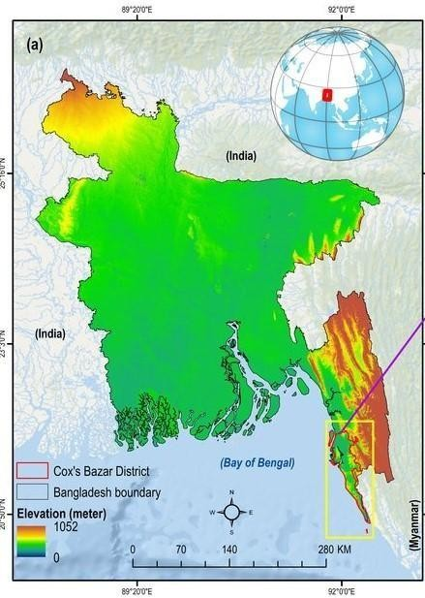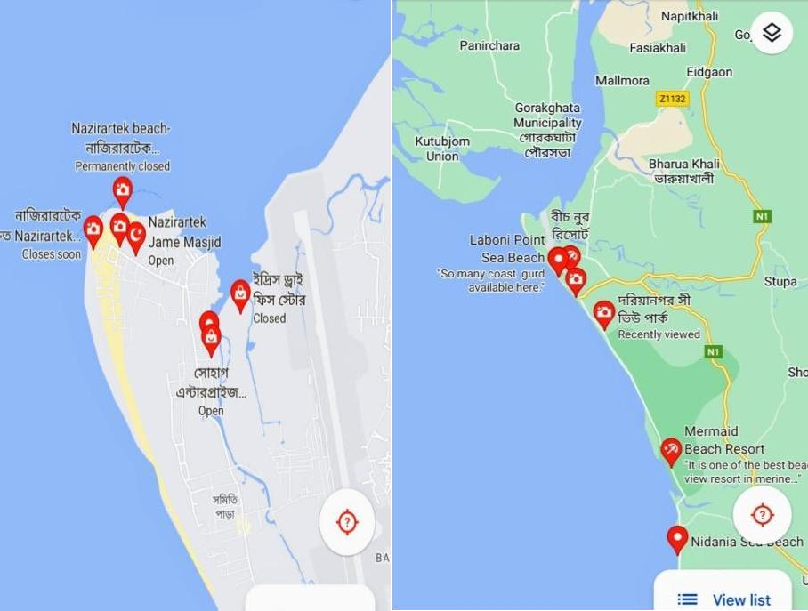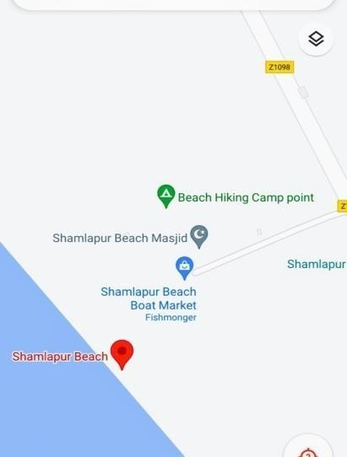

Figure 1: Map of sampling area

  - Biochemical Analysis:

3.2.1 Protein determination:
Protein is determined by micro kjeldahl apparatus which is consisted into two parts: digestion compact system (DK 20/26, VELP scientific) and distillation system (Model: UDK 129, VELP scientific). At first, samples from lobster muscles were ground into small pieces and 0.3g was taken in the digestion tube. In that tube, 4g catalyst and 5ml conc. H₂SO₄ were added which were placed in the digestion unit for digesting into 30 minutes. Then, those digestion tubes were cooled down at room temperature for 30 minutes and 25 ml distilled water were also added into them. In the conical flask of distillation unit 10ml mixed indicator were taken, then 25ml NaOH (white pipe) and distilled water (black pipe) were taken in below of distillation unit. Finally, the samples were titrated with 0.2N HCL. Here, nitrogen content is determined using automated kjeldahl apparatus. The nitrogen content is multiplied by a 6.25 conversion factor to determine the total protein content.

Formula of determination of protein:

Percent (%) of N= ml of titrant × strength of HCL 0.2N × equivalentof nitrogen (0.014) ×100 Percent (%) of Protein = Percent (%) of N × 6.25
weight of sample

Lipid determination:
Lipid is determined by Soxhlet apparatus (Model: RD 40, Food ALYT). The samples from lobster muscle were ground into small pieces and the empty beaker was sterilized into hot air oven. Chiller 1 and chiller 2 were switched on and when the temperature would get below 12ºC, it started to work. Empty beaker was weighted and the beaker was marked. Then a 2g sample was taken and placed on a foil-lined thimble paper, which was then placed beneath the magnetic holder by a magnetic ring and raised. In the designated beaker, 70ml of diethyl ether was taken, and the stopcock was opened vertically while the beaker was screwed with solvent underneath the condenser. The extraction beaker was placed in the burner by lifting the lever handle as the thimble was lowered into the beaker. The thimbles were then lifted up after boiling at 100⁰C for 20 minutes. The reflux stop-cork was sealed after 20 minutes. It took 10-15 minutes for the solvent to evaporate.

It was then turned off by raising the lever, and the extraction beaker was removed. It was then placed in a hot air oven set at 105⁰C for 30 minutes, cooled at desiccators, and finally weighted.

Formula of determination of lipid:

Percent (%) of Lipid = weight of lipid × 100 %
weight of sample

Moisture determination:
Determining moisture content is a crucial aspect of material quality and, in most production and laboratory facilities, is essentially a function of quality control. Here, determination of moisture content was done by Laboratory Drying Oven (Model: BINDER, ED 115). The sample was ground into small pieces and the empty crucibles were sterilized into hot air oven. The empty crucibles were cooled down and weights of empty crucibles were taken. Then 3g sample was put into crucible and placed it into the chamber of hot air oven for 12 hours (overnight) at 105ºC. After that time, the samples were kept into desiccators up to cooling and took the final weight of sample with crucible.

Formula of determination of moisture:

Percent (%) of Moisture = weight of wet material −weight of dry material
weight of wet material
× 100%

Ash determination:
To determine the amount of inorganic matter that is still present after burning organic material is the ash determination principle. Two stages of heating are used: first, to completely char the sample and remove any remaining water; secondly, to assess it at 550º C in a muffle furnace. All food-related materials can be prepared using this method. Here, determination of ash is done by Muffle Furnace (Model: LHMF 100A, LABNICS Equipment).The sample was ground into small pieces and the empty crucibles were sterilized into hot air oven. The empty crucibles were cooled down and weights of empty crucibles were taken. Then 3g sample was put into crucible and placed it into the chamber of muffle furnace for 5 hours at 550ºC. After that time, the samples were kept into desiccators up to cooling and took the final weight of sample with crucible.

Formula of determination of ash:

Percent (%) of Ash = Ash weight × 100%
Sample we ight

Fibre determination:
Fibre was determined by Raw Fibre Extractor (Model: F1WE3, VELP scientifica). Here, the weights of empty crucibles were measured and 1g sample was taken into the crucible denoted by F_{o.} Then the crucibles were set with the fibre analyzer and each sample was boiled using 150ml H₂SO₄ (1.25%) for 30 minutes. Following cooling, each sample was cleaned three times with 30 ml of hot, distilled water, and then twice with 150 ml of 1 point 25 percent NaOH. Similar to this, each sample was boiled three times in 30ml of hot, distilled water after it had cooled for a short while. The sample was then washed three times in the condenser chamber with 25ml of acetone and once with 30ml of regular distilled water. The sample was heated to 105° C in a hot air oven for 1 hour, and the crucibles were then cooled in desiccators. The sample was then weighted as F1 and heated for three hours at 550°C in the muffle furnace. The crucibles were subsequently cooled down once more in the desecrator for 30 minutes, and the final weight was determined to be F2.

Formula of determination of fibre:

Fibre Content Percent (%) = F1−F2 × 100%
F0

F₁ = weight of sample with ash residue

F₂ = weight of crucible with dry residue F₀= weight of sample

Fatty acid Analysis:
Fatty acids were determined by ―Two-Steps trans esterification (2TE)‖ method after slight modification according to Griffiths et al. (2010). At first, lipid was extracted by digital Soxhlet Apparatus (Food Alytrd40) after mixing 70 ml diethyl ether into 500mg dry lobster powder. After extraction, solvent was removed at 60⁰C by Hot Air Oven. 1.5ml methanolic NaOH was added into lipid extract and mixed at 80⁰C by sonicator for 5 minutes. After cooling at room temperature, 2ml methanol were added into the mixer and sonicated for 30 minutes at 80⁰C. After cooling tubes at room temperature, 1 ml iso- octane and 5 ml saturated NaCI was mixed through well shaking. The fatty acid methyl esters (FAMEs) containing upper organic layer was transferred to a new tube and
1 ml sample was taken into vial for analysis of fatty acid methyl esters by Gas Chromatography Mass Spectrophotometry (GC-2020Plus, Shimadzu, Japan). FAME was separated using a capillary column with the following specifications: length 30 m, internal diameter 0.25 mm, flim thickness 0.15 µm, phase ratio 250 was used to separate FAME. With a flow rate of 1 point 42 ml/min, helium (He) was used as the carrier gas. The temperature program for the column was as follows: 180⁰C to 280⁰C at 50C/min, held at 280⁰C, and FAMEs were identified (FAME mix C8-C24; Sigma-Aldrich; Germany) by comparing retention time to a standard.

.0 Microbial Analysis
3.4.1 Total Plate Count
      - Media preparation:
A popular microbiological growth medium called Plate Count Agar is used to measure or keep track of the total or viable bacterial growth of a sample. Firstly, all the glass-ware was sterilized by covering aluminium foil paper in hot air oven at the temperature of 180ºC for 1.30 hours. The glass-ware sterilized included test tube with screw cap, test tube (for serial dilution - 5 pieces), petridish, glass rod (L-shaped), beaker, test tube holder. Then the media was prepared through taking exactly 23.5 gm of agar (plate count agar, Hi media) and mixed with 1000 ml of distilled water and boiled to dissolve the ingredients completely. The media was then sterilized in an autoclave (DAIHAN) by applying 15 Ibs/inch² of pressure for 15 minutes at 121°C. Then, using a biosafety cabinet (ESCO, Class II, BSC), the sterilized agar was put into the previously sterilized

petri dishes. After solidification of agar media petri-dishes were placed in incubator (Nuve, FN 055) at 37°C for 24 hours at inverted position. Triplet replications were done for each type of sample.

3.4.1.2 Serial dilution and sample inoculation:
Consecutive decimal dilution technique was used in the TPC method. Stock solution of sample was prepared through taking 9 ml of 0.85% physiological saline and 1 gm of sample and blending for 3 minutes. Then 5 test tubes were selected which contain 9 ml of distilled water. Then 1 ml of stock solution was transferred to 1st test tube.
In this way 10⁻ ¹, 10⁻², 10⁻³, 10⁻⁴, 10⁻⁵ decimal dilutions were prepared. Then 1ml of sample from 10⁻³, 10⁻ ⁴ and 10⁻⁵ dilution were pipette into pre-prepared agar plate. The sample was spreaded in agar plate by using L shaped glass rods. The petri-dishes were incubated at 37°C for 24 to 48 hours. After incubation, counted the colonies through colony counter (KMC-1300V) and petri-dishes which had a range 30 to 300 colonies were accepted. There is sufficient evidence that 10⁻¹ and 10⁻² dilution contain more than 300 colonies, for the reasons two dilutions were not usually used in the total plate count method (Collins and Lyne, 1984). The total bacterial colony was determined by following formula:
Colony forming unit (CFU/g) = Number of colonies ×dilution factor ×10
weight g of sample

3.4.1.3 Determination of Escherichia coli (E. coli)
The absence of E. coli indicates the food safety of the human. Both Mac-conkey‘s (Hi media) agar and EMB (Eosin methylene blue agar) are used to determine E. coli in raw and smoked fish.

By using Mac-conkey agar Media preparation
Exactly 51.53 g of agar were used to create the media, which was then combined with 1000 ml of distilled water and boiled while being stirred in a heater to completely dissolve the ingredients. The media was then autoclaved for 15 minutes at 121°C and 15 Ibs/inch² pressure to sterilize it. Then the sterilized agar was placed in the previously sterilized petri-dishes under biological safety cabinet (JSCB-1200SB) and kept two replications for each dilution. After solidification of agar media petri-dishes were placed

in incubator at 37°C for 24-48 hours at inverted position. E. coli mac-conkey agar was determined in these samples by following steps:
Stock solution was prepared of these samples and consecutive decimal dilution was performed to make the sample tenfold dilution. In this way 10⁻¹, 10⁻², 10⁻³, 10⁻⁴, 10⁻⁵ decimal dilutions were prepared. From these dilution tubes sample was inoculated in the prepared agar plate and spread the sample by using inoculating loop. Then petri-dishes were incubated at 37°C for 24 to 48 hours. In the Mac-conkey‘s agar plate, E. coli gives pink color colonies.

By using EMB (Eosin methylene blue) agar:
EMB agar, a commercial preparation used to isolate fecal coliforms, is a selective and differential medium. It was used to check for E. coli in these samples.

Media preparation
The media was prepared through taking exactly35.96gEMB agar and was suspended
In 1000mL distilled water and then it was heated to boil. Then, the medium was autoclaved at 121 °C for 15 minutes under 15 lb/inch2 pressure, cooled to 45 °C or lower, and shaken to oxidize the methylene blue and restore its blue color.
After that the media was poured into sterile petridish and incubated at 37ºC for 24hours to ensure the contamination. The contaminated plate was avoided and sample was taken in uncontaminated petridish up to 10⁻⁵ by keeping two replications for each dilution and again plates were kept in incubator at 37ºC for24 hours. In EMB agar, E. coli gives a distinctive metallic green sheen.
      - Salmonella determination:
The presence of Salmonella in raw and smoked fishes was determined by using XLD (Xylose-lysine-deoxycholate) agar and SS (Salmonella Shigella) agar media.

By using XLD (Xylose-lysine-deoxycholate) agar Media preparation
XLD (Xylose-lysine-deoxycholate, Hi media) agar was used for the determination of Salmonella in these samples. Exactly 56.68 gm of agar was mixed with 1000 ml of distilled water. Then the agar media was heated with frequently agitation by using hot plate. The media was not autoclaved or overheated. After boiling, the agar media was transferred to water bath at 45-50°C for 2 minutes. Sterilized petri dishes held the media.

Petri dishes were inverted in an incubator at 37°C for 24-48 hours after the agar media had solidified. Then consecutive decimal dilution method was performed to make the sample tenfold dilution. In this way 10⁻¹, 10⁻², 10⁻³, 10⁻⁴, 10⁻⁵ decimal dilutions were prepared. Samples were inoculated from tubes and spread the sample by using inoculating loop. Then petri-dishes were incubated at 37°C for 24 to 48 hours. Salmonella gives red colonies with black center in the XLD agar media.

- By using SS (Salmonella Shigella) agar media:
Around 63.02g of SS agar (Hi media) was suspended in 1000 mL of distilled water for the detection of Salmonella and heated the medium until boiling with frequent agitation by using magnetic stirrer. Then after cooling at the temperature of 45-50°C, the medium was poured in sterile plates. Then consecutive decimal dilution technique was done up to 10-5dilution by keeping two replications for each dilution and again plates were kept in incubator at 37ºC for24 hours. In SS agar, Salmonella gives colour less colonies with black centers.

Statistical Analysis:
MS Excel was used to calculate the means, standard deviations, and standard errors of the data, which were then presented as mean and standard deviation throughout the text. All statistical evaluations of proximate composition, fatty acid content, and microbiological analysis were done with IBM SPSS (v. Software 26.0). The collected data were analyzed by using ANOVA (a one-way analysis of variance). Tukey's tests were employed to look for differences between the various areas that were statistically significant at the 95 percent confidence interval. It was also possible to distinguish between the various areas using a post-hoc analysis.

Chapter-4: Results

4.1.0 Biochemical composition of mud spiny lobster:
    - Proximate Composition:
    - Protein determination:
The percentage mean protein content of lobsters of three different areas is presented in table 1. From the results the protein content of all three different areas lobsters are ranged from 20.41 to 22.16%. The highest protein content was recorded at Nazirar Tek (22.16%), followed by Shamlapur (21.39%) and the lowest in lobsters of Dorianogor (20.41%).
Protein Content
25
22.16
20.41
21.39
20
15
10
Dorianogor
Nazirar tek Shamlapur
5
0
Dorianogor
Nazirar tek
Shamlapur
Percentage

Figure 2: Percentage of Protein in three different areas.

      - Lipid determination:
The amount of lipid in lobsters from Dorianogor, Nazirar tek and Shamlapur are shown in table 2. Here, lobsters of Dorianogor have the highest lipid content (2.81%) whereas Nazirar tek has the least amount of lipid (2.66%).
3
2.81
Lipid Content
2.66
2.71
2.5
2
1.5

1
Dorianogor Nazirar tek
Shamlapur
0.5
0
Dorianogor
Nazirar tek
Shamlapur

Figure 3: Percentage of Lipid in three different areas
      - Ash Determination:
Ash content determination of lobster in three different areas of cox‘s bazaar was analyzed. Highest amount of ash were found in shamlapur areas which is 1.92 %. Lobster of nazirartek areas contains least amount of ash, 1.90 %. Results were shown in table 3.

Ash Content
2.5
1.91
1.9
1.92
2

1.5

1
Dorianogor Nazirar tek
Shamlapur
0.5

0
Dorianogor
Nazirar tek
Shamlapur

Figure 4: Percentage of ash in three different areas.

      - Moisture Determination:
The results reveals higher amount of moisture content in all the three areas than other parameters ranging from 69.73% to 71.65 %. The highest amount of moisture is found at Dorianogor, followed by Nazirar tek and the least amount is observed at Shamlapur.
100
Moisture Content
80
71.65
70.91
69.73
60

40

20
Dorianogor Nazirar tek
Shamlapur
0
Dorianogor
Nazirar tek
Shamlapur

Figure 5: Percentage of moisture in three different areas.

      - Fibre Determination:
Fibre content is noticed the highest (3.98%) amount at Dorianogor followed by Nazirar tek and Shamlapur which represents same amount (3.97%) and the values are significantly different here which are resulted from one way ANOVA test.
Fibre Content
5
4
3
2
1
0
3.98
3.97
3.97
Dorianogor Nazirar tek
Shamlapur
Dorianogor Nazirar tek Shamlapur

Figure 6: Percentage of fibre in three different areas.

      - Proximate composition comparison:
The proximate composition of the collected lobster in three different areas has been estimated and listed in table and their graphical presentation is shown in figure 8. From the present investigation it is evident that the muscle tissue of lobster contains a significant amount of nutrients like moisture, protein, fat, ash and fiber. From the table-6, protein content was found within 20.41% to 22.16% ranges in lobsters of three different stations. Then lipid content was observed from 2.66% to 2.81% ranges which were comparatively low. It was noticed that ash content is very low in all and almost 1.90% in amount in all the three areas. The dominance of moisture content ranges from 69.73% to 71.65% was recorded. Furthermore, 3.97% to 3.98% fibre content was determined in lobsters of those three areas.

Table 6: Proximate composition of lobster in three different areas

Parameter | Dorianogor | Nazirartek | Shamlapur
Protein | 20.41ª ±0.58 | 22.16 ª ±0.56 | 21.39 ª ±1.47
Lipid | 2.81 ª ±0.15 | 2.66 ª ±0.12 | 2.71 ª ±0.02
Ash | 1.91 ª ±0.005 | 1.90 ª ±0.015 | 1.92 ª ±0.02
Moisture | 71.65 ª ±1.25 | 70.91 ª ±0.08 | 69.73 ª ±0.09
Fibre | 3.98 ª ±0.005 | 3.97 ª ±0.005 | 3.97 ª ±0.005
Similar superscript represent no significant difference (P>0.05) between means while different superscript represent significant difference (P<0.05) between means Vertical bar=±SD
80

70

60

50

40

30

20
Dorianogor
Nazirar tek Shamlapur
10

0

Dorianogor Nazirar tek
Shamlapur
Protein
20.41
22.16
21.39
Lipid
2.81
2.66
2.71
Ash
1.91
1.9
1.92
Moisture
71.65
70.91
69.73
Fibre
3.98
3.97
3.97

Figure 7: Proximate analysis of lobster in three areas

    - Fatty Acid Content of Lobster:
In fatty acid GCMS analysis, Methyl Tridecanoate is found highest (96.12%) amount in Dorianogor whereas lobsters of Nazirar tek and Shamlapur have least in amount 0.55% and 0.19% respectively. Nazirartek has Methyl Eirocate highest (94.30%) in amount followed by Shamlapur (64.54%) and lowest (15.64 %) at Dorianogor. Methyl Linoleate is highly found at Shamlapur (79.44%) comparatively Dorianogor (48.93%) and Nazirar tek (39.49%). Methyl Tricosanoate and Methyl Lignocerate are not detected at all the three areas.

Table 7: Fatty acid analysis of lobster

List of Fatty Acid | Dorianagor | Nazirartek | Shamlapur
Saturated Fatty acid
Methyl Octanoate | 0.034±0.004 | 0.033±0.0005 | 0.023±0.001
Methyl Decanoate | 0.021±0.001 | 0.046±0.002 | 0.010±0.000
Methyl Laurate | 51.79±89.06 | 0.55±0.008 | 0.19±0.13
Methyl Tridecanoate | 96.12±5.16 | 0.55±0.008 | 0.19±0.13
Methyl Myristate | 18.6±4.93 | 0.46±0.074 | 0.209±0.008
Methyl Palmitate | 1.61±0.34 | 5.95±6.38 | 24.34±0.89
Methyl Stearate | 1.01±1.24 | 0.79±0.15 | 3.56±0.51
Methyl Heptadecanoate | 10.84±7.96 | 6.74±1.17 | 5.03±0.043
Methyl Heneicosanoate | 7.26±8.17 | 1.16±1.94 | 15.98±13.48
Methyl behenate | 3.77±0.29 | 1.336±0.002 | 0.676±0.036
Mono unsaturated fatty acid
Methyl Palmitpleate | 7.51±0.964 | 11.35±12.33 | 23.0±10.90
Methyl Oleate | 50.29±4.79 | 8.31±0.68 | 1.12±0.023
Methyl Eicosapaennoate | 0.41±0.55 | 0.012±0.005 | 0.007±0.002
Methyl Eirocate | 15.64±17.79 | 94.30±76.57 | 64.54±90.04
Methyl Nervonate | 0.03±0.021 | 0.012±0.004 | 0.032±0.27
Poly unsaturated fatty acid
Methyl Linoleate | 48.93±31.79 | 39.49±7.48 | 79.44±49.72
Methyl Linolenate | 0.33±0.26 | 4.94±1.18 | 2.94±0.56
Methyl 11-Eicosenponoate | 15.42±13.34 | 0.078±0.071 | 0.065±0.034
Methyl Arachidate | 1.18±0.52 | 5.62±2.64 | 10.35±6.65
Methyl Arachidonate | 1.84±0.43 | 0.03±0.012 | 0.007±0.004
Methyl Docosapentaenoate | 0.017±0.009 | 0.03±0.0125 | 0.005±0.002
Methyl Eicosatrienoate | 5.49±4.44 | 6.41±1.32 | 6.97±5.96
Methyl Docosahexanoate | 0.33±0.31 | 1.41±1.17 | 0.73±0.14

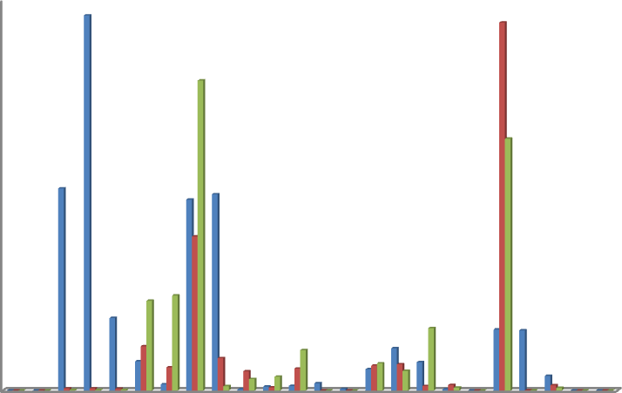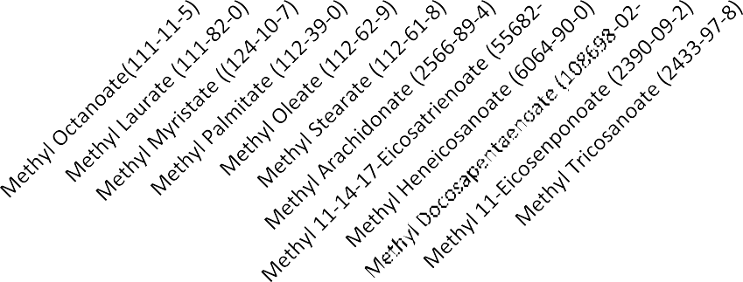
100
90
80
70
60
50
40
30
20
10
0
Doriya nagor Nazirartek
Shamlapur

Figure 8: Percentage of fatty acids in three different areas.

    - Microbiological Assessment of Lobster:
The microbiological quality assessment of lobster from three different places namely Dorianogor, Nazirar tek and Shamlapur were based on Total Plate Count (TPC) of bacteria and determination of presence of Escherichia coli and Salmonella sp. This analysis was done to determine microbiological quality of lobsters and results have been showed in table 10. It showed that microbial load in lobsters of Dorianogor, Nazirar tek and Shamlapur which were (4.60×10⁶), (6.23×10⁶) and (4.77 ×10⁶) respectively. Escherichia coli and Salmonella sp. were absent in lobsters of those places.

Table 8: Microbiological quality of Panulirus polyphagus

Area | Total Plate Count (cfu/g) | Escherichia coli |  | Salmonella sp.
 |  | XLD Agar | SS Agar | Mac Conkey Agar | EMB Agar
Dorianogor | (4.60 ± 0.46×10⁶ )ª | Negative (-) | Negative (-) | Negative (-) | Negative (-)
Nazirar tek | (6.23 ± 0.65×10⁶ )^{b} | Negative (-) | Negative (-) | Negative (-) | Negative (-)
Shamlapur | (4.77 ± 0.65×10⁶ )^{ab} | Negative (-) | Negative (-) | Negative (-) | Negative (-)
Similar superscript represent no significant difference (P>0.05) between means while different superscript represent significant difference (P<0.05) between means Vertical bar=±SD

Chapter-5: Discussion

Proximate Composition Analysis of Lobster:

Protein is a crustacean's most important biomolecule from eggs to adulthood and is notably more prevalent in the early phases (Varadharajan and Soundarapandian, 2014). The biochemical makeup of an organism, which is typically thought to reflect the nutritional quality of the organism, can be influenced by biotic and abiotic factors including the season, the size of the animal, the food, the temperature, and the stage in the life cycle. The group of animals known as crustaceans contributes significantly to the food chain's cycle due to their widespread human consumption. Several crustaceans are suggested for human consumption as food due to their delicious nature, high protein content, and good amino acid composition (Banu, et. al., 2016).
All living cells primarily consist of protein for structural and functional purposes. It supplies the body with roughly 10 to 15 percent of the dietary energy needed for growth and repair. The consumption of diets high in protein provides more than enough amino acids, with the excess being used for energy purposes. Crustaceans are a good source of animal protein. It is well known that lobster is a fantastic source of protein and other nutrients needed to maintain a healthy body. Merline, and Dr. Chitra, 2020 conducted a research on proximate composition of lobster, where 18.3% protein were observed that was almost similar to present findings, Dorianogor contains 20.41% protein, Nazirartek and Shamlapur has 20.16% and 21.39%, respectively. They are, therefore, highly recommended as a good protein source more preferable to red meat. Lobsters are carnivorus in nature and as such they contain high amounts of protein due to their feeding habit.
The biological and structural processes of cells depend on lipids. Lipids play crucial roles in maintaining cellular integrity as well as serving as the main organic reserve and source of metabolic energy in crustaceans. In general, lipids serve as a major food reserve alongside protein and can fluctuate from time to time as a result of environmental factors like temperature (Varadharajan and Soundarapandian, 2014). The structural makeup of their bodies may be the cause of the differences in proximate composition.

Animals skin contains more fat than their carapace does. In times of fasting and starvation, lipids serve as an alternative energy source.
In the current study the amount of lipid percentage of three different areas namely Dorianogor, Nazirar tek and Shamlapur which are 2.81%, 2.66% and 2.71% respectively. The concentrations of lipid content are within the range of previously recorded 2.75% from Kommuri, et. al, 2022. The percentage of moisture in the composition of fish is a good indicator of the relative energy, fat and protein contents (Abemourad and Pourshafi, 2010; Barua, et. al., 2012). Determining the relative amount of moisture content in fish, one can obtain relative estimates of energy and fat contents (Salam, 1994: Jonsson, and Jonsson, 1998)
The indicator of a substance's water content is its moisture content. A reliable measure of the proportional calorie, protein, and fat amounts is the amount of moisture in the lobster's composition. Relationship between muscle moisture content and fat mass (i.e., when moisture was highest, fat content was lowest and vice versa). With increasing size, flesh typically had more fat and less water content (i.e., increasing age). Strong enzymatic reactions can occur when there is a high moisture content present in the environment. High moisture content can be detrimental; too, as it increases the oxidative destruction of polyunsaturated fatty acids, makes fish more prone to microbial spoilage, and ultimately lowers fish quality, which shortens the time the fish can be preserved (Omolara and Omotayo, 2009). The proportion of moisture in lobster varies widely between 65 - 90 % although it is normally in the range of 70- 75% reported by Barua et. al., 2012. The current results support this claim, showing, for Dorianogor, Nazirar Tek, and Shamlapur, respectively, 71.65 percent, 70.91 percent, and 69.73 percent. The amount of body fat a lobster has, which may also be related to the lobster's access to feed, has a significant impact on the differences in moisture content among different lobster species.
One of the least investigated biochemical components in crustaceans is ash content. It is the burned organic material's inorganic byproduct. It is acknowledged as a significant source of nutrients for crustaceans. A good source of minerals like calcium, potassium, zinc, iron, and magnesium, the studied species are indicated by the observed range of ash content. Hassan, 1996, investigated that seasonal variations, age, sex, size, and sexual

maturity, food source and availability in the respective habitat of organisms, as well as other factors like water chemistry, salinity, temperature, and contaminants, may all have an impact on differences in mineral concentration. The result states that mud spiny lobster of three different areas such as Dorianogor, Nazirar tek and Shamlapur contain about 1.91%, 1.90% and 1.92% ash content in the proximate composition respectively. The values obtained for ash content in the present study are similar to the observation made by Kommuri, et.al, 2022 who recorded 1.59 % ash content for Lobster (Panulirus polyphagus). The variation in the body ash content of lobsters can be linked to their nutritional status and the food supply in their specific feeding environment.
The main component of dietary fiber is sugars, which are primarily monosaccharides and disaccharides, and starches, which are polysaccharides, which are converted to glucose in the small intestine and give the body energy (3.75 kcal (16 kj)/g). The amount of lipids and protein increases with decreasing crude fiber content. Carnivores should consume no more than 4% of the recommended daily allowance of fiber because they can't effectively digest it. Accordingly, the result of this study reveals the amount of fibre content of lobsters of three places which are Dorianogor 3.98%, Nazirar tek 3.97% and Shamlapur 3.97%.
Generally, the biochemical composition of the lobster‘s entire body reveals its quality. Therefore, understanding the metabolic composition of fish is useful in a variety of contexts. Because of its unique nutritional advantages, lobster is becoming increasingly popular due to a growing awareness of healthy diets. Therefore, accurate information on biochemical composition is crucial for nutritionists as well as processors to process and preserve seafood products for export as well as other crucial uses in human food, medicine, and other industries. From all the parameters analysed, in the lobster samples of three different places, moisture has the highest concentration followed by protein, fibre, fat and ash respectively. Protein had the highest concentration followed by fat, moisture, carbohydrate, ash and fibre respectively. Results from the present study are in agreement with previous workers Merline and Dr. Chitra, (2020). This information can be harnessed for maximum nutritional benefits of the consumer. The results from this study will aid individuals who consume lobster to make appropriate choice based on their nutritional requirement, particularly dieticians and individuals who are very keen on the

nutritional content of their food. Thus, individuals with ailments requiring definite quantities of particular nutrients can choose eating lobsters that satisfy their nutritional requirements. However, depending on factors like size, sex, feeding, season, and physical conditions, these values can differ significantly within and between species. Considerable variations may also be seen in how these substances are distributed among the bodies various organs and tissues (Weatherly and Grills, 1987).

Fatty Acid Composition Analysis:
It is advised that more analytical research be done, particularly on the lipid compositions of lobster, because such in-depth knowledge of lipid components and their fatty acid constituents is necessary to comprehend how to reduce oxidative or hydrolytic factors that affect lobster quality. Additionally, fatty acids composition is the most reliable way to assess the selectivity of a hydrogenation reaction because it helps identify the types of oils that can produce solid fats for industrial applications (Buckley et al, 1989). The outcome of fatty acid methyl esters (FAMEs) composition analysis with GCMS, where 25 compounds are identified as fatty acid methyl esters consisting of 10 saturated fatty acids, 5 monounsaturated fatty acids, and 10 polyunsaturated fatty acids. Saturated fatty acid namely methyl tridecanoate is found highest (96.12%) amount in Dorianogor whereas lobsters of Nazirar tek and Shamlapur has least in amount 0.55% and 0.19% respectively. Nazirar tek has highest amount of mono unsaturated fatty acid (methyl eirocate) which is 94.30% in amount followed by Shamlapur (64.54%) and lowest (15.64%) at Dorianogor. Poly unsaturated fatty acid (methyl linoleate) is found at Shamlapur (79.44%) which is comparatively higher than Dorianogor (48.93%) and Nazirartek (39.49%). Fatty acids, which naturally occur in the lipids of fish and crustaceans, are the main byproducts of the fatty acid synthetase system (Limam and Sadok, 2014). Shellfish and fish use 16:0 and 18:0 as well as 18:1n-9 as their main sources of b-oxidation and metabolic energy production (Limam, Z. and Sadok, S., 2014). The predominant monounsaturated fatty acid (MUFA) in crustaceans was oleic acid (18:1n-9). Fish and shellfish are able to produce these fatty acids on their own, and they also naturally occur in considerable quantities in aquatic food webs (Limam and Sadok, 2014). Arachidonic acid (20:4n-6), eicosapentaenoic acid (20:5n-3), and

docosahexaenoic acid (22:6n-3) were the most prevalent polyunsaturated fatty acids (PUFA) in the muscle lipids, followed by linoleic acid (18:2n-6). It is well known that these fatty acids, especially n-3 highly unsaturated fatty acids, play an important role in fish and crustacean diets (Rainuzzo, et. al., 1997; Sargent, et.al., 1999), despite the fact that they are essential elements for human nutrition (Simopoulos, 2004).It has been demonstrated that 20:5n-3 and 22:6n-3 are important for growth, molting, and reproduction in crustaceans (Takeuchi and Murakami, 2007; Floreto, et. al., 2000).

Microbial Quality of Lobsters:
Microbiological spoilage, autolytic alterations, chemical oxidation, and organoleptic changes like odor, color, and texture are all indicators of seafood spoilage (Gram & Huss, 1996 ; Ashie, et. al., 1996). Color and smell seem to be the most crucial factors that affect shelf life in crustaceans like lobsters. Due to their sensitive tissues and aqueous habitat, lobsters are very vulnerable to microbial infection. The body and shell of these organisms contain millions of bacteria. When the defensive mechanism fails and the bacteria spread and penetrate the muscle after lobsters die, many of them become potential spoilers. Unhygienic handling, inappropriate storage, physical damage, and contact with unclean water are some of the main causes of the lobsters' low quality in the retail sector. The highest total bacterial load was observed in Nazirar tek which is 6.23×10⁶ CFU/g, followed by lobster of Shamlapur which is observed 4.77×10⁶ CFU/g and the lowest count of total bacterial load was found at Dorianogor which is 4.60×10⁶ CFU/g. As expected, greater loads were identified in the intestines and gills, the most likely sources of contamination, although the overall viable counts in the lobster muscle samples were extremely low, virtually always falling below the level of 6 Log CFU/g (Erica Tirloni, et. al., 2016). Aquatic species' microbiome makeup varies and is unique depending on their environment and feeding patterns.

Chapter-6: Conclusion

Based on the nutritive value of the species derived from the study, lobsters are good protein sources; low in carbohydrate and fat contents.The present study has revealed that lobster contains poly- unsaturated fatty acids which are important for nerve function, blood clotting, and brain health and muscle strength. It is known that low-carb diets are effective methods for losing weight. It is also a fantastic source of polyunsaturated fatty acids, which have been linked to better outcomes in a number of pathological disorders, including some types of cancer and arthritis, and which appear to have therapeutic effects in reducing the risk of cardio- vascular diseases. The present study has revealed that muscle of the spiny lobsters contains a high nutritive value and the great palatability of this species encourages its suitability for being appropriate seafood. The quality of aquatic environment also influenced the physiological and nutritional compositions of these crustaceans. This study has also depicted that the spiny lobsters are ideal diet food and consumption of lobsters may help to prevent nutrition deficiencies in the future. Regarding fishery economics, an increase in consumer demand for these lobsters will cause them to be landed in fresh and preserved form, improving the fishermen's revenue and lowering poverty levels in fishing towns. Lobsters are desirable for the development of fisheries due to their high value and marketability, as well as their straightforward harvesting method, live-storage capacity, and durability provided by the exoskeleton.

Chapter-7: Recommendations and Future Perspectives

The purpose of the study is to determine the proximate composition, fatty acid determination of lobsters of three different areas and analyze their microbial quality (Total plate count of bacteria, presence or absence of Salmonella, Escherichia coli etc). Although a qualitative approach is followed to explore the objective of the research, there are some limitations:
    - Very little research is found on Bangladeshi species of lobster.
    - Seasonal abundance was also a drawback in my research work.

However, there may be some recommendations in this sector, such as:

- Seasonal variation of lobster can be analyzed
- Proximate composition analysis of processed and cooked lobsters products may be significant one
- Barcoding, nucleic acid sequencing of available lobster species in Bangladesh can be executed
- By-product analysis of lobster can be done
- Detailed macro and micro nutrients, minerals of lobsters can be determined
- New hatchery technologies of lobster can be adapted

References
Abemourad A. And Pourshafi K. 2010, Chemical and proximate composition properties of different fish species obtained from Iran, World of fish and marine science, 2, 237-239.
Ajayabhaskar, D., 2002. Nutritional evaluation of molluscan seafood. India: Annamalai University, p.129.
Alabdulkarim, B., Bakeet, Z.A.N. and Arzoo, S., 2012. Role of some functional lipids in preventing diseases and promoting health. Journal of King Saud University- Science, 24(4), pp.319-329.
Albalat, A., Nadler, L.E., Foo, N., Dick, J.R., Watts, A.J., Philp, H., Neil, D.M. and Monroig, O., 2016. Lipid composition of oil extracted from wasted Norway lobster (Nephrops norvegicus) heads and comparison with oil extracted from Antarctic krill (Euphasia superba). Marine Drugs, 14(12), p.219.
Ashie, I.N.A., Smith, J.P., Simpson, B.K. and Haard, N.F., 1996. Spoilage and shelf‐life extension of fresh fish and shellfish. Critical Reviews in Food Science & Nutrition, 36(1-2), pp.87-121.
Aurand, L.W., Woods, A.E. and Wells, M.R., 2017. Food Composition and Analysis.
Test of food, USA; 1987. Consultado, 12, pp.57-84.

Banu, S., Hareesh, K. and Reddy, M.S., 2016. Evaluation of nutritional status of penaeid prawns through proximate composition studies. International Journal of Fisheries and Aquatic Studies, 4(1), pp.13-19.
Barua, P., Pervez, M.A., Sarkar, D. and Sarker, S., 2012. Proximate biochemical composition of some commercial marine fishes from Bay of Bengal, Bangladesh. Mesopotamian Journal of Marine Sciences, 27(1), pp.59-66.
Bourne, D.G., Young, N., Webster, N., Payne, M., Salmon, M., Demel, S. and Hall, M., 2004. Microbial community dynamics in a larval aquaculture system of the tropical rock lobster, Panulirus ornatus. Aquaculture, 242(1-4), pp.31-51.

Bresson, J.L., Flynn, A., Heinonen, M., Hulshof, K., Korhonen, H., Lagiou, P., Løvik, M., Marchelli, R., Martin, A., Moseley, B. and Palou, A., 2009. Safety of ‗Lipid extract from Euphausia superba'as a novel food ingredient Safety of ‗Lipid extract from Euphausia superba'as a novel food ingredient: Scientific Opinion of the Panel on Dietetic Products, Nutrition and Allergies. European Food Safety Authority Journal, 7(2 (938)).
Bucher, H.C., Hengstler, P., Schindler, C. and Meier, G., 2002. N-3 polyunsaturated fatty acids in coronary heart disease: a meta-analysis of randomized controlled trials. The American journal of medicine, 112(4), pp.298-304.
Buckley, D.J., Gray, J.I., Asghar, A., Price, J.F., Crackel, R.L., Booren, A.M., Pearson,
A.M. and Miller, E.R., 1989. Effects of dietary antioxidants and oxidized oil on membranal lipid stability and pork product quality. Journal of Food Science, 54(5), pp.1193-1197.
Connor, W.E. and Lin, D.S., 1982. The effect of shellfish in the diet upon the plasma lipid levels in humans [Crab, lobster, shrimp, clams, oysters, scallops]. Metabolism, Clinical and Experimental (USA).
Crustacean nutrition and larval feed, with emphasis on Japanese spiny lobster, Panulirus japonicus. Bulletin-Fisheries Research Agency Japan, 20, p.15.
Dainty, R.H., 1996. Chemical/biochemical detection of spoilage. International journal of food microbiology, 33(1), pp.19-33.
Dalgaard, P., 1995. Qualitative and quantitative characterization of spoilage bacteria from packed fish. International journal of food microbiology, 26(3), pp.319-333.
Dalgaard, P., 2000. Freshness, quality and safety in seafoods. Flair-flow Europe technical manual F-FE 380A/00. Danish Institute for Fisheries Research May.
Dalgaard, P., Gram, L. and Huss, H.H., 1993. Spoilage and shelf-life of cod fillets packed in vacuum or modified atmospheres. International journal of food microbiology, 19(4), pp.283-294.

Dalgaard, P., Mejlholm, O., Christiansen, T.J. and Huss, H.H., 1997. Importance of Photobacterium phosphoreum in relation to spoilage of modified atmosphere‐packed fish products. Letters in Applied Microbiology, 24(5), pp.373-378.
Damsgaard, C.T., Lauritzen, L., Kjær, T.M., Holm, P.M., Fruekilde, M.B., Michaelsen,
K.F. and Frøkiær, H., 2007. Fish oil supplementation modulates immune function in healthy infants. The Journal of nutrition, 137(4), pp.1031-1036.
Daniels, C.L., Merrifield, D.L., Boothroyd, D.P., Davies, S.J., Factor, J.R. and Arnold, K.E., 2010. Effect of dietary Bacillus spp. and mannan oligosaccharides (MOS) on European lobster (Homarus gammarus L.) larvae growth performance, gut morphology and gut microbiota. Aquaculture, 304(1-4), pp.49-57.
Dorsett, C., 1990. Shellfish: proximate composition, minerals, fatty acids, and sterols. Journal of the American Dietetic Association, 90(5), pp.677-685.
Egerton, S., Culloty, S., Whooley, J., Stanton, C. and Ross, R.P., 2018. The gut microbiota of marine fish. Frontiers in microbiology, 9, p.873.
Floreto, E.A., Bayer, R.C. and Brown, P.B., 2000. The effects of soybean-based diets, with and without amino acid supplementation, on growth and biochemical composition of juvenile American lobster, Homarus americanus. Aquaculture, 189(3-4), pp.211-235.
Fraser, O.P. and Sumar, S., 1998. Compositional changes and spoilage in fish (part II)‐microbiological induced deterioration. Nutrition & Food Science.
Freitas, R., Medina, A., Correia, S. and Castro, M., 2007. Reproductive biology of spiny lobster Panulirus regius from the north-western Cape Verde Islands. African Journal of Marine Science, 29(2), pp.201-208.
Friedman, M., 1996. Nutritional value of proteins from different food sources. A review.
Journal of agricultural and food chemistry, 44(1), pp.6-29..

Gerber, M. and Cenée, S., 1991. The role of fat, animal protein and some vitamin consumption in breast cancer: a case control study in southern France. International Journal of Cancer, 48(1), pp.1-9.
Goñi, R., Quetglas, A. and Reñones, O., 2001. Diet of the spiny lobster Palinurus elephas (Decapoda: Palinuridea) from the Columbretes Islands Marine Reserve (north- western Mediterranean). Journal of the Marine Biological Association of the United Kingdom, 81(2), pp.347-348.
Gram, L. and Dalgaard, P., 2002. Fish spoilage bacteria–problems and solutions. Current opinion in biotechnology, 13(3), pp.262-266.
Gram, L. and Huss, H.H., 1996. Microbiological spoilage of fish and fish products. International journal of food microbiology, 33(1), pp.121-137.
Gram, L., 1992. Spoilage of three Senegalese fish species stored in ice and at ambient temperature. Seafood science and technology, pp.225-233.
Guerin, M., Huntley, M.E. and Olaizola, M., 2003. Haematococcus astaxanthin: applications for human health and nutrition. TRENDS in Biotechnology, 21(5), pp.210-216.
Gunstone, F.D. ed., 2006. Modifying lipids for use in food. Woodhead publishing.

Hamed, I., Özogul, F., Özogul, Y. and Regenstein, J.M., 2015. Marine bioactive compounds and their health benefits: a review. Comprehensive reviews in food science and food safety, 14(4), pp.446-465.
Harris, W.S., 1997. n-3 fatty acids and serum lipoproteins: human studies. The American journal of clinical nutrition, 65(5), pp.1645S-1654S.
Hassan, M., 1996. Influence of pond fertilization with broiler droppings on the growth performance and meat quality of major carps.

Holthuis L.B., 1991. FAO species catalogue. Vol 13. Marine lobsters of the world. An annotated and illustrated catalogue of species of interest to fisheries known to date. FAO Fisheries Synopsis. 125. Vol. 13. Rome. FAO, 292 pp.

Horrocks, L.A. and Yeo, Y.K., 1999. Health benefits of docosahexaenoic acid (DHA). Pharmacological research, 40(3), pp.211-225.
Hossain, M.A.R., 2014. An overview of fisheries sector of Bangladesh. Research in Agriculture Livestock and Fisheries, 1(1), pp.109-126.
Huss, H.H., 1995. Quality and quality changes in fresh fish. FAO fisheries technical.

Jeyakumari, A., Janarthanan, G., Chouksey, M.K. and Venkateshwarlu, G., 2016. Effect of fish oil encapsulates incorporation on the physico-chemical and sensory properties of cookies. Journal of food science and technology, 53(1), pp.856-863.
Jonsson, N and Jonsson, B. 1998, Body composition and energy allocation in life‐ history stages of brown trout. Journal of Fish Biology, 53(6), 1306-1316.
Kampouris, T.E., Koutsoubas, D., Milenkova, D., Economidis, G., Tamvakidis, S. and Batjakas, I.E., 2020. New data on the biology and fisheries of the threatened Palinurus elephas (Fabricius, 1787)(Decapoda, achelata, Palinuridae) from the north-west Aegean sea, Greece. Water, 12(9), p.2390.
Köhler, A., Sarkkinen, E., Tapola, N., Niskanen, T. and Bruheim, I., 2015. Bioavailability of fatty acids from krill oil, krill meal and fish oil in healthy subjects–a randomized, single-dose, cross-over trial. Lipids in health and disease, 14(1), pp.1-10.
Kolanowski, W. and Berger, S., 1999. Possibilities of fish oil application for food products enrichment with omega-3 PUFA. International journal of food sciences and nutrition, 50(1), pp.39-49.
Kolanowski, W. and Weißbrodt, J., 2007. Sensory quality of dairy products fortified with fish oil. International dairy journal, 17(10), pp.1248-1253.
Koutsoumanis, K. and Nychas, G.J.E., 1999. Chemical and sensory changes associated with microbial flora of Mediterranean boque (Boops boops) stored aerobically at 0, 3, 7, and 10 C. Applied and Environmental Microbiology, 65(2), pp.698-706.

Koutsoumanis, K. and Nychas, G.J.E., 2000. Application of a systematic experimental procedure to develop a microbial model for rapid fish shelf life predictions. International Journal of Food Microbiology, 60(2-3), pp.171-184.
Kris-Etherton, P.M., Harris, W.S. and Appel, L.J., 2002. Fish consumption, fish oil, omega-3 fatty acids, and cardiovascular disease. circulation, 106(21), pp.2747- 2757.
Leu, S.S., Jhaveri, S.N., Karakoltsidis, P.A. and Constantinides, S.M., 1981. Atlantic mackerel (Scomber scombrus, L): seasonal variation in proximate composition and distribution of chemical nutrients. Journal of Food Science, 46(6), pp.1635- 1638.
Limam, Z. and Sadok, S., 2014. Effects of season and site of catch on the biochemical composition of the muscle and by-products of Penaeus kerathurus and Metapenaeus monoceros from Tunisian coasts. Cah. Biol. Mar, 55, pp.379- 388.98.
Lund, B.M., Baird-Parker, T.C. and Gould, G.W., 2000. The microbial safety and quality of foods. Gaithersburg, MD.
MacDonald, P., Greenhalgh, J.F.D. and Morgan, C.A. 1998. Animal Nutrition, 5th edition: Longman Publication, 607 McGill University. June 27, 2007.

Merline, X. and *Dr. Chitra, G,2020. Comparative study on the proximate composition of prawn, lobster and puffer fish from pamban, rameswram island, south east coast of india. Internationaljournalof creative research thoughts, volume-8, ISSN: 2320-2882.
Murshed-e-Jahan, K., Belton, B. and Viswanathan, K.K., 2014. Communication strategies for managing coastal fisheries conflicts in Bangladesh. Ocean & coastal management, 92, pp.65-73.

Nagabhushanam, R. and Mane, U.H., 1978. Seasonal variation in the biochemical composition of Mytilus viridis at Ratnagiri on the West Coast of India. Hydrobiologia, (1).
Nguyen, T.T., Barber, A.R., Corbin, K. and Zhang, W., 2017. Lobster processing by- products as valuable bioresource of marine functional ingredients, nutraceuticals, and pharmaceuticals. Bioresources and Bioprocessing, 4(1), pp.1-19.
Nychas, G.J.E., Drosinos, E.H. and Board, R.G., 1998. Chemical changes in stored meat. The microbiology of meat and poultry, 1, pp.288-320.
O. Omolara and O. Omotayo. 2009. Preliminary Studies on the effect of processing methods onthe quality of three commonly consumed marine fishes in Nigeria.‖ Biokemistri.; 21(1): 1 - 7.
Okuzumi, M. and Fujii, T., 2000. Nutritional and functional properties of squid and cuttlefish.
Oliveira, G.T., Fernandes, F.A., Bueno, A.A.P. and Bond-Buckup, G., 2007. Seasonal variations in the intermediate metabolism of Aegla platensis (Crustacea, Aeglidae). Comparative Biochemistry and Physiology Part A: Molecular & Integrative Physiology, 147(3), pp.600-606.
Omolara, O. and Omotayo, O. 2009. Preliminary Studies on the effect of processing methods on the quality of three commonly consumed marine fishes in Nigeria.‖ Biokemistri, 21(1): 1 - 7.
P. Barua, M.A. Parvez , S. Dand Sarker and Sarker, 2012, Proximate biochemical composition of some commercial marine fishes from Bay of Bengal, Bangladesh, Mesopot Journal of marine science, 27, 59-66.
Parangipettai, South East Coast of India. Journal of Aquaculture Research & Development, 5(2),p.1.

Pavan Kumar Kommuri , Naresh Mugada , Ramesh Babu Kondamudi, 2021. Proximate Analysis and Mineral Composition of Commercially Important Spiny Lobsters from

Visakhapatnam Coast, Andhra Pradesh, India Asian Journal of Fisheries and Aquatic Research, Page: 39-47

R.S. Sakthi Priyadarshini, P.K. Karuppasamy, N. Ramamoorthy and P. Santhanam., 2015 Comparative Biochemical Composition of Penaeidean shrimps from Chennai Coast, Tamil Nadu, India. Journal of Marine Biosciences. Vol, 1(2), 68-74.
Rainuzzo, J.R., Reitan, K.I. and Olsen, Y., 1997. The significance of lipids at early stages of marine fish: a review. Aquaculture, 155(1-4), pp.103-115.
Rizliya, V. and Mendis, E., 2014. Biological, physical, and chemical properties of fish oil and industrial applications. In Seafood processing by-products (pp. 285-313). Springer, New York, NY.
Rosa, R. and Nunes, M.L., 2003. Biochemical composition of deep-sea decapod crustaceans with two different benthic life strategies off the Portuguese south coast. Deep Sea Research Part I: Oceanographic Research Papers, 50(1), pp.119- 130.
Sargent, J., Bell, G., McEvoy, L., Tocher, D. and Estevez, A., 1999. Recent developments in the essential fatty acid nutrition of fish. Aquaculture, 177(1-4), pp.191-199.
Shahidi, F. and Miraliakbari, H., 2006. Marine oils: compositional characteristics and health effects. In Nutraceutical and Specialty Lipids and their Co-products (pp. 241-264). CRC Press.
Shamsuzzaman, M.M., Islam, M.M., Tania, N.J., Al-Mamun, M.A., Barman, P.P. and Xu, X., 2017. Fisheries resources of Bangladesh: Present status and future direction. Aquaculture and Fisheries, 2(4), pp.145-156.
Shewan, J.M., 1977. The Bacteriology of fresh and spoiling fish and the biochemical changes induced by bacterial sections.

Sikorski, Z.E., Kołakowska, A. and Burt, J.R., 2020. Postharvest biochemical and microbial changes. In Seafood: Resources, nutritional composition, and preservation (pp. 55-75). CRC Press.
Simopoulos, A.P., 1997. Nutrition tid‐bites: Essential fatty acids in health and chronic disease. Food Reviews International, 13(4), pp.623-631.
Simopoulos, A.P., 2002. Omega-3 fatty acids in inflammation and autoimmune diseases.
J. Am. Coll. Nutr., 21: 495-505

Simopoulos, A.P., 2004. Omega-6/omega-3 essential fatty acid ratio and chronic diseases. Food reviews international, 20(1), pp.77-90.
Simopoulos, A.P., Leaf, A. and Salem, N., 1999. Essentiality of and recommended dietary intakes for omega-6 and omega-3 fatty acids. Annals of nutrition & metabolism, 43(2), pp.127-130.
Sinn, N. and Bryan, J., 2007. Effect of supplementation with polyunsaturated fatty acids and micronutrients on learning and behavior problems associated with child ADHD. Journal of Developmental & Behavioral Pediatrics, 28(2), pp.82-91.
Skonberg, D.I. and Perkins, B.L., 2002. Nutrient composition of green crab (Carcinus maenus) leg meat and claw meat. Food chemistry, 77(4), pp.401-404.
Soundarapandian, P., Dinakaran, G.K. and Ghosh, M., 2010. Effect of diets on the biochemical changes of fattened commercially important crab Portuns sanguinolentus (Herbst). Current Research Journal of Biological Sciences, 2(2), pp.107-113.
Soundarpandian, P. and Ananthan, G., 2008. Effect of unilateral eyestalk ablation on the biochemical composition of commercially important juveniles of Macrobrachium malcolmsonii (H. Milne Edwards).
Srilatha, G., Chamundeeswari, K., Ramamoorthy, K., Sankar, G. and Varadharajan, D., 2013. Proximate, amino acid, fatty acid and mineral analysis of clam, Meretrix

casta (Chemnitz) from Cuddalore and Parangipettai coast, south east coast of India. Journal of Marine Biology and Oceanogr, 2(2), pp.2324-86.
Sucita, H., Deguchi, Y. and Ueda, R., 1995. The intestinal microflora of the Japanese spiny lobster and other coastal animals. Crustaceana, 68(8), pp.170-173.
Takeuchi, T. and Murakami, K., 2007. Crustacean nutrition and larval feed, with emphasis on Japanese spiny lobster, Panulirus japonicus. Bulletin-Fisheries Research Agency Japan, 20, p.15.
Tirloni, E., Stella, S., Gennari, M., Colombo, F. and Bernardi, C., 2016. American lobsters (Homarus americanus) not surviving during air transport: evaluation of microbial spoilage. Italian journal of food safety, 5(2).
Tsvetnenko, E., Kailis, S., Evans, L. and Longmore, R., 1996. Fatty acid composition of lipids from the contents of rock lobster (Panulirus cygnus) cephalothorax. Journal of the American Oil Chemists' Society, 73(2), pp.259-261.
USDA. 2003 National Nutrient Database for Standard Reference, Release 16. Nutrient Data Laboratory.
Varadharajan, D. and Soundarapandian, P., 2014. Proximate composition and mineral contents of freshwater crab Spiralothelphusa hydrodroma (Herbst, 1794) from Parangipettai, South East Coast of India. Journal of Aquaculture Research & Development, 5(2), p.1.
Venugopal, V. and Shahidi, F., 1996. Structure and composition of fish muscle. Food Reviews International, 12(2), pp.175-197.
Venugopal, V., 2005. Seafood processing: adding value through quick freezing, retortable packaging and cook-chilling. CRC press.
Vieira, G.H., Martin, A.M., Saker‐Sampaiao, S., Omar, S. and Goncalves, R.C., 1995. Studies on the enzymatic hydrolysis of Brazilian lobster (Panulirus spp) processing wastes. Journal of the Science of Food and Agriculture, 69(1), pp.61- 65.

Weatherly A.H. and Grills H. S, 1987, The biology of Gish growth, Academic press, London. A.Salam, 1994, Body composition of northern pike (Esox lucius L.) in relation to body size and condition factor. Fisheries Research, 19(3-4), 193-204.
Xavier, R.M., 1996. Studies on the biochemistry and processing of edible meat of muricid gastropods Chicoreus virgineus (Roding, 1798) and Rapana rapiformis (Born, 1778). Annamalai Nagar: Annamalai University.

Yamashita, E., 2013. Astaxanthin as a medical food. Functional Foods in Health and Disease,3(7),pp.254-2
`

Photo Gallery

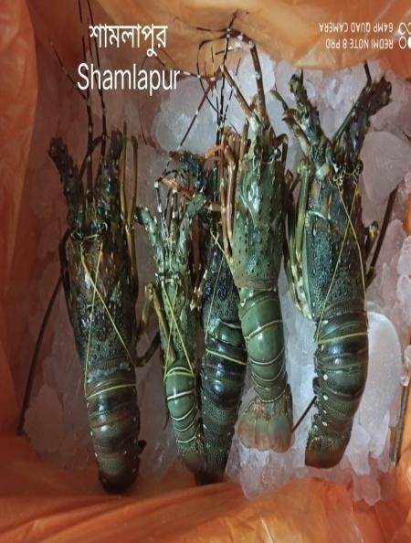  Shamlapur | Dorianogor | 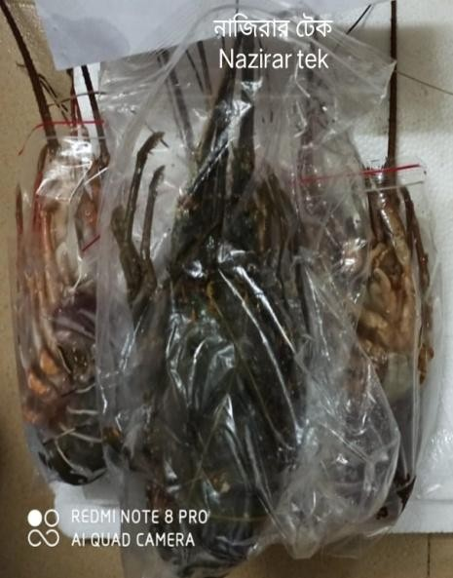  Nazirar tek
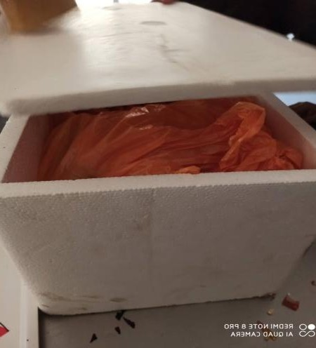  Icing and Packaging | Ready for Transportion | 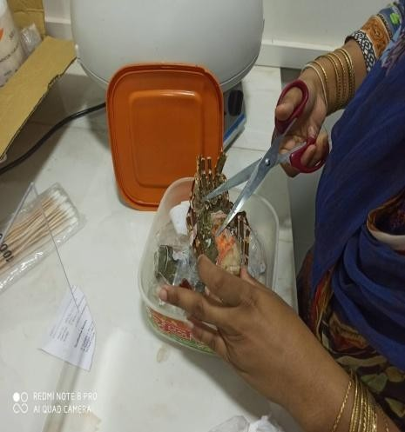  Preaparing Sample for Proximate Analysis
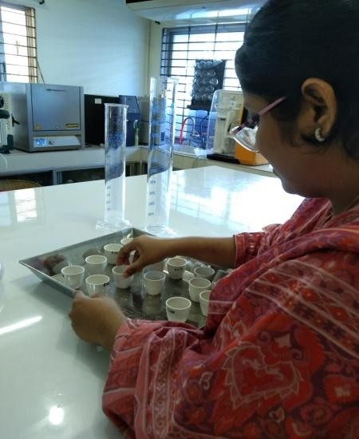  Taking sample in crucible | 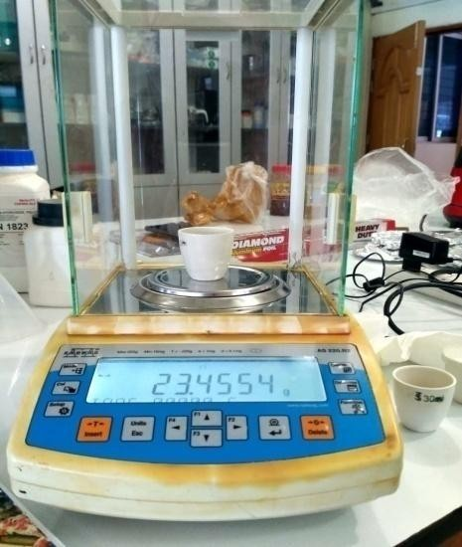  Measuring sample weight | 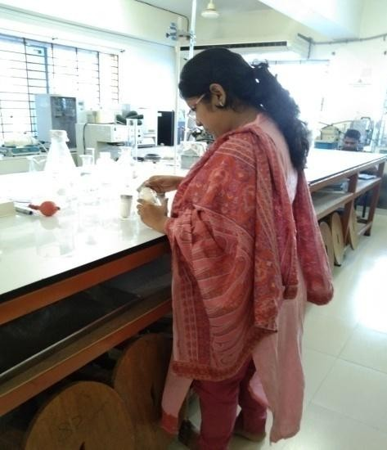  Working in the Laboratory

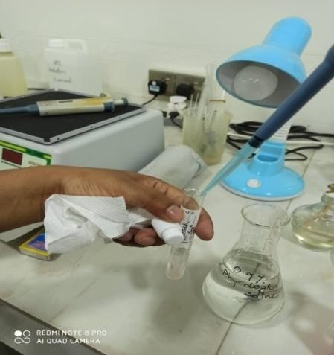  Biochemical Tests | 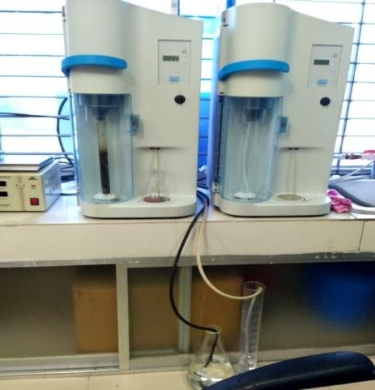  Kjeldahl Apparatus (Distillation Unit) | 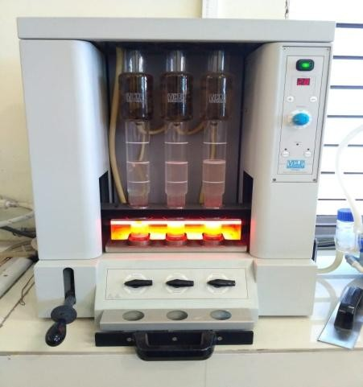  Fibre Extractor
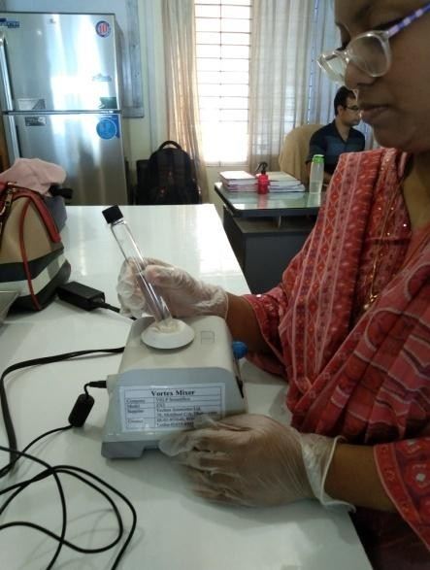  Reagent Preparation | 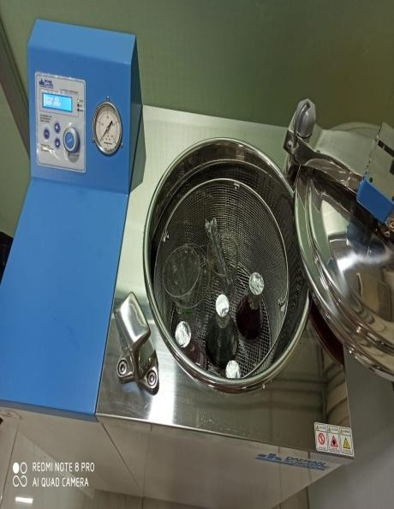  Autoclaving | 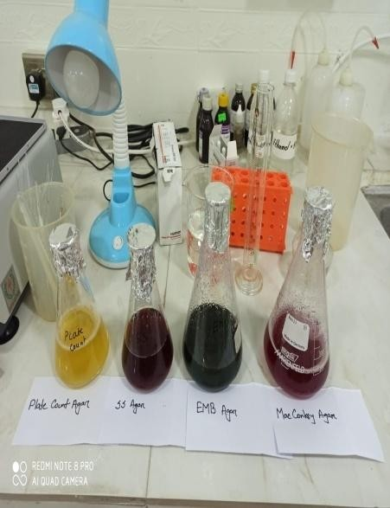  Media Preparation
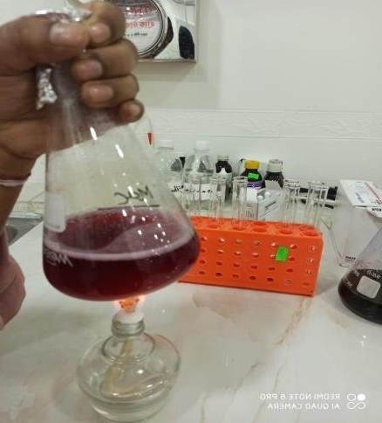  Heating | 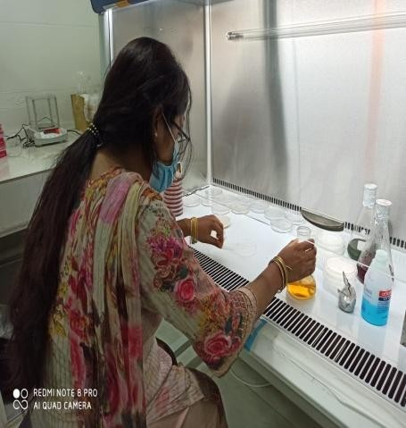  Working on Biosafety Cabinet | 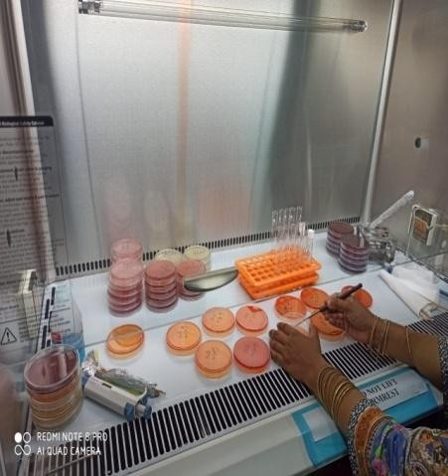  Inoculate the sample

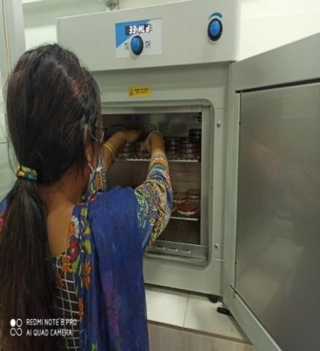  Media Plate kept in Incubator | 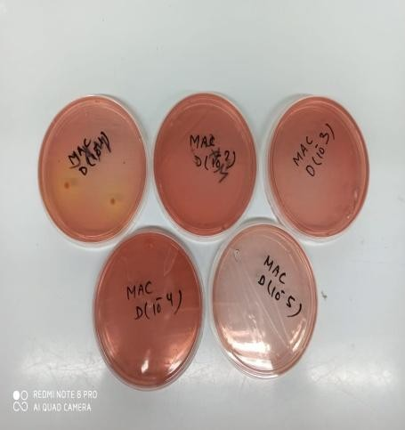  Analysis Microbial Growth | 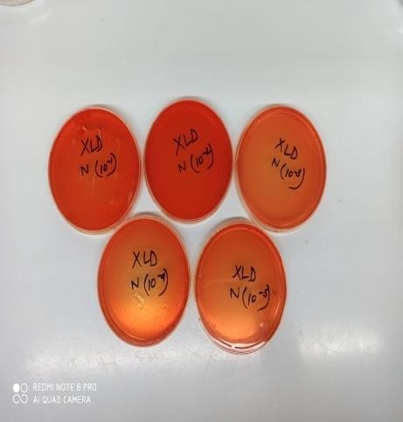  Analysis Microbial Growth

Appendices

Table 1: Protein determination in three different areas.

Sample | Initial  Reading | Final  Reading | Net  amount | Protein  conc. | Mean  Value | Standard  deviation (±sd)
Dorianogor -1 | 19.4 | 23.2 | 3.6 | 21.00 | 20.41 | ±0.58
Dorianogor -2 | 1.0 | 4.4 | 3.4 | 19.83
Dorianogor -3 | 5.0 | 8.5 | 3.5 | 20.41
Nazirar tek -1 | 0.7 | 4.5 | 3.8 | 22.16 | 22.16 | ±0.56
Nazirar tek -2 | 16.7 | 20.6 | 3.9 | 22.75
Nazirar tek -3 | 20.6 | 24.3 | 3.7 | 21.58
Shamlapur-1 | 24.3 | 27.7 | 3.4 | 19.83 | 21.39 | ±1.47
Shamlapur-2 | 27.7 | 31.4 | 3.7 | 21.58
Shamlapur-3 | 3.0 | 6.9 | 3.9 | 22.75

Similar superscript represent no significant difference (P>0.05) between means while different superscript represent significant difference (P<0.05) between means
Vertical bar=±SD

Table 2: Lipid determination in three different areas.

Sample | Empty  Beaker Weight | Sample weight | Final Weight | Amount  of lipid (%) | Mean | Standard  deviation (±sd)
Dorianogor -1 | 92.47g | 3.28g | 92.56g | 2.74 | 2.81 | ±0.15
Dorianogor -2 | 92.65g | 3.35g | 92.75g | 2.98
Dorianogor-3 | 92.57g | 3.32g | 92.66g | 2.71
Nazirar tek -1 | 91.57g | 3.28g | 91.66g | 2.74 | 2.66 | ±0.12
Nazirar tek -2 | 92.42g | 3.15g | 92.50g | 2.54
Nazirar tek -3 | 92.45g | 3.32g | 92.54g | 2.71
Shamlapur-1 | 92.64g | 3.34g | 92.73g | 2.69 | 2.71 | ±0.02
Shamlapur-2 | 92.58g | 3.30g | 92.67g | 2.73
Shamlapur-3 | 92.60g | 3.32g | 92.69g | 2.71

Similar superscript represent no significant difference (P>0.05) between means while different superscript represent significant difference (P<0.05) between means
Vertical bar=±SD

Table 3: Ash determination in three different areas

Sample | Empty Crucible weight | Sample with crucible  weight | Sample weight | Final weight with  crucible | Ash amount (%) | Mean value | Standad deviation (±SD)
Dorianogor -1 | 24.40g | 27.54g | 3.14g | 24.46g | 1.91 | 1.91 | ±0.005
Dorianogor -2 | 23.67g | 26.79g | 3.12g | 23.73g | 1.92
Dorianogor -3 | 22.92g | 26.06g | 3.14g | 22.98g | 1.91
Nazirar tek -1 | 25.35g | 28.50g | 3.15g | 25.41g | 1.90 | 1.90 | ±0.015
Nazirar tek -2 | 24.43g | 27.59g | 3.16g | 24.49g | 1.89
Nazirar tek -3 | 23.21g | 26.34g | 3.13g | 23.29g | 1.92
Shamlapur-1 | 26.23g | 29.45 g | 3.15g | 26.27g | 1.90 | 1.92 | ±0.02
Shamlapur-2 | 27.37g | 30.49 g | 3.12g | 27.43g | 1.92
Shamlapur-3 | 26.42g | 29.51 g | 3.09g | 26.48g | 1.94

Similar superscript represent no significant difference (P>0.05) between means while different Superscript represent significant difference (P<0.05) between means
Vertical bar=±SD

Table 4: Moisture determination in three different areas.

Sample | Empty crucible weight | Sample (Wet) Weight | Sample with crucible  weight | Final weight with  crucible | Sample (Dry) Weight | Moisture content | Mean | Standard deviation (±sd)
Dorianogor-1 | 28.33g | 3.01g | 31.34g | 29.16g | 0.83g | 72.55 | 71.65 | ±1.25
Dorianogor-2 | 23.30g | 3.02g | 26.32g | 24.14g | 0.84g | 72.18
Dorianogor-3 | 23.94g | 3.09g | 27.03g | 24.86g | 0.92g | 70.23
Nazirar tek-1 | 23.48g | 3.13g | 26.61g | 24.42g | 0.94g | 69.97 | 70.91 | ±0.08
Nazirar tek-2 | 24.07g | 3.12g | 27.19g | 24.97g | 0.90g | 71.15
Nazirar tek-3 | 23.24g | 3.10g | 26.34g | 24.12g | 0.88g | 71.61
Shamlapur-1 | 26.25g | 3.14g | 29.39g | 27.20g | 0.95g | 69.75 | 69.73 | ±0.09
Shamlapur-2 | 26.31g | 3.16g | 29.47g | 27.27g | 0.96g | 69.62
Shamlapur-3 | 23.35g | 3.08g | 26.43g | 24.28g | 0.93g | 69.81

Similar superscript represent no significant difference (P>0.05) between means while different superscript represent significant difference (P<0.05) between means
Vertical bar=±SD

Table 5: Fibre determination in three different areas.

Sample | Empty  Crucible weight | Sample weight  © | Oven Dry analysis(A) | Muffle  Furnace Analysis(B) | Fibre Content | Mean | Standard  deviation (±sd)
Dorianogor-1 | 30.68g | 1.0025g | 30.64g | 30.60g | 3.99 | 3.98 | ±0.005
Dorianogor-2 | 30.32g | 1.0036g | 30.57g | 30.53g | 3.98
Dorianogor-3 | 30.28g | 1.0032g | 30.59g | 30.55g | 3.98
Nazirar tek-1 | 30.20g | 1.0061g | 30.17g | 30.13g | 3.97 | 3.97 | ±0.005
Nazirar tek-2 | 30.59g | 1.0050g | 30.28g | 30.24g | 3.98
Nazirar tek-3 | 30.52g | 1.0057g | 30.59g | 30.55g | 3.97
Shamlapur-1 | 30.35g | 1.0052g | 30.50g | 30.46g | 3.97 | 3.97 | ±0.005
Shamlapur-2 | 30.40g | 1.0074g | 30.46g | 30.42g | 3.97
Shamlapur-2 | 30.52g | 1.0054g | 30.58g | 30.54g | 3.98

Similar superscript represent no significant difference (P>0.05) between means while different superscript represent significant difference (P<0.05) between means
Vertical bar=±SD

Brief Biography of the Student

Labonno Barua is the second daughter of Pronoy Barua and Citra Barua, was born in 10th July, 1996 in Chattogram. She has achieved secondary school certificate from Bangladesh Mohila Samiti Girls’ High School and College and higher secondary school certificate from Govt. Haji Mohammad Mohsin College. She has also obtained her B.Sc (Hon’s) in Fisheries from faculty of Fisheries, Chattogram Veterinary and Animal Sciences University. She is now a candidate of Master of Science under the Department of Fishing & Post Harvest Technology, Chattogram Veterinary and Animal Sciences University.
She has done many farm works in cox’s bazaar district and works in different fish feed mill. She has done internship in Bangladesh’s various fisheries related organizations and also externship at University of Malaysia Terrenganu, UMT for her advanced qualifications besides academic study.
She has actively participate in research during his B.Sc (Hon’s) period under the project title Phytochemical and Biological studies of Tinospora cordifolia. And published a paper as a co- author in Journal of Pharmaceutical Research International. 32(33): 77-84, 2020; Article no.JPRI.62379 ISSN: 2456-9119 (Past name: British Journal of Pharmaceutical Research, Past ISSN: 2231-2919, NLM ID: 101631759). Furthermore another manuscript is submitted for publication Evaluation of Antioxidant and Anticancer Activity of Tinospora cordifolia against Ehrilich ascites Carcinoma: In Vitro, In Vivo and In Silico Approach.
Her research interest area includes Fishery by-products technology, Seaweed Biotechnology, Biotechnology in fish processing. She is determined to make her a competent researcher and wants to develop the fisheries technological sector in Bangladesh.

