**pic. 11:** Egg of Oesophagostomum sp.

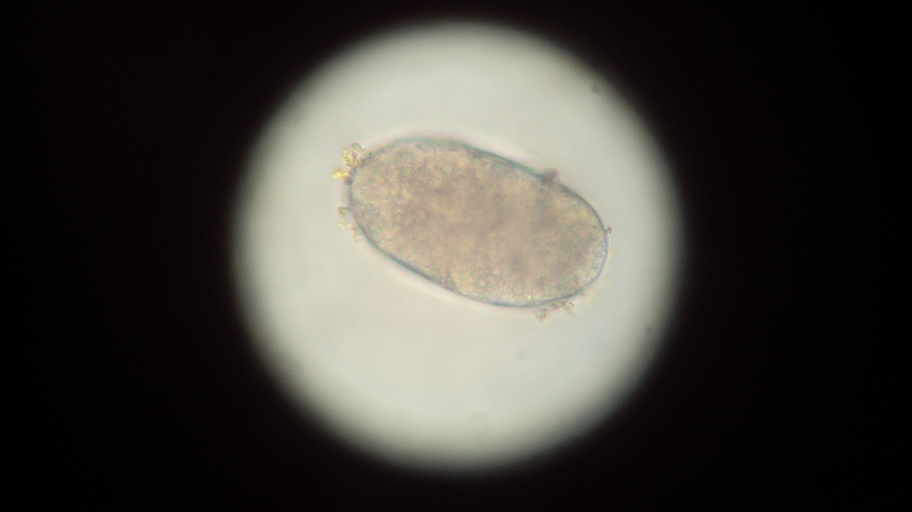

**pic. 12:** Egg of Trichostrongylus sp.

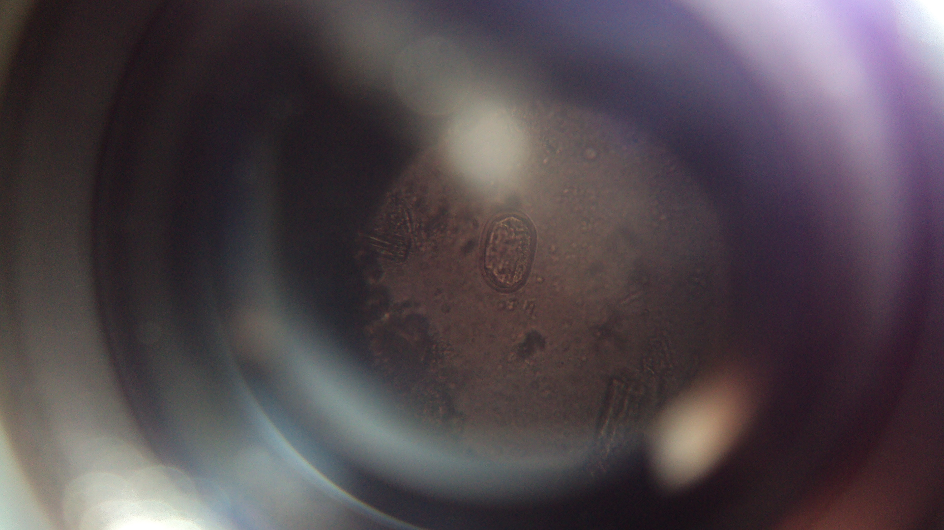

**pic. 9**: Consolidated pneumonic lung



**pic. 10:** Egg of trichuris sp.

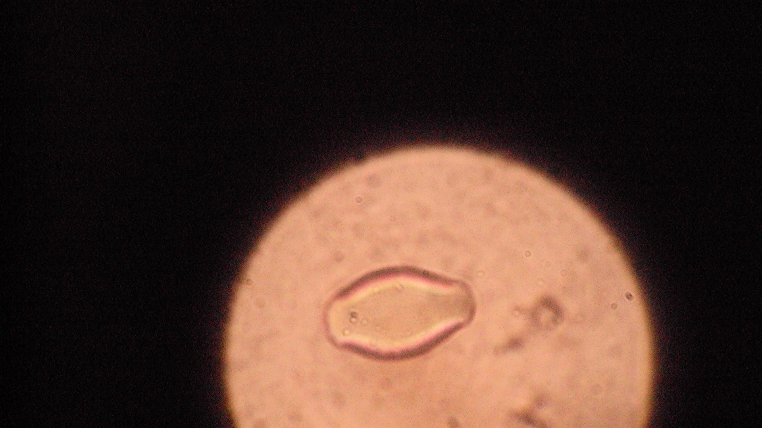

**pic. 8:** Hemorrhages on intestine



**pic. 7:** Zebra stripes in the mucosa of colon

