Pic: (1-5) Clinical sign and fluid therapy; (6-9) postmortem changes; (10-12) different species egg in PPR goats.

**pic. 6:** Haemorrhages on lung



**pic. 5:** Ocular discharges

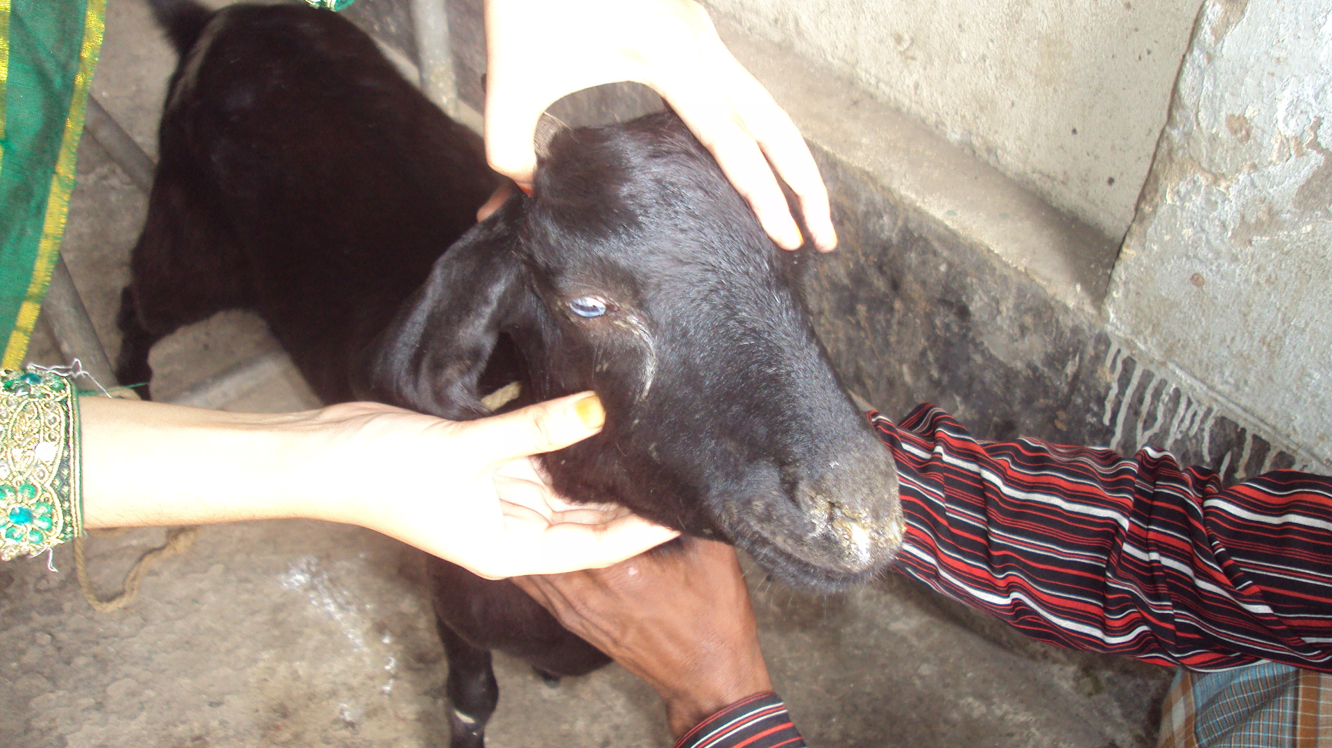

**pic. 4:** Fluid Therapy performed in PPR goat

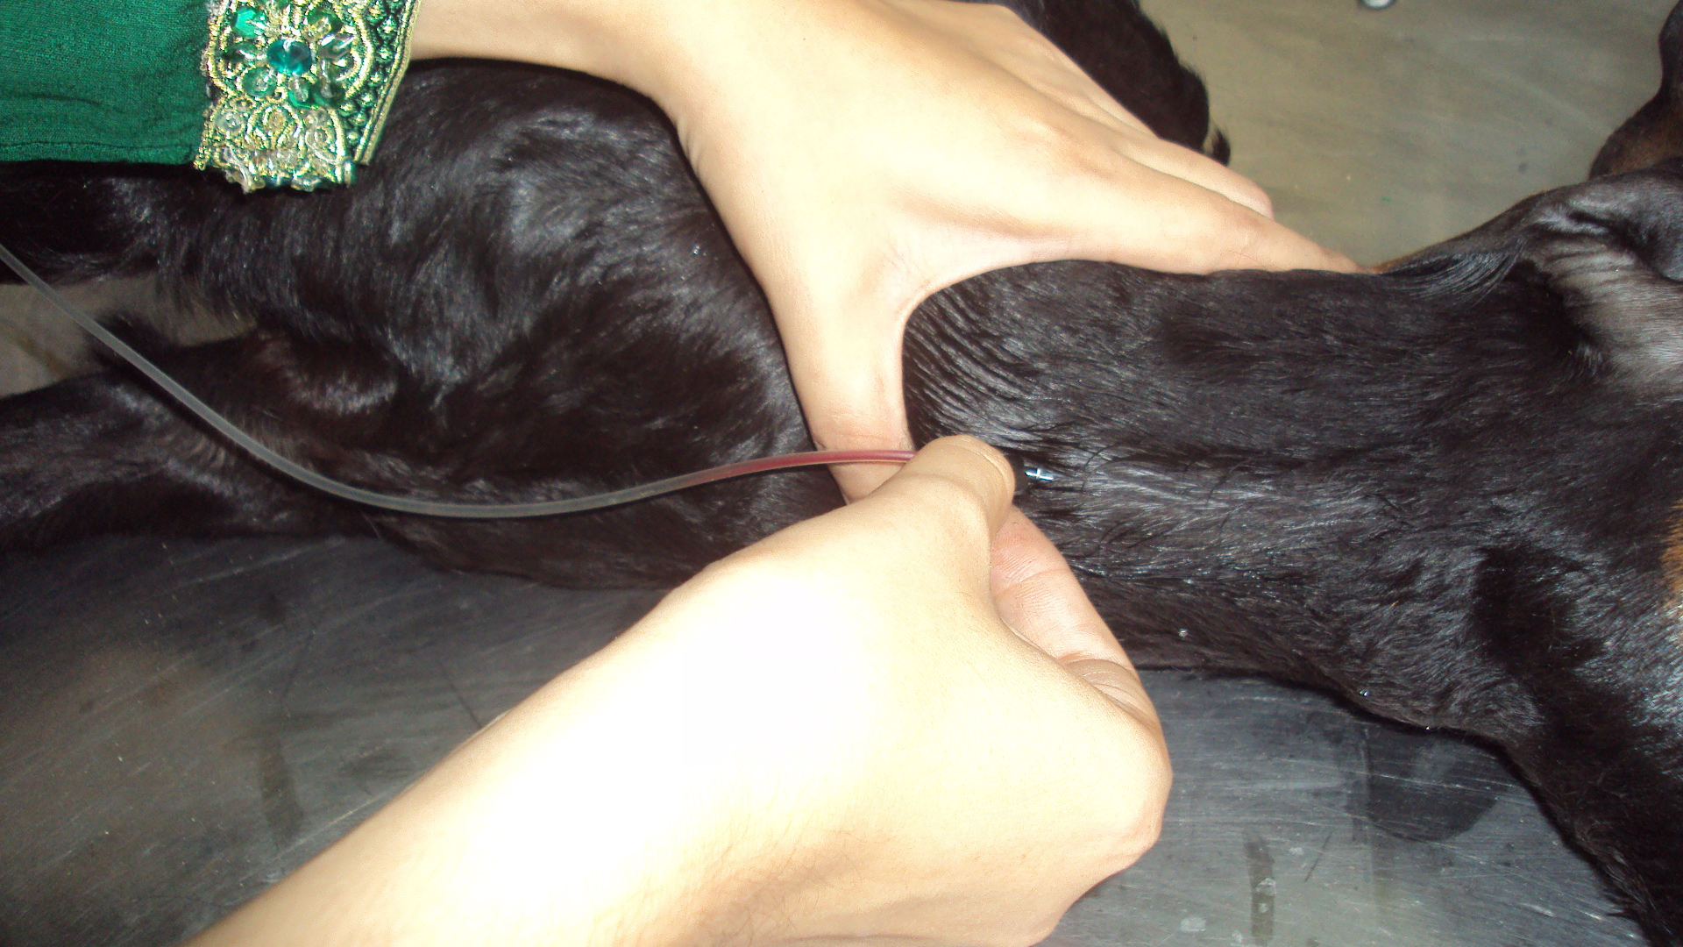

**pic. 3:** Temperature taken from PPR goat

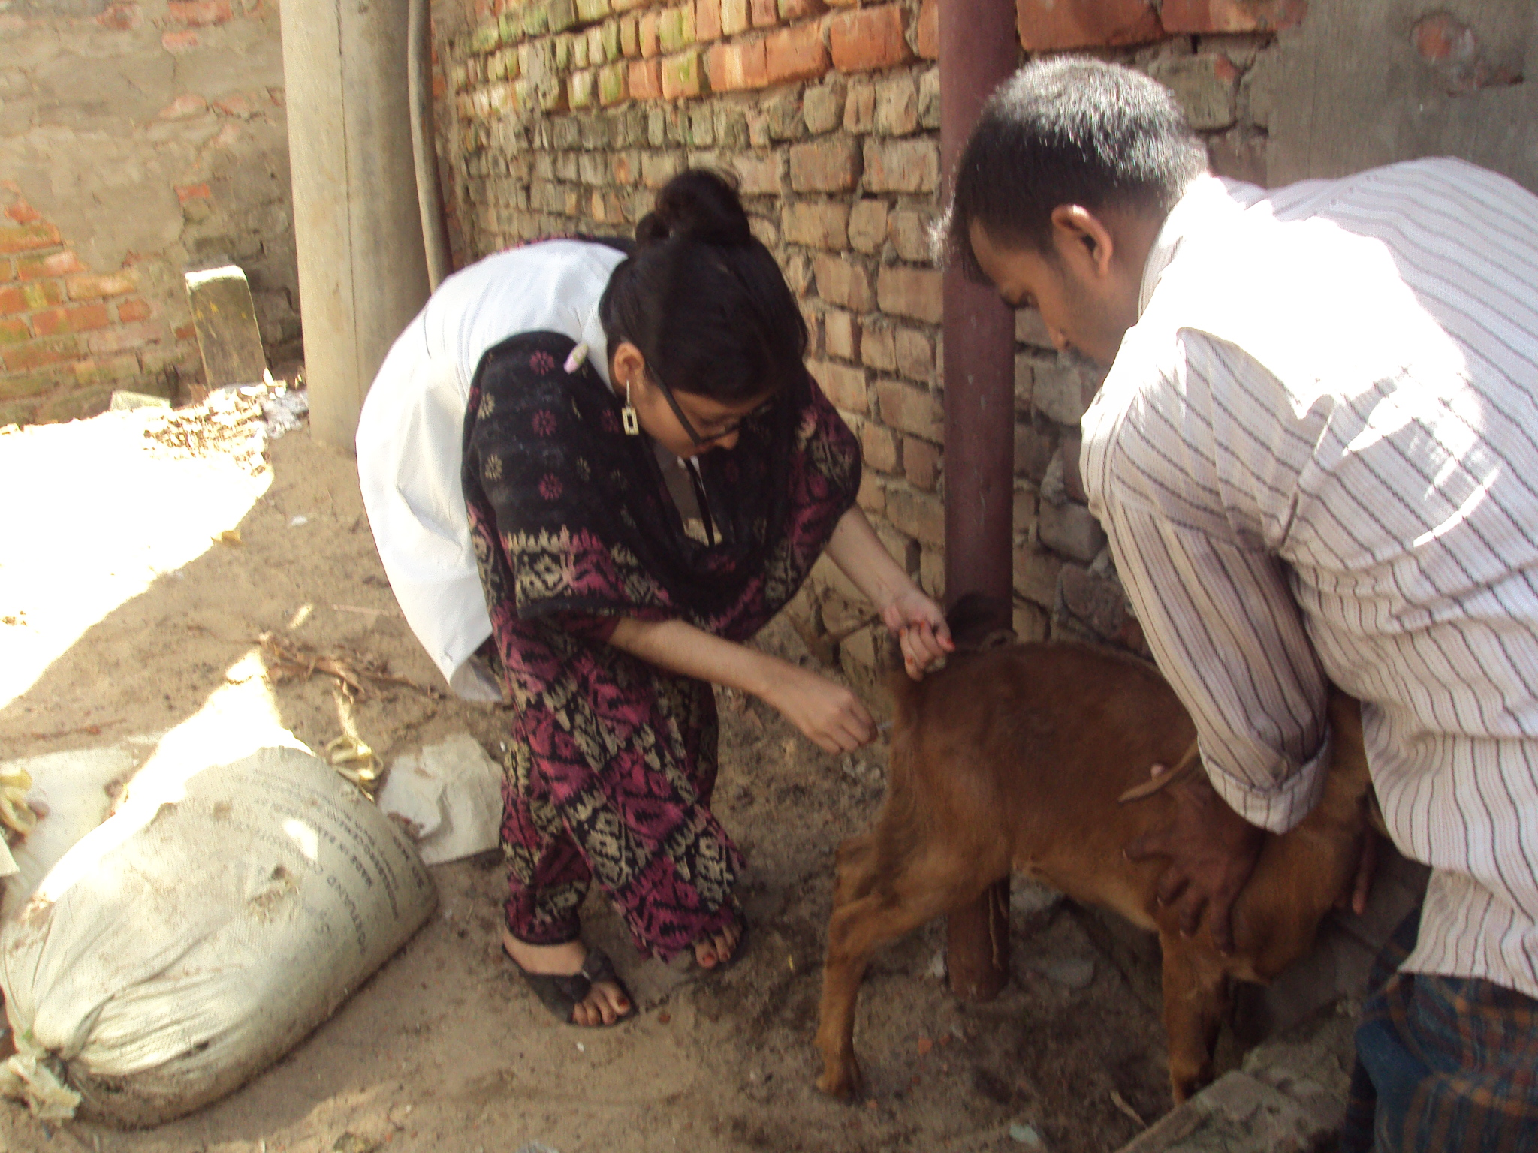

**pic. 2:** Diarrhoea in PPR affected goat

**Pic. 1:** Oculonasal discharges

