Chapter 1 : Introduction

Rabies is endemic in our country both in humans and animal, get from being bitten by an animal infected with the rabies virus and always deadly in humans and animal but can be totally prevented by study with appropriate management of bite, recognize the exposure and promptly get appropriate medical care before developing the symptoms of rabies.
Rabies is a zoonotic disease caused by RNA viruses in the family of Rhabdoviridae, Genus Lyssavirus. Virus is typically present in the saliva of clinically ill mammals and is transmitted through a bite. After entering the central nervous system of the next host, the virus causes an acute, progressive encephalomyelitis that is almost always fatal (Botvinkin et al., 2003). About 55,000 people has been reported to be died due to rabies each year across the world (Knobel et al., 2005). Dogs are the main reservoir of the virus and are responsible for spillover infections in humans and animal (Hossain et al., 2011). Any warm blooded animal can get rabies. Cattle, goat, horse, domestic cats and humans often found infected with rabies in Bangladesh (Mohiuddin, 2001). Rabies can also infect coyotes, wolves, ferrets skunks and foxes.
The most important conditions for the successful spread of rabies virus prevail in Bangladesh; a large population of stray dogs, which potentially interact with the population and with other species of animals. Although rabies occur throughout the year in all parts of Bangladesh, however the mortality rate in livestock is unknown, and large number of rabies cases remain unrecorded. Scattered reports from various sources indicate, however, that about 25,000 animals are vaccinated every year with pre-exposure and post-exposure vaccines produced locally and imported from other countries (Mohiuddin, 2001).
With political will and solid global epidemiologic information, rabies elimination is possible. Molecular typing of circulating rabies viruses is necessary to identify and develop effective control measures, and to understand the spread of certain rabies virus variants and their incursion into new regions (Nadin-Davis et al., 2007). If animal bites are managed appropriately and timely the rabies can be prevented to a large extent. In this regard the post exposure treatment and management of animal bite cases is of prime importance
Considering the above facts the present clinical report was designed with the following objectives:
1. To estimate the proportionate prevalence of rabies in two internship placements of Bangladesh and India
2. To record the frequency of observed clinical signs of rabies in different species
3. To know the therapeutic management of livestock species bitten by dog

Chapter 2 : Review of Literature

The following literature review has overviewed the etiological agent of rabies, its host range, clinical signs, prevalence and distribution, risk factors and consequences on livestock and public health.

Rabies results from infection by the rabies virus, a neurotropic virus in the genus Lyssavirus, family Rhabdoviridae. It is classified as genotype 1, serotype 1 in this genus. There are many strains of the rabies virus; each strain is maintained in particular reservoir host(s). It causes acute encephalitis in warm-blooded animals (Drew, 2004). The disease is zoonotic, meaning it can be transmitted from one species to another, such as from dogs to animal, commonly by a bite from an infected animal. The rabies virus travels to the brain by following the peripheral nerves. The incubation period of the disease is usually a few days to months, depending on the distance the virus must travel to reach the central nervous system (Cotran et al., 2005). From the point of entry, the virus is neurotropic, traveling quickly along the neural pathways into the central nervous system, and then to other organs. The salivary glands receive high concentrations of the virus, thus allowing further transmission.
Rabies occurs in two epidemiological forms, urban and sylvatic. The former prevails in dogs and the later in bats, wolves, foxes, jackals, mongooses, coyotes, skunks and other wild animals. Rabies has a long history of association with dogs, the first written record of rabies is in the Codex of Eshnunna (ca. 1930 BC), which dictates that the owner of a dog showing symptoms of rabies should take preventive measure against bites. If a person is bitten by a rabid dog and later died, the owner was fined heavily (Robert et al, 1996). Wild carnivores appear to be main reservoirs and transmitters of epidemic and endemic sylvatic rabies and dogs the most dangerous reservoir for human and domestic animals. Within a given ecosystem, one or two species are usually responsible for the perpetuation of rabies epidemics. In Bangladesh foxes and jackals are the main reservoirs of rabies (Mohiuddin, 2001). Most of the developing countries in Asia are the victims of rabies. Mortality from endemic canine rabies was estimated to be 55 000 deaths per year with 56% of the deaths estimated to occur in Asia. According to WHO, high death rate was experienced in India in 2004 and lowest in Cambodia and Magnolia (Raux et al., 2000). Rabies is endemic in Pakistan in all parts of the country. Animal bites are reported abundance during winter months resulting in a noticeable rise in the number of rabies cases. In 2006-2007, more than 3,000 rabies cases were reported which reduced to 205 in the year 2008 (Iwasaki and Tobita, 2008). In India, about 15 million people are bitten by dogs every year, it has been reported that 25,000-30,000 deaths are due to rabies annually, but due to preventive measures, the death rate reduced to 20,585 per year (Rozario, 2008). Rabies is an important public health problem in Bangladesh where nearly 100,000 people being bitten by dogs in 2009 and 3,000 died of rabies. Rabies among wildlife especially raccoons, skunks, and bats has become more prevalent since the 1950s, accounting for more than 85% of all reported cases of animal rabies every year since 1976 (Krebs, 1994).
Restlessness, aggression, profuse salivation, frenzy and mania are the common clinical signs regardless of species type (Hudson et al., 2010). Biting and lip twitching are common in horse. Death almost invariably results 2 to 10 days after first symptoms. Once symptoms have presented, survival is rare, even with the administration of proper and intensive care (Bishop et al., 2003; Robert, 2005; Rupprecht et al., 2006; Schoenstadt, 2008).

Rabies can be diagnosed by specific clinical signs with history of rabid dog. Diagnosis of rabies based on clinical grounds alone is difficult and unreliable except when specific clinical signs are present. Some patients present with a paralytic or Guillain-Barre-like syndrome or other atypical clinical features (Rupprecht et al., 2004). Cerebral inclusion bodies called “Negri bodies” are 100% sensitive for rabies infection but are found in only about 80% of cases (Drew, 2004). If possible, the animal from which the bite was received should also be examined for rabies. Magnetic resonance imaging performed with adequate precautions, suitable for potentially infectious patients, can be helpful in diagnoses (Laothamatas, 2003). The fluorescent antibody technique is a rapid and sensitive method for diagnosing rabies infection in animals and humans (Bourhy et al., 2008). It is the gold standard for rabies diagnosis; however, the accuracy of this test depends upon the expertise of the examiner, and the quality of anti-rabies conjugate and the fluorescence microscope. Virus isolation may be necessary to confirm the results of antigen detection tests and for further characterization of the isolate (Bourhy et al., 2008).

Animal bites, if managed appropriately and timely the disease is preventable to a large extent. In this regard the post exposure treatment of animal bite cases is of prime importance. In rabies endemic country like Bangladesh where every animal bite is potentially suspected as a rabid animal bite, the treatment should be started immediately. If an animal bitten or scratched by an animal, wash the wound immediately with soap and water. If the animal is wild or a stray, call the local authority and report the animal’s location. All scratch wounds should be thoroughly cleaned as soon as possible by scrubbing with soap and water for 10 minutes; thorough wound cleansing alone without other post-exposure prophylaxis (PEP) has been shown to markedly reduce the likelihood of rabies infection. Thorough wound cleansing will also help prevent other common bite wound infections. A virucidal agent, such as povidone-iodine solution, may also be used to clean the wound. Tetanus prophylaxis and measures to control bacterial infection also should be administered as indicated (Lewis, 1995; Jhon, 2001; Weiss et al., 1998; Goldstein, 1992; Smith et al., 2000). It is common practice to offer antibiotic prophylaxis to patients with more severe wounds or to those with risk factors for infection (Medeiros and Saconato, 2001). The decision to suture large wounds should take into account cosmetic factors and the potential for bacterial infections. In order to prevent rabies strategic planning and management, an estimate of the dog population and evaluation of a mass vaccination campaign is required (Matter et al., 2000).

Someone who has been bitten by an unknown animal should always be treated without waiting for symptoms, given the potentially fatal consequences of a rabid biter: there have been very few cases of someone surviving rabies when treatment was not begun until after symptoms appeared. Depending on local laws, dogs that are showing neurological signs at the time of the bite are euthanized in order to have their brain tested for rabies (CDC, 2004). The rate of death after a bite of rabid animal is 35-57%, depending on the severity of the wound and the virus content of the saliva (Hemachuda, 2000). Although transdermal bite with bleeding on the face, head and neck carry the highest risk, a bite in leg and hind region must be treated with same urgency.

Rabies can be prevented in domesticated animals by vaccination and by the avoidance of contact with rabid wild animals. Three aspects have always been taken into consideration by populations under threat from rabies, these are knowledge about rabies, post bite management and immunization. One should have the knowledge to respond quickly and appropriately in a rabies situation, either by giving the public direct information, or by referring to the appropriate professionals for assistance.

Chapter 3: Methodology

Two internship placements were considered for the study of suspected rabies cases in different species due to dog bites. They included Upazilla Veterinary Hospital (UVH) Satkania, Chittagong and Madras veterinary college hospital (MVC), Chenni, India.
The study was conducted at UVH during 15 July to 9 September and at MVC during October to November, 2012.
During the whole study period different livestock species bitten by stray dog history were studied at the internship placements. Individual case was examined througly to record clinical signs in clinical sheet. Other information such as species, age, sex, site of dog bite and vaccination status of individual cases were also recorded in the clinical sheet.
According to clinical signs and symptoms cases were diagnosed as suspected rabies cases. The following clinical signs were considered to define suspected rabies case such as excessive salivation, behavioural change, aggression, restlessness, mania, hyperexcitability or hyperaesthesia (Drew, 2004; Hudson et al., 2010; Rupprecht et al., 2006). After clinical assessment of the cases, necessary therapeutic measures were taken to manage the problem.

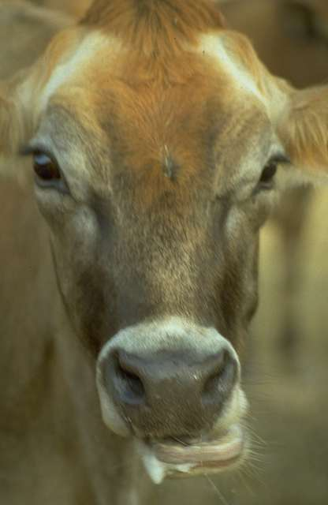
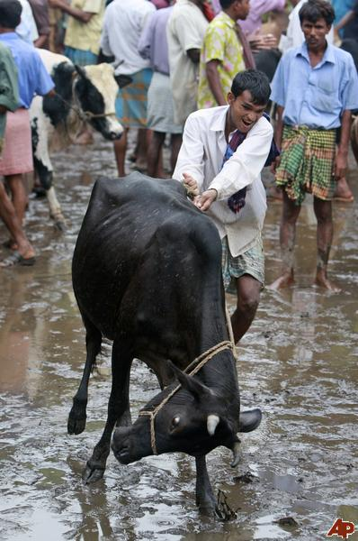
Figure 2. Salivation in a suspected rabid cattle (Hudson et al., 2010).
Figure 1. Sign of aggression in a rabid cattle (Rahman et al., 1984).
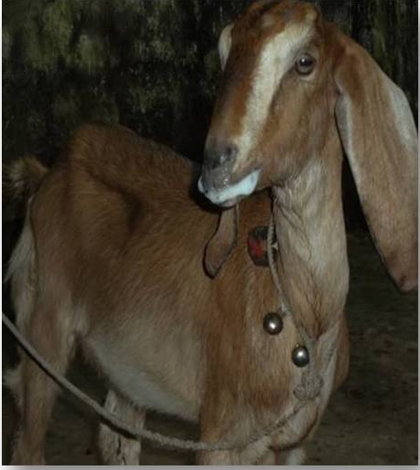
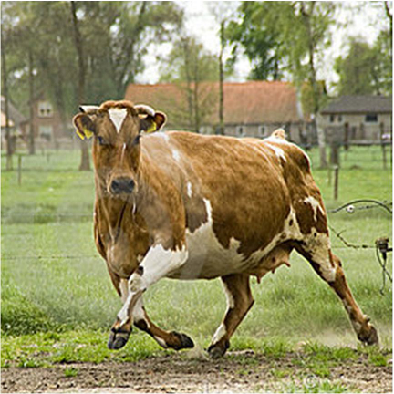
Figure 3. Sign of restlessness in a suspected case (Robert et al., 1984).
Figure 4. Profuse salivation in a suspected rabid goat (Bishop et al., 2003).
Data were entered into the MS Excel program 2007 and sorted and cleaned the data. Descriptive statistics were performed on the data obtained by using MS excel 2007. The results were expressed as frequency and percentage.

Chapter 4: Results

4.1. Proportionate prevalence of suspected rabies cases according to internship placements, species and vaccination status
The occurrence of suspected rabies cases in different species due to dog bite was 41.4% in Bangladesh and 3.5% in India. The recorded suspected rabies cases were 38% in cattle and 3.5% each in goat and horse. Vaccinated animals had less recorded suspected rabies cases (6.9%) than non-vaccinated animals (38%) (Table.1).
Table 1. Occurrence of suspected rabies cases due to dog bite in different species in internship placements belonging to Bangladesh and India (N=29)

Factors | Category | Suspected rabies due to dog bite
 |  | Yes (%) | No (%)
Country | Bangladesh  (Satkania upazilla veterinary hospital) | 12 (41.4%) | 16 (55.2%)
 | India  (Madras veterinary college hospital) | 1 (3.5%) | 0
Species | Cattle | 11 (38.0%) | 5 (17.2%)
 | Goat | 1 (3.5%) | 11 (38.0%)
 | Horse | 1 (3.5%) | 0
Vaccination  (Rabicin) | Yes | 2 (6.9%) | 5 (17.2%)
 | No | 11 (38.0%) | 11 (38.0%)

4.2. Proportionate prevalence of suspected rabies cases according to age and gender of different species
In cattle, the incidence of suspected rabies cases was higher in older animals (>1year) (13.8%) than younger (10.3%). Only one male goat at the age of 0.5 year had suspected rabies. A adult male horse had the suspected rabies in this study (Table.2).
According to gender female cattle had higher suspected rabies cases (24.1%) than male cattle (13.8%) (Table.2).
Table 2. Occurrence of suspected rabies cases in different species according to their age and gender
Species | Age(Years) and sex categories |  | Suspected rabies due to dog bite
 |  |  | Yes (%) | No (%)
Cattle |  | 0-1 | 3 (10.3%) | 1 (3.5%)
 |  | >1-2 | 4 (13.8%) | 1 (3.5%)
 |  | >2 | 4 (13.8%) | 3 (10.3%)
Goat |  | 0-0.5 | - | 3(10.3%)
 |  | 0.5-1 | 1 (3.5%) | 5 (17.2%)
 |  | >1 | - | 3 (10.3%)
Horse |  | >4 | 1(3.5%) | -
Cattle |  | Male | 4 (13.8%) | 3 (10.3%)
 |  | Female | 7 (24.1%) | 2 (6.9%)
Goat |  | Male | 1 (3.5%) | 6 (20.7%)
 |  | Female | - | 5 (17.2%)
Horse |  | Male | 1(3.5%) | -

4.3. Observable clinical signs recorded from suspected rabies cases according to different species
A range of clinical signs was recorded from different species in the study. They included aggression (38.0%), mania (34.5%) excessive salivation (34.5 %), frenzy (13.8%) and restlessness (3.5%). Suspected rabid goat had only profuse salivation (3.5%). Aggression, frenzy, biting tendency and lip twitching were recorded from a suspected rabid horse in this study.
Table 3. Frequency of different clinical signs recorded from suspected rabies cases due to dog bites
Recorded clinical signs | Cattle | Goat | Horse
 | n (%) | n (%) | n (%)
Aggression | 11 (38.0%) | - | 1 (3.5%)
Mania | 10 (34.5%) | - | -
Profuse  salivation | 10 (34.5%) | 1(3.5%) | -
Frenzy | 4 (13.8%) | - | 1 (3.5%)
Biting | - | - | 1 (3.5%)
Restlessness | 1 (3.5%) | 1 (3.5%) | -
Lip twitching | - | - | 1(3.5%)

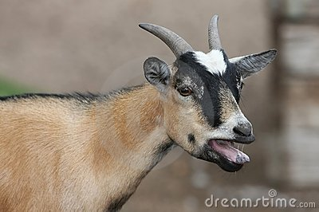
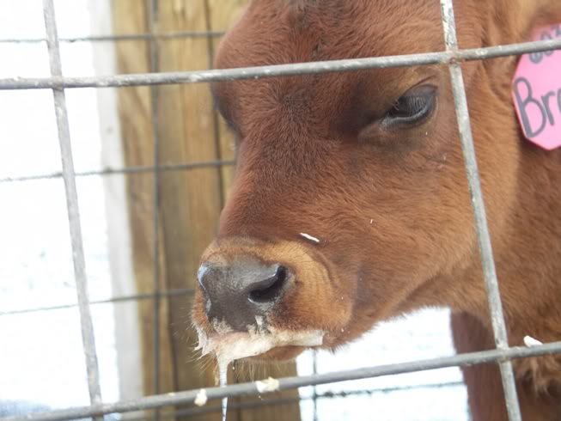
4.4. Pictures of observable clinical signs of suspected rabid cases

Figure 2. Sign of restlessness in a rabid goat
Figure 1. Profuse salivation in a suspected rabid cattle
Figure 2. Sign of restlessness in a rabid goat.
Figure 1. Profuse salivation in a suspected rabid cattle.
4.5. Dog bite management of different suspected rabid and non-rabid cases
Dog bite management of different studied animals were performed by washing the biting site by alkaline soap followed by dressing the wound with either antiseptic or antibiotic powder. 6 of 15 bitter cattle and 1 of 13 bitter goats were given with post-exposure vaccine to manage the problems (Table.4).
Table 4. Different management practices for the studied animals bitten by stray dogs
Species | n | Wash with alkaline soap | Dressing with antiseptic/antibiotic | Post bite vaccination with rabies
 |  | n (%) | n (%) | n (%)
Cattle | 15 | 3 (10.3%) | 6 (20.7%) | 6 (20.7%)
Goat | 13 | 4 (13.8%) | 8 (27.6%) | 1(3.5%)
Horse | 1 | - | 1(3.5%) | -
Total | 29 | 7 (24.1%) | 15 (51.7%) | 7 (24.1%)

Chapter 5: Discussion

The proportionate prevalence of suspected rabies cases in different livestock species in the present study corresponds to the earlier studies in Bangladesh and India (Blanton et al. 2006, Ichhpujani et al.2008, Hossain et al. 1986, Rahman et al. 1984). They found 1.2% case in cattle, 0.5% in goat and 3% in horse. However, the low level of prevalence of rabies was reported in goat (0.5%) in Bangladesh (Hossain et al., 1986) and in cattle (0.2%) in Bangladesh (Rahman et al., 1984). The results of current study was higher than the earlier studies it may be due to the fact that they included all others diseases with rabies in the study, but in current study include only reported cases of dog bites that suspected to rabies.
Vaccinated animals had less recorded suspected rabies cases (6.9%) which suggest that vaccine was effective to control rabies. This finding is supported by Matibag et al. (2008) and Robert et al. (1984).
The suspected rabies was higher in older animal than young regardless of species. The identical result is repoted by Krebs et al. (2004). In cattle, female was more commonly affected by suspected rabies case which is similar to the findings of Jhonston and Beaurgard (1970).
In the suspected rabid cattle major clinical signs recorded (Table.3) in the study were aggression (38%), salivation (34.5%), mania (34.5%) and frenzy (13.8%). Similar result were reported by Bishop et al. (2003). However, Hudson et al. (2010) differed the results from the current study. They recorded aggression or hyperesthesia (70%), salivation (100%) and behavioural change or mania (100 %). In goat, profuse salivation (3.5%) and restlessness (3.5%) recorded in this study differed from the study of Bishop et al. (2003) who recorded salivation (16%) and restlessness (3%). It is because only one positive suspected case was recorded in goat in the present study and the current study only includes the reported cases in hospital. In horse, the frequency of aggression, frenzy, biting and lip twitching recorded in the current study are agreed by Bishop et al. (2003).
In this study dog bite was attempted to manage by washing the biting sites with alkaline soap followed by antiseptic or antibiotic and post-exposure vaccine. Similar management practiced was previously adopted by others (Goldstein, 1992, Jhon, 2001, Lewis, 1995, Smith et al., 2000, Weiss et al., 1998). In order to avoid post bite complication antibiotic was used which is supported by Dire et al. (1992), Smith et al., (2003) and Presutti (1997).

Chapter 6: Conclusion and Recommendation

The study was conducted with total of 29 clinical cases of dog bites of different livestock species in India and Bangladesh. The result from the study indicates management of dog bites and prevalence of suspected rabies cases in two countries also in different livestock species, sex and age categories of animal. Prevalence of suspected rabies due to dog bites was 41.4% in Bangladesh and 3.5% in India Total 7 of 29 bitter animals were given with post-exposure vaccine to manage the problems and 51.7% cases of dog bites were managed by using antiseptic or antibiotics. Vaccinated animals had less recorded suspected rabies cases (6.9%) than non-vaccinated animals (38%). Public education is the key to reducing the risk of rabies among domesticated animals and humans. Pre-exposure rabies vaccination should be offered to pet, domesticated animal and persons in high-risk groups, such as veterinarians, veterinary technicians, animal control personnel, wildlife rehabilitators, taxidermists, trappers, and rabies testing/research laboratory workers.

References

Blanton JD, Robertson K, Palmer D, Rupprecht CE. 2006. Rabies surveillance in the United States during 2008. J Am Vet Med Assoc. 235(6): 676-89.
Bishop GC, Durrheim DN, Kloeck N, Godlonton JD, Bingham J, Speare R. 2003. Rabies Advisory Group: Department of agriculture and Department of health.
Botvinkin AD, Poleschuk EM, Kuzmin IV. 2003. Novel lyssaviruses isolated from bats in Russia. Emerg Infect Dis. 9: 1623-5.
Bourhy H, Reynes JM, Dunham EJ, Dacheux L, Larrous F, Huong VT. 2008. The origin and phylogeography of dog rabiesvirus. J Gen Virol. 89: 2673-81.
CDC. 2004. Human rabies prevention-United States.Recommendations of the Advisory.
Cotran RS, Kumar V, Fausto N (2005). Robbins and Cotran Pathologic Basis of Disease .7th ed. St. Louis: Elsevier/Saunders. p. 1375.
Dire DJ, Hogan DE, Walker JS. 1992. Prophylactic oral antibiotics for low-risk dog bite wounds. Pediatr Emerg Care. 8: 194-9.
Drew WL. 2004. Rabies. Sherris Medical Microbiology. 4th ed. Chapter 41, pp. 597-600.
Goldstein EJ. 1992. Bite wounds and infection. Clin Infect Dis. 14: 633-8.
Hossain M, Ahmed K, Bulbul T, Hossain S, Rahman A, Biswas MN. 2011. Human Rabies in rural Bangladesh. . Epidemiol Infect. 140:1-8.
Hemachuda T. 2000. Rabies in asia. no1, p. 17.
Hossain MA, Shahidullah M, Ali MA. 1986. A report on surgical diseases and reproductive disorders reported at the Veterinary Hospital of Bangladesh Agricultural University, Mymensingh. Bang. Vet. J. 20: 1-5.

Hudson LC, Weinstock D, Jordan T, Bold Fletcher NO. 2010. Clinical Features of Experimentally Induced Rabies in Cattle and Sheep. 43: 85-95.

Ichhpujani RL, Mala C, Veena M, Singh J, Bhardwaj M, Bhattacharya D, Pattanaik SK, Balakrishnan N, Reddy AK, Samnpath G, Gandhi N, Nagar SS, Shiv L. 2008. Epidemiology of animal bites and rabies cases in India. A multicentric study. 40(1): 27-36.
Iwasaki Y, and Tobita M. 2008. Pathology. In Rabies. Edited by Jackson AC, Wunner WH San Diego: Academic: 283-306.
Jhon Presutti R. 2001. Prevention and Treatment of Dog Bites Mayo Clinic Jacksonville, Jacksonville, Florida Am Fam Physician. 63(8): 1567-1573.
Johnston DH, Beauregard M. 1970. Rabies epidemiology in Ontario. Health of Animals Branch. Ontario, Canada.
Kim CH, Lee CG, Yoon HC, Nam HM, Park CK, Lee JC, Kang MI, Wee SH. 2006. Rabies, an Emerging Disease in Korea. 53(3): 111-115.
Knobel DL, Cleaveland S, Coleman PG, Fevre EM, Meltzer MI, Miranda ME. 2005. Re- evaluating the burden of rabies in Africa and Asia. Bull World Health Organ. 83:360-8.
Krebs JW, Mandel EJ, Swerdlow DL. 2004. Rabies surveillance in the United States during. J Am Vet Med Assoc. 225:1837–1849.
Laothamatas J. 2003. MR imaging in human rabies. AJNR. American Journal of Neuroradiology. 24: 1102–1109.
Matibag GC, Ditangco RA, Kamigaki T, Wijewardana TG, Kumarasiri PVR, Niranjala De Silva D, Panduka De G, Gunawardena S, Obayashi Y, Kanda K, Tamashiro S. 2008. Rabies-related risk factors and animal ownership in a community in Sri Lanka. The Internet Journal of Epidemiology. 6: 1.

Matter HC. 2000. Study of the dog population and the rabies control activities in the Mirigama area of Sri Lanka. Acta Tropica. 75(1):95-108.
Medeiros I, Saconato H. 2001. Antibiotic prophylaxis for mammalian bites. The Cochrane Database of Systematic Reviews, Issue 2. p 10.
NadinDavis SA, Turner G, Paul JP, Madhusudana SN, Wandeler AI. 2007. Emergence of Arctic-like rabies lineage in India. Emerg Infect Dis. 13: 111–6.
Presutti RJ. 1997. Bite wounds, Early treatment and prophylaxis against infectious complications. Postgrad Med.101: 243–4,246–52,254.
Rahman MM, Samad M, Majibur R. 1984. Examination of goat in some areas associated with bacterial diseases of Bangladesh. 6: 25-30.
Raux H, Flamand A, Blondel D. 2000. Interaction of the rabies virus P protein with the LC8 dynein light chain. J Virol. 74:10212-10216.
Robert H Williams, David J. 1996. Veterinary Medicine:An Illustrated History.Mosby. 3209-9.
Robert F, Korns MD, Zeissig A. 1984. Dog, Fox, and Cattle Rabies in New York State. Evaluation of Vaccination in Dogs. State Department of Health, Albany, N. Y.
Rozario M. 2008. Rabies in India. CMAJ . 178(5): 564-566.
Rupprecht CE, Hemachudha T, Scheld M, Whitley RJ, Marra C. 2004. Rabies. Infections of the central nervous system. pp: 243-259.
Rupprecht CE, Willoughby R, Slate D. 2006. Current and future trends in the prevention, treatment and control of rabies. Expert Review of Anti-infective Therapy. 4 (6): 1021–1038.
Schoenstadt A. 2008. "Rabies Symptoms". eMedTV. Retrieved 2010-01-30.
Sehularo K. 1994. Rabies in Bostwana; Department of Veterinary Services, Mahalapye, Botswana.
Smith PF, Meadowcroft AM, May DB. 2000. Treating mammalian bite wounds. J Clin Pharm Ther. 25: 85-99.
Sultan Mohiuddin M. (2001). Rabies in animal in Bangladesh, Rabies control in Asia p:207
Weiss HB, Friedman DI, Coben JH. 1998. Incidence of dog bite injuries treated in emergency departments. JAMA. 279: 51-3.

