CHAPTER-I
INTRODUCTION

Livestock plays a crucial role in the agricultural economy. About 36% of the total animal protein comes from the livestock. In Bangladesh 25% people are directly engaged in livestock sector, and 50% people are partly associated in livestock production. Last year, in 2012 the contribution of livestock sub-sector to the GDP was 2.57% (Anon. 2013 a).

Recent livestock in Bangladesh have found on poultry production as a tool in poverty alleviation. Now a days poultry is highly raising industry in Bangladesh. The present poultry population is estimated to about 185.70 million of chicken of which 162.70 million is deshi chickens and remaining are hybrid (Rahman, 2003). It is estimated that there are approximately 163.5 million chickens which contributing partially for the alleviation of poverty and malnutrition of the people. At present situation commercial poultry eggs and meats are accomplishing the greater demand of animal protein as well as the human nutrition in the country. About 0.26 million metric ton of meat and 5210 million table eggs are produced per year (Rahman, 2003). The total egg production of Bangladesh in 2012 were 42561 lac (Anon. 2013 a).

However in recent years due to rapid urbanization around major cities lands are becoming scarce for crop production and also due to increased demand for meat and eggs. In the urban areas people are switching over from scavenging native chickens to commercial chickens which are mainly exotic purebred or hybrid crosses. The commercial layer or broiler farms operated by low income group people in rural situation, with around fifty or more chicken, raised in semi intensive to intensive operations.

Mass production of chicken eggs has become a highly efficient, competitive enterprise. In a commercial layer farm pullets will begin to laying eggs at 20-22 weeks of age and once laying will eventually peak at 85-93% production. Each hen can be expected to lay about 270 qualityeggs by the age of 75 weeks. About 1.8 kg feed is needed to produce per dozen eggs (Miah et al. 2002).

In Bangladesh the national poultry flock includes mainly chicken, ducks and pigeons which are kept in different production systems. Poultry population estimates differ depending on the source of information, according to numbers provided by the government of Bangladesh's Livestock Department, the total chicken population is steadily increasing from about 143 million birds in 2001 to 195 million birds in 2006. Over the same period the duck population increased from 25.8 million in 2001 to 34.1 million in 2006. The pigeon population was reported to be 10.9 million in 2005 (Bangladesh Bureau of Statistics, 2006). Other types of Domesticated birds such as geese are present in only small number.

Recently the prospects of rearing exotic hens by the rural poor in Bangladesh have highlighted (Rahman, 2003). The found projects are important tool for poverty alleviation and social empowerment for the poor, especially for the rural women. Seeing the prospects, various government and nongovernment organizations have come forward helping distress women and unemployed youths across the country in establishing farms so as to make them sell reliant. The nutritional and diseases problem are major constraints in Bangladesh for the development and maintenance of poultry, suitable breed and proper management results in profitable poultry production which are lack in traditional poultry rearing system (Rahman, 2003).

The HISEX brown, brown feathered brown egg layer is a very competitive producer of strong shelled eggs. She has an excellent livability and is ready to stand the challenges of today’s egg industry. She produces large quantities of uniform colored brown eggs with a reputation for having an outstanding feed efficiency (Anon. 2013 b). The favorable genetic characteristics can only be achieved when the bird is provided with all its requirements. These include, but are not limited to, good quality feed, good housing and healthcare. The goal of managing the HISEX brown is to attain the greatest number of eggs in the desired weight range at the most efficient cost per dozen or per pound of egg mass. To attain this goal, birds should be fed correctly during both the growing and egg production phase The HISEX brown should be started and maintained on a feed program that provides all the known required nutrients for growth and sexual development. The objective is to be certain that the pullet reaches the target body weight during each week of growth (Anon. 2013 b).

The HISEX brown is bred to tolerate the challenges of various housing conditions. In general, there is a “happy medium” in regards to how much space a bird needs. The initial investment in housing and equipment is reduced when less space is allocated for each bird. Too little space will reduce performance. Too much space, on the other hand, may result in higher energy costs for warming the building and over consumption of feed may occur, etc. (Anon. 2013 c).

Therefore the present study was undertaken with following objectives:
1. To observe the management practices of HISEX brown layer.
2. To observe and compare the production performances of the birds of 38th to 41st
weeks of age of that farm with the standard level.

CHAPTER –II

REVIEW OF LITERATURE

2.1 Housing system
75% of all the commercial layers on the world are now are kept on cage (North, 1996). Eggshell quality indicators were affected more by genotype than by housing. The interaction between genotype and housing is not significant for eggshell thickness but it is significant for eggshell weight and strength. Although eggshell thickness is lower in those eggs which are produced in cages, but eggshell strength is higher (Tumovaet al. 2011).
Eggshell strength is affected by housing system, genotype and egg collection time. It is higher in cages than on litter, and lower in the Moravia genotype in comparison with the HISEX brown and ISA brown strain (Tumova et al. 2011).
Cannibalism occurred in the enriched cages but is constrained to a few cages. Once started, the mortality rates rose quickly and not much could be done to change it. A technical problem can develop stress in the group which can cause cannibalism. The use of laying materials in the nests improved the egg quality since less eggs were bruised or dented. Also the percentage of eggs laid outside the nests was reduced with the use of nesting materials (Rodenburg et al. 2009).

2.2 Feed intake
Adlibitum fed hens weighed significantly heavier and produce fewer eggs then restricted fed hens (Robinson and Willson, 1996). Feed restriction reduce body weight and hen day egg production proportionately to the restricted level that was with the decreased body weight (Scott et al. 1999).
Feed consumption was not affected by shed density during the starter and growth phases, but was reduced during the layer phase when density was higher than the optimum and increased when density was less than the optimum. Feed conversion was best when the optimum house density was achieved. Feed conversion for egg production improved with size of flock (Ames and Ngemba, 1985).
Better performance of egg type layers with increase in flock size. This may be due to better management by owners of larger flocks, thereby avoiding unnecessary wastage of feed (Nair and Ghadoliya, 2000; Kumar and Mahalati, 1998).

2.3 Egg production
Egg production is the major index of performance of commercial layer business because of its accounts for 90% of the income from the enterprise (Oluyemi and Robert, 1979). Egg production is one of the most important economic traits in chicken. As feed cost accounts for about one half or two thirds of the total cost of producing egg, increased efficiency of the laying stock in terms of higher food conversion for egg production should be the principle breeding objective (Oluyemi and Robert, 1979).
Feed restriction during growth (7-22weeks old) stage body weight reduced significantly, after that body weight increased at sexual maturity as well as egg production also increased (Krishnappa et al. 1992). Excess intake is predominantly stored as fat which gradually results in increased body weight. Excessive body weight broiler breeder females were negatively correlated with hen day egg production (Spralt and Leeson, 1987).
The egg production of commercial layer commences about 19weeks of age, rises sharply to a peak at about 26 to 27 weeks of age and then declines gradually. It is a usual practice to replace the layers at the age of 72-76 weeks (Rahman, 2003). The maximum a fowl is capable of producing in the first laying year is about 300 eggs (Oluyemi& Robert, 1979).

2.4 Formula used in determination of egg production
Egg production of any farm can be measured by various indexes, they are given below:
2.4.1. Hen–day egg production (HDEP): Hen-day egg orpercentlay on daily basis was calculated by using the following formula (North, 1996).
No. of egg produced/ laid × 100
HDEP % =
No. of birds available in the flock on that day

Hen-day egg production for the whole production period was worked out by summing up the daily hen-day egg production of the flock.
2.4.2. Hen-housed egg production (HHEP): It is obtained by dividing the total number eggs produced by the number of birds housed in the laying pens. This does not take mortality in to account. HHEP was calculated by using the following formula (North, 1996).
No. of egg produced/ laid × 100
HHEP % =
No. of birds housed

2.5 Age & weight at sexual maturity
Age at sexual maturity is important trait from the economic stand point. The age in days laying commences is important not only with respect to its bearing on total first year lay but also because the earlier life that a pullet commences laying, the sooner she produces revenue (Hurwitz and Plavnik, 1989). Age and weight at sexual maturity are influenced by feed intake, lighting, increase and decrease of day light and environmental factors (Morris and Fox, 1960). A pronounced sexual effect was also found on the age at sexual maturity (Hurwitz and Plavnik, 1989)

2.6 Age, Body weight and Egg weight Correlation
Egg weight was function of both age and body weight at the onset of production. The significant correlation between egg weight and body weight was even after a year of production. They also describe that the relationships among egg weight. Body weight and age at the onset of the egg production have special importance (Hurwitz and Plavnik, 1989).

2.7 Egg size
From stand point of hatchability and market value of egg size is economically important. The Weight of egg is the most easily obtained criterion of size. The Standard sized chicken egg weighs 26 ounces per dozen or 2 ounces per egg which is equivalent to 56.7g (Warren,1953; Mostageer and Kamar,1960).

Egg size negatively correlated with the age at sexual maturity but positively correlated with the body size. Egg weight inheritance is predominantly maternal (Warren,1953; Mostageer and Kamar,1960).Nutrition and environmental temperature had also been reported to affect the size of egg (Heuser,1936; Parkhurst,1944).

CHAPTER –III

MATERIALS AND METHODS

The study was performed at ISLAM poultry farm, Potia, Chittagong, Bangladesh where HISEX brown layer strain birds are reared in cage housing system. The study was conducted for one month of time from 1st to 31st January, 2013. The study population was 7572 layer birds.

3.1 Data Collection
Data are collected from register and by asking questions to the farm owner. Production data has taken from their register. Management data has taken from observation and getting information from the owner. There are some parameters following:

Parameters
1. Age at sexual maturity.
2. Age at 50% egg production.
3. Age at peak production.
4. Body weight at sexual maturity.
5. Mortality rate was collected on group basis.
6. Daily egg production percentage.
7. Ration formation.
8. Vaccination schedule.

3.2 Housing system
- Tin shed house was constructed with 1 feet high side wall.
- Wire mesh were used from the side wall of the shed.
- Curtain was used to protect the birds from cold.

Brooder House
- Rice husk was used as litter.
- Floor space 0.5 square ft. per chick initially then increased gradually.
- Round waterer of size 5L for 50 chicks.
- Brooder with 3-4 bulbs of 100W for 500 birds.
- Chick guard is 1.5 ft. height and 7ft. diameter for chicks.
- 500 chicks were remain in a space of 250 square ft. for brooding.

Layer House
- Cage housing system.
- Each cage contain 3 birds and the each cage is 7.5 square ft.
- Each bird takes 2.5 square ft. space.
- Each cage contain a linear feeder and a plastic bowl as a waterer for 3 birds.

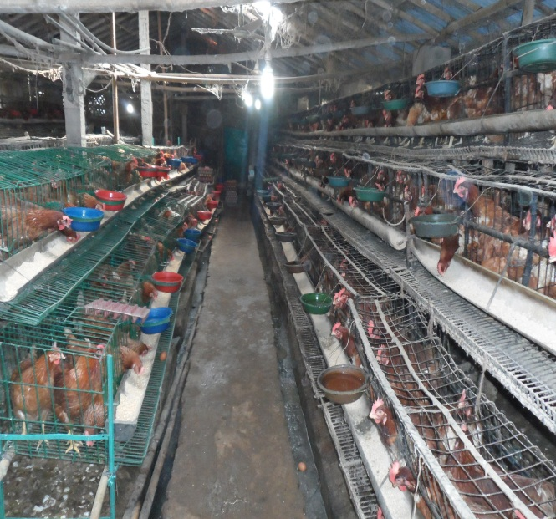
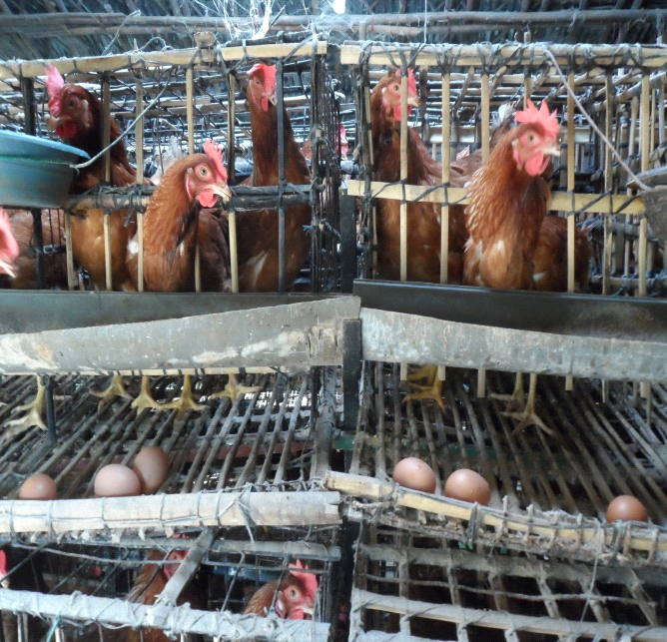

Figure: Cage rearing system of HISEX brown

3.3 Bio-security:
- Restricted movement of personnel.
- Footbath at the entry of the gate for both stuff and vehicles.
- Spray with antiseptic solution is done routinely around the farm.
- The feeder, hover, water lines are cleaned every morning.
- The poultry droppings is removed and cleaned daily.
- Every morning there was a routine work to remove the dead birds and kept them out side of the shed for post mortem.
- Around 10-12kg lime was spread all over the farm almost twice in a week.
- To prevent the insects, fly, mosquito, spider, and other microbes the farm was sprayed every 14 days interval by using H₂O₂ solution.

3.3.1 Fumigation
Fumigation place | ppm + Formalin  ( gm + ml) | Fumigation time
Layer house | (20 + 40) | 20 minutes

3.4 Deworming
Deworming was done at the age of 45 days of the birds and second time deworming was done at the age of 90 day.

3.5 Debeaking
Debeaking was done at the age of 84 days of birds by using debeaker.

3.6 Vaccination schedule
Vaccination was done against Gumboro disease, Ranikhet disease, Fowl Cholera, Infectious coryza, coccidiosis,Fowl pox. The vaccination schedule is given below:

Table 3.6.1: Vaccination schedule of Islam Poultry Farm.

Age | Vaccine
3rd day | IB + Ranikhet
5th day | IBD-Gumboro
7th day | IBD + Ranikhet
10-13th day | Coccidis
14th day | IBD-Gumboro
21th day | Ranikhet
28th day | Gumboro
35th day | Bronchitis
42th day | Fowl pox
52th day | Cholera
60th day | Coryza
70th day | Fowl pox
95th day | Cholera
112th day | Coryza
125th day | IB + ND + EDS

3.7 Lighting
Lighting schedule followed in this farm is given below in table:

Table 3.7.1: Lighting schedule for HISEX brown of Islam Poultry Farm.

Age/day/week | Light/day(in hour) | Watt/sq.ft
1-3 days | 24hours | 0.56 watt
4-6 days | 23 hours | 0.50 watt
1-2 weeks | 23 hours | 0.25 watt
2-3 weeks | 22 hours | 0.19 watt
3-4 weeks | 18 hours | 0.19 watt
4-5 weeks | 16 hours | 0.19 watt
5-6 weeks | 14 hours | 0.19 watt
6-10 weeks | 13 hours | 0.19 watt
11-18 weeks | 12 hours | 0.095 watt
18-20 weeks | 11.30 hours | 0.019 watt
20-21 weeks | 12 hours | 0.25 watt
21-22 weeks | 12.30 hours | 0.25 watt
22-23 weeks | 13 hours | 0.25 watt
23-24 weeks | 13.30 hours | 0.25 watt
24-25 weeks | 14 hours | 0.25 watt
25-26 weeks | 14.30 hours | 0.25 watt
26-27+weeks | 16 hours | 0.25 watt

3.8 Feeding system
The birds were 38th to 41st weeks of age reared in the ISLAM poultry farm. There is a standard ration which supplied with some deviation of standard level:

Table 3.8.1: Standard ration for HISEX brown in Islam Poultry Farm.
Age in week | 0-4 | 4-7 | 8-14 | 15-17 | 17-40 | 40-60 | + 60
CP% | 21-22% | 19.5% | 17.5 | 15.0 | 17-18 | 16-17 | 15-16
ME/K CAL/KG | 2900 | 2900 | 2825 | 2775 | 2800 | 2775 | 2750
Crude Fiber% |  | 3-5 | 3-6 | 4-7 | 3-6 | 3-6 | 3-7
Crude fat % |  | 2.5-6 | 2.5-7.0 | 2.5-7.0 | 3-7 | 3-7 | 3-7
Linoleic acid |  | 1.2 | 1.0 | 1.0 | 1.2 | 1.2 | 1.2

The following rations were approximately maintained in the ISLAM poulry farm for 100 kg of feed, beside these there were some feed additives, toxinbinder, vitamin minerals are also used. But sometimes there may be some changes also occurred in the ration according to physical condition of the birds and also according to environment.
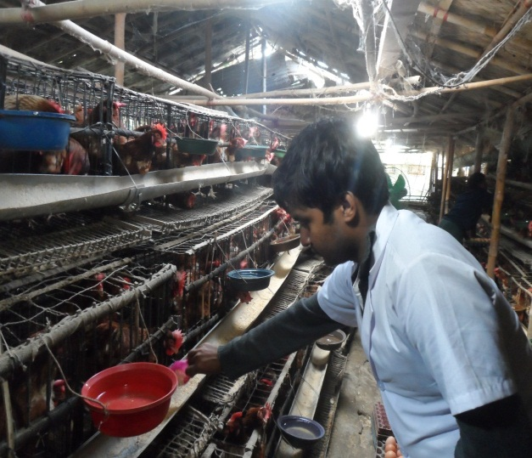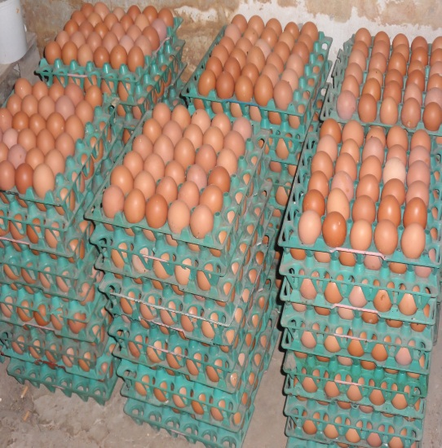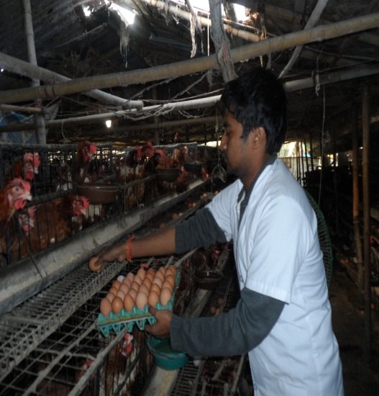

Pictures of Feeding and Egg collection
Table 3.8.2: Ration followed in Islam Poultry Farm
Age | 6-10 weeks | 11-17 weeks | 17-19 weeks | 20-28 weeks | 29-45weeks | Over 46 weeks
Maize | 61 kg | 57 kg | 61 kg | 58 kg | 58.5 kg | 59 kg
Soya | 20.5 kg | 13 kg | 16.5 kg | 22.5 kg | 22.5 kg | 23 kg
Propac | 3 kg | 2 kg | 2 kg | 3 kg | 2.5 kg | 2.5 kg
Readymedicine | 2.5 kg | 2.5 kg | 2.5 kg | 3 kg | 2.5 kg | 2.5 kg
Limestone | 1.5 kg | 1 kg | 2.5 kg | 7.5 kg | 9 kg | 9.5 kg
Energy | 0.5kg | 0.5 kg | 0.5 kg | 1 kg | 0.5 kg | 0.75 kg
Ricepolish | 11 kg | 24 kg | 15 kg | 5 kg | 4.5 kg | 4 kg

3.9 Watering
For the prevention of diseases clean water and germ free water were supplied to bird and each 100 birds need one round drinker in case of brooder condition, but when birds were shifted to the cage there was used a plastic bowl for each 3 birds. Beside plane water most of time some additional antibiotics, vitamins, like Protivit, AD3E; livertonic,Vit-E etc. were supplied to the birds by mixing with water.

3.10 Calculation Method
Egg production percentage was calculated by using the following formula (North, 1996)

No. of egg produced/ laid × 100
HHEP % =
No. of birds housed

No. of egg produced/ laid × 100
HDEP % =
No. of birds available in the flock on that day

Mortality rate was calculated on the monthly loss basis and average egg production,
egg weight and feed consumption were calculated during 32weeks of age.
CHAPTER –IV
RESULTS

The result of current study is shown under the following subheading.
4.1 1st week of observation
Time period: From 01/01/2013 to 07/01/2013
Age of the birds: 38 weeks
Total no of birds were: 7572
Table: 4.1.1 Egg production percentage, body weight gain, feed intake and mortality rate in 1st week observation at the age of 38th week.
Date | Age in weeks | Days in a week | Total No. of birds | No. of dead birds | Feed intake per hen per day (gm) |  | Body weight: Kg per hen |  | Total egg Prod. Per day | % of  Egg Prod. Per day
1/1/13 | 38 | 1stday | 7572 | 0 | 120 |  | 1.85 |  | 6412 | 84.68
2/1/13 | 38 | 2ndday | 7572 | 0 | 120 |  | 1.85 |  | 6522 | 86.13
3/1/13 | 38 | 3rdday | 7572 | 0 | 120 |  | 1.85 |  | 6588 | 87.00
4/1/13 | 38 | 4thday | 7572 | 0 | 120 |  | 1.85 |  | 6584 | 86.95
5/1/13 | 38 | 5thday | 7571 | 1 | 120 |  | 1.85 |  | 6514 | 86.03
6/1/13 | 38 | 6thday | 7571 | 0 | 120 |  | 1.85 |  | 6528 | 86.22
7/1/13 | 38 | 7thday | 7570 | 1 | 120 |  | 1.85 |  | 6540 | 86.39
Average |  |  |  | 0.026% |  | 120 |  | 1.85 |  |  | 86.20

This table showed that the number of total dead birds were 2 and the mortality rate of the 1st week was 0.026%. The table represented the amount of feed intake per day per bird which was 120 gm. This table revealed the weight gaining of per bird per week that was 1.85 kg. This table also denoted that the average percentage of egg production of 1st week was 86.20%.

4.2 2nd week of observation
Time period: From 08/01/2013 to 14/01/2013
Age of the birds: 39 weeks
Total no of birds were: 7570
Table: 4.2.1 Egg production percentage, body weight gain, feed intake and mortality rate in 2nd week observation at the age of 39th week.
Date | Age in weeks | Days in a week | Total No. of birds | No. of dead birds | Feed intake per hen per day (gm) | Body weight: Kg per hen | Total egg Prod. Per day | % of  Egg Prod. Per day (%)
8/1/13 | 39 | 1stday | 7570 | 0 | 120 | 1.85 | 6512 | 86.02
9/1/13 | 39 | 2ndday | 7568 | 2 | 120 | 1.85 | 6520 | 86.15
10/1/13 | 39 | 3rdday | 7568 | 0 | 120 | 1.85 | 6482 | 85.65
11/1/13 | 39 | 4thday | 7567 | 1 | 120 | 1.85 | 6465 | 85.43
12/1/13 | 39 | 5thday | 7566 | 1 | 120 | 1.85 | 6432 | 85.01
13/1/13 | 39 | 6thday | 7566 | 0 | 120 | 1.85 | 6452 | 85.27
14/1/13 | 39 | 7thday | 7566 | 0 | 120 | 1.85 | 6466 | 85.46
Average |  |  |  | 0.052% | 120 | 1.85 |  | 85.57

This table represented that the numbers of total dead birds were 4 and the mortality rate of the 2nd week was 0.052%. The table revealed the amount of feed intake per day per bird which was 120 gm. This table denoted the weight gaining of per bird per week that was 1.85 kg. This table also showed that the average percentage of egg production of 2nd week was 85.57%.

4.3 3rd week of observation
Time period: From 15/01/2013 to 21/01/2013
Age of the birds: 40 weeks
Total no of birds were: 7566
Table: 4.3.1 Egg production percentage, body weight gain, feed intake and mortality rate in 3rd week observation at the age of 40th week.
Date | Age in weeks | Days in a week | Total No. of birds | No. of dead birds |  | Feed intake per hen per day (gm) | Body weight: Kg per hen | Total egg Prod. Per day | % of  Egg Prod. Per day (%)
15/1/13 | 40 | 1stday | 7566 | 0 |  | 120 | 1.90 | 6498 | 85.88
16/1/13 | 40 | 2ndday | 7565 | 1 |  | 120 | 1.90 | 6458 | 85.36
17/1/13 | 40 | 3rdday | 7563 | 2 |  | 120 | 1.90 | 6438 | 85.12
18/1/13 | 40 | 4thday | 7563 | 0 |  | 120 | 1.90 | 6408 | 84.72
19/1/13 | 40 | 5thday | 7562 | 1 |  | 120 | 1.90 | 6414 | 84..81
20/1/13 | 40 | 6thday | 7562 | 0 |  | 120 | 1.90 | 6428 | 85.00
21/1/13 | 40 | 7thday | 7561 | 1 |  | 120 | 1.90 | 6440 | 85.17
Average |  |  |  |  | 0.066% | 120 | 1.90 |  | 85.15

This table revealed that the numbers of total dead birds were 5 and the mortality rate of the 3rd week was 0.066%. The table showed the amount of feed intake per day per bird which was 120 gm. This table represented the weight gaining of per bird per week that was 1.90kg. This table also denoted that the average percentage of egg production of 3rd week was 85.15%.

4.4 4th week of observation
Time period: From 22/01/2013 to 28/01/2013
Age of the birds: 41 weeks
Total no of birds were: 7561
Table: 4.4.1 Egg production percentage, body weight gain, feed intake and mortality rate in 4th week observation at the age of 41st week.
Date | Age in weeks | Days in a week | Total No. of birds | No. of dead birds | Feed intake per hen per day (gm) | Body weight: Kg per hen | Total egg Produce Per day | % of egg Produce Per day (%)
22/1/13 | 41 | 1st day | 7561 | 0 | 120 | 1.90 | 6422 | 84.93
23/1/13 | 41 | 2nd day | 7561 | 1 | 120 | 1.90 | 6416 | 84.85
24/1/13 | 41 | 3rd day | 7560 | 1 | 120 | 1.90 | 6410 | 84.78
25/1/13 | 41 | 4th day | 7560 | 0 | 120 | 1.90 | 6394 | 84.57
26/1/13 | 41 | 5th day | 7558 | 2 | 120 | 1.90 | 6380 | 84.41
27/1/13 | 41 | 6th day | 7558 | 0 | 120 | 1.90 | 6428 | 85.04
28/1/13 | 41 | 7th day | 7557 | 1 | 120 | 1.90 | 6402 | 84.71
Average |  |  |  | 0.066% | 120 | 1.90 |  | 84.75

This table represented that the number of total dead birds were 5 and the mortality rate of the 4th week was 0.066%. The table denoted the amount of feed intake per day per bird which was 120 gm. This table showed the weight gaining of per bird per week that was 1.90 kg. This table also revealed that the average percentage of egg production of 4th week was 84.75%.

CHAPTER-V
DISCUSSION
The present study was undertaken to observe the management practices and compare the production performances of the birds in ISLAM poultry farm, Potia, Chittagong, during the period January, 2013. Comparison of Per week Average production, mortality rate, feed intake, body weight gain at the age of 38th to 41st weeks of HISEX brown between observed in the farm and the standard.
Table: 5.1 Comparison between observation and standard level
Age  In week | Total birds | Dead birds per week | Standard |  |  |  | Observation
 |  |  | Feed intake per hen per day (gm) | Body Wt. Kg per hen per week | Mortality Rate(%) | % of Prod. Of egg in a week | Feed intake per hen per day (gm) | Body wt gain kg per hen per week (kg) | Mortality rate perweek(%) | Total eggs gain per week | % of Prod. Of egg in a week (%)
38 | 7572 | 2 | 120 | 1.910 | 1.6 | 93 | 120 | 1.85 | 0.026 | 45688 | 86.20
39 | 7570 | 4 | 120 | 1.915 | 1.7 | 93 | 120 | 1.85 | 0.052 | 45329 | 85.57
40 | 7566 | 5 | 120 | 1.920 | 1.8 | 92 | 120 | 1.90 | 0.066 | 45084 | 85.15
41 | 7561 | 5 | 120 | 1.930 | 1.8 | 92 | 120 | 1.90 | 0.066 | 44852 | 84.75

(Source of standard level: Anon. 2013. c)

From the above given analysis and comparison it was found that the percentage of egg production of HISEX brown of standard level is 93%, 93%, 92% and 92% respectively at the age of 38th, 39th, 40th and 41st weeks of age but in the farm it was calculated 86.20%, 85.57%, 85.12% and 84.75% which were slightly lower than the standard level. In this study it was seen that the highest production was achieved at the 38th week of age, after that the production become lower as the age rises, it is similar to the egg production of commercial layer commences about 19th week of age, rises sharply to a peak at about 26th to 27th weeks of age and than declines gradually (Rahman, 2003).
Again it was found that the mortality rate were 0.026%, 0.052%, 0.066% and 0.066% in that farm according to the observation respectively at the age of 38th, 39th, 40thand 41st weeks; whether the standard levels are 1.6%, 1.7%, 1.8% and 1.9% which are higher than the observed result. So that it is very good for the farm that the mortality rate is very lower than the normal standard.
Amount of feed intake per day per bird was 120 gm which was also similar to the standard level.
In case of weight gain the standard levels are 1.910 kg, 1.915 kg, 1.920 kg and 1.930 kg per bird respectively at the age of 38th, 39th, 40th and 41st weeks and the observation were 1.85 kg, 1.85 kg, 1.90 kg and 1.90 kg respevtively in the farm. Weight gain was almost same to the standard level that means the production performance and the weight gain were good in that farm because of good management system and no wastage of feed. It is as like as better performance of egg type layers with increase in flock size. This may be due to better management by owners of larger flocks and avoidance of unnecessary wastage of feed (Nair and Ghadoliya, 2000; Kumar and Mahalati, 1998).

CHAPTER-VI
CONCLUSION

Although the studied farm follows the rules of layer farming method, the egg production did not reached to the peak production compared to standard level but mortality was lowest during rearing of chicks and laying period. From this study it may be concluded that the egg production can be increased up to the standard level with good management practices. It can be also assured that the farm will be more profitable for getting standard level production it is also very important to maintain biosecurity.

CHAPTER-VII

REFERENCES

Ames, G.C.W. and Ngemba, L.M. 1985. Poultry production in zaire. World economic and rural sociololy, 28: 51-89.

Anon.2013.a. Economic review of Bangladesh, 2012.,Retrieved 05/02/2013 from http://www.mof.gov.bd

Anon.2013.b. HISEX brown management guide., Retrieved 08/02/2013 from http://www.centurionpoultry.com

Anon.2013.c. HISEX brown., Retrieved 08/02/2013 from http://www.hendrix-genetics.com

Bangladesh Bureau of Statistics. 2006.

Hurwitz, S. and Plavnik, L. 1998. Severe feed restriction in pullets during the early growing period: performance and relationship among age, body weight and egg weight at the onset of production. Poultry Science, 68: 914-924.

Krishnappa, P., Devagowda, G.R. and Ramappa, B.S. 1992. Effect of restricted feeding on subsequent performance of broiler breeder dams. Indian Joural of Poultry Science, 27: 29-31.

Miah, M.S., Islam, and Ali 2002.Growth and Egg Production Performance of Purebred and Crossbred Chicken. The Bangladesh Veterinarian, 19: 43-47.

Morris, I.R. and Fox, S. 1960. The use of lith to delay sexual maturity in pullets . Animal Breeding Abstract, 28: 458.

Mostageer, A. and Kamar, G.A.R. 1960. On the inheritance of egg weight. Poultry Science, 40: 857.

Nair, B.C. and Ghadoliya, M.K. 2000.Economic viability of layer farming in the state of Goa. Indian journal poultry science, 35: 73-76.

North, O.M. and Bell, D. 1996. Commercial Chicken Production Manual.4th end. Chapman and Hall New York, Pp: 175-210, 227-254, 407-432and 711-713.

Oluyemi, J.A. and Robert, F.A. 1979. Management and housing of adult birds, In poultry production in warm wet climates, 49-106 pp.

Parkhurst, R.I. 1944. Some factors affect egg weight in domestic fowl. Poultry Science, 12: 97.

Rahman, M. 2003. Growth of poultry industry in Bangladesh :Poverty alleviation and employment. Proc. of 3rd international poultry show and seminar, from February 28 to March 2, 2003, held in Bangladesh China Friendship Conference Centre (BCFCC) at Sher-e-Bangla Nagar, Dhaka, Bangladesh, 1-7 pp.

Robinson, E.E. and Willson, J.J. 1996. Reproductive failure in over weight males and females broiler breeder. Animal Food Science and Technology, 58: 1-2 and 143-150.

Rodenburg, T.B., Tuyttens, F.A.M., De reu, K., Herman, L. and Zoon, J. 2009. Welfare assessment of laying hens in furnished cages and non cage system. Animal welfare, 18: 533-538.

Saleque, M. A. 2001. Poultry as a tool in poverty alleviation; a special programme for the rural poor in Bangladesh, Proc.Of 2nd WPSA. International poultry show and seminar, 66-69 pp.

Scott, T.A., Silversides, F.G., Tietge, D. and Swift. 1999. Effect of Feed From, formulation and restriction on performance of laying hen. Canadian Journal on Animal Science , 26: 79 and 171-178.

Spralt, R.S. and Leeson, S. 1987. Broiler breeder performance in response to diet protein and energy. Poultry Science, 66: 683-693.

Tumova, E., Englmaierova, M., Ledvinka, Z. and Charvatova, V. 2011. Interaction between housing system and genotype in relation to internal and external egg quality parameters. The journal of animal science, 56: 490-498.

Tumova, E., Skrivan, M., Englmaierova, M. and Zita, L. 2011. The effect of genotype, housing system and egg collection time on egg quality in egg type hens. The journal of animal science, 54: 17-23.

Warren, D.C. 1953. Practical Poultry Breeding. The McMillan Company, New York.

