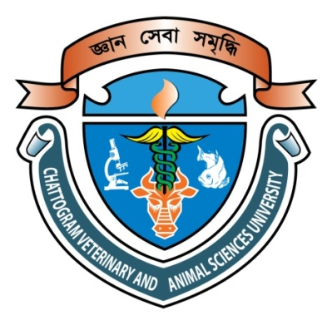

Nutritional Status and Associated Risk Factors of Malnutrition Among Disabled Rohingya Refugee Children in Cox’s Bazar Bangladesh

Muhammad Zahirul Islam
Roll No. : 0118/28
Registration No.: 569
Session: 2018-2019

This is to certify that we have examined the above Master’s thesis and have found that is complete and satisfactory in all respects, and that all revisions required by the thesis examination committee have been made

Department of Applied Food Science and Nutrition
Faculty of Food Science and Technology

Chattogram Veterinary and Animal Sciences University
Chattogram-4225, Bangladesh

June 2020

