STUDY ON PRODUCTION PERFORMANCE & MORTALITY RATE OF NOVOZEN BROWN IN POULTRY FARM AT BOALKHALI, CHITTAGONG.
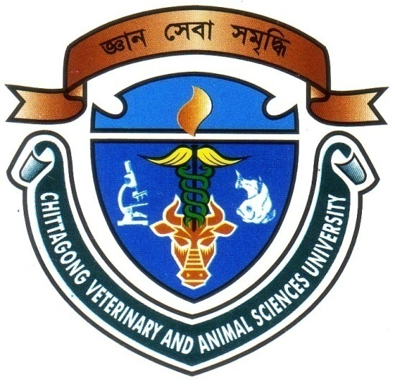

A Production Report Submitted by
Roll No: 07/36
Reg. No: 322
Intern ID: C-32
Session: 2006-2007

This Production Report is Submitted for Fulfillment of the Degree of Doctor of Veterinary Medicine (DVM)

CHITTAGONG VETERINARY AND ANIMAL SCIENCES UNIVERSITY
KHULSHI, CHITTAGONG

Feb. 2013
STUDY ON PRODUCTION PERFORMANCE & MORTALITY RATE OF NOVOZEN BROWN IN POULTRY FARM AT BOALKHALI , CHITTAGONG.

A Production Report is submitted as per approved
Style and Content

------------------------------- Signature of Author  MD.ABU SAYEM  Roll No. :07/36  Reg. No. : 322 ID. No. : C-32  Session :2006-07 | ------------------------------------  Signature of supervisor  MD. AKHTAR-UZ-ZAMAN  Professor  Dept.of Dairy &Poultry Science,  Chittagong veterinary & Animal Sciences University.

CHITTAGONG VETERINARY AND ANIMAL SCIENCES UNIVERSITY
KHULSHI, CHITTAGONG

Feb. 2013

INDEX

Sl. No | Content | Page No
01 | Introduction | 1-2
02 | Objectives | 4
03 | Review of Literature | 5
04 | Materials & Methods | 6-13
06 | Result and Discussion | 14
07 | Conclusion | 15
08 | References | 16-17

ACKNOWLEDGEMENT

These are few lines of acknowledgement can never substitute the deep appreciation that I have for all those without whose help, support and inspiration this dissertation would not have taken its present shape.
The author is ever grateful and indebted to the Almighty Allah, the creator and soul authority of universe, who enabled me to complete this work successfully.
The author express his deepest sense of gratitude, sincere appreciation and profound regards to authors reverend teacher Md. Akhtar-Uz-Zaman professor, Dept. of Dairy & Poultry Science, Chittagong Veterinary and Animal Sciences University for his scholastics guidance, uncompromising principles, sympathetic supervision, valuable advice, constant inspiration, radical investigation and constructive criticism in all phases of this study and preparing the manuscript.
.
I express my sincere gratitude to all teaching and non teaching staff members of my working departments for their support.
My sincere thanks to all of my Friends and well Wishers for their help, encouragement and inspiration during the study period and preparing a report.

The Author:

ABSTRACT

The study was carried out at Mousumi poultry farm in Chittagong for a period of 01/01/2013to31/01/2013 to observe management of housing, feeding, lighting, production performance, mortality rate disease control practices of 22,000 layer birds of Novozen brown under open housing system. During study period, in case of layer, the body weight was observed 1.87kg, 1.89kg, 1.94kg and mortality was 0.027%, 0.018% and 0.018% respectively in 33th, 34th, 35th weeks of age and average feed intake was 116.79gm/day. The hen day egg production was 87.05% from 33rd to 35th week of age and hen house egg production was 87.13% at 33rd of age. The mortality was 0.021% in per week and total mortality was 0.063% in total experimental period. It may be concluded that peak production can be achieved during 33rd week of age.

Key words: Chicks, Starter, Performance, Management, Layer,

