A CASE REPORT TO ASSESS THE FEASIBILITY OF BLOOD TRANSFUTION IN THEILERIOSIS IN CATTLE
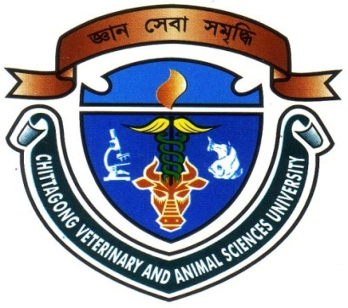

A clinical report submitted by-
Roll no: 07/52
Reg. no : 339
Intern ID : E-48
Session: 2006-2007
A clinical report presented in part fulfillment for the requirement for the doctor of veterinary medicine (DVM), CVASU.

June,2013
A CASE REPORT TO ASSESS THE FEASIBILITY OF BLOOD TRANSFUTION IN THEILERIOSIS IN CATTLE

A clinical report presented in part fulfillment for the requirement for the degree of veterinary medicine (DVM), CVASU.

……………………… ………………………………
Signature of the Author Signature by the Supervisor
Md.Delwar Hossen DR. Monoar Sayeed Pallab
Roll no : 07/52 Assistant Professor
Reg. no :339 Dept. of Medicine and Surgery, Intern ID: E-48 CVASU.

June,2013
CONTENTS
Serial No. | Chapter | Subjects | Page No.
1 |  | Acknowledgment | i
2 |  | Abstract | ii
3 | I | Introduction | 1-3
4 | II | Review of Literature | 4-11
5 | III | Materials and Methods | 12-16
6 | IV | Results and Discussions | 17-18
7 | V | Conclusion | 19
8 |  | References | 20-22

List of Tables
Serial No. | Name | Page No.
01 | Parameters of the animal before treatment and after treatment.

List of Figures
Serial No.. | Name | Page No.
01 | Collection of blood from the donor cattle.
02 | Storage of blood in blood bags.
03 | Transfusing of blood to the recipient cattle.
04 | Blood infusion set.

List of graphs
Serial No. | Name | Page No.
01 | Graphical presentation of the changes of PCV, Hb in blood of a theileria affected animal before and after treatment.

TITLE: A CASE REPORT TO ASSESS THE FEASIBILITY OF BLOOD TRANSFUTION IN THEILERIOSIS IN CATTLE

ABSTRACT
The study was conducted at Veterinary College and Research Institute of Namakkal(VC & RI ) under Tamilnadu Veterinary and Animal Sciences University (TANUVAS), to assess the success of blood transfusion in theileriosis of a cattle. The cattle was severely infected with theileriosis. The diagnosis of theileriosis was made by clinical examinations and pathological tests. As it was clinical study, the haematological progress gave us clear idea which we observed the clinical parameters before and after transfusion. Before transfusion of blood the Packed Cell volume(PCV) and Haemoglobin(Hb) of the recipient cow were 15% and 6(g/dl) respectively, which were below the normal range.Clinically the superficial lymphnodes were very swollen. After medication and blood transfusion we found PCV 22% and Hb 8(g/dl) having pink color mucous membrane. However, it was pale before blood transfusion. The cattle was successfully recovered after seven days.
Key words: Cattle, Theileriosis, Blood transfusion.

ii

Acknowledgement
The author would like to express the deepest sense of gratitude; all sorts of praises to the almighty of Allah subhanahuwata-ala, the omnipotent, omnipresent and omniscient, whose blessing have enabled the author to complete this report and thereby the degree of Doctor of Veterinary Medicine.
It is the author proud’s privilege to acknowledge his sincere and deepest sense of gratitude to the most respected teacher and supervisor Dr.Monoar Sayeed Pallab, Assistant Professor ,Department of Medicine and Surgery, Faculty of Veterinary Medicine, Chittagong Veterinary and Animal Sciences University, Chittagong for his untiring efforts, inspection, encouragement, affectionate feelings and invaluable guidance throughout the course of this study. Without his scholastic supervision, congenial cooperation, unfailing interest and constructive criticism this report would not have seen the light of the day.
The author is ever grateful and immensely indebted to his honorable Professor Dr. A. S. Mahfujul Bari, Vice-Chancellor, and Professor Dr. Md. Kabirul Islam Khan, Dean, Faculty of Veterinary Medicine, Chittagong Veterinary and Animal Sciences University. I highly express my sincere gratitude and gratefulness to the internship coordinator and Director of External Affairs, Professor Bibek Chandra Sutradhar, Department of Medicine and Surgery, Chittagong Veterinary and Animal Sciences University, for his constant inspiration, cordial co-operation, and valuable suggestion for completion of the research work.

The Author
June 2013

i

