HEAMATO-BIOCHEMICAL PROFILE OF CROSSBRED COWS AND CALVES

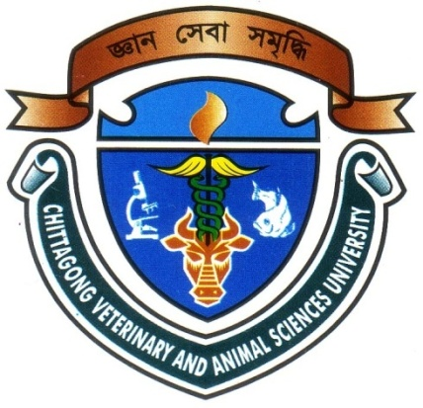

A Clinical Report submitted by
Examination Roll: 07/47
Reg. No: 334
Internship ID: E-43
Session: 2006-2007

This report is submitted for partial fulfillment of the Degree of
Doctor of Veterinary Medicine (DVM)

Chittagong Veterinary and Animal Sciences University
Khulshi, Chittagong-4225, Bangladesh.

June, 2013

HEAMATO-BIOCHEMICAL PROFILE OF CROSSBRED COWS AND CALVES
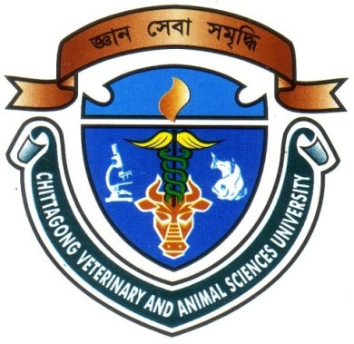

A Clinical Report
Submitted as per approved style and contents

………………………………………  Signature of Author  Md. Imran Ahmed  Roll No : 07/47  Reg. No : 334  Intern ID : E-43  Session : 2006-2007 | ……… ………………………………  Signature of Supervisor  Professor Dr. Md. Abul Quasem  Department of Anatomy & Histology  Chittagong Veterinary and Animal Sciences University, Bangladesh.

June, 2013
CONTENTS
Serial No. | Title | Page
 | LIST OF TABLES | i
 | ACKNOWLEDGEMENT | ii
 | LIST OF ABBREVIATIONS | iii
 | ABSTRACT | iv
CHAPTER 1 | INTRODUCTION | 1-2
CHAPTER 2 | REVIEW OF LITERATURE | 3-9
CHAPTER 3 | MATERIALS AND METHODS. | 10-19
CHAPTER 4 | RESULTS | 20-23
CHAPTER 5 | DISCUSSION | 24-26
CHAPTER 6 | CONCLUSION | 27
 | REFERENCE | 28-33
 | APPENDIX | 34-37

