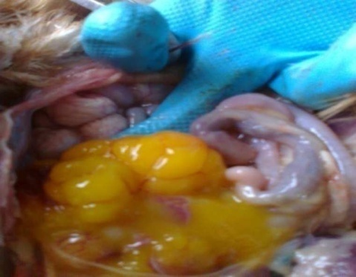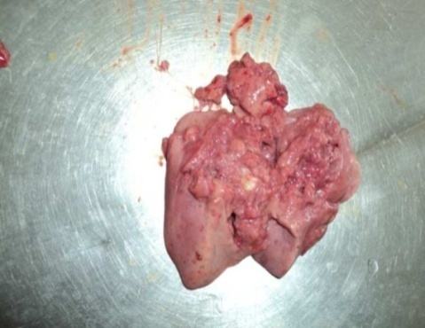

IMAGE GALLERY

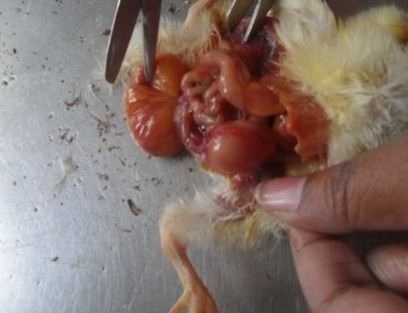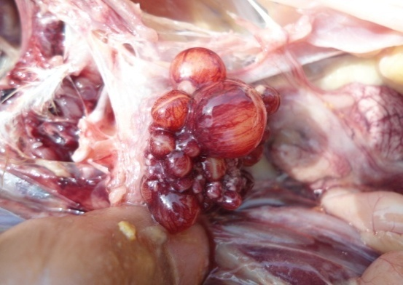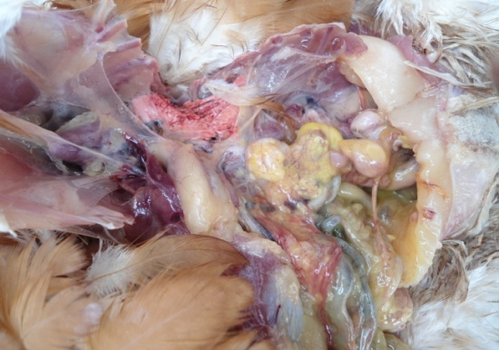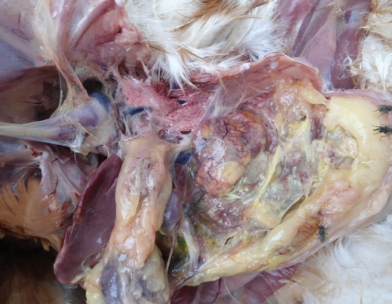

**Fig.-5: Egg peritonitis in Salmonellosis**

**Fig.-1: Misshapen ovum in Salmonellosis.**

**Fig.-2: Fragile Liver in Salmonellosis.**

**Fig.-4: Unabsorbed Yolk Sac in Chick in Salmonellosis**

**Fig.-3: Congested ovum in Salmonellosis**.

**Fig.-6: Deposition of caseous mass in Salmonellosis.**