A COMPARATIVE STUDY OF DIFFERENT METHODS OF MEAT PRESERVATION

AS THE PARTIAL FULFILLMENT FOR THE DEGREE
OF

DOCTOR OF VETERINARY MEDICINE (DVM)

EXAMINATION ROLL NO: 07/52
INTERN ID: E-48
REGISTRATION NO: 339
SESSION: 2006-2007
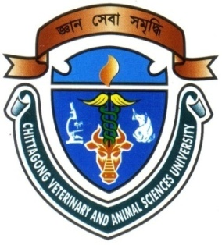

Faculty of Veterinary Medicine

CHITTAGONG VETERINARY AND ANIMAL SCIENCES UNIVERSITY

KHULSHI, CHITTAGONG-4202

FEBRUARY 2013
A COMPARATIVE STUDY OF DIFFERENT METHODS OF MEAT PRESERVATION
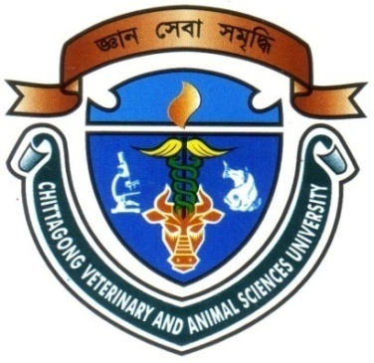

Approved as to style and content by

Signature of the Supervisor

Name: Md. Manirul Islam
Designation: Associate Professor
Department of Animal Science & Nutrition
Chittagong Veterinary and Animal Sciences University.

CHITTAGONG VETERINARY AND ANIMAL SCIENCES UNIVERSITY

KHULSHI, CHITTAGONG-4202

FEBRUARY 2013
Acknowledgements
The author bends his heads to the Almighty who is omnipotent, omniscient and omnipresent for His endless blessing to conduct this research work for the fulfillment of the requirement for the degree of Doctor of Veterinary Medicine (DVM).

The author desires to express his earnest gratefulness and profound appreciation to the following persons for the accomplishment of this dissertation.

The author convening her gratitude and great appreciation to the venerable internship supervisor Md. Manirul Islam, Associate Professor, Department of Animal Sciences & Nutrition, Faculty of Veterinary Medicine for his valuable guidance, suggestion, supervision and encouragements during the entire period of this study to complete this report.

I take the opportunities to express my deepest sense of respect and appreciations to the honorable Professor Dr. A. S. Mahfujul Bari, Vice-Chancellor, and Professor Dr. Md. Masuduzzaman, Dean, Faculty of Veterinary Medicine, Chittagong Veterinary and Animal Sciences University. I highly express my sincere gratitude and gratefulness to the internship coordinator and Director of External Affairs, Professor Bibek Chandra Sutradhar, Department of Medicine and Surgery, Chittagong Veterinary and Animal Sciences University, for his constant inspiration, cordial co-operation, and valuable suggestion for completion of the research work.

The Author

i
TITLE: A COMPARATIVE STUDY OF DIFFERENT METHODS OF MEAT PRESERVATION
ABSTRACT
The study was conducted to observe comparative assessment of meat preservation by using different method. The experiment was divided into three treatment groups having two replications. Three samples were collected from locally available markets. Where sample 1 was persevered by freezing method, sample 2 by pickling with vinegar and sample 3 by salting with common salt. The initial pH of the meat samples (S₁,S₂, S₃) were 5.84, 6.33 and 5.90 respectively. The initial moisture percentage of these (3) samples were 77.43, 70.25 and 76.10, respectively. And the total viable count of bacteria was(1.8x10⁶/CFU) in sample1, 2.3x10⁶/CFU) in sample3 which were negligible and in sample2 the microbial load was 14x10⁶CFU/gm. After one month of preservation, the second reading was taken from the same samples. There are some changes observed in pH, moisture, texture, color and TVC. It is revealed that the preserving of meat by salting is significantly better than other two methods. So, it may be concluded that the meat preserving by salting more safety, more reliable and more economic for human consumption.

Key wards: Meat, preservation, freezing, pickling, Salting, pH and TVC.

ii
CONTENTS
Serial no. | Name of the contents | Page no.
01 | Acknowledgement | i
02 | Abstract | ii
03 | Introduction | 1-2
04 | Review of Literature | 3-12
05 | Materials and Methods | 13-19
06 | Results and Discussion | 20-22
07 | Conclusion | 23
08 | References | 24-28

