INTRODUCTION

Poultry industries play an important role in poverty alleviation and economic development of Bangladesh. Poultry meat contributes approximately 37% of total animal protein supplied in the country (Rahman and Rahman, 1998). Government of the People's Republic of Bangladesh has recently given priority in potential poultry sector. There are 89.48 million poultry population in Bangladesh (Samad, 1996).

There are several constraints in poultry industries in Bangladesh. Among them pullorum disease (caused by S. pullorum, recently used nomenclature) is one of the major constraints of poultry industries in Bangladesh (Hossain et al., 2006).Salmonella infection is one of the most important bacterial diseases in poultry causing heavy economic loss through mortality and reduced production (Haider et al., 2003; Talha et al., 2001).There are mainly two types of non motile avian Salmonella sp. namely Salmonella gallinarum and Salmonella pullorum that cause fowl typhoid and pullorum disease, respectively (Hossain et al., 2006). Salmonella are Gram negative, short plump shaped rods, non-sporeforming, non- capsulated, aerobicand facultative anaerobic organisms and classified under the family Enterobacteriaceae (OIE Manual, 2006). More than 2300 serotypes of Salmonella have been identified, only about 10% of these have beenisolated from poultry (Gast, 1997). Pullorum disease is usually confined to the first 2-3 weeks of age and occasionallyoccurs in adults (Shivaprashad, 1997). Fowl typhoid is frequently referred to as a disease of adult birdsand there are also reports of high mortality in young chicks (Christensen et al., 1992).

The epidemiologyof fowl typhoid and pullorum disease in poultry, particularly with regard to transmission from onegeneration to the next are known to be closely associated with infected eggs (Wigley et al., 2001).Contaminated eggs produced by infected laying hens are thought to be one of the main sources of human infection with Salmonella Enteritidis (Humphrey et al., 1989). Eggs may become contaminatedwith Salmonella in two main ways: (i) Salmonella may silently infect the ovaries of apparently healthyhens and contaminate the eggs before the shells are formed. (ii) Salmonella infected bird droppingscontain Salmonella that can contaminate the outer egg shells and may penetrate when crack the shell (Deryck and Pattron, 2004).

Pathogenesis and sequential pathology of Pullorum Disease (PD) is an important factor to understand the disease mechanism. For the detection of Salmonella organism many of technologies have been developed. Immunohistochemistry is a latest technique for that purpose (Christine et al., 1999). A few researches have been completed on Salmonella pullorum infections using the conventional methods like necropsy, histopathology and isolation of bacteria by culture, stain and sugar fermentation tests (Islam et al., 2006; Haider et al., 2003).

Selection procedures for detection of Salmonella infection in poultry is the aim of many studies (Seran et al., 2010). In vitro culture is the predominant means for isolating and identifying salmonella species from fecal samples. This is time consuming usually require 72 to 96 hours for the organism to be defined by its cultural, biochemical and serological properties (Pomeroy B. S. and Nagaraja K. V. 1991). A number of serological test have been developed for detecting invasive serotypes, the most successful being slide agglutination using either serum or whole blood for the detection of poultry flocks infected with Salmonella gallinarum or its biovarpullorum (Snoeyenbos G. S., 1991 and Nagaraja et al., 1991). This test has been applied for successfully for more than 50 years and has contributed considerably to the control of pullorum disease and fowl typhoid from flocks in several countries. This test is however crude and has been found to be too unreliable and insensitive for use with other serotypes (Barrow P. A. 1992). Tube and micro agglutination test and the more sensitive micro antiglobulin tests have been applied to experimental and field infection with serogroups with B, C and D. However these tests are cumbersome and do not lend themselves readily to extensive use for large scale flock screening (Feberwee et al., 2001).

Salmonella serogroups B and D represents a high percentage of salmonella strains isolated from chicken meat (Seran et al., 2010) and among layer farm chickens (Ibrahim H. M., 2011). These serogroups are nearly most of the strains causing disease in Egypt, so these tests was directed against serogroups. In Egypt S. pullorum antigen (for tube and slide agglutination assays) and S. typhimurium for tube agglutination test are the only prepared antigen in Veterinary Serum and Vaccine Research Institute, Abbasia, Cairo (Mona et al., 2012).

Knowledge of the prevalence of the disease with confirmatory diagnosis is of paramount importance to embark on a control or prevention program as clinical signs, post-mortem findings and flock history are of limited value in arriving at a diagnosis because of the similarity of the diseases to a number of other diseases (Snoeyenbos G.S., 1978). Therefore, this study was conducted to estimate the prevalence of S. Gallinarum/Pullorum in apparently healthy chickens and to measure the relative importance of fowl typhoid and pullorum disease in morbidity/ mortality of intensively managed chickens in Kazi layer farm.

REVIEW OF LITERATURE

2.1. Overall prevalence of Salmonella infection

Large increases in the number of cases of human food-poisoning caused by salmonella have occurred in several countries in recent years. Diagnosis and control of avian Salmonellosis depend upon the use of effective antigens in the used serological test (OIE, 2010).

Dominant serotypes from clinical cases vary with geographical region: for example, S. enteritidisis the most common in Europe (Hassanein et al., 2011). Ten strains of S. typhimurium, 9 strains of serogroup B, 4 strains of Salmonella serogroup D and 3 strains of S. pullorum were detected (Sadek, 1996). The seroprevalence of Salmonella infection in layer chickens was studied andS. Pullorum and S. gallinarum is the most predominant in salmonella infection (Islam et al., 2006). While serovar identified by Hassanein et al. (2011) was Salmonella enterica subsp. Enterica serovar Enteritidis using PCR method.These serogroups are nearly most of the strains causing disease in Egypt, so the test was directed against these serogroups. Because the ELISAs for avian Salmonellas are indirect, detecting primarily specific IgG in serum or IgG in egg yolk, the assay can also be adapted to detect specific IgM produced early in infection (Hassan et al., 1991) and the polyvalent antigens are more reliable for detection of salmonellosis than monovalent antigen (Sadek, 2005).
The overall seroprevalence of Salmonellosis was recorded as 43.4% (Islam et al., 2006). Yang et al. (1996) reported relatively similar findings (39.02%). Ashenafi et al. (2003) and Habib-ur-Rahman et al. (2003) reported 64.2% and 63.5 % respectively, that was much higher than that of the present study. The variation of seroprevalence might be speculated due to geographical variation or difference of management. But the present finding (43.4%) in commercial farms was higher than the seroprevalence (23.46%) recorded by Sikder et al. (2005) in local chickens. The difference with Sikder et al. (2005) was corresponded with the findings of Jha et al. (1995) and Robinson et al. (2000), who recorded seroprevalence rate higher in commercial flock than local chickens.

A total of 605 sera samples were collected from 121 commercial layer farms and were subjected to RPA test. Out of these, 85 (14.1%) were found positive for single Salmonella infection. The overall prevalence ofSalmonellainfection was 25.3% (14.1+11.2) (Hossain et al., 2010). Similar reports have been described by Alam et al. (2003) who reported 23.8% seropositive chickens for Salmonellainfection in Dinajpur district of Bangladesh. Bouzoubaa et al. (1992) recorded 23.5% seropositive chickens for salmonellosis from Morocco. Besides Minga et al. (1987) and Bhattacharya et al. (2001) reported 33.8% and 37.7% seropositive chickens for Salmonellainfection in Tanzania and India, respectively. Whereas, Terzolo et al. (1977), Prukner (1987), Ghosh (1988), Muneer et al. (1988), Waltman and Home (1993), Yang et al. (1996), Hasegawa et al. (1999) reported 9.0%, 13.9%, 19.6%, 7.5%, 15.0%, 10.0% and 16.0% prevalence of Salmonellainfection in chickens, respectively.

A total of 6 samples collected from 5 birds were positive as the bacteria were isolated from both liver and cecum in one of the chickens. Four (12.9%) and 1 (3.2%) of 31 sick/dead birds examined had S. Gallinarum and S. Pullorum respectively. Five of the 6 isolates recovered were S. Gallinarumwhile the rest 1 was S. Pullorum. Of the recovered 6 isolates, 3 (50%) were from liver, 2 (33.3%) from cecum and 1 (16. 7%) from spleen. Salmonella Gallinarum was isolated from all the organs tested (liver, spleen and cecum) while the only isolate of S. Pullorum was recovered from liver. Salmonella Gallinarum/Pullorum was isolated from dead chickens originated from 2 of the 3 farms investigated in the autopsy study. Four of 20 (20%) sick/dead birds from one of the farms were positive for S. Pullorum/Gallinarum, while 1 out of 10 chickens (10%) was positive in the other farm. Interestingly, 207cloacal swab samples were negative while S. Gallinarum/Pullorum was isolated from 20% of sick/dead chicken from the same farm.Salmonella Pullorum was isolated from a 7 day old chick, while S. Gallinarum was isolated from three 7 day old chicks and a year old chicken (Kassaye et al., 2010).

In order to determine seroprevalence of Salmonella a total of 364 sera samples were collected from six Model Breeder Poultry Farm during winter and rainy season. All sera samples were tested by Serum Plate Agglutination (SPA) test. The results of seroprevalence of Salmonella infection in flock no. 1 was found to be 13.33% at first sampling but it increased to 14.70% at second sampling (5 months after first sampling). The prevalence of Salmonellainfection also 21.87% to 24% in flock no. 2, 19.44% to 27.58% in flock no. 3, 14.28% to 25% in flock no. 4 and 28.57% to 30% in flock no. 5 and 30.25% to 30.76% in flock no.6. The prevalence rate was recorded the highest (30.76%) in flock no. 6, during second sampling at the age of 39 lowest (13.33%) in flock no. 1, during first sampling at the age of 32 weeks (Sikder et al., 2005).

2.2. Prevalence of Salmonella infection in different ages

Concerning to the prevalence depending on the ages, the highest prevalence of Salmonella was 37.6% (27.2+10.4) at 64 weeks and above age group whereas the lowest prevalence was 16.6% (3.3+13.3) at 16-23 weeks age group (Hossain et al., 2010). Similar report was demonstrated by Sikder et al. (2005) who reported the highest Salmonella infection was 30.8% at 39 weeks of age and the lowest was 13.3% at 32 weeks of age. Truong et al. (2003) reported that the prevalence of Salmonellainfection increased with the increase of age.

2.3. Seasonal incidence of Salmonella infection

The prevalence of Salmonalla infection was the highest (18.5+11.9=30.4%) in summer followed by winter (11.6+12.1=23.7%), rainy (14.2+10.8=25.0%) and autumn (13.3+10.0=23.3%) (Hossain et al., 2010). Similar report was demonstrated by Rahman et al. (2004) who reported 48.1% prevalence of Salmonellainfection in summer in comparison to 23.7% in winter. Sikder et al. (2005) also recorded the highest (25.0%) prevalence of Salmonellainfection in rainy season than in winter (21.9%). Bhattacharjee et al. (1996) reported the highest prevalence of salmonellosis during pre-monsoon (13.1%) in comparison to winter (10.4%), monsoon (6.8%) and post-monsoon (6.8%) period. The highest rate of Salmonellainfection in summer season is probably due to the high growth rate of bacteria and the influence of hot weather that might reduce the immune status of the birds against infection (Hossain et al., 2010).

2.4. Prevalence of Salmonella infection with regard to flock size
Serological investigation showed the highest (17.1+17.1=34.2%) Salmonellainfection in large flocks (≥5001 birds) in comparison to small (≤1000 birds) flocks (12.5+8.8=21.3%) (Hossain et al., 2010). The present data were higher than those in the report of Skov et al. (1999) who recorded 16.8% Salmonella infection in a flock containing 30-40 thousand chickens in comparison to 11.9% in a flock containing 10-20 thousand and 9.7% in a flock containing less than 10 thousand chickens. Mdegela et al. (2000) recorded higher prevalence of Salmonella infection in commercial flocks (18.4%) than in scavenging chickens (6.3%) and reported that infection rate increased with the increase of flock size.

2.5. Detection of salmonella by necropsy findings
The prevalence of salmonella infection in liver, ovary and intestinal swabs of dead poultry was 11.42%. The findings revealed that prevalence was higher in liver and ovarian samples than intestinal samples (Hossain et al., 2006).

Some sequential gross pathological lesions were observed in the study of Shahinuzzaman et al., 2011.Chicks were sacrificed at day 1 (D1), day 3 (D3), day 5 (D5), day 7 (D7) and day 9 (D9) of PostInfection (PI) and observed the remarkable gross lesions in liver, lung, heart and cecum. Grossly, liver foundfragile (40%) at D7 and D9. Cheesy materials in cecum (20%) showed at D9. The highest reisolation of S.pullorum demonstrated in cecum (68%).To get the complete information caused by inoculated Salmonella pullorum bacteria, reisolation procedures were performed by some routine methods. Cecum (68%) was the prominent organ for reisolation of Salmonella pullorum and then liver (52%), lung (48%), crop (44%), spleen (12%) and heart (4%) respectively from D1 to D9. It was confirmed by observing the colony characters of Salmonella pullorumon Brilliant Green Agar (BGA), Salmonella-Shigella(SS) agar and TripleSugar Iron (TSI) agar. Out of 150 samples 57 gave positive colony characters of Salmonella pullorum. Formore confirmation of Salmonella pullorum reisolation, carbohydrate fermentation test of some basic sugars and biochemical test was performed. 5 Isolates were selected for this purpose (Shahinuzzaman et al., 2011).Enlarged and congested liver with focal necrosis; haemorrhagic and discoloured ovary with stalk formation and mild haemorrhagic to catarrhal enteritis in intestine and caecum were recorded during necropsy(Islam et al., 2006). These types of necropsy findings were supported by Calnek et al. (1991), Chauhan and Roy (1996), Syed-Habib-ur-Rahman et al. (2004), Hossain et al. (2003) and Khan et al. (1998)

Materials and method
This study was conducted on Hisex brown stain (layer) at Kazi poultry farm in Chittagong district. Samples were collected from three flocks in the period of January to May, 2013.
3.1.Sampling procedure
From each flocks chickens were randomly selected for blood collection. 2-2.5 ml of blood was collected aseptically from wing vein using sterile syringe and needle. After that syringe with blood was kept in a cool box in a standing position for 6 hours, serum was harvested by decanting. The harvested sera were transferred to 1.5 ml micro centrifuge tubes and were kept in a cool box before shipping to the laboratory. Sera samples were stored at -20°C in the laboratory until use for RPA test (OIE, 2002).
3.2.Preparation of antigens
Antigens are the killed and colored Salmonella organisms. Salmonella pullorum antigens from standard (O: 1, 9,121 and 123) and variant (O: 1, 9,121 and 122) strains were used in this surveillance program for pullorum disease and fowl typhoid (Proux et al., 2002). The Salmonella antigen (Nobilis® SP) used in this study were purchased from the Intervet International B.V. Boxmeer-Holland.
3.3. Rapid plate agglutination (RPA) test
The RPA test was conducted according to the instructions of OIE Manual (2002). For this test 0.02 ml of antigen and 0.02 ml of chicken serum were placed side by side with micropipettes on a glass plate. Then antigen and serum sample were mixed thoroughly by stirring with a small tooth pick. The glass plate was illuminated from below so as to facilitate observing the reaction, avoiding excessive heat from the light source. Positive reaction was characterized by the formation of definite clumps within 2 minutes after mixing the test serum with antigen (Fig.3.and 4.). The clumps usually started appearing and became concentrated at the periphery of the mixture. Negative reaction was judged by the absence of agglutination reaction. Care was taken so that the natural granulation of the antigen showed not to be taken as a positive reaction.

3.4.Pathological study
A total number of 25 dead layer chickens were examined to detect Salmonella infections. At necropsy, gross tissue changes were observed and recorded carefully and representative tissue samples (liver, lungs, spleen & intestine) containing lesions were preserved in 10 % buffered formalin for histopathological studies.

Results and discussion

4.1. Overall prevalence of Salmonella infection

A total of 20 sera samples were collected from commercial layer farms and were subjected to Rapid Serum Agglutination test. Out of these, 12 (60%) were found positive for single Salmonella infection. The overall seroprevalence of Salmonellosis was recorded as 43.4% (Islam et al., 2006). Yang et al. (1996) reported relatively similar findings (39.02%) which are lower than that of the present study. Ashenafi et al. (2003) and Habib-ur-Rahman et al. (2003) reported 64.2% and 63.5 % respectively, that was almost similar than that of the present study. The variation of seroprevalence might be speculated due to geographical variation or difference of management. But the present finding (43.4%) in commercial farms was higher than the seroprevalence (23.46%) recorded by Sikder et al. (2005) in local chickens. The difference with Sikder et al. (2005) was corresponded with the findings of Jha et al. (1995) and Robinson et al. (2000), who recorded seroprevalence rate higher in commercial flock than local chickens.
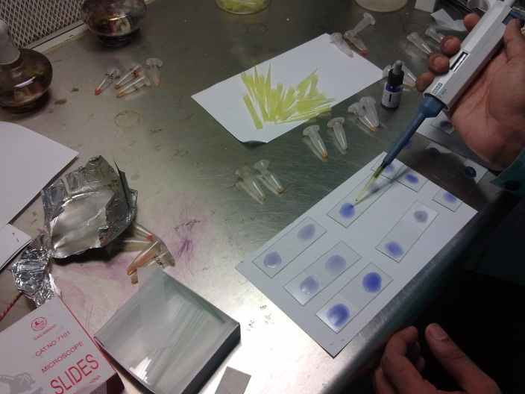 | 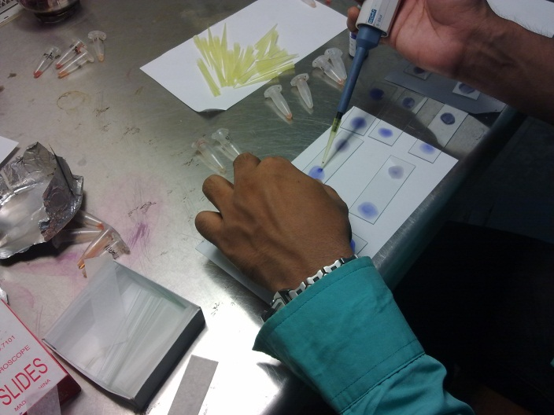
Fig.1. Pouring of antigen from bottle and serum from eppendorf tube in glass slide. | Fig.2. Mixing of antigen with test serum.
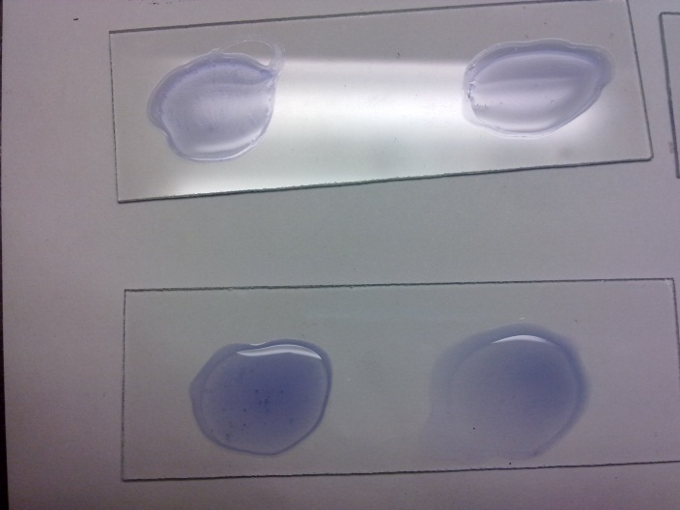 | 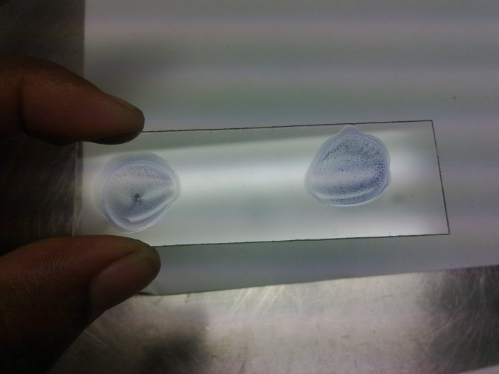
Fig.3. Medium size clumps show moderately positive reaction. | Fig.4. Large clumps, almost complete background clearing show highly positive reaction.

23.8% seropositive chickens for Salmonellainfection were found in Dinajpur district of Bangladesh (Alam et al., 2003). Bouzoubaa et al. (1992) recorded 23.5% seropositive chickens for salmonellosis from Morocco. Besides Minga et al. (1987) and Bhattacharya et al. (2001) reported 33.8% and 37.7% seropositive chickens for Salmonella infection in Tanzania and India, respectively. Whereas, Terzolo et al. (1977), Prukner (1987), Ghosh (1988), Muneer et al. (1988), Waltman and Home (1993), Yang et al. (1996), Hasegawa et al. (1999) reported 9.0%, 13.9%, 19.6%, 7.5%, 15.0%, 10.0% and 16.0% prevalence of Salmonella infection in chickens, respectively.

4.2. Prevalence of Salmonella infection in different ages

Table.1: Seroprevalence of salmonella at the age of 48 weeks in Kazi layer farm.
Total no. of sample | Positive sample | Prevalence (%) of salmonella at the age of 48 weeks in Kazi layer farm
20 | 12 | 60

The prevalence found in the farm was 60% at the age of 48 weeks which is higher than the studies of Hossain et al. (2010) and Sikder et al. (2005). Concerning to the prevalence depending on the ages, the highest prevalence of Salmonella was 37.6% (27.2+10.4) at 64 weeks and above age group whereas the lowest prevalence was 16.6% (3.3+13.3) at 16-23 weeks age group (Hossain et al., 2010). Similar report was demonstrated by Sikder et al. (2005) who reported the highest Salmonella infection was 30.8% at 39 weeks of age and the lowest was 13.3% at 32 weeks of age. Truong et al. (2003) reported that the prevalence of Salmonella infection increased with the increase of age.

4.3. Seasonal incidence of Salmonella infection

The prevalence of Salmonalla infection in this study was 60% in summer season. The prevalence of Salmonalla infection was the highest (18.5+11.9=30.4%) in summer followed by winter (11.6+12.1=23.7%), rainy (14.2+10.8=25.0%) and autumn (13.3+10.0=23.3%) (Hossain et al., 2010). Similar report was demonstrated by Rahman et al. (2004) who reported 48.1% prevalence of Salmonella infection in summer in comparison to 23.7% in winter. Sikder et al. (2005) also recorded the highest (25.0%) prevalence of Salmonella infection in rainy season than in winter (21.9%). Bhattacharjee et al. (1996) reported the highest prevalence of salmonellosis during pre-monsoon (13.1%) in comparison to winter (10.4%), monsoon (6.8%) and post-monsoon (6.8%) period. The highest rate of Salmonella infection in summer season is probably due to the high growth rate of bacteria and the influence of hot weather that might reduce the immune status of the birds against infection (Hossain et al., 2010).

4.4. Prevalence of Salmonella infection with regard to flock size
Serological investigation showed 60% salmonella infection in 4500 birds that is comparatively higher than the study of Hossain et al. 2010. Serological investigation showed the highest (17.1+17.1=34.2%) Salmonella infection in large flocks (≥5001 birds) in comparison to small (≤1000 birds) flocks (12.5+8.8=21.3%) (Hossain et al., 2010). The present data were higher than those in the report of Skov et al. (1999) who recorded 16.8% Salmonella infection in a flock containing 30-40 thousand chickens in comparison to 11.9% in a flock containing 10-20 thousand and 9.7% in a flock containing less than 10 thousand chickens. Mdegela et al. (2000) recorded higher prevalence of Salmonella infection in commercial flocks (18.4%) than in scavenging chickens (6.3%) and reported that infection rate increased with the increase of flock size.

4.5. Pathological study

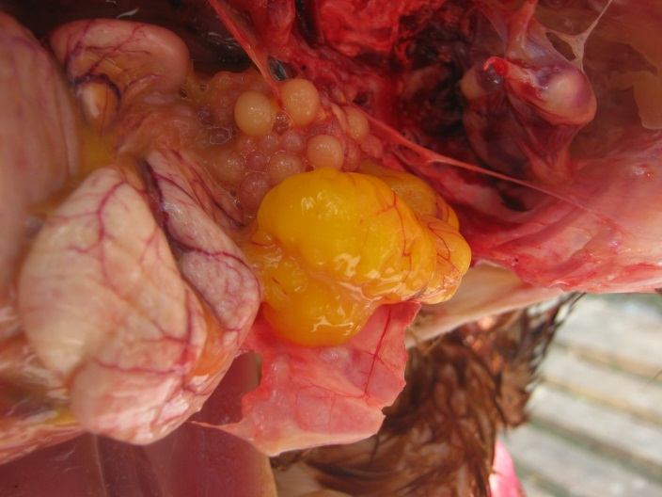 | 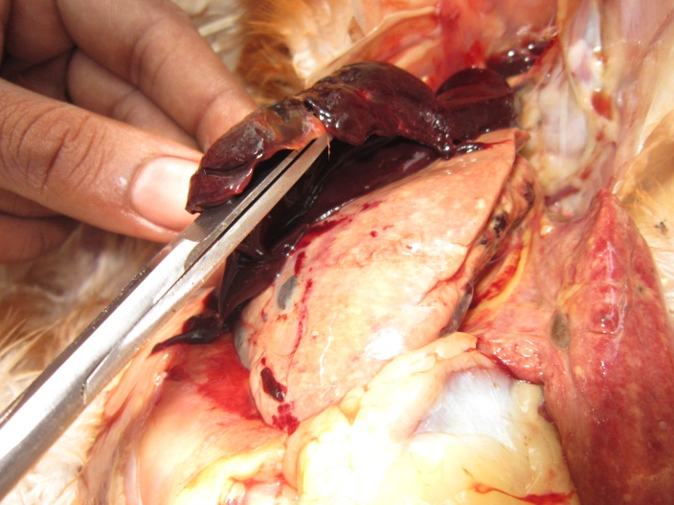
Fig.5. Salmonella infected chicken shows congestion, discoloration and misshaped ova formation. | Fig.6. The liver shows friable congestion and bronze discoloration with focal necrosis.

In this study enlarged and congested liver with focal necrosis; haemorrhagic and discoloured ovary with stalk formation and mild haemorrhagic to catarrhal enteritis in intestine and caecum were recorded during necropsy. These types of necropsy findings were supported by Calnek et al. (1991), Chauhan and Roy (1996), Syed-Habib-ur-Rahman et al. (2004), Hossain et al. (2003) and Khan et al. (1998).

CONCLUSION
Although the sample size was small, an effort was made to conclude the seroprevalence of salmonella infection which was 60% in respect to age, season and flock size. This may conform that a higher level of salmonella was present in the farm. Besides friable congestion and bronze discoloration of liver with focal necrosis; hemorrhagic, discolored and misshaped ovary with mild hemorrhagic to catarrhal enteritis in intestine and caecum were recorded during necropsy.

REFERENCES

Alam, J., Koike, I., Giasuddin, M., and Rahman, M. 2003. Seroprevalence of poultry diseases in native chickens in Bangladesh. Ninth BSVER Annual Scientific Conference, Publication No. 24, pp. 26.

Ashenafi, H., Shetu, Y. and Oldemeskel, M. 2003. Identification of major infections of local chickens of central Ethiopia. Bulletin of Animal health and Production in Africa 51: 95-101.

Bhattacharya, A., and Majumder, P. 2001. Fowl typhoid outbreak in broiler chick flocks in Tripura and its control. Indian Journal of Animal Science, 71, 1034-1035.

Barrow, P.A., 1992. Further observations on the serological response to experimental Salmonella typhimurium in chickens measured by ELISA. Epidem. Infect, 108: 231-241.

Bouzoubaa, K., Lemainguer, K. and Bell, J. G. 1992. Village chickens as a reservoir of Salmonella pullorum and Salmonella gallinarum in Morocco. Preventive Veterinary Medicine, 12, 95-100.

Christine, S., Henderson, I., Denise, Bounous and Margie, D.L., 1999. Early events in the pathogenesis of avian salmonellosis. Infect. Immun., 67: 3580-3586.

Chauhan, H.V.S. and Roy, S. 1996. Poultry diseases, diagnosis and treatment. 2nd ed. New age international (P) ltd. publishers, New Delhi, India.

Christensen, J.P., Olsen, J.E., Hansen, H.C. and Bisgaard, M. 1992. Characterization of Salmonella enterica serovar Gallinarum biovars Gallinarum and Pullorum by plasmid profiling and biochemical analysis. Avian Pathol. 21: 461-470.

Clanek, B.W., Barnes, H.J., Beard, C.W., Mcdougald, L.R. and Saif, Y.M. 1991. Diseases of Poultry. 10th edn. Iowa State University Press, Ames, USA. Pp 81-130.

Deryck, D. and Pattron. 2004. Scientific status summary on bacteria associated with foodborne diseases and also related to public health significance of Salmonella in institute of food technologists, Chicago.

Feberwee, A.T.S., Hartman, E.G., Wit, J.J., Elbers A.R.W. and de Jong, W.A., 2001. Vaccination against Salmonella enteritidis in Dutch commercial layer flocks with a vaccine based on a live salmonella gallinarum 9R strain: evaluation of efficacy, safety and performance of serologic salmonella test. Avian Dis., 45: 83-91.

Gast, R.K. 1997. Paratyphoid Infections. In: Diseases of Poultry, Calnek, B.W., Barnes, H.J., Beard, C.W., McDoughald, L.R., and Saif, Y.M., (eds). 10th ED. Iowa State University press. Ames, IA. Pp: 97-121.

Ghosh, S. S. 1988. Incidence of pullorum disease in Nagaland. Indian Veterinary Journal, 65, 949-951.

Hassanein, R., S., Fathi, H., Ali, A.M., El-Malek, Moemen, A.M. and Elsayh, K.I. Veterinary, 2011. Detection and identification of Salmonella species in minced beef and chicken meats by using Multiplex PCR. Assiut City World, 4(1): 5-11.

Hossain, K.M.M., Hossain M.T. and Yamato, I. 2010. Seroprevalencs of Salmonella and Mycoplasma gallisepticum infections in chicken in Rajshahi and surrounding districts of Bangladesh. International Journal of Biology. Vol. 2, No. 2.

Hossain, M.S., Chowdhury, E.H., Islam, M.M., Haiderand, M.G. and Hossain, M.M. 2006. Avian salmonellosis Infection: Isolation and identification of organisms and histopathological study. Bangl. J. Vet. Med., 4:07-12.

Hossain, M.A., Aalbaek, B., Christensen, J.P., Elisabeth, H., Islam, M.A. and Pankaj, K. 2003. Observations on experimental infection of Salmonella Gallinarum in Fayoumi and Hyline layer chickens. Bangladesh J. Progress. Agri. 14: 85-89.

Habib-ur-Rehman, S., Sirzanin, Hamayun, K., Saleem, K., Nazir, A. and Bhatti, W.M. 2003. Incidence and gross pathology of Salmonellosis in chicken in Hyderabad. J. Asso. Vet. Advances. 2: 581-584.

Haider, M.G., Hossain, M.G., Hossain, M.S., Chowdhury, E.H., Das P.M. and Hossain, M.M., 2003. Isolation and characterization of enterobacteria associated with health and disease in Sonali chickens. Bangl. J. Vet. Med., 2: 15-21.

Hasegawa, M., Pandey, G. S., Tuchili, L. M., Babe, E., and Kobayshi, K. 1999. The epidemiology survey of certain poultry diseases in commercial breeding farms in Zambia. International Journal of Animal Science, 14, 17-21.

Hassan, J.O., Mockett, A.P.A., McLeod, S. and Barrow, P. 1991. Indirect antigen trap ELISA using polyclonal antisera for detection of group B and D salmonella as in chickens. Avian Pathol., 20(2): 270-281.

Humphrey, T.J., Baskerville, A., Mawer, S., Rowe, B. and Hopper, S. 1989. Salmonella Enteritidis phage type 4 from the contents of intact eggs: a study involving naturally infected hens. Epidemiol. Infect. 103: 415-423.

Ibrahim, H.M. 2011. Laboratory diagnosis of salmonellosis in poultry by newly prepared Salmonella antigens , M.V.Sc. thesis (Microbiology), Fac. Vet. Med., Cairo University.

Islam, M.M., Haider, M.G. Chowdhury, E.H. Kamruzzaman, M. and Hossain, M.M. 2006. Seroprevalence and pathological study of Salmonella infections in layer chickens and isolation and identification of causal agents. Bangl. J. Vet. Med., 4: 79-85.

Jha, V.C., Thakur, R.P., Chand, T.K. and Yadav, J.N. 1995. Prevalence of Salmonellosis in chickens in the Eastern Nepal. Vet. Bull. 65: 7.

Kassaye, A., Lencho, T. and Mesele, A. 2010. Prevalence of salmonella infection in intensive poultry farms in Hawassa and isolation of salmonella species of sick and dead chickens. Ethiop. Vet. J., 14(2): 115-124.

Khan, A.H.M.N.A., Bari, A.S.M., Islam, M.R., Das, P.M. and Ali, M.Y., 1998. Pullorum disease in semi mature chickens and its experimental pathology. Bangladesh Veterinary Journal 32: 124-128.

Mona, I., El-Enbaawy, Zakia, Ahmed, A.M., Sadek, M.A. and Darwish, H.M. 2012. Preparation and Evaluation of Elisa Polyvalent Salmonella Antigen for Detection of Salmonella Infection among Poultry. World Applied Sciences Journal 20 (6): 806-811.

Mdegela, R.H., Yongolo, M.G.S., Minga, U. M., and Olsen, J.E. 2000. Molecular epidemiology of Salmonella gallinarum in chickens in Tanzania, Avian Pathology, 29, 457-463.

Muneer, M.A., Arhad, M., Sheikh, M.A., and Ahmad, M.D. 1988. Identification of pullorum disease carriersusing spot agglutination test. Pakistan Veterinary Journal, 8, 93-94.

Minga, U.M., Kikopa, R., Minja, K.S.G.Z., and Mwasha, J.D. 1987. The prevalence and improved serodiagnosis of fowl typhoid in Tanzania. Proceedings of the 5th Tanzania Veterinary Association Scientific Conference, Tanzania Veterinary Association, pp. 325-338.

Nagaraja, K.V., B.S. Pomeroy B.S. and Williams, J.E., 1991. Paratyphoid infections. In: Calnek BW. Barnes HJ. Beard C(1, Reid WVM, Yoder HWN, eds. Diseases of poultry. Ames, Iowa: Iowa State University Press, pp: 99-130.

OIE, 2010. Salmonellosis. chapter 2.9.9. terrestrial manual versionadopted by the world assembly of del egates of the OIE in May 2010.

OIE Manual, 2006. Salmonellosis. Office International des Epizooties. http:www.oie.int/chapter X.4.T.

OIE. 2002. Office International Des Epizooties. Manual of Standards for Diagnostic Tests and Vaccines. 4th eds., Paris, France.

Proux, K., Humbert, F., Jouy, E., Houdayer, C., Lalande, F., Oger, A. and Salvat, G. 2002. Improvements required for the detection of Salmonella pullorum and gallinarum. Canadian Veterinary Research, 66(3),

Pomeroy, B.S. and Nagaraja, K.V. 1991. Fowl typhoid. In: Diseases of poultry. Eds., Calnek B.W.N.T., H.J. Barnes, C.W. Beard, W.M.A. Reid and H.W.N. Yoder. Ames, Iowa: Iowa State University Press, pp: 87-99.

Prukner, E. 1987. Bacterial infections in the etiology of poultry diseases. Peradarstvo, 22 (11-12), 295-298.

Rahman, M.A., Samad, M.A., Rahman, M.B. and Kabir, S.M.L. 2004. Bacterio-pathological studies on salmonellosis, colibacillosis and pasteurellosis in natural and experimental infections in chickens. Bangladesh Journal of Veterinary Medicine 2(1): 1-8.

Robinson, H., Mdegela, M.G.S., Yongolo, U, Minga, M. and Johin, E. 2000. Molecular epidemiology of Salmonella gallinarum in chickens in Tanzania. Avian Pathology 29: 457-463.

Rahman, M.M. and Rahman, A. 1998. Cattle and Poultry development activities. In: Kromobikash O Karjakrom, Directorate of Livestock Services (DLS), Bangladesh. 1st ed., pp: 31-55.

Shahinuzzaman, A.B.M., Saha, A.K., Mazumder, A.C., Das, S., Sufian, M.A., Baki, M.A. and Hossain, M.M. 2011. Sequential pathological and immunohistochemical study of pullorum disease in experimentally infected chicks. International Journal of Poultry Science 4 (11): 905-910, 2005

Seran, T., Aysegul, E. and Kamil, T.C. 2010. Salmonella Serogroup Detection in Poultry Meat Samples by Examining Multiple Colonies from Selective Plates of Two Standard Culture Methods Foodborne Pathogens and Disease, 7(10): 1229-1234

Sikder, A.J., Islam, M.A., Rahman, M.M., and Rahman, M.B. 2005. Seroprevalence of Salmonella and Mycoplasma gallisetpticum infection in the six model breeder poultry farms at Patuakhili district in Bangladesh. International Journal of Poultry Science, 4 (11), 905-910.

Sadek, M.A., 2005. Serological studies on the different antigens of avian Salmonella. Ph.D. Thesis (Bacteriology, Immunology and Mycology), Fac. Vet, Med.,Moshtohor, Zagazig University (Benha Branch), Egypt.

Syed-Habib-ur-Rahman, Khan, M.S., Hamayun, K., Nazir, A. and Bhatii, W.M. 2004. Incidence and gross pathology of Salmonella gallinarum infection in chicken. Journal of Animal and Veterinary Advances 3: 175-178.

Skov, M. N., Angen, Chriel, M., Olsen, J. E. and Bisgaard, M. 1999. Risk factors associated with Salmonella enterica serovar typhimurium infection in Danish broiler flocks. Poultry Science, 78, 848-854.

Shivaprashad, H.L. 1997. Pullorum disease and fowl typhoid. In: Diseases of Poultry, 10th ed.; Calnek, B.W., Barnes, H.J., Beard, C.W., McDoughald, L.R., Saif, Y.M., Eds.; Iowa State University press: Ames, IA, USA. Pp 82-96.

Samad, M.A. 1996. Pakhy Palon (Poultry rearing). In: Lavejanak Poshupakhy Palon O Adhunik Chikitsha (Profitable Livestock Husbandry and Modern Treatment). Published by Bulbul. BAU, Mymensingh, Bangladesh, pp: 48.

Sadek, M.A. 1996. Bacteriological and immunological studies on paratyphoid in ducks. M.V.Sc. Thesis (Bacteriology, Immunology and Mycology), Fac. Vet, Med., Cairo University.

Snoeyenbos, G.H. 1991. Pullorum disease. In: Calnek BM',Barnes H.J, Beard CXV, Reid WN'M, Yoder HW. eds. Diseases of poultry. Ames. Iowa: Iowa State University Press, pp: 73-86.

Snoeyenbos, G. H. 1978. Pullorum disease. In: Hofstad, M.S., Calnek, Helmboldt, C.F., Reid, W.M. and Yoder, H.W. (Eds): Diseases of Poultry 7th edn. Iowa State University Press, Ames, pp. 80-100.

Talha, A.F.S.M. 2003. Investigation on the prevalence of Mycoplasma gallisepticum in village chickens and possibility of establishing Mycoplasma gallisepticum free flocks and significance Mycoplasma gallisepticum on different production parameters in layer chickens in Bangladesh. M.Sc. Thesis, Department of Veterinary Microbiology, The Royal Veterinary and Agricultural University, Denmark and Department of Pathology, Bangladesh Agricultural University, Mymensingh.

Truong, Q. and Tieu, Q. A. 2003. Prevalence of Salmonella gallinarum and pullorum infection in the Luong Phuong chickens reared in the household sector. Khoa-Hoc-Ky-Thuat-Thu-Y-Veterinary Science and Technology, 10, 15-19.

Terzolo, H. R., Verona, A. Z., Furowiez, de. A. J. J. D., and Verona, De. A. Z. 1977. Finding in fowls Escherichia coli strains having common antigens with the Salmonella genus. Revista-de-la-Association-Argentina-de-Microbhiologia, 9, 4-10.

Wigley, P., Berchieri, A. Jr., Page, K.L., Smith, A.L. and Barrow, P.A. 2001. Salmonella enterica serovar pullorum persists in splenic macrophages and in the reproductive tract during persistent, disease free carriage in chickens. Infect. Immun. 69: 7873-7879.

Waltman, W. D., and Home, A. M. 1993. Isolation of Salmonella from chickens reacting in the pullorum typhoid agglutination test. Avian Diseases, 37, 805-810.

Yang, Y. C., Sun, Y., Wang, M. M., Zhang, Y. K. Li. X. X., and Sun, B. A. 1996. Discussion of on site detection of pullorum disease in breeding chickens and control measures. Chinese Journal of Veterinary Medicine, 22, 20-22.

