CHAPTER I

INTRODUCTION

Meat is considered as an important source of proteins, essential amino acids, B complex vitamins and minerals. Due to this rich composition, it offers a highly favorable environment for the growth of pathogenic bacteria. The microbiological contamination of carcasses occurs mainly during processing and manipulation, such as skinning, evisceration, storage and distribution at slaughterhouses and retail establishments (Gill, 1998; Abdalla et al., 2009). Fecal matter was a major source of contamination and could reached carcasses through direct deposition, as well as by indirect contact through contaminated and clean carcasses, equipment, workers, installations and air (Borch and Arinder, 2002). Cattle slaughter operations, such as bleeding, dressing and evisceration, expose sterile muscle to microbiological contaminants that were present on the skin, the digestive tract and in the environment (Gill and Jones, 1999; Bacon et al., 2000). The contamination and/or cross-contamination of carcasses, during slaughtering operations were demonstrated and the results indicated presence of bacteria of potential public health significance (Biss and Hathaway, 1995; Doyle, 1991). There were significant increases in total bacterial counts at skinning points than that at washing operations; also, dirty workers hands, clothes and equipments of the slaughterhouse acted as intermediate sources of contamination of meat (Gill, 1998; Gilmour et al., 2004; AbdelSadig, 2006; Abdalla et al., 2009). Therefore intermittent microbial analysis and constant monitoring are necessary to produce hygienic and wholesome meat to ensure safe public health (Mukhopadhyay et al., 2009). On the other hand, dark, firm, and dry carcasses contain lean with dark, purplish red to black color with a high pH and water holding capacity. An increased incidence of spoilage and reduced shelf life possess problem. It has become apparent that reducing stress levels through appropriate management decisions can drastically reduce DFD carcasses. Therefore, cattle must be monitored throughout feeding, implanting, penning, processing, transporting and holding prior to slaughter. Beef characterized as dark cutting will have an abnormally dark purplish red to black colored lean. Dark cutting beef is most often known as dark, firm, and dry (DFD). DFD beef can also be called “high pH” (Miller M, 2007). Another fact is that, the water-holding capacity of fresh meat (ability to retain inherent water) is an important property of fresh meat as it affects both the yield and the quality of the end product. This characteristic can be described in several ways, but in fresh products that have not been extensively processed, it is often described as drip loss or purge. The mechanism by which drip or purge is lost from meat is influenced by both the pH of the tissue and by the amount of space in the muscle cell and particularly the myofibril that exists for water to reside. Numerous factors can affect both the rate and the amount of drip or purge that is obtained from the product. These factors can include how the product is handled and processed (number of cuts made and size of resulting meat pieces, orientation of the cuts with respect to the axis of the muscle cell, rate of temperature decline after harvest, temperature during storage and even the rate of freezing and temperature of frozen storage). Also of extreme importance is the metabolic state of the live animal at the time of harvest. Ultimately, characteristics of the muscle in the live animal can have a strong influence on the amount of moisture that is lost from the resulting meat products (Huff-Lonergan E, 2010).

Based on the above discussion my present study was to conduct with the following objectives:
- To investigate the microbial contamination of raw ground beef at a particular interval in different markets of Chittagong Metropolitan Area.
- To observe the chemical and microbial effects of those samples in different time intervals.

CHAPTER II

REVIEW OF LITERATURE

2.1. Slaughterhouse Contamination

The deep muscle tissues of healthy, slaughtered livestock contain few, if any, micro-organisms. However, their exterior surfaces (hide, hair, skin, feathers,) are naturally contaminated with a variety of microorganisms as are their gastro-intestinal tracts. From the moment of slaughter, each processing step subjects the carcass to opportunities for contamination with micro-organisms from the exterior surfaces, utensils and equipment and, most importantly, from the gastro-intestinal tract. Cutting of carcasses also involves the use of utensils and equipment and transfers micro-organisms to the cut surfaces. Theoretically removal of the skin should expose the sterile surface of the muscle but in practice the extra handling seems to contribute significantly to the bacterial load on the surfaces. This happens with meat production where the skin is removed early in the slaughtering process (e.g. beef, mutton, lamb, ostrich, and goat). (Bergh T, 2007)

2.1. A. Sources of contamination

- Slaughtering facilities and equipment: Rusty equipment and grease from the rails are also sources of contamination.
- Abattoir personnel: Workers can also be a source of contamination of meat.
- Animals slaughtered: Animals that are slaughtered in an abattoir can be the most important source of contamination. Animals infected with one or more kinds of micro-organisms, in other words sick animals, can spread their contamination to the meat and other edible animal products, as well as to the abattoir workers.
- Slaughtering and Processing Procedures: i) Apart from poor slaughtering techniques, the following factors also contribute to contamination during the slaughter and processing of meat: Untrained and careless workers. Production line and slaughtering speeds that are too fast mean that the hands and equipment cannot be washed and disinfected regularly. Not enough working spaces and cramped working conditions. Overloading the refrigeration facilities, causing carcasses to touch each other and consequently ineffective chilling.
- The Abattoir and Its Environment: The situation of the abattoir can also be a source of contamination. Large amounts of pollution from smoke, dust or unpleasant smells can make it extremely difficult to maintain a high standard of hygiene.
- Water Quality: Water is used as the universal cleaning medium. However, pure water does not exist in nature and the quality of water (chemical and microbiological) varies considerably depending on area and time of year. (Bergh T, 2007)

2.2. TVC (Total viable count) or APC (Aerobic plate count) of raw beef

Aerobic plate count (APC) is the most widely used microbiological test on foods. Its purpose is to determine the number of living micro-organisms per unit of food. Counts on solid samples (meat products, etc) are expressed as colony-forming units (CFU) per gram, while counts on liquid samples (water) are expressed as CFU per millilitre. Surface counts are expressed as CFU per 10 square centimeters (Bergh T, 2007).

Heredia et al. (2001) reported that the microbial quality of ground meat analyzed was unsatisfactory, and the product was important cause of food poisoning.

Ali (2007) recorded high contamination level on flank site and lower contamination level on rump sites during skinning.

Eisel et al. (1997) determined aerobic plate count (APC), coliform count (CC) and Escherichia coli count (ECC) for the samples of incoming beef products, food contact surfaces, environmental surfaces and air.

Grunspan et al. (1996) studied 10 samples of minced beef and recorded total microorganisms by using plate count agar (PCA) as 1.7-8.8x10⁴ CFU/gm.

Shrokki (1997) studied minced beef and minced beef-pork samples and reported the medium counts of aerobic microorganisms as 1.4x10⁶ CFU/gm and 4.2x10⁶ CFU/gm for beef and beef-pork respectively.

Aslam et. al. (2000) studied 25 samples of minced beef and recorded total microorganisms by using plate count agar (PCA) in total viable count (TVC) as 31-319x10³ CFU/gm. The highest contamination i.e. 319x10³ CFU/gm was observed in the sample might be the heaps of the garbage that were scattered from place to place near the shop. In the secondary source of contamination, the work place, equipments and worker might be considered. The low total viable count i.e. 31x10³ CFU/gm was observe in the sample which was a little satisfactory in hygienic manner.

Duitschaever et al. (1973) found total aerobe mesophiles and psychrotrophic bacteria in 64% of ground meat samples with the counts more than >10⁶ cfu/g.

Emswiler et al. (1976) reported 4.60 and 4.86x10⁶ cfu/g of total aerobic mesophiles.

Chambers et al. (1976) examined 457 ground beef samples and isolated total aerobe mesophiles, oxidase (+) psycrophiles and coliform bacteria at the average levels of 10⁶, 10⁵ and 10² cfu/g respectively.

Tekinsen et al. (1980) examined 20 samples and found that total aerobe mesophiles, psychrotrophic bacteria, fecal Streptococci spp., Staphylococci spp., coliform, E. coli, bacteria that capable of reducing sulphide and Clostridium perfringens were counted at the average levels of 8.4x10⁷, 6.2x10⁷, 1.5x10⁵, 9.6x10⁵, 8.5x10⁶, 4.2x10⁶, 6.7x10³ and 3.9x10² cfu/g, respectively.

Khalafalla et al. (1993) examined 10 ground beef meat samples and total aerobe mesophiles, Enterobacteriaceae and Staphylococci spp. were found at the levels of 10⁶, 10⁴ and 10³ cfu/g respectively.

Westhoff and Feldstein (1976) examined 140 ground beef meat samples and reported coliform, fecal coliform, E. coli and total aerobe mesophiles at the average of numbers of 2.0x10², 1.0x10¹, 5.0x10⁰ and 7.9x10⁶ cfu/g, respectively.

Adetunde et al. (2011) reported that the mean TVBC of beef per gram of meat sample from the neck and thigh were 2.12×10⁷ and 3.26×10⁷ respectively for the beef from the slaughter yard. Beef sampled from the open market also had the neck and thigh as 4.16×10⁷ and 9.97×10⁷ respectively.

2.3) pH :

The normal or ultimate pH level of muscle should be between 5.3 and 5.7. An ultimate pH promotes a bright red attractive colour in beef, whereas, lower pH (below 5.3) causes pale, soft, weepy meat. Consequentially, the normal pH decline of meat during rigor mortis is altered due to a lower level of glycogen at death resulting from stress on the animal prior to harvest, which results in meat retaining a high pH. DFD beef exhibits a dark, purplish red to almost black lean color and a dry, often-sticky lean surface. Due to high pH, lean surfaces act similarly to a dry sponge resulting in increased water binding capacity within the muscle. DFD beef can also be called “high pH” beef as a result of an animal’s depleted muscle glycogen reserves prior to slaughter. Lactic acid is a by-product of glycogen utilization by the muscle when energy is produced in a stress event. After death, lactic acid accumulation in the meat is responsible for the pH decline from 7.0 to about 5.7 during normal rigor mortis development. Dark, firm and dry beef is of significantly lower quality as it has a reduced shelf life and a greater ability to support microbial growth. Increased microbial growth leads to increased spoilage and an undesirable flavor. A depleted state of glycogen less than approximately 0.6% will hinder normal postmortem pH decline. Muscle with a post-rigor pH of greater than 5.9 generally develops some form of dark cutting characteristic. The pH range of normal meat of an unstressed animal is 5.4-5.7. DFD meat will have a much higher pH of 5.9-6.5, with some meat being as high as a pH of 6.8. Reduced shelf life is largely due to a higher than normal pH and an increased water-holding ability, which are both conducive to microbial growth. (Miller M, 2007)

2.4) Moisture:

The muscle contains approximately 75% water. The other main components include protein (approximately 20%), lipids or fat (approximately 5%), carbohydrates (approximately 1%) and vitamins and minerals (often analyzed as ash, approximately 1%) .The author also stated that the meat that has a very high ultimate pH (i.e. > 6.3) tends to be dark in color and the surface of the meat appears relatively dry. This dark, firm and dry product has a very high water-holding capacity. The accelerated pH decline and low ultimate pH are related to the development of low water-holding capacity and unacceptably high purge loss. Another report of the same author is that the pH that is attained after the muscle is in rigor has an influence on the water-holding capacity (drip loss) of meat (Huff-Lonergan, 2010).

Lomauro et al. (1990) reported a figure for ground beef moisture diffusivity and Motarjemi (1988) reported the diffusivity of raw minced beef at various temperatures and moisture content, but these would not be the same as for whole beef.

CHAPTER III

METRIALS AND METHODS

3.1. Study Area

Present study was carried out in five markets randomly selected from the Chittagong Metropolis, the business capital of Bangladesh. It has a total area of 157 square kilometers (61 sq mi). Chittagong city has a population of 4 million. Male 54.36% and female 45.64%. Population density per square km is 15276. Islam is the most common religion among the people. Muslims form 83.92% of the total population. Other major religions are Hinduism (13.76%), Buddhism (2.01%), Christianity (0.11%) and others 0.2%.

3.2. Study Design

At the beginning of the study, different slaughterhouse were visited named to observe the general hygienic measurement like slaughtering methods, animal restraining, processing of carcass, sources of water supply and waste disposal methods etc. Among all 5 markets were randomly selected in Chittagong Metropolitan Area for collection of samples. After that, samples were collected from those selected market. Finally, the physical, chemical and microbial were done at Poultry Research and Training Institute (PRTC) in Chittagong Veterinary and Animal Sciences University (CVASU), Khulshi, Chittagong-4202.

3.3. Collection of the samples:
The randomly selected markets were Cornel hat (City corporation market), Riazuddin market, Jhautola, Pahartali and Wireless market. Total five raw ground beef samples was collected from these markets at about 250 gm in sterile plastic bag and transported under 4 ºC in a Cole man box filled with ice to prevent further contamination within 3 hours. The samples were

analyzed immediately upon arrival in the Poultry Research and Training Institute (PRTC) laboratory, Chittagong Veterinary and Animal Sciences University (CVASU), Khulshi, Chittagong-4202.
Table-01: Summary of the samples collected from different markets.
Sample No | Place of collection | Type of sample | Weight of sample | Date of collection | Time of collection
01 (Control) | Cornel hat | Beef | 250 gm | 27.11.2012 | 8.0 AM
02 | Riazuddin market | Beef | 250 gm | 27.11.2012 | 8.0 AM
03 | Pahartali market | Beef | 250 gm | 27.11.2012 | 8.0 AM
04 | Jhautola market | Beef | 250 gm | 27.11.2012 | 8.0 AM
05 | Wireless market | Beef | 250 gm | 27.11.2012 | 8.0 AM
N.B. Sample number 01 is considered as control group to comparing the differences among the microbial, physical and chemical quality of the samples. Here, the control was kept at 4 ⁰C in the refrigerator all the time of my study period and other samples were kept in normal room temperature as observed in butcheries.

3.4. Analysis of the samples:
3.4. A. Aerobic plate count or total viable count:
3.4. A. a. Materials required:
- Digital balance
- Test tube
- Blender machine
- Scissors
- Micro-pipette (1000 micro litre) and tips
- Petri dishes
- Phosphate buffer saline (PBS)
- Plate count agar
- Meat samples.
3.4. A. b. Preparation of sample:
- 50 gm raw ground beef from each sample was weight by a digital balance machine in a sterile Petri dishes and finely chopped with scissors.
- Then 450 ml of phosphate buffer saline was added for each sample separately in the beaker of a blender machine. After that the mixture was thoroughly blend in order to make sausages and samples are prepared for microbial analysis.

- Preparation of Plate count agar (PCA):
Composition of PCA agar: 0.5% peptone, 0.25% yeast extract,0.1% glucose,1.5% agar (pH adjusted to neutral at 25⁰ C).
23gm of agar powder was added into 1000ml distilled water. Then boiled the mixture up to dissolve and finally sterilized at 121 ⁰C and 15 lb of pressure for 15 minutes. After autoclaving, cool the agar to between 45°C and 50°C prior to pouring the plates to minimize the amount of condensation that forms. The thickness of the agar should be roughly 0.3 cm, which can be achieved by pouring 15 to 20 ml of media per 100 x 15 mm plate.

3.4. A. c. Test Protocol:
- A series of test tube (Total no. 05) was taken, separately for each sample and 9 ml of phosphate buffer saline (PBS) was added to each of the test tube.
- The test tube was marked according to the sample number respectively, such as for sample number 01, the numbering was S₁-T₁ to T_{5.}
- From the original sample, (which was previously prepared), 1 ml was added to the test tube number 01 i.e. S₁T₁ and mixed thoroughly.
- Then 1 ml from test tube no. 01 was transferred to the test tube no. 02 i.e. S₁T₁ to S₁T₂ and this procedure was continued up to the test tube no. 05 i.e. S₁T₂ to S₁T₃.... and lastly to S₁T₅ and finally 1 ml of diluted sample was discarded from the test tube no. 05 in order to made serial 10 fold dilution.
- After that, for test tube no. 05, 2 Petri dishes were taken and labelled it according to the test tube number i.e. S₁T₅P₁ and S₁T₅P₂, respectively.
- From the test tube no. 05, 0.5 ml of sample mixture was added to each of the Petri dishes and gently spread with the glass spreader.
- Finally the Petri dishes were kept in incubator in inverted position at 37 ⁰C for 24-48 hours; date was 27.11.2012 at 12.0 PM and counted at every 24 hours interval by the colony counter.
- The Petri dishes which contain the colony in the range of 30-300, was included to the result and other was discarded.
- The average number of colony of the two Petri dishes was multiplied by its dilution factor, which was x10⁵. The result is given in the result and discussion chapter.
- The test was performed 3 times at different interval for each of the sample to evaluate the periodic growth of the organisms within the samples and after completion of the test for first time, the control was kept at 4 ⁰C in refrigerator to observe the growth rate of the organisms.
- After performing the test for second time on 27.11.2012, then the samples were kept in freezing condition as done by retail butchers and the test was conducted for third time at the next day i.e. 28.11.2012 at 11.30 AM.

3.4. B. Measurement of pH:
3.4. B. a. Equipment and Reagents
- Blender machine
- Beaker, 100 ml
- Separatory funnel
- pH meter, suitable for reading pH from 0 to 14 in 0.1 unit increments. A rugged, designated combination electrode should be used for pH measurement of meats and poultry
- Distilled water
- Certified buffer solutions of pH 7, and either pH 4 or 10

3.4. B. b. Preparation of samples:

- 16 gm raw ground beef from each sample was weighed by a digital balance machine in a sterile Petridis and finely chopped with scissors.
- 80 ml of distilled water with the weighed sample was taken in a blender jar and blending it to make fine sausages and samples was prepared for the estimation of pH.
3.4. B. c. Procedure

- Firstly, the pH meter was calibrated, according to manufacturer's instructions, using certified buffers pH 7 and either pH 4 or 10.
- As Meat is a solid product and require blending. A 1:5 or 1:10 dilution was made with distilled water in a clean blender jar. Samples were blend to a thin uniform consistency and perform the pH measurement.
- The temperature control on the pH meter was adjusted to that of the meat sample (ideally 25°C) and then the pH electrode was immersed into the liquid phase.
- The above procedure was performed 3 times for each of the sample at a constant interval of time and pH result was recorded to the nearest 0.1 unit.
- After performing the test for second time on 27.11.2012, then the samples were kept in freezing condition as done by retail butchers and the test was conducted for third time at the next day i.e. 28.11.2012 at 10.30 AM.
3.4. C. Measurement of Moisture:
3.4. C. a. Required equipments:
- Digital balance
- Scissors
- Petri dishes
- Hot air woven
- Desiccators
3.4. C. b. Preparation of samples and test procedure:
- 20 gm raw ground beef from each sample was weight by a digital balance machine in a sterile Petridis and samples are prepared for the estimation of moisture.
- Weight of the empty Petri dishes was recorded separately.
- The weighing sample were placed into the Petri dishes and re-weighing the Petri dishes separately.
- Then the Petri dishes were placed into a hot air woven and allowed to dry at 105 ⁰C for 24 hours.
- After 24 hours, these Petri dishes were transferred into desiccators for cooling.
- Weight of the Petri dishes along with the sample was recorded again until it reaches to a constant weight.
- The percentages of the moisture was then calculated by the following equation:

Moisture % = 100 – DM (Dry matter) % ---------------------------------------- (1)
Again we know,
DM % = A – B/A x 100
Here, A = Initial weight of the sample.
B = Up to constant weight of the sample.
Different activities during the study period
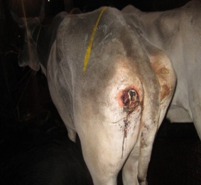
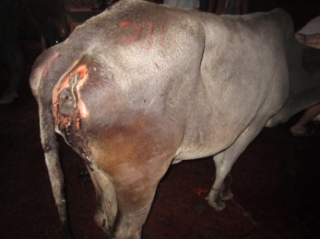
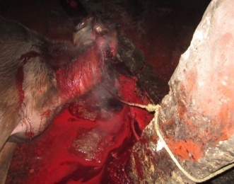
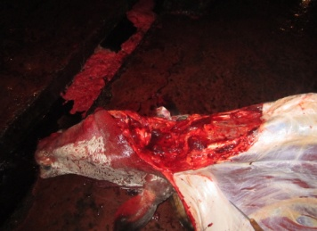

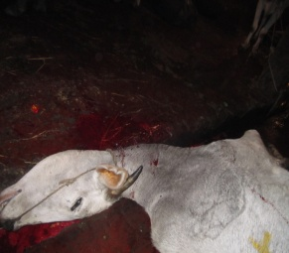
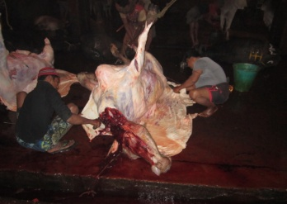
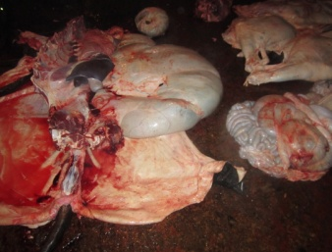
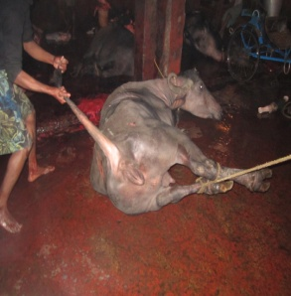

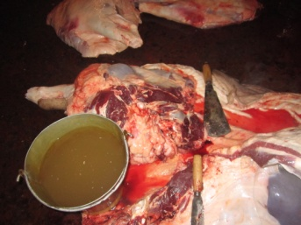
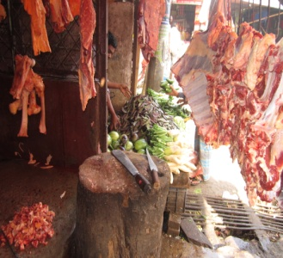
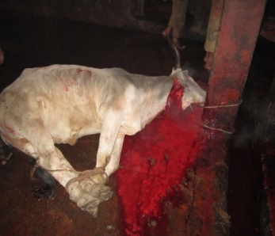
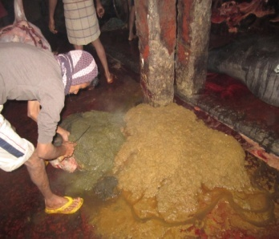

Fig-1: Slaughter and various sources of contamination
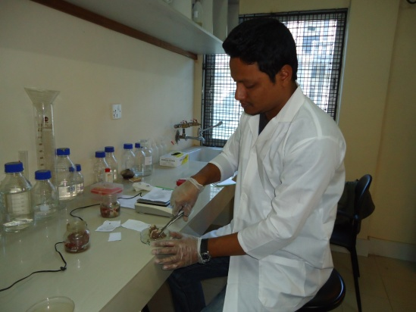
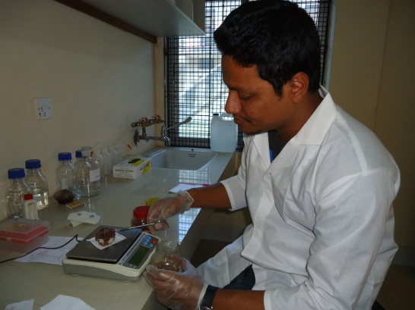

2(a) 2(b)
Fig-2: Preparation of meat samples for chemical and microbial analysis.

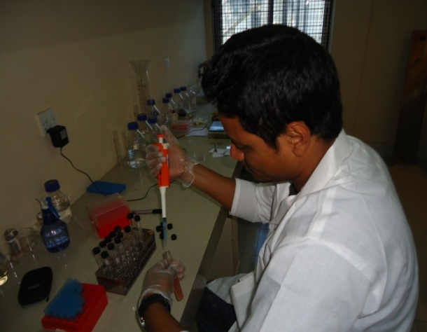
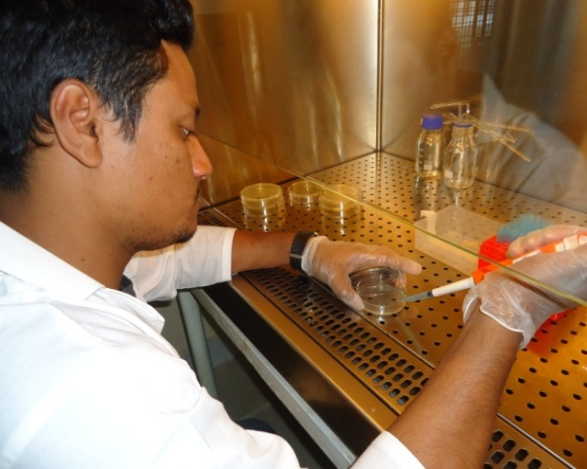

3(a) 3(b)
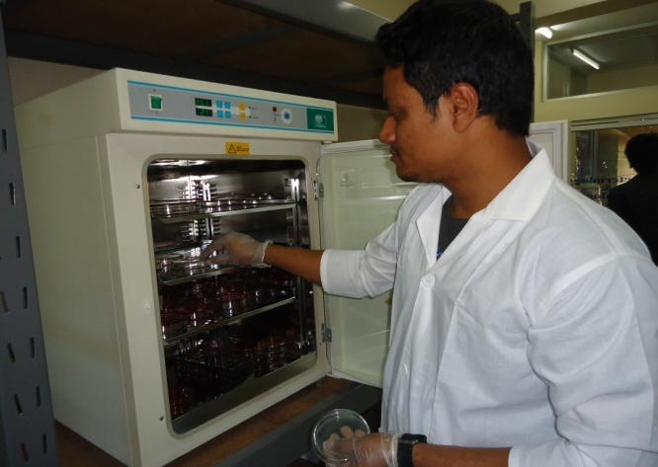
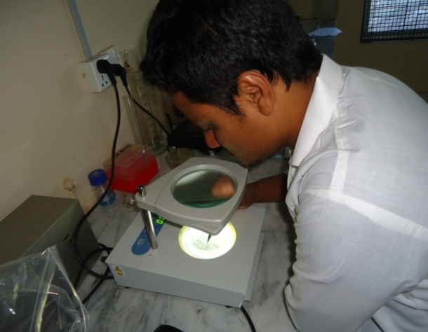

3(c) 3(d)
Fig-03: Performing the Total viable count (TVC) of meat samples.

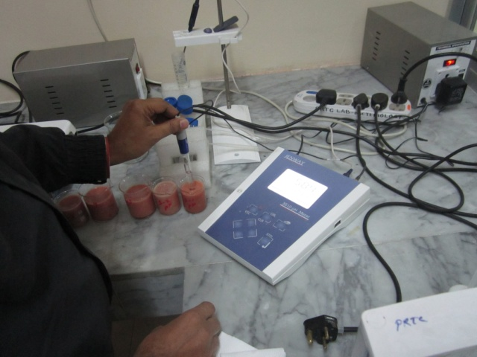

Fig-04: Performing the pH test by pH meter of meat samples.

CHAPTER IV
RESULT AND DISCUSSION

4.1 Total Viable Count (TVC):
The quality of the beef samples was determined using the total viable count. The table shows the mean total viable aerobic bacteria count at different time intervals.
Table-2: Total aerobic bacteria counts obtained from the various meat shops in the selected markets.
Name of the markets | Reading 1  (Date: 29.11.12  Time: 2.00 PM) | Reading 2  (Date: 29.11.12  Time: 6.30 PM) | Reading 3  (Date: 30.11.12  Time: 11.00 AM)
Cornel hat. (Control) | - | 5.5 x 10⁶ CFU/gm | 6.7 x 10⁶ CFU/gm
Riazuddin market (02) |  | 5.6 x 10⁶ CFU/gm | 9.6 x 10⁶ CFU/gm
Pahartali (03) |  | 6.6 x 10⁶ CFU/gm | 9.4 x 10⁶ CFU/gm
Jhautola (04) |  | 14.4 x 10⁶ CFU/gm | 21.9 x 10⁶ CFU/gm
Wireless market (05) | 14 x 10⁶ CFU/gm | 19.9 x 10⁶ CFU/gm | 32.8 x 10⁶ CFU/gm
CFU/gm = Colony forming unit per gram of meat sample.
The final counting of the first reading was recorded on 29.11.2012 at 2.0 P.M, similarly second reading was recorded on the same date at 6.30 PM and final counting of the third reading was recorded on 30.11.2012 at 11.00 AM. The first reading of the samples was almost non-countable as there were less number of colony counted i.e. less than 25 colony except sample from the Wireless market i.e. 14 x 10⁶ CFU/gm. After 6 hours, at second reading the growth of the colony in those samples was significant and countable. Among the samples, the highest TVC was counted on sample collected from Wireless market i.e. 19.9 x 10⁶ CFU/gm. The initial reading of the same market was also higher. The lowest colony was counted from the sample which is collected from Cornel hat, “the control” of this study and that was 5.5 x 10⁶ CFU/gm. In second reading, the organisms load of the other markets was also significantly higher such as in the sample collected from Jhautola market i.e 14.4 x 10⁶ CFU/gm. The result of the third reading has shown that the lowest number of colony was counted from the control sample which was refrigerated at 4 ⁰C through the entire study period and growth of colony stunted and sluggish but very high number of TVC was counted samples collected from Jhautola and Wireless market which was 21.9 x 10⁶ CFU/gm and
32.8 x 10⁶ CFU/gm, respectively. Hygienic condition of animal slaughtering, processing, and water supply of the slaughterhouse was unsatisfactory. After processing of an animal, the carcass was sended to those of the retail butcheries. But among these markets, the hygienic condition of Cornelhat market, Riazuddin market and Pahartali market was fairly satisfactory. But other two markets do not possess any sign of hygienic measurement. The butchers used the water supplied from the dirty sources for washing of the processing site and carcass also. They are not so much conscious about their personal hygiene.

4.2 pH:
pH change of the meats samples is to indicate the pre-slaughtering stress and the amount of lactic acid produced by the lactic acid forming bacteria presence in the meat samples. The room temperature was maintained at 25 ⁰C.
Table-03: The pH changes in meat at the different interval of time.
Name of the markets | Reading 1  (Date: 27.11.12  Time: 11.30 PM) | Reading 2  (Date: 27.11.12  Time: 5.30 PM) | Reading 3  (Date: 28.11.12  Time: 10.30 AM)
Cornel hat. (Control) | 5.84 | 5.91 | 5.81
Riazuddin market (02) | 6.28 | 6.24 | 6.04
Pahartali (03) | 5.90 | 5.90 | 5.94
Jhautola (04) | 6.01 | 6.00 | 5.85
Wireless market (05) | 6.33 | 6.40 | 6.01

In first reading, the pH was considered as normal in the samples collected from Cornel hat market and Pahartali market i.e. 5.84 and 5.9, respectively. But the pH of the samples of Riazuddin market, Jhautola market and Wireless market were very high and that was 6.28, 6.01 and 6.33, respectively. Similarly the second reading was showed that a very little change from the first reading. In third reading, although the first three samples do not show any major variation but the sample no. 04 & 05 were found a drastic decreasing of pH. These samples were collected from Jhautola and Wireless market i.e. 5.85 and 6.01, respectively. Those samples also possess a higher number of TVC counts which was previously discussed and the animal was suffering from pre-slaughtering stress. The sample no. 04 & 05 initially possessed a high pH i.e. 6.01 and 6.33, respectively (in the first reading) which ensures the pre-slaughtering stress of animal. After death due to heavy contamination of carcass, organisms enter and multiplied and large amount of lactic acid is produced, which leads to decline of the pH.

Fig-05: Graphical presentation of the pH change in the meat samples.

4.3 Moisture:
Moisture percentage was determined to ensure the further contamination and pH change in the tested meat sample. The test was conducted on 28.11.12 at 10.00 AM and the final result was recorded on 30.11.2012 at 12.00 PM.

Table-04: The moisture percentages of the meat samples in different markets.
Samples collected from different markets | Moisture % of meat sample (30.11.12)
Cornelhat market (Control) | 73.43 %
Riazuddin market (02) | 70.25 %
Pahartali market (03) | 72.10 %
Jhautola market (04) | 67.42 %
Wireless market (05) | 65.79 %

Moisture percentages of first 3 samples i.e. collected from Cornelhat, Riazuddin and Pahartali market were found slightly decreased from the normal range, which was 73.43%, 70.25% and 72.10%, respectively. But the last two samples shows the lowest moisture percentages i.e. collected from Jhautola and Wireless market, which was 67.42% and 65.79%, respectively. This unstability of the moisture percentages ensures that the animals were suffered from pre-slaughtering stress and carcass were heavily contaminated during slaughtering and further processing. The mean total viable count of these two samples was also highest among 5 samples as well as there was also found a drastic change in the pH of sample no. 04 and 05. A lowest moisture percentage along with the decreasing pH again fastest the growth rate of microorganisms presence in the meat samples.

Fig-06: Graphical presentation of the moisture % of meat collected from different markets.

4.4 Physical parameters:
Among different physical criteria colour, odour and texture of the collected meat samples from different market were considered. Table-05 shows the physical parameters of different meat samples.

Table-05: Physical parameters (Colour, odour and texture) of the meat samples from different markets.
Samples collected from different markets | Colour  Day 1 Day 2 |  | Odour  Day 1 Day 2 |  | Texture  Day 1 Day 2
Cornelhat market (Control) | Bright red | Bright red | Light fleshy | Light fleshy | Thick & fibrous. | Thick & fibrous.
Riazuddin market (02) | Dark red | Dark red | Light fleshy | Light fleshy | Thick & fibrous. | Thick & fibrous.
Pahartali market (03) | Bright red | Bright red | Light fleshy | Light fleshy | Thick & fibrous. | Thick & fibrous.
Jhautola market (04) | Dark red | Somewhat pale | Light fleshy | Fleshy | Thick & fibrous | Somewhat weepy
Wireless market (05) | Dark red | Somewhat pale | Light fleshy | Fleshy | Thick & fibrous | Somewhat weepy

Among 5 samples, the colour of the sample collected from cornelhat and Pahartali market were bright red while the other three samples possesses a dark-reddish colour at first day. But at next day, the sample collected from Jhautola and Wireless market turned into somewhat pale colour and other three sample did not shows any colour change. On the other hand, all the samples were possesses a light fleshy odour which was not so prominent at first day. At next day, the odour of first three sample was same as previous day except sample no. 04 and 05. These were possesses a prominent fleshy odour. Texture of all samples were normal at first day and it was continued for first three samples while the samples collected from Jhautola and Wireless turned into a weepy textures.

CHAPTER V
CONCLUSION

From the above discussion it may be concluded that meat sample that was collected from the animal of minimum pre-slaughtering stress, free from infectious diseases, processed in a fairly hygienic condition and sold after freezing and chilling i.e. control sample of this study, is safe for public health.
The general sanitary conditions at the meat shops in addition to poor hygienic practices by the butchers are probable contributors to the microbial contamination on the beef. The other samples from different market encountered a higher total viable count, decreased pH and minimum water-holding capacity ensures the pre-slaughtering stress and unhygienic management of the carcass during slaughtering, skinning and in the retail butcheries, which may be a potential source of food infection and threatened the public health significantly.

CHAPTER VI
REFERENCES

Abdalla MA, Siham E, Suliman YYH and Alian A (2009). Microbial Contamination of Sheep Carcasses at El Kadero Slaughterhouse – Khartoum State. Sud. J. Vet. Sci. Anim. Husb. 48: 1-2.

Abdelsadig MB (2006). Study of some Critical Control Points in ElKadaro Slaughterhouse. M.Sc. in public health. University of the Academy of Medical Science and Technology. Sudan.

Adetunde LA, Glover RLK, Oliver AWO and Samuel T (2011). Source and Distribution of Microbial Contamination on Beef and Chevon in Navrongo, Kassena Nankana District of Upper East Region in Ghana. J Anim Prod Adv 2011, 1(1): 21-28.

Ali AA (2007). Prevalence of bacterial contamination of public health concern on bovine carcasses at Khartoum state- Sudan. M.Sc.Thesis Sudan University of Science and Technology, Sudan.

Aslam A, Mariam I, Haq I and Ali S (2000). Microbiology of Raw Minced Beef. Pakistan Journal of Biological Sciences 3 (8): 1341- 1342.
Bacon RT, Belk KE, Sofos JN, Clayton RP, Reagan JO and Smith GC (2000). Microbial populations on animal hides and beef carcasses at different stages of slaughter in plants employing multiple-sequential interventions for decontamination. J. Food Prot. 63: 1080–1086.

Bergh T (2007). MEAT INSPECTORS MANUAL: Part 01- ABATTOIR HYGIENE; Module 01- Microbiology, pp. 06-20.

Bergh T (2007). MEAT INSPECTORS MANUAL: Part 01- ABATTOIR HYGIENE; Module 06- Sanitation, pp. 77- 78.
Biss ME and Hathaway SC (1995). Microbiological and visible contamination of lamb carcasses according to pre slaughter presentation status: Implications for HACCP. J. Food Prot. 58: 776-783.

Borch E and Arinder P (2002). Bacteriological safety issues in beef and ready-to-eat meat products, as well as control measures. Meat Sci. Savoy 62(3): 381-390.

Chambers JV, Brechbill DO and Davi AH (1976). A microbiological survey of raw ground beef in Ohia. J. Milk Food Tec, 39: 530-535.

Doyle MP (1991). Escherichia coli O157:H7 and its significance in food. Int. J. Food Microbiol, 12: 298-302.

Duitschaever CL, Arnott DR and Bullock DH (1973). Bacteriological quality of raw refrigerated ground beef. J. Milk Food Tec, 36: 375-377.

Eisel WG, Linton RH and Muriana PM (1997). A survey of microbial leaves for incoming raw beef, environmental sources and ground beef in red meat processing plant. Food microbial. J, 14: 273- 282.

Emswiler BS, Pierson CJ and Kotula AW (1976). Bacteriological quality and shelf life of ground beef. J. Appl. Microbiol, pp. 826-830.
Gill CO (1998). Microbiological contamination of meat during slaughter and butchering of cattle, sheep and pigs. In: DAVIES A, BOARD R, (Eds.). The Microbiology of Meat and Poultry. London: Blackie Academic and Professional, pp. 118-157.

Gill CO and Jones T (1999). The microbiological effects of breaking operation on hanging beef carcass sides. Food Res. Int. 32: 453– 459.

Glimour A, Murry KA and Madden RH (2004). Determination of the principal points of products contamination during beef carcass dressing process in Northern Ireland. J. Food Prot. 67(7): 1494-6.

Grunspan ED, Ulon SN, Herrmann GP, Shirmer VR and Santos AFD (1996). Microbial contamination of minced meat from butcher’s shops in Santa Maria. Ciencia-Rural, 26: 263- 267.
Herbert LS, Lovett DA and Radford RD (1976). Evaporative weight loss during meat chilling. Food Technology in Australia, 30(April), 145–148.

Heredia N, Garcia S, Rojas G and Salazar L (2001). Microbiological condition of ground meat retailed in Monterry. Mexico J. Food Prot, 64: 1249- 1251.

Huff-Lonergan E (2010). Water-Holding Capacity of Fresh Meat. American Meat Science Association Fact Sheet, pp. 01-14.
Khalafalla FK, Gergis AF and El-Sherif A (1993). Effect of freezing and mincing technique on microbial load of minced meat. Die Nahrung, 37: 422-427.

Lomauro CJ, Bakshi AS and Labuza TP (1990). Moisture transfer properties of dry and semi moist foods. Journal of Food Science, 55: 218–223.

Miller M (2007). Dark, Firm and Dry Beef. Beef facts: Product enhancement. National Cattlemen’s Beef Association, pp. 01-04.

Mukhopadhyay HK, Pillai RM, Pal UK and Ajay Kumar VJ (2009). MICROBIAL QUALITY OF FRESH CHEVON AND BEEF IN RETAIL OUTLETS OF PONDICHERRY. Tamilnadu J. Veterinary & Animal Sciences 5 (1) 33-36.

Shrokki (1997). Hygienic quality of commercial minced meat as indicated by aerobic microorganisms and coliform bacteria. Food and nutrition J., 27: 97- 139.
Tekinsen CO, Yurtyeri A and Mutluer B (1980). Bacteriological quality of ground meat in Ankara. J. Vet. Med. Ankara Uni, 27: 45-63.

Westhoff D and Feldstein F (1976). Bacteriological analysis of ground beef., J. Milk Food Tec, 39: 401- 404.

