Nutritive values of some selected unconventional feeds available in Chittagong district of Bangladesh

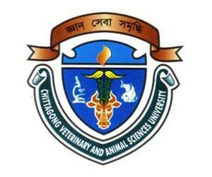

A Report
By

_____________________________
(SAYEDA AYESA SULTANA)
Roll No: 07/48, Reg. No: 335
Internship ID: E-44, Session: 2006-2007

Submitted in partial of the requirement for the fulfillment of the degree of
Doctor of Veterinary Medicine (DVM)

Approved as to style and content by

_________________________________
(MD. EMRAN HOSSAIN)
Associate Professor
Department of Animal Science & Nutrition
Chittagong Veterinary and Animal Sciences University
Khulshi, Chittagong-4202

February, 2013
Nutritive values of some selected unconventional feeds available in Chittagong district of Bangladesh

A Report
By

Roll No: 07/48, Reg. No: 335
Internship ID: E-44, Session: 2006-2007

Submitted in partial of the requirement for the fulfillment of the degree of Doctor of Veterinary Medicine (DVM)

Approved as to style and content by

_______________________
(Md. Emran Hossain)
Associate Professor
Department of Animal Science & Nutrition
Chittagong Veterinary and Animal Sciences University
Khulshi, Chittagong-4202

February, 2013
Nutritive values of some selected unconventional feeds available in Chittagong district of Bangladesh

INDEX

Contents | Page No.
1. Abstract | 01
2. Introduction | 01-02
3. Materials and Methods | 02-03
3.1 Study area | 02
3.2 Collection of sample | 02
3.3 Preparation of sample | 02
3.4 Analysis of sample | 03
3.5 Calculation of ME | 03
3.6 Data analysis | 03
4. Results and Discussion | 03-12
4.1 Banana flower (Musa sapientum) | 04
4.2 Cabbage (Brassica oleracea var. capitata) | 05
4.3 Castor bean (Ricinus communis) | 06
4.4 Cauliflower (Brassica oleracea var. botrytis) | 6-7
4.5 Gram husk (Cicer arietinum) | 7
4.6 Pea husk (Pisum sativum) | 8
4.7 Pumpkins (Cucurbita maxima) | 8-9
4.8 Radish (Raphanus sativus) | 9
4.9 Ridge gourd (Luffa acutangula) | 10
4.10 Spinach (Spinacia oleracea) | 10-11
4.11 Dhol kolmi (Ipomoea carnea) | 11-12
5. Conclusion | 15
6. Acknowledgement | 15
7. References | 15-18

Nutritive values of some selected unconventional feeds available in Chittagong district of Bangladesh

1. Abstract
________________________________________________________________

The study was conducted to find out the chemical composition of some selected unconventional feeds to use them as feed for large animals to enhance their productivity as well as to reduce feed cost. Total 11 different types of unconventional feeds like Cauliflower (Brassica oleracea var.botrytis), Radish (Raphanus sativus), Cabbage (Brassica oleracea var capitata), Pumpkin (Cucurbita maxima), Spinach (Spinacea oleracea), Banana flower (Musa sapientum), dhol kolmi (Ipomoea carnea), Ridge guard (Luffa acutangula), Castor bean (Ricinus communis) leaves, Gram husk (Cicer arietinum) and Pea husk (Pisum sativum) available in different areas of Chittagong, Bangladesh were collected, chopped and tested immediately for moisture content. The remaining samples were sun-dried, processed and analyzed for chemical analysis using standard procedure. Results indicated that, all the samples contained substantial amount of crude protein, crude fibre, nitrogen free extracts, ether extracts and ash. It could therefore be inferred that, these feeds could be incorporated in appreciable quantities for substituting the conventional feed resources of animal diet.
________________________________________________________________

Key words: Unconventional feed, moisture, dry matter, crude protein, crude fiber, nitrogen free extract, ether extract and ash.

2. Introduction

Bangladesh is an agricultural country. Livestock is one of its important components which provide protein, solve unemployment and earn foreign exchange (Taylor and Roese, 2006; Cole, 1996). Dairy sector is playing an important role in the economy of Bangladesh. It provides a large part of the increasing demands for animal protein like meat and milk. It also helps to earn cash income by exporting leather and leather products and also by creating employment opportunities. Although, dairying is the most ancient occupation established in the rural setting of Bangladesh, its development is unsatisfactory due to several problems (Shamsuddoha et al., 2000). In commercial dairying, feed cost alone accounts 60-70% of total production cost (Bulbul and Hossain 1989). Therefore, this is a demand of time to explore locally available cheaper alternative feed resources to reduce feed cost.

Most of the developing countries have been battling against the problem of how to adequately feed their livestock because of inadequate production of conventional feed ingredients for livestock feeding. Many of these countries are also well blessed with considerable good fertile, arable land, good sunshine and abundant and well distributed rainfall. The inadequate quantities of concentrated feedstuffs they produce yearly are competed by humans and their livestock. Usually humans have to have their needs satisfied first leaving the remainder for livestock (Babatunde, 1992).

Cattles have been fed various crop residues and unconventional feedstuffs for years. Proper utilization of unconventional feeds by ruminants will not only benefit the animal industry but will increase the economic return of many cash crops (Mustafa, 2002).Vegetable and fruit by-products have a good potential for use of ruminant and non-ruminant rations so that the gap between the demand and supply of feeds and fodders can be shortened. Efforts are focused on determining the seasonal availability and nutritive value of locally available fruit and vegetable by-products with a view to formulate adequate year round feeding system. Therefore, present study was undertaken to find out the chemical composition of some neglected fruits and vegetable wastes to bridge the gap between the demand and supply of the conventional feeds for livestock (Kumar et al., 2010).

3. Materials and methods
3.1 Study area

There are lots of small and large scale farm in Chittagong metropolitan area where most of the farmer usually feed their livestock with unconventional feed along with conventional based on availability. Therefore, local unconventional feeds available in these areas were selected as the study area.

3.2 Collection of sample

Samples were collected by using simple random sampling technique. Eleven feed samples were collectedly randomly. Approximately 2000 grams of each sample was collected. Samples were wrapped up by polythene bag and preserved in the laboratory for chemical analysis.

3.3 Preparation of sample

Samples were subjected to grinder to make it homogenous powder after sun drying. Later on, it was mixed properly and exposed to shade to cool down for sampling. Individual samples were identified by marker and subjected to chemical analyses.
3.4 Analysis of sample

Chemical analyses of the samples were carried out in triplicate for moisture, dry matter (DM), crude protein (CP), crude fibre (CF), nitrogen free extracts (NFE), ether extracts (EE) and ash in the animal nutrition laboratory and PRTC laboratory in Chittagong Veterinary and Animal Sciences University, Chittagong, Bangladesh as per AOAC (1994).

3.5 Calculation of ME

Metabolizable energy (ME) was calculated separately for all 11 different feed samples. Calculation was performed by mathematical formula as per Lodhi et al. (1976).

3.6 Statistical analysis

Data related to chemical composition of unconventional feeds were compiled by using Microsoft Excel 2007. Chi-square (χ²) test was performed to analyze the data by using SPSS 16.0. Statistical significance was accepted at 5% level (P<0.05).

4. Results and Discussion

Chemical composition of the unconventional feeds particularly, moisture, dry matter (DM), crude protein (CP), crude fiber (CF), nitrogen free extract (NFE), ether extract (EE) and total ash contents in different samples have been presented in Table 1 and Table 2.

Table 1. Chemical composition (g/100gDM) of the unconventional feeds

English name | Scientific name | ME⁺⁺ | DM | CP | CF | EE | NFE | Ash
Banana blossum | Musa sapientum | 2185.7 | 8.9 | 13.8 | 27.4 | 3.9 | 44.7 | 10.2
Cabbage | Brassica oleracea | 2521.1 | 6.1 | 18.9 | 13.8 | 0.9 | 56.4 | 10.0
Castor bean | Ricinus communis | 2201.8 | 24.2 | 21.0 | 25.0 | 1.6 | 43.1 | 9.3
Cauliflower | Brassica oleracea | 2316.8 | 9.7 | 17.3 | 21.0 | 1.5 | 50.5 | 9.7
Pumpkin | Cucurbita maxima | 2889.2 | 12.6 | 12.9 | 9.9 | 2.1 | 70.8 | 4.3
Radish | Raphanus sativus | 2544.0 | 6.3 | 14.9 | 13.6 | 0.9 | 61.1 | 9.5
Ridge gourd | Luffa acutangula | 2577.5 | 18.3 | 23.4 | 12.1 | 1.2 | 53.0 | 10.3
Spinach | Spinacia oleracea | 2469.1 | 8.7 | 11.4 | 13.9 | 2.2 | 59.4 | 13.1
Dhol kolmi | Ipomoea carnea | 2493.4 | 19.3 | 26.3 | 13.0 | 0.2 | 49.8 | 10.7
Level of Sig. |  | *** | *** | NS | 0.05 | NS | NS | NS
⁺⁺Metabolizable energy (kcal/kg); ^{DM}Dry matter; ^{CP}Crude protein, ^{CF}Crude fibre, ^{NFE}Nitrogen free extract, ^{EE}Ether extract; ^{NS}Non-significant (P>0.05); *Significant at 5% level (P<0.01); ***Significant at 0.1% level (P<0.001)

Table 2. Chemical composition (g/100gDM) of the unconventional feeds.

English name | Scientific name | ME⁺⁺ | DM | CP | CF | EE | NFE | Ash
Gram husk | Cicer arietinum | 1798.9 | 88.4 | 4.5 | 48.3 | 5.6 | 38.4 | 3.2
Pea husk | Pisum sativum | 1350.9 | 89.2 | 6.2 | 48.4 | 2.3 | 30.5 | 12.6
Level of Sig. |  | *** | NS | NS | NS | NS | NS | *
⁺⁺Metabolizable energy (kcal/kg); ^{DM}Dry matter; ^{CP}Crude protein, ^{CF}Crude fibre, ^{NFE}Nitrogen free extract, ^{EE}Ether extract; ^{NS}Non-significant (P>0.05); *Significant at 5% level (P<0.05); ***Significant at 0.1 level (P<0.001)

In this study ME, DM, CP, CF, EE, NFE and ash were determined for some selected unconventional feeds to make a decision as to whether they could be a suitable alternative for traditional feeds.

4.1 Banana flower (Musa sapientum)

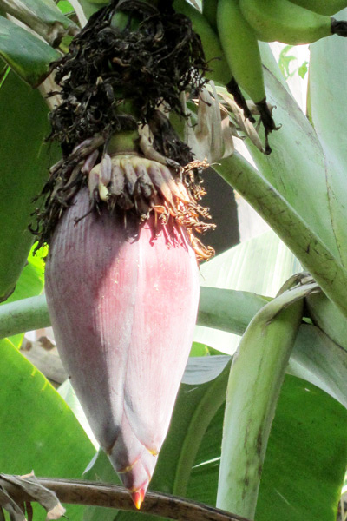
Banana flower (Musa sapientum) known as banana blossom or heart, is a wonder looking male, sterile flower of the banana plant. Banana flower, similarly to banana is an excellent source of potassium, vitamins A, C and E. According to research conducted by the Chinese Academy of Tropical Agricultural Sciences, banana flowers have tremendous nutritional values. This is a good source of fiber and protein. The flowers contain a class of phytochemical known as saponins. They also have antioxidant activity to reduce the risk of cardiovascular diseases.

Banana flowers are an excellent source of flavonoids. These phytochemicals help prevent damage to DNA cells by neutralizing free radicals. They have cholesterol lowering, anti-inflamation, anticancer and anti-aging activities (http://food-nutrition.knoji.com/banana-flowers-or-banana-blossom-culinary-uses-and-nutritional-value).
In present study, banana flower contained 2185.7 Kcal/kg ME, 91.1 g/100g moisture, 13.8 g/100g crude protein, 27.4 g/100g crude fibre, 3.9 g/100g ether extract, 44.7 g/100g nitrogen free extracts and 10.2 g/100g ash which is close to the result of Kanchana et al. (2005) who found 88.75 g/100g moisture, 21.01 g/100g crude protein, 20.315 g/100g crude fibre and 8.74 g/100g ash. Therefore, banana flower could be a promising alternative feed resource for livestock.
4.2 Cabbage (Brassica oleracea var capitata)

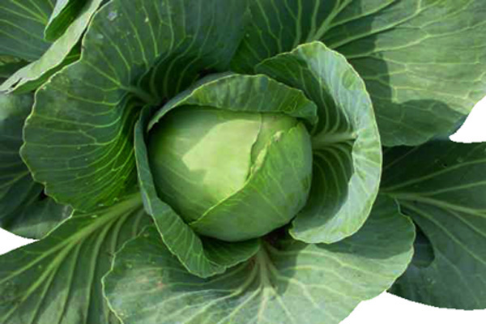
Cabbage (Brassica oleracea var capitata) is an herbaceous flowering plant with leaves forming a compact head chrematistics. This is an abundant feedstuff both for man and animal and available throughout the whole country. This is low in calorie because of its high water content. Cabbage is a good source of fibre, provitamin A, vitamin C and B₉. It is a vital source of calcium. Recently, cabbage was found to contain substances such as indole, isothiocyanates and dithiolthiones which seem to have powerful anti-cancer properties.

A wide number of experiments performed over last twenty years, both on animals and people, have confirmed the beneficial effect of eating cabbage on a regular basis to help prevention of colon, stomach, lung and oesophagus cancer (http://www.fondation-louisbonduelle.org/france/en/know-your-vegetables/nutritional-assets-of-vegetables/chouvert.html#axzz2K5t0e2kn).
Cabbage contains 24 kcalME/g, 92.0 g/100g moisture, 1.3 g/100g protein, 0.2 g/100g fat, 5.4 g/100g fibre (Akula et al., 2007). In present study, cabbage contained 2521.1 Kcal/kg ME, 93.9 g/100g moisture, 18.9 g/100g crude protein, 13.8 g/100g crude fibre, 0.9 g/100g ether extract, 56.4 g/100g nitrogen free extracts and 10.0 g/100g ash.
Cabbage leaf contains high levels of glucosinolates, which form compounds with antioxidant and anticancer activities during preparation (Mvere and Werff, 2004). According to Gopalan et al. (2004), brassica vegetables are highly regarded for their nutritional value as they provide higher amounts of vitamin C, soluble fibre and many other multiple nutrients with potent anti-cancer properties.

It has recently been discovered that 3,3-Diindolylmethane in Brassica vegetables is a potent modulator of the innate immune response system with potent anti-viral, anti-bacterial and anti-cancer activity (Wikipedia, 2009). Iron in leaf cabbage is available in an easily digestible form (Mvere and Werff, 2004).
4.3 Castor bean (Ricinus communis)

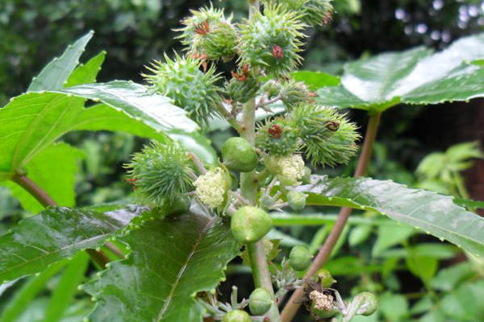
Castor bean (Ricinus communis) has been cultivated for centuries for the oil produced by its seeds. The Egyptians burned castor oil in their lamps more than 4000 years ago (Oplinger, 1990). Castor bean is cultivated all over the world on commercial scale including some advanced countries. Among these, India, China, Brazil, Ethiopia, Paraguay, Vietnam and Thailand are the major castor growing countries and account for 97.0% of the world's production (FAO, 2008). In present study, castor bean contained 2201.8 Kcal/kgME, 75.6 g/100g moisture, 21.0 g/100g crude protein, 25.0 g/100g crude fibre, 1.6 g/100g ether extract, 43.1 g/100g nitrogen free extracts and 9.3 g/100g ash.
The castor beans grown in India for castor oil production has high leaf-protein content but has not been processed because, although the immature leaves are safe to consume, a poisonous alkaloid ‘ricin’ combined with protein forms in the mature leaf (Martin et al., 1975). The nutritional values of leaf proteins have been investigated by (Waterlow, 1962; Duckworth and Woodham 1961; Gerloffet al.,1965 and Subba Rau et al., 1969). While leaf amino acid compositions have been investigated by (Chibnall et al., 1963) and (Gerloff et al., and Byers 1963).
4.4 Cauliflower (Brassica oleracea var. botrytis)
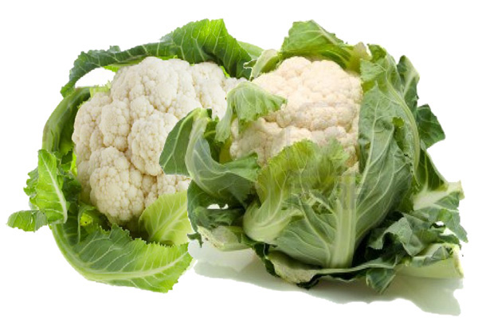
Cauliflower (Brassica oleracea var. botrytis) is a vegetable. Its scientific name is Brassica oleracea var. botrytis species. It originated in the northeast Mediterranean and is presently cultivated in most of the countries of the world including Bangladesh. Cauliflower has a small compact head covered with hundreds of flower clusters attached to a short stalk. Cauliflower's nutrients make it a true champion in the fight against cancer. (http://metro.ca/conseil-expert/jardinier/panier-legumes/legumes-fleurs/chou-fleur.en.html). In addition to fibre, this is a good source of protein, thiamin, riboflavin, phosphorus, potassium, vitamin C, vitamin K, vitamin B₆, folate, pantothenic acid and manganese (http://nutritiondata.self.com/facts/vegetables-and-vegetable-products/2391/2).
In present study, cauliflower contained 2316.8 Kcal/kg ME, 91.3 g/100g moisture, 17.3 g/100g crude protein, 21 g/100g crude fibre, 1.5 g/100g ether extract, 50.5 g/100g nitrogen free extracts and 9.7 g/100g ash. Cauliflower contains 27 kcalME/g, 97.0 g/100g moisture, 2.7 g/100g protein, 0.2 g/100g fat and 5.2 g/100g crude fibre (Akula et Al., 2007). In another study, cauliflower contained 1.9 g/100g proteins, 91.95 g/100g water, 0.7 g/100g ash and 2 g/100g dietary fiber. According to Gopalan et al. (2004), cauliflower has 66 kcl energy, 80.0 g/100g moisture, 6.0 g/100g protein, 1.0 g/100g fat, 3.0 g/100g mineral and 2 g/100g fibre. Therefore, cauliflower and its wastes could be a promising alternative feed resource for livestock.

4.5 Gram husk (Cicer arietinum)

Gram husk (Cicer arietinum) is frequently used in dairy ration because it is not only cheap but also abundant especially in Chittagong region. In present study, gram husk contained 1798.9 Kcal/kg ME, 11.6 g/100g moisture, 4.5 g/100g crude protein, 48.4 g/100g crude fibre, 5.6 g/100g ether extract, 38.4 g/100g nitrogen free extracts and 3.2 g/100g ash.

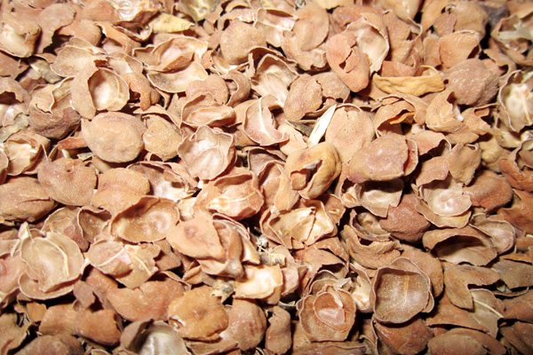
In another study, Sreerangarajua (2000) found 51.0 g/100g crude protein and 11.0 g/100g ether extracts in gram husk. The proximate composition of Bengal gram (Cicer arietinum) husk is comparable to that of cereal straw (Sen et al., 1978). It is one of the preferred feed ingredients in the diet of crossbred dairy cows in and around Bangalore, India. It is reported that gram husk contain some anti nutritional factors (Barry, 1989) particularly certain types of tannins. So gram husk can be cautiously used in ruminant ration.
4.6 Pea husk (Pisum sativum)
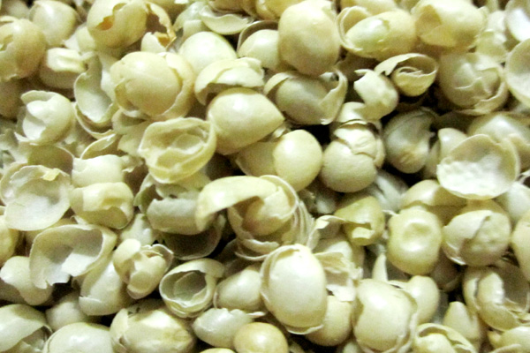
Pea husk (Pisum sativum) in present study, contained 1350.9 Kcal/kg ME, 10.8 g/100g moisture, 6.2 g/100g crude protein, 48.4 g/100g crude fibre, 2.3 g/100g ether extract, 30.5 g/100g nitrogen free extracts and 12.6 g/100g ash which is similar to FAO (2002) where the they found 93.7 g/100g dry matter, 6.7 g/100g crude protein, 38 g/100g crude fibre, EE 0.3 g/100g ether extracts and 5.0 g/100g ash. According to Gowda et al. (2004), pea husk contained 92.3 g/100g dry matter, 6.0 g/100g crude protein, 1.1 g/100g ether extracts, 42.6 g/100g crude fibre, 5.0 g/100g ash and 45.2 g/100g nitrogen free extracts. So, peas husk could be a potential and valuable feed for livestock as it is available in whole country at a reasonable price.
4.7 Pumpkin (Cucurbita maxima)
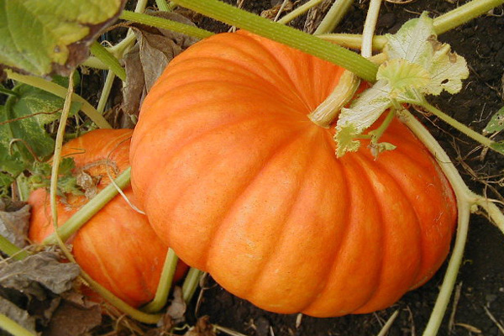
Pumpkins (Cucurbita maxima) are gourd squashes of the genus Cucurbita and the family Cucurbitaceae. The pumpkins are cultivated worldwide and have high production yields. In fact, most of the species belongs to the Cucurbitaceae family is a nutritious food in Bangladesh. With a high nutritional value, pumpkins are associated with a lot of health benefits. Apart from the flesh, even the seeds of pumpkins boast of a large number of nutrition benefits. The high amount of fiber, present in a pumpkin, is good for the bowel health. Pumpkin is very rich in carotenoid which is known for keeping the immune system strong and healthy. Being rich in alpha-carotene, pumpkin is believed to slow down the process of aging and also prevent cataract formation. Pumpkins have been known to reduce the risk of macular degeneration and a serious eye problem like blindness (http://lifestyle.iloveindia.com/lounge/benefits-of-pumpkin-1659.html).
In present study, pumpkin contained 2889.2 Kcal/kg ME, 87.4 g/100g moisture, 12.9 g/100g crude protein, 9.9 g/100g crude fibre, 2.1 g/100g ether extract, 70.8 g/100g nitrogen free extracts and 4.3 g/100g ash. In another study, Rahman (2008) found 4.0 g/100g dry matter, 1.0 g/100g crude protein, 0.7 g/100g crude fibre, 0.1 g/100g ether extract in pumpkin which is contradictory to our finding. Jenkins, (2010) found 16.5 g/100g dry matter, 14.45 g/100g crude protein, 38.6 g/100g neutral detergent fiber, 32.5 g/100g acid detergent fiber in pumpkin. So pumpkins are a good source of energy and adequate in protein for beef cattle.

4.8 Radish (Raphanus sativus)

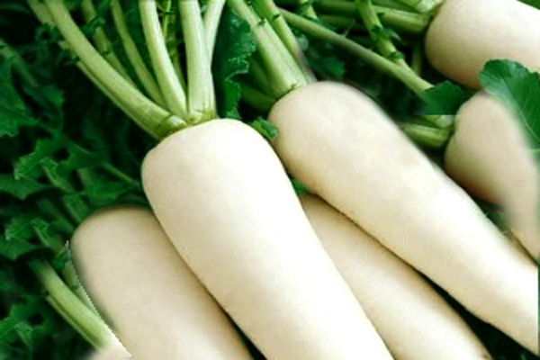
Radish (Raphanus sativus) belongs to Brassicaceae family. It is cheap and available feedstuffs in Bangladesh and found around 6 month in a year. Radishes are known for their anti-bacterial and anti-fungal properties. Radish contains vitamin C, potassium, sodium and trace amount of other minerals. Radishes are low in saturated fatty acids. They are a good source of riboflavin, vitamin B₆, calcium, magnesium, copper and manganese. Radish is an excellent source of dietary fiber, folate, vitamin C and potassium.
Radish is an important vegetable crop worldwide. In present study, radish contained 2544.0 kcal/kg ME, 93.7 g/100g moisture, 14.9 g/100g crude protein, 13.6 g/100g crude fibre, 0.9 g/100g ether extract, 61.1 g/100g nitrogen free extracts and 9.5 g/100g ash which is close to the result of Zhao-liang et al. ( 2008) who found 29.7 to 88.2 g/100g dry matter, 4.507 to 18.546 g/100g crude fiber, 2.233 to 15.457 g/100g total soluble sugar , 0.1416 to 0.3341 g/100g vitamin C and 0.34 to 1.15 g/100g protein on fresh weight basis.

4.9 Ridge gourd (Luffa acutangula)

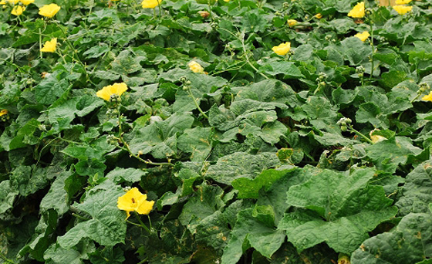
Ridge gourd (Luffa acutangula) locally known as Dhundol. The fruits are edible and eaten as vegetable. It is good for health. The seeds are emetic and carthartic. Young fruits are cool, demulcent, producive of loss of appetite and extive of mind, bile and phlegmare (Rahman et al., 2008). This is low in saturated fat and cholesterol, high in dietary fiber, vitamin C, riboflavin, zinc, thiamin, iron, magnesium and manganese. It has blood-purifying properties. It helps to purify, restore and nourish liver from alcohol intoxication. It has high beta carotene that is good for eyes. In present study, ridge gourd leaf contained 2577.5 kcal/kg ME, 81.7 g/100g moisture, 23.4 g/100g crude protein, 12.1 g/100g crude fibre, 1.2 g/100g ether extract, 53.0 g/100g nitrogen free extracts and 10.3 g/100g ash.

Hussain et al. (2010) found 7.31 g/100g dry matter, 13.47 g/100g crude protein, 2.09 g/100g crude fibre, 2.09 g/100g ether extract and 5.55 g/100g ash in ridge gourd leaves which is close to our findings. In another study (Abitogun, 2010) the range of the proximate components in ridge gourd leaf was crude protein (42.17-70.65 g/100g), moisture (5.69-6.42 g/100g), fat content (1.53-33.64 g/100g), ash content (3.87-3.92 g/100g), crude fibre (1.95-2.80 g/100g), carbohydrate (12.68-14.68 g/100g) and the available energy (1507.53-2177.13KJ).

4.10 Spinach (Spinacia oleracea)

Spinach (Spinacia oleracea) belongs to the Amaranthaceae family. This is a wonderful green-leafy vegetable often recognized as one of the functional foods for its nutritional, antioxidants and anti-cancer constituents. Around 100g of spinach contains about 25 g/100g of the daily intake of iron (http://www.nutrition-and-you.com/spinach.html). Spinach is a leafy green vegetable of winter season. Spinach is a prominent source of iron, vitamins A and C, thiamin, potassium and folic acid, carotenoids, lutein and zeaxanthin (Abbas et al., 2010). It contains 3.2 g/100g protein, 0.3 g/100g fat and 4.3 g/100g fibre (Akula et al., 2007).

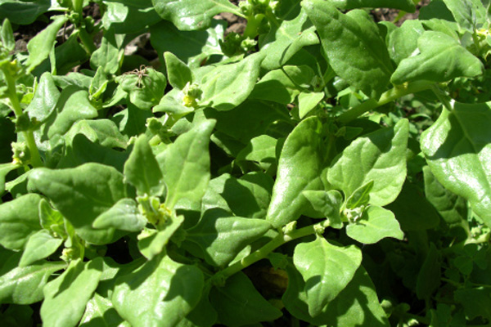
According to Gopalan et al. (2004) spinach contained 2.6 kcalME/g, 92 g/100g moisture, 2.0 g/100g protein, 1.0 g/100g fat, 2.0 g/100g mineral and 1.0 g/100g fibre. In present study, spinach contained 2469.1 Kcal/kg ME, 91.3 g/100g moisture, 11.4 g/100g crude protein, 13.9 g/100g crude fibre, 2.2 g/100g ether extract, 59.4 g/100g nitrogen free extracts and 13.1 g/100g ash.

4.11 Dhol kolmi (Ipomoea carnea)

Dhol kolmi (Ipomoea carnea) is a herbaceous aquatic or semi-aquatic perennial plant of the tropics or subtropics. Leaves are flat and vary in shape depending on variety, from heart-shaped to long, narrow and arrow-shaped. Narrow leaves are 1-2.5 cm wide and 20-30 cm long. Broad leaves are up to 5 cm wide and 15-25 cm long. The leaves are very low in cholesterol. It is also a good source of protein, dietary fiber, phosphorus, vitamin A, vitamin C, riboflavin, niacin, vitamin B₆, folate, calcium, iron, magnesium, potassium and manganese. Dhol kolmi (Raw) is an excellent source of Vitamin A and Vitamin C.

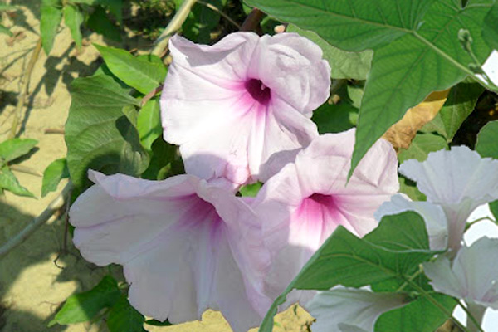
In many developing countries, the largest contribution of vitamin A intake comes from the provitamin A carotenoids in plant foods, which may contribute up to 82 g/100g of the total vitamin A intake, whereas the contribution from fish and meat is of minor importance, because these foods are expensive and/or are not accessible (Berg VD et al., 2000). Malaysians mostly consume green vegetables such as Chinese mustard leaves, Chinese kale, lettuce, spinach and swamp cabbage (Amin and Cheah 2003; Wen et al., 2010). In present study, swamp cabbage contained 2493.4 Kcal/kg ME, 80.7 g/100g moisture, 26.3 g/100g crude protein, 13.0 g/100g crude fibre, 0.2 g/100g ether extract, 49.8 g/100g nitrogen free extracts and ASH 10.7 g/100g.

5. Conclusion

The main reason why unconventional feeds widely differ in their energy content is the variation in the content of their proximate components. The role of unconventional feeds in ruminant nutrition continues to increase. The utilization of unconventional feeds will not only benefit the beef industry but will also increase the economic return for several crops in Bangladesh. To standardize the feeding value of unconventional feeds, a systematic evaluation system based on based direct feeding trial should be adopted in future.

6. ACKNOWLEDGEMENT

All praises are due to the Almighty Allah, the creator and supreme authority of the universe, who empowers me to complete this work successfully.

It is deemed as a proud privilege and extra terrestrial pleasure to express author ever indebtedness, deepest sense of gratitude, sincere appreciations, profound regards to reverend and beloved teacher and supervisor MD. EMRAN HOSSAIN, Associate Professor, Dept. of animal Science & nutrition, Chittagong Veterinary and Animal Sciences University for his constructive and constant guidance, continuous encouragement, scholastic guidance, and affectionate feelings throughout the course of work. The author is deeply owed, Professor JANNATARA KHATUN, Head of the Department. Dept. of animal Science & nutrition, Chittagong Veterinary and Animal Sciences University, for her valuable advice during work.
The Author
February, 2013

6. References

Abbas T, Shahid MA, Pervez MA, Rashad M, Balal C, Ayyub M (2010). Institute of Horticultural Sciences, University of Agriculture, Faisalabad (Punjab) Pakistan, University College of Agriculture, University of Sargodha (Punjab) Pakistan, (01-Dcember-2010). Spinach: A valuable Green Leafy Vegetable with Excellent Nutritional and Medical Value.
Abitogun AS and Ashogbon AO (2010). Nutritional Assessment and Chemical Composition of Raw and Defatted Luffa cylindrica. Adekunle Ajasin University, Akungba, Ondo State, Nigeria.
Akula US, Baijahth H, Beekrum S, Odhav B (2007). Preliminary assessment of nutritional value of traditional leafy vegetables in KwaZulu-Natal, South Africa. J Food Composit Anal, 20: 430-435.
Amin I and Cheah SF (2003). Determination of Vitamin C, β-carotene and Riboflavin contents in Five Green Vegetables Organically and Conventionally Grown. Malaysian Journal of Nutrition, 9 (1): 31-39.
AOAC (2000). Official Methods of Analysis. Association of Official Analytical Chemists. (17th end). Gaithersburg, Maryland, USA.
Babatunde GM (1992). Availability of banana and plantain products for animal feeding.
Barry TN (1989). Condensed tannins; their role in ruminal protein and carbohydrate digestion and possible effects on rumen ecosystem. In: Role of Protozoa and Fungi in Ruminant Digestion. Armidale, Australia, pp: 153-169.
Berg VD, Faulks H, Granado R, Hirschberg J, Olmedilla B, Sandmann G, Southon S and Stahl W (2000). The potential for the improvement of carotenoid levels in foods and the likely systemic effects. Journal of the Science of Food and Agriculture, 80: 880–912.
Bulbul SM and Hossain MD (1989). Probable problems of poultry feed formulation in Bangladesh. Poultry Advisor, 12 (3): 27-29.
Chibnall AC, Rees MW and Lugg JWH (1963). The amino acid composition of leaf proteins. J Sci Food U.
Cole HH (1996). Introduction to Livestock production. 2nd Edn. Freeman and co, SanFrancisco and London.
Duckworth J and Woodham A (1961). Leaf protein concentrates. Effect of source of raw material and methods of drying on protein value for chicks and rats. J Sci Food Agric, 12: 5-15.
FAO (2002) Food Balance Sheet 2002. Rome, Italy: Food and Agriculture Organization of United Nation. Accessed on 10 November 2009. http://faostat.fao.org/faostat.
FAO (2008). Food and Agriculture Organization of United Nations.
Gerloff ED, Lima IH, and Stahmann MA (1965). Amino acid composition of leaf protein concentrates. Agric food ind, 13:139-149.
Gopalan C, Rama SBV and Balasubramanian SC (2004). Nutritive Value of Indian Foods. National Institute of Nutrition, ICMR, Hyderabad.
Gowda NK S, Ramana JV, Prasad CS, Khub S ( 2004). Micro nutrient content of certain tropical conventional and unconventional feed resources of Southern India. Trop Anim Health Prod, 36 (1): 77-94.
http://food-nutrition.knoji.com/banana-flowers-or-banana-blossom-culinary-uses-and-nutritional-value/.
http://lifestyle.iloveindia.com/lounge/benefits-of-pumpkin-1659.html).
http://metro.ca/conseil-expert/jardinier/panier-legumes/legumes-fleurs/chou-fleur.en.html.
http://nutritiondata.self.com/facts/vegetables-and-vegetable-products/2391/2).
http://www.fondation-louisbonduelle.org/france/en/know-your-vegetables/nutritional-assets-of-vegetables/chouvert.html#axzz2K5t0e2kn)
http://www.nutrition-and-you.com/spinach.html.

Hussain J, Rehman NU, Alhamayun KM, Hussain SM, Shinwari ZK (2010). Proximate and essential nutrient evaluation of selected vegetables species from kohat region, Pakistan; Pak J Bot, 42(4): 2850, (2010).
Jekin KH (2010). Feed Value of Alternative Crops for Beef Cattle: Beef cattle feeding options may include field peas, dry edible beans, pumpkins, and sugarbeets.
Kanchana S, Wickramarachchi and Senaratne L. Ranamukhaarachchi (2005). Preservation of Fiber-Rich Banana Blossom as a Dehydrated Vegetable, Agricultural System and Engineering Program, Asian Institute of Technology, Thailand. Science Asia, 31 (2005): 265-271.
Kumer s, anil p (2010). Utilization of fruits vegetables and minor oil seed cakes as an unconventional feedstuffs.
Lodhi GN, Daulat S and Ichhponani JS (1976). Variation in nutrient content of feeding stuffs rich in protein and reassessment of the chemical method for metabolizable energy estimation for poultry. The Journal of Agricultural Science, 86(2): 293-303.
Martin FW, Telek L and Ruberte R (1975). Some tropical leaves as feasible sources of protein. In review.
Mustafa AF (2002). Ruminal Fermentation and Utilization of Unconventional Feeds in Western Canada.
Mvere B, Werff VDM (2004). Brassica oleracea (cabbage) In : Grubben GJH and Denton OA (Editors). Prota 2: vegetables/Legumes. [CD-Rom]. PROTA, Wageningen, Netherlands.
Oplinger ES, Oelke EA, Kaminski AR, Combs SM, Doll JD, and Schuler RT (1990). Castor beans.
Rahman AHMM, Anisuzzaman M, Ahmed F, Rafiul AKM and Naderuzzaman ATM (2008). Department of Botany, University of Rajshahi, Rajshahi: Study of Nutritive Value and Medicinal Uses of Cultivated Cucurbits. Bangladesh Journal of Applied Sciences Research, 4(5): 555-558, 2008.
Sen KC, Ray SN, Ranjhan SK (1978). Nutritive Value of Indian Cattle Feeds and Feeding of Animals, ICAR, New Delhi.
Shamsuddoha, Edwards AK, Geoff W 2000. “Dairy Industry in Bangladesh: Problems and Prospects”. Australian Agricultural and Resource Economics Society >2000 Conference (44th), January, 23-25, 2000, Sydney, Australia.
Sreerangarajua IU, Krishnamoorthyb, Kailasb MM (2000). Evaluation of Bengal gram (Cicer arietinum) husk as a source of tannin and its interference in rumen and Post-rumen nutrient digestion in sheep. Animal Feed Science and Technology, 85 (2000).
Subba R, Mahadeviah BHS and Singh H (1969). Nutritional studies on whole extract coagulated leaf protein and fractionated chloroplastic and cytoplasmic proteins frlucerne (Medicago sativa). J Sci Food Agric, 20: 355.
Swamp cabbage, cooked, boiled, drained, with salt: http://nutritiondata.self.com/facts/vegetables-and-vegetable-products/2945/2.
Taylor G and Roese G (2006). Basic pig husbandry. NSW, New South Wales.
Waterlow JC (1962). The absorption and retention of nitrogen from leaf protein by infants recovering from malnutrition. Br J Nutr, 16: 531.
Wen TN, Prasad KN, Bao Y and Amin I (2010), Bioactive substance contents and antioxidant activity of blanched and raw vegetables. Innovative Food Science and Emerging Technologies, 11: 464-469.
Wikipedia (2009). Brassica. http://en.wikipedia.org/wiki/Brassica.
Zhao-liang LU, Li-wang LIU, Xiao-yan LI, Yi-qin GONG, Xi-lin HOU, Xian-wen ZHU, Jin-lan YANG, Long-zhi WANG (2008). Analysis and Evaluation of Nutritional Quality in Chinese radish (Raphanus sativus): Agricultural Sciences in China Volume 7, Issue 7, July 2008, Pages 823–830.

