CHAPTER I
INTRODUCTION
Bangladesh, a densely populated agro-based developing country, has a total area of 147570 square kilometers and a total population of 142.6 million people with a density of over 966 persons per square kilometer (SPBB, 2008). Bangladesh livestock population statistics indicates poultry is the most important species of farm animals. It is an emerging sub sector of livestock, play a vital role in her economic development by providing employment to different sections of people which has started here practically during 1980s ( Huque and Paul, 2001 ).

In 1998-99, total meat production in Bangladesh was 656,000 tones, of which chicken and duck meat contributed 154,000 tones, which ranked second after beef. Per capita meat consumption was only 5.12 kg per year (BBS, 2000), and per capita protein intake 63gm per day (BBS, 2003) which is markedly below recommended requirements. Thus there is a need to increase the animal protein production to fulfill the demand of the increasing people.

In this regard, quail farming can offer a viable and practical solution to the problem of protein malnutrition and also animal protein shortage. Furthermore, due to improvement of life style and per capita income in our country, some customers have personal preferences about the variety of color, texture and flavor of poultry meat. There is a great passion for choosing the colored poultry species with lean and tasty meat in compared to soft textured broiler chicken. Quail can meet up the protein demand and customers’ preference as well as encouragement of the gradual development of rising poultry sectors in our country.

Now quail is being considered as an industrial poultry in Bangladesh because of its unique characteristics. The high egg production (250- 300 eggs per bird per year), early sexual maturity (egg producing age only 7 week of age), early marketing age (marketing age 5 weeks.), short generation interval (3-4 generation per year), faster growth rate, requirement of small amount of feed (20-25 gm/bird/day after maturity), low mortality, less worries for vaccination (high disease resistance), low investment for farming and low space requirement are made encouraging economic traits for quail production (Panda, 1989).
The great scope to popularize quail in this country for augmentation of animal protein supply more economically. For efficient and maximum production of quail chicks for meat and eggs, a thorough understanding of the anatomy of air sac of the quail is invaluable. On the other hand, every year about 30% of poultry bird die due to various diseases. Of those there are many diseases related to air sacs of poultry. The diseases which cause harmful effect in poultry sectors of Bangladesh are Colibacillosis (E. coli), Cholera (Pasteurella multocida), Chronic Respiratory Disease (Mycoplasma gallisepticum), Aspergillosis (Aspergillus sp.) Coryza (Bordetella avium), Avian Influenza (H5N1), Psittacosis (Chlamydia psittaci).
And also there are many other diseases that affect air sacs and act as secondary cause of many other respiratory diseases and reduces production,causes death of bird.To diagnose and prevent the diseases of air sacs we must know the location,position,number ultimately anatomy of air sacs.
For over two and one-half centuries it has been know that there is certain structures accessory to the bird lungs-air sacs. The morphology of the air sacs, especially in several domestic birds, has been amply reported in various textbook (Calislar,1984., King and McLelland,1984., Ocal and Erden,2002) and papers (Rigdon et al.,1958.,Lucas et al.,1959.,Mennega and Calhoun,1968). The sacs appear as thin walled, membranous, non-vascular, non-mascular with more or less fibrous connective tissue basement.All the sacs with the exception of the interclavicular can be freed of connections with adjacent tissues. As the present conceptions concerning of functions of sacs must be said. The key of breathing system is that distention and compression of the air sac, not the lungs moves, air in and out and that at any given moment. Air may be moving into and out of the lungs and being passed in the air sacs. The air sacs permit a unidirectional flow of air through the lungs. Unidirectional flow means that air moving through birds lungs is largely fresh air and a higher oxygen content. The purpose of the study of air sacs is to know the number, location, position of air sacs and the breathing mechanism of bird.
Objective:
- To know the anatomy of lung and air sacs of Japanese quail.
- To know the aeration system of lung and its relationship with air sacs.

CHAPTER II

REVIEW OF LITERATURE
2.1 Japanese quail

Quail along with chickens, pheasants and partridges are belong’s to the Family Phasianoidea of Order Galliformes of the Class Aves of the Animal Kingdom. Species or subspecies of the genus Coturnix are native to all continents except the Americas. One of them Coturnix coturnix or common quail are migratory birds of Asia, Africa and Europe. Several interbreeding subspecies are recognized, of them the European quail (Coturnix coturnix coturnix) and the Asiatic or Japanese quail (Coturnix coturnix japonica) are more important. One subspecies that commonly migrates between Europe and Asia was eventually domesticated in China. These birds were raised as pets and singing birds. The domesticated coturnix were brought at about eleventh century to Japan from China across the Korean bridge (Howes, 1964). In any event, coturnix was first domesticated in the Orient and not in the Middle East as has been claimed by some authors. Although European coturnix migrating south in the fall across the Mediterranean Sea were, in their exhausted condition, easily caught or trapped the available Egyptian and Biblical records do not indicate that these birds were ever bred in captivity.
Earliest written records from Japan reveals that Japanese quail were apparently domesticated in Asia by the 12th century (Mills et al., 1997), bred initially for the enjoyment of their vocalizations and later for eggs and meat. It is claimed that a Japanese Emperor obtained relief from tuberculosis after eating quail meat, and this led to selection of domestic quail for meat and egg production in Japan in the latter part of the nineteenth century (Howes, 1964). By 1910, the Japanese quail in Japan were widely reared for their meat and eggs. Between 1910 and 1941, the population of Japanese quails increased rapidly in Japan especially in the Tokyo, Mishima, Nagoya, Gifu and Toyohashi areas. This period also represented a time of imperial expansion in Japanese history and domesticated Japanese quail were established in Korea, China, Taiwan and Hong Kong, and later on spread to Southeast Asia.

The domesticated subspecies, Coturnix coturnix japonica, is called the Japanese quail but is also known by other names: Common quail, Eastern quail, Asiatic quail, Stubble quail, Pharoah's quail, Red-throat quail, Japanese gray quail, Japanese migratory quail, King quail, and Japanese King quail. The correct popular nomenclature for Coturnix coturnix japonica should be Japanese quail or coturnix, but not coturnix quail since in Latin "coturnix" may be translated as quail.

2.2 Avian respiratory system

The respiratory system in birds has the principal function of exchanging oxygen and carbon dioxide between atmosphere and blood. It is also involved in temperature regulation and phonation. It has these features in common with the respiratory system of mammals but it differs significantly in the anatomical arrangement of its parts (Fedde, 1998).

The respiratory system of birds is different from all other vertebrates. Birds have a lot of “empty space” inside them to keep them light for flying. These “empty spaces” are filled with clear, “glad wrap” bags of air, the air sacs. When a bird breathes in and out, it is not the lungs that are moving. A bird’s lungs are static. It is the air sacs that move and pump oxygen through a complex bronchial network of a stationary lung (John Kimball, 2010).

2.3 Air sacs of Japanese quails

Birds posses numerous anatomical characteristics particularly in the respiratory system, such as air sacs (sacci pneumatic) (Tasbas et al., 1994; Sturkie, 2000). These structures are extra-pulmonary extensions of the bronchi; they are present around several visceral organs and extend into many of the skeletal bones at various levels (Hogg, 1990). Their volumes are changeable owing to the muscles on the body wall (King and Payne, 1962).

The morphology of the air sacs, especially in several domestic birds, has been amply reported in various textbook (Calislar, 1984; King and McLelland, 1984; Ocal and Erden, 2002) and papers (Lucas et al., 1959; Mennega and Calhoun,1968).

The air sacs of birds constitute thin-walled chambers, located largely in the cervical, thoracic and abdominal cavities (Dunker, 1971). Powered by respiratory muscles, they act as bellows in the ventilatory mechanism, and communicate with the non-expanding avian lungs via the ostia (McLelland, 1989). The wall of the air sac consists essentially of a single luminal epithelium that covers a thin layer of connective tissue underlaid by peritoneal epithelium. A small number of muscle cells can be observed, probably extending from the smooth muscle layer present around the bronchi (Bennett and Malmorfs, 1970; Dunker, 1971; Groth, 1972).
Most birds have 9 air sacs, functionally, these 9 air sacs can be divided into anterior sacs (interclavicular, cervical, and anterior thoracics) and posterior sacs (posterior thoracics and abdominals). Air sacs have very thin walls with few blood vessels. So, they do not play a direct role in gas exchange. Rather, they act as a 'bellows' to ventilate the lungs (Powell 2000).

2.4 Gas flow patterns in the respiratory system during breathing

Active contraction of muscles of the body wall coupled with its elastic recoil during both inspiration and expiration are responsible for the cyclic changes in the volume of the coelom (Fedde, 1987).
The neopulmonic parabronchial network contains only about 15 to 20% of the gas exchange surface in the lung in chickens; the ventilation/perfusion ratio is very high in this network (Duncker, 1971; Scheid et al., 1989). Thus, the gas in the caudal air sacs has only a small reduction in the oxygen partial pressure compared to that in air, and has a carbon dioxide partial pressure that is only increased by a small amount above that in air (Fedde, 1986). On the other hand, gas that enters the cranial air sacs has been exposed to a large fraction of the gas exchanging surface in the lung (the paleopulmonic parabronchi) and has partial pressures of oxygen (PO₂) and carbon dioxide (PCO₂) only a few torr different from that in end-expired gas or in mixed venous blood entering the lung (Meyer et al., 1976; Scheid et al., 1989).
The lack of any anatomical valves in the avian lung, the unidirectional gas flow through the
paleopulmonic parabronchi has been postulated to occur because of “aerodynamic valving” (Dotterweich, 1936).There has recently been renewed interest in determining the mechanisms responsible for aerodynamic valving in the avian lung during both inspiration and expiration(Butler et al., 1988; Kuethe, 1988; Wang et al., 1988, 1992; Banzett et al., 1991; Brown et al.,1995). A constricted region of the primary bronchus (termed the segmentum accelerans) just cranial to the opening of the medioventral secondary bronchi (at least in the goose lung, Brown et al., 1995) causes the gas stream to be accelerated during inspiration so that it does not enter the medioventral secondary bronchi.

2.5 Gas exchange in avian lung

In the avian lung, oxygen diffuses (by simple diffusion) from the air capillaries into the blood and carbon dioxide from the blood into the air capillaries. This exchange is very efficient in birds for a number of reasons. First, the complex arrangement of blood and air capillaries in the avian lung creates a substantial surface area through which gases can diffuse. The surface area available for exchange (SAE) varies with bird size. For example, the SAE is about 0.17 m 2 for House Sparrows (about 30 gms; Passer domesticus), 0.9 m 2 for Rock Pigeons (about 350 gms; Columba livia), 3.0 m 2 for a Mallard (about 1150 gms; Anas platyrhynchos), and 8.9 m 2 for a male Graylag Goose (about 3.7 kg; Anser anser) (Maina, 2008). However, smaller birds have a greater SAE per unit mass than do larger birds. For example, the SAE is about 90 cm 2/gm for Violet-eared Hummingbirds (Colibri coruscans; Dubach 1981), about 26 cm 2/gm for Mallards, and about 5.4 cm 2/gm for Emus (Dromaius novaehollandiae; Maina and King 1989). Among mammals, there is also a negative relationship between SAE and body size, with smaller mammals like shrews having a greater SAE per unit mass than larger mammals. However, for birds and mammals of similar size, the SAE of birds is generally about 15% greater (Maina et al. 1989).
A second reason why gas exchange in avian lungs is so efficient is that the blood-gas barrier through which gases diffuse is extremely thin. This is important because the amount of gas diffusing across this barrier is inversely proportional to its thickness. Among terrestrial vertebrates, the blood-gas barrier is thinnest in birds. Natural selection has favored thinner blood-gas barriers in birds and mammals because endotherms use oxygen at higher rates than ectotherms like amphibians and reptiles. Among birds, the thickness of the blood-gas barrier varies, with smaller birds generally having thinner blood-gas barriers than larger birds. For example, the blood-gas barrier is 0.099 μm thick in Violet-eared Humming birds and 0.56 μm thick in Ostriches (West, 2009).

CHAPTER-III
MATERIALS AND METHODS
The present experiment was undertaken to find out the macroanatomy of air sacs of Japanese quail of either sex.
3.1 Selection of study population

Study population was the Japanese quail (Coturnix coturnix japonica).
3.2 Source of Japanese Quail

Clinically healthy adult Japanese quails were collected from the Riajuddin market, Chittagong. All the collected birds were within the range of 4 to 5 weeks of age and the average weight of the bird were 80 to 90 gm.

3.3 Lab Preparation
3.3.1 Required Instruments
- Glass rod
- Petri dish
- Volumetric flask
- Electric balance
- Aluminum foil
- Beaker
- Cylinder
- Funnel
- Deep fridge
- Plastic bag
- Pencil, pen, scalpel, knife
- Scale, tag paper
- Scissors, gloves, thread, needle, etc.
- Disposable syringe
3.3.2 Required chemicals
  - Distilled water
  - Potassium hydroxide
  - Latex
  - Red carmine
  - Ammonium chloride

3.3.3 Preparation of latex solution
About 200 ml of latex was measured in a beaker and red carmine was added into it. Then 300 gm of ammonium hydrochloride was mix with it and stirred well with a stirrer. Thus the red carmine mixed latex was prepared for infusion.
3.3.4 Preparation of 30% KOH
About 700 ml of distilled water was measured in a measuring cylinder and then taken into a volumetric flux. Then 300 gm of potassium hydroxide was mix with it and stirred well with a stirrer. It was kept in an isolated place for immersing the latex infused quail.
3.4 Laboratory examination
3.4.1 Determination of live weight of bird
Live weight was measured using sensitive electronic balance (Mettler Toledo B154, ± 0.001g, China) prior to sacrifice of the quail.
3.4.2 Sacrifice of quail
The quails were sacrificed by excessive chloroform inhalation
3.5 Infusion of latex
About 16 ml of prepared latex was infused by using disposable syringe through trachea with moderate pressure. It allowed the latex to occupy the the air sacs through lungs.
3.6 Keeping the quail in deep fridge
The quail was kept in deep fridge for about two months. It allowed the latex to become hard cast.
3.7 Exposing the latex cast
The quail was immersed in 30% KOH at 40°C for 24 hours. Within this time the muscles and bones were removed. Thus the latex cast was found as same as the shape of the air sacs.

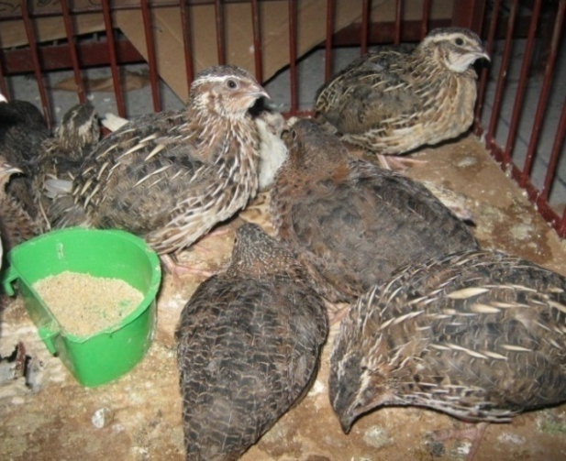
Photograph 3.1: Adult Japanese quail
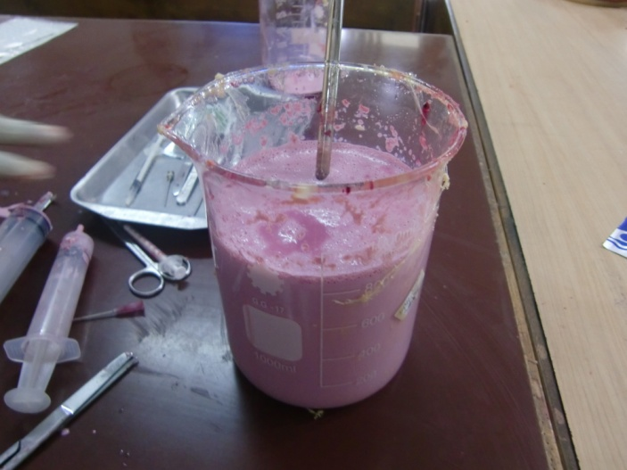
Photograph 3.2: Preparation of latex
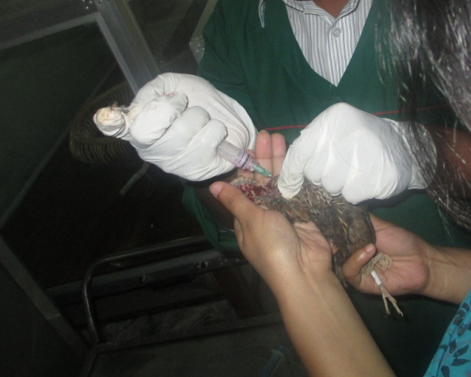
Photograph 3.3: Infusion of Latex into the lung
through trachea
CHAPTER IV
RESULTS

4.1 The lungs

The lungs were located in the dorsal part of the thorax and very close to the thoracic vertebrae and ribs. Their sharp cranial extremities extended as far as the second ribs. The ventral border lied between the 3rd and 6th ribs.

The lung had three surfaces. The convex costal surface was very close to the ribs and intercostals muscles, possessing the impressions of the ribs. The medial surface was convex. The hilus of the lungs was located on the cranioventral end of this surface. They had also concave ventral surfaces in shape.

4.2 The air sacs

The air sacs related to the lungs in Japanese quail were the cervical sac, the clavicular sac, the cranial thoracic sac, the caudal thoracic sac and the abdominal sac.

4.2.1The cervical sac
The cervical sac was present in front of the cranial border of the lungs and among the clavicular sac, trachea, oesophagus and neck muscles. The right and left cervical sacs, bilaterally located at the right and left sides of the cervical and thoracic vertebrae, made contact ventromedially with each other, but had no connection. The caudal border of the sac was limited by the second rib. The cervical sac showed no intermuscular and subcutaneous diverticula.

4.2.2 The clavicular sac

The clavicular sac was a single air sac formed by the partial fusion of the bilaterally located parts. This part resembled “V” shape, was ventrally connected under the trachea and attachment of the wings to the body, and occupied the cranial thoracal aperture completely. The sac was located cranial to the heart and cranioventral to the lungs, and was limited by the thoracic girdle and sternum. Trachea and esophagus lied dorsal to the sac separating it from the cervical sac. It had 2 separate connections with the lungs; the caudolateral parts through the 1st and 2nd,and the caudomedial parts with the 3rd medioventral bronchi.
The diverticula located extrathoracally were scattered by the cranial thoracic aperture. The subscapular diverticulum was present between the scapula and cervical sac.It was not fully developed and close to the clavicular sac. The axillar diverticulum was found ventral to the head of the humerus in chick-pea like appearance,beneath the shoulder muscles. This diverticulum was composed of highly developed humeral component.

4.2.3 The cranial thoracic sac

Not perfectly symmetrically located, the the cranial thoracic sacs were nearly rectangular in shape. The sac was limited laterally by the 4th, 5th and 6th ribs, and by the lateral and intermedial trabecula of the sternum. It covered the ventromedial surface of the lungs.
Medial border of the sac was in relation with the heart, liver and oesophagus. The sac had no diverticula for aeration.

4.2.4 The caudal thoracic sac

The caudal thoracic sac showed a triangle shaped symmetrically located caudoventral to the lungs. Craniolateral border of the sac was also in relation with the last two ribs. Its extension was roughly similar to the cranial thoracic one. Since medial surface of the sac was entirely covered by the abdominal sac, it displayed no relation with the viscera, especially caudally located ones. This sac had no diverticulum to aerate any bones.

4.2.5 The abdominal sac

The abdominal sac was significantly larger as compared to the others and possessed asymmetrically located two parts in the abdomen. Its extension was from the caudodorsal border of the lungs through the cloacae. The right abdominal sac was roughly 13.3 mm longer than the left one. On the other hand, the left abdominal sac was wider.

The right abdominal sac had the impression of the spleen on its craniomedial surface and that of the intestine on the caudomedial surface. It was limited laterally by the abdominal and partly pelvic walls. The sac covered entirely the ventral surface of the kidney and the roof of the pelvis. Similarly, the left abdominal sac possessed impressions of some viscera. Its dorsal boredr covered also the left kidney. Both the right and left abdominal sacs gave paramedially a couple of diverticula on their dorsal surface. This sac had no diverticulum for aeration also.

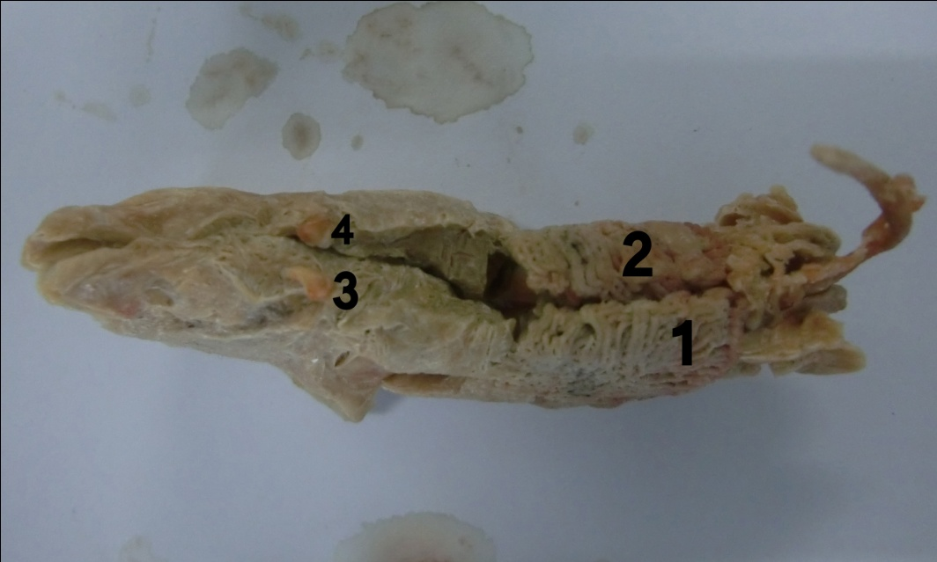

Photograph 4.1: Dorsal view of latex cast. 1. Right lung, 2.Left lung,
3. Right abdominal sac diverticulum, 4. Left abdominal sac diverticuin
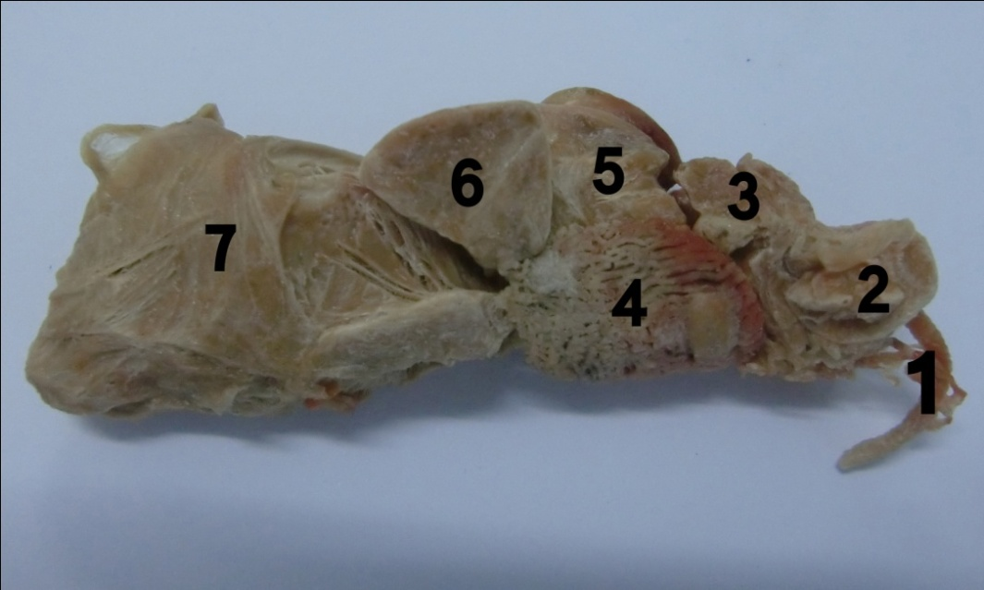

Photograph 4.2: Left lateral view of latex cast. 1.Trachea, 2.Cervical sac, 3.Clavicular sac, 4.Lung, 5.Cranial thoracic sac 6.Caudal thoracic sac, 7.Abdominal sac
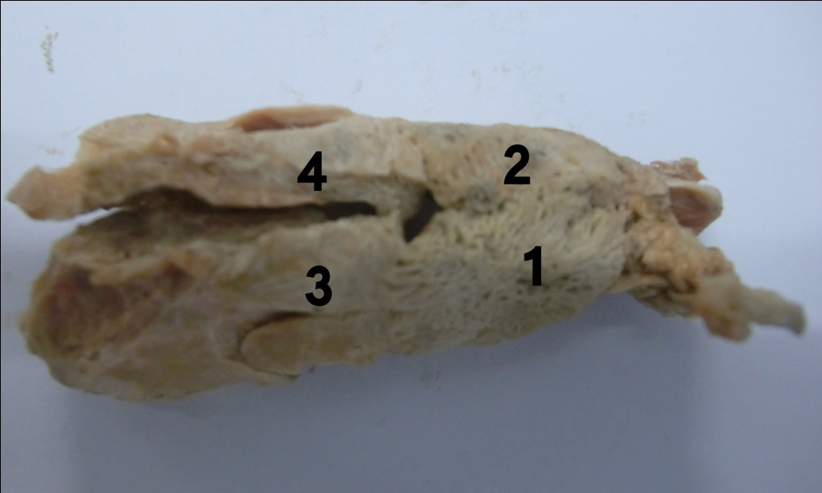
Photograph 4.3: Ventral view of latex cast. 1.Left lung, 2. Right lung, 3.Left abdominal sac, 4 Right abdominal sac

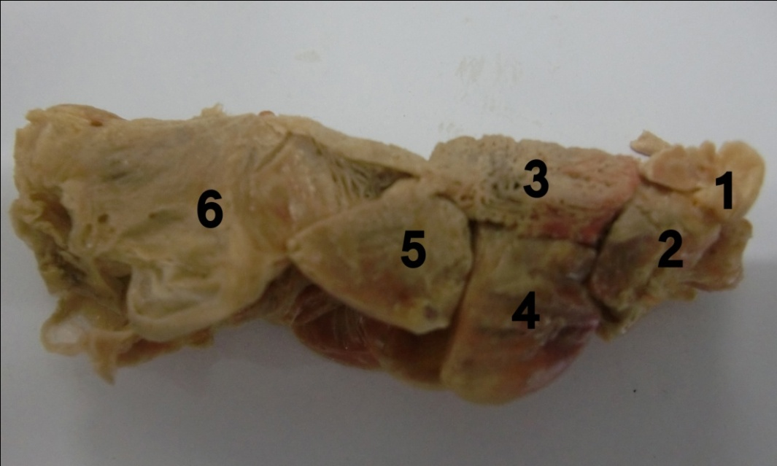
Photograph 4.4: Right lateral view of latex cast. 1.Cervical sac, 2.Clavicular sac, 3.Lung, 4.Cranial thoracic sac, 5.Caudal thoracic sac, 6.Abdominal sac

CHAPTER V
DISCUSSION

The cervical sac aerates the vertebral column from the 3rd cervical to the 5th thoracic vertebrae inclusive and the first two vertebral ribs in chickens (King and Kelly, 1956), however, no indication of aeration of vertebral ribs is present (Tylor et al., 1962). Nickel et al.,1977 noted that diverticula of cervical sacs pneumatized all the cervical vertebras in the domestic fowl; Also Murray et al.,1967 described that the vertebrae are pneumatized as far anteriorly as the axis and as far posteriorly as the last sacral vertebra. King and Payne, 1962 stated in Gallus domesticus that the extensions of the sac along the vertebral column, reached the aerated spaces of the cervical and thoracic vertebrae. However, the cervical sac aeration of only cervical vertebrae was present in the quails of this study. This sac had no intervention on the aeration of the thoracic vertebrae.

The findings of the clavicular sac of this observation were mostly agreed with those of Lucas et al., 1959 and Ringdon et al., 1958 that the interclavicular air sacs were fused to form one sac.Diverticulum humerale aerated humerus in Gallus domesticus (King and Payne, 1962), white pekin duck (Mennega and Calhoun, 1968), but not in the quails of this study.Therefore,this study indicated that humerus in the quail is a non aerated bone.

Getty 1975, Mannega et al., 1968 and Taşbaş et al., 1994 did not mention any diverticula of the cranial thoracic sac in domestic birds and also Çevik Demirkan et al.,2006 stated that the cranial thoracic sac did not aerated any of the bones in the respiratory system in mallard ducks.In this study,the sac connected to the 1st,2nd and 4th medioventral bronchi and gave no diverticulum for aeration.

The caudal thoracic sacs was not found to be a kind of such sac as reported by Lucas et al., 1959, but Das et al.,1965 stated that two caudal thoracic sacs were distinctly separated by an oblique septum,however,it was an only one sac in the quails of this study.These sacs were reported to receive air through the laterobronchi of their own side (Nickel et al., 1977), but our study showed seven bronchi of the sac received air through the 4th medioventral and the 1st and 2nd lateroventral bronchi.

Although some studies (Lucas et al., 1959; Taşbaş et al., 1994) have shown the cranial thoracic sac to be larger than the caudal, others (Akester, 1960; King and Payne, 1962) have indicated the opposite.

The left abdominal sac in Denizli rooster was slightly larger than the right one (Tasbas et al., 1994); but in this study, the right sac was larger than the left one in the quails. In accordance with Tylor et al., 1962 and Fitzgerald, 1970, the left and right abdominal sacs paramedially produced diverticulum femorale which had no entry into the femur. According to Calislar ,1984, the diverticulum pneumatized the lumbar vertebrae, sacrum and coxae and in ostriches, it penetrated into the femur through a large foramen in front of the trochanter major. The abdominal sacs (larger one) gave several diverticula and located at the milieu of caput femoris (Ringdon et al., 1958).

CHAPTER VI
CONCLUSION
In conclusion, the data generated here may provide valuable contribution to the understanding of morphology of air sacs in Japanese quails. The structure, size, location and position of different air sacs are not uniform. Many common diseases affect the air sacs, reduce the productions and thus cause economic loss. Proper anatomical knowledge of air sacs can play important role for diagnosis and treatment of common air sac related diseases and thus the poultry disease diagnosis can be improved. Furthermore, clinicians who are interested in respiratory diseases of quails may get some benefits from this study.

RECOMMENDATIONS

The study suggests following recommendation-

- Further research is needed to know the exact position and location of sacs with more reliable chemicals.

LIMITATIONS

The study has following constraints-
- It was very difficult to locate the exact location and position of air sacs of quail.
- It was also very difficult to measure the individual size of different air sacs.
- The results were impaired by the great shrinkage of the injectable substance and by uneven filling of the sac.

BIBLIOGRAPHY

Akester, A.R. 1960. The comparative anatomy of the respiratory pathways in the domestic fowl (Gallus domesticus), pigeon (Colomba livia) and domestic duck (Anas platyrhyncha). Journal of Anatomy. 94: 487-505.

Banzett, R. B., Butler, J. P., Nations, C. S., Barnas, G. M., Lehr, J. L., and Jones, J. H., 1987. Inspiratory aerodynamic valving in goose lungs depends on gas density and velocity. Respiration Physiology. 70:287–300.

BBS, 2000. Bangladesh Bureau of Statistics. Statistical Year Book of Bangladesh, Published June 2002, 21st edition, Pp:395,450, 581, 592, 595. http://www.bbs.gov.bd

BBS, 2003. Bangladesh Bureau of Statistics. Statistical Bulletin Bangladesh, July Pp: 9-10. http://www.bbs.gov.bd

Bennett, T., Malmorfs, T. 1970. The adrenergic nervous system of the domestic fowl (Gallus domesticus L.) .Z. Zellfrorsch. 106: 22–50.

Brown, R. E., Kovacs, C. E., Butler, J. P., Wang, N., Lehr, J., and Banzett, R. B., 1995. The avian lung: is there an aerodynamic expiratory valve. Journal of Experimental Biology. 198:2349–2357.

Butler, J. P., Banzett, R. B., and Fredberg, J. J. 1988. Inspiratory valving in avian bronchi: aerodynamic considerations. Respiration Physiology. 72:241–256.

Calishar, T. 1984. Anatomy of domestic animals II: Horse and Poultry Dissection, Istambul University Press, Istambul, turkey.

Çevik Demirkan, A., Hazıroğlu, R.M., Kürtül, İ. 2006. Air sacs (sacci pneumatici) in mallard ducks (Anas platyrhynchos). Ankara Univ Vet Fak Derg, 53: 75-78.

Das, L.N. and Mishra, D.B.1965. Comparative anatomy of the Domestic duck. Indian Veterinary Journal. 42: 320-326.

Dotterweich, H., 1936. Die Atmung der Vo¨ gel. Z. vergl. Physiology. 23:744–770.

Dubach, M. 1981. Quantitative analysis of the respiratory system of the House Sparrow, Budgerigar, and Violet-eared Hummingbird. Respiration Physiology. 46: 43-60.

Dunker, H-R.1971. The lung air sac system of birds. A contribution to the functional anatomy of the respiratory apparatus. Ergebnisse Anatomy . Bd . 45 :1–171.

Fedde, M. R., 1986. Respiration in: Avian Physiology. 4th ed. P. D. Sturkie, ed. Springer-Verlag, New York, NY, Pp:191–220.

Fedde, M. R., 1987. Respiratory muscles. in: Bird Respiration. Vol. I. T. J. Seller, ed. CRC Press, Boca Raton, FL,Pp: 3–37.

Fitzgerald, T.C. 1970. The coturnix quail anatomy and Histology, Iowa State University Press, Ames, Iowa.

Getty, R. 1975. Sisson and Grossman’s The Anatomy of The Domestic Animals. In: King, A.S., Respiratory system, 5th edition, W.B. Saunders Company, Philadelphia.

Groth, H-P.1972. Licht und fluoreszenzmikroskopishche Untersuchungen zur Innervation des Luftsacksystems der Vogel. Z. Zellforsch. 127: 87–115.

Hogg , D.A. 1990. The development of pneumatisation in the skull of the domestic fowl. Journal of Anatomy. 169: 139-151.

Hogg, D.A. 1984. The distribution of pneumatisation in the skeleton of the adult domestic fowl. Journal of Anatomy. 138: 617-629.

Howes J. R. 1964. Japanese quail as found in Japan. Quail Quarterly. 1: 19-30.

Huque Q. M. E. and Paul, D. C. 2001. Strategies for family poultry with special reference to women participation. Paper presented In 1st SAARC Poultry Conference Held On 24-26, September 2001 At Pune ,India.

Kimball, J. 2010.Currumbin Valley:birds,reptiles and exotics vet. Currumbin Valley Vet Services.

King, A.S. and Kelly, D.F. 1956. The aerated bones of gallus domesticus: the fifth thoracic vertebra and sterna ribs. British Veterinary Journal. 112: 279-283.

King,A.S. and Payne,D.C. 1962.The maximum capacities of the lungs and air sacs of Gallus domesticus. Journal of Anatomy. 96: 495-503.

Kuethe, D. O. 1988. Fluid mechanical valving of air flow in bird lungs. Journal of Experimental Biology. 136:1–12.

Lucas, A.H., Keeran, R.J. and Coussens, c. 1959. Air sacs of chicken, turkey, duck and owl. Anatomical Record. 133: 452.

Maina, J. N. 2008. Functional morphology of the avian respiratory system, the lung-air system: efficiency built on complexity, Ostrich .79: 117-132.

Maina, J. N., and A. S. King. 1989. The lung of the Emu, Dromaius novaehollandiae: a microscopic and morphometric study. Journal of Anatomy. 163: 67-74.

Maina, J.N. 1989. The morphometry of the avian lung in Form and function in birds (A.S. King and J. McLelland, eds.),London, Academic Press, Pp: 307-368.

Mannega, A., Calhoun, M.L. 1968. Morphology of the lower respiratory structures of the white Pekin duck. Poultry Science. 47: 266-280.

McLelland J. 1989. Anatomy of the lungs and air sacs. In Form and Function in Birds, Vol. 4 (eds King AS, McLelland J), London, Academic Press, pp: 221–279.

Meyer, M., H. Worth, and P. Scheid, 1976. Gas-blood CO2 equilibrium in parabronchial lungs of birds. Journal of Applied Physiology. 41:302–309.

Mills A. D., Crawford, L. L., Domjan, M. and Faure, J. M. 1997. The behavior of the Japanese or domestic quail (Coturnix japonica). Neuroscience & Biobehavioral Reviews.21:261-281.
Murray, P.H. and Fisher H.I. 1967. Air sacs of respiratory origin in some procellariiform birds. The Condor, 69: 586- 595.

Nickel,R., Schummer A., and Seiferle,E. 1977. Anatomy of The Domestic Birds. Verlag Paul Parey, Berlin-Hamburg.

Ocal,k. and Erden, H. 2002.In N. Dursun,(edition),Anatomy of Domestic Birds,(Medisan Publishing Company,Ankara,Turkey),97-102

Panda B. 1989. A decade of research and development on quail. Central Avian Research Institute, Izatnagar, India. Physiology. 70:287–300.

Powell, F.L. 2000. Respiration in Avian physiology, fifth edition (G. Causey Whittow, ed.). Academic Press, New York, NY, Pp: 233-264.

Rigdon, A.H., Furguson, T.M., Feldman, G.L. and Couch, J.R. 1958. Air sacs in the turkey. Poultry Science. 37: 53-60.

Sturkie, P.D. 2000.Avian Physiology, 5th edition.,(Springer-Verlag,New York).

Scheid, P., M. R. Fedde, and J. Piiper, 1989. Gas exchange and airsac composition in the unanesthetized, spontaneously breathing goose. Journal of Experimental Biology. 142:373–385.

SPBB, 2008. Statistical Pocket Book of Bangladesh (2008). Published at January 2009. http://www.bbs.gov.bd

Tasbas, M., Hariroglu, R.M., Cakir, A. and Ozer, m 1994. Morphological investigations of the respiratoric system in denizli Cocks. Ankara University Veterinary Fak. Derg. 41: 154-168.

Tylor, R.O., Bcone, M.A. and Barnett, B.D. 1962. Plastic infusion and casting of the avian air sacs. Poultry Science. 41: 1940-1943.

Wang, N., Banzett R. B., Butler J. P. and Fredberg J. J. 1988. Bird lung models show that convective inertia effects inspiratory aerodynamic valving. Respiration Physiology. 73:111–124.

West, J. B. 2009. Comparative physiology of the pulmonary blood-gas barrier: the unique avian solution. American Journal of Physiology - Regulatory, Integrative and Comparative Physiology. 297: R1625-R1634.

